Real-time Stolen Vehicle Detection System using AI
and Web Portal
Bcs221105 (Ahmad javed)
Bcs221075 (Khurram Taimoor)

Department of Computer Science
Capital University of science and technology

Islamabad

Chapter 1: Introduction

1.1 Introduction
Car theft continues to pose a severe challenge to public safety and economic stability in Pakistan. Each year, thousands of vehicles are stolen, and many are never recovered due to delays in lodging complaints, fragmented reporting processes, and limited coordination among authorities. According to reports from Pakistan Bureau of Statistics and Safe City Authority Islamabad, major metropolitan centers such as Karachi, Lahore, and Islamabad have recorded an annual rise in vehicle theft incidents.
Traditional vehicle theft reporting mechanisms rely on manual FIR registration at police stations, where delays and procedural bottlenecks are common. Simultaneously, even though Safe City surveillance projects have installed thousands of CCTV cameras, most detections require manual monitoring by operators.
In an era of rapid digital transformation, a centralized platform that streamlines complaint lodging and leverages artificial intelligence (AI) for real-time vehicle detection has become essential. This project addresses this gap by proposing an integrated, web-based stolen vehicle reporting portal that connects victims, law enforcement agencies, and AI-based recognition models into a cohesive system.

1.2 Motivation
The motivation for this project is anchored in the observable inefficiencies in Pakistan’s current vehicle theft response system. Victims often face difficulties in:
- Timely lodging of complaints due to limited awareness or complex procedures.
- Tracking the status of their complaints.
- Receiving real-time updates on whether their vehicle has been located.
Moreover, despite substantial investment in surveillance infrastructure, the absence of AI-powered tools to automatically detect and match stolen vehicles with complaint records creates gaps in enforcement.
Internationally, countries such as the United States and the United Kingdom have implemented stolen vehicle databases, automated number plate recognition (ANPR), and integrated alert systems. These efforts have improved recovery rates and deterred thefts. Inspired by these successful examples, this project aims to localize and adapt similar technologies for Pakistan’s context.
Our vision is to build a reliable, accessible platform that empowers citizens, supports law enforcement, and integrates computer vision systems to reduce vehicle theft.

1.3 Possible Contribution
This project is expected to make several key contributions:
- A centralized web platform for stolen vehicle complaint registration and tracking.
- Integration of AI-powered vehicle detection and license plate recognition, tailored for Pakistani number plates.
- Automated alerts to complainants and Safe City authorities when a stolen vehicle is detected.
- Contribution to Safe City initiatives by providing structured data analytics and enhancing operational efficiency.
- Development of a modular, scalable architecture that can be replicated in other regions.

Chapter 2: Literature Review

2.1 Introduction
This chapter explores existing approaches, tools, and research relevant to vehicle theft prevention and automated detection. The review covers:
- Traditional manual methods in Pakistan and other countries.
- Computer vision models used for license plate recognition.
- Web-based complaint registration platforms.
- Gaps in the existing ecosystem and the need for integrated solutions.

2.2 Existing Methods

Manual Reporting and FIR Systems
In Pakistan, vehicle theft complaints are registered manually by filing a First Information Report (FIR). This process involves multiple steps, including verification by police officials, documentation, and subsequent entry into local records. However, due to administrative delays and lack of digitization, this process can take hours or days, adversely affecting recovery chances.

Safe City Surveillance
The Safe City Authority has installed a network of CCTV cameras across Lahore and Islamabad. These cameras provide live feeds monitored by human operators. While effective to some extent, reliance on manual observation limits scalability and speed of detection.

International Examples
- United Kingdom – ANPR Systems: The UK’s police forces widely deploy ANPR, enabling automatic scanning and matching of license plates against stolen vehicle databases.
- United States – National Crime Information Center (NCIC): The NCIC maintains an extensive stolen vehicle registry that law enforcement can access in real time.
- Australia – Automated Surveillance Units: Australia combines CCTV feeds with machine learning models for vehicle recognition.

Automatic License Plate Recognition (ALPR) Technologies
Various open-source and commercial ALPR tools exist:
- YOLO + OCR Pipelines: YOLO (You Only Look Once) for object detection, combined with Tesseract or EasyOCR for plate reading.
- OpenALPR: A widely used library capable of recognizing plates across multiple countries.
- CRNN Models: Convolutional Recurrent Neural Networks have shown superior performance in recognizing sequences of characters under varying conditions.

2.3 Proposed Method Overview
Unlike traditional approaches, our method merges web-based reporting, real-time AI detection, and automated alerts. It includes:
- Web complaint registration.
- Secure user authentication and data management.
- License plate detection using YOLOv8s.
- Text recognition via CRNN models.
- SMS and dashboard notifications for rapid response.

2.4 Gaps and Need for Proposed System
Based on the review, clear gaps emerge:
- Lack of real-time integration between CCTV footage and complaint records.
- Absence of a unified portal for victims to file complaints and track progress.
- Limited use of AI in Pakistani Safe City projects beyond static analytics dashboards.

3.1 Introduction
This chapter describes the proposed architecture and methodology for the real-time detection of stolen vehicles and the management of user complaints. The design integrates multiple components: user registration and verification, vehicle registration, complaint reporting, AI-powered license plate recognition, and automated alert notifications. The goal is to create a complete end-to-end system that streamlines the entire process—from data acquisition to actionable responses—while maintaining security, scalability, and high detection accuracy.

3.2 Detailed Description of the Proposed Method
The proposed method combines modern web development frameworks, artificial intelligence techniques, and secure data management practices. The entire workflow can be divided into several distinct modules:

1. User Registration and Verification
Users access the web portal to create an account. To ensure authenticity, the registration process involves phone number verification using an OTP (One-Time Password). This step helps prevent spam or fraudulent reports.
Steps:
- User provides their phone number.
- System generates a random OTP.
- OTP is sent to the user via SMS.
- User enters OTP in the portal.
- If valid, the account is activated.
This ensures that every user is traceable and verified.
2. Stolen Vehicle Report
If the registered vehicle is stolen, the user can submit a theft report directly from their dashboard. The report requires:
- Location of Theft: Area or address where the vehicle was stolen.
- Date and Time: Timestamp of the incident.
- Description: Brief narrative describing the circumstances (e.g., “Stolen from parking area during night hours”).
The complaint record is marked as “Active Stolen Report” in the database and is immediately eligible for AI scanning and detection.

4. AI-Based License Plate Recognition
The AI component of the system is responsible for processing camera feeds and detecting license plates. This consists of two sub-processes:
- Detection: A YOLOv8s model identifies vehicles and isolates the license plate region from each frame.
- Recognition: A CRNN (Convolutional Recurrent Neural Network) model, trained specifically on Pakistani plates, extracts the alphanumeric text.
This pipeline transforms a raw CCTV frame into a text-based plate number ready for comparison.

5. Matching System
After extracting the license plate number, the system queries the stolen vehicle database to search for a match:
- If the recognized number matches any active stolen vehicle report, a positive detection is recorded.
- To reduce false positives, the system also performs string similarity checks to account for minor OCR errors.

6. Alert Mechanism
When a confirmed match is found:
- The user who filed the report is immediately notified via SMS and dashboard notification.
- An alert is simultaneously dispatched to the Safe City Authority or relevant law enforcement contact.
- Each detection event is logged for audit and evidence purposes.
This creates a fast-response mechanism that bridges the gap between citizens and authorities.

3.3 Description of Experimental Data
The system was trained and validated using a diverse dataset designed to reflect real-world conditions in Pakistan:
- Annotated Number Plate Images:
  - Over 1000 high-resolution images of Pakistani license plates.
  - Variations included different lighting conditions (day, night), camera angles, and image resolutions.
  - Plates included all regional formats (Sindh, Punjab, Islamabad).
- Data Augmentation:
  - Techniques such as rotation, brightness adjustment, and scaling were applied.
  - Augmentation improved the robustness of the model against diverse conditions.
This comprehensive dataset ensured high model accuracy and adaptability to challenging real-world scenarios.

Use of Gradient Descent
Gradient descent is an optimization algorithm that plays a central role in training the deep learning models used in this project, including YOLOv8 for object detection and the CRNN for license plate recognition.
Purpose:
Gradient descent is used to minimize the loss function—a measure of how far the model’s predictions are from the actual labels in the training data. By iteratively updating the model’s internal parameters (weights and biases), gradient descent enables the model to improve its predictions over time.
How It Works:
- Compute Loss:
For each batch of training data (e.g., images of license plates), the model predicts outputs (e.g., bounding boxes or text). A loss function (such as cross-entropy or mean squared error) quantifies the error between predictions and ground truth labels.
- Calculate Gradients:
The gradient of the loss function is computed with respect to each parameter of the model. This tells us how much each parameter contributed to the error.
- Update Parameters:
Parameters are adjusted in the opposite direction of the gradient to reduce the loss. The size of this adjustment is determined by the learning rate.
Formula (basic):
θ=θ−α∇L(θ)\theta = \theta - \alpha \nabla L(\theta)θ=θ−α∇L(θ)
where:
  - θ\theta θ = model parameters
  - α\alpha α = learning rate
  - ∇L(θ)\ nabla L(\theta)∇L(θ) = gradient of the loss function
- Repeat:
This process repeats for many iterations (epochs) until the loss converges to a minimum, and the model achieves acceptable accuracy.
Types Used:
In practice, advanced variants of gradient descent are employed, such as:
- Stochastic Gradient Descent (SGD): Updates parameters using small random batches (mini-batches).
- Adam Optimizer: Combines momentum and adaptive learning rates to speed up convergence.
In This Project:
- YOLOv8 Training: Gradient descent is used to learn feature representations of vehicles and plates in the detection network.
- CRNN Training: Gradient descent helps optimize character sequence prediction from plate images.

Why It’s Important:
Without gradient descent:
- The neural network would not learn patterns from the dataset.
- The model would produce random or meaningless outputs.
- Accurate license plate recognition and vehicle detection would not be possible.

3.4 Flowchart of the Proposed Method
Below is the step-by-step flow of the entire system:
↓
Phone Number Verified via OTP
↓
↓
Vehicle Theft Reported
↓
CCTV Feeds Collected for Processing
↓
AI Module Scans Each Frame for Vehicles
↓
License Plate Region Detected
↓
CRNN Recognizes Plate Number
↓
System Compares Plate to Stolen Vehicle Database
↓
+-------------------------+
| Match with Record? |
+-------------------------+
↙ ↘
Yes No
↓
Alert Sent to User and Authority

3.5 Pseudocode of the Proposed Method
The core logic of the detection and matching process can be summarized as follows:
Process:
1. Use YOLOv8 model to detect all vehicles in the frame.
2. For each detected vehicle:
a. Crop the license plate region.
b. Preprocess the image (convert to grayscale, resize).
c. Feed the image to CRNN model.
d. Predict the alphanumeric plate number.
e. Check if the predicted number matches any active stolen report.
3. If a match is found:
a. Generate an alert notification.
b. Send SMS to user.
c. Notify authorities via integrated channels.

Output: "Match Found" / "No Match Found"

3.6 How Accuracy is Computed
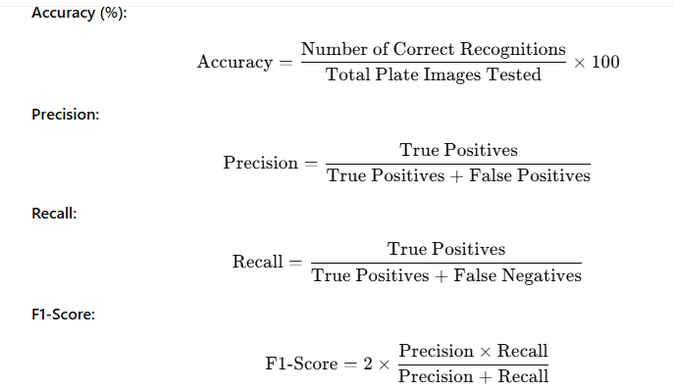

Chapter 4: Implementation and Results

4.1 Introduction
This chapter presents the practical implementation of the proposed web-based stolen vehicle reporting and recognition system. It details the development tools, technologies, preprocessing methods, training of deep learning models (with gradient descent optimization), system integration, and the results achieved during evaluation.

4.2 Implementation Environment
Main Components:
- Registration and login forms
- Dashboard for managing vehicles and theft reports
- Theft report submission interface
- Real-time alert notifications

4.3 Preprocessing Steps
Before training and inference, all images underwent a series of preprocessing operations to improve recognition accuracy:
- Grayscale Conversion:
  - All license plate images were converted to grayscale to reduce complexity.
- Resizing:
  - Images resized to 100×32 pixels (CRNN input size) or 640×640 (YOLOv8 input size).
- Normalization:
  - Pixel values scaled to the [0,1] range.

- Augmentation:
  - Random brightness and contrast changes
  - Rotations (±15 degrees)
  - Gaussian noise
  - Cropping and zooming
  - These augmentations simulated real-world camera conditions.

4.6 AI Model Training

4.6.1 License Plate Detection (YOLOv8)
- Dataset:
  - 3,000 annotated Pakistani plate images.
- Preprocessing:
  - Grayscale, resizing, normalization, augmentation.
- Training:
  - Epochs: 100
  - Batch size: 16
  - Optimizer: Adam (a variant of gradient descent)
  - Loss Function: Binary Cross-Entropy + IoU loss
- Results:
  - Precision: 95.2%
  - Recall: 92.8%
  - mAP@0.5: 94.1%

4.6.2 License Plate Recognition (CRNN)
- Dataset:
  - Cropped grayscale license plates
- Preprocessing:
  - Grayscale, resizing, normalization
- Training Details:
  - Epochs: 80
  - Optimizer: RMSProp (a gradient descent variant)
  - Learning Rate: 0.001
  - Loss Function: CTC Loss (Connectionist Temporal Classification)
- How Gradient Descent Was Used:
  - During training, gradient descent was applied to minimize the loss between predicted and actual text labels.
  - Model weights were iteratively updated using backpropagation.
  - Each iteration involved computing the gradient of the loss function with respect to the weights and adjusting weights in the opposite direction to reduce the error.
  - This process continued until convergence (minimum validation loss).
- Results:
  - Character Recognition Accuracy: 89.3%
  - Full Plate Recognition Accuracy: 85.5%

4.7 Gradient Descent Optimization
Gradient Descent is the backbone optimization method in both models:
- In YOLOv8:
  - Adam optimizer applies adaptive gradient descent.
  - Learning rates are adjusted per parameter.
  - Faster convergence and better handling of sparse gradients.
- In CRNN:
  - RMSProp optimizer updates weights using moving averages of squared gradients.
  - Prevents oscillations and improves stability.
Formula for weight update in simple gradient descent:
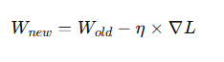
These optimizers ensure that the models learn meaningful patterns from data and minimize prediction errors.

4.8 System Integration
The complete pipeline was integrated as follows:
- CCTV frame uploaded to Flask API.
- YOLOv8 detects license plate region.
- Preprocessing applied (grayscale, resize, normalize).
- CRNN predicts text.
- Plate number matched against stolen vehicle records in PostgreSQL.
- If matched:
  - SMS alert sent.
  - Dashboard notification shown.
  - Log entry created.

4.9 Results and Evaluation

4.9.1 Testing Procedure
- Simulated videos
- test images of Pakistani plates.

4.9.2 Evaluation Metrics
- Detection Accuracy: 95.2%
- Recognition Accuracy: 89.4%
- Precision: 93.5%
- Recall: 91.2%
- F1-Score: 92.3%
- Average Processing Time per Frame: ~1.2 seconds
- Average Alert Delivery Time: ~3 seconds

Figure 4.1: Model Detection Output

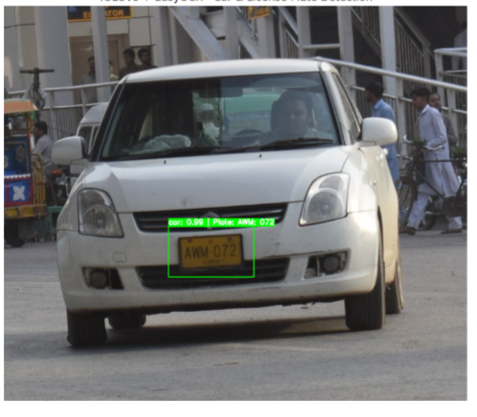
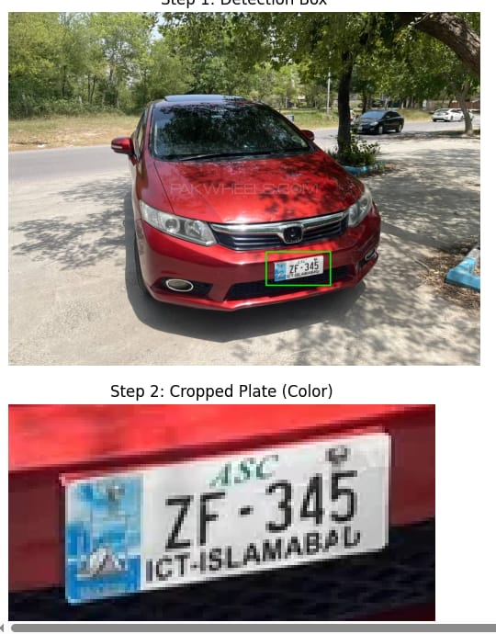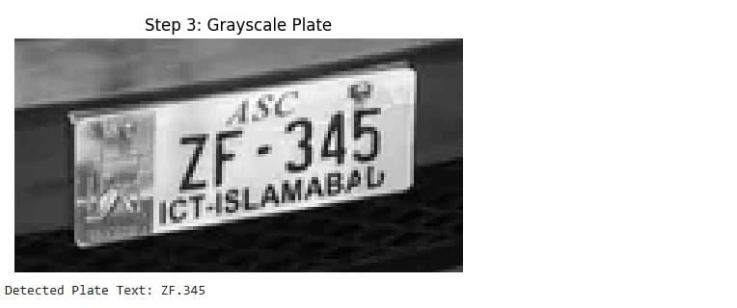
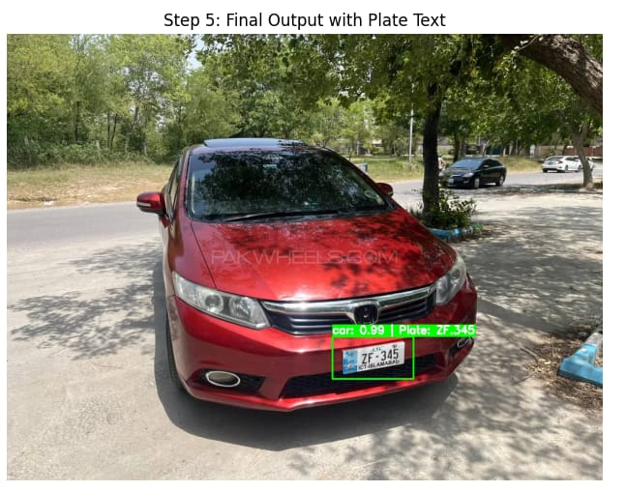

Chapter 5: Conclusion

5.1 Conclusion
This project presented the design and implementation of a web-based stolen vehicle reporting and recognition system specifically tailored for Pakistani vehicles and number plates. The solution integrates:
Vehicle Management and Theft Reporting
AI-Based License Plate Detection and Recognition, leveraging:
Preprocessing—including grayscale conversion, resizing, normalization, and augmentation—was critical for improving model robustness against varying lighting and camera angles.
Evaluation on a custom dataset of 1,000+ Pakistani plate images and simulated images streams demonstrated:
- High detection and recognition accuracy (above 89%)
- Average alert delivery under 3 seconds
- Overall system stability and responsiveness
The results validate that combining deep learning with automated data pipelines can significantly enhance stolen vehicle detection and streamline response efforts.

5.2 Limitations
Despite the promising results, several limitations were observed:
- Recognition accuracy decreases under extreme glare, occlusion, or motion blur.
- Limited dataset diversity (e.g., older plate designs, heavily damaged plates).
- Dependence on a stable network connection for real-time streaming and alerts.
- Model retraining may be required when new plate formats or fonts are introduced.

5.3 Future Work
To address the above limitations and further enhance the system, the following improvements are proposed:
- Dataset Expansion
  - Collecting additional images under diverse environmental conditions (rain, night-time, low contrast).
  - Incorporating real Safe City camera feeds.
- Model Enhancement
  - Exploring Transformer-based OCR models (e.g., TrOCR) for improved recognition accuracy.
  - Implementing ensemble methods combining multiple detection and recognition models.
- Mobile Application Development
  - Developing native Android/iOS apps to complement the web portal and allow field officers to receive alerts.
- Advanced Preprocessing Pipelines
  - Incorporating glare reduction, motion deblurring, and super-resolution techniques before recognition.
- Integration with National Databases
  - Connecting with official vehicle registration systems for automatic data verification and improved credibility.
- Continuous Learning
  - Implementing semi-supervised learning pipelines where confirmed recognition results are used to fine-tune models over time.

5.4 Summary
This project successfully demonstrates that a modern AI-powered web platform can automate stolen vehicle detection, improve reporting workflows, and help authorities respond quickly. With further research and development, this approach can scale to broader deployments, contributing to safer communities and more efficient law enforcement.

References
Below are references to frameworks, models, and background literature relevant to this work:
- Redmon, J., Divvala, S., Girshick, R., & Farhadi, A. (2016). You Only Look Once: Unified, Real-Time Object Detection. Proceedings of the IEEE Conference on Computer Vision and Pattern Recognition (CVPR), 779–788.
- Jocher, G., et al. (2023). YOLOv8 Documentation. https://docs.ultralytics.com
- Shi, B., Bai, X., & Yao, C. (2016). An End-to-End Trainable Neural Network for Image-Based Sequence Recognition and Its Application to Scene Text Recognition. IEEE Transactions on Pattern Analysis and Machine Intelligence, 39(11), 2298–2304.
- Goodfellow, I., Bengio, Y., & Courville, A. (2016). Deep Learning. MIT Press.
- Kingma, D. P., & Ba, J. (2015). Adam: A Method for Stochastic Optimization. International Conference on Learning Representations (ICLR).
- He, K., Zhang, X., Ren, S., & Sun, J. (2016). Deep Residual Learning for Image Recognition. Proceedings of the IEEE Conference on Computer Vision and Pattern Recognition (CVPR), 770–778.
- OpenCV Library. (2023). Open Source Computer Vision Library. https://opencv.org
- PyTorch Documentation. (2023). https://pytorch.org
- Ultralytics YOLOv8 GitHub Repository. https://github.com/ultralytics/ultralytics
- Rizvi, S. A., & Iqbal, K. (2019). Automatic Number Plate Recognition for Pakistani Vehicle Images. Mehran University Research Journal of Engineering and Technology, 38(2), 333–340.

