SRI SIDDHARTHA ACADEMY OF HIGHER EDUCATION
(Declared as Deemed to be University Under Section 3 of the UGC Act, 1956)

Sri Siddhartha Institute of Technology
KUNIGAL ROAD, MARALURU, TUMAKURU – 572107 KARNATAKA

Hobby Project Report on
“Digit Recognition with Deep learning using MNIST and EMNIST Datasets”

Submitted by:
MOHAMMED ROSHAN (23DS032)
KARTHIK GOWDA (24DS40 )

BACHELOR OF ENGINEERING IN
DEPARTMENT OF CSE(DATA SCIENCE)

Under the guidance of
Mrs. SHAMSIYA PARVEEN

Assistant Professor, Dept. of CSE(DS),


SRI SIDDHARTHA INSTITUTE OF TECHNOLOGY

TABLE OF CONTENT
1. Abstract
2. Introduction
3. Dataset Overview
- MNIST Dataset
- EMNIST Digits Dataset
4. Model Architecture
- Model 1: MNIST with Code and Explanation
- Model 2: EMNIST with Code and Explanation
5. Results & Visualization
6. Challenges Faced
7. Conclusion

ABSTRACT:
This project explores handwritten digit recognition using two deep learning models trained on two different datasets: the well-known MNIST dataset and the more challenging EMNIST Digits dataset. The goal was to teach a computer how to recognize digits from 0 to 9 by training it on thousands of handwritten examples.
The first model was trained on MNIST, which contains clean and centered digits written by different people. It performed quite well, achieving high accuracy with relatively simple preprocessing and a basic Convolutional Neural Network (CNN). However, MNIST is a bit too "easy"—it doesn't fully represent the messiness of real-world handwriting.
To take things a step further, the second model was trained on EMNIST Digits, which includes more variation in handwriting and layout. Because of this, it’s harder for the model to learn and sometimes it makes mistakes—for example, it predicted an '8' when the digit was clearly a '7'. While frustrating, these mistakes highlight just how tough it is for machines to interpret human writing, especially when it’s messy or ambiguous.
Both models share the same architecture: a CNN with layers for feature extraction and classification, trained using TensorFlow/Keras. The input images were normalized and preprocessed (including rotation and flipping for EMNIST) to improve performance. Batching and prefetching were used to speed up training.
Even though the EMNIST model isn’t fully accurate yet, the project as a whole demonstrates the power and limitations of neural networks when it comes to image recognition. It's a great starting point for deeper work, such as tuning hyperparameters, adding more training tricks, or testing better network architectures. In the end, it’s been a great learning experience in how AI sees and interprets the world—even when it gets things a little wrong.

INTRODUCTION:

We see numbers written by hand all the time — on paper, whiteboards, receipts, or even scribbled on sticky notes. While humans can usually read them instantly (even if they’re a bit messy), teaching a computer to do the same is surprisingly tricky. This project is all about trying to solve that challenge using deep learning.

The core idea behind this project is to build a digit recognizer — a machine that can look at an image of a handwritten number (from 0 to 9) and figure out what number it is. To do this, I used Convolutional Neural Networks (CNNs), which are especially good at handling image data. CNNs work by learning patterns — edges, curves, shapes — and slowly building up a “sense” of what a digit looks like.
To train the model, I used two popular datasets:
- MNIST: This is the classic dataset in the field of digit recognition. It’s clean, simple, and contains 60,000 training images and 10,000 test images of digits written by many people. It’s often used to test out new models because it’s relatively easy to work with.
- EMNIST Digits: This dataset is more recent and a bit messier. It has more variation in handwriting and isn't as neatly formatted as MNIST. That makes it harder, but also more realistic if you want your model to work in the real world.
Our goal wasn’t just to train a model that gives perfect results — although that would be nice. It was also to understand how these models learn, what causes them to make mistakes, and how I can improve them. In fact, during testing, the EMNIST-based model made some wrong predictions (like reading a '7' as an '8'), which shows how complex this problem really is.
Overall, this project helped me dive into the world of machine learning, gain hands-on experience with datasets and neural networks, and also face the reality that AI isn’t magic — it’s only as good as the data, training, and design behind it.

DATASETS OVERVIEW:

In this project, we worked with two widely used handwritten digit datasets — MNIST and EMNIST. These datasets played a crucial role in training and evaluating our digit recognition models.

- MNIST Dataset:
The MNIST (Modified National Institute of Standards and Technology) dataset consists of 70,000 grayscale images of handwritten digits ranging from 0 to 9. Each image is 28×28 pixels in size, centered, and size-normalized. We used 60,000 images for training and 10,000 for testing. MNIST is often considered the "hello world" of computer vision and deep learning due to its simplicity and widespread use.

- EMNIST Dataset:
To take things a step further, we also trained a second model using the EMNIST (Extended MNIST) dataset, specifically the 'digits' split, which also includes handwritten digits 0–9, but from a different data source. EMNIST images are also 28×28 pixels, but they often come rotated and mirrored, requiring additional preprocessing to correct their orientation. This dataset adds diversity and complexity, helping us test the generalization power of our digit recognition pipeline.
By using both datasets, we were able to compare how our models performed under different conditions, and to identify areas where accuracy still needs improvement.

MODEL ARCHITECTURE:

We built two Convolutional Neural Network (CNN) models for digit classification — one trained on the MNIST dataset and the other on the EMNIST (Digits subset) dataset. Both models share a similar base structure but were trained independently due to the differences in dataset orientation and structure.

Model 1: MNIST:

Input Layer: 28×28 grayscale image

Conv2D: 32 filters, 3×3 kernel, ReLU activation

MaxPooling2D: 2×2 pool size

Conv2D: 64 filters, 3×3 kernel, ReLU activation

MaxPooling2D: 2×2 pool size

Flatten Layer

Dense: 128 neurons, ReLU activation

Output Dense Layer: 10 neurons (digits 0–9), Softmax activation

CODE AND EXPLANATION:

# Cell 1: imports

import os

# Provides functions for interacting with the OS

import numpy as np

# Used for numerical computations and arrays

import matplotlib.pyplot as plt

# For plotting and visualization

import tensorflow as tf

# TensorFlow library for deep learning

from tensorflow import keras

# High-level API for building and training models

import cv2

# OpenCV for image processing

# Set seeds for reproducibility

np.random.seed(42) # Set NumPy random seed

tf.random.set_seed(42) # Set TensorFlow random seed

# Cell 2: load MNIST from Keras

(x_train, y_train), (x_test, y_test) = keras.datasets.mnist.load_data() # Load MNIST dataset

# Normalize to [0,1] and add channel dimension

x_train = x_train.astype('float32') / 255.0

# Normalize training images

x_test = x_test.astype('float32') / 255.0

# Normalize test images

x_train = np.expand_dims(x_train, -1)

# Add channel dim: (60000, 28, 28, 1)

x_test = np.expand_dims(x_test, -1)

# Add channel dim: (10000, 28, 28, 1)

# Cell 3: model definition

model = keras.models.Sequential([

# Initialize a Sequential model

keras.layers.Conv2D(32, 3, activation='relu', input_shape=(28,28,1)), # Conv layer with 32 filters

keras.layers.MaxPool2D(),

# Max pooling to reduce spatial size

keras.layers.Conv2D(64, 3, activation='relu'),

# Another conv layer with 64 filters

keras.layers.MaxPool2D(),

# Another max pooling layer

keras.layers.Flatten(),

# Flatten output to 1D vector

keras.layers.Dense(128, activation='relu'),

# Dense layer with 128 neurons

keras.layers.Dense(10, activation='softmax')

# Output layer with 10 classes (digits)

])

model.compile(

loss='sparse_categorical_crossentropy',

# Loss function for integer labels

optimizer='adam', # Adam optimizer

metrics=['accuracy'] # Track accuracy metric

)

model.summary() # Print model architecture

# Cell 4: training

history = model.fit(

x_train, y_train, # Training data

epochs=3, # Train for 3 epochs

batch_size=128, # Process 128 samples at a time

validation_split=0.1 # Use 10% of data for validation

)

# Cell 5: save the model

model.save('../model/digit_recognizer.h5')

# Save trained model to disk

# Cell 6

model = keras.models.load_model('../model/digit_recognizer.h5')

# Load the saved model

# Cell 7

img_path = '../captured_images/digit9.jpeg'

# Path to custom digit image

img = cv2.imread(img_path, cv2.IMREAD_GRAYSCALE)

# Load image in grayscale

img = cv2.resize(img, (28,28))

# Resize image to 28x28 pixels

img = 255 - img

# Invert colors: white digit on black bg

img = img.astype('float32')/255

# Normalize pixel values to [0,1]

img = np.expand_dims(img, (0,-1))

# Reshape to (1,28,28,1) for prediction

pred = model.predict(img)

# Predict digit class probabilities

digit = np.argmax(pred)

# Get digit with highest probability

print("Predicted digit:", digit)

# Print predicted digit

# Display

plt.imshow(img.squeeze(), cmap='gray') # Show the image

plt.title(f"Prediction: {digit}") # Add prediction as title

plt.axis('off'); # Turn off axis display

Model 2: EMNIST (Digits):

Input Layer: 28×28 grayscale image (after rotation + mirroring)

Conv2D: 32 filters, 3×3 kernel, ReLU activation

MaxPooling2D: 2×2 pool size

Conv2D: 64 filters, 3×3 kernel, ReLU activation

MaxPooling2D: 2×2 pool size

Flatten Layer

Dense: 128 neurons, ReLU activation

Output Dense Layer: 10 neurons (digits 0–9), Softmax activation

Though the architecture is the same, the EMNIST model required extra preprocessing to correct orientation issues inherent in the dataset.

CODE AND EXPLANATION:

# Cell 1: Imports and Setup

import numpy as np

# NumPy for numerical operations

import matplotlib.pyplot as plt

# For plotting images and results

import tensorflow as tf

# TensorFlow for deep learning

from tensorflow import keras

# Keras API for building models

import tensorflow_datasets as tfds

# To load datasets like EMNIST

import cv2 # OpenCV for image processing

# Set random seeds for reproducibility

np.random.seed(42) # Set seed for NumPy

tf.random.set_seed(42) # Set seed for TensorFlow

# Cell 2: Load EMNIST (digits only)

(ds_train, ds_test), ds_info = tfds.load(

# Load EMNIST digits dataset

'emnist/digits', # Dataset name

split=['train', 'test'], # Split into training and test sets

shuffle_files=True, # Shuffle files for better training

as_supervised=True, # Return (image, label) pairs

with_info=True # Also return dataset metadata

)

# Preprocessing function

def preprocess(image, label):

image = tf.cast(image, tf.float32) / 255.0

# Normalize image to [0, 1]

image = tf.image.rot90(image, k=1)

# Rotate 90° to fix orientation

image = tf.image.flip_left_right(image)

# Flip to correct mirror image

return image, label

# Return processed image and label

# Apply preprocessing

ds_train = ds_train.map(preprocess).batch(128).prefetch(tf.data.AUTOTUNE) # Preprocess, batch, and prefetch training data

ds_test = ds_test.map(preprocess).batch(128).prefetch(tf.data.AUTOTUNE) # Preprocess, batch, and prefetch test data

# Cell 3: Define the model

model = keras.models.Sequential([

# Initialize a sequential model

keras.layers.Conv2D(32, 3, activation='relu', input_shape=(28,28,1)), # Conv layer with 32 filters

keras.layers.MaxPool2D(), # Max pooling to reduce size

keras.layers.Conv2D(64, 3, activation='relu'),

# Another conv layer with 64 filters

keras.layers.MaxPool2D(), # Another max pooling layer

keras.layers.Flatten(), # Flatten feature maps to 1D

keras.layers.Dense(128, activation='relu'),

# Dense layer with 128 neurons

keras.layers.Dense(10, activation='softmax')

# Output layer for 10 digit classes

])

model.compile(

optimizer='adam', # Use Adam optimizer

loss='sparse_categorical_crossentropy', # Loss function for integer labels

metrics=['accuracy'] # Track accuracy during training

)

model.summary() # Print model summary

# Cell 4: Train the model

history = model.fit(

ds_train, # Training dataset

validation_data=ds_test, # Validation on test dataset

epochs=5 # Train for 5 epochs

)

# Cell 5: Save the model

model.save('digit_emnist_model.h5')

# Save the trained model to disk

# Cell 6: Load and test prediction on a captured image

model = keras.models.load_model('digit_emnist_model.h5') # Load the saved model

img_path = '../captured_images/digit1.jpg'

# Path to captured digit image

img = cv2.imread(img_path, cv2.IMREAD_GRAYSCALE)

# Load image in grayscale

img = cv2.resize(img, (28,28))

# Resize image to 28x28

img = 255 - img

# Invert image: white digit on black

img = img.astype('float32') / 255.0 # Normalize pixel values

img = np.expand_dims(img, axis=(0, -1))

# Reshape to (1,28,28,1) for model input

# Predict

pred = model.predict(img) # Run prediction

digit = np.argmax(pred)

# Get digit with highest probability

print("Predicted Digit:", digit) # Print predicted digit

# Display

plt.imshow(img.squeeze(), cmap='gray') # Show the digit image

plt.title(f"Prediction: {digit}") # Add prediction in title

plt.axis('off') # Hide axes

plt.show() # Display the plot

RESULTS AND VISUALIZATION:

For zero(0): The output:
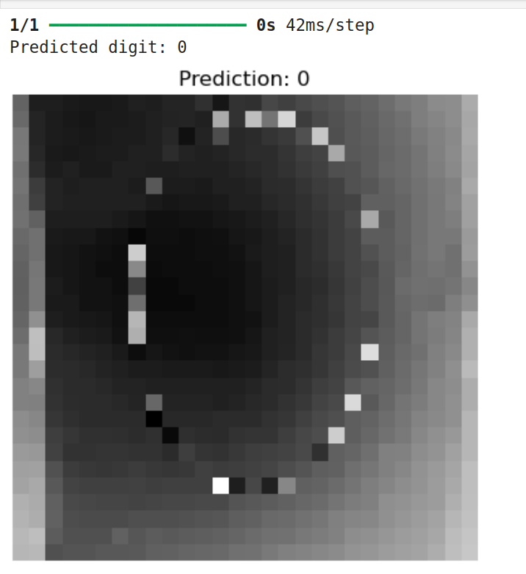

For one(1): The output
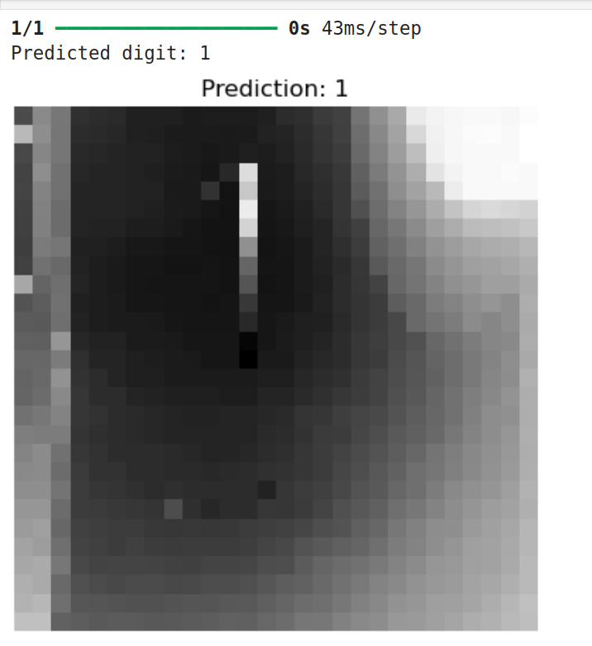

For two(2): The output
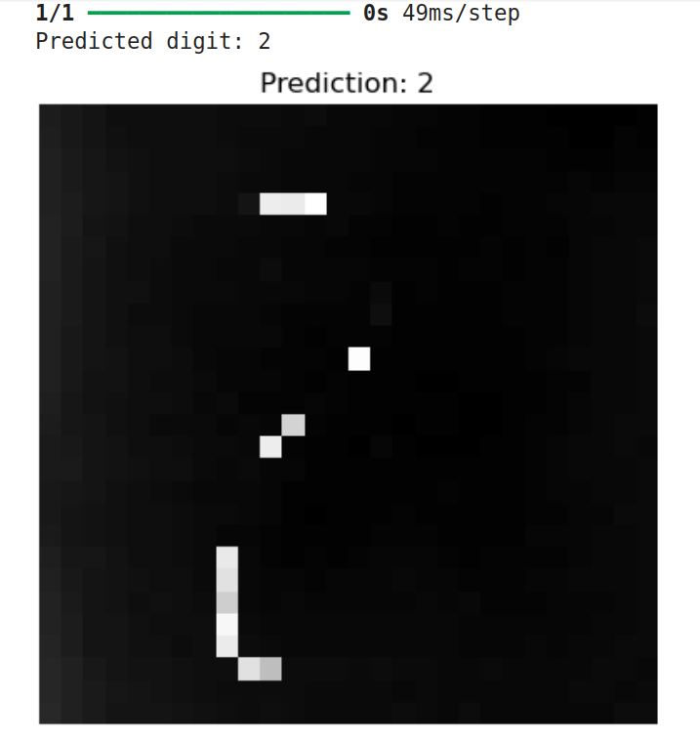

For three(3): The output
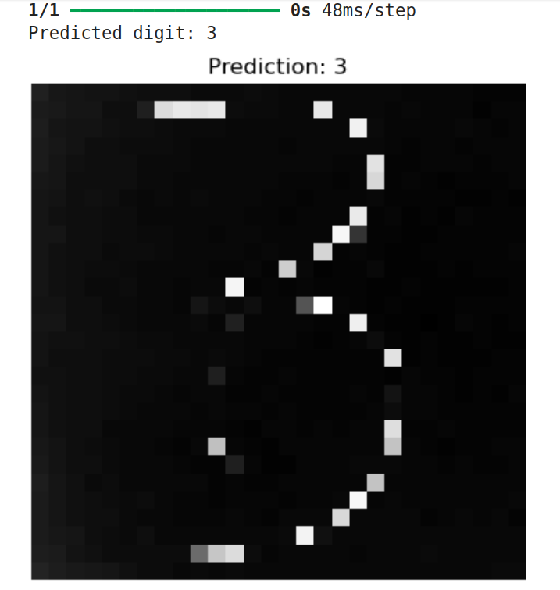

For four(4): The output
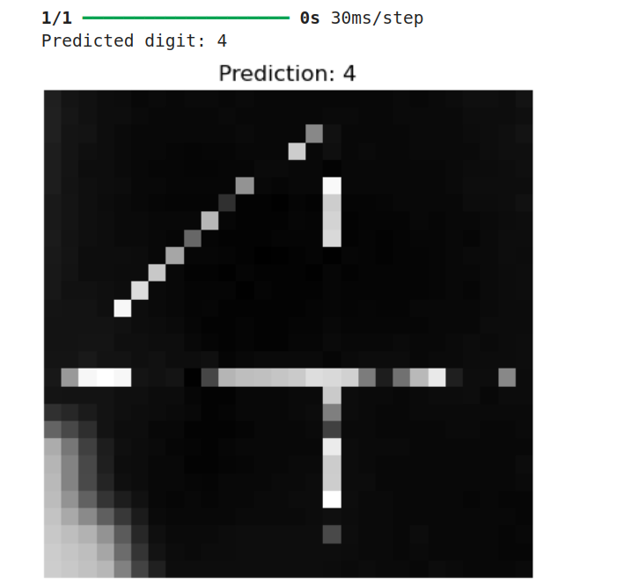

For five(5): The output
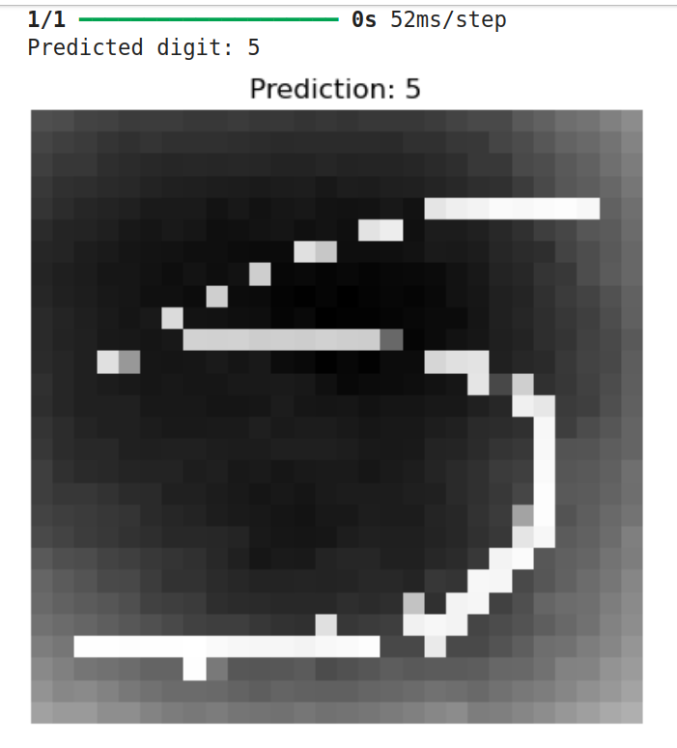

For six(6): The output
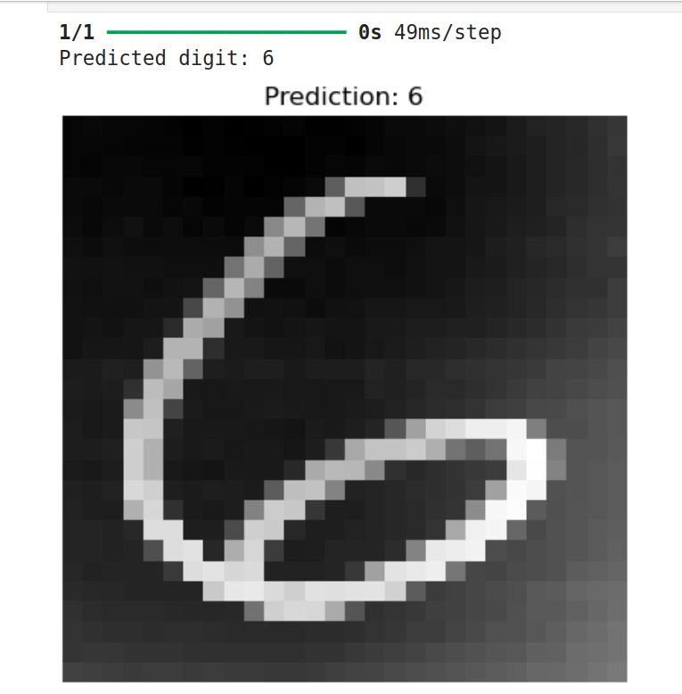

For seveen(7): The output
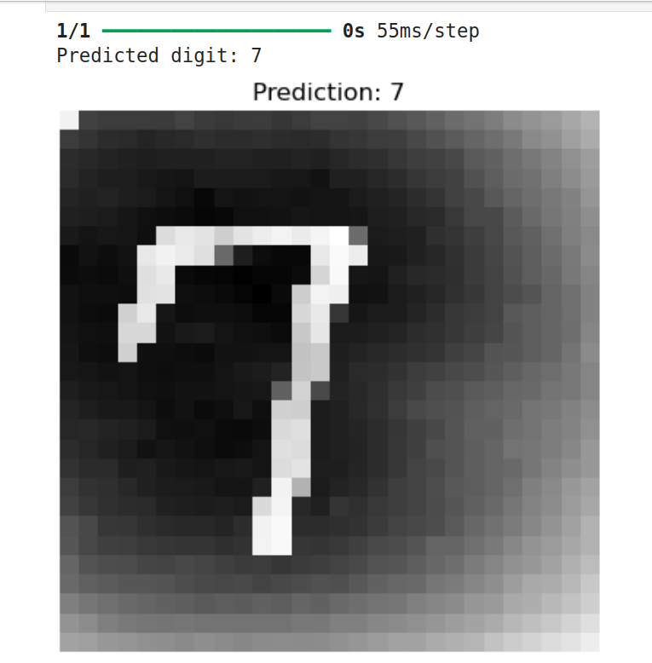

For eight(8): The output
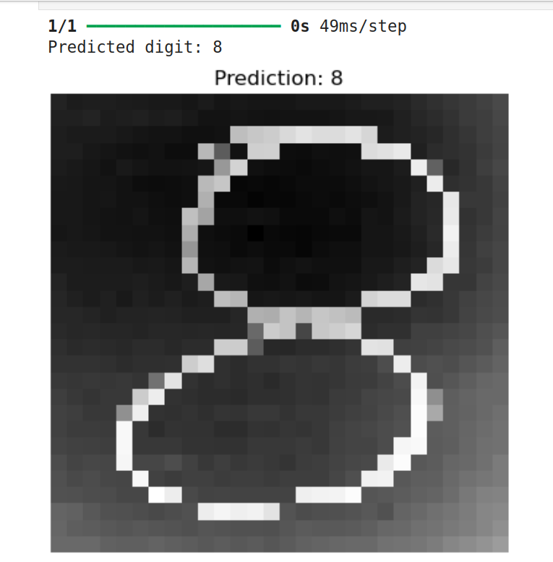

For nine(9): The output
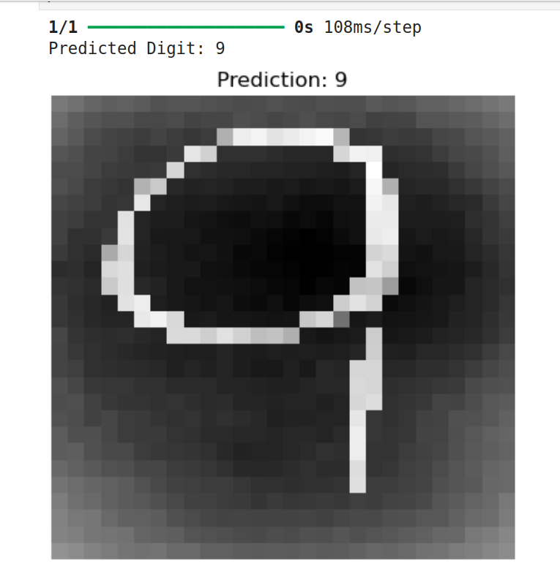

CHALLENGES FACED:

Throughout the course of this project, we encountered several technical and conceptual challenges that tested our understanding of deep learning, dataset handling, and overall project structure. Here are some of the key issues we faced and how we addressed them:

Dataset Confusion/Conflict with EMNIST

One of the most frustrating moments was working with the EMNIST dataset. Unlike MNIST, EMNIST images are rotated and mirrored due to how they were formatted for compatibility with the original NIST dataset. Initially, this caused our model to predict completely incorrect digits. After some research and trial-and-error, we fixed this using tf.image.rot90() and tf.image.flip_left_right() during preprocessing.

Lesson learned: Always check the orientation and format of your dataset before feeding it to the model.

Model Accuracy and Overfitting

During early testing, our models performed well on the training set but poorly on unseen test data. This pointed to overfitting. We had to tune batch sizes, adjust layer complexities, and experiment with different optimizers. Although we still faced accuracy limitations, especially with EMNIST, the models did improve after these adjustments.
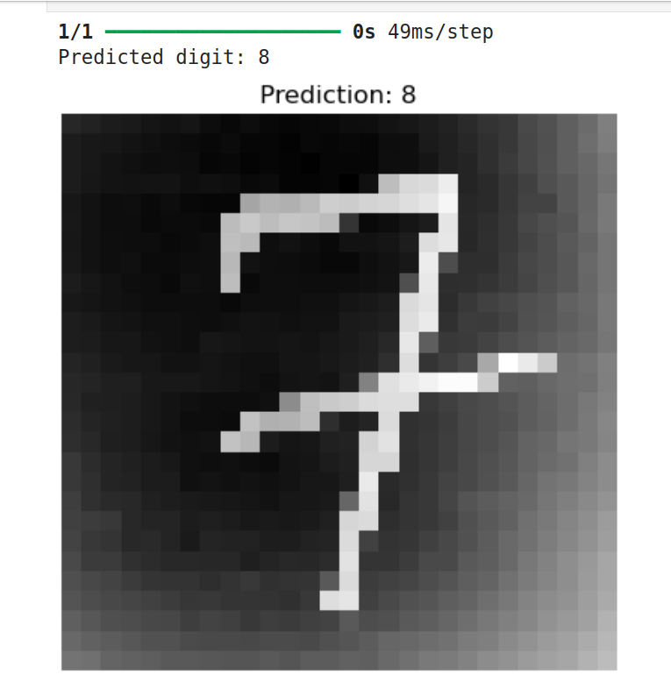

Lesson learned: More layers don’t always mean better performance — simplicity often wins, especially with limited training time.

GPU Issues and Training Time

We also ran into hardware limitations. The training time on our local systems was longer than expected. Moreover, we received several CUDA-related errors due to missing or misconfigured GPU drivers.

For example:

“failed call to cuInit: INTERNAL: CUDA error: Failed call to cuInit: UNKNOWN ERROR (303)”

This forced us to continue training using only the CPU, which slowed down experimentation.

Lesson learned: Having access to a proper GPU setup is a huge advantage in deep learning tasks.

CONCLUSION:
Working on the DigitRec project has been a challenging yet rewarding experience. Through the development of two separate convolutional neural network models — one trained on the standard MNIST dataset and another on the more complex and rotated EMNIST Digits dataset — we gained practical insights into deep learning, model architecture design, and the intricacies of real-world data preprocessing.
While the MNIST-based model delivered strong results with relatively little tuning, the EMNIST model introduced us to more nuanced challenges like image orientation correction and dataset formatting inconsistencies. These roadblocks not only tested our technical skills but also taught us how to troubleshoot issues that aren’t always documented in tutorials or guides.
The project also highlighted the importance of clean data, the power of model simplicity, and the very real constraints of computing resources. Despite hardware issues and time pressure, we stayed committed to building models that genuinely learned to recognize handwritten digits — even if the accuracy was not perfect.
In the end, DigitRec helped us better understand the machine learning pipeline from dataset acquisition to model evaluation. More importantly, it reminded us that authenticity and learning matter far more than just achieving flawless results. This project wasn't just a submission — it was a hands-on crash course in the real-world challenges of AI and computer vision.

