Loading BLE .hex file to AIM
Original Document: Md Rafi Islam
This documentation will describe the steps to load BLE hex file to the AIM device.

- Download and install nRF Connect for desktop application. download from here.
- Download and install J-Link from Segger from here.
- Follow the steps below to load the BLE hex file to AIM.
- Required devices:
    - Murata interface module
    - AIM device
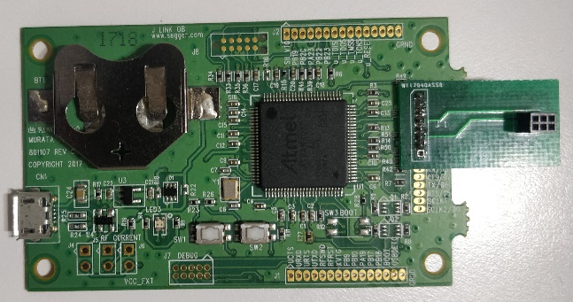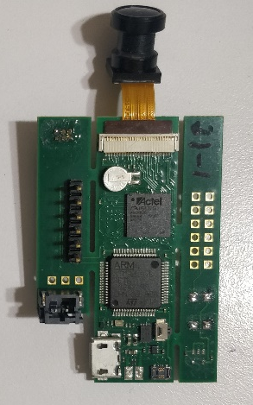
i. Murata interface module ii. AIM device
- Connect the Murata interface module and AIM device in such a way that the Micro B connector of the interface module stays at the bottom and Micro B connector of AIM stays on the right side. Image is given below for reference.
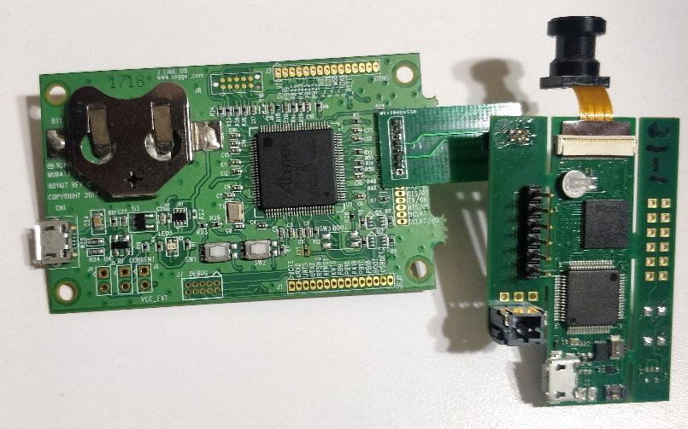
Micro B connector of the interface module
Micro B connector of AIM
Fig. Interface Module and AIM connection
- Connect the Murata interface module to the PC. Image is given below for reference. You DO NOT need to connect the battery to the AIM device.
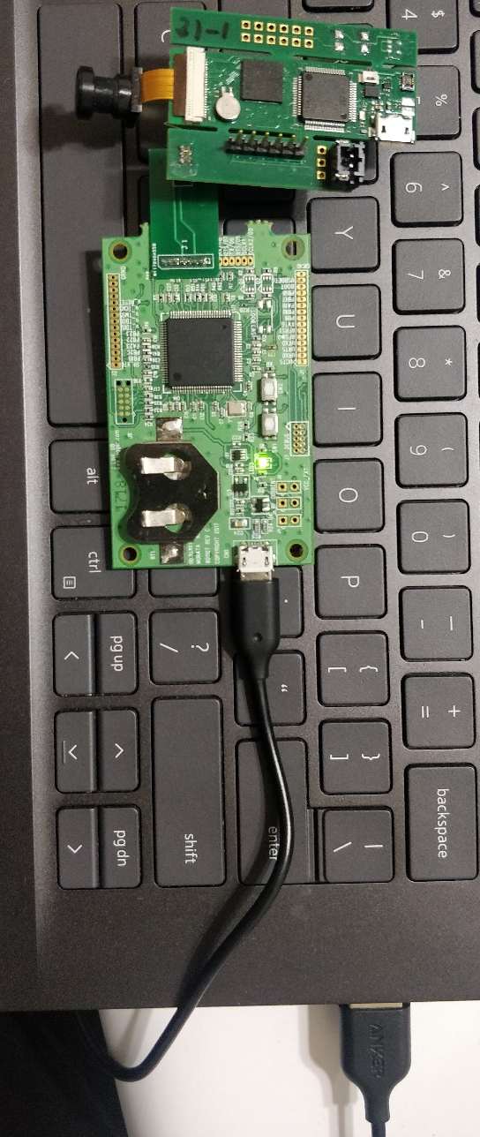
Fig. Murata Interface Module and PC connection

- Next, open the "nRF Connect for desktop" application. Scroll down the application and open "Programmer."
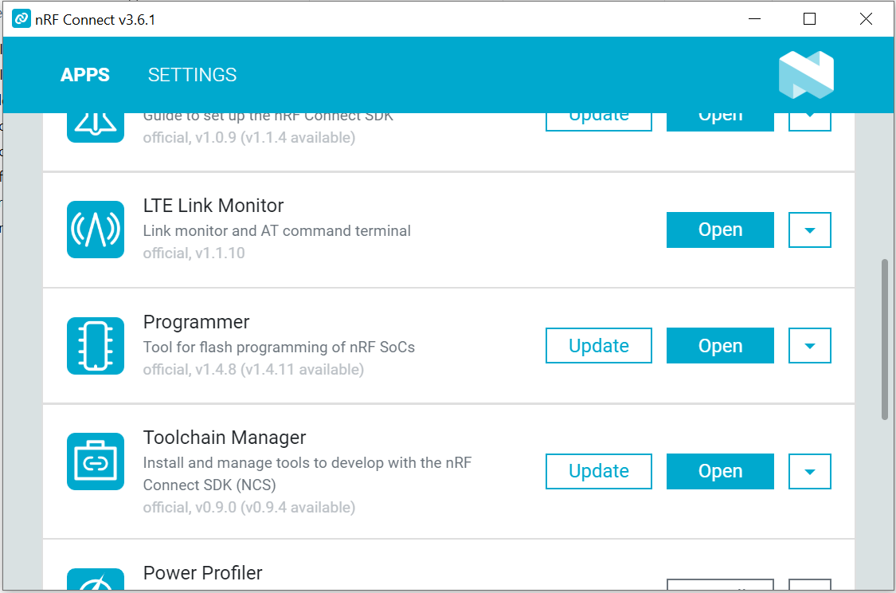
- Then, select your device from top left corner of the Programmer app (“000483022664” in the image below), add the hex file from top right corner (“Add HEX file” in the image below). Finally, click on “Erase & write.”
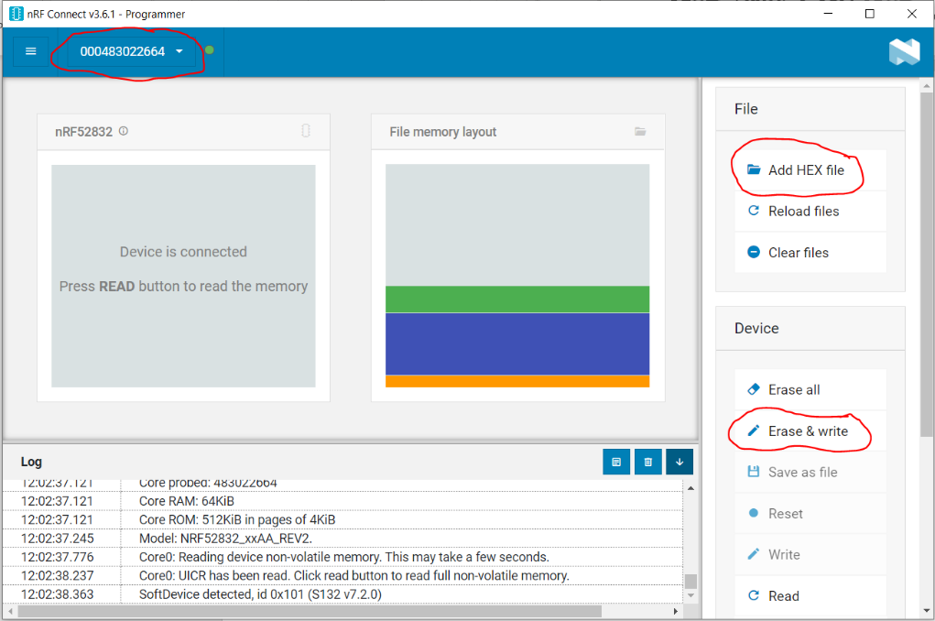

- After writing is finished, the last line in the Log (at the bottom left of Programmer application) will show “SoftDevice detected, id 0x101 (S132 v7.2.0)”
- Open nRF Connect application in your cell phone and start scanning. Your BLE should appear in the scanner.

