**Project 2**

**Name:** Md. Rafiul Amin, **People Soft ID:** 1637374

**Project task:** Generating pixels/images with fully connected network.

**Proposed Model:**

The task has been soved using tensorflow libray with keras wrapper. The code was implemented with jupyter notebook. We used keras library two create dense layer for building up our model. We choose truncated normal distribution for initializing the network weights. We create a fully connected neural network model in order to generate a pixel value for a specified coordinate (x,y) and radius (r). Also, we use a vector z as input. Z is a random binary vector with length 8.Our proposed model is as follows:

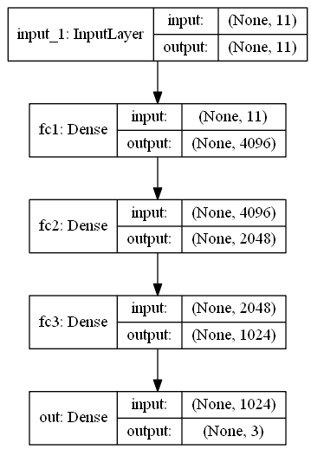

Without training the neural net (as mentioned in the task description), we open try to predict six different pixel values for different given parameters:

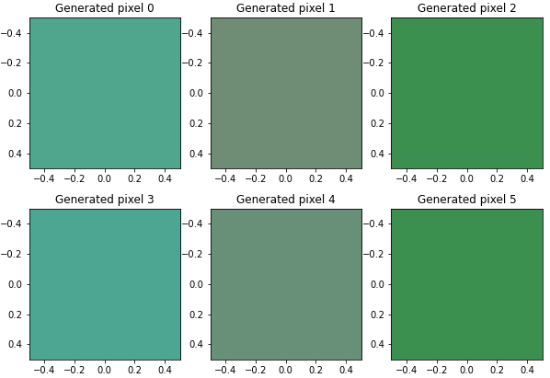

Figure 1: Six pixels generated with the proposed network.

The parameters used here are as follows:

$$\left[xy,r,z_{1},z_{2},z_{3},z_{4},z_{5},z_{6},z_{7},z_{8}\right]=\{\left[10,20,5,1,0,0,0,0,0,0,0\right],\left[1,2,5,1,0,0,0,0,0,0,0\right],\left[1,2,100,1,0,0,0,0,0,0,0\right],$$

$$\left[10,20,5,0,0,0,0,0,0,0,1\right],\left[1,2,5,0,0,0,0,0,0,0,1\right],[1,2,100,0,0,0,0,0,0,0,1]\}$$

This shows, how changing vector z is changing the output.

Using the same network we generated following six images. The images are generated by sweeping values of $x∈\{0,1,2,⋯, 8\}$, $y∈\{0,1,2,⋯, 8\}$, and $r={(\frac{x}{a})}^{2}+{(\frac{y}{a})}^{2}$. We choose $a=1,2,3,4,8$ for the following images, respectively.

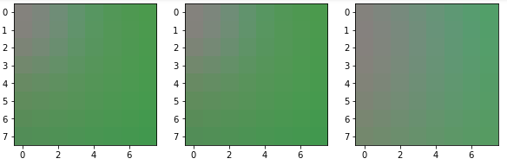

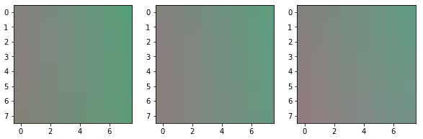

This shows how changing the reducing the radius having a zoom in effect on in the images. This shows that, how the same neural network can be used to generate same images with different resolutions.