## Simulation to find the Expected value for the output of the matrix game:

We use the following code to perform the simulation to obtain the graph of the expected value,

%% Given matrix

A = [3, 0; -1 1];

%% simulated outcome

NumberOfBernouliExp = 1000; X = []; Y = []; Z = [];

p1 = 0:0.02:1;

p2 = 0:0.02:1;

outcome = [];

for l = 1:length(p1)

for m = 1:length(p2)

for exp_id = 1:NumberOfBernouliExp

% we take (1-p) and to denote

% the probability of success in binornd

% as p is the probability of selecting zero

i = binornd(1,1-p1(l)) + 1;

j = binornd(1,1-p2(m)) + 1;

outcome_arr(exp_id) = A(i,j);

end

outcome(l,m) = mean(outcome_arr);

end

end

figure,mesh(p1, p2, outcome); xlabel('p_1','fontsize',18); ylabel('p_2','fontsize',18);

zlabel('Outcome','fontsize',18);

The corresponding output figure is as follows,

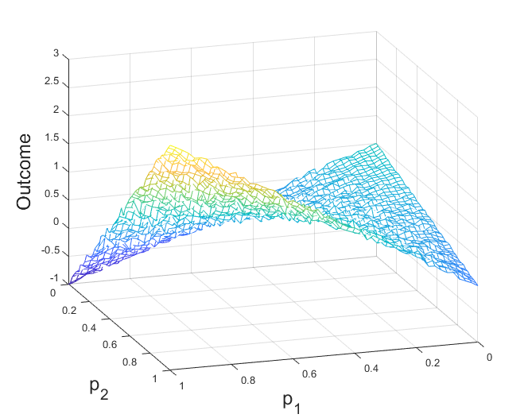

Figure : Simulated Graph for the Expected Values of Outcomes for Different mixed strategies.

## Analytical Expression for Outcome with Mixed Strategy:

For a given matrix $A= \left[\begin{matrix}a_{11} & a_{12} \\ a_{21} & a_{22}\end{matrix}\right]$, we know expected value of the outcome of the game, corresponding to the strategy pair {P1, P2}, will be equal to,

$$J\left(y,z\right)=\sum_{i=1}^{m}{\sum_{j=1}^{n}{a_{ij}y_{i}z_{i}=y'Az}}$$

where $y$ and $z$ are the probability distribution vectors defined by $y=(y_{1},⋯,y_{m})'$ and $z=\left(z_{1},⋯,z_{n}\right)'$. For the given problem $m=n=2$ and $y=(p_{1}, (1-p_{1}))'$ and $z=\left(p_{2}, \left(1-p_{2}\right)\right)$. Therefore, the corresponding outcome function in terms of $p_{1}$ and $p_{2}$:

$J\left(y,z\right)=a_{11}p_{1}p_{2}+a_{21}\left(1-p_{1}\right)p_{2}+a_{12}p_{1}\left(1-p_{2}\right)+a_{22}\left(1-p_{1}\right)\left(1-p_{2}\right)$ (1)

We write the following code to plot the function with regards to $p_{1}$ and $p_{2}$:

%% Given matrix

A = [3, 0; -1 1];

%% Analytical expression for the outcome using probability

outcome_fnc = @(x,y)(x*y*A(1,1)+(1-x)*y*A(2,1)+(1-x)*(1-y)*A(2,2)+(x)*(1-y)*A(1,2));

p1 = 0:0.001:1; p2 = 0:0.001:1;

for l = 1:length(p1)

for m = 1:length(p2)

outcome(l,m) = outcome_fnc(p1(l),p2(m));

end

end

figure, mesh(p1, p2, outcome);

xlabel('p_1','fontsize',18); ylabel('p_2','fontsize',18);

zlabel('Outcome','fontsize',18)

The output is as follows,

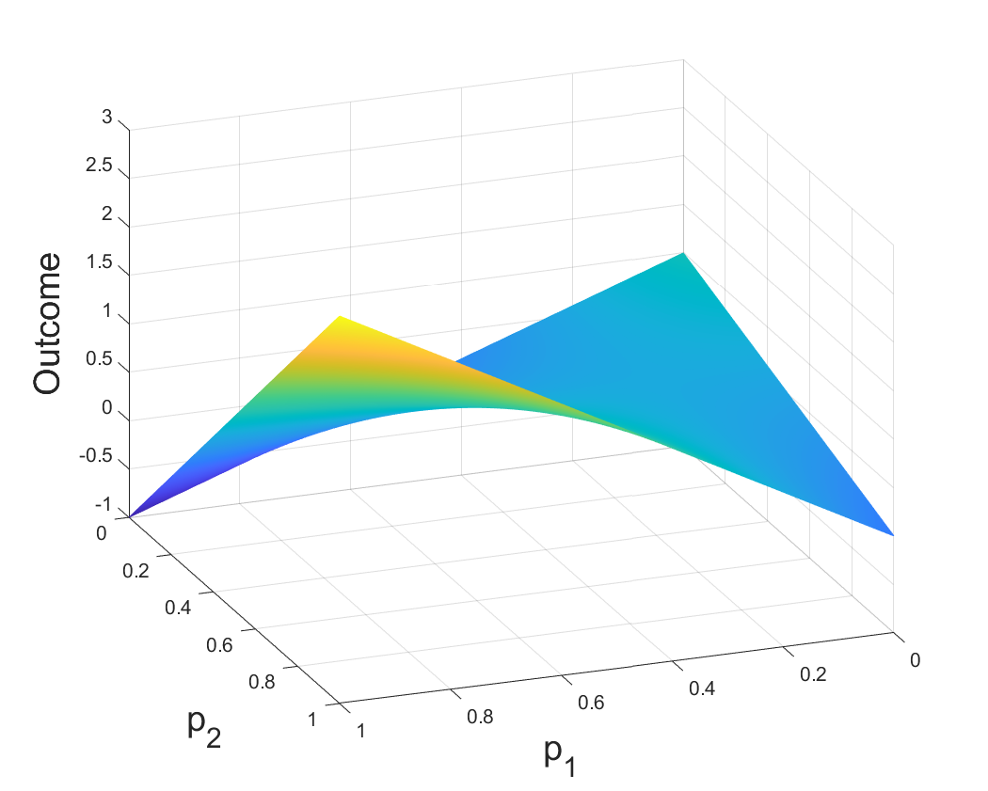

Figure : Outcome function vs mixed strategy probabilities of player 1 and player 2.

## Analytical Calculation of Saddle Point:

We rewrite the outcome function in $(1)$ as follows:

$$J\left(p_{1},p_{2}\right)=αp_{1}+βp_{2}+γp_{1}p_{2}+δ$$

Where $α=(a_{12}-a_{22})$, $β=(a_{21}-a_{22})$, $γ= \left(a_{11}+a_{22}-a_{21}-a_{12}\right)$, and $δ=a_{22}$

We know, a point is a saddle point of a function of two variables if,

$\frac{∂J}{∂p_{1}}=0, \frac{∂J}{∂p_{2}}=0$, and $\frac{∂^{2}J}{∂p_{1}^{2}}\frac{∂^{2}J}{∂p_{2}^{2}}- {\left[\frac{∂^{2}J}{∂p_{1}∂p_{2}}\right]}^{2}<0$

at that point. Calculating partial derivatives,

$$\frac{∂J}{∂p_{1}}=α+γp_{2}=0⇒p_{2}= -\frac{α}{γ},$$

$$\frac{∂J}{∂p_{2}}=β+γp_{1}=0⇒p_{1}= -\frac{β}{γ},$$

$$\frac{∂^{2}J}{∂p_{1}^{2}}=0, \frac{∂^{2}J}{∂p_{2}^{2}}=0,$$

and

$$\frac{∂^{2}J}{∂p_{1}∂p_{2}}=γ$$

For the given matrix $A=\left[\begin{matrix}3 & 0 \\ -1 & 1\end{matrix}\right]$, $α=\left(a_{12}-a_{22}\right)=0-1= -1$, $β=\left(a_{21}-a_{22}\right)= -1-1= -2$, $γ= \left(a_{11}+a_{22}-a_{21}-a_{12}\right)$ = 3+1 +1-0 = 5, $δ=1.$

Plugging in the values, we have $p_{1}= \frac{1}{5}$ and $p_{2}=\frac{2}{5}$.

Now plugging in the solution of $p_{1}$ and $p_{2}$ in the left hand side of the second order solution we obtain,

$$\frac{∂^{2}J}{∂p_{1}^{2}}\frac{∂^{2}J}{∂p_{2}^{2}}- {\left[\frac{∂^{2}J}{∂p_{1}∂p_{2}}\right]}^{2}= 0×0-{\left[γ\right]}^{2}= -5$$

Which is less than zero. Therefore, $p_{1}^{*}= \frac{1}{5}$ and $p_{2}^{*}=\frac{2}{5}$ is the saddle point.

Therefore, the saddle security level is,

$$J\left(p_{1}^{*},p_{2}^{*}\right)=\left(-1\right)×\frac{1}{5}+\left(-2\right)×\frac{2}{5}+5×\frac{1}{5}×\frac{2}{5}+1= 0.4$$