# Digital Image Processing

## Project

1. Original Image:

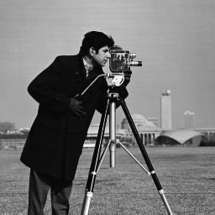

1. Subsampled Image:

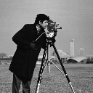

1. Code for Blurring Matrix is given below:

For this step, a 1 dimensional Gaussian vector has been created for size of 7 (P = 7). Then with matrix multiplication 2-D Gaussian Musk has been created.

P = 7;

X=-(P-1)/2:(P-1)/2;

X = X;

mu = 0;

sigma = 0.8;

Y = normpdf(X,mu,sigma);

M = Y'*Y;

M = M / sum(sum(M));

1. With 2D convolution output is:

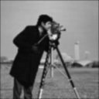

1. Output image contains dark borders of one width 1.
2. Reshape is done as instructed in the problem statement.
3. The blurring convolution matrix is formed using following code.

[r,c] = size(Im2);

f=double(reshape(Im2,[r*c, 1]));

f

H = zeros(r*c,r*c);

for i=1:r

for j=1:c

for p=-int16((P-1)/2):int16((P-1)/2)

for q=-int16((P-1)/2):int16((P-1)/2)

x=(i-1)*c+j;

y=(i+p-1)*c+j+q;

%if(x>=1 && x <= 128^2 && y>=1 && y <= 128^2)

if((i+p)>=1 && (i+p) <= r && (j+q)>=1 && (j+q) <= c)

H(x,y)=M(1+p+int16((P-1)/2),1+q+int16((P-1)/2));

end

end

end

end

end

Output is given below:



Which also contains the dark border. 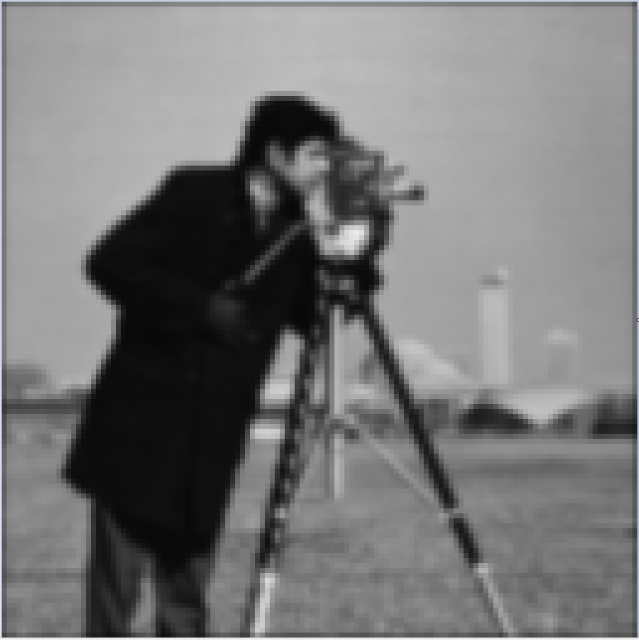

Dark Border

1. We normalize H using the following code:

for i=1:r*c

H(i,:) = H(i,:)/sum(H(i,:));

end

g = H * f;

Im5 = uint8(reshape(g,[r,c]));

figure, imshow((Im5));

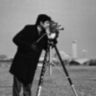

The output is as follows:

The new output does not contain the dark border.