**Q700 Automated Deployment - Dev & User Guide**

**v0.01 - June, 2017**

# Overview

This document provides instructions on development and deployment of Q700 Builds and Data Patches (DPs) using CA, Jenkins, and Urban Code.

Covers:

* Builds
* Data Patches, both with and without arguments

Audience:

* Developers
* Deployers

## Manifest Files

Central to automated deployment for Q700 is the "manifest file". This file is a csv file which replaces the Excel "Build note" / "Datapatch note" from the non-automated days.

Before finishing development of a Build/DP, the developer will create a manifest file and check it into CA, using the package for the build/DP in question.

Manifest files reside in CA under the Source/Manifests directory, under either the Builds or DataPatches directory.

Naming convention:

Builds: nnxx_manifest.csv (eg, 61GP_manifest.csv)

Data Patches: DPXyyyy-nnnn_manifest.csv (eg, DPX2017-0123_manifest.csv)

Manifest files can be generated manually, or by using the <Gen_Q100_Manifest.py> Python script. Manifest files generated using this script can (and sometimes must) be manually "tweaked" before checking into CA.

The structure/layout of a manifest file is very similar to the Excel spreadsheet it replaces, with header information, a roll forward section, a roll back section, etc. After checking in, the Jenkins build process uses the manifest file to produce the Jenkins build.

# Using <Gen_Q100_Manifest.py>

???Bogdan - refine this section

Installing:

* Install Python from MyHandinstalls
* Install the Gen_Q100_Manifest.py script and bat file
* Set up password file
* ???more?

Using:

* Go to dir c:\???
* Execute for package(s) (Takes multiple package numbers as an arg, eg, 61GC 60##)
* Do manual modifications on the manifest file if necessary.
* Check manifest file into the Source/Manifests/Builds|DataPatches dir using the package for the build you are working on
* Jenkins process always uses the most recent version of a manifest file that it finds in a package
* Jenkins works from the "Build" state, so when ready to create a Jenkins build, promote your package to the Build State
* Later states in CA (eg, QA Staging, QA, etc) are now out of scope - They are not used in the DevOps world.
* Once the CA package containing the code and the manifest file is in the Build state, it is time to move to Jenkins.
* Note: Copy the name of the package to use in Jenkins (We have to use full package name not first 4 chars)

# Creating a build in Jenkins

* Go to <https://rbcjenkins.fg.rbc.com:8443/> and login by using LAN ID and PWD.

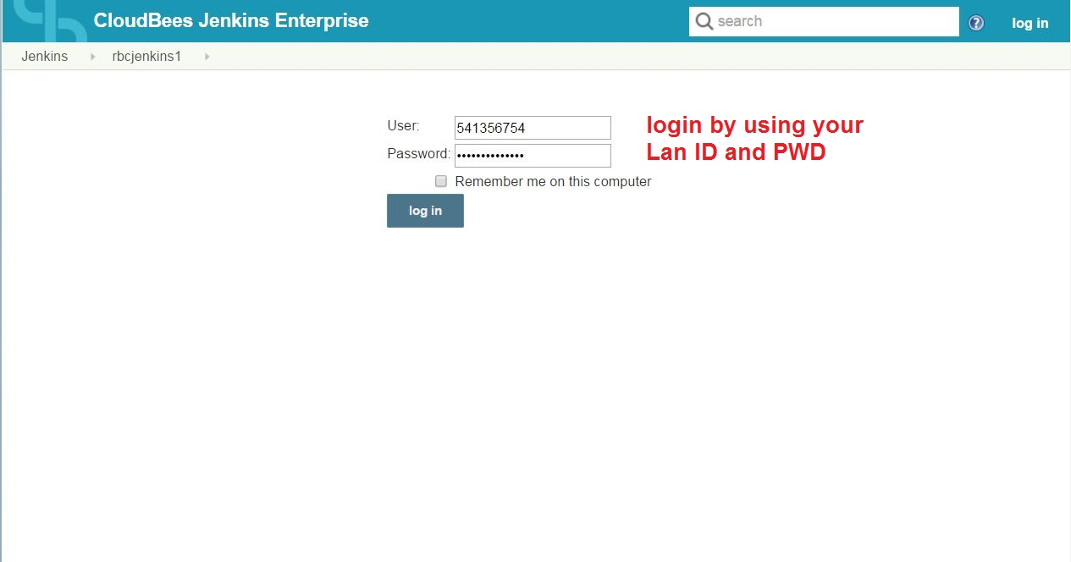

* After login to the Jenkins you will be in the main page, and then select the project that you are working on and click on the name. (e.g. Q700)

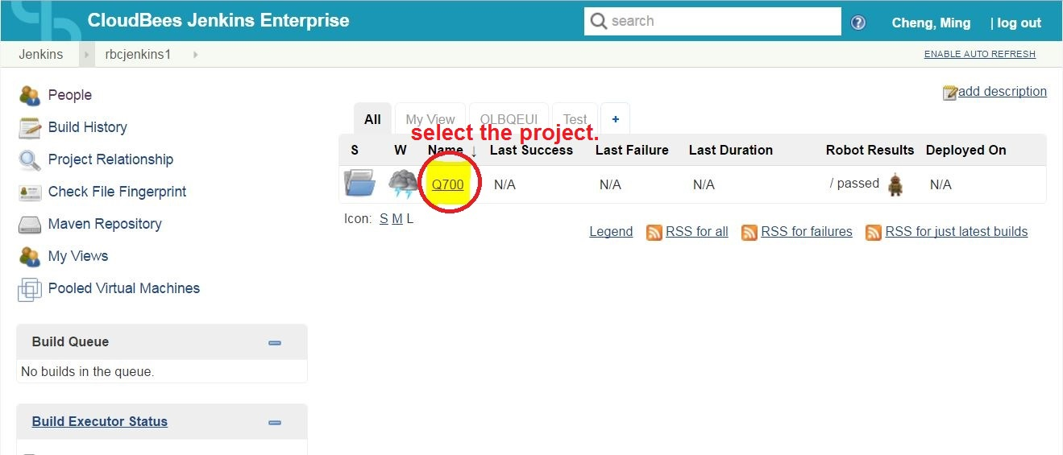

* Select the build type:
  + Q700_Full_DevOps To promote a Build
  + Q700_DataPatches_DevOps To promote a DP

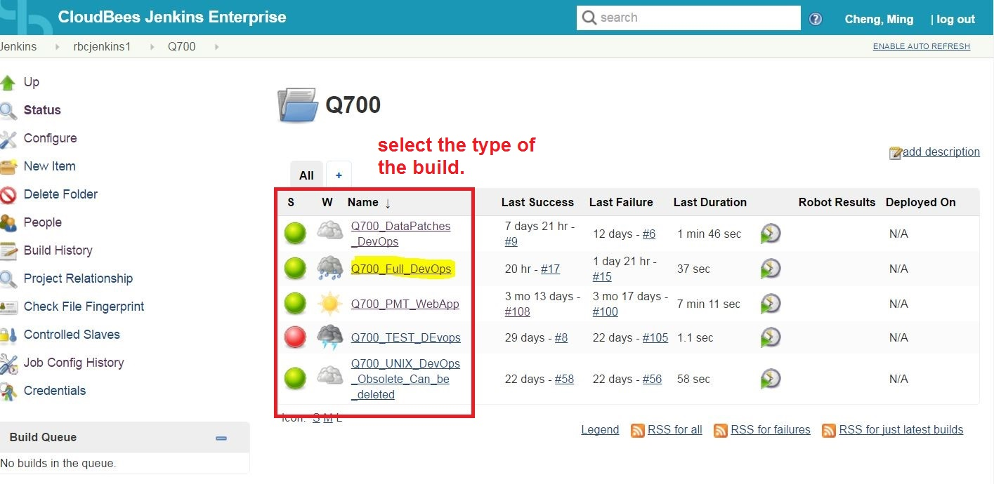

* Click the ‘Build with Parameters’ to create a build.

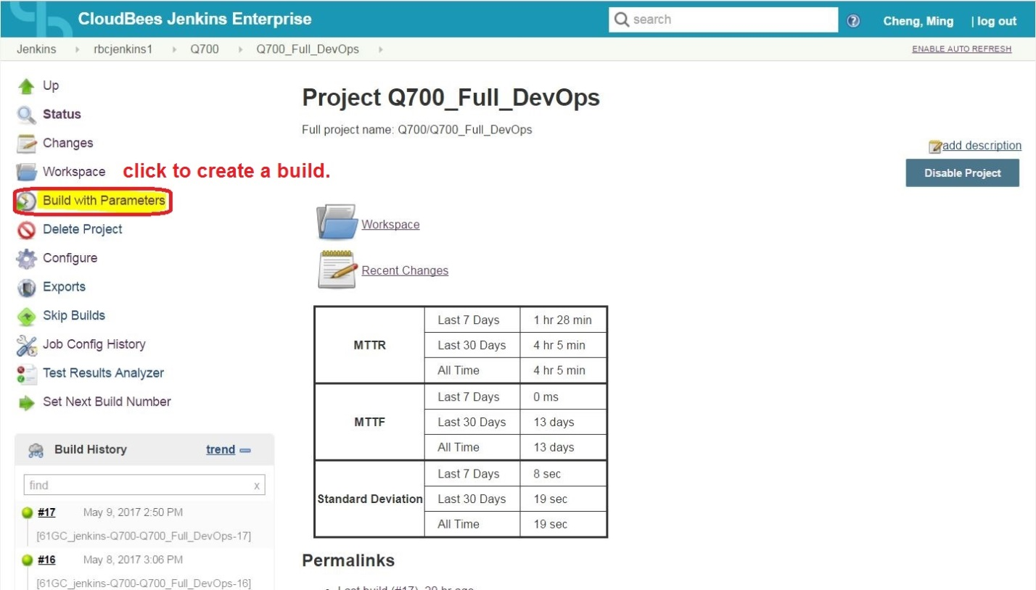

* Paste the full package name here as the build parameter, and then click the build button.(e.g. 61GC_CA036978_Q700_DummyBuildForCICDname) [We have to use the full build name here as

The parameter]

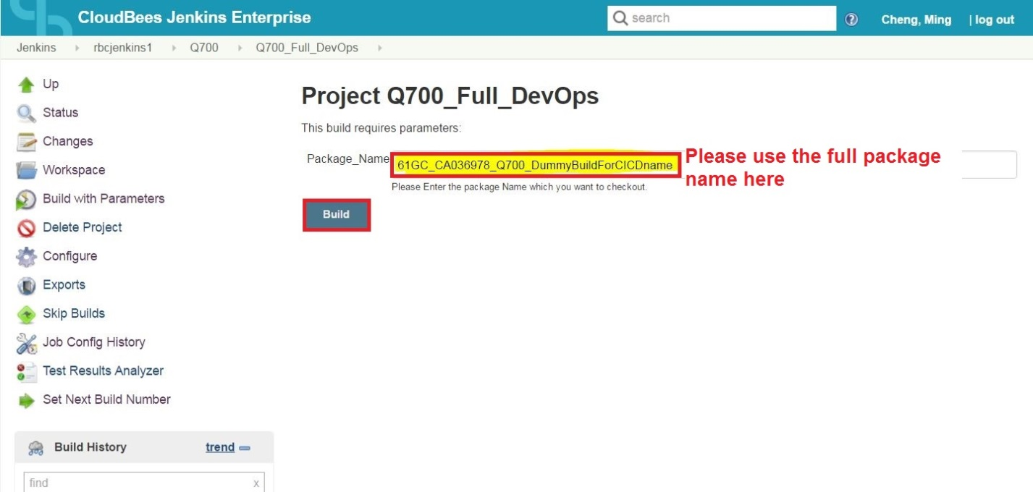

* After the build has been successfully created, you need remember the build name. That is the one that will be using to deploy in UCD. (e.g. 61GC_jenkins-Q700-Q700_Full_D​evOps-17)

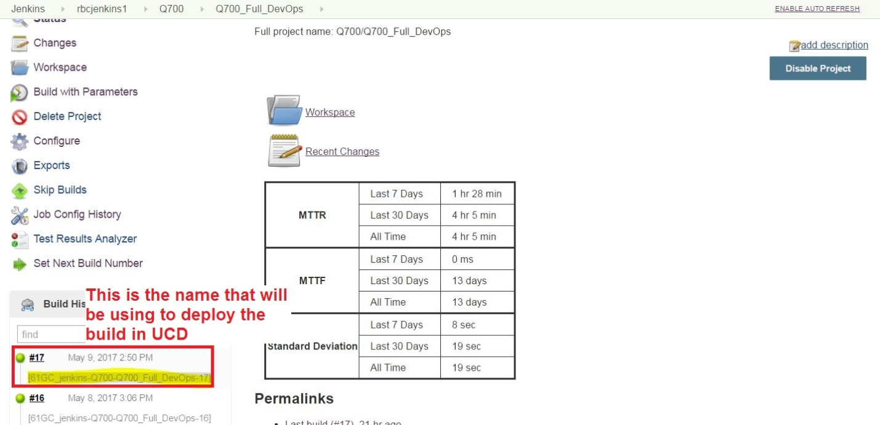

# Deploying a build to an environment using UrbanCode

* Go to <https://rbcucd.fg.rbc.com:8443/> and login by using LAN ID and PWD.

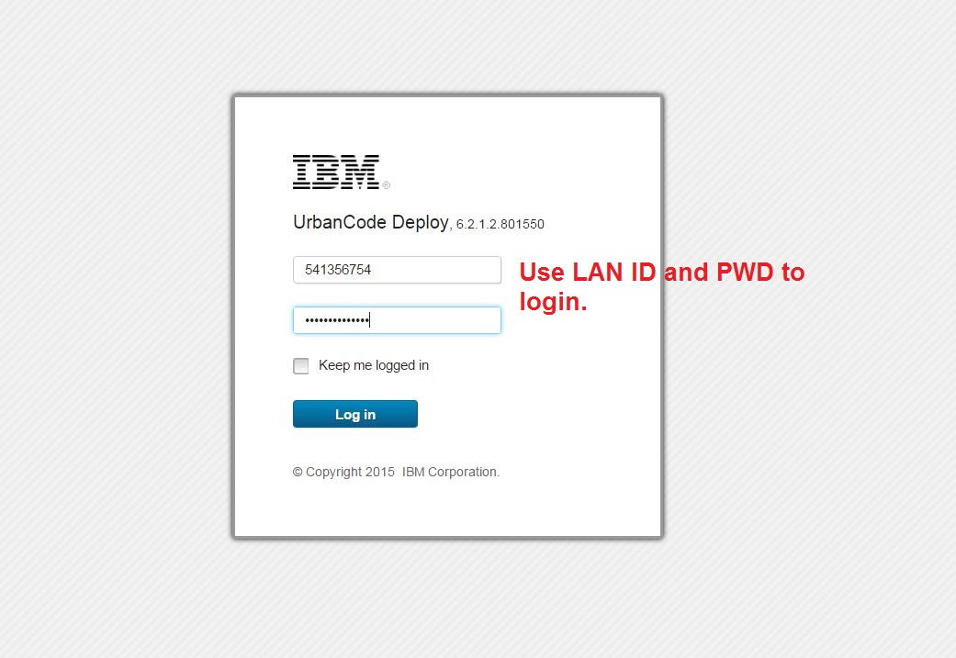

* After you login to the UCD, please click the application from the ribbon. Then you will see your project. Click the name to enter.

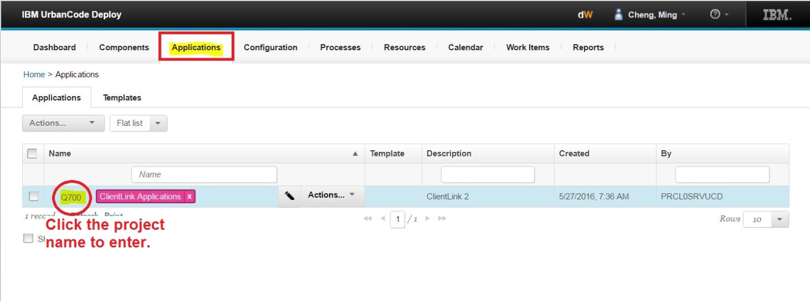

* Select an environment to deploy the build (e.g. DEVX). Then click the ‘PLAY’ icon on left side of the bar.

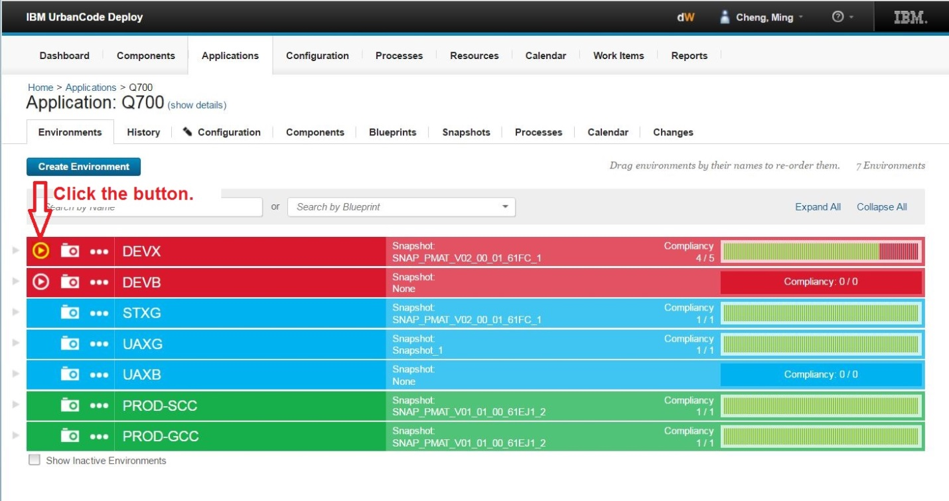

* Select a process
  + ClientLink_Full_Deploy Deploy a Build
  + ClientLink_Full_Rollback Roll back a Build
  + ClientLink_DataPatches_Deploy Deploy a DP
  + ClientLink_DataPatches_Rollback Roll back a DP

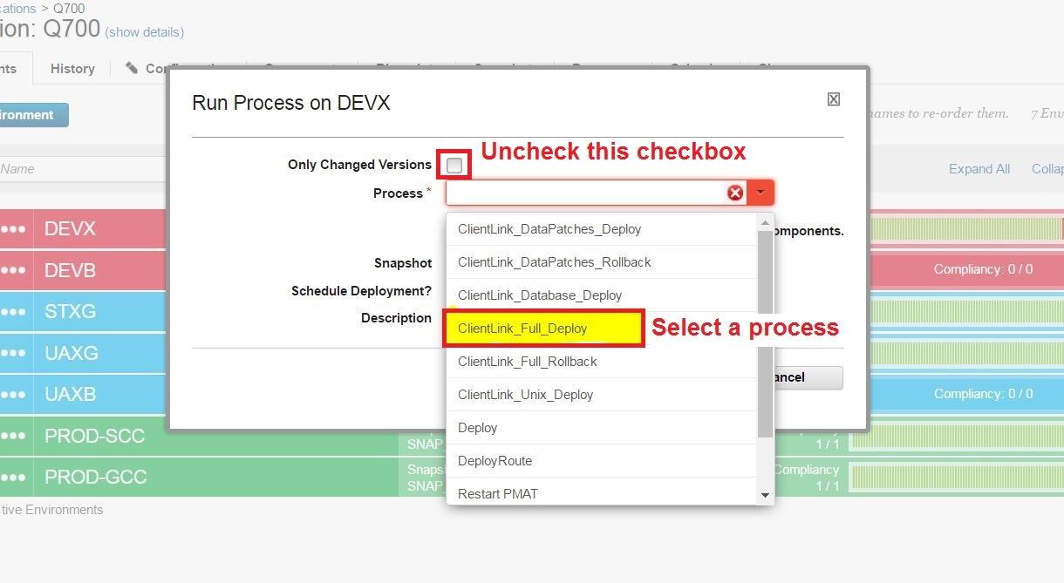

* Select the right version of build to deploy (generally, the most recent / highest number) and then click Submit. (e.g. 61GC_jenkins-Q700-Q700_Full_DevOps-17)
* We need to un-check the "Only Changed Versions" checkbox to ensure that it is always a full deployment of all code in the build.

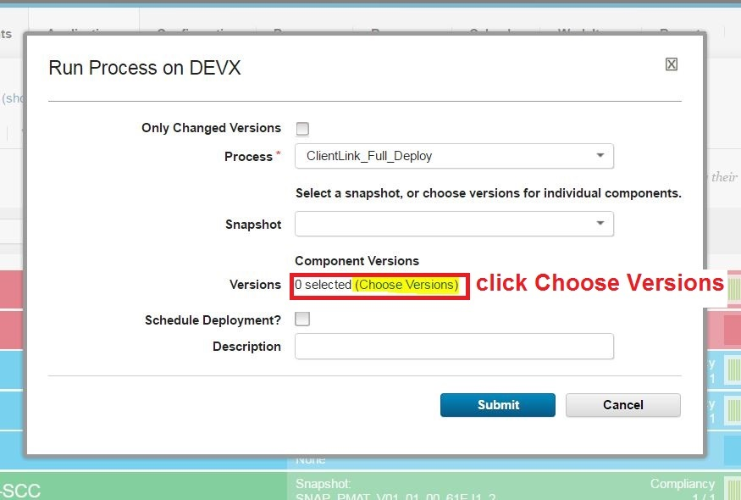

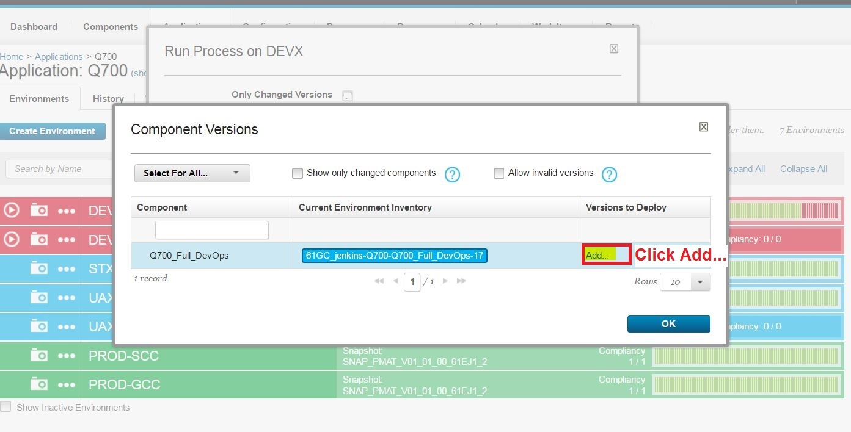

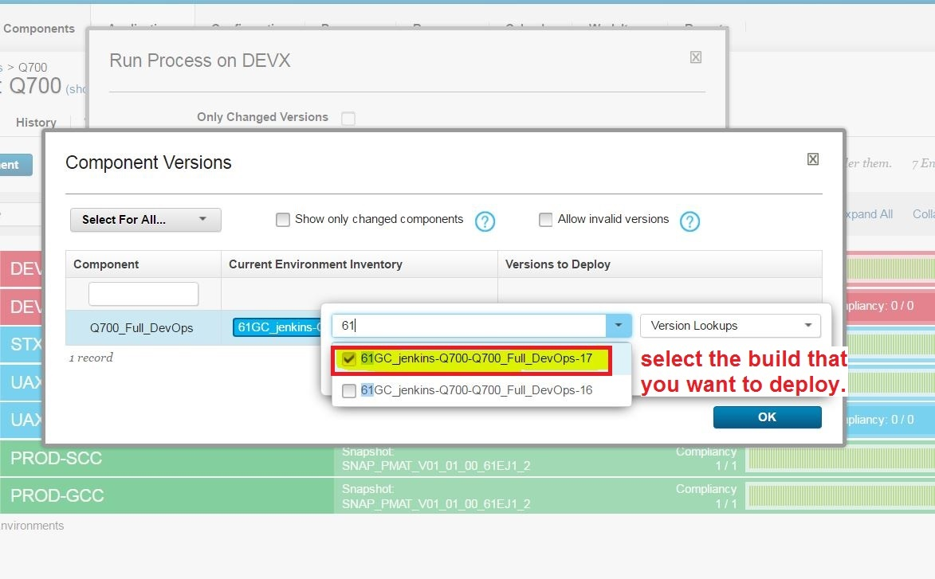

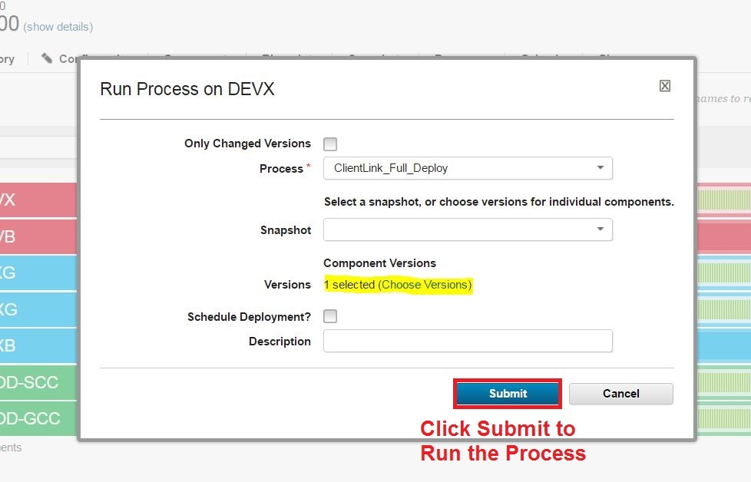

**Maintain:**

Reboot the Agent

(Note: The permission of the Agent is set to 775. You can run it without a SU account.)

Location (UNIX):

DEVX: usvlinkt81.saifg.rbc.com

DEVB: usvlinkt91.devfg.rbc.com

Go to agent Dir: cd /usr/local/clientlink/ucd/agent/bin

Run: 1. agent stop –force

2. agent start

(You can test the connection by running ‘agent run’. If it works, then you can start the agent with step 2.)

(After the Agent run, you can upgrade or restart the agent remotely from UCD)

Go to UCD 🡪 Resources 🡪 Agents

Select the agent that you want to restart by checking the box.

Select restart action

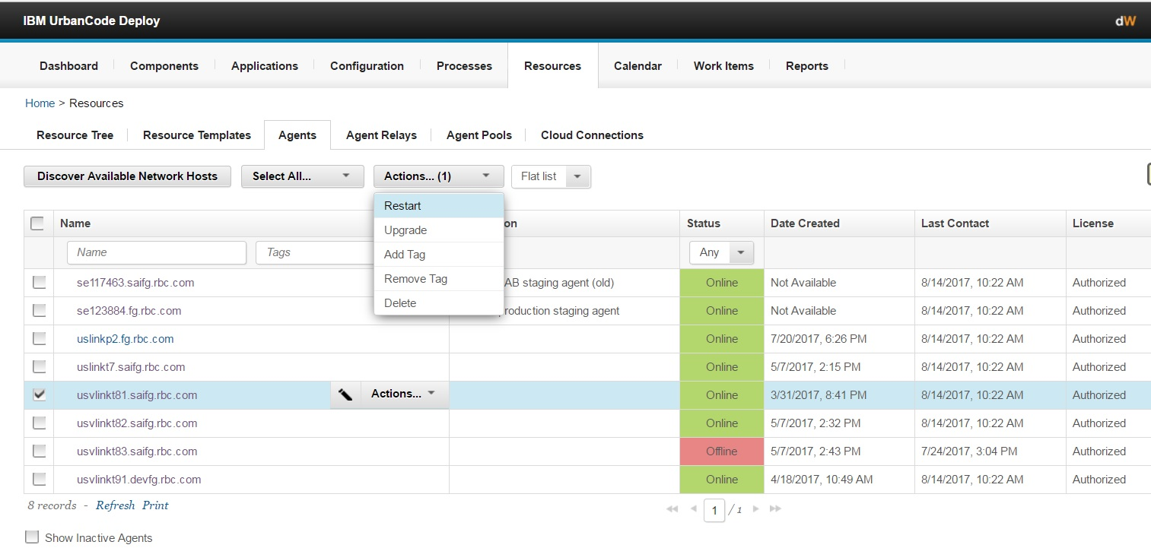

*Please read the following document that explains Archiving and Restoring Component Versions.*

[*https://connect.fg.rbc.com/docs/DOC-630808*](https://connect.fg.rbc.com/docs/DOC-630808)