Guide for Manifest generation script

Version: 1.1

Last Modified: AUG 29, 2017

Prepared by:
RBC Investments –Saeid Rezaei

Table of Contents
Table of Contents 2
Document Revision 3
Overview 4
Scope 4
Pre-Setup 4
Setup Manifest 6
Execute Script 8

Document Revision
Version | Name | Date | Description
1.1 | Saeid Rezaei | 2017-08-29 | Initial document
1.2 | Bogdan Negreanu | 2017-08-31 | Revised

Overview

This document is intended to help with the setup and use of the manifest generator script, used to create manifest files for ClientLink-related automated deployments.

The manifest generator script is written in Python and is used to produce the manifest file that is used by the Jenkins automated build tool for deploying various artefacts attached to one or more CA SCM packages.

Scope
This script is being prepared for Client link technical users and shall not be used outside of this team.

Pre-Setup

- Ensure that the CA Harvest SCM client is already installed on your machine. If not installed, it can be found and set up from the RBC Software Center.
- Go to start type Software center
- Click on Find additional application from the Application Catalog
- On the right top box, search for CA HARVETST
- Install the software and follow the instruction
- 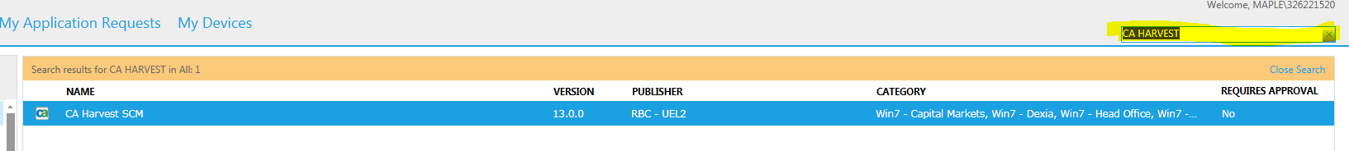
- Install “Python” if it’s not installed on your machine,
- Go to RBC My HandInstalls
- Find the Python v3.5.1 (64bit) installation and install it on your system (Do not change the default path)
- Please ensure that you check the option to include the Python binaries location in your environment PATH
- Type Python on your start menu to ensure software has been setup, if yes, you should see below screen

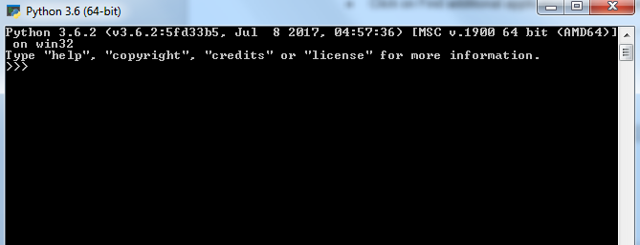

- Type quit () to escape from Python console

Setup Manifest

- Create sub folder SCM_Create_Build under C:\work\python, if does not exist (this item is recommended, although you can create and copy files into any folder you wish)
- Create the credential file, in order to do that, go to command shell, and type below command
svrenc -usr RBC ID -pw PASSWORD_HERE -dir c:\work\python\SCM_Create_Build -f user_acct
Important note: You need to re-do this step anytime you change your LAN password.
- Check the local drive (c:\work\python\SCM_Create_Build), You should see user_acct file on it, (Hint: Sometimes this files create as hidden, in this case Folder option select, show hidden files, folder, and drive under Hidden files and folders, and hit the save button
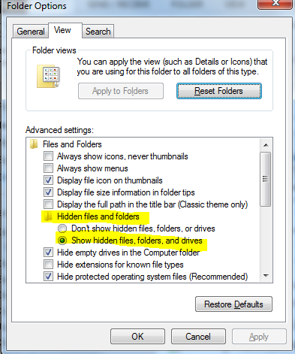

- Download (Check out for brows) latest version of the following files from CA SCM and place them into your local C drive (C:\Work\Python\SCM_Create_Build),
Go to Q700 >> Development >> View >> Q100 >> Source >> DevOpsScripts
Gen_Q100_Manifest.cfg
Gen_mainfest.bat
Gen_Q100_Manifest.py
(Hint: First two files change rarely, however development team may need to improve Gen_Q100_Manifest.py, Hence please make sure you have the latest version all the time)

- Open the .bat file gen_manifest.bat, and check the line # 27, it should point to the folder that you’ve created on 1st step above (cd C:\Work\Python\SCM_Create_Build) – if you wish to keep all this work on different sub directory you would need to modify this line.
- Make sure Python’s path is available from everywhere in your system, otherwise go to Environment Variables, find the path in System variable hit the edit button and add the Python installation path to that line with “;” at the end

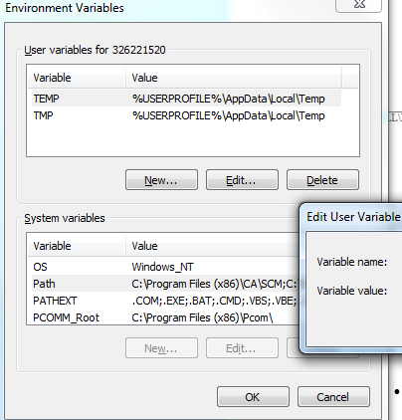

- If you want to skip above setting, you would need to find the path for python.exe and modify gen_manifest.bat last line as below:
<<Path for python>>/python.exe Gen_Q100_Manifest.py %1 %2 %3 %4 %5
i.e.: C:\Users\326221520\AppData\Local\Programs\Python\Python36\python.exe Gen_Q100_Manifest.py %1 %2 %3 %4 %5
- Save the file and exit
- Open the configuration file called, Gen_Q100_Manifest.cfg , check the path outputDir and make sure exist on your system, otherwise either create or change it to the exiting directory, You would see the final .csv file on that folder
- Check the directory for credentials file (last line), and make sure user_acct exist on the same path (You should have that file by following 2nd step)

Execute Script
- Check the CA Harvest SCM, and make sure your package name exist under Q700 >> Development >> Packages, otherwise create one
- Make sure you have “Checked In” your object(s) and you can see items under your packages>> Versions, otherwise do right click mouse on package name and click on “Check In”, find your object
Important: Manifest generation must be done at the end of each development life cycle, for instance in Development stage, Developer should generate file once all unit test is done and all objects are Checked In.
- Execute the .bat file with up to 5 parameters as Build number (i.e. : gen_manifest 61GV)
- Check the .csv file in in c:\temp or any other directory that you have specified in Gen_Q100_Manifest.cfg as outputDir
- Open the .csv file and fill the missing sections, such as description, any column that shows as “**Fill in**…

See the example:
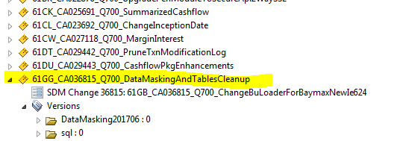

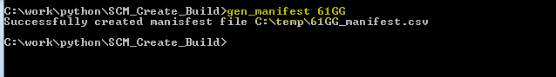

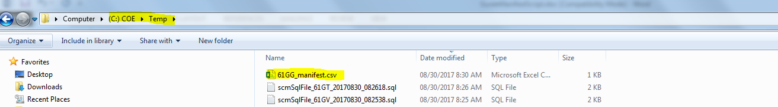

This document has been prepared by technical systems analyst team in RBC-WM, Client Link. Should you have any question or suggestion please contact either Negreanu, Bogdan bogdan.negreanu@rbc.com , or Saeid Rezaei (saeid.rezaei@rbc.com)

