**Pizza Basket Analysis**

-- 1. Identify Most Frequently Ordered Pizzas.

SELECT pt.name AS pizza_name, COUNT(od.order_id) AS total_orders

FROM pizza_types pt

JOIN pizzas p ON pt.pizza_type_id = p.pizza_type_id

join order_details od on od.pizza_id = p.pizza_id

GROUP BY pt.name

ORDER BY total_orders DESC

LIMIT 10;

-- 2. Find Pizza Combinations Ordered Together

SELECT pt1.name AS pizza_A, pt2.name AS pizza_B, COUNT(*) AS frequency

FROM order_details od1

JOIN order_details od2

ON od1.order_id = od2.order_id AND od1.pizza_id <> od2.pizza_id

JOIN pizzas p1 ON od1.pizza_id = p1.pizza_id

JOIN pizzas p2 ON od2.pizza_id = p2.pizza_id

JOIN pizza_types pt1 ON p1.pizza_type_id = pt1.pizza_type_id

JOIN pizza_types pt2 ON p2.pizza_type_id = pt2.pizza_type_id

WHERE pt1.name < pt2.name

GROUP BY pizza_A, pizza_B

ORDER BY frequency DESC

LIMIT 10;

**Calculate Support, Confidence, and Lift**

-- 3. Support (How frequently an item appears in transactions).

SELECT pt.name AS pizza_name,

COUNT(od.pizza_id) / (SELECT COUNT(DISTINCT order_id) FROM order_details) AS support

FROM order_details od

JOIN pizzas p ON od.pizza_id = p.pizza_id

join pizza_types pt on p.pizza_type_id = pt.pizza_type_id

GROUP BY pt.name

ORDER BY support DESC;

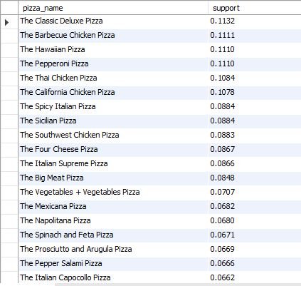

-- 4. Confidence (How often B is bought when A is bought).

WITH pizza_order_count AS (

SELECT pizza_id, COUNT(*) AS total_orders

FROM order_details

GROUP BY pizza_id

)

SELECT pt1.name AS pizza_A, pt2.name AS pizza_B,

COUNT(*) / poc.total_orders AS confidence

FROM order_details od1

JOIN order_details od2

ON od1.order_id = od2.order_id AND od1.pizza_id <> od2.pizza_id

JOIN pizzas p1 ON od1.pizza_id = p1.pizza_id

JOIN pizzas p2 ON od2.pizza_id = p2.pizza_id

JOIN pizza_types pt1 ON p1.pizza_type_id = pt1.pizza_type_id

JOIN pizza_types pt2 ON p2.pizza_type_id = pt2.pizza_type_id

JOIN pizza_order_count poc ON p1.pizza_id = poc.pizza_id

WHERE pt1.name > pt2.name

GROUP BY pt1.name, pt2.name, poc.total_orders

ORDER BY confidence DESC

LIMIT 10;

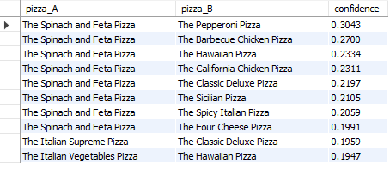

-- 5. Lift (Strength of the relationship).

WITH total_orders_cte AS (

SELECT COUNT(DISTINCT order_id) AS total_orders

FROM order_details

),

pizza_counts AS (

SELECT pizza_id, COUNT(DISTINCT order_id) AS orders_count

FROM order_details

GROUP BY pizza_id

),

pair_counts AS (

SELECT

od1.pizza_id AS pizza_A_id,

od2.pizza_id AS pizza_B_id,

COUNT(DISTINCT od1.order_id) AS pair_count

FROM order_details od1

JOIN order_details od2

ON od1.order_id = od2.order_id

AND od1.pizza_id < od2.pizza_id

GROUP BY od1.pizza_id, od2.pizza_id

)

SELECT

pt1.name AS pizza_A,

pt2.name AS pizza_B,

(pc_pair.pair_count * tot.total_orders) / (pc1.orders_count * pc2.orders_count) AS lift

FROM pair_counts pc_pair

JOIN pizza_counts pc1 ON pc_pair.pizza_A_id = pc1.pizza_id

JOIN pizza_counts pc2 ON pc_pair.pizza_B_id = pc2.pizza_id

CROSS JOIN total_orders_cte tot

JOIN pizzas p1 ON pc_pair.pizza_A_id = p1.pizza_id

JOIN pizzas p2 ON pc_pair.pizza_B_id = p2.pizza_id

JOIN pizza_types pt1 ON p1.pizza_type_id = pt1.pizza_type_id

JOIN pizza_types pt2 ON p2.pizza_type_id = pt2.pizza_type_id

ORDER BY lift DESC

LIMIT 10;

