Roll: 220105
GitHub Profile: https://github.com/mdraihan27
GitHub Repo: https://github.com/mdraihan27/svm-and-knn/tree/main
Collab File Links:
- SVM:
https://colab.research.google.com/drive/1vGQ8JtyJgONfguFmxQuDLnO7B-QRXUy8?usp=sharing
- KNN: https://colab.research.google.com/drive/1B9RH5yANQ720LwrLDbmk7dYDtJNSR-0p?usp=sharing
Dataset Links:
- Diabetes Dataset (Used for SVM):
Drive link
Kaggle link
- Heart Disease Dataset (Used for KNN):
Drive link
Kaggle link
Screenshots:
- SVM
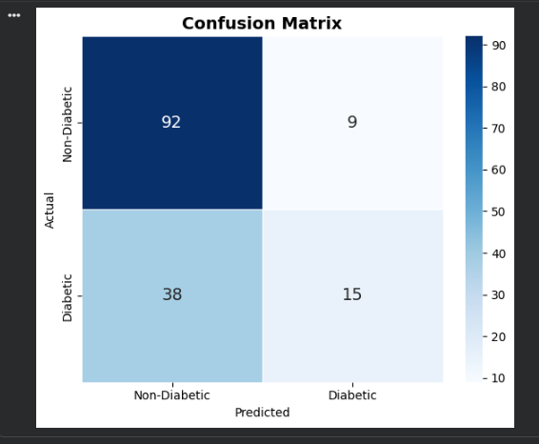
Figure 1: Confusion Matrix.
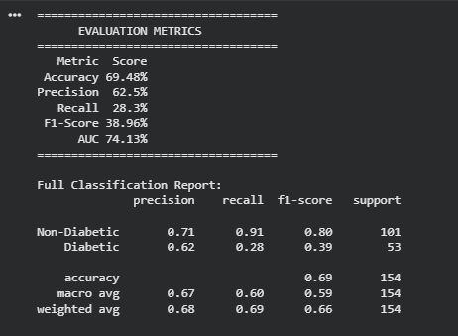
Figure 2: Evaluation Metrics.
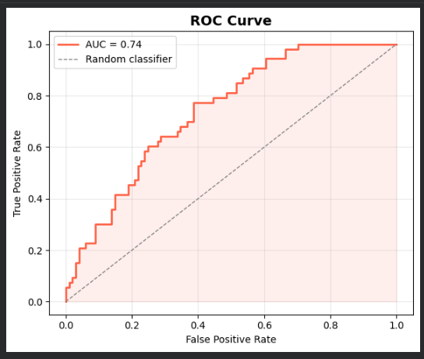
Figure 3: ROC curve.
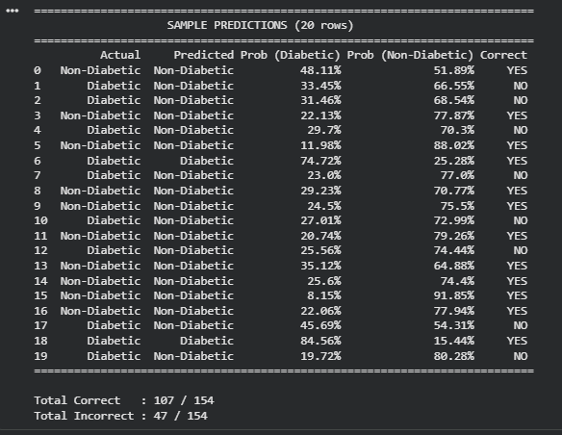
Figure 4: Sample predictions.
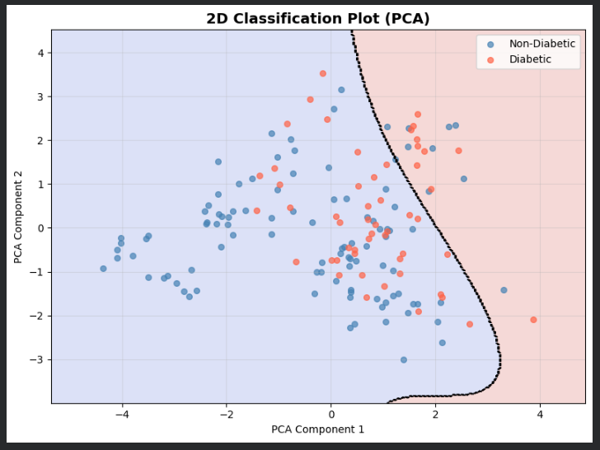
Figure 5: 2d classification plot.
- KNN:
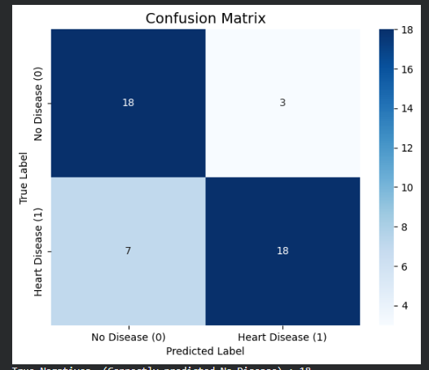
Figure 6: Confusion Matrix.
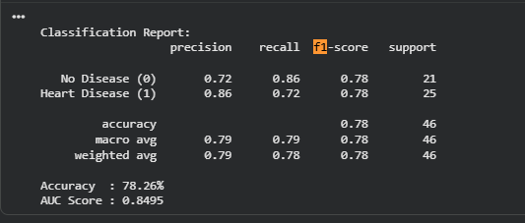
Figure 7: Evaluation Metrics.
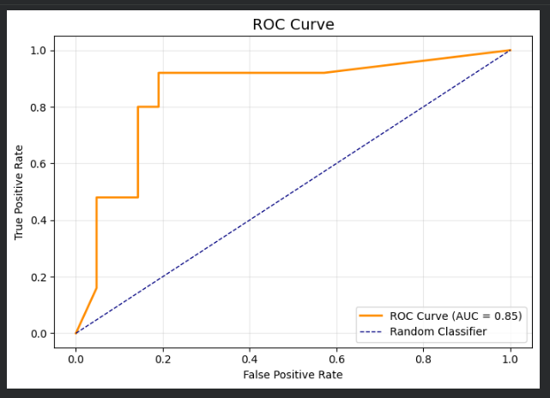
Figure 8: ROC Curve.
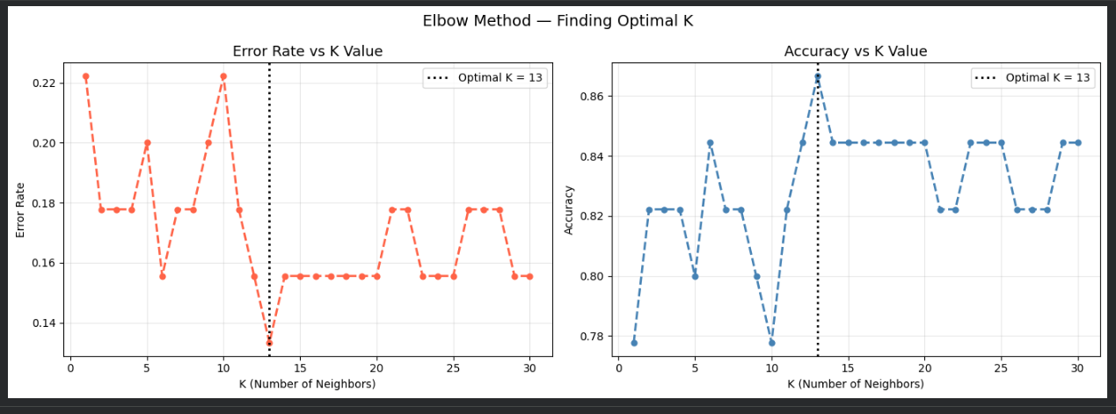
Figure 9: Elbow method plot.

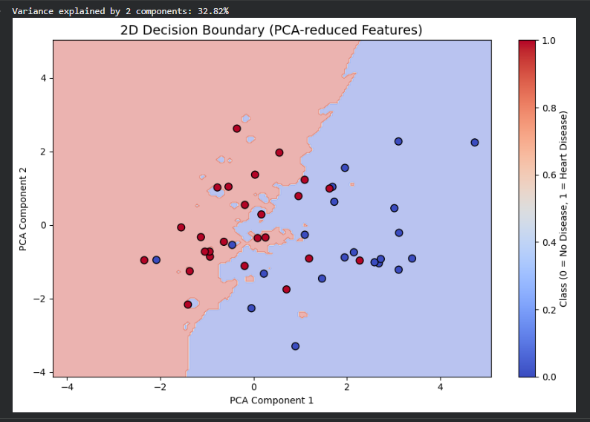
Figure 10: 2d decision boundary plot.

