

GARGI MEMORIAL INSTITUTE OF TECHNOLOGY

CONTINUOUS ASSESSMENT – 2

NAME – SYED ABDUL AZIM

DEPARTMENT – C.S.E

UNIVERSITY ROLL NO. – 28100120054

UNIVERSITY REGISTRATION NO. – 202810100120005 OF 2020-21

PAPER NAME – NEURAL NETWORK & DEEP LEARNING

PAPER CODE – PEC-IT602C

YEAR – 4TH

SEMESTER – 7TH

CONTACT NUMBER – 7478947109

What is Deep Learning?

Deep Learning is a subset of machine learning, which is essentially a neural network with three or more layers. These neural networks attempt to simulate the behavior of the human brain-albeit far from matching its ability-allowing it to “learn” from a large amount of data. While a neural network with a single layer can still make approximate predictions, additional hidden layers can help to optimize and refine for accuracy.

Deep learning drives many artificial intelligence (AI) applications and services that improve automation, performing analytical and physical tasks without human intervention. Deep learning technology lies behind everyday products and services (such as digital assistants, voice-enabled TV remotes, and credit card fraud detection) as well as emerging technologies (such as self-driving cars).

How does Deep Learning Work?

Deep learning neural networks, or artificial neural networks, attempts to mimic the human brain through a combination of data inputs, weights, and bias. These elements work together to accurately recognize, classify, and describe objects within the data.

Deep neural networks consist of multiple layers of interconnected nodes, each building upon the previous layer to refine and optimize the prediction or categorization. This progression of computations through the network is called forward propagation. The input and output layers of a deep neural network are called visible layers. The input layer is where the deep learning model ingests the data for processing, and the output layer is where the final prediction or classification is made.

Another process called backpropagation uses algorithms, like gradient descent, to calculate errors in predictions and then adjusts the weights and biases of the function by moving backward through the layers to train the model. Together, forward propagation and backpropagation allow a neural network to make predictions and correct for any errors accordingly. Over time, the algorithm becomes gradually more accurate.

Applications of Deep Learning

Real-world deep learning applications are a part of our daily lives, but in most cases, they are so well-integrated into products and services that users are unaware of the complex data processing that is taking place in the background. Some of these examples include the following:

* **Law enforcement**

Deep learning algorithms can analyze and learn from transactional data to identify dangerous patterns that indicate possible fraudulent or criminal activity. Speech recognition, computer vision, and other deep learning applications can improve the efficiency and effectiveness of investigative analysis by extracting patterns and evidence from sound and video recordings, images, and documents, which helps law enforcement analyze large amounts of data more quickly and accurately.

* **Financial Services**

Financial institutions regularly use predictive analytics to drive algorithmic trading of stocks, assess business risks for loan approvals, detect fraud, and help manage credit and investment portfolios for clients.

* **Customer service**

Many organizations incorporate deep learning technology into their customer service processes. Chatbots—used in a variety of applications, services, and customer service portals—is a straightforward form of AI. Traditional chatbots use natural language and even visual recognition, commonly found in call center-like menus. However, more sophisticated chatbot solutions attempt to determine, through learning, if there are multiple responses to ambiguous questions. Based on the responses it receives, the chatbot then tries to answer these questions directly or route the conversation to a human user.

Virtual assistants like Apple's Siri, Amazon Alexa, or Google Assistant extend the idea of a chatbot by enabling speech recognition functionality. This creates a new method to engage users in a personalized way.

* **Healthcare**

The healthcare industry has benefited greatly from deep learning capabilities ever since the digitization of hospital records and images. Image recognition applications can support medical imaging specialists and radiologists, helping them analyze and assess more images in less time.

Example of Deep Learning

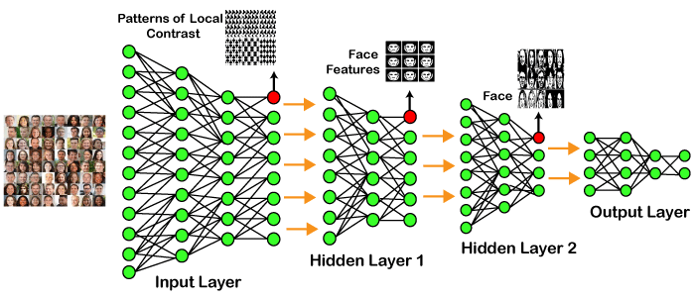

In the example given above, we provide the raw data of images to the first layer of the input layer. After then, these input layers will determine the patterns of local contrast which means it will differentiate based on colors, luminosity, etc. Then the 1st hidden layer will determine the face feature, i.e., it will fixate on the eyes, nose, lips, etc. And then, it will fixate those face features on the correct face template. So, in the 2nd hidden layer, it will determine the correct face here as can be seen in the above image, after which it will be sent to the output layer. Likewise, more hidden layers can be added to solve more complex problems, for example, if you want to find out whether a particular kind of face has large or light complexions. So, as and when the hidden layers increase, we can solve complex problems.

Architectures

* **Deep Neural Networks**  
  It is a neural network that incorporates the complexity of a certain level, which means several numbers of hidden layers are encompassed in between the input and output layers. They are highly proficient in model and process non-linear associations.
* **Deep Belief Networks**  
  A deep belief network is a class of Deep Neural networks that comprises multi-layer belief networks.  
  **Steps to perform DBN:**
  1. With the help of the Contrastive Divergence algorithm, a layer of features is learned from perceptible units.
  2. Next, the formerly trained features are treated as visible units, which perform the learning of features.
  3. Lastly, when the learning of the final hidden layer is accomplished, then the whole DBN is trained.
* **Recurrent Neural Networks**  
  It permits parallel as well as sequential computation, and it is exactly similar to that of the human brain (large feedback network of connected neurons). Since they are capable enough to reminisce all of the imperative things related to the input they have received, so they are more precise.

What is the Deep Feed Forward network?

A Feed Forward Neural Network is an artificial neural network in which the connections between nodes do not form a cycle. The opposite of a feed-forward model is the simple neural network is a recurrent neural network, in which certain pathways are cycled. The feed-forward model is the simplest form of a neural network as information is only processed in one direction. While the data may pass through multiple hidden nodes, it always moves in one direction and never backward.

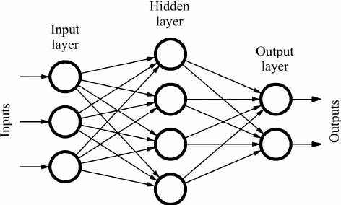

How does a Feed Forward Neural Network work?

A Feed Forward Neural Network is commonly seen in its simplest form as a single layer perceptron. In this model, a series of inputs enter the layer and are multiplied by the weights. Each value is then added together to get a sum of the weighted input values. If the sum of the values is above a specific threshold, usually set at zero, the value produced is often 1, whereas if the sum falls below the threshold, the output value is -1. The single-layer perceptron is an important model of feed-forward neural networks and is often used in classification tasks. Furthermore, single-layer perceptrons can incorporate aspects of machine learning. Using a property known as the delta rule, the neural network can compare the outputs of its nodes with the intended values, thus allowing the network to adjust its weights through training to produce more accurate output values. This process of training and learning produces a form of gradient descent. In multi-layered perceptrons the process of updating weights is nearly analogous, however, the process is defined more specifically as back-propagation. In such cases, each hidden layer within the network is adjusted according to the output values produced by the final layer.

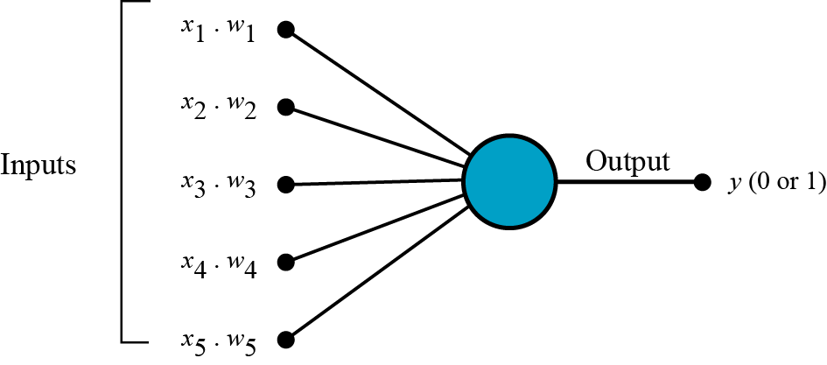

Application of Feed Forward Neural Networks

While Feed Forward Neural Networks are fairly straightforward, their simplified architecture can be used as an advantage in particular machine learning applications. For example, one may set up a series of feed-forward neural networks to run them independently from each other, but with a mild intermediary for moderation. Like the human brain, this process relies on many individual neurons to handle and process larger tasks. As the individual networks perform their tasks independently, the results can be combined at the end to produce a synthesized, and cohesive output.

Regularization

Regularization is a technique that makes slight modifications to the learning algorithm such that the model generalizes better. This in turn improves the model’s performance on the unseen data as well.

L1 & L2 Regularization

L1 and L2 are the most common types of regularization. These update the general cost function by adding another term known as the regularization term.

Cost function = Loss (say, binary cross entropy) + Regularization term

Due to the addition of this regularization term, the values of weight matrices decrease because it assumes that a neural network with smaller weight matrices leads to simpler models. Therefore, it will also reduce overfitting to quite an extent.

However, this regularization term differs in L1 and L2.

In L2, we have:



Here, **lambda** is the regularization parameter. It is the hyperparameter whose value is optimized for better results. L2 regularization is also known as weight decay as it forces the weights to decay towards zero (but not exactly zero).

In L1, we have:



In this, we penalize the absolute value of the weights. Unlike L2, the weights may be reduced to zero here. **Hence, it is very useful when we are trying to compress our model. Otherwise, we usually prefer L2 over it.**

Dropout

This is one of the most interesting types of regularization techniques. It also produces very good results and is consequently the most frequently used regularization technique in the field of deep learning.

To understand dropout, let’s say our neural network structure is akin to the one shown below:

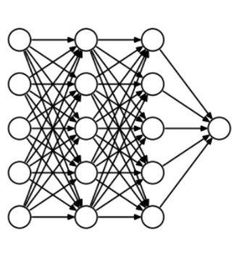  
So, what does a dropout do? At every iteration, it randomly selects some nodes and removes them along with all of their incoming and outgoing connections as shown below.

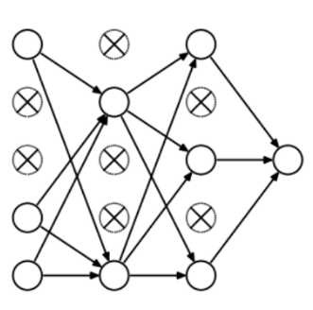

So, each iteration has a different set of nodes and this results in a different set of outputs. **It can also be thought of as an ensemble technique in machine learning.**

Ensemble models usually perform better than a single model as they capture more randomness. Similarly, dropout also performs better than a normal neural network model.

This probability of choosing how many nodes should be dropped is the hyperparameter of the dropout function. As seen in the image above, dropout can be applied to both the hidden layers as well as the input layers.



Convolutional Neural Network

Convolution Neural Networks are a special kind of neural network mainly used for image classification, clustering of images, and object recognition. DNNs enable unsupervised construction of hierarchical image representations. To achieve the best accuracy, deep convolutional neural networks are preferred more than any other neural network.

Recurrent Neural Network

Recurrent Neural Networks are yet another variation of feed-forward networks. Here each of the neurons present in the hidden layers receives an input with a specific delay in time. The Recurrent neural network mainly accesses the preceding info of existing iterations. For example, to guess the succeeding word in any sentence, one must know the words that were previously used. It not only processes the inputs but also shares the length as well as weights crossways time. It does not let the size of the model increase with the increase in the input size. However, the only problem with this recurrent neural network is that it has a slow computational speed as well as it does not contemplate any future input for the current state. It has a problem with reminiscing prior information.

Recurrent Neural Network

Deep Belief Networks are machine learning algorithm that resembles deep neural network but are not the same. These are feedforward neural networks with a deep architecture, i.e., having many hidden layers. Simple, unsupervised networks like restricted Boltzmann machines- RBMs or autoencoders make DBNs, with the hidden layer of each sub-network serving as the visible layer for the next layer.