# Alegria Change Request

Inhoud

Alegria Implementation Request 1

1. Introduce product name on button on category page 1

2. Payment solution 2

3. Bottom blue banner appears on home page to indicate to visitor to promote Webshop. 3

4. Contact page rework 3

5. Category page changes: 3

6. Wordpress environment update: 4

## Introduce product name on button on category page

* See impacted button in screen shot

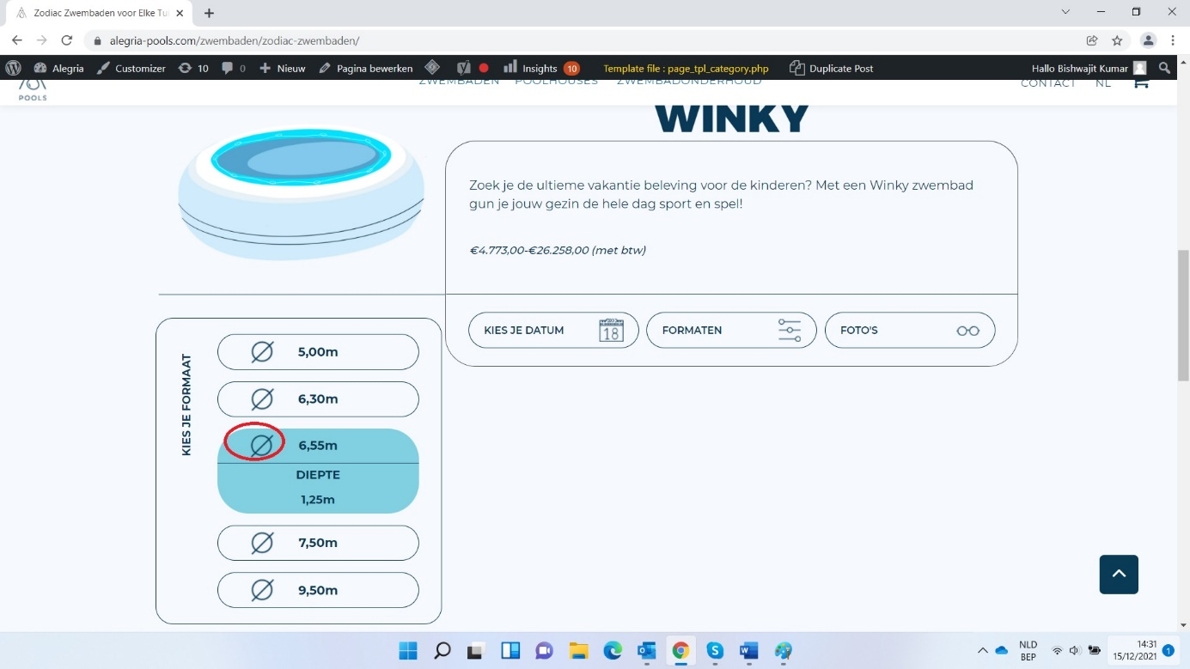

* Change to be introduced – the button which currently holds an image + text will be adapted such that the image is replaced by product name from the attached xls.

- 

* Thus, the button size needs to be adapted such that both smallest text plus longest variant of it look good and consistent.
* Col E – name used in category page
* Col F – name used in product page
* Same fonts as used now. Size can be finetuned/adapted on feedback.
* Depth variations in cm or m (confirmation from client awaited)? // New decided names in xls have cm. While all current names and depth variations are in m//
* Will be evaluated on multiple screen formats
* **Feedback awaited from client before starting implementation**

## Payment solution

* Solutions provided by multisafepay
  1. Woo-commerce plug-in
  2. Integrating multiple payment components by adding CSS components (ref: docs.multisafepay.com/payment-components/multiple/
  3. Our own integration using API documentation
* Information for integration received from Multisafepay provided options:
* Link to demo env : [https://testmerchant.multisafepay.com/](https://eur02.safelinks.protection.outlook.com/?url=https%3A%2F%2Ftestmerchant.multisafepay.com%2F&data=04%7C01%7CRaf%40radikal.io%7C400acae9fd2c4364abb608d9370ca9d7%7C49c3d703357947bfa8887c913fbdced9%7C0%7C0%7C637601350006519394%7CUnknown%7CTWFpbGZsb3d8eyJWIjoiMC4wLjAwMDAiLCJQIjoiV2luMzIiLCJBTiI6Ik1haWwiLCJXVCI6Mn0%3D%7C1000&sdata=4392iOP7Ou%2FxDXraBzORc%2BTidhCd%2BqwPDCp3uVTjb8I%3D&reserved=0)
* API integration setup documentation : [https://www.multisafepay.com/documentation/doc/API-Reference/](https://eur02.safelinks.protection.outlook.com/?url=https%3A%2F%2Fwww.multisafepay.com%2Fdocumentation%2Fdoc%2FAPI-Reference%2F&data=04%7C01%7CRaf%40radikal.io%7C400acae9fd2c4364abb608d9370ca9d7%7C49c3d703357947bfa8887c913fbdced9%7C0%7C0%7C637601350006529356%7CUnknown%7CTWFpbGZsb3d8eyJWIjoiMC4wLjAwMDAiLCJQIjoiV2luMzIiLCJBTiI6Ik1haWwiLCJXVCI6Mn0%3D%7C1000&sdata=W6%2BINrmRMXonDs7Gk8YcMSIts8%2B7qfwvD6Z8Q5lZqGk%3D&reserved=0)
* Link to virtual payment card for test environment :  <https://docs.multisafepay.com/getting-started/test-your-integration/test-payment-details/>
* Link documentation for MSP backend :  [https://www.multisafepay.com/be_nl/documentatie-be/handleiding-multisafepay-control/](https://eur02.safelinks.protection.outlook.com/?url=https%3A%2F%2Fwww.multisafepay.com%2Fbe_nl%2Fdocumentatie-be%2Fhandleiding-multisafepay-control%2F&data=04%7C01%7CRaf%40radikal.io%7C400acae9fd2c4364abb608d9370ca9d7%7C49c3d703357947bfa8887c913fbdced9%7C0%7C0%7C637601350006539316%7CUnknown%7CTWFpbGZsb3d8eyJWIjoiMC4wLjAwMDAiLCJQIjoiV2luMzIiLCJBTiI6Ik1haWwiLCJXVCI6Mn0%3D%7C1000&sdata=urZQdywj%2B2gKmzgu%2BD%2B0lhwk7Ko%2BpwiS8saTYFK8XKA%3D&reserved=0)
* Payment methods to be included:
* Creditcards (master + visa)
* Debit cards (maestro + bancontact + QR code)
* Bank transfer (sepa direct debit)
* Payment request made to client – (10% of Total Amt in Shopping car) ceiled to a maximum of five thousand Euro.
* Settings for WooCommerce (to be provided by client):
* Adress of shop
* Countries list where products can be sold
* Shipping of products allowed to countries: list
* Shipping costs if any to be configured
* Email address to be configured for: new order, cancelled order, failed order
* Email address sender Name+address for confirmations to client
* Emailcontent to be configured
* No more reservation of product without payment completion. Alegria to confirm that
* **Feedback awaited from client, but implementation can only start after multisafepay account registration is complete**

## Bottom blue banner appears on home page to indicate to visitor to promote Webshop.

* See over which banner it goes:

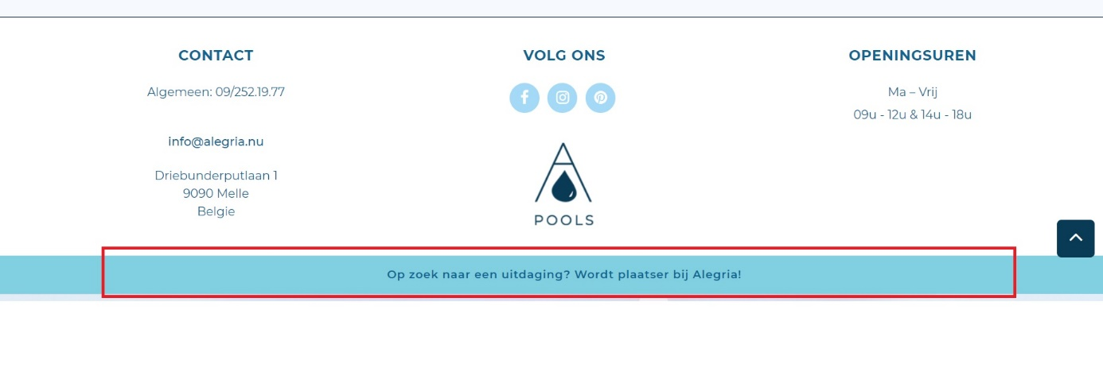

* Currently the banner has text: looking for a challenge? Become an installer for Alegria. This should be customisable. The idea is that the client sees this message: Buy now your swimming-pool ONLINE: Wood | Zodiac | Built-In
  1. The categories are clickable and lead to respective category page
  2. In future other content and text options can be setup.
  3. This should appear fixed only when the client is viewing the Home page.
  4. Exploring if easy to implement that it appears for twenties and then disappears AGAIN only to reappear after 5minutes again.
* **Feedback awaited from client before starting implementation**

## Contact page rework

* We foresee that it remains same irrespective of the image FORMAT and size. Including overspan
* People not working anymore – already updated.
* Implementation confirmed by client.

## Category page changes:

* After clicking on format, new window pops up with format. Here when hovering LXB 3,00x5,00m, colour should change to same blue colour that happens after clicking.

* When clicking on of the dimensions, the depth variations appear. And when one hovers on the depth 1,20m, it should again on change colour to white. Same color as on product page slider.

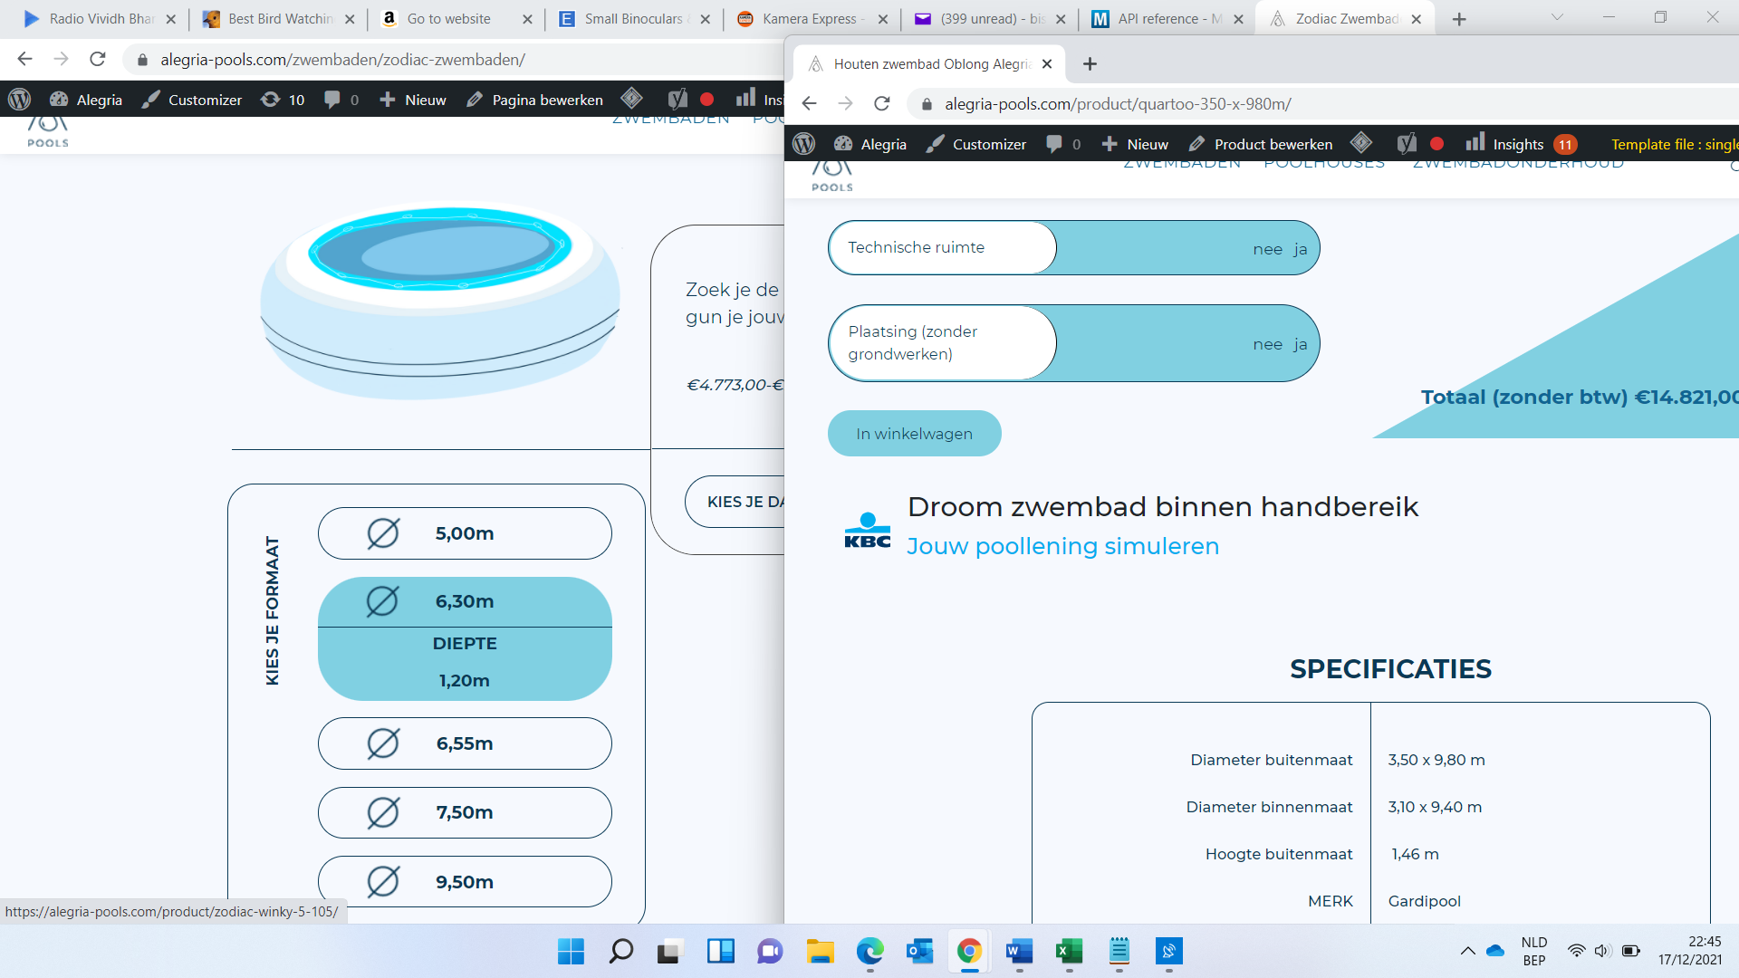

* Tekst KIES JE FORMAAT should be changed to KIES JE DIEPTE
* Implementation confirmed by client.

## Wordpress environment update:

* Wo commerce major update 5.X -> 6.0.0
* Other plugins update including WPML multilingual