1. this signature font option is appearing - it shouldn't be there. The real signature font option is there and it isn't this  
   **Comment : done**

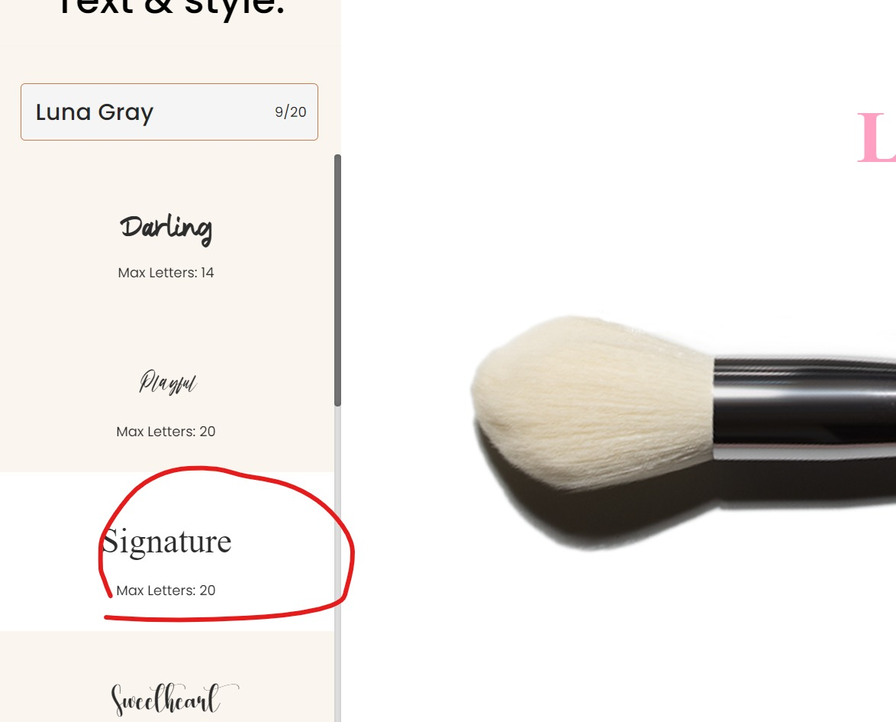

1. I would also like to make the previous text on the image bigger. Some text style appears big and some are too small

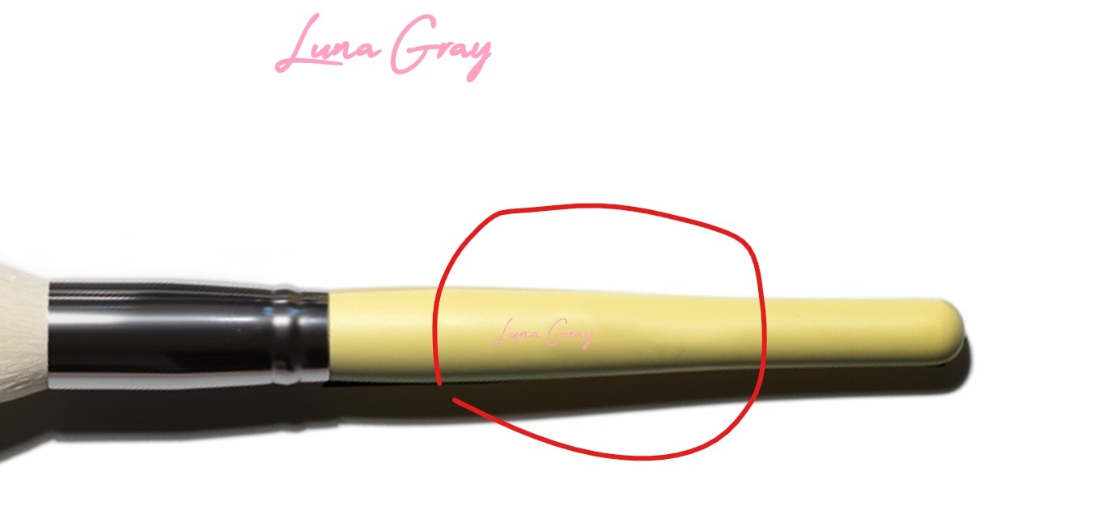

**Comment:** You need set default font size 40px;

Please match with. .<https://enuesque.com/product/azure-sky-complete-brush-set/>

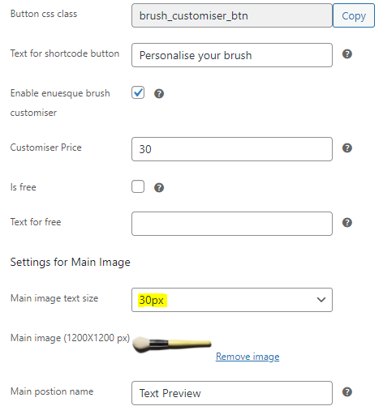

1. this text style size is good but some are too small

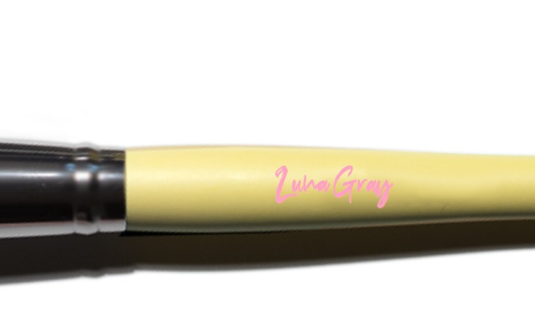

**Comment : It depends on the text size in backend**

1. the text placement for desktop and mobile is still not the same

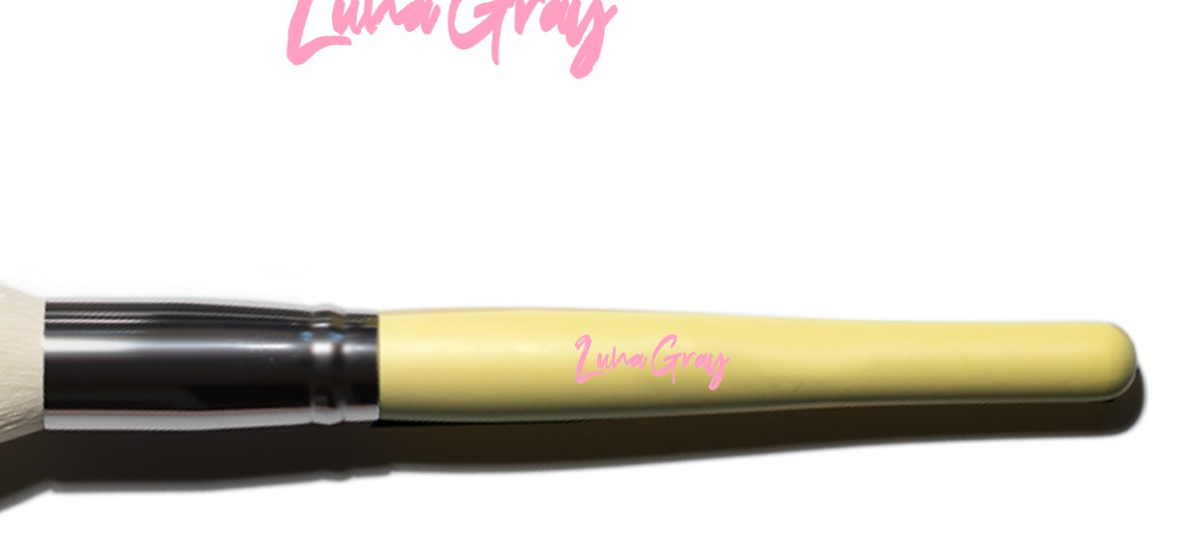

**Comment:** Image resolutions is different , Use this dimension of image (width: 1200px & height: 1200px);

See this url: <https://enuesque.com/product/azure-sky-complete-brush-set/>

1. Text placement on mobile is still low

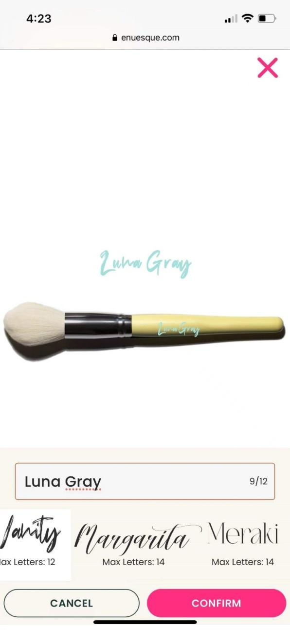

**Comment:** image resolutions is different , Use this dimension of image (width: 1200px & height: 1200px);

See this url: <https://enuesque.com/product/azure-sky-complete-brush-set/>

**Overall comment :**  
  
All our customization depends on product image and brush handle size. Please follow bellow product when you create new product . Otherwise it is not possible to fix image and text position for every device.  
<https://enuesque.com/product/azure-sky-complete-brush-set/>