**BRAC UNIVERSITY**

**Department of Computer Science & Engineering**

**Practice Problem sheet (Week6)**

**CSE 350: Digital Electronics and Pulse Technique** 

# **Question 1**

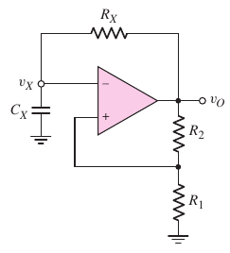

The Dual Slope ADC in week 5 problem 4 uses a clock signal of **1 MHz**. Suppose, we want to supply this clock signal from a square-wave generator circuit. The square-wave generator circuit we studied in week 6 is a schmitt-trigger oscillator, as shown in the above figure.

Assume, the saturation output voltages of the om-amp are symmetric (i.e. equal in magnitude). Now, follow the steps stated below to design the circuit.

| (a) | Calculate the duty cycle of the circuit, considering symmetric output voltages. |
| --- | --- |
| (b) | Derive the expression of **Time Period, T** in terms of the circuit parameters. |
| (c) | Choose standard resistor and capacitor values to obtain the desired time period (or frequency.) |
| (d) | Calculate the deviation (in percentage) in frequency for your designed circuit. |
| (e) | How can we design a schmitt trigger oscillator circuit with a specific duty cycle (like 30%)? |

Solution:

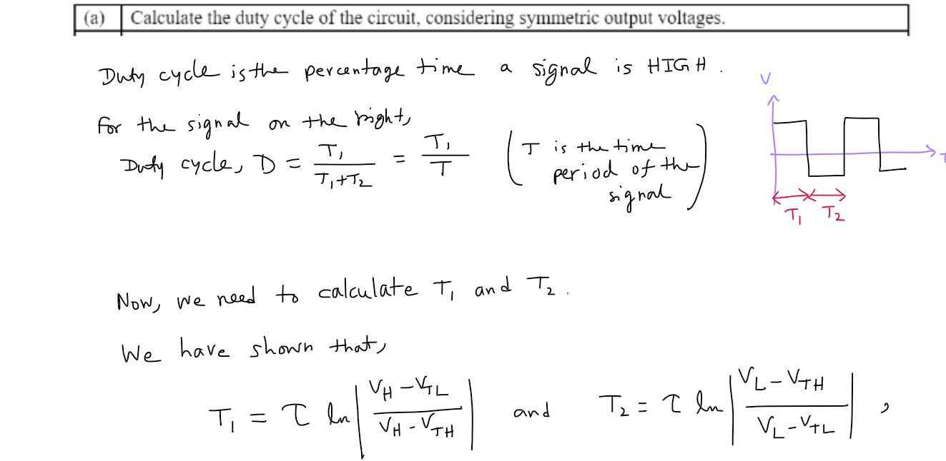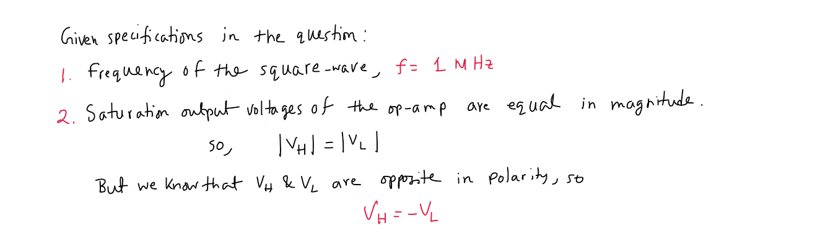

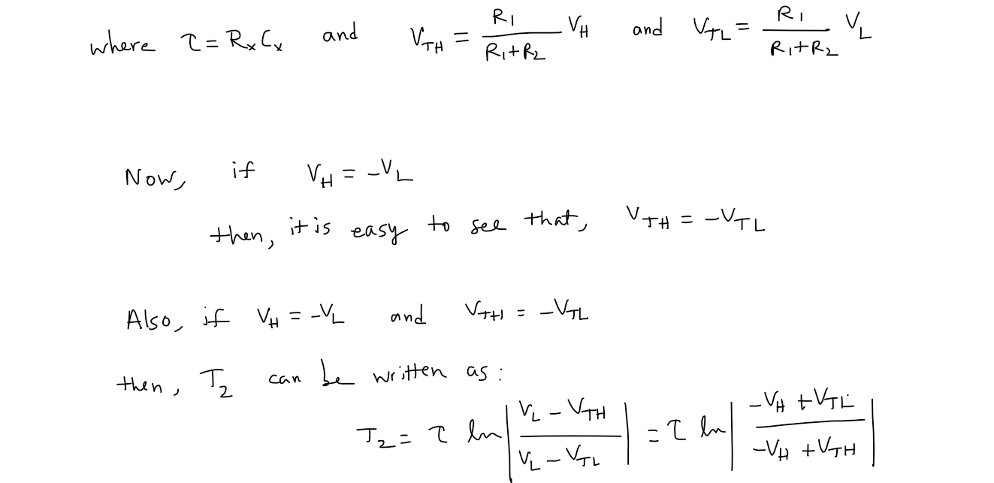

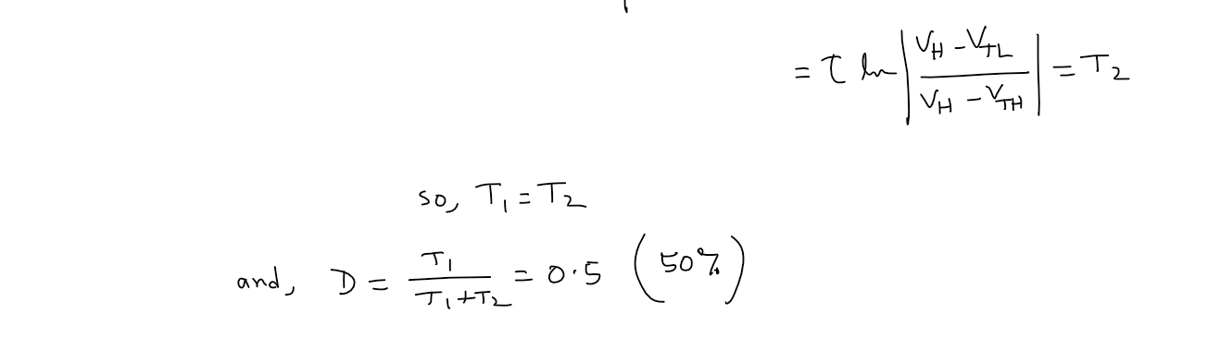

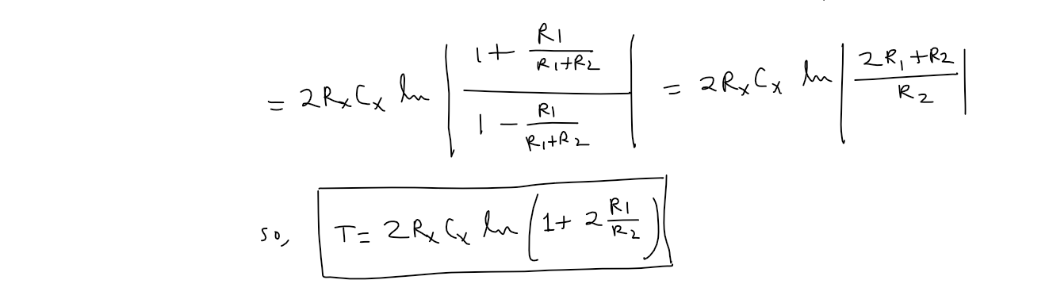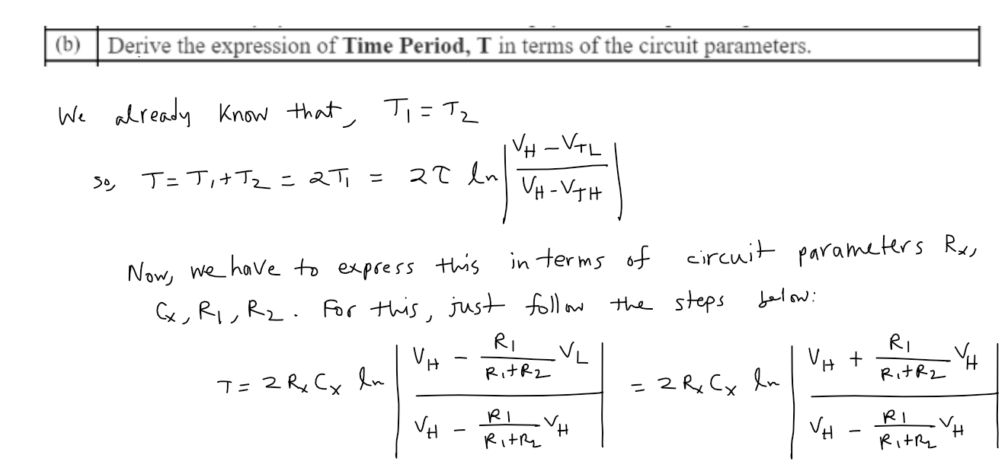

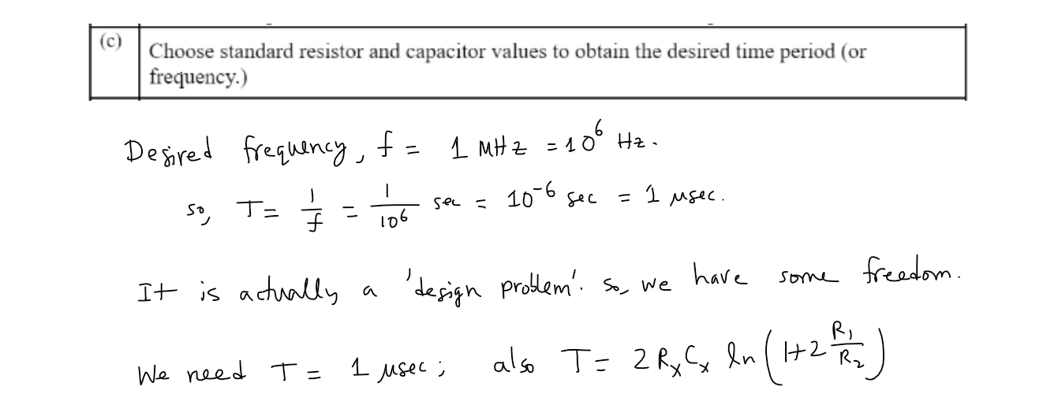

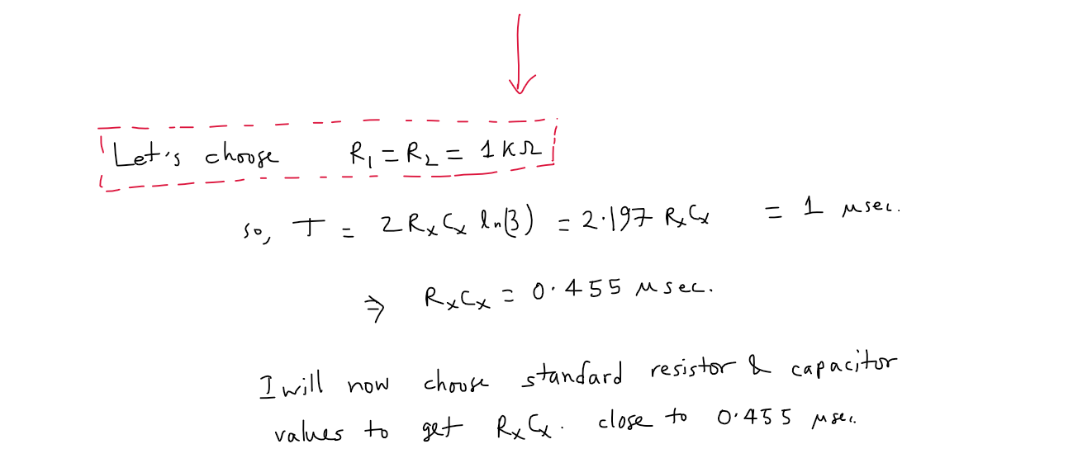



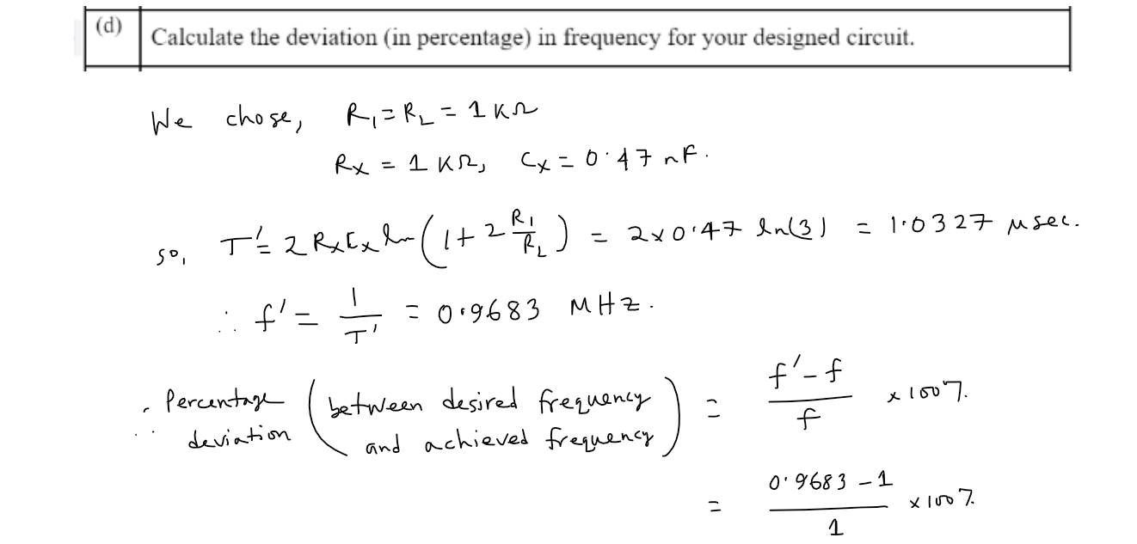

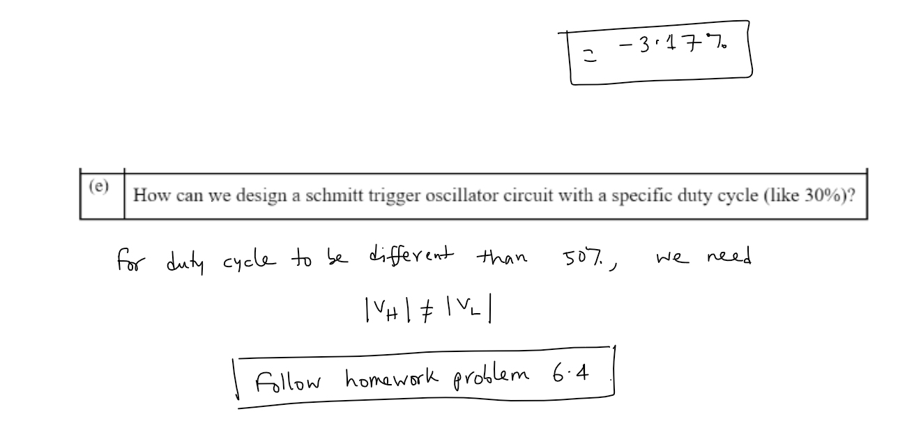

# **Question 2**

Previously, we designed a street light control circuit using a simple op-amp comparator. But it damaged some of the street lights.

Now, we want to design a street light control circuit using Schmitt trigger, as shown below. This design employing Schmitt trigger circuit is robust to environmental noise and photodetector’s shot-noise, so hopefully it will not damage the street lights this time.

We want to install our street light control system in Mohammadpur, Dhaka. So, we went there last week to collect photodetector circuit data. Our collected data over 24 hours is shown in the plot below. Note that, the output voltage of a photodetector circuit is directly proportional to the amount of light incident on it and we use this output voltage as an input voltage of the schmitt trigger circuit.

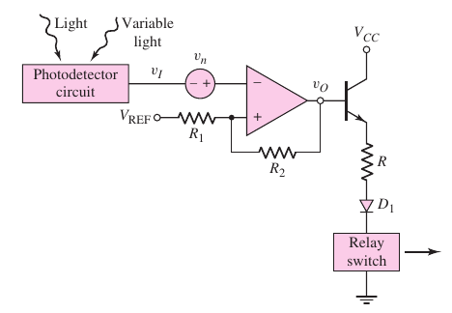

Now, help us in selecting the appropriate values of the circuit parameters.

| (a) | Choose an appropriate value of the switching voltage **VS .** |
| --- | --- |
| (b) | We found that the combined noise voltage has a peak-to-peak voltage of around 0.1 V. Considering this, choose an appropriate value of the hysteresis width of the schmitt trigger circuit. |
| (c) | For your chosen switching voltage and hysteresis width, select the values of **R1 , R2 , VREF**. |

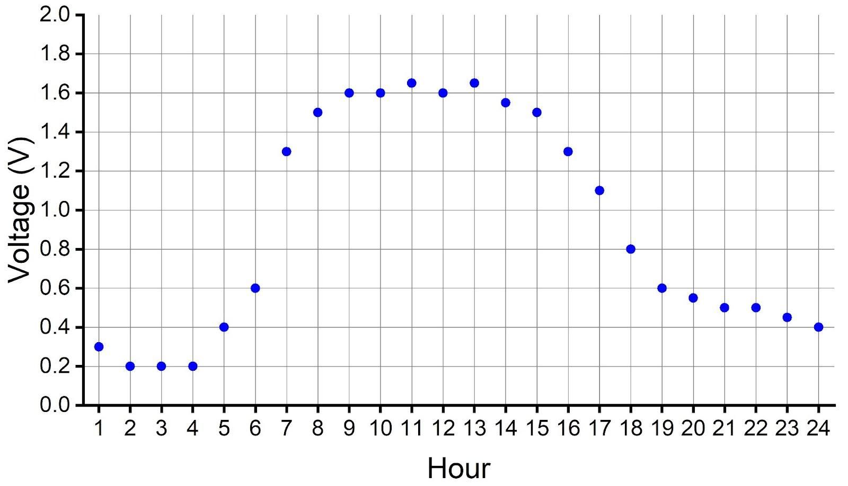

Solution:

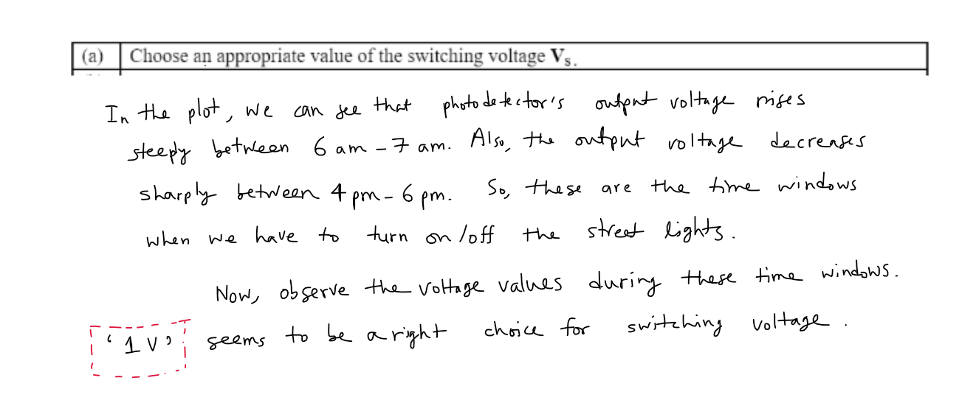

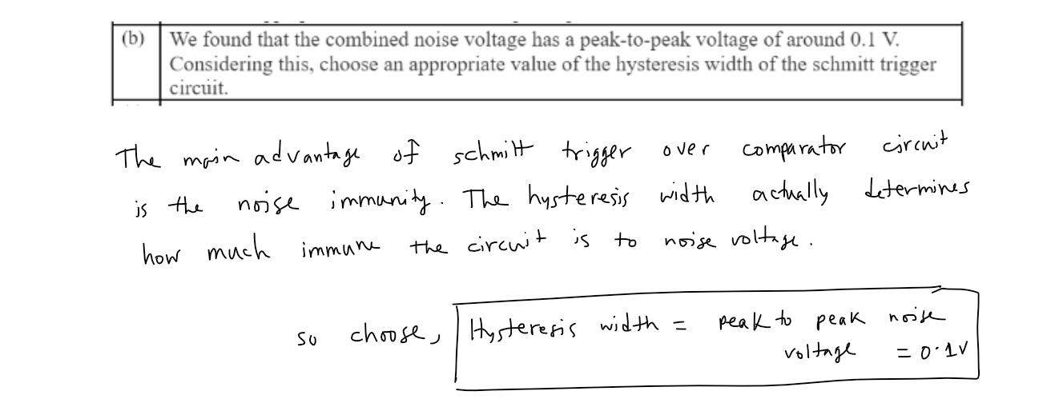

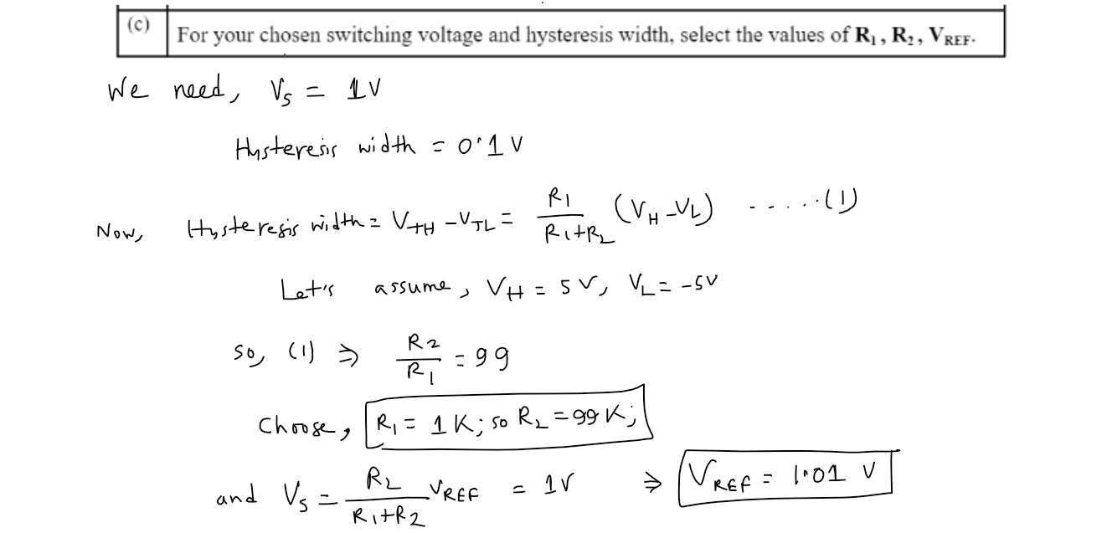

# **Question 3**

Assume for the square wave generator below, R2 = 0.86 * R1 and +Vsat = -Vsat . Prove that T = 2RfC

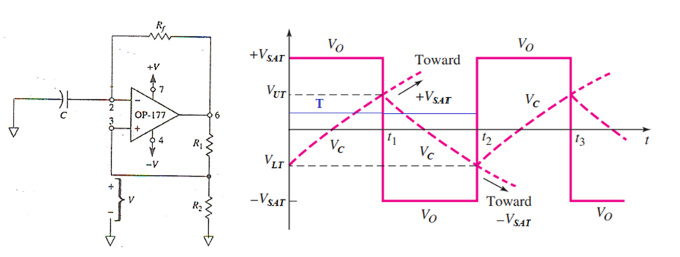

Solution:

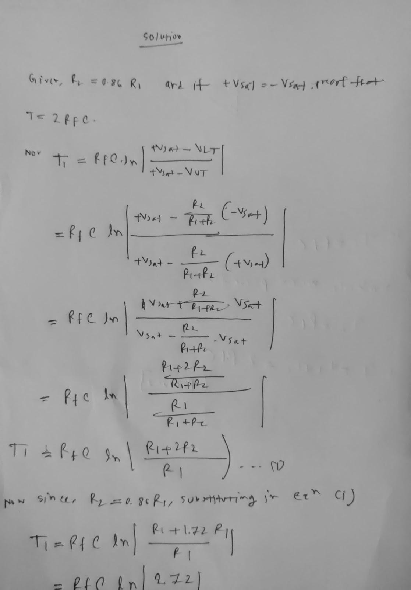

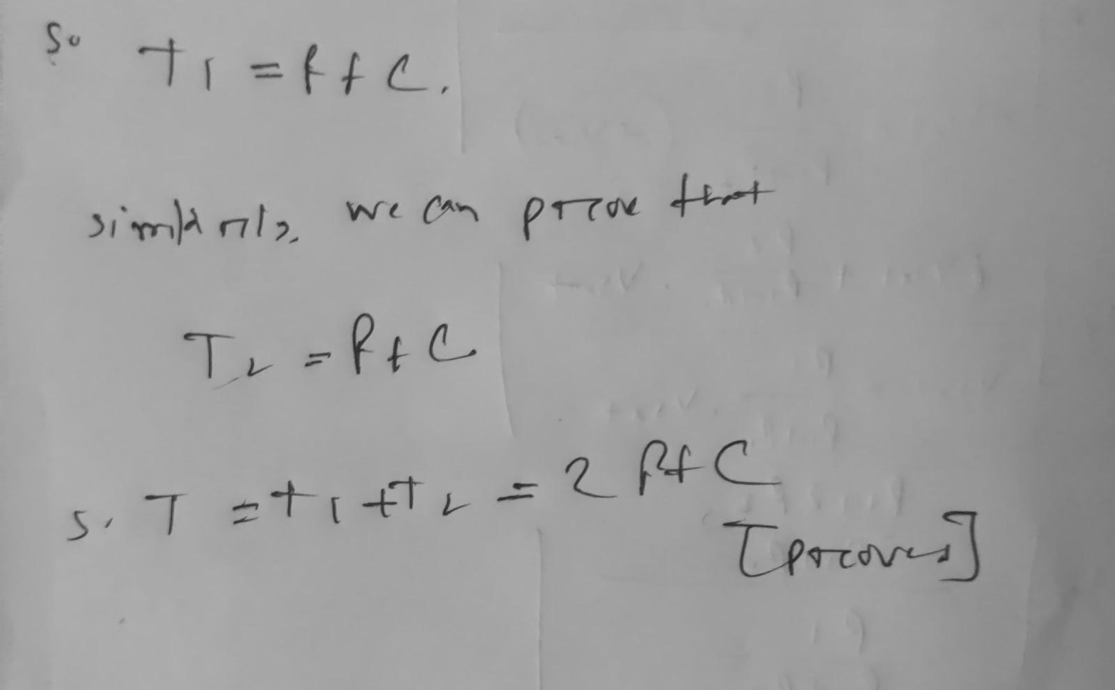

# **Question 4**

Assume for the triangular wave generator below, +Vsat = -Vsat . Prove that

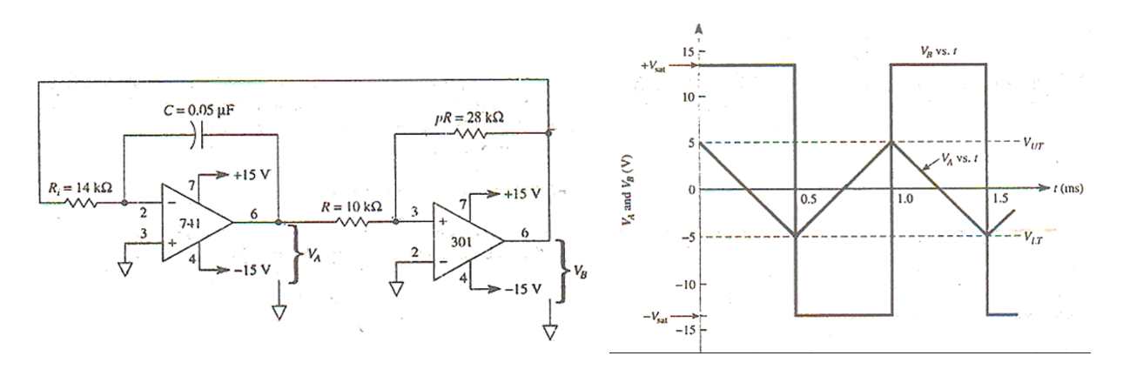

Solution:

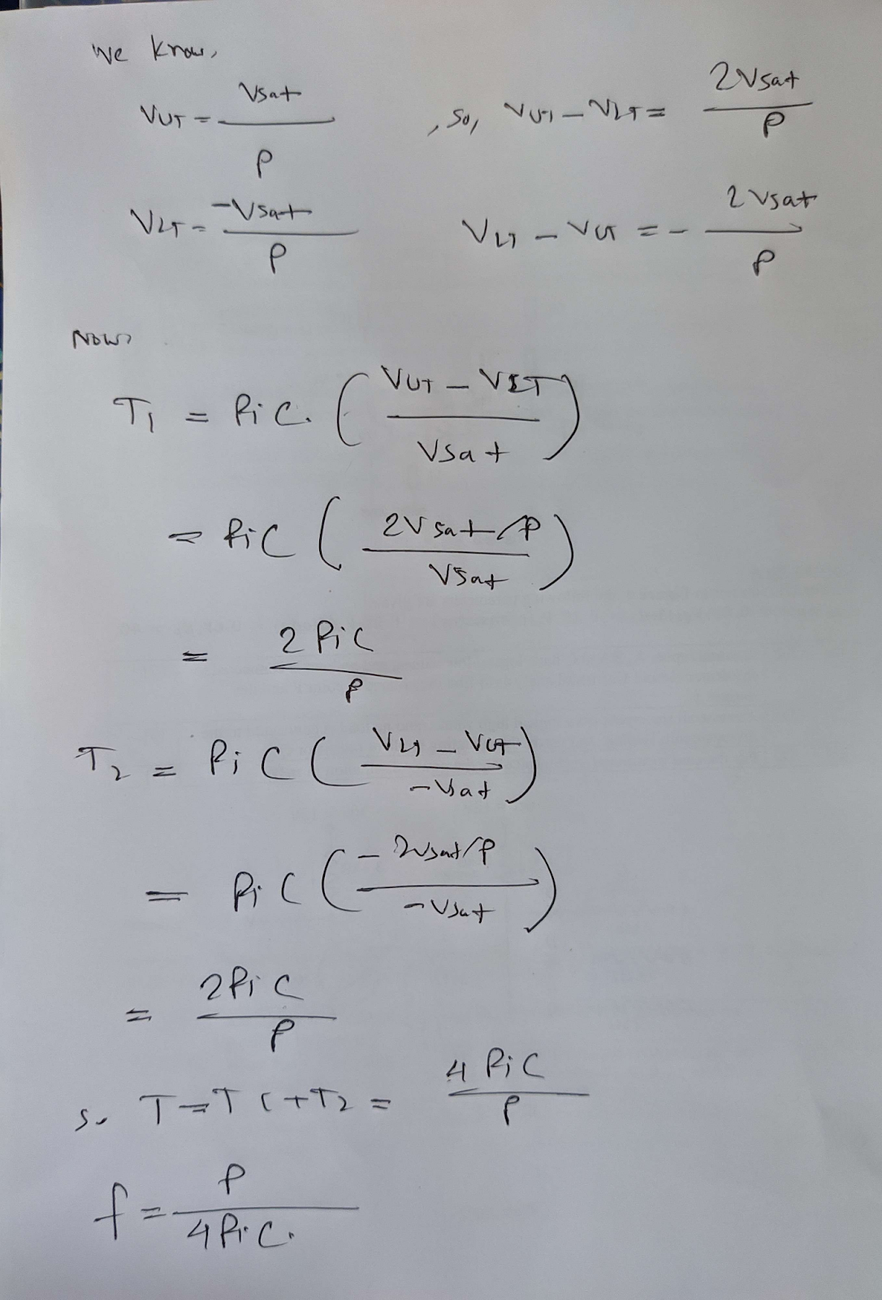

# **Question 5**

For the OP-AMP comparator circuit below, Vin vs time plot is given. Draw the Vout vs time plot for the given input.

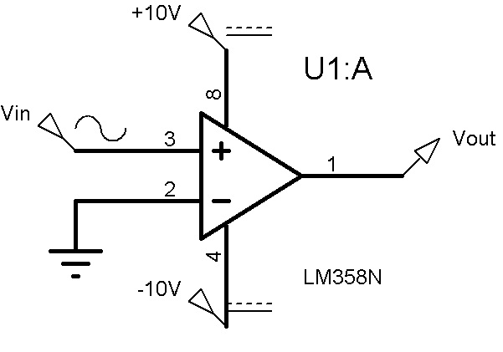

Solution:

For the OP-AMP comparator, we know that

Vout = VH if V+ > V-

Vout = VL if V+ < V-

Since, V- is connected to ground, we have,

Vout = +10V if Vin > 0V

Vout = -10V if Vin < 0V

**Output for input (a)**

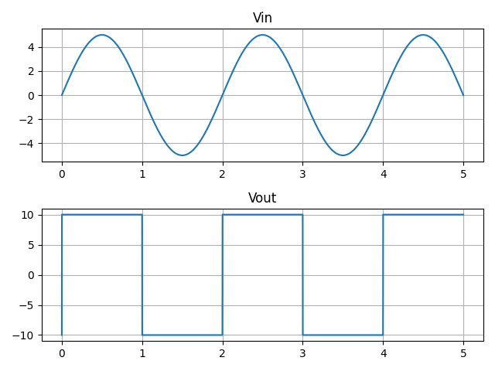

**Output for input (b)**

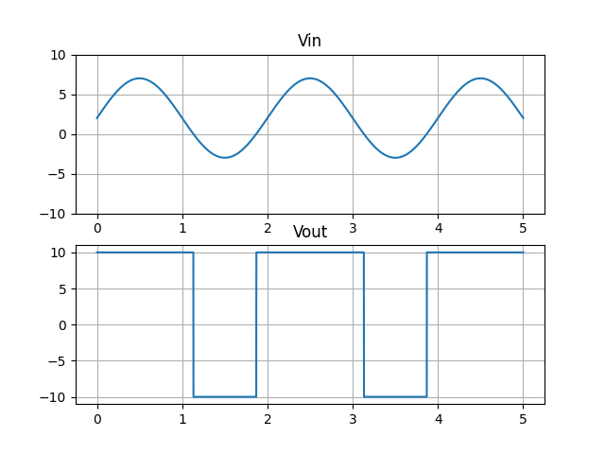

# **Question 6**

For the OP-AMP comparator circuit below, Vin vs time plot is given. Draw the Vout vs time plot for the given input.

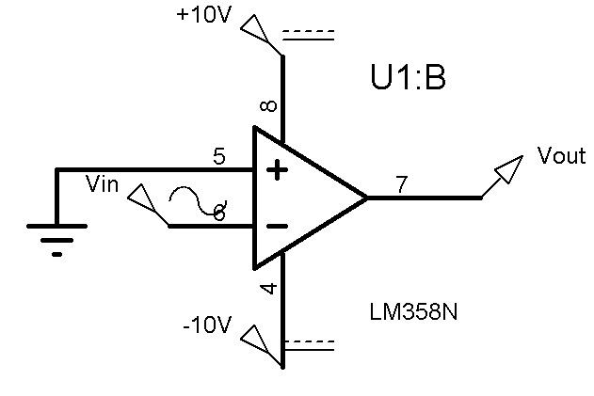

Solution:

For the OP-AMP comparator, we know that

Vout = VH if V+ > V-

Vout = VL if V+ < V-

Since, V+ is connected to ground, we have,

Vout = +10V if Vin < 0V

Vout = -10V if Vin < 0V

**Output for input (a)**

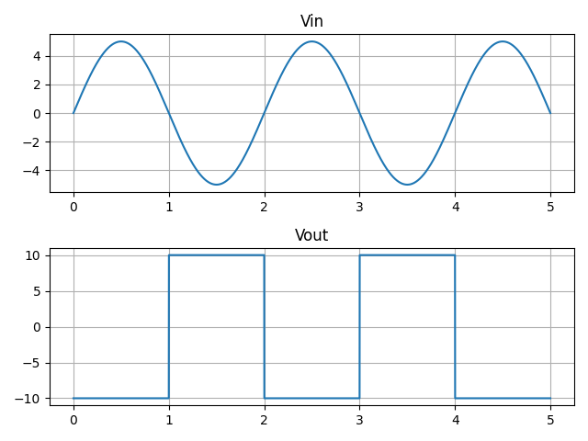

**Output for input (b)**

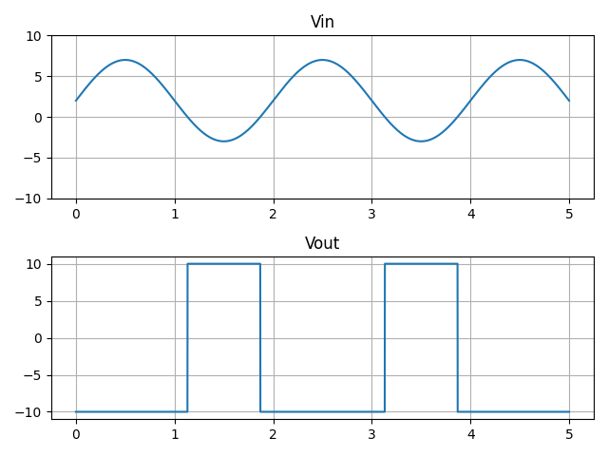

# **Question 7**

For the non-inverting schmitt trigger circuit below, Vin vs time plot is given. Draw the Vout vs time plot for the given input.

`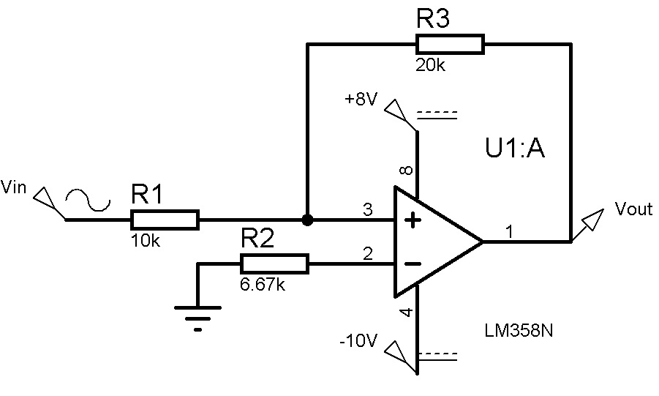

Solution:

For the non-inverting Schmitt trigger above, the threshold voltages are given as:

Upper threshold, = 5V

Lower threshold, = -4V

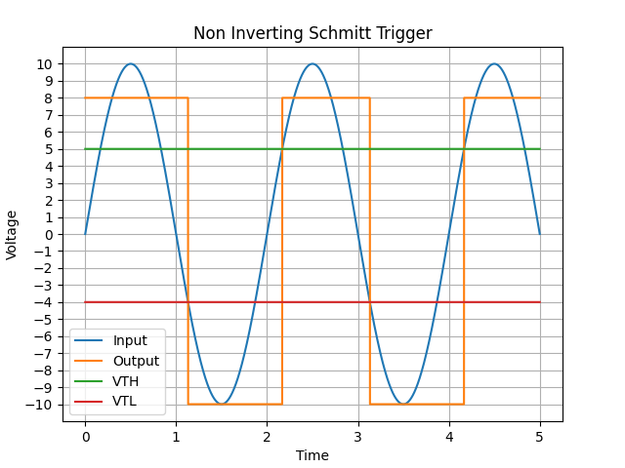

# **Question 8**

For the inverting schmitt trigger circuit below, Vin vs time plot is given. Draw the Vout vs time plot for the given input.

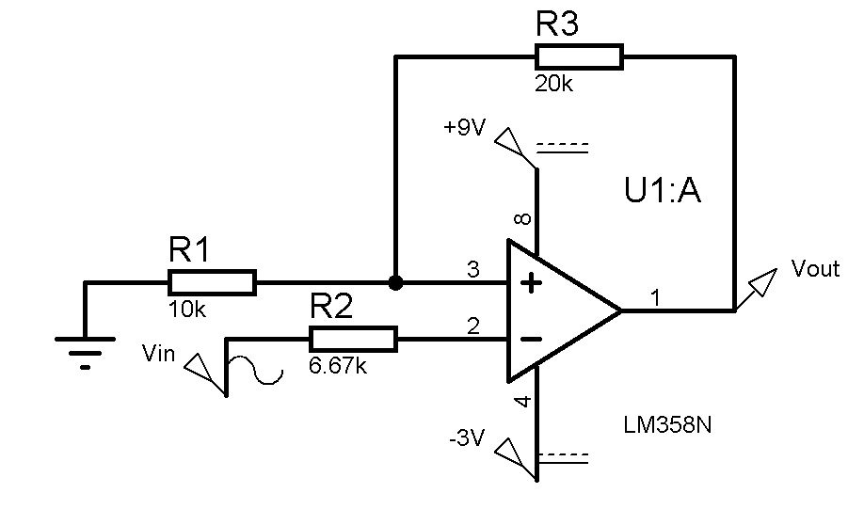

Solution:

For the inverting Schmitt trigger above, the threshold voltages are given as:

Upper threshold, = 3V

Lower threshold, = -1V

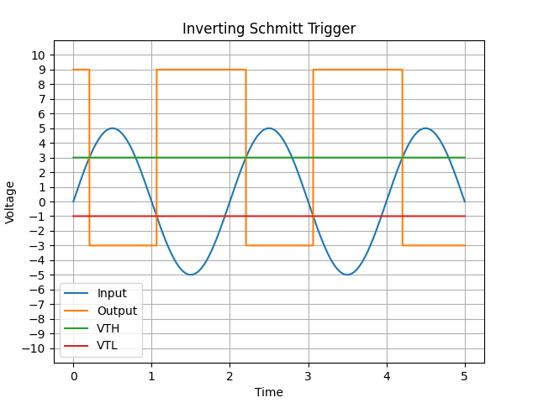

# **Question 9**

A light detector circuit has a sensor unit that generates a voltage proportional to the light intensity. You have been tasked with designing a circuit that will output high when the light level is low, and when the light intensity exceeds a certain threshold, the output will go low (turning off any artificial light). Two possible candidate circuits are 1. **Inverting Comparator** 2. **Inverting Schmitt Trigger** as given below. The signal from the light sensor is corrupted by interference from the AC power line as shown in the graph below.

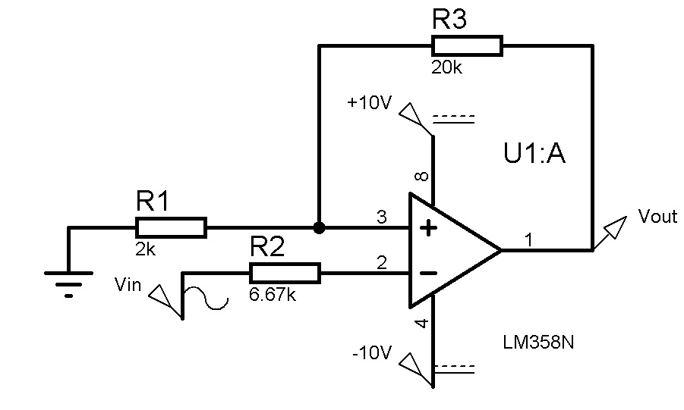

Solution:

**Part (a)**

For the OP-AMP comparator, we know that

Vout = VH if V+ > V-

Vout = VL if V+ < V-

Since, V+ is connected to ground, we have,

Vout = +10V if Vin < 0V

Vout = -10V if Vin < 0V

Thus for the first circuit, the output is given as (output switches whenever input crosses the x axis):

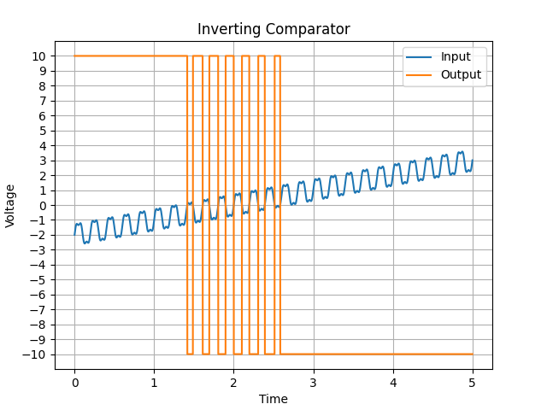

**Part (b)**

For the inverting Schmitt trigger above, the threshold voltages are given as:

Upper threshold, = 0.91V

Lower threshold, = -0.91V

Hysteresis width = = 1.82V

Maximum allowable noise voltage = Hysteresis width / 2 = 0.91V

When input voltage crosses the upper threshold for the first time, the output voltage goes low, and the lower threshold is activated. Unless the input voltage goes below the lower threshold level, the circuit will not switch again.

The

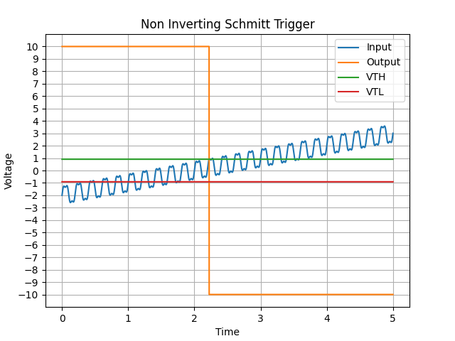

**Part (c)**

Whenever input crosses the threshold, the output of the first circuit will switch, resulting in oscillation on the output of the first circuit due to interference. However, the output of the second circuit only switches once due to the hysteresis of the Schmitt trigger. As such, the second circuit is more preferable.