**Laravel 7/6 Socialite Login with Google Gmail Account**

**Step 1: Install Laravel 6**

In this step, if you haven't laravel 6 application setup then we have to get fresh laravel 6 application. So run bellow command and get clean fresh laravel 6 application.

composer create-project --prefer-dist laravel/laravel googleLogin

**Step 2: Install Socialite**

In first step we will install Socialite Package that provide api to connect with google account. So, first open your terminal and run bellow command:

composer require laravel/socialite

After install above package we should add providers and aliases in config file, Now open **config/app.php** file and add service provider and aliase.

'providers' => [

....

Laravel\Socialite\SocialiteServiceProvider::class,

],

'aliases' => [

....

'Socialite' => Laravel\Socialite\Facades\Socialite::class,

],

**Read Also:** **[Laravel Login with Linkedin using Socialite Package](https://www.itsolutionstuff.com/post/laravel-5-login-with-linkedin-using-socialite-packageexample.html" \t "_blank)**

**Step 3: Create Google App**

In this step we need google client id and secret that way we can get information of other user. so if you don't have google app account then you can create from here : <https://console.developers.google.com/apis/dashboard?project=silken-forest-306207> you can find bellow screen :

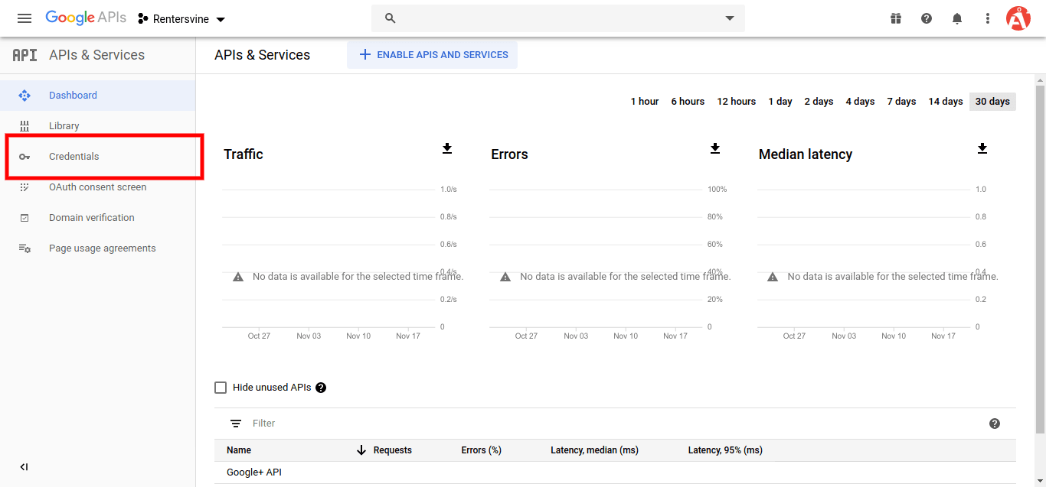

Now you have to click on **Credentials** and choose first option **oAuth** and click **Create new Client ID** button. now you can see following slide:

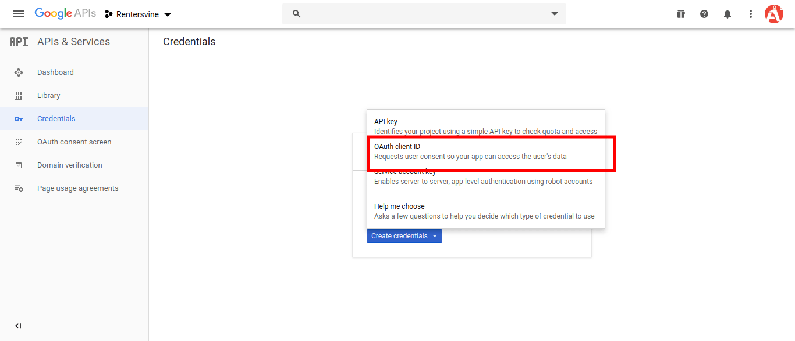

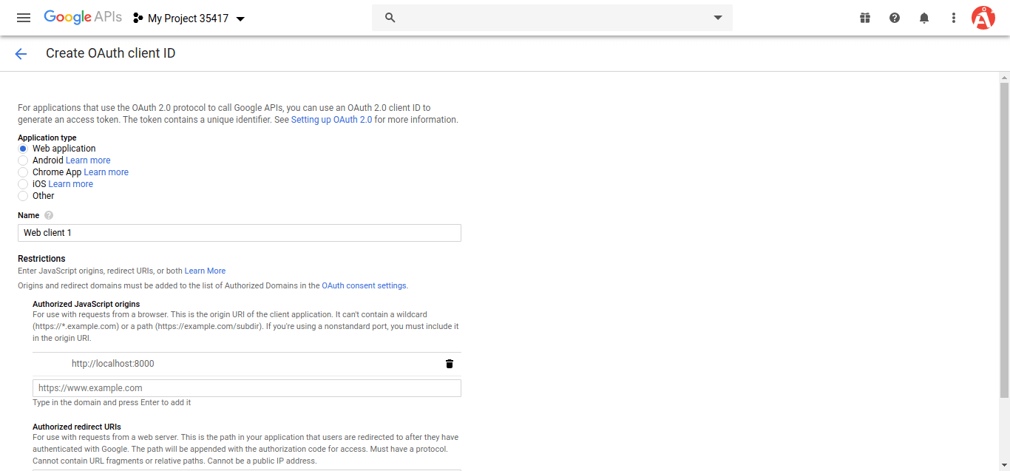

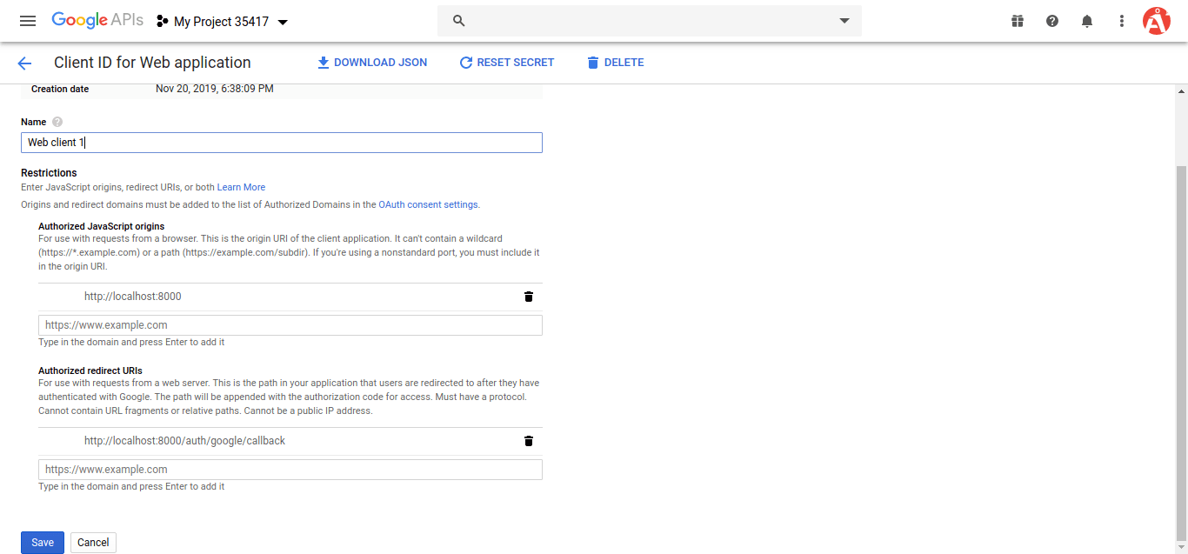

after create account you can copy client id and secret.

Now you have to set app id, secret and call back url in config file so open **config/services.php** and set id and secret this way:

**config/services.php**

**return** [

....

'google' => [

'client\_id' => 'app id',

'client\_secret' => 'add secret',

'redirect' => 'http://localhost:8000/auth/google/callback',

],

]

**Step 4: Create Auth**

In this step, we need to install laravel ui and generate auth in laravel 6 application so, let's run following command:

**Install Laravel UI:**

composer require laravel/ui

**Create Auth:**

php artisan ui bootstrap --auth

**NPM Install:**

npm install

**Run NPM:**

npm run dev

**Step 4: Add Database Column**

In this step first we have to create migration for add google\_id in your user table. So let's run bellow command:

php artisan make:migration add\_google\_id\_column

**Migration**

<?php

**use** Illuminate\Support\Facades\Schema;

**use** Illuminate\Database\Schema\Blueprint;

**use** Illuminate\Database\Migrations\Migration;

**class** AddGoogleIdColumn **extends** Migration

{

/\*\*

\* Run the migrations.

\*

\* @return void

\*/

**public** **function** up()

{

Schema::table('users', **function** ($table) {

$table->**string**('google\_id')->nullable();

});

}

/\*\*

\* Reverse the migrations.

\*

\* @return void

\*/

**public** **function** down()

{

//

}

}

Update mode like this way:

**app/User.php**

<?php

**namespace** App;

**use** Illuminate\Contracts\Auth\MustVerifyEmail;

**use** Illuminate\Foundation\Auth\User **as** Authenticatable;

**use** Illuminate\Notifications\Notifiable;

**class** User **extends** Authenticatable

{

**use** Notifiable;

/\*\*

\* The attributes that are mass assignable.

\*

\* @var array

\*/

**protected** $fillable = [

'name', 'email', 'password', 'google\_id'

];

/\*\*

\* The attributes that should be hidden for arrays.

\*

\* @var array

\*/

**protected** $hidden = [

'password', 'remember\_token',

];

/\*\*

\* The attributes that should be cast to native types.

\*

\* @var array

\*/

**protected** $casts = [

'email\_verified\_at' => 'datetime',

];

}

**Step 5: Create Routes**

After adding google\_id column first we have to add new route for google login. so let's add bellow route in routes.php file.

**app/Http/routes.php**

Route::**get**('/', **function** () {

**return** view('welcome');

});

Auth::routes();

Route::**get**('/home', 'HomeController@index')->name('home');

Route::**get**('auth/google', 'Auth\GoogleController@redirectToGoogle');

Route::**get**('auth/google/callback', 'Auth\GoogleController@handleGoogleCallback');

**Step 6: Create Controller**

After add route, we need to add method of google auth that method will handle google callback url and etc, first put bellow code on your GoogleController.php file.

**app/Http/Controllers/Auth/GoogleController.php**

<?php

**namespace** App\Http\Controllers\Auth;

**use** App\Http\Controllers\Controller;

**use** Socialite;

**use** Auth;

**use** Exception;

**use** App\User;

**class** GoogleController **extends** Controller

{

/\*\*

\* Create a new controller instance.

\*

\* @return void

\*/

**public** **function** redirectToGoogle()

{

**return** Socialite::driver('google')->redirect();

}

/\*\*

\* Create a new controller instance.

\*

\* @return void

\*/

**public** **function** handleGoogleCallback()

{

**try** {

$user = Socialite::driver('google')->user();

$finduser = User::**where**('google\_id', $user->id)->first();

**if**($finduser){

Auth::login($finduser);

**return** redirect('/home');

}**else**{

$newUser = User::create([

'name' => $user->name,

'email' => $user->email,

'google\_id'=> $user->id,

'password' => encrypt('123456dummy')

]);

Auth::login($newUser);

**return** redirect('/home');

}

} **catch** (Exception $e) {

dd($e->getMessage());

}

}

}

**Step 7: Update Blade File**

Ok, now at last we need to add blade view so first create new file login.blade.php file and put bellow code:

**resources/views/auth/login.blade.php**

**Read Also:** [**Send Email with Laravel 7/6 using Markdown Mailable Class**](https://www.itsolutionstuff.com/post/send-email-with-laravel-6-using-markdown-mailable-classexample.html)

@extends('layouts.app')

@section('content')

**<div** **class**="container"**>**

**<div** **class**="row justify-content-center"**>**

**<div** **class**="col-md-8"**>**

**<div** **class**="card"**>**

**<div** **class**="card-header"**>**Laravel 6 - Login with Google Account Example - ItSolutionStuuf.com**</div>**

**<div** **class**="card-body"**>**

**<form** **method**="POST" **action**="{{ route('login') }}"**>**

@csrf

**<div** **class**="form-group row"**>**

**<label** **for**="email" **class**="col-md-4 col-form-label text-md-right"**>**{{ \_\_('E-Mail Address') }}**</label>**

**<div** **class**="col-md-6"**>**

**<input** **id**="email" **type**="email" **class**="form-control @error('email') is-invalid @enderror" **name**="email" **value**="{{ old('email') }}" **required** **autocomplete**="email" **autofocus>**

@error('email')

**<span** **class**="invalid-feedback" **role**="alert"**>**

**<strong>**{{ $message }}**</strong>**

**</span>**

@enderror

**</div>**

**</div>**

**<div** **class**="form-group row"**>**

**<label** **for**="password" **class**="col-md-4 col-form-label text-md-right"**>**{{ \_\_('Password') }}**</label>**

**<div** **class**="col-md-6"**>**

**<input** **id**="password" **type**="password" **class**="form-control @error('password') is-invalid @enderror" **name**="password" **required** **autocomplete**="current-password"**>**

@error('password')

**<span** **class**="invalid-feedback" **role**="alert"**>**

**<strong>**{{ $message }}**</strong>**

**</span>**

@enderror

**</div>**

**</div>**

**<div** **class**="form-group row"**>**

**<div** **class**="col-md-6 offset-md-4"**>**

**<div** **class**="form-check"**>**

**<input** **class**="form-check-input" **type**="checkbox" **name**="remember" **id**="remember" {{ **old**('remember') ? 'checked' : '' }}**>**

**<label** **class**="form-check-label" **for**="remember"**>**

{{ \_\_('Remember Me') }}

**</label>**

**</div>**

**</div>**

**</div>**

**<div** **class**="form-group row mb-0"**>**

**<div** **class**="col-md-8 offset-md-4"**>**

**<button** **type**="submit" **class**="btn btn-primary"**>**

{{ \_\_('Login') }}

**</button>**

@if (Route::has('password.request'))

**<a** **class**="btn btn-link" **href**="{{ route('password.request') }}"**>**

{{ \_\_('Forgot Your Password?') }}

**</a>**

@endif

**<a** **href**="{{ url('auth/google') }}" **style**="margin-top: 20px;" **class**="btn btn-lg btn-success btn-block"**>**

**<strong>**Login With Google**</strong>**

**</a>**

**</div>**

**</div>**

**</form>**

**</div>**

**</div>**

**</div>**

**</div>**

**</div>**

@endsection

Ok, now you are ready to use open your browser and check here : URL + '/login'.