KickStart My Chart

* Using the Excel table provided, you will be modifying and analyzing the data of four thousand past Kickstarter projects as you attempt to uncover some of the market trends.
* Use conditional formatting to fill each cell in the state column with a different color, depending on whether the associated campaign was "successful," "failed," "cancelled," or is currently "live".
* Create a new column at column O called percent funded that uses a formula to uncover how much money a campaign made towards reaching its initial goal.
* Use conditional formatting to fill each cell in the percent funded column using a three-color scale. The scale should start at 0 and be a dark shade of red, transitioning to green at 100, and then moving towards blue at 200.
* Create a new column at column P called average donation that uses a formula to uncover how much each backer for the project paid on average.
* Create two new columns, one called category at Q and another called sub-category at R, which use formulas to split the Category and Sub-Category column into two parts.

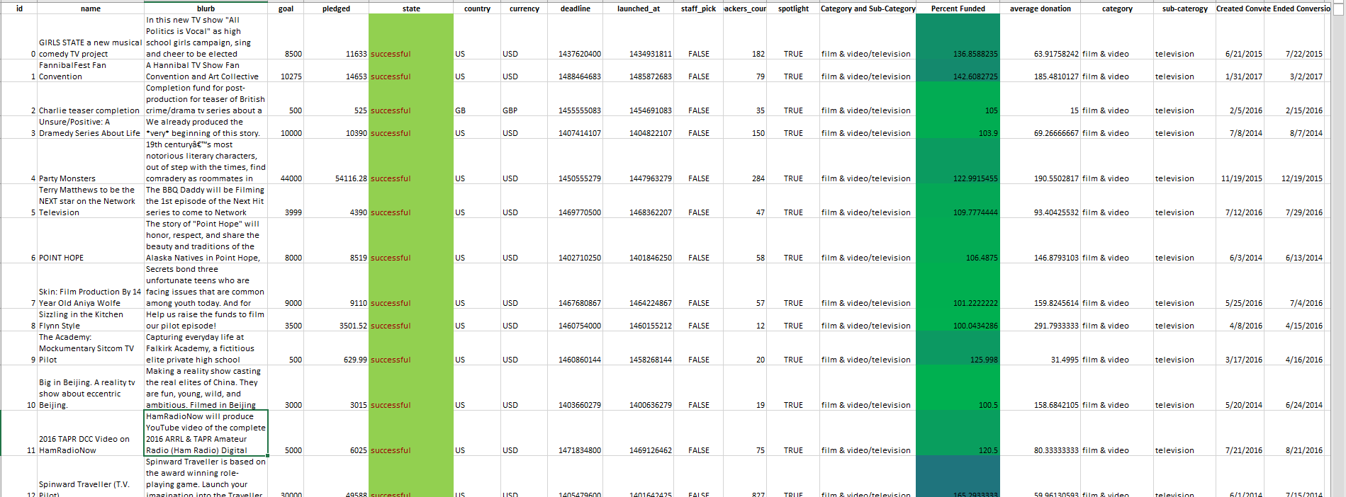

* Create a new sheet with a pivot table that will analyze your initial worksheet to count how many campaigns were "successful," "failed," "cancelled," or are currently "live" per category.
* Create a stacked column pivot chart that can be filtered by country based on the table you have created.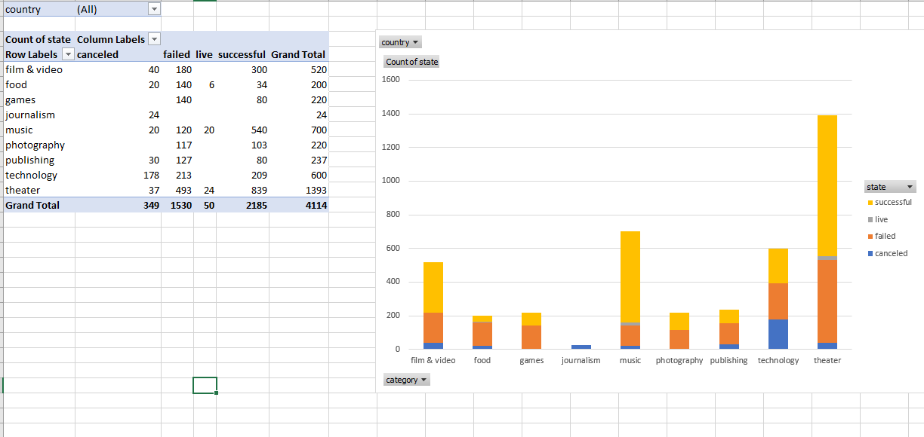
* Create a new sheet with a pivot table that will analyze your initial sheet to count how many campaigns were "successful," "failed," "cancelled," or are currently "live" per sub-category.
* Create a stacked column pivot chart that can be filtered by country and parent-category based on the table you have created.
* The dates stored within the deadline and launched_at columns are using unix timestamps. Fortunately for us, there is a formula out there that can be used to convert these timestamps into a normal date.

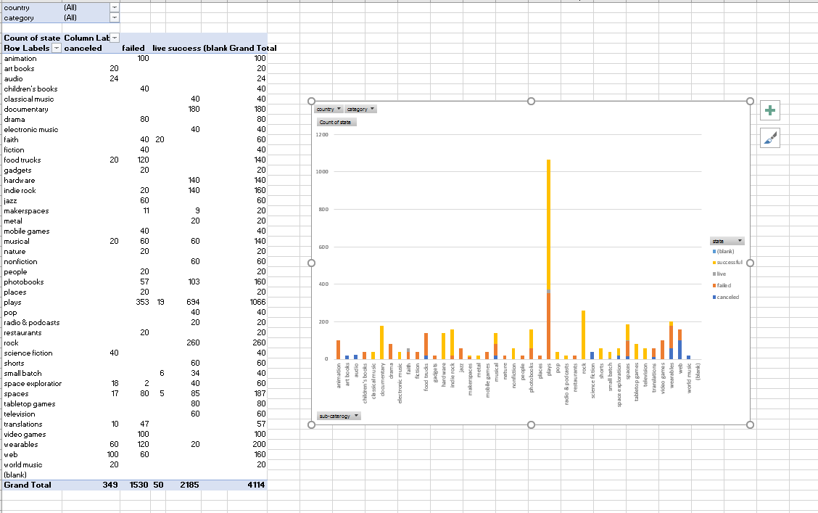

* Create a new column named Date Created Conversion that will use this formula to convert the data contained within launched_at into Excel's Date format
* Create a new column named Date Ended Conversion that will use this formula to convert the data contained within deadline into Excel's Date format
* Create a new sheet with a pivot table with a column of state, rows of Date Created Conversion, values based on the count of state, and filters based on parent category and Years.
* Now create a pivot chart line graph that visualizes this new table.
* Create a report in Microsoft Word and answer the following questions...

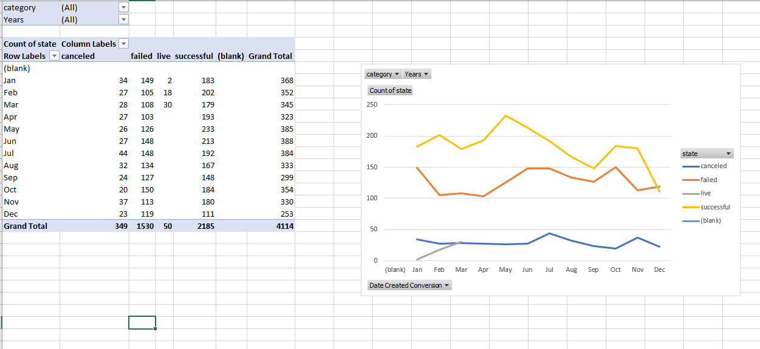

**What are three conclusions we can make about Kickstarter campaigns given the provided data?**

* Success rate is slightly above 50%
* Success rate is high on projects with high margin
* Majority of the interest is in Theater and Music Categories
* Success rate in music category is very high
* Sub-category ‘plays’ is an outlier
* Highly active 2nd quarter and slowed down 4th quarter

**What are some of the limitations of this dataset?**

* One of the limitation is, there is no data that supports the reasons for success, failure or cancel.
* Can not be used to predict what will be successful project or not.

**What are some other possible tables/graphs that we could create?**

* Could create graphs/ trends based on % complete vs Category or Sub-category

**Bonus:**

Create a new sheet with 8 columns: Goal, Number Successful, Number Failed, Number Canceled, Total Projects, Percentage Successful, Percentage Failed, and Percentage Canceled. In the goal column, create twelve rows with the following headers...

Less Than 1000

1000 to 4999

5000 to 9999

10000 to 14999

15000 to 19999

20000 to 24999

25000 to 29999

30000 to 34999

35000 to 39999

40000 to 44999

45000 to 49999

Greater than or equal to 50000

* Using the COUNTIFS() formula, count how many successful, failed, and canceled projects were created with goals within those ranges listed above. Populate the Number Successful, Number Failed, and Number Canceled columns with this data.
* Add up each of the values in the Number Successful, Number Failed, and Number Canceled columns to populate the Total Projects column. Then, using a mathematic formulae, find the percentage of projects which were successful, failed, or were canceled per goal range.
* Create a line chart which graphs the relationship between a goal's amount and its chances at success, failure, or cancellation.

