Practical No. 05

Task 1: Comparative Research

Comparative Research: DALL·E vs Midjourney
Prompt Example: “A steampunk city under moonlight with flying airships and glowing lanterns.”

1. Image Quality
- DALL·E: Produces clean, coherent, and realistic images. Buildings, airships, and lanterns would appear well-structured with proper lighting.
- Midjourney: Generates highly detailed, dramatic, and visually striking art. The same prompt would result in a more cinematic, painterly scene with glowing atmospheric effects.
✅ Verdict: DALL·E = precise & realistic | Midjourney = artistic & dramatic

2. Prompt Accuracy
- DALL·E: Interprets the full prompt literally (moonlight, airships, lanterns all present and positioned logically).
- Midjourney: Captures the mood and feel but may improvise—e.g., emphasizing lantern glow and dramatic skies more than strict prompt details.
✅ Verdict: DALL·E = more literal | Midjourney = more creative

3. Style Flexibility
- DALL·E: Handles many styles (photorealism, painting, cartoon, emoji) and supports editing features like inpainting/outpainting.
- Midjourney: Strong at stylization—users can push aesthetics (fantasy, anime, surreal, etc.) and even reference styles/characters.
✅ Verdict: DALL·E = broader editing | Midjourney = richer artistic styles

4. Usability
- DALL·E: Accessible via ChatGPT, Bing Image Creator, and API—easy for beginners.
- Midjourney: Runs mainly through Discord commands (/imagine), plus a newer web app. Powerful, but less intuitive for first-time users.
✅ Verdict: DALL·E = easier | Midjourney = more advanced but steeper learning

5. Licensing & Terms
- DALL·E: Users own their images and can use them commercially without restrictions.
- Midjourney: Paid users can commercialize their outputs, but all content is also licensed back to Midjourney. Free users = non-commercial use only with attribution.
✅ Verdict: DALL·E = clearer, safer rights | Midjourney = commercial use allowed (paid), but more legal grey areas

Overall Summary
- DALL·E: Best for accurate, clean, and commercially safe images.
- Midjourney: Best for visually stunning, artistic, and stylized results.

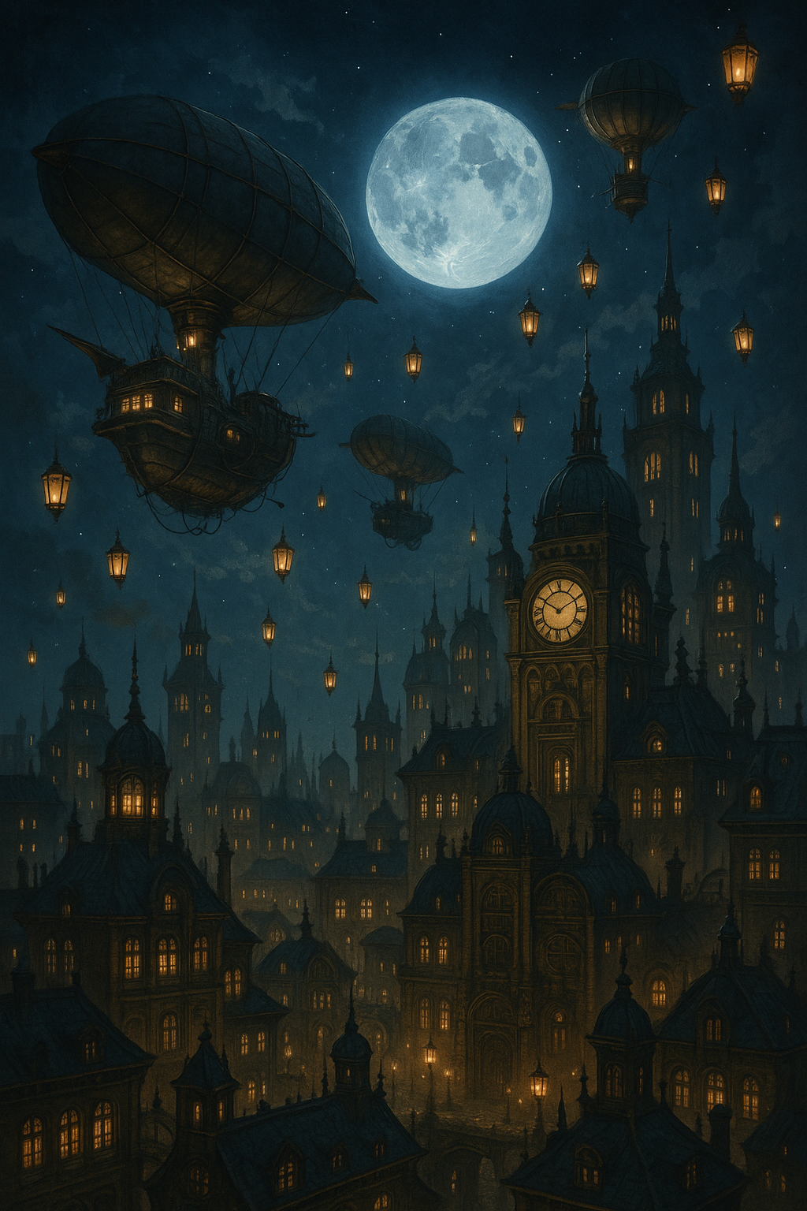

Task 2: Visual Design Project

Generate concept art for an educational topic

For concept art on DNA structure, here’s how we can design it:

Concept Art Plan – DNA Structure
- Main Focus: The double helix shape (spiral ladder).
- Elements to Include:
  - Sugar-phosphate backbone (two spirals forming the “sides” of the ladder).
  - Base pairs (A-T, C-G) shown as “rungs” connecting the two sides.
  - Color coding for each base pair:
    - Adenine (A) = Green
    - Thymine (T) = Red
    - Cytosine (C) = Blue
    - Guanine (G) = Yellow
  - Labels for backbone, base pairs, and double helix.
  - A clean, modern style (so it looks both scientific and visually engaging).

Image Prompts (for AI generation)
Here are 3 variations of concept art we can make:
- Simplified Educational Diagram
"Illustration of DNA double helix, colorful labeled base pairs (A-T, C-G), sugar-phosphate backbone, clear educational style, flat vector design"
- 3D Realistic Concept Art
"3D scientific illustration of DNA double helix, glowing colorful base pairs, futuristic concept art style, detailed, educational"
- Creative Infographic Style
"Infographic of DNA structure, double helix with labeled parts, color-coded base pairs, modern flat design, suitable for students"

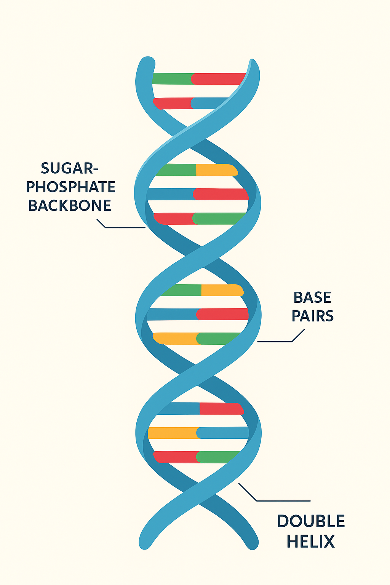

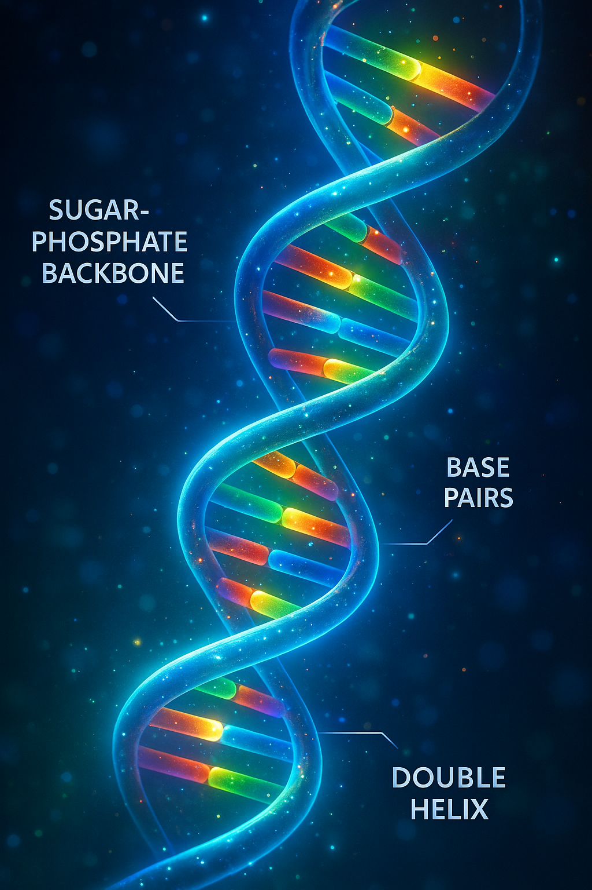

Name:- Mohammad Rehan Tabish shekh Ruknoddin
Class:- SE
Branch:- AI&DS
Division:- A
Roll No:- A-38

