Notes :

When it is necessary to relax the density-independence assumptions on the stage-progression function PX(t) and survivorship ΠX(t) for the immature (X = I) and mature (X = M) stages, it may become challenging to propose appropriate probability functions. In this sense, the integral framework may not be a convenient way to describe the structured population size when more complicated densitydependent self-regulation is considered, as will be demonstrated by the model (2.14) presented later and those reviewed in the coming Section 3. Furthermore, an integral system can also be derived from a state-structured partial differential equation when the related survival and stage-progression functions can be formulated from the corresponding evolution system [37].

Hurtado 2019
Particles in state X at a given time can therefore be classified by which event they are awaiting next, i.e., a particle is in state Xi if it is waiting for the ith event to occur, and X1, . . ., Xk is a partition of X.

The rate function r (t) can be viewed as either the intensity function5 for the Poisson process governing when individuals leave state X, or as the (mean field) per-capita rate of loss from state X as shown in Eq. (11).

Lou & Sum 2022:
When it is necessary to relax the density-independence assumptions on the stage-progression function PX(t) and survivorship ΠX(t) for the immature (X = I) and mature (X = M) stages, it may become challenging to propose appropriate probability functions. In this sense, the integral framework may not be a convenient way to describe the structured population size when more complicated densitydependent self-regulation is considered, as will be demonstrated by the model (2.14) presented later and those reviewed in the coming Section 3. Furthermore, an integral system can also be derived from a state-structured partial differential equation when the related survival and stage-progression functions can be formulated from the corresponding evolution system [37].

When the duration of staying in the immature stage is regulated by the population density, it would be more convenient to use another variable x called “state” [30], which generalizes the concept of the age, to describe the population density evolution. Based on the fact that maturation can be measured to some extent by state, the maturity of an individual occurs when its state x achieves a fixed threshold l.

McDonal 1978:

p = n-1
a = theta = rate

LCT:
-pas clair du tout la chaine : x->z->v1->vp->

Lag as an alternative to stage structure
délai → existence réelle ou construction du modèle
-exemple délai = représentation implicite des stades juvéniles
-(ou alors une certaine idée d’un état/stage caché par lequel passe la transition)

donc dans le cas constru, si derrière y’a des str d’âge, on peut directement explicitement la mettre en équation
« Consider for example the insect member of the mutualistic system of lb. It may not be necessary to model a generation span as a delay if, instead of using 7 adult populations only, one sets up a more detailed model in which the population dynamics of eggs, larvae, pre-adult instars and adults are all explicitly specified. »

mais parfois un délai c pratique car ça cache des transi qu’on connaît pas
eg maturation cellule : soit on modélise tous les xi→xi+1 soit on modélise x_n avec un feedback délayé sur son recrutement.

...et dans tout cas le LCT ça revient à représenter des stades intermédiaires avec la transi la plus simple possible.

→ G l’impression qu’on va explorer les deux cas:
-délai de maturation « implicite » : Gurney, Beretta, Eurich
-Stages « vrais » : Murdoch, Godfray, Nelson, Wearing.

The form GP is convenient because of the specially simple a form of the new equations, and because it goes over into discrete lag by increasing p and a indefinitely while keeping the mean lag (p+l)/a fixed.

It should however be noted that this sharpening of the distribution requires quite high p, and that for p below 10 the width of the distribution is of order p/a.

Time lags types
In most of the applications of this trick which I shall examine, it is sufficient to replace one of the variables in part of one of the equations, as here. However, one may wish to include an integral over past time of some function of one or more of the variables. As an example, consider the equation
dx/dt = xy
soit on remplace x par x(t-tau) (DIAGONAL LAG), soit y (OFF DIAGONAL LAG), soit les deux (TOTAL LAG)
→ LCT pr les deux premiers,

Analyse stab
Tedious analys de stab LCT car R-H chiant quand n ++

Analyse de stab : on peut retrouver une forme LCT du polynome caractéristique avec :

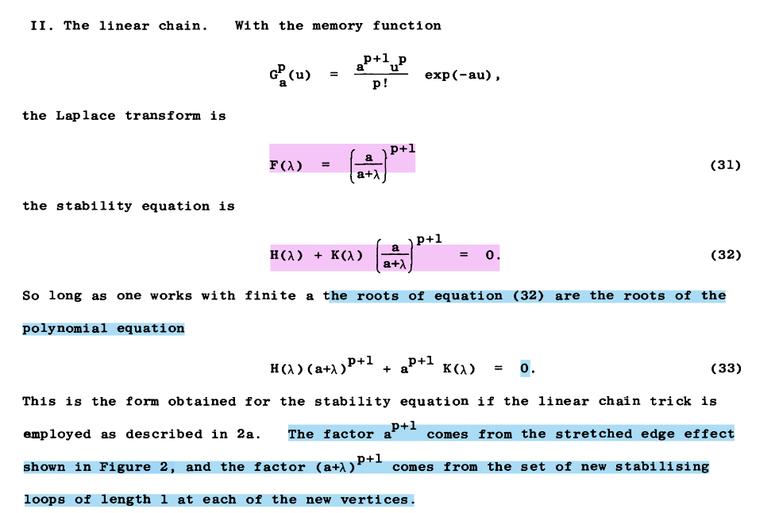
vs un exp(-alpha r) dans le terme constant en cas de lag fixe.

Discrete lags
dx/dt = rx(1-x(t-T)/K) ou rx(t-T)(1-x/K) ?
dx/dt = x.f(x) , in which the function f(x) is the net reproductive rate per individual, that is to. say the difference of birth and death rates. This is a natural formulation for mammal and bird populations, in which the adults are still around at the time of birth or hatching. […] For an insect population, in which all adults may have died before the new generation emerges, a delay in the birth terms, both linear and non-linear, would seem more appropriate.

Stab under distributed lag:
This corresponds to a critical value of the average lag, T = 2/a, of 4/r. This is substantially larger than the critical value of T in the discrete lag caae. Clearly this would be a poor approximation to the discrete lag result, as compared with the use of the Pade approximant yielding an equation, (10), of the same order in A. However that is not what is intended. Distributed lag is liable to be more realistic than discrete lag,

Beretta-like calcul avec solution w0 de l’équation caractéristique (imaginaire pure)
→ For large p and a, fixing T as constant, one recovers the discrete lag result, as expected. The general nature of these results is displayed in Figure 7. The critical T is always greater than the critical T of the discrete case, and the ratio T_osc/T_av (T_av : distributed average delay) is always smaller than the ratio T_osc/T (fixed delay) of the discrete case. As P increases, the discrete case results are approached.

[Just before] In 4c the distributed lag with memory function GP(U) did not need to be a treated by the linear chain trick.

Metz
Metz
t is important to notice that the system Equation(85)–(88) is a nonlinear structured population model with a finite individual state space containing p+2 elements. Indeed, Equation(85)–(87) can be interpreted as a structured model with p+1 progressive stages and in addition a state −1. Individuals in state −1 do not give birth or change state. Individuals in stage k=0, 1, …, p give birth to individuals in stage 0 and state −1 at the per capita rate β k (I) and are recruited to the next stage k+1 at a constant per capita rate α. The recruitment from the last stage p to the ‘next’ stage is interpreted as death. In addition, there is a stage-independent background mortality μ(I). The variable E k represent the number of individuals in state and the vector the population state. Observe, that for given input I the system Equation(85)–(87) is linear and time-dependent. The feedback law Equation(88) is a linear functional of the population state.

