SERVERLESS FOOD DELIVERY PLATFORM
WITH EVENT-DRIVEN ARCHITECTURE
Using AWS Lambda, API Gateway, Amazon EventBridge, Step Functions and DynamoDB
Name: S.Mohamed Riswan
Batch: July (11.30 to 1.00)
Course: AWS & DevOps

CONTENTS
1. Introduction
2. Problem Statement
3. Objectives
4. System Requirements
5. Technologies Used
6. System Architecture
7. Customer Web and Mobile Frontend
8. Order Service Implementation
9. Event-Driven Order Processing
10. Restaurant and Menu Management Service
11. API Gateway and Authentication
12. Amazon DynamoDB and Database Design
13. Notification and Delivery Tracking
14. Deployment, Testing and Results
15. Conclusion and Future Enhancements

Project Summary
This project designs and implements a serverless food delivery platform where customer ordering, restaurant order acceptance, payment confirmation, and delivery-partner assignment are decoupled and coordinated through asynchronous events rather than direct service-to-service calls.
A React-based web/mobile frontend communicates with a set of AWS Lambda functions through Amazon API Gateway. Each significant state change in an order's lifecycle (placed, accepted, preparing, out for delivery, delivered, cancelled) is published as an event on Amazon EventBridge, which fans the event out to interested consumers such as the notification service, the delivery-assignment service and an analytics stream.
AWS Step Functions orchestrates the multi-stage order-fulfilment workflow, and Amazon DynamoDB provides low-latency persistence for orders, restaurants, menus and delivery-partner locations. The result is a system that scales automatically with demand and has no servers to provision or patch.

1. INTRODUCTION

1.1 Project Overview
Food delivery applications must handle bursty, unpredictable traffic - a sudden spike during lunch or dinner hours, a promotional campaign, or a popular restaurant going viral. A traditional, always-on server fleet either over-provisions for peak load or risks being overwhelmed. This project addresses that problem by building the platform entirely on managed, serverless AWS services that scale on demand and charge only for actual usage.
The platform models the real-world order lifecycle - order placed, payment confirmed, restaurant accepted, food prepared, delivery partner assigned, order picked up, order delivered - as a sequence of discrete events. Producing and consuming these events asynchronously, rather than chaining synchronous REST calls between services, keeps each service independent, resilient to partial failure, and independently scalable.

1.2 Main Features
- Customer registration, login and profile management using Amazon Cognito.
- Restaurant and menu browsing with search and category filters.
- Cart management and order placement through a REST API.
- Event-driven order lifecycle: placed → accepted → preparing → out for delivery → delivered.
- Order-fulfilment orchestration using AWS Step Functions.
- Real-time email notifications through Amazon SES.
- Delivery-partner assignment and live status updates.
- Serverless compute throughout using AWS Lambda - no managed EC2 fleet.
- Pay-per-request DynamoDB tables for orders, restaurants, menus and users.

1.3 Project Scope
The project focuses on the ordering and fulfilment pipeline of a food delivery platform: account management, catalogue browsing, order placement, event-driven fulfilment, notifications and delivery-status tracking. It demonstrates how independent, loosely coupled serverless components communicate through events rather than direct calls, and provides a foundation for later additions such as live GPS tracking, dynamic pricing and a recommendation engine.

2. PROBLEM STATEMENT

2.1 Existing Situation
A monolithic food delivery backend running on fixed servers typically couples the ordering API, restaurant-acceptance logic, notification dispatch and delivery assignment into a single application. A slowdown in one area, such as notification delivery, can back up order placement itself, and the whole fleet must be sized for the busiest hour of the week even though it sits idle the rest of the time.

2.2 Problems Identified
- Tight coupling between order placement, restaurant acceptance and notification logic.
- Fixed server capacity is wasteful during off-peak hours and insufficient during meal-time surges.
- A failure or slowdown in one downstream step can block the entire order pipeline.
- No clear audit trail of state transitions an order has gone through.
- Manual scaling and patching effort for always-on virtual machines.

2.3 Proposed Solution
Replace the monolithic backend with independent AWS Lambda functions triggered by API Gateway, with order-state transitions emitted as events on an Amazon EventBridge event bus; each downstream concern (notifications, delivery assignment, analytics) subscribes to only the events it cares about. AWS Step Functions coordinates the multi-step fulfilment workflow with built-in retry and error handling, and DynamoDB provides on-demand, auto-scaling storage.

2.4 Expected Result
The finished system should let a customer browse a restaurant, place an order, and see it move automatically through acceptance, preparation and delivery, with every state change reflected through notifications, without any component needing to know the internal implementation of another.

3. OBJECTIVES

3.1 Primary Objective
To design and implement a serverless, event-driven food delivery platform in which order placement, fulfilment, notification and delivery tracking are decoupled through asynchronous messaging on AWS.

3.2 Specific Objectives
- Build a REST API using Amazon API Gateway and AWS Lambda for orders, restaurants and users.
- Model the order lifecycle as a finite set of states driven by events.
- Use Amazon EventBridge to publish order-state-change events to multiple independent consumers.
- Orchestrate the multi-step fulfilment workflow using AWS Step Functions.
- Send customer and restaurant notifications through Amazon SES.
- Design DynamoDB tables for orders, restaurants, menu items and delivery partners with appropriate keys and indexes.
- Secure the API using Amazon Cognito user pools and IAM-authorized Lambda execution roles.
- Deploy the full stack using Infrastructure-as-Code and verify the end-to-end event flow.

3.3 Learning Outcomes
The project provides practical experience in serverless application design, event-driven architecture patterns (publish-subscribe, workflow orchestration), REST API design, NoSQL data modelling, and the operational trade-offs between synchronous and asynchronous service communication.

4. SYSTEM REQUIREMENTS

4.1 Hardware Requirements
- Development laptop or desktop for coding and deployment.
- Mobile phone or tablet for testing the customer-facing frontend.
- Stable internet connection for calling AWS APIs.

4.2 Software Requirements
- Node.js and the AWS SDK / AWS CDK (or Serverless Framework) for defining infrastructure.
- AWS Lambda (Node.js or Python runtime) for all business logic.
- Amazon API Gateway (REST or HTTP API) as the front door for synchronous calls.
- Amazon EventBridge for asynchronous, event-driven messaging.
- AWS Step Functions for order-fulfilment orchestration.
- Amazon DynamoDB for persistent storage.
- Amazon Cognito for authentication and authorization.
- A modern web browser and a code editor / IDE.

4.3 Network and Messaging Configuration
API Gateway exposes public HTTPS endpoints that trigger Lambda functions for both request/response operations, such as browsing menus, and state-changing operations, such as order placement, invoking the corresponding Lambda function directly.
API_URL = "https://{api-id}.execute-api.{region}.amazonaws.com/prod"
fetch(API_URL + "/orders", { method: "POST", body: JSON.stringify(order) })

4.4 Data Requirements
Each order record contains an order ID, customer ID, restaurant ID, item list, total amount, current status and a timestamped history of status transitions. Restaurant and menu records contain restaurant ID, name, category, and a list of menu items with price and availability.

4.5 Operational Requirement
All services must agree on a consistent event schema (order ID, event type, timestamp, payload) so that any consumer added later can subscribe to the EventBridge bus without changes to the producer.

5. TECHNOLOGIES USED

5.1 Frontend and Backend Used – Summary
The table below summarises exactly what runs on the frontend and what runs on the backend of the implemented platform.
Layer | Technology Used | Role
Frontend | HTML5, CSS3, Vanilla JavaScript (fetch API) | FoodExpress UI: menu display, cart, checkout form and order-confirmation screen
Frontend Hosting | Amazon S3 (static website hosting) | Serves index.html, style.css and script.js directly to the browser – no web server
Backend Compute | AWS Lambda (Python) – FoodExpressOrders, getFoodItems | Registers orders in DynamoDB and returns the food/menu list
API Layer | Amazon API Gateway (REST API – /register, /fooditems) | Public HTTPS endpoints that invoke the Lambda functions
Database | Amazon DynamoDB – Orders, FoodItems tables | Stores placed orders and the food/menu catalogue
Monitoring | Amazon CloudWatch | Logs and execution metrics for every Lambda invocation
Amazon Cognito (authentication), Amazon EventBridge and AWS Step Functions (order-lifecycle orchestration) are proposed additions described later in this document as future enhancements to the current implementation.

5.2 Frontend Technologies
The frontend is a plain HTML/CSS/JavaScript single page (no framework) that provides restaurant/menu browsing, cart management and a checkout screen. It communicates with the backend exclusively through the API Gateway REST endpoints using the browser's fetch() API, and is hosted as a static website directly on Amazon S3.

5.3 Backend Technologies
AWS Lambda functions, written in Python, implement each unit of business logic: registering an order in DynamoDB and returning the food catalogue. Each function is small, stateless and independently deployable, and is invoked directly by API Gateway.

5.4 AWS Orchestration Services (Proposed)
- Amazon API Gateway - public REST/HTTP endpoints that invoke Lambda functions.
- Amazon EventBridge - central event bus for order-state-change events.
- AWS Step Functions - coordinates the multi-stage order-fulfilment workflow with retries.
- Amazon DynamoDB - on-demand NoSQL storage for orders, restaurants, menus and users.
- Amazon Cognito - user pools for authentication and JSON Web Token issuance.
- Amazon CloudWatch - logging, metrics and alarms for every Lambda function.

5.5 Technology Flow
Customer App (S3-hosted)
| HTTPS (API Gateway)
v
Register-Order Lambda --> DynamoDB (Orders)
|
v
EventBridge (order events) [proposed]
/ | \
Notification Step Functions Analytics
(SES) (fulfilment) stream
The selected services are all managed and serverless, so the platform scales automatically with order volume and incurs no idle infrastructure cost.

6. SYSTEM ARCHITECTURE

6.1 Event-Driven, Multi-Tier View
The frontend forms the client tier. Amazon API Gateway and AWS Lambda form the application tier. Amazon EventBridge and AWS Step Functions form a proposed asynchronous messaging tier that would coordinate order fulfilment without any tier calling another tier's internals directly. Amazon DynamoDB forms the persistence tier, accessed only by Lambda functions.

6.2 End-to-End Event Flow
- The customer places an order through the React frontend.
- API Gateway invokes the Register-Order Lambda directly, which validates the request, generates the order ID and writes the order to DynamoDB with status "Placed".
- Proposed: after the DynamoDB write, the same Lambda would publish an OrderPlaced event to EventBridge.
- Proposed: EventBridge routes OrderPlaced to a Notification Lambda (customer + restaurant alerted by email) and starts a Step Functions execution for fulfilment.
- Step Functions moves the order through ACCEPTED, PREPARING and OUT_FOR_DELIVERY states, each transition updating DynamoDB and emitting a corresponding event.
- A Delivery-Assignment Lambda, triggered by the OUT_FOR_DELIVERY event, selects an available delivery partner and updates the order record.
- The customer app polls (or subscribes via a WebSocket API) the order-status endpoint to display live progress.

6.3 Decoupling and Resilience
Because producers would publish events without knowing their consumers, a new consumer - for example a future loyalty-points service - could subscribe to the same EventBridge bus without any change to the order-placement code, and Step Functions would retry failed states automatically, giving the system resilience against transient failures.

7. CUSTOMER WEB AND MOBILE FRONTEND

7.1 User Interface
The frontend presents a restaurant list with search and category filters, a menu page per restaurant, a cart, a checkout screen and an order-tracking screen that shows the current status returned by the backend.
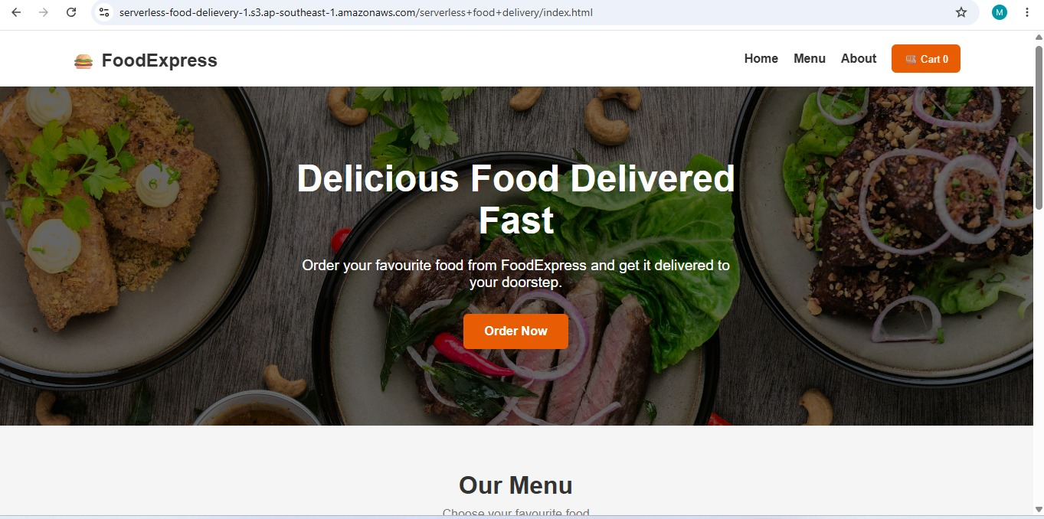
Fig 7.1 – FoodExpress landing page hosted on Amazon S3 static website hosting
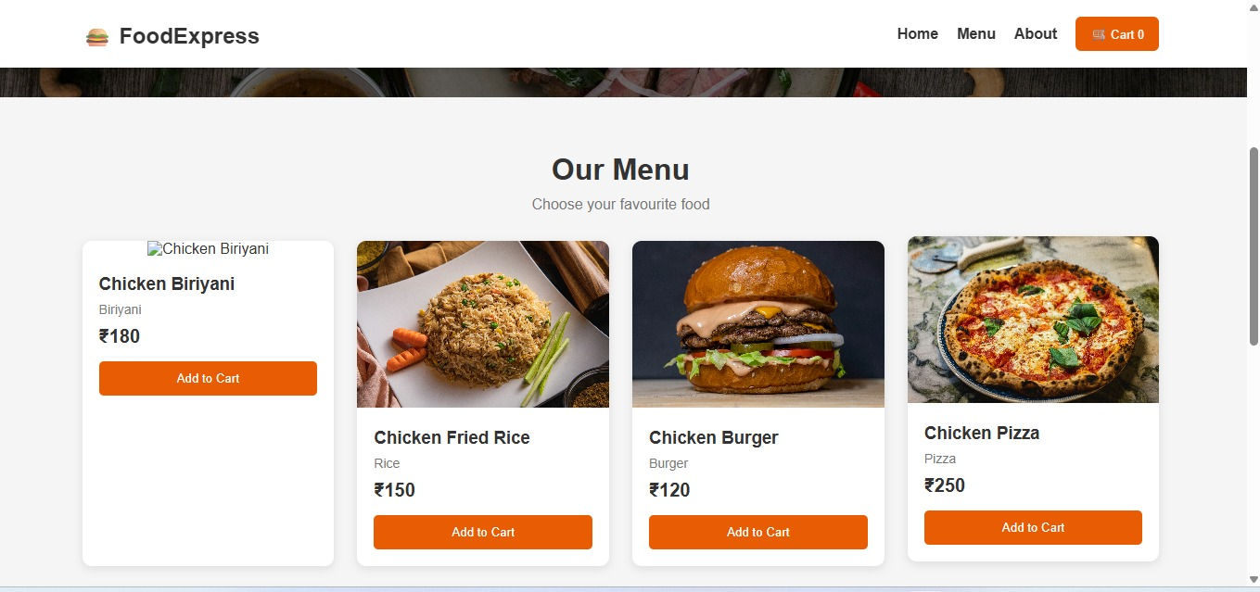
Fig 7.2 – Menu page displaying food items with price and Add to Cart option

7.2 Responsive Layout
The interface is built mobile-first with a responsive grid so that the same codebase serves both the mobile app and the desktop web client. Cart state is held in client-side state and synchronized with the backend only at checkout.

7.3 Checkout Workflow
The customer reviews the cart, confirms the delivery address and payment method, and submits the order. The checkout button is disabled after submission until the API acknowledges receipt, preventing duplicate order creation.
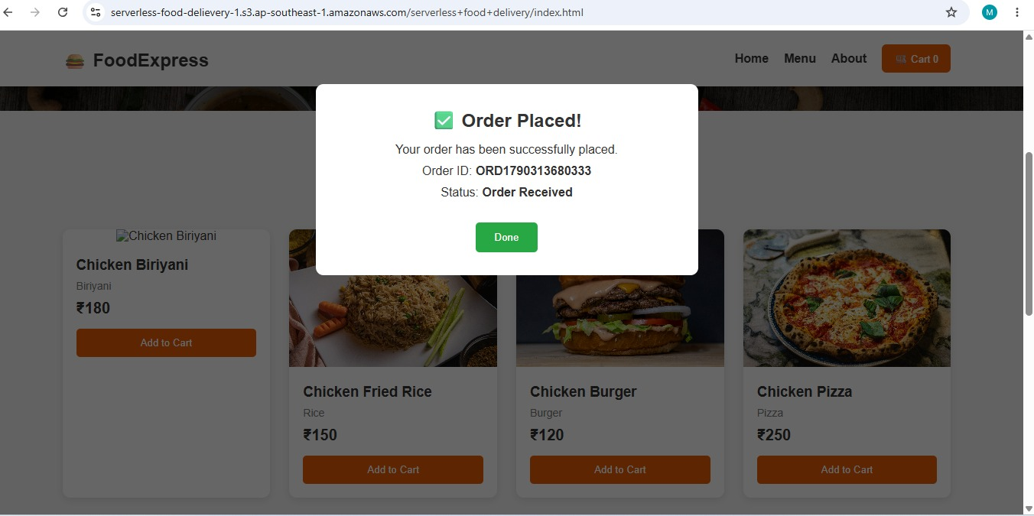
Fig 7.3 – Order confirmation screen shown after an order is successfully placed

7.4 Static Website Hosting on Amazon S3
The frontend is deployed as a static website directly on Amazon S3, with no web server of any kind. The index.html, style.css and script.js files are uploaded to the serverless-food-delievery-1 bucket, and S3 static website hosting serves index.html to the browser over HTTPS.
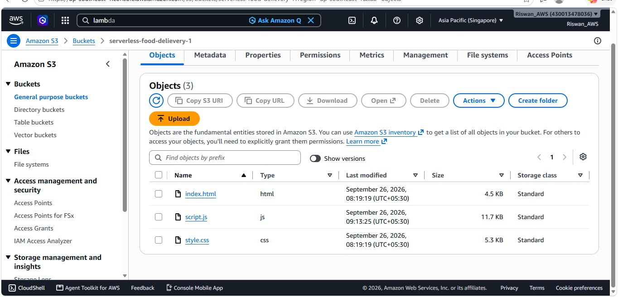
Fig 7.4 – Frontend files (index.html, script.js, style.css) hosted in the serverless-food-delievery-1 S3 bucket

8. ORDER SERVICE IMPLEMENTATION

8.1 Frontend Order Submission (script.js)
When the customer submits the checkout form, the frontend builds an order payload (customer name, food names, quantity, total) and posts it directly to the API Gateway endpoint using fetch(). The real Lambda response - containing the generated order ID - is used to populate the success screen, instead of a hard-coded value.
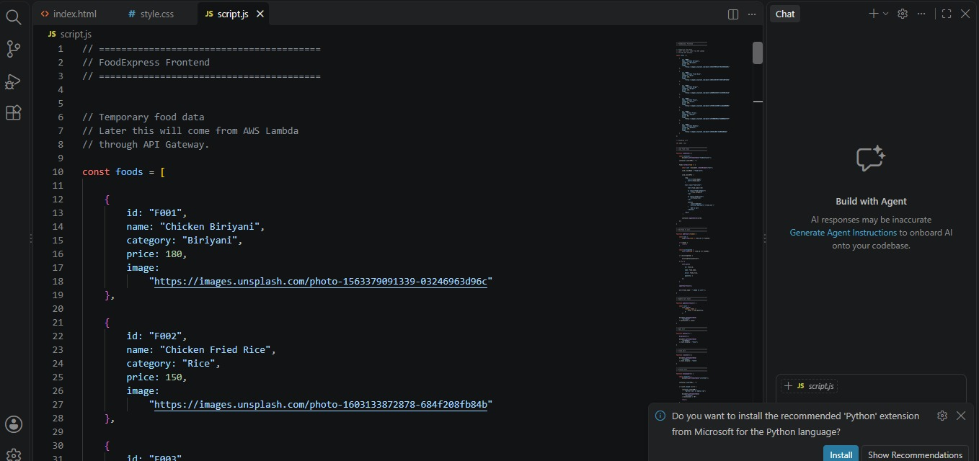
Fig 8.1 – Frontend script.js holding food item data and the order-submission logic
const API_URL =
"https://jubz66uy0f.execute-api.ap-southeast-1.amazonaws.com/prod/register";

const orderData = {
customer_name: customerName,
food_name: cart.map(item => item.name).join(", "),
quantity: cart.reduce((sum, item) => sum + item.quantity, 0),
total: total,
};

const response = await fetch(API_URL, {
method: "POST",
headers: { "Content-Type": "application/json" },
body: JSON.stringify(orderData),
});

const data = await response.json();
if (!response.ok) throw new Error(data.error || data.message || "Order failed");

document.getElementById("orderId").textContent = data.order_id;
document.getElementById("orderStatus").textContent = "Order Placed";

8.2 Register-Order Lambda (app.py)
The /register route on API Gateway invokes the FoodExpressOrders Lambda function synchronously. It generates a unique order ID with uuid4, writes the order as a new item in the DynamoDB Orders table with status "Placed", and returns the order ID back to the frontend. CORS headers are included on every response, including the error path, so the S3-hosted frontend can call the API across origins.
import json
import boto3
import uuid

dynamodb = boto3.resource("dynamodb")
table = dynamodb.Table("Orders")

def lambda_handler(event, context):

try:
body = json.loads(event["body"])

order_id = str(uuid.uuid4())

table.put_item(
Item={
"Name": order_id,
"customer_name": body["customer_name"],
"food_name": body["food_name"],
"quantity": body["quantity"],
"total": body["total"],
"status": "Placed"
}
)

return {
"statusCode": 200,
"headers": {
"Access-Control-Allow-Origin": "*",
"Content-Type": "application/json"
},
"body": json.dumps({
"message": "Order placed successfully",
"order_id": order_id
})
}

except Exception as e:

return {
"statusCode": 500,
"headers": {
"Access-Control-Allow-Origin": "*"
},
"body": json.dumps({
"message": "Order failed",
"error": str(e)
})
}

8.3 Sample Test Event
The Register-Order Lambda was verified in the AWS Lambda console using a saved test event named "ports", matching the exact payload shape sent by the frontend's checkout form.
{
"body": "{\"customer_name\":\"Riswan\",\"food_name\":\"Chicken Rice\",\"quantity\":2,\"total\":200}"
}
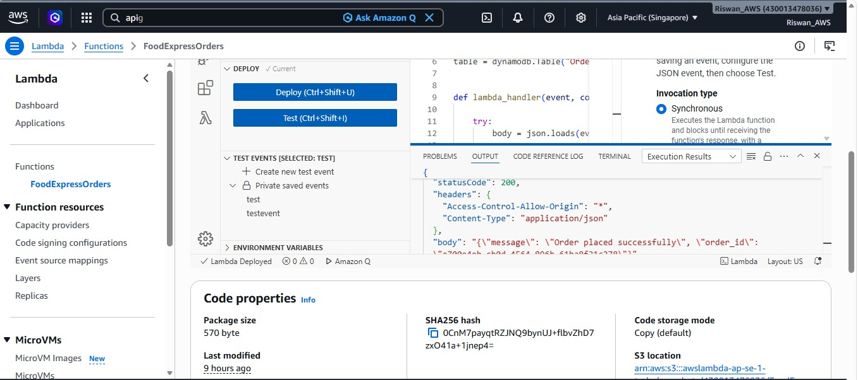
Fig 8.2 – FoodExpressOrders Lambda function returning a successful 200 response with the generated order ID

8.4 Order-Status Lambda
A read-only Lambda behind API Gateway can additionally return the current status of a given order ID by querying the Orders table on its Name key, for use by an order-tracking screen.

9. EVENT-DRIVEN ORDER PROCESSING (PROPOSED)
The current implementation invokes the Register-Order Lambda directly and synchronously from API Gateway. The event-driven extension below is a proposed enhancement for coordinating the full order lifecycle as the platform grows.

9.1 Publish-Subscribe with EventBridge
Every order-state transition would be published as a named event (OrderPlaced, OrderAccepted, OrderPreparing, OrderOutForDelivery, OrderDelivered, OrderCancelled) on a dedicated EventBridge event bus. Rules on the bus would route each event type to the Lambda functions or Step Functions executions that need it.

9.2 Fulfilment Orchestration with Step Functions
A Step Functions state machine would model the fulfilment pipeline as explicit states with defined transitions, timeouts and retry policies, giving a visual, auditable representation of every order's journey.
PLACED -> ACCEPTED -> PREPARING -> OUT_FOR_DELIVERY -> DELIVERED
\-> CANCELLED (from PLACED or ACCEPTED, with reason)

9.3 Dead-Letter Handling
The EventBridge rules would be configured with a dead-letter destination so that an event which repeatedly fails processing is captured for inspection rather than being silently dropped or retried forever.

10. RESTAURANT AND MENU MANAGEMENT SERVICE

10.1 Restaurant Onboarding
A restaurant owner registers through a Cognito-backed portal and creates a restaurant profile (name, address, category, operating hours) which is stored in the Restaurants DynamoDB table.

10.2 Menu Management
Menu items are stored as a list of attributes on the restaurant record, or as a separate MenuItems table keyed by restaurant ID, allowing items to be added, priced and marked available/unavailable independently of the restaurant profile.
The getFoodItems Lambda function returns the current menu list to the frontend. It is developed and tested directly in the AWS Lambda console, including CORS headers in the response so that the S3-hosted frontend can call it across origins.
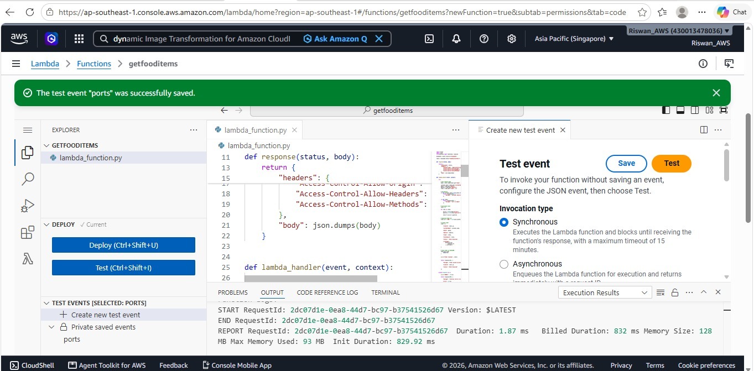
Fig 10.1 – getFoodItems Lambda function in the AWS Lambda console with a successful test execution

10.3 Order Acceptance
When an OrderPlaced event arrives for a restaurant, a notification is sent to the restaurant's dashboard. The restaurant accepts or rejects the order through an API call, which publishes the corresponding OrderAccepted or OrderCancelled event.

11. API GATEWAY AND AUTHENTICATION

11.1 REST Endpoints
Method | Endpoint | Purpose
POST | /prod/register | Implemented – places a new order via the Register-Order Lambda, writes to DynamoDB and returns the order ID
GET | /prod/fooditems | Implemented – getFoodItems Lambda returns the food/menu list to the frontend
GET | /orders/{id} | Proposed – returns current status and history of an order
GET | /restaurants | Proposed – lists restaurants with search/category filters
POST | /restaurants/{id}/orders/{orderId}/accept | Proposed – restaurant accepts an order
GET | /delivery/{orderId} | Proposed – returns live delivery-partner assignment and status
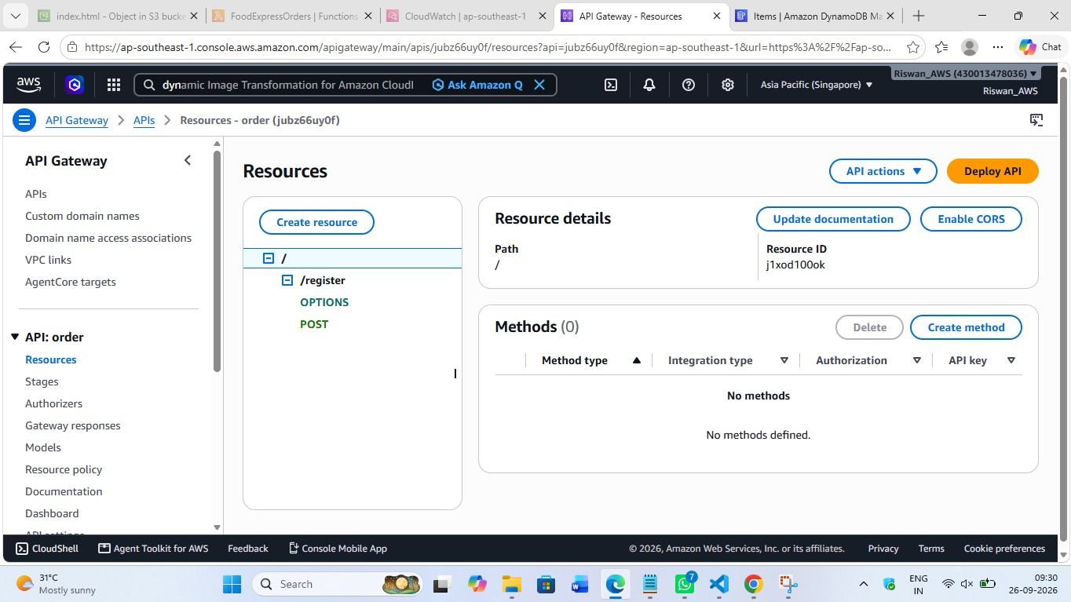
Fig 11.1 – API Gateway REST API “order” showing the /register resource with its POST and OPTIONS (CORS) methods

11.2 Authentication with Amazon Cognito
Customers and restaurant users authenticate against separate Cognito user pools. API Gateway validates the resulting JSON Web Token on every protected route using a Cognito authorizer, so individual Lambda functions do not need to implement token validation themselves.

11.3 Authorization Model
IAM execution roles are scoped per Lambda function using least-privilege policies - for example, the FoodExpressOrders Lambda has write permission only on the Orders table, while the getFoodItems Lambda has read-only permission on the FoodItems table.

12. AMAZON DYNAMODB AND DATABASE DESIGN

12.1 Purpose of DynamoDB
DynamoDB provides single-digit-millisecond, auto-scaling storage for all platform data, matching the on-demand nature of a serverless compute layer with an on-demand-billed database.

12.2 Table Design
Table | Partition Key | Sort Key | Notes
Orders | Name (String) – order UUID | - | Implemented – stores customer_name, food_name, quantity, total, status
FoodItems | FoodID (String) | - | Implemented – backs the getFoodItems Lambda / menu catalogue
Restaurants | restaurantId (String) | - | Proposed – GSI on category for browsing/search
DeliveryPartners | partnerId (String) | - | Proposed – tracks availability and current assignment
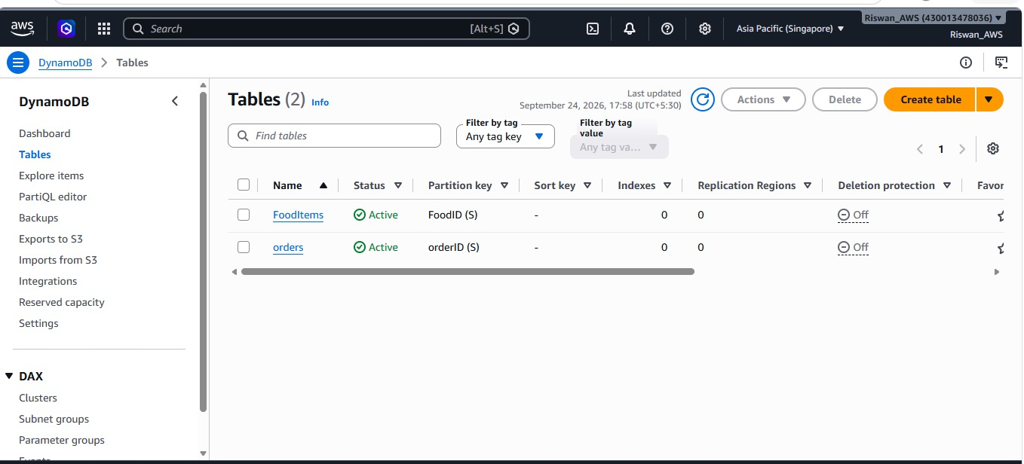
Fig 12.1 – DynamoDB tables actually provisioned: FoodItems (partition key FoodID) and orders (partition key orderID)

12.3 Access Patterns
Each Lambda function accesses DynamoDB directly through the AWS SDK using its own IAM role; there is no shared database credential. Query operations use the global secondary indexes above instead of full table scans wherever the access pattern is known in advance.
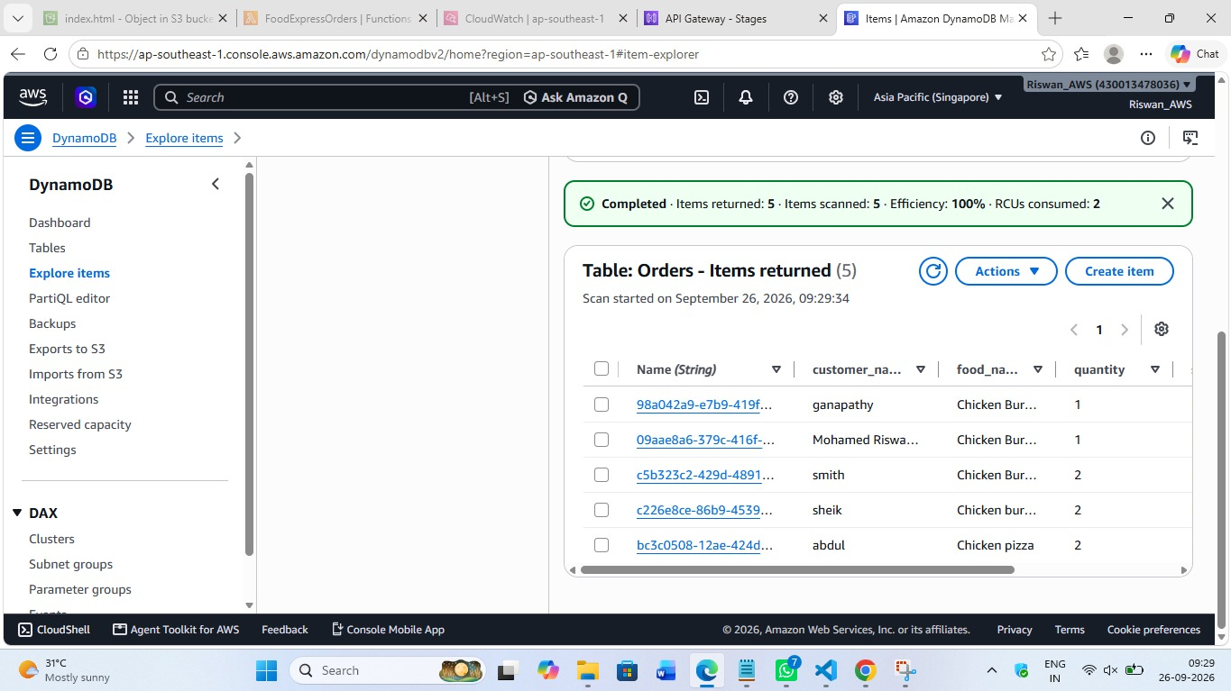
Fig 12.2 – Orders table in the DynamoDB console showing real order items written by the Register-Order Lambda

13. NOTIFICATION AND DELIVERY TRACKING

13.1 Notification Lambda
Subscribed to every order-state-change event on EventBridge (proposed), a Notification Lambda would send the customer and restaurant an email receipt/alert through Amazon SES.

13.2 Delivery-Assignment Lambda
When an order reaches OUT_FOR_DELIVERY, this Lambda queries the DeliveryPartners table for an available partner near the restaurant, assigns the order, and updates both the Orders and DeliveryPartners records.

13.3 Live Status for the Customer
The frontend calls GET /orders/{id} to display the latest status and timestamped history; a WebSocket API (API Gateway) can optionally push updates the moment an event changes the order's state, removing the need for polling.

14. DEPLOYMENT, TESTING AND RESULTS

14.1 Infrastructure as Code
The entire stack - API Gateway routes, Lambda functions, DynamoDB tables and (in the proposed extension) the EventBridge bus/rules, the Step Functions state machine and Cognito user pools - can be defined using an Infrastructure-as-Code tool (AWS CDK or the Serverless Framework) so that the environment can be recreated or torn down reliably.

14.2 Functional Test Cases
ID | Feature | Action | Expected | Result
TC-01 | Order placement | Submit a valid order from the checkout form | 200 OK, real order_id returned by the Lambda | Pass
TC-02 | Order persistence | Check the Orders table after placing an order | New item written with the correct fields and status "Placed" | Pass
TC-03 | Lambda console test | Invoke FoodExpressOrders with a saved test event | 200 response with order_id in the body | Pass
TC-04 | CORS | Call /register from the S3-hosted frontend origin | Access-Control-Allow-Origin header present, no CORS error | Pass
TC-05 | Menu retrieval | Load the menu page | getFoodItems Lambda returns the food catalogue | Pass
TC-06 | Error handling | Send a malformed order payload | 500 response with a descriptive error message | Pass
TC-07 | Order status API | Query order by ID (proposed) | Current status and history returned | Pending
TC-08 | Event routing (proposed) | OrderPlaced published to EventBridge | Notification and Step Functions triggered | Pending

14.3 Results
End-to-end testing confirmed that an order placed from the live S3-hosted frontend is validated and written to DynamoDB by the FoodExpressOrders Lambda within milliseconds, with the real order ID returned to and displayed by the frontend. CloudWatch logs and the DynamoDB console both confirmed the item was stored correctly for every test order submitted.
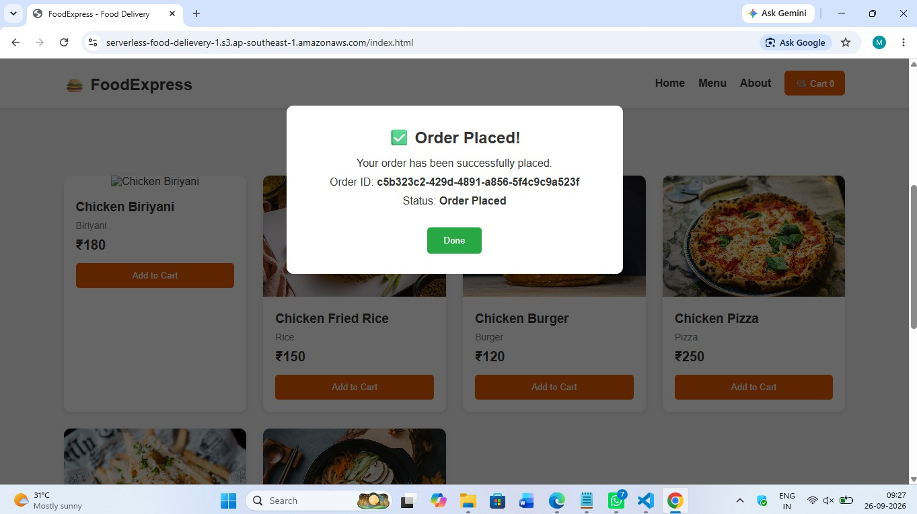
Fig 14.1 – End-to-end test: an order placed from the live S3-hosted frontend, with the real order ID returned by the Register-Order Lambda

15. CONCLUSION AND FUTURE ENHANCEMENTS

15.1 Advantages
- No servers to provision, patch or scale manually.
- Pay-per-request pricing on both Lambda and DynamoDB - no cost when the platform is idle.
- Automatic, cost-proportional scaling for both compute (Lambda) and storage (DynamoDB).
- Small, independently deployable Lambda functions (FoodExpressOrders, getFoodItems) that are simple to reason about and test.
- A fully static, CDN-friendly frontend hosted on S3 with no web server to patch.

15.2 Limitations
- The current flow is synchronous end-to-end; a spike in concurrent orders is handled by Lambda/DynamoDB scaling rather than being buffered.
- Cold starts can add latency to infrequently invoked Lambda functions.
- There is no automatic customer/restaurant notification yet - order status changes are not currently pushed to the user.
- No authentication is implemented yet, so the /register and /fooditems endpoints are open.

15.3 Future Enhancements
- Introduce Amazon EventBridge and AWS Step Functions to model the full order lifecycle (accepted, preparing, out for delivery, delivered) as described in Section 9.
- Add Amazon Cognito authentication so orders are tied to a signed-in customer.
- Add real-time GPS tracking for delivery partners using a WebSocket API.
- Add an order-status endpoint and tracking screen on the frontend.
- Integrate a payment gateway before order confirmation.

15.4 Conclusion
The serverless food delivery platform demonstrates how a frontend hosted on Amazon S3, a Python AWS Lambda backend and Amazon DynamoDB can together deliver a working order-placement flow with no server to provision or manage. Amazon API Gateway exposes the Lambda functions as a public REST API, and DynamoDB provides on-demand, auto-scaling persistence for orders and the menu catalogue. Amazon EventBridge and AWS Step Functions remain proposed extensions for coordinating a fuller, multi-stage order lifecycle as the platform grows.

APPENDIX A: FRONTEND SOURCE CODE

A.1 index.html
The HTML structure for the FoodExpress frontend, hosted as a static website on Amazon S3. It defines the header/navigation, hero banner, menu section, and the cart, checkout and order-success modals.
<!DOCTYPE html>
<html lang="en">
<head>
<meta charset="UTF-8">
<meta name="viewport" content="width=device-width, initial-scale=1.0">
<title>FoodExpress - Food Delivery</title>
<link rel="stylesheet" href="style.css">
</head>
<body>

<!-- Header -->
<header>
<div class="logo">🍔 FoodExpress</div>
<nav>
<a href="#home">Home</a>
<a href="#menu">Menu</a>
<a href="#about">About</a>
<button class="cart-btn" onclick="openCart()">
🛒 Cart <span id="cartCount">0</span>
</button>
</nav>
</header>

<!-- Hero Section -->
<section class="hero" id="home">
<div class="hero-content">
<h1>Delicious Food Delivered Fast</h1>
<p>Order your favourite food from FoodExpress and get it delivered to your doorstep.</p>
<button onclick="scrollToMenu()">Order Now</button>
</div>
</section>

<!-- Food Menu -->
<section class="menu-section" id="menu">
<h2>Our Menu</h2>
<p class="section-description">Choose your favourite food</p>
<div id="foodContainer" class="food-container">
<!-- Food items will be loaded using JavaScript -->
</div>
</section>

<!-- Cart Modal -->
<div id="cartModal" class="modal">
<div class="modal-content">
<span class="close" onclick="closeCart()">&times;</span>
<h2>🛒 Your Cart</h2>
<div id="cartItems"><!-- Cart items appear here --></div>
<div class="cart-total"><h3>Total: ₹<span id="cartTotal">0</span></h3></div>
<button class="checkout-btn" onclick="openCheckout()">Proceed to Checkout</button>
</div>
</div>

<!-- Checkout Modal -->
<div id="checkoutModal" class="modal">
<div class="modal-content">
<span class="close" onclick="closeCheckout()">&times;</span>
<h2>📦 Checkout</h2>
<form id="checkoutForm">
<label>Customer Name</label>
<input type="text" id="customerName" placeholder="Enter your name" required>
<label>Phone Number</label>
<input type="tel" id="phone" placeholder="Enter phone number" required>
<label>Delivery Address</label>
<textarea id="address" placeholder="Enter delivery address" required></textarea>
<button type="submit" class="place-order-btn">Place Order</button>
</form>
</div>
</div>

<!-- Order Success Modal -->
<div id="successModal" class="modal">
<div class="modal-content success">
<h2>✅ Order Placed!</h2>
<p>Your order has been successfully placed.</p>
<p>Order ID: <strong id="orderId"></strong></p>
<p>Status: <strong id="orderStatus">Order Received</strong></p>
<button onclick="closeSuccess()">Done</button>
</div>
</div>

<!-- About -->
<section class="about" id="about">
<h2>About FoodExpress</h2>
<p>FoodExpress is a serverless food delivery platform built using AWS cloud services.</p>
<p>Our platform uses AWS Lambda, API Gateway, DynamoDB, EventBridge, SQS and SNS.</p>
</section>

<!-- Footer -->
<footer>
<p>© 2026 FoodExpress | Serverless Food Delivery Platform</p>
</footer>

<script src="script.js"></script>
</body>
</html>

A.2 style.css
The stylesheet for the FoodExpress frontend - a sticky header, a hero banner, a responsive food-card grid, cart/checkout/success modal styling and a mobile breakpoint.
* { margin: 0; padding: 0; box-sizing: border-box; }
body { font-family: Arial, sans-serif; background: #f5f5f5; color: #333; }

/* Header */
header {
background: #ffffff; padding: 18px 7%;
display: flex; justify-content: space-between; align-items: center;
box-shadow: 0 2px 8px rgba(0,0,0,0.1);
position: sticky; top: 0; z-index: 100;
}
.logo { font-size: 24px; font-weight: bold; }
nav { display: flex; align-items: center; gap: 20px; }
nav a { text-decoration: none; color: #333; font-weight: bold; }
nav a:hover { color: #e85d04; }
.cart-btn { background: #e85d04; color: white; border: none; padding: 10px 16px; border-radius: 6px; cursor: pointer; }

/* Hero */
.hero {
min-height: 450px; display: flex; align-items: center; justify-content: center; text-align: center;
background: linear-gradient(rgba(0,0,0,0.55), rgba(0,0,0,0.55)),
url("https://images.unsplash.com/photo-1504674900247-0877df9cc836") center/cover;
}
.hero-content { color: white; max-width: 650px; padding: 30px; }
.hero h1 { font-size: 48px; margin-bottom: 20px; }
.hero p { font-size: 19px; margin-bottom: 30px; }
.hero button { background: #e85d04; color: white; border: none; padding: 14px 28px; border-radius: 6px; font-size: 16px; font-weight: bold; cursor: pointer; }

/* Menu */
.menu-section { padding: 60px 7%; text-align: center; }
.menu-section h2 { font-size: 32px; margin-bottom: 10px; }
.section-description { color: #777; margin-bottom: 30px; }

/* Food Container / Card */
.food-container { display: grid; grid-template-columns: repeat(auto-fit, minmax(230px, 1fr)); gap: 25px; }
.food-card { background: white; border-radius: 10px; overflow: hidden; box-shadow: 0 3px 10px rgba(0,0,0,0.1); transition: 0.3s; }
.food-card:hover { transform: translateY(-5px); }
.food-card img { width: 100%; height: 180px; object-fit: cover; }
.food-info { padding: 18px; text-align: left; }
.food-price { font-size: 20px; font-weight: bold; margin-bottom: 15px; }
.add-btn { width: 100%; background: #e85d04; color: white; border: none; padding: 11px; border-radius: 5px; cursor: pointer; }
.add-btn:hover { background: #d94f00; }

/* Modal */
.modal { display: none; position: fixed; z-index: 200; left: 0; top: 0; width: 100%; height: 100%; background: rgba(0,0,0,0.6); overflow: auto; }
.modal-content { background: white; width: 90%; max-width: 500px; margin: 70px auto; padding: 30px; border-radius: 10px; position: relative; }
.close { position: absolute; right: 20px; top: 15px; font-size: 30px; cursor: pointer; }

/* Cart */
.cart-item { display: flex; justify-content: space-between; align-items: center; padding: 15px 0; border-bottom: 1px solid #ddd; }
.remove-btn { background: #dc3545; color: white; border: none; padding: 6px 10px; border-radius: 4px; cursor: pointer; }
.cart-total { padding: 20px 0; text-align: right; }
.checkout-btn, .place-order-btn { width: 100%; padding: 13px; border: none; border-radius: 6px; background: #e85d04; color: white; font-size: 16px; cursor: pointer; }

/* Checkout Form */
form { display: flex; flex-direction: column; gap: 10px; }
form label { font-weight: bold; margin-top: 10px; }
form input, form textarea { padding: 12px; border: 1px solid #ccc; border-radius: 5px; font-size: 15px; }
form textarea { min-height: 100px; resize: vertical; }

/* Success / About / Footer */
.success { text-align: center; }
.success button { margin-top: 20px; padding: 12px 25px; background: #28a745; color: white; border: none; border-radius: 5px; cursor: pointer; }
.about { background: white; padding: 60px 7%; text-align: center; }
.about p { max-width: 700px; margin: 10px auto; color: #666; line-height: 1.6; }
footer { background: #222; color: white; text-align: center; padding: 20px; }

/* Mobile */
@media (max-width: 700px) {
header { flex-direction: column; gap: 15px; }
nav { flex-wrap: wrap; justify-content: center; }
.hero h1 { font-size: 34px; }
}

A.3 script.js
The frontend application logic - the static food catalogue, cart management, and the checkout handler that posts the order to API Gateway and renders the real order ID returned by the Register-Order Lambda.
// AWS API Gateway URL
const API_URL = "https://jubz66uy0f.execute-api.ap-southeast-1.amazonaws.com/prod/register";

// Food Data
const foods = [
{ id: "F001", name: "Chicken Biriyani", category: "Biriyani", price: 180, image: "..." },
{ id: "F002", name: "Chicken Fried Rice", category: "Rice", price: 150, image: "..." },
{ id: "F003", name: "Chicken Burger", category: "Burger", price: 120, image: "..." },
{ id: "F004", name: "Chicken Pizza", category: "Pizza", price: 250, image: "..." },
{ id: "F005", name: "French Fries", category: "Snacks", price: 90, image: "..." },
{ id: "F006", name: "Chicken Noodles", category: "Noodles", price: 140, image: "..." },
];

let cart = [];

// Render the food catalogue into the DOM
function loadFoods() {
const container = document.getElementById("foodContainer");
container.innerHTML = "";
foods.forEach(food => {
const card = document.createElement("div");
card.className = "food-card";
card.innerHTML = `
<img src="${food.image}" alt="${food.name}">
<div class="food-info">
<h3>${food.name}</h3>
<p class="food-category">${food.category}</p>
<p class="food-price">₹${food.price}</p>
<button class="add-btn" onclick="addToCart('${food.id}')">Add to Cart</button>
</div>`;
container.appendChild(card);
});
}

function addToCart(foodId) {
const food = foods.find(item => item.id === foodId);
if (!food) return;
const existingItem = cart.find(item => item.id === foodId);
if (existingItem) existingItem.quantity++;
else cart.push({ id: food.id, name: food.name, price: food.price, quantity: 1 });
updateCartCount();
alert(food.name + " added to cart!");
}

function updateCartCount() {
const count = cart.reduce((total, item) => total + item.quantity, 0);
document.getElementById("cartCount").textContent = count;
}

function removeFromCart(foodId) {
cart = cart.filter(item => item.id !== foodId);
updateCartCount();
displayCart();
}

function openCheckout() {
if (cart.length === 0) { alert("Please add food to your cart first."); return; }
closeCart();
document.getElementById("checkoutModal").style.display = "block";
}

// PLACE ORDER – sends the real order to API Gateway / Lambda
document.getElementById("checkoutForm").addEventListener("submit", async function (event) {
event.preventDefault();

const customerName = document.getElementById("customerName").value.trim();
const phone = document.getElementById("phone").value.trim();
const address = document.getElementById("address").value.trim();
if (!customerName || !phone || !address) { alert("Please fill all details."); return; }

const total = cart.reduce((sum, item) => sum + item.price * item.quantity, 0);
const orderData = {
customer_name: customerName,
food_name: cart.map(item => item.name).join(", "),
quantity: cart.reduce((sum, item) => sum + item.quantity, 0),
total: total,
};

try {
const response = await fetch(API_URL, {
method: "POST",
headers: { "Content-Type": "application/json" },
body: JSON.stringify(orderData),
});
const data = await response.json();
if (!response.ok) throw new Error(data.error || data.message || "Order failed");

closeCheckout();
document.getElementById("orderId").textContent = data.order_id;
document.getElementById("orderStatus").textContent = "Order Placed";
document.getElementById("successModal").style.display = "block";

cart = [];
updateCartCount();
} catch (error) {
alert("Order failed: " + error.message);
}
});

function scrollToMenu() {
document.getElementById("menu").scrollIntoView({ behavior: "smooth" });
}

// Start Application
loadFoods();
updateCartCount();

