In figure 1 you can see the plot of the points belonging to class 1 and 2. In this homework, our task was to predict which class each point belongs to using multivariant classification assuming normal Gaussian distribution.

Figure 2 shows the predicted class of the points given a linear discriminant function. Using a linear discriminant function resulted in an accuracy rate of 90.1639%. Figure 3 shows the predicted class of the points given a quadratic linear discrimination function. This method resulted in an accuracy rate of 81.1475%. Finally, figure 3 shows the predicted class of the points given a common covariance discrimination function. This resulted in an accuracy rate of 95.9016.

Each of the discriminant functions reacted differently when the number of data points was varied. The linear function increased slightly, and quadratic function decreased greatly; while the common covariance function increased toward 100%.

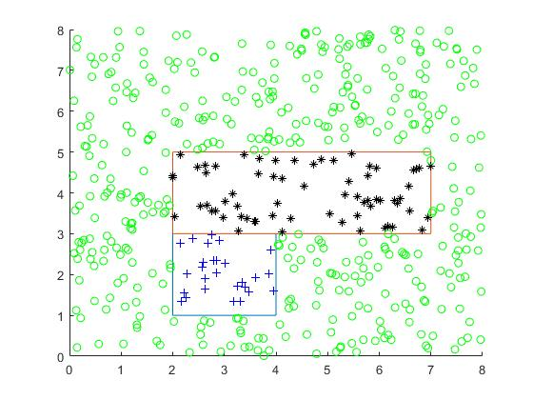

**Figure 1. Correct Classification**

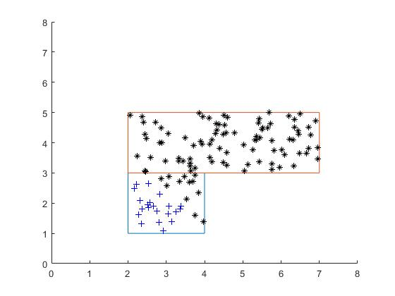

**Figure 2. Classification (Linear Discriminant Function)**

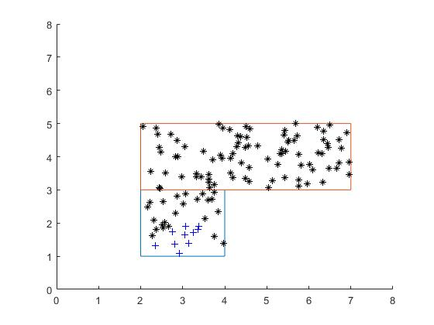

**Figure 3. Classification (Quadratic Function)**

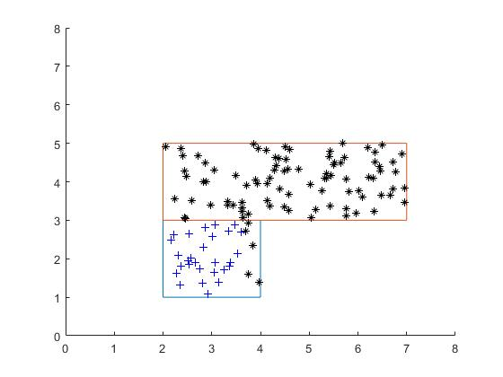

**Figure 4. Classification (Common Covariance Function**