**Part 1: Laravel Installation**

I have installed Laravel to follow following steps,

1. Install php latest version in my computer.
2. Install xampp server.
3. Install composer in my computer.
4. Open CLI and write Laravel installation command –
   1. Create a New Laravel Project:

**“composer create-project laravel/laravel project-name”**

* 1. Navigate to the project directory:

**“cd project-name”**

* 1. Start the server of Laravel application:

**Then - “php artisan serve”**

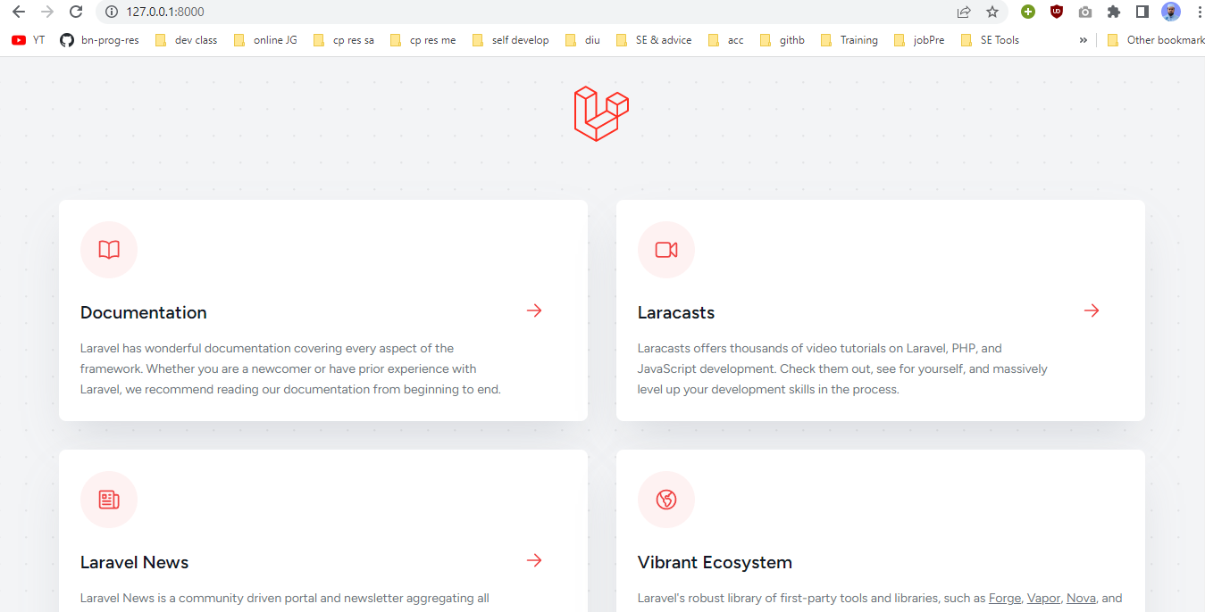**Picture of Running Server:**

**Part 2: Laravel Folder Structure**

The purpose of each of the following folders in a Laravel project:

**App:** This folder contains the core application code, including models, controllers, middleware, and other classes specific to your application's business logic.

**Bootstrap:** This folder contains files responsible for bootstrapping the Laravel framework, including the application's configuration, autoloading, and environment setup.

**Config:** This folder, you can find various configuration files for your application, such as database settings, cache configurations, service providers, and more.

**Database:** The database folder holds database-related files, such as migrations, seeders (for populating the database with test data), and factories (for generating dummy data during testing).

**Public:** The public folder is the web server's document root and contains the publicly accessible files for your application, including the index.php file, CSS, JavaScript, and other assets.

**Resources:** The resources folder contains the views, language files, and other resources used by your application. It includes subfolders like views, lang, sass, and js, where you can organize your application's frontend assets.

**Routes:** The routes folder contains the application's route definitions, where you define the endpoints and corresponding actions for handling HTTP requests.

**Storage:** The storage folder is used to store various files generated by the application, such as logs, session files, cache files, and uploaded files. It has subdirectories like app, framework, and logs.

**Tests:** The tests folder contains the automated tests for your application. It includes unit tests, feature tests, and other testing-related files.

**Vendor:** The vendor folder is created by Composer and contains all the dependencies required by your application. It includes the Laravel framework itself, along with other third-party libraries and packages installed via Composer.

**Create a new route and displays a simple "Hello, World!":**

