Trafag AG · Microswitch EOL tester
ScadaViewer
Instructions for Use
Web application for viewing, evaluating and exporting production and test data of microswitches
Customer | Trafag AG
Project | 50-1182875
Machine | Microswitch EOL tester
Software | ScadaViewer 2.7.0
Document issue | 2.2 · October 2026
Supplier | Mechatronic Design & Solutions (MDS)

Contents
1 Introduction 3
1.1 Purpose of the application 3
1.2 Data flow and file states 3
1.3 Where the application runs and how to open it 4
1.4 User roles and permissions 4
1.5 About this document 5
2 Sign-in and basic controls 6
2.1 Signing in 6
2.2 Top bar 6
2.3 Menu, help and keyboard shortcuts 7
2.4 On-screen keyboard 9
3 Database 11
3.1 Order list 12
3.2 Switches, date filter and sorting 12
3.3 Order search 13
3.4 Expanding an order 13
3.5 Storage: local, NAS and USB flash drive 14
3.6 Downloading data (CSV, XLSX) 15
3.7 Bulk download 15
3.8 Order in progress: finishing and deleting 16
3.9 Deleting files 17
3.10 Remote storage (NAS) 18
3.11 Test measurements (Testing) 18
4 Order detail 20
4.1 Order header 20
4.2 Order data 21
4.3 Category distribution 22
4.4 Timeline 23
4.5 Piece table and values outside the limits 23
4.6 Sorting and filtering pieces 24
4.7 Exporting and printing an order 25
5 Record detail (piece) 26
5.1 Force–travel diagram 26
5.2 Contact switching times 27
5.3 NOK categories and parameter table 27
5.4 Printing a record report 28
6 Measurement detail (Testing) 30
6.1 Signal data 31
6.2 Printing a measurement report 34
7 Settings 35
7.1 Preferences 35
7.2 Connection 35
7.3 Time / NTP 36
7.4 Users 37
8 Info 38
9 Troubleshooting 39
Appendix A Parameter overview 40
Appendix B Terms and abbreviations 43

1 Introduction

1.1 Purpose of the application
ScadaViewer is a web application for viewing and evaluating data from the microswitch EOL tester — an end-of-line test station that measures every microswitch and sorts it into categories. For every piece of an order the tester records the force, position and electrical contact signals; the Analyzing service calculates the characteristic parameters of the switch from them and the DatabaseGateway service writes them to CSV files on the tester PC and uploads them to network storage (Synology NAS). ScadaViewer makes this data available in tables, charts and diagrams and lets you filter, export and print it.
Main functions:
- overview of production orders (Production) and test measurements (Testing) on the tester PC and in the NAS archive, order search by number,
- monitoring of the order in progress, finishing it manually after an outage, and monitoring of local storage, NAS and USB flash drive usage,
- order detail: order data (lots, testing parameters, sorting categories and limits), distribution of pieces into categories 1–6, production timeline,
- piece table with a filter by status, category and NOK area and with values outside the sorting limits highlighted,
- record detail (one piece) with the force–travel diagram, the switching time diagram and a graphical explanation of every parameter,
- signal data of test measurements (position, force, contact voltage, current and resistance) with zoom at full resolution,
- CSV / XLSX export of single files and in bulk (to a USB flash drive at the tester, to the browser from the office), A4 print reports,
- the tester PC as the time source (NTP server) for the other industrial PCs (IPCs) of the tester.
Note: ScadaViewer never alters measured values. It only acts on files in the local storage of the tester PC: deletion, removal of synchronised copies and manually finishing an order in progress (which cuts off an incomplete last row, if any). It never deletes or alters files on the NAS.
In the user interface ScadaViewer is shown as MDS Machine Portal – Data Monitoring (top bar, sign-in window).

1.2 Data flow and file states
One production order = one file PROD_<order>_<microswitch ID>_<date>_<time>_DONE.csv (order in progress …_WIP.csv), one test measurement = one file TEST_<microswitch name>_<date>_<time>_DONE.csv. A file goes through three states, shown by the application in the Sync column:
Table 1 – Order file states
State (Sync) | Folder on the tester PC | Meaning
In progress | production/wip | The order is being produced; DatabaseGateway appends every further piece.
Local | …/done_local | The order is closed and waiting to be uploaded to the NAS. The tester PC holds the only copy of the data so far.
Synced | …/done_remote | The order has been uploaded to the NAS; the local copy only serves fast access and can be removed (section 3.5).

The production file has a block structure: [Metadata] (order, recipe, microswitch ID and name, supplier lots), [TestingParameters] (test parameters from the recipe), [SortingCategories] (limits of categories 1–6), [SortingLimits] (Trafag and supplier limits of every measured parameter) and [Data] (one row per piece).
Values are in customer units: forces in mN, positions and travels in µm, times in µs, contact resistances in mΩ. The positions FP, OP, RP, TTP and FPR give the height of the actuator above the mounting-hole axis (P = C − x, where C is the calibration constant of the tester and x the carriage travel); they therefore decrease when the switch is actuated.

1.3 Where the application runs and how to open it
The application runs as a Windows service on the tester PC. It is permanently open in kiosk mode on the tester monitor (on one screen; the tester HMI runs on the other). From the office, open it in Chrome or Edge at the address provided by your administrator, for example:
http://<tester PC address>:8080
From the office the application is view-only: data can be browsed, downloaded and printed, but deleting, finishing an order, storage clean-up, the USB flash drive, setting the time, user management and changing settings are only possible on the tester PC. During remote access the top bar shows the label Remote access · view only.

1.4 User roles and permissions
Every account has one of four roles (from lowest to highest): Operator → Technician → Administrator → Manufacturer. A higher role may do everything a lower one can. The Manufacturer role is intended for the tester supplier (MDS service) – do not confuse it with the microswitch supplier, from whom the lots come and whose limits are called “supplier limits”. Sign-in via the PLC (section 2.1) has the permissions of the Administrator role. The Office column applies to any role when accessing from a computer other than the tester PC.
Table 2 – Permissions by role (at the tester) and from the office
Action | Operator | Technician | Administrator | Manufacturer | Office
Viewing, printing reports | ✓ | ✓ | ✓ | ✓ | ✓
CSV / XLSX download (single and bulk) | — | — | ✓ to flash drive | ✓ to flash drive | ✓ to browser
Clean synced files | ✓ | ✓ | ✓ | ✓ | —
Deleting a Synced file (incl. batch) | — | ✓ | ✓ | ✓ | —
Deleting a Local file (not on the NAS) | — | — | ✓ | ✓ | —
Deleting / finishing the order in progress | — | — | ✓ | ✓ | —
USB flash drive — safe removal | — | — | ✓ | ✓ | —
Data paths and storage limit | — | — | ✓ | ✓ | —
Setting the PC time (everyone sees the overview) | — | — | ✓ | ✓ | —
User management | — | — | ✓ lower roles only | ✓ lower roles only | —

User management: a new account may have at most the role of the user creating it; passwords can be changed and accounts deleted only for lower roles (section 7.4).
Note: At the tester, files are not downloaded to the PC’s Downloads folder but saved exclusively to the inserted USB flash drive (section 3.6). That is why export at the tester is reserved for the Administrator role and higher.

1.5 About this document
This document describes ScadaViewer version 2.7.0. The figures were taken with sample data in the format written by DatabaseGateway; order numbers, lots, times and values are examples only. The PLC is disconnected in the figures (red status in the top bar) — in operation at the tester the status is green. For illustration, the Database date filter in the figures is set to a longer period than the default two days. In addition, every page of the application has its own brief help (? icon next to the title, section 2.3).

2 Sign-in and basic controls

2.1 Signing in
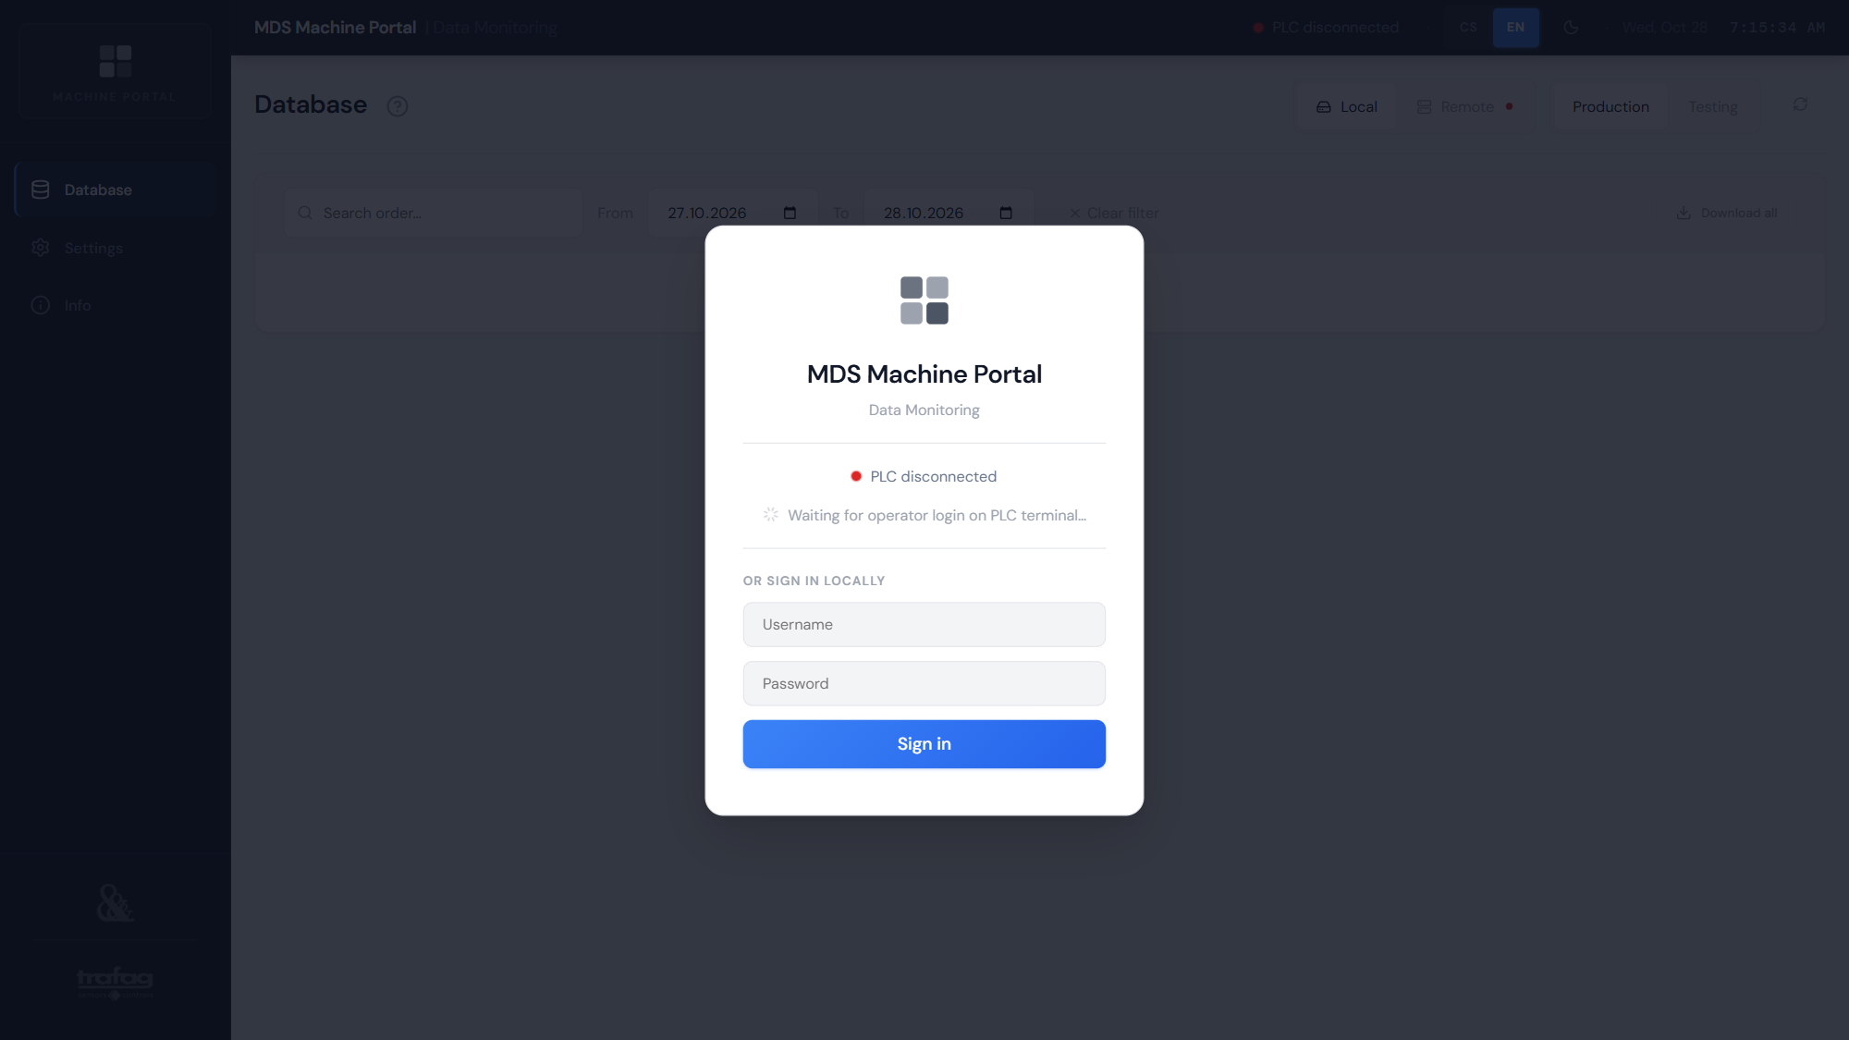
Figure 1 – Sign-in screen on the tester PC
On the tester PC there are two ways to sign in:
- Automatically via the PLC — when a user with the highest access level signs in on the tester terminal, the application signs in automatically with the permissions of the Administrator role. It stays signed in as long as the user is signed in on the PLC: after sign-out on the PLC (or loss of the PLC connection) the application signs out within a few seconds. Meanwhile the screen shows “Waiting for operator login on PLC terminal…” – a sign-in with a lower access level on the PLC does not sign in the application.
- With user name and password — fill in the fields under Or sign in locally and press Sign in. On the tester PC a password sign-in ends after 15 minutes of inactivity (no touch, click, mouse wheel or key), so that technician or administrator rights are not passed on to the next shift.
From the office only sign-in with user name and password is available. A password sign-in is valid for at most 8 hours (at the tester it also ends after 15 minutes of inactivity), after which the application shows “Session expired — please sign in again.” After five wrong password attempts, sign-in from that computer is blocked for 10 minutes. With a password sign-in, sign out with the Sign out button (arrow-leaving-door icon) in the top bar; with a PLC sign-in, sign out on the PLC terminal.
Caution: An account with the default password admin cannot sign in from the office, and at the tester the application shows a prompt to change it at the bottom. Change the default password right at commissioning (Settings → Users, section 7.4).

2.2 Top bar
Figure 2 – Top bar with password sign-in at the tester (empty middle section omitted)
Table 3 – Top bar items
Item | Meaning
PLC connected / disconnected | Connection to the tester controller via the ADS protocol (green = OK, red = no connection). A short notification appears when the state changes.
Local storage / NAS (only when filling up) | Appears from 80% usage (orange), red from 95%; for local storage also when the disk is running out of space. Click it to go to the Database.
Remote access · view only | The application is open on a computer other than the tester PC (section 1.3).
Local access / user name | Only with user name and password sign-in: “Local access” at the tester, the signed-in user’s name remotely. Not shown with PLC sign-in.
Sign out (arrow-leaving-door icon) | Signs you out – only with user name and password sign-in; with PLC sign-in, sign out on the PLC terminal.
CS / EN | Application language; the choice is remembered in the browser.
Moon / sun | Dark or light appearance.
Date and time | Current date and time of the device on which the application is open. On the tester PC this is the PC time used to time-stamp new records; from the office it is your own computer’s time (for the tester PC time see Settings → Time / NTP, section 7.3).

2.3 Menu, help and keyboard shortcuts
The left menu contains the Database, Settings and Info pages; click the logo to return to the Database. The application is designed for a touch monitor — all buttons are sized for finger operation.
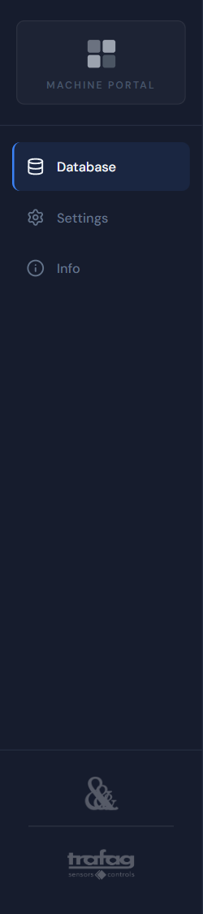
Figure 3 – Left menu
The ? icon next to the title of every page opens its help: what the page is for and what it contains. Close it with the cross or the Esc key.
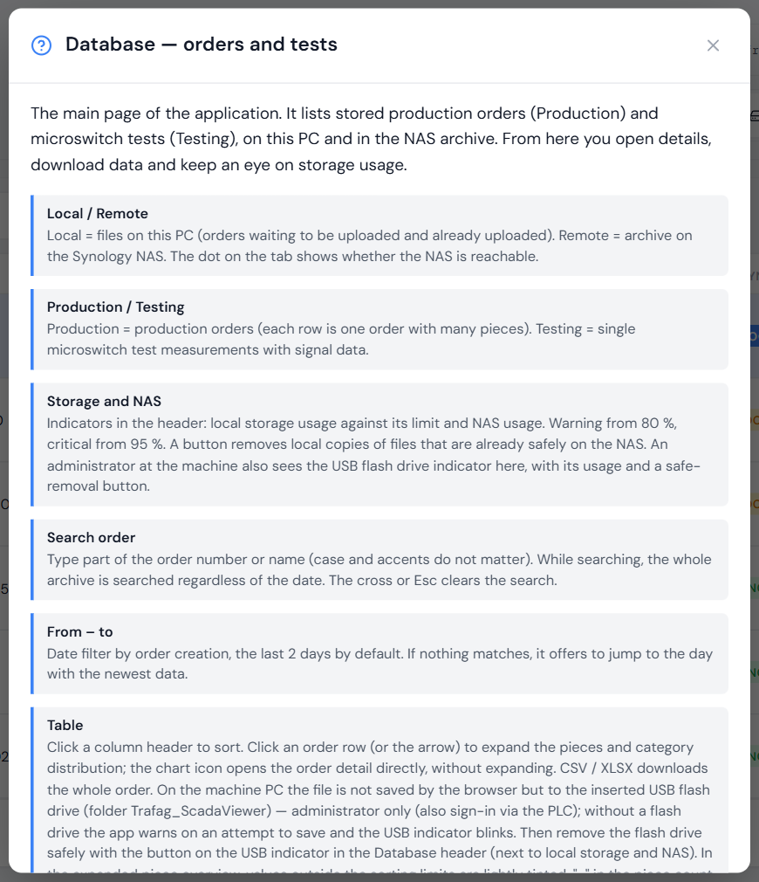
Figure 4 – Help of the Database page
- F5 — refreshes the file list in the Database (without reloading the whole page).
- Esc — closes an expanded order, a dialog or the help.
- If the connection to the application server is lost, a red bar “Server unavailable — checking connection…” appears; it disappears by itself once the connection is restored.

2.4 On-screen keyboard
On the tester PC the Windows system keyboard is disabled in kiosk mode. When you tap a text field (order search, sign-in, settings), the application keyboard therefore appears, with Czech diacritics, digits and symbols (?123). Enter submits the form, the down arrow at the bottom right hides the keyboard, a double tap on Shift locks capital letters. Configure the behaviour in Settings → Preferences (section 7.1).
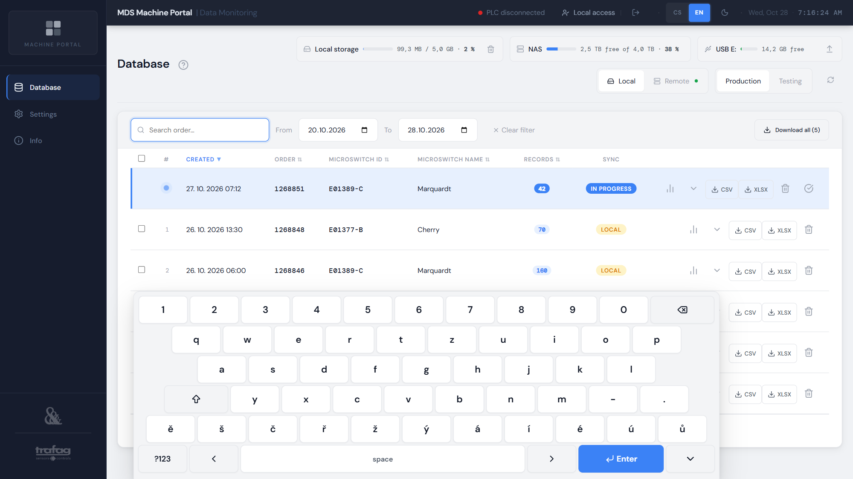
Figure 5 – On-screen keyboard at the Search order field

3 Database
The Database is the main page of the application. It lists files — one row is one order (Production) or one measurement (Testing). The order in progress is always highlighted at the top and its piece count updates automatically.
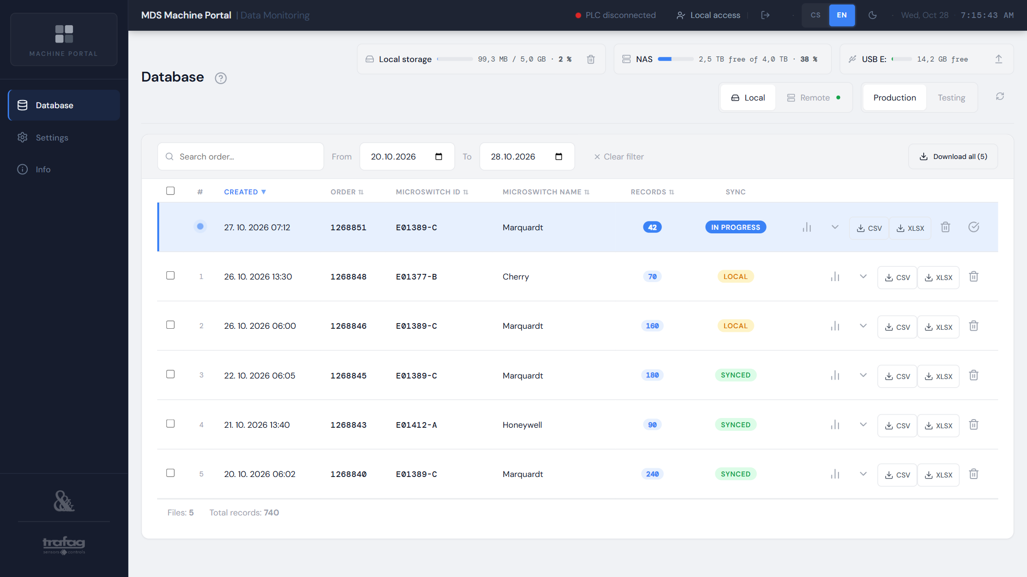
Figure 6 – Database — orders on the tester PC

3.1 Order list
Table 4 – List columns and buttons
Column / item | Meaning
Check box | Selects files for bulk download or deletion (the order in progress cannot be selected).
# | Row number; a blue dot for the order in progress.
Created | When measuring of the order started.
Order | Order number.
Microswitch ID | Material (SAP) number of the microswitch.
Microswitch name | Type / supplier of the microswitch.
Records | Number of records = measured pieces; “…” = being counted.
Sync | File state In progress / Local / Synced (section 1.2).
Chart icon | Opens the order detail (chapter 4).
Arrow | Expands the piece overview directly in the list (section 3.4).
CSV / XLSX | Downloads the order (section 3.6).
Bin | Deletes the local file (section 3.9). The icon is also shown on the Remote tab, but files on the NAS cannot be deleted (section 3.10).
Tick-in-circle button (In progress only) | Finish order (section 3.8).

The list appears immediately even with tens of thousands of files — the order number and date are read from the file name. The microswitch ID and name and the piece count are added in the background once the file has been read (“…” = being determined). On the Remote tab only the orders of the displayed page are counted. Below the table are the paging controls and a summary: number of files and total number of records.

3.2 Switches, date filter and sorting
Figure 7 – Database header: storage indicators and switches
- Local / Remote — files on the tester PC, or the archive on the NAS. A green dot on the Remote tab = NAS reachable, red = unreachable.
- Production / Testing — production orders, or test measurements.
- Refresh (circular arrows icon) — manual list refresh (like F5). Automatic refresh runs at the interval set in Settings; new files in local storage appear within a few seconds.
- From / To — period by creation date, the default is today and yesterday; Clear filter shows everything. The filter is not saved – each time the Database opens, the default period applies again. If the filter hides all files, the application says how many are outside the period and offers a button to show the latest ones.
- Sorting — click a column header (Created, Order, Microswitch ID, Microswitch name, Records); click again to reverse the order.

3.3 Order search
The Search order… field (Production tab only) finds orders by part of their number or name; letter case and diacritics do not matter. While searching, the whole archive is searched regardless of the date — the From / To fields are greyed out and the bar shows “Searching all dates”. The search text is kept when you return from an order detail. The cross in the field or the Esc key clears the search and the date filter applies again.
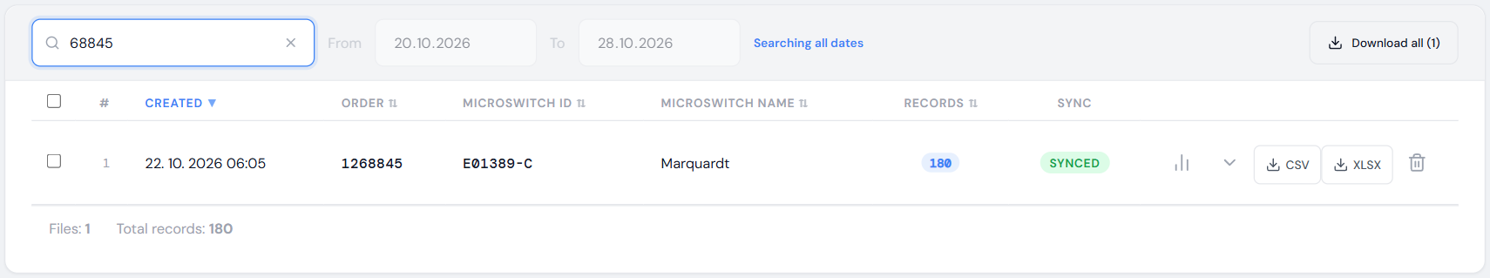
Figure 8 – Searching for an order by part of its number

3.4 Expanding an order
Tapping an order row (or the arrow) shows the category distribution chart (section 4.3), the piece count against the planned quantity (Total / Expected, if available) and a table of pieces with their parameters – 200 pieces per page in a scrollable box, with paging. Values outside the sorting limits are tinted according to the legend (section 4.5). Below the table are the number of records and the time span of the order. Tap a piece to open its detail (chapter 5); the Order detail button opens the whole order. For a measurement (Testing), tapping the row opens the measurement detail directly.
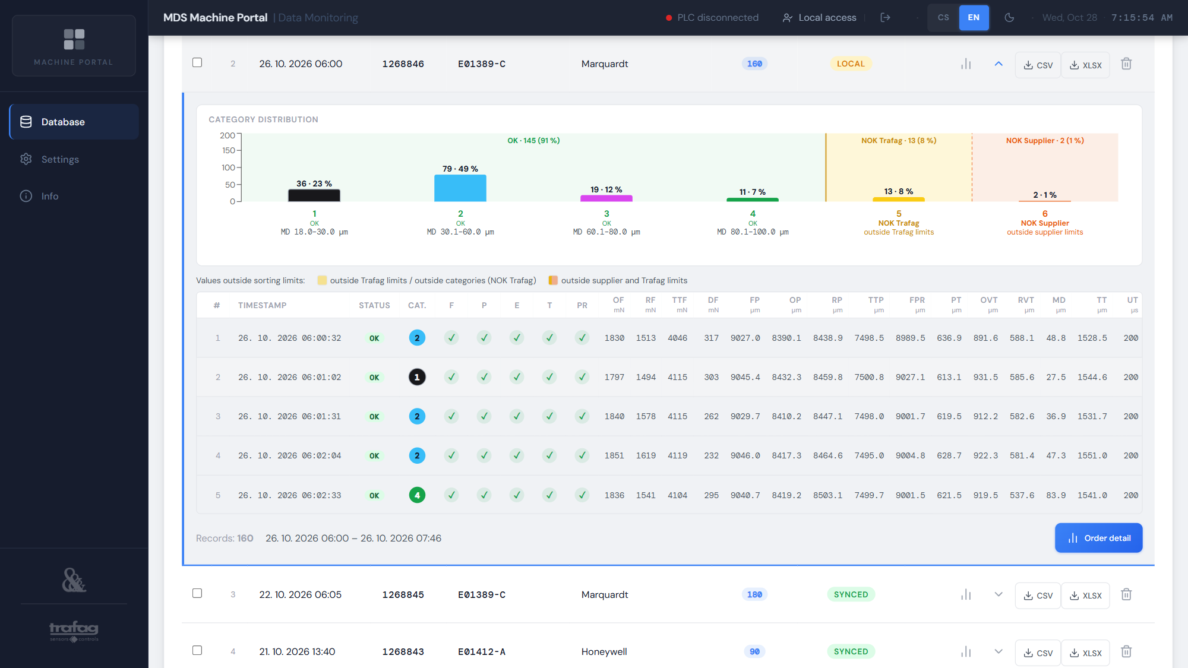
Figure 9 – Order expanded in the list (the piece table scrolls)

3.5 Storage: local, NAS and USB flash drive
The Database header shows three indicators side by side:
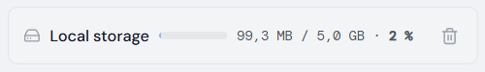
Figure 10 – Local storage
- Local storage — total size of files on the tester PC (in progress, Local and Synced) against the configured limit (default 5 GB). From 80% it turns orange and also appears in the top bar, from 95% red. It also warns when less than 10% of the disk is free (critical below 5%).
- NAS — free and total space of the NAS shared folder (if the folder has a quota on the Synology, the quota is shown). Same thresholds of 80% and 95%. If the NAS fills up, tester data can no longer be uploaded and stays only on the tester PC.
- USB — for an administrator at the tester only: drive letter, usage and free space of the inserted flash drive; the up arrow on the right = Safely remove. Without a flash drive it shows “insert a drive”.
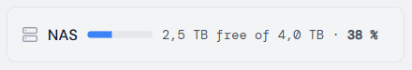
Figure 11 – NAS usage
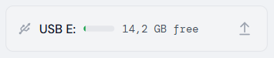
Figure 12 – USB flash drive at the tester with the safe-removal button

Freeing space — Clean synced files
Synchronised orders (Synced) are already on the NAS; any signed-in user at the tester can delete their local copies with the bin button next to the local storage indicator:
- Tap the bin icon next to the local storage indicator.
- The dialog shows how many synced files will be deleted and their total size.
- Confirm with Clean synced files. Every file is verified on the NAS (name and size) before deletion; anything missing or different on the NAS is kept. Local files and the order in progress are never deleted.
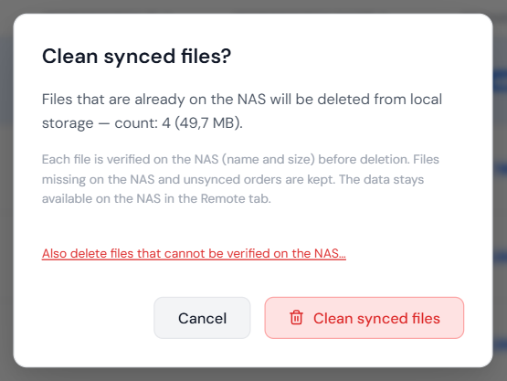
Figure 13 – Confirming clean-up of synced files
Caution: The link “Also delete files that cannot be verified on the NAS…” deletes synced files without checking the NAS. Only use it if you know the data on the NAS is fine (e.g. the NAS is temporarily unreachable and the PC disk is full); the application asks you to confirm the risk.

3.6 Downloading data (CSV, XLSX)
- CSV — the original file unchanged, exactly as written by DatabaseGateway (semicolon separator, UTF-8 with BOM encoding). Suitable for archiving and further processing.
- XLSX — an Excel file built by the server: numbers as numbers (you can calculate with them), time as a date, number formats by unit. For a block production file the layout matches the DatabaseGateway sample order file (sample_production.xlsx) — the tinted blocks Metadata, TestingParameters, SortingCategories and SortingLimits at the top, the Data table with a frozen header and filter below. Even an order with tens of thousands of pieces is ready within a few seconds.
On the tester PC the file is not saved by the browser but to the inserted USB flash drive, in the folder Trafag_ScadaViewer (if a file with the same name exists, it is saved as “… (2)” — nothing is overwritten). Only an administrator (including PLC sign-in) may save. Without a flash drive or permission the buttons are dimmed; tapping them shows the reason and the USB indicator blinks. After saving, remove the flash drive only after Safely remove and the message “Flash drive … can be removed”.
From the office files are downloaded by the browser; for XLSX, Chrome and Edge first open a “Save as” dialog.

3.7 Bulk download
The Download all (N) button in the filter bar downloads all files that match the current filter — the tab (Local / Remote, Production / Testing), the From – To period, or the search; N is their number. After ticking rows, the selection bar offers Download selected. At most 500 files can be downloaded at once; with more, narrow the filter. The order in progress is not included (it is still being written).
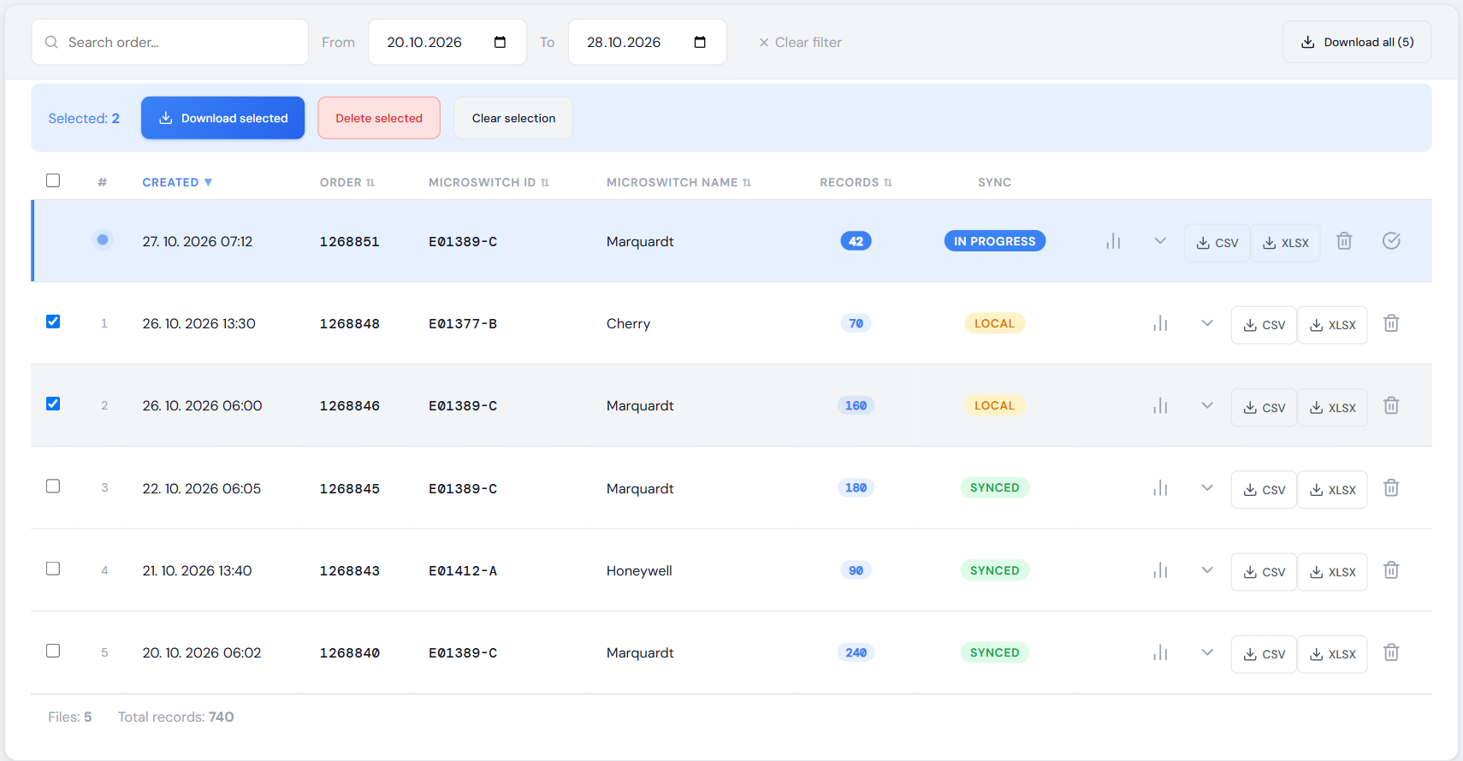
Figure 14 – Selecting files — Download selected, Delete selected
The Bulk download dialog shows the scope, the number of files and their size (approximate for XLSX) and offers the format CSV (original files) or XLSX (Excel).
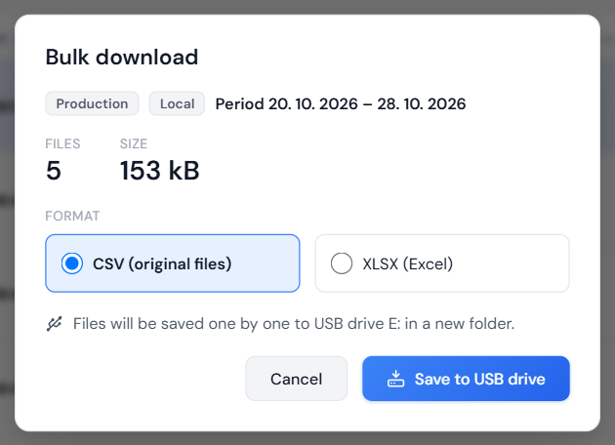
Figure 15 – Bulk download of all orders of a period
- At the tester (administrator): Save to USB drive saves the files one by one to a new sub-folder, e.g. E:\Trafag_ScadaViewer\production_2026-10-20_2026-10-27 (search = production_hledani_<text>, selection = production_vyber_<YYYYMMDD_HHMMSS>). The dialog shows the progress and saving can be cancelled (completed files remain). If the CSV files do not fit on the flash drive, saving does not start at all; for XLSX the space is not checked in advance – if it runs out, the batch stops and the summary shows how many files were saved. At the end there is a summary with any errors and a Safely remove button. While saving, the flash drive cannot be removed and no further batch can be started.
- From the office: Download ZIP downloads one ZIP file containing all files. A file that cannot be read is missing from the ZIP and its name and the reason are listed in the file CHYBY.txt.
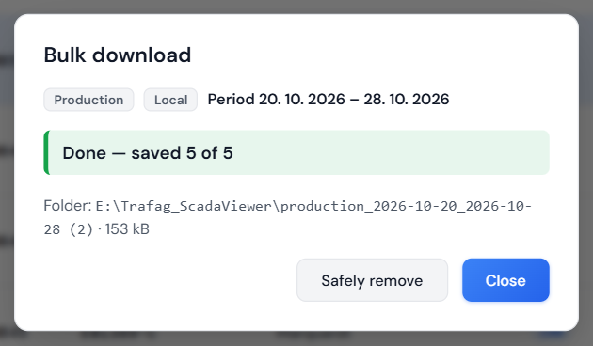
Figure 16 – Summary after saving to the flash drive

3.8 Order in progress: finishing and deleting
Normally the tester (PLC) closes an order — the file then changes to Local and DatabaseGateway uploads it to the NAS. If an order ends unexpectedly on the tester (e.g. power failure) and remains In progress, an administrator at the tester can close it manually with the tick-in-circle button Finish order: the file is closed with all pieces measured so far (an incomplete last row is cut off) and DatabaseGateway uploads it to the NAS within a few minutes.
- An order that the PLC reports as currently running cannot be finished — end it on the tester first.
- If the PLC connection is down, it cannot be verified that the order is not running on the tester; the dialog therefore requires ticking I understand, the order is not running on the machine.
- A finished order cannot be continued — the PLC rejects the next piece of that order (Rejected).
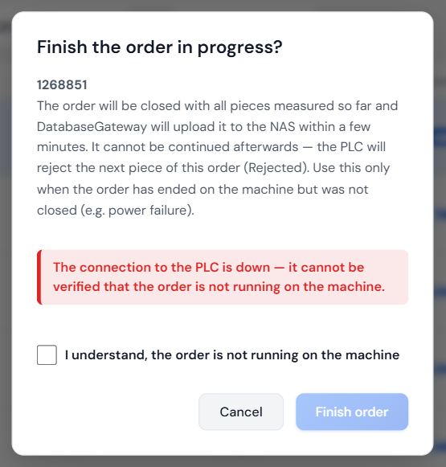
Figure 17 – Finishing the order in progress without PLC connection
An administrator can also delete the order in progress (bin in the row, one at a time only, never in bulk). The data is not on the NAS yet and is lost permanently; if the tester keeps producing the order, the PLC rejects the next piece and the order must be created again. The dialog therefore requires ticking I understand, delete the order in progress.
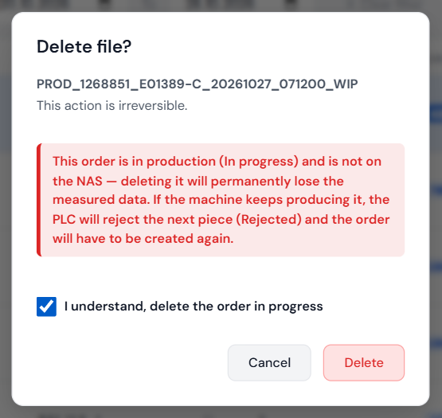
Figure 18 – Deleting the order in progress — confirming the risk

3.9 Deleting files
Only files in local storage can be deleted, and only on the tester PC. Delete one file with the bin icon, several files by ticking them and pressing Delete selected (at most 200 at once; the dialog lists their names). Rules:
- Synced (a copy is on the NAS) — technician and higher.
- Local (not yet on the NAS = the only copy of the data) — administrator only; the dialog warns that the data will be lost permanently.
- In progress — administrator only, one at a time and after confirming the risk (section 3.8).
- If DatabaseGateway is writing to the file at that moment, deletion is refused — try again shortly.
- The application never deletes files on the NAS (Remote tab).
Caution: Deletion cannot be undone.

3.10 Remote storage (NAS)
The Remote tab shows the archive of orders and measurements on the NAS, including older ones no longer on the tester PC. It works the same way as local storage, without the Sync column. Files on the NAS cannot be deleted – the bin icon is shown in the row but the application refuses the deletion. When the NAS is unreachable, a warning appears and the dot on the tab is red — local data keeps working and orders are uploaded once the NAS is reachable again.
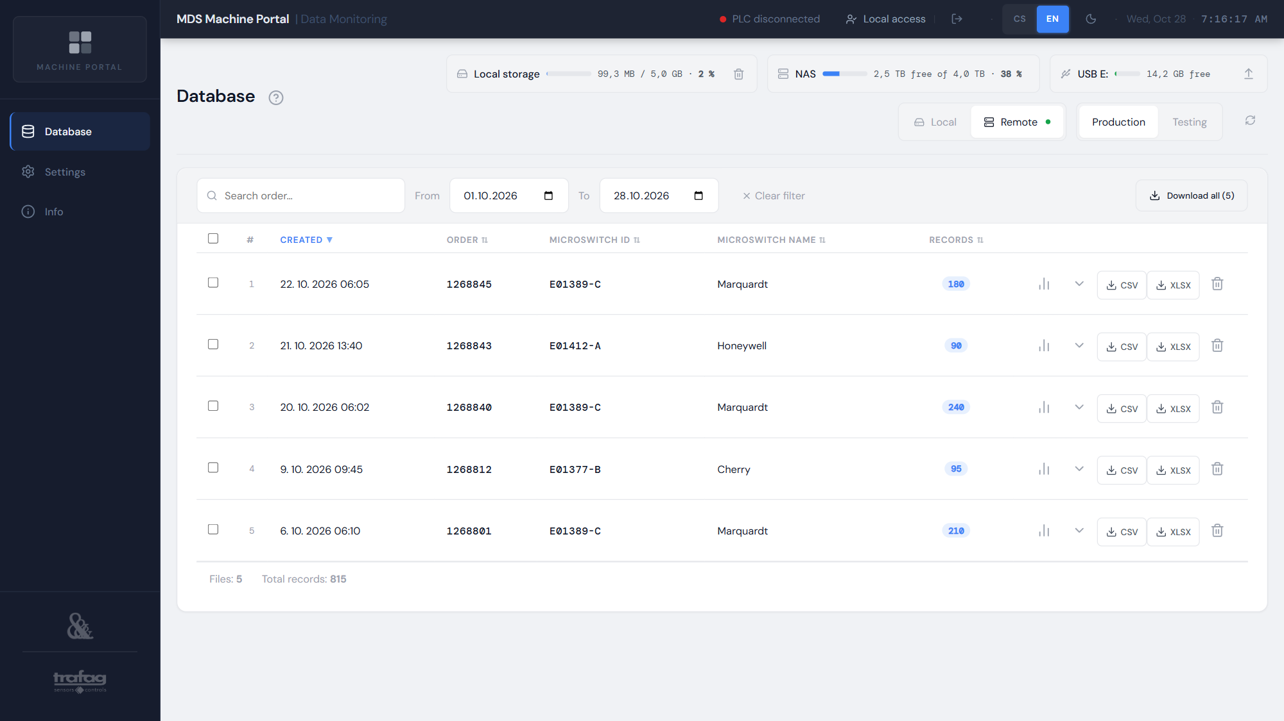
Figure 19 – Order archive on the NAS

3.11 Test measurements (Testing)
The Testing tab lists individual test measurements of a microswitch (name, date, synchronisation state). Tap a row or the chart icon to open the measurement detail (chapter 6).
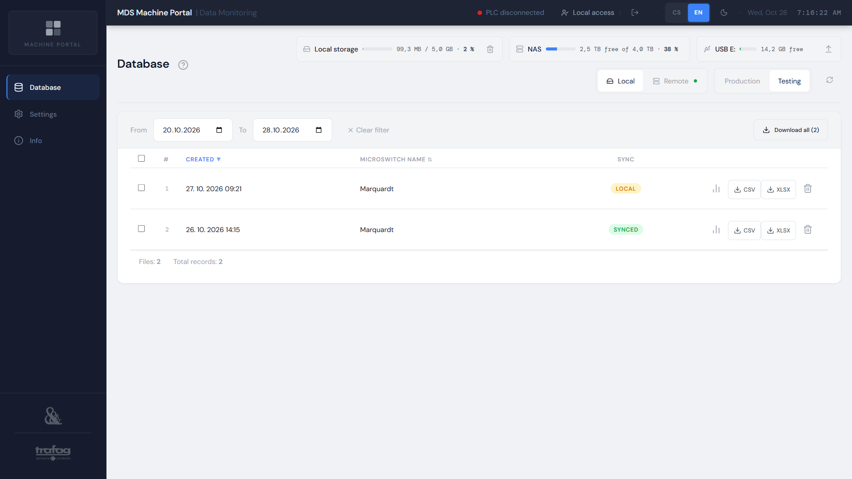
Figure 20 – List of test measurements

4 Order detail
Open the order detail with the chart icon in the order row or the Order detail button in an expanded row. The Back to database button returns you to the same place in the list.
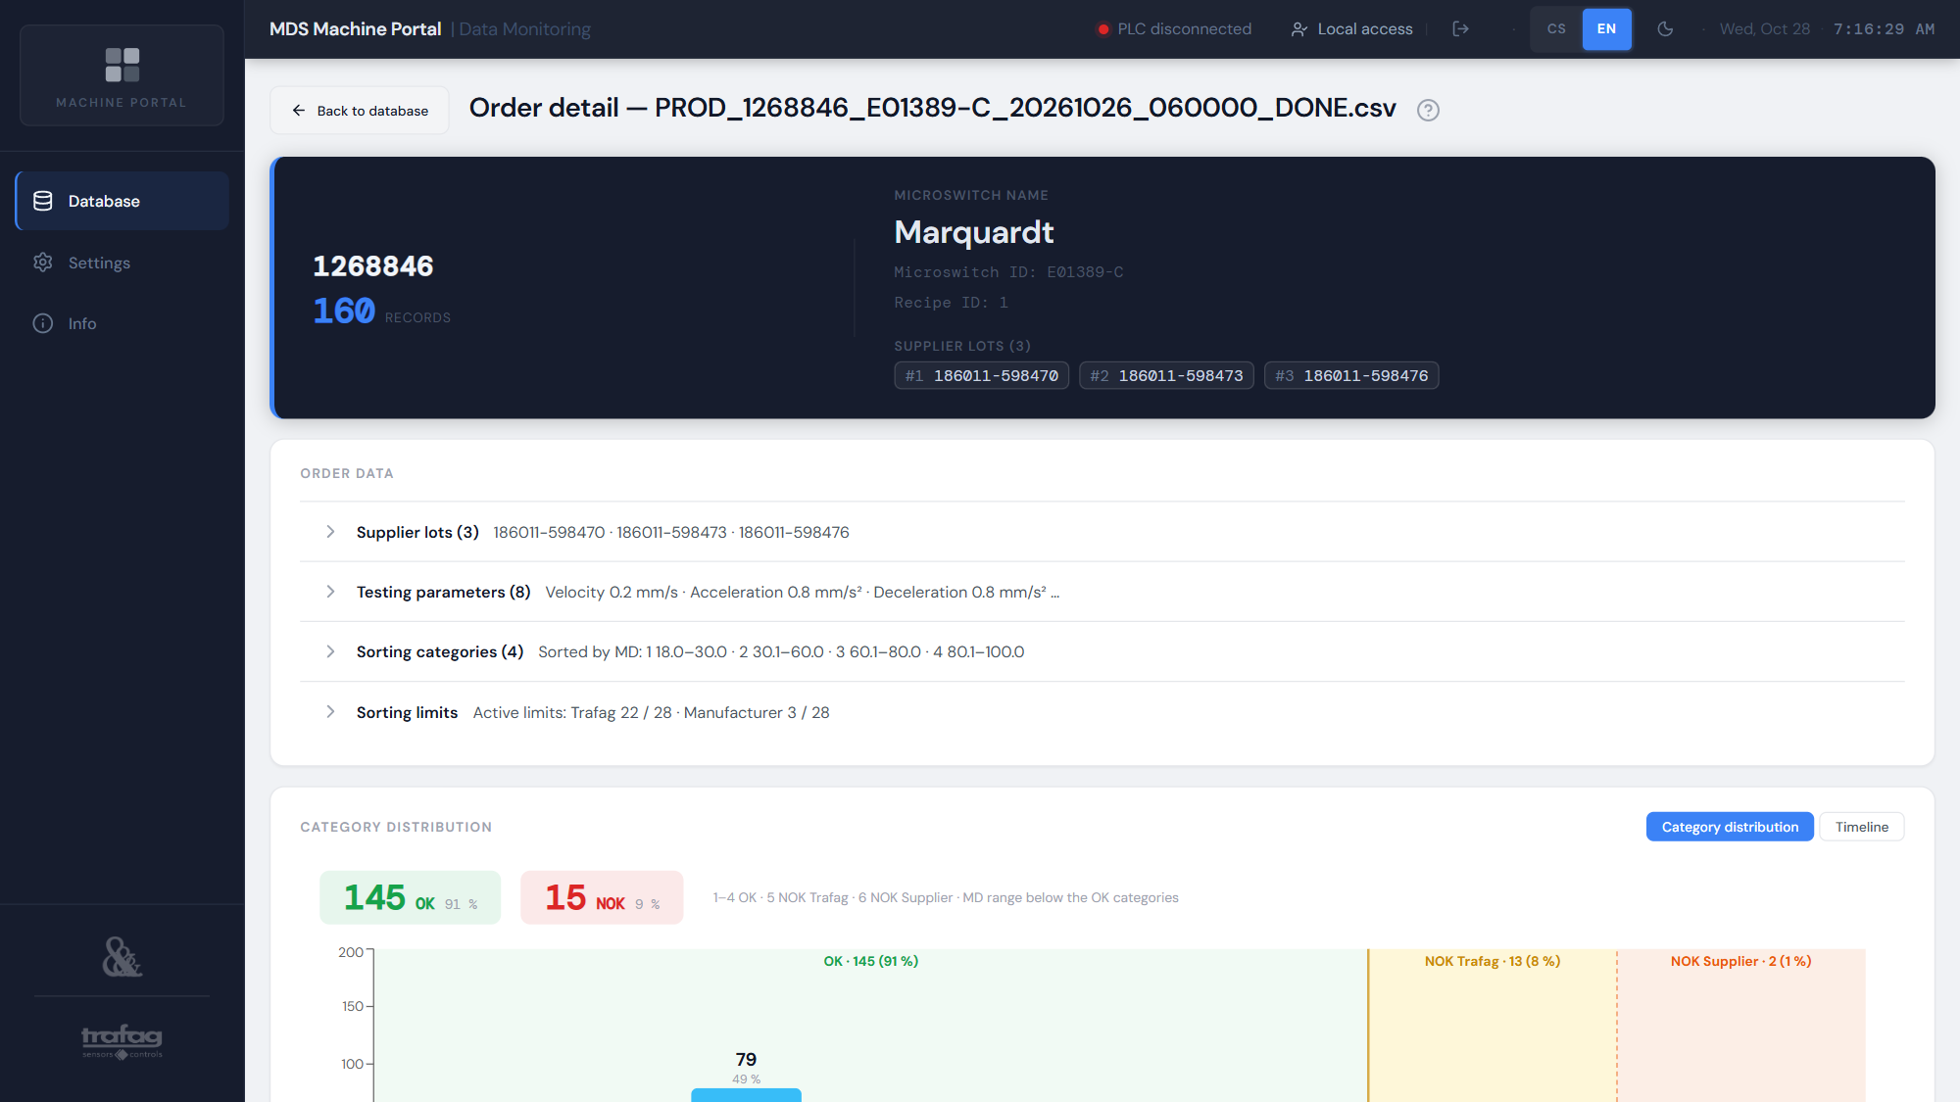
Figure 21 – Order detail — header, order data and category distribution

4.1 Order header
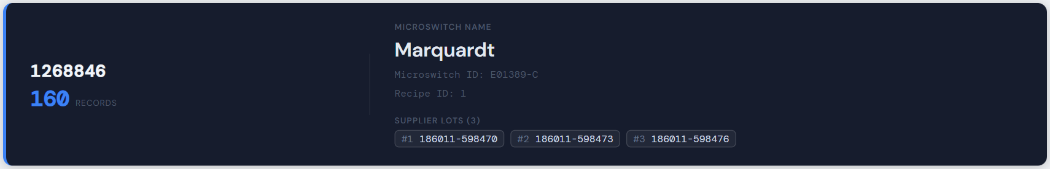
Figure 22 – Order header
Order number and number of measured pieces; on the right the microswitch name and ID, the recipe ID the tester measured with, and the supplier lots of the microswitches. The first three lots are shown; the “+N more” button opens the full list in Order data.

4.2 Order data
The Order data panel summarises the blocks of the order file in expandable rows; each row shows a summary and expands or collapses when tapped:
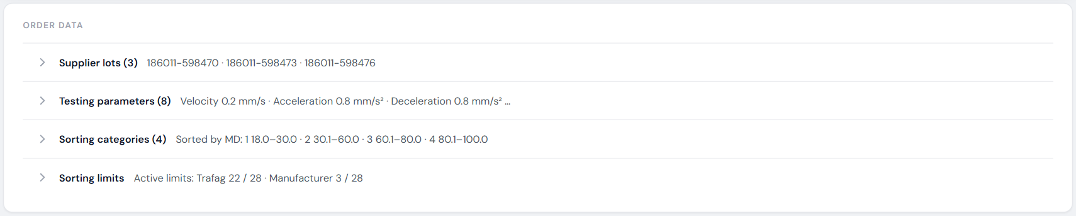
Figure 23 – Order data — collapsed rows with summary
Table 5 – Rows of the Order data panel
Row | Content
Supplier lots | All microswitch lots in order of appearance (the file does not link a lot to a specific piece).
Testing parameters | Parameters the tester measured with: drive velocity, acceleration, deceleration and jerk, maximum force (Max_Force), contact measuring current and voltage and the resistance limit.
Sorting categories | The sorting quantity (usually MD) and the Min / Max limits of categories 1–4. A piece outside all categories but within the limits = category 5 (NOK Trafag).
Sorting limits | For every measured parameter the Trafag (blue) and microswitch supplier (Manufacturer column, orange) Min / Max limits; “—” = limit not active, grey row = parameter without a limit. The All / Active only switch hides parameters without a limit. On a touch screen this is where you find the limits that the piece tables show only on mouse hover (section 4.5).

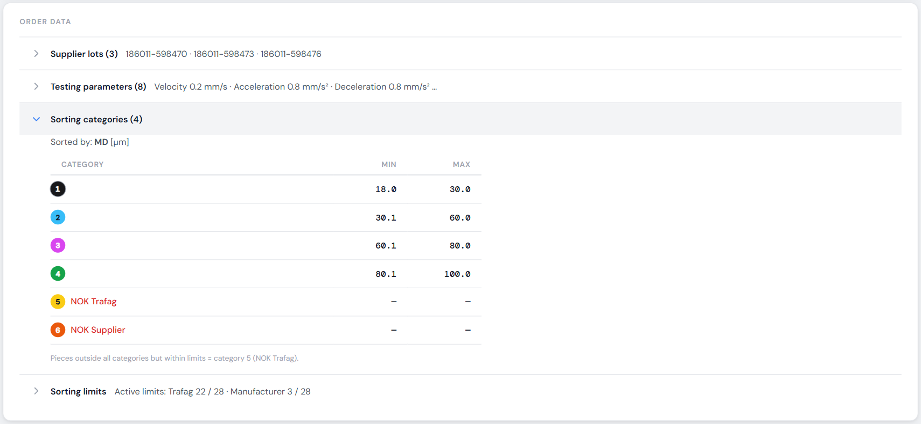
Figure 24 – Sorting categories by MD
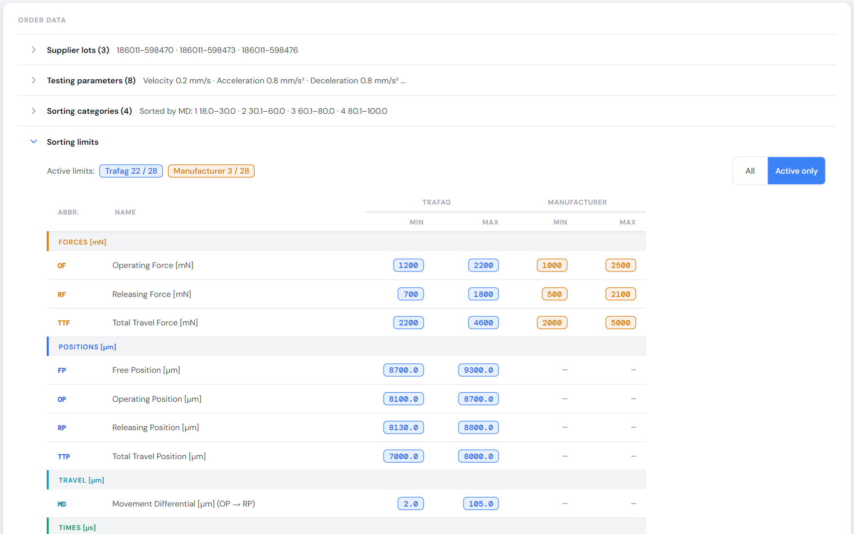
Figure 25 – Sorting limits — active only (detail)

4.3 Category distribution
The chart shows how many pieces were sorted into each category (sorting box). The category colours match the box labels at the tester. The OK band (green) covers categories 1–4, the separate NOK Trafag (yellow) and NOK Supplier (orange) bands categories 5 and 6, each with its total and share. Below the OK categories the range of the sorting quantity (MD) is shown if present in the file. Above the chart is the OK / NOK summary.
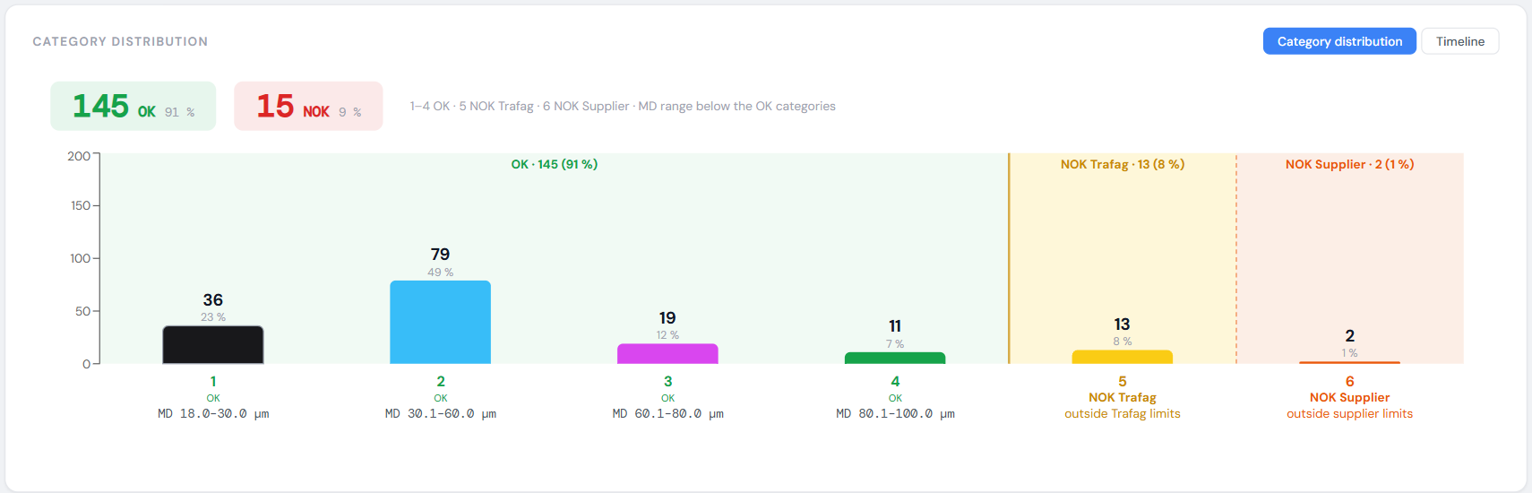
Figure 26 – Category distribution of an order
Table 6 – Sorting categories
Category | Status | Meaning
1 – 4 | OK | The piece passed; the number is the sorting box according to the limits of the sorting quantity (section 4.2).
5 | NOK Trafag | The piece is outside the Trafag limits, or outside all categories 1–4.
6 | NOK Supplier | The piece is outside the microswitch supplier limits.

4.4 Timeline
The Timeline switch shows how production of the order progressed over time: the curve shows the number of pieces produced, flat sections are pauses. Indicators above the chart:
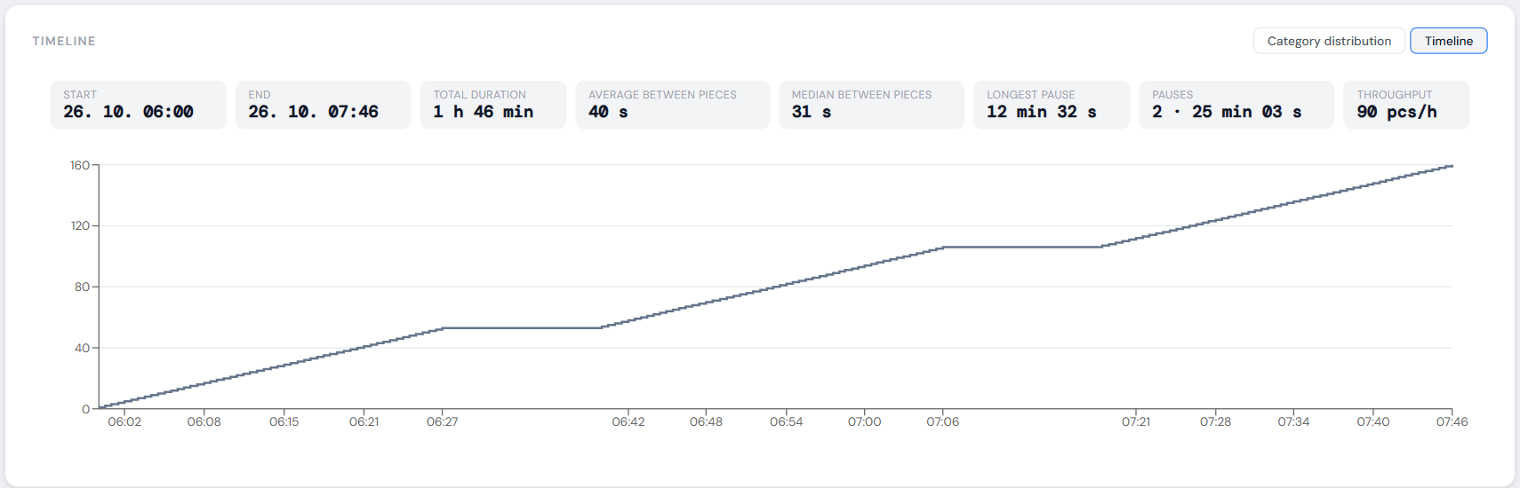
Figure 27 – Order timeline
Table 7 – Timeline indicators
Indicator | Meaning
Start / End | Time of the first and last piece.
Total duration | From the first to the last piece including pauses.
Average / median between pieces | Cycle time of one piece; the median is not affected by pauses.
Longest pause | Longest gap between two pieces and when it occurred.
Pauses | Number and total of gaps longer than 5× the median and at least 1 minute.
Throughput | Pieces per hour over the whole order duration (pauses included).

When the clocks go back at the end of summer time (a repeated hour), the application does not mix up the pieces and extends the order duration correctly.

4.5 Piece table and values outside the limits
Below the chart is the piece table (200 per page). The Forces, Positions, Travel, Times and Electric tabs switch the parameter groups; the record time, category, status and the five NOK categories (columns NOK F – Force, NOK P – Position, NOK E – Electric, NOK T – Times, NOK PR – Process) always stay visible. ✓ = OK, red exclamation mark = the piece failed in that area. Tap a row to open the record detail (chapter 5).
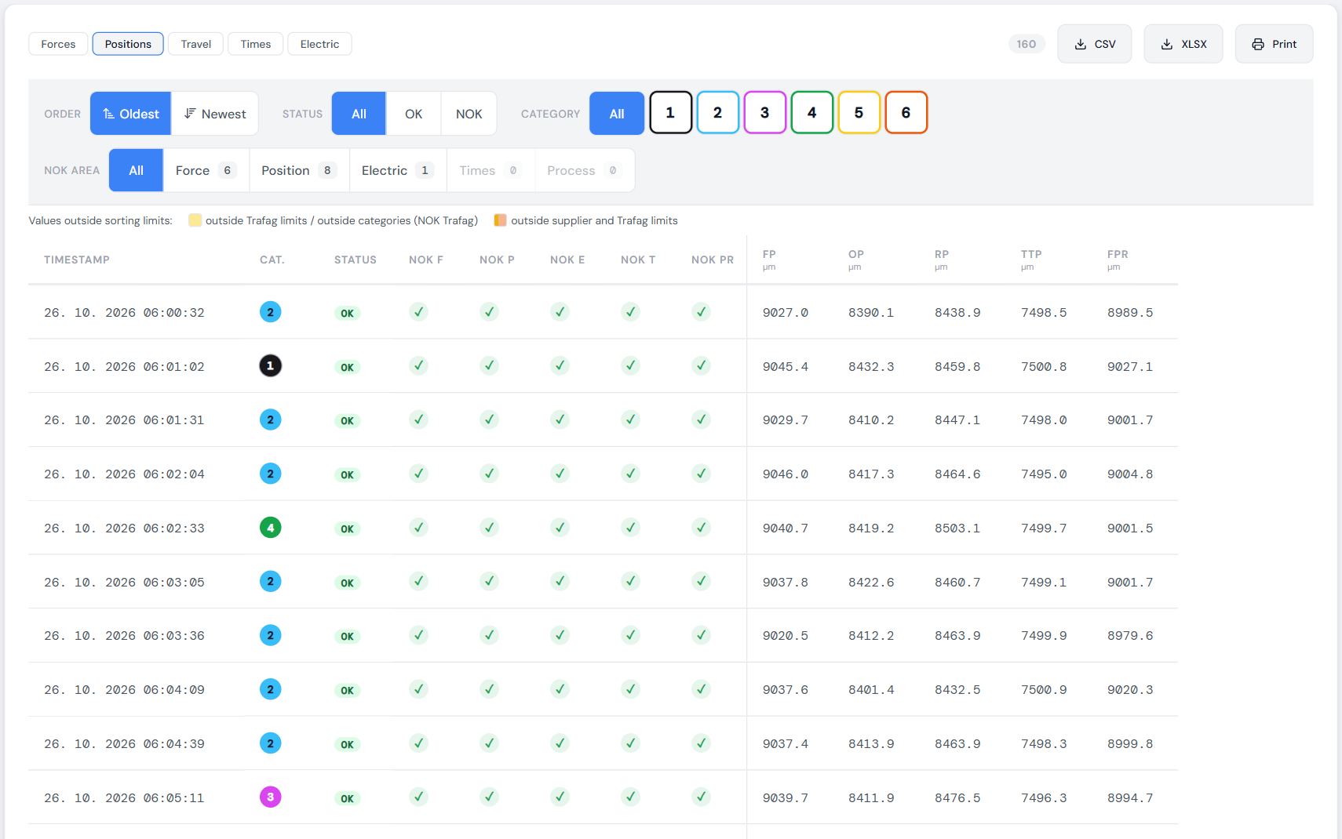
Figure 28 – Piece table — Positions group
Values outside the sorting limits of the order (section 4.2) are lightly tinted; with a mouse, hovering over a value shows the relevant limits (on a touch screen see Order data → Sorting limits). The legend above the table shows only the kinds of tint present in the displayed pieces:
Table 8 – Tinting of values outside the sorting limits
Tint | Meaning
yellow | Outside the Trafag limits, or the sorting quantity (MD) outside categories 1–4 → NOK Trafag.
orange | Outside the supplier limits → NOK Supplier.
orange with a yellow bar on the left | Outside both the supplier and Trafag limits.

4.6 Sorting and filtering pieces
The bar above the table changes the order and selection of pieces; filtering is done by the server, so the counts and paging stay consistent:
- Order (sorting) — Oldest (production order) or Newest.
- Status — All, OK or NOK.
- Category — All, or any combination of categories 1–6 (buttons in the box colours).
- NOK area — All, or Force, Position, Electric, Times, Process: pieces that failed in that area. The number on the button is the count of such pieces in the whole order; with several areas selected, failing in any one of them is enough. An area without NOK pieces is disabled.
- The filter parts are combined (e.g. NOK + category 6 + Electric). With an active filter, “Shown: X of Y” and a Clear filter button are visible. The order header and the category chart still show the whole order.
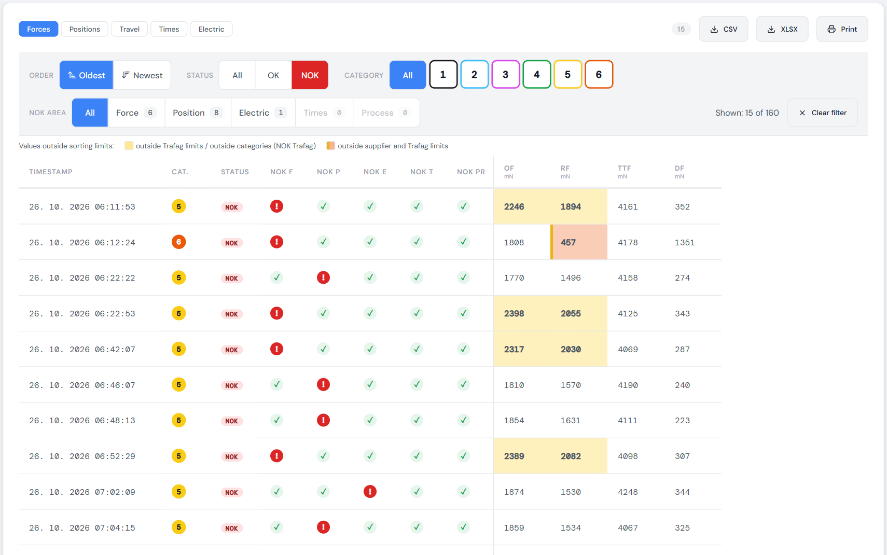
Figure 29 – Filter — NOK pieces only, with values outside the limits tinted
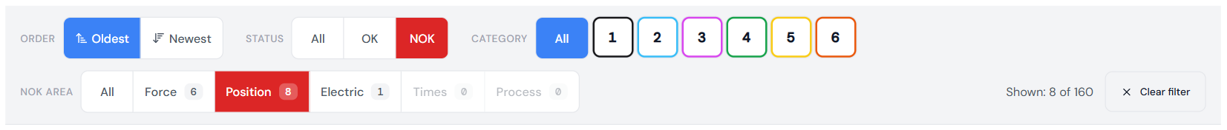
Figure 30 – NOK area filter — pieces failing in Position

4.7 Exporting and printing an order
The CSV and XLSX buttons above the table download the whole order regardless of the filter (section 3.6). The Print button prepares an A4 report: order header and data, OK / NOK summary and tables of all parameter groups for the current page of the table (at most 200 pieces) with the applied filter and sorting. For a larger order or with a filter, the top of the report states which pieces it contains (e.g. “Printed pieces: 1–200 of 4,005 (page 1 of 21)”) and which filter applies; the # column is the position of the piece in the whole order. The report header shows the print time and the signed-in user, the footer the page number. Charts are not included in the order report.

5 Record detail (piece)
The Record detail page shows one measured piece (one record = one row of the order file). Open it by tapping a row in the piece table. The title shows the position of the piece in the order (e.g. 4 / 160); the summary line shows the order, recipe ID, microswitch name and ID, record time, category and OK / NOK status. It is used to assess why the piece was sorted into its category.
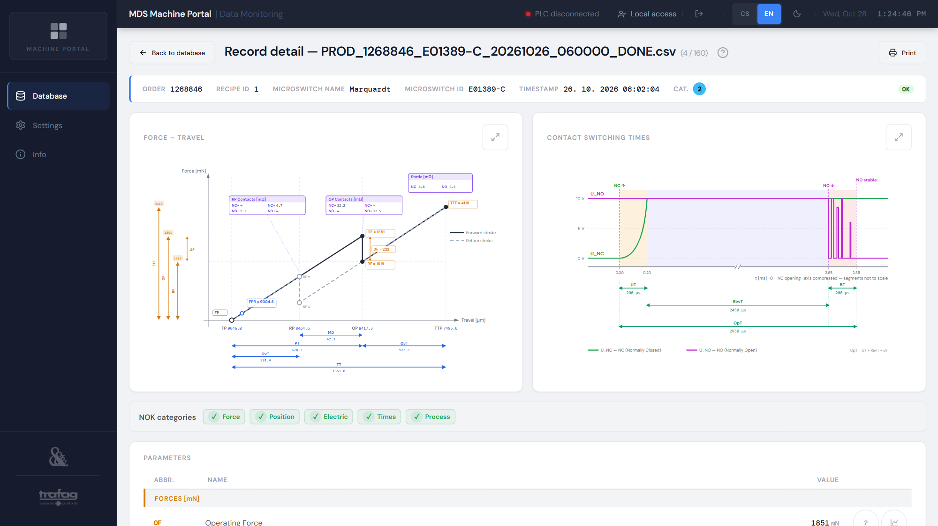
Figure 31 – Record detail — force–travel and switching time diagrams

5.1 Force–travel diagram
Schematic hysteresis loop of the microswitch with the values of this piece. The solid line is the forward stroke (actuation), the dashed line the return stroke (release). The horizontal axis is the actuator position (free position FP on the left, end of travel TTP on the right), the vertical axis the force.
Table 9 – Points, travels and forces in the force–travel diagram
Item | Definition
FP | Free position of the actuator without external force.
OP | Operating position on the forward stroke – the first closing of the NO contact.
RP | Releasing position (return changeover of the NC contact) on the return stroke.
TTP | End of travel — the deepest point of actuation.
FPR | Free position return — where the force drops to zero on the return stroke; close to FP for a good piece.
PT | PT = FP − OP (pre-travel)
OvT | OvT = OP − TTP (overtravel)
MD | MD = RP − OP (movement differential, positional hysteresis)
RvT | RvT = FP − RP = PT − MD (releasing travel, Leerlaufweg according to DIN 41636-1)
TT | TT = FP − TTP (total travel)
OF / RF / TTF | Force at OP, at RP and at the end of travel.
DF | DF = OF − RF (differential force, force hysteresis)
OP / RP Contacts | Resistances of the NC and NO contacts just before (−) and just after (+) the changeover at OP and RP.
Static | Static resistance of the closed NC and NO contact outside the changeover.

5.2 Contact switching times
The voltage of the NO (top) and NC (bottom) contacts during the changeover, similar to an oscilloscope. Time 0 is the start of opening of the NC contact. Marked times:
- UT (Unstable Time) — instability of the NC contact: from the start of opening until it is stably open.
- RevT (Reverse Time) — transfer time during which both contacts are open: from the stable opening of NC to the first touch of the NO contact.
- BT (Bounce Time) — bouncing of the NO contact from the first touch until it is stably closed.
- OpT (Operating Time) = UT + RevT + BT — total switching time.
Segments are to scale; if one is much longer than the others, the axis is shortened (“//” mark) — the values in the dimensions always apply.
Use the arrows button in the corner of a diagram to enlarge it to full screen.

5.3 NOK categories and parameter table
Below the diagrams are the five NOK categories (Force, Position, Electric, Times, Process) and a table of all parameters in the Forces, Positions, Travel, Times and Electric groups: abbreviation, name, value with unit. “—” = value not determined, ∞ = open contact (resistance above 999.9 mΩ). Values outside the order limits are tinted as in the piece table.
The ? button next to a parameter shows its description and calculation. The chart button (Show in chart) opens a diagram in which the parameter is highlighted together with the points it is calculated from; all other elements are dimmed. The diagram is schematic with the values of this piece.
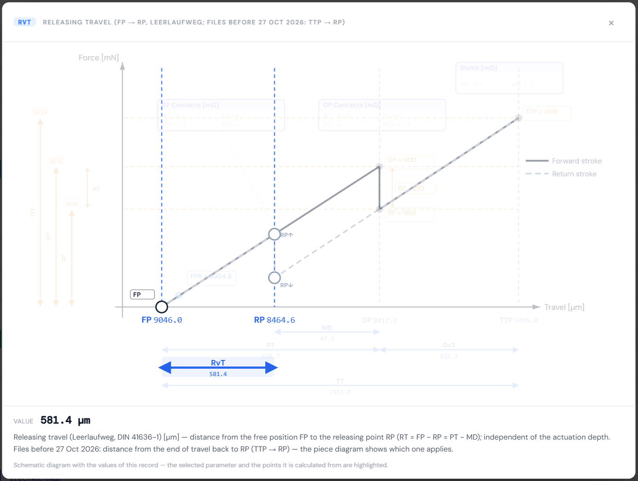
Figure 32 – Graphical explanation of the RvT parameter

5.4 Printing a record report
The Print button creates an A4 report with both diagrams and the parameter table; the Back to database button returns to the previous page (order detail or Database) at the same position.
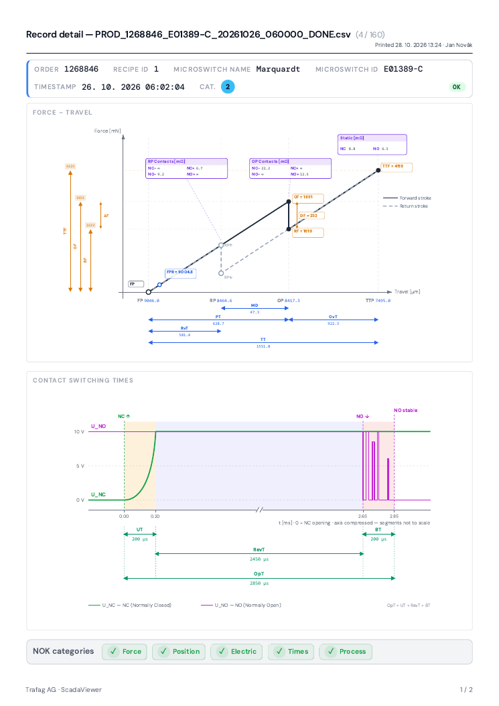
Figure 33 – Printed record report (page 1)
Tip: All parameters and their abbreviations are described in Appendix A, terms in Appendix B.

6 Measurement detail (Testing)
A test measurement is a detailed measurement of one microswitch including the raw signals. The header shows the name, the microswitch ID and recipe ID, the measurement time and duration and the OK / NOK result. The result is determined by the NOK categories: if the measurement fails in any area, it is NOK. The content is divided into tabs; the CSV, XLSX and Print buttons are on the right.
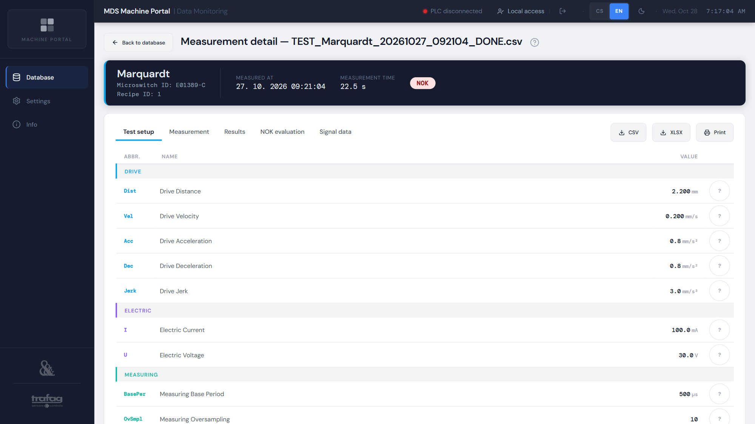
Figure 34 – Measurement detail — Test setup
Table 10 – Measurement detail tabs
Tab | Content
Test setup | Test inputs: drive distance, velocity, acceleration, deceleration and jerk, contact measuring current and voltage, sampling (base period in µs, oversampling, samples reserve) and safety limits for distance and force.
Measurement | Measurement duration, the time recorded by the controller and (in newer files) the calibration constant C.
Results | Evaluated parameters — the same table as for production, including “?” and the parameter chart.
NOK evaluation | Result and the status of the five NOK categories.
Signal data | Charts of the measured signals (section 6.1).

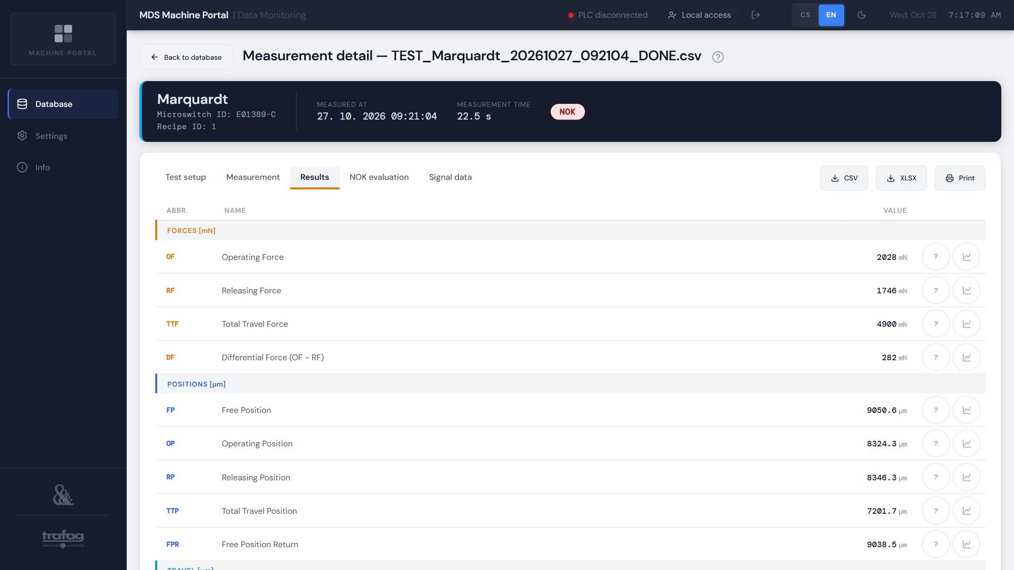
Figure 35 – Measurement results
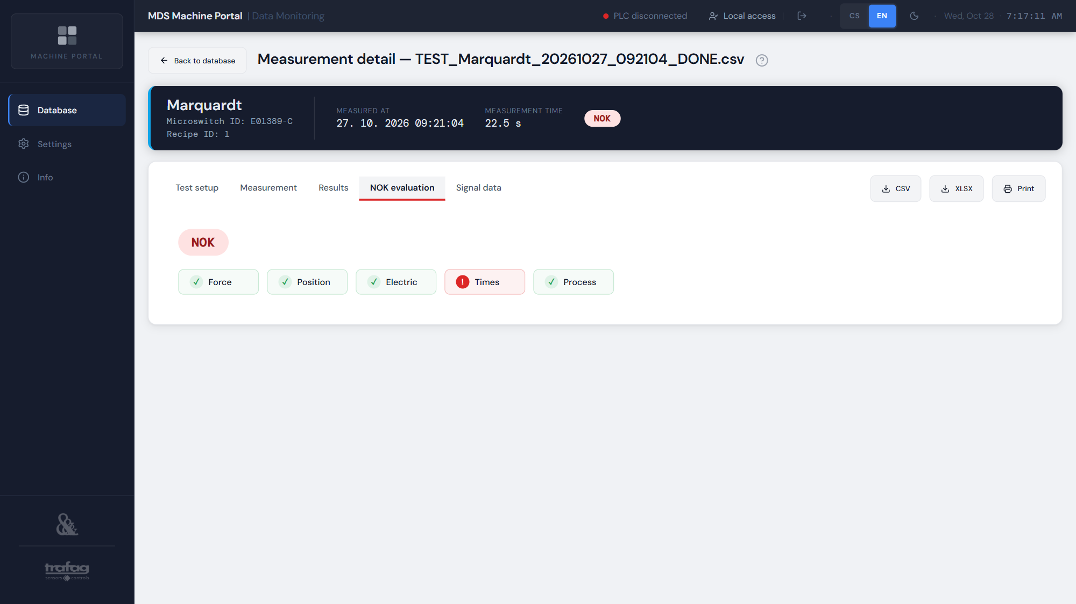
Figure 36 – NOK evaluation — the measurement failed in the Times area

6.1 Signal data
The Signal data tab shows the measurement in charts; the number of samples is at the top right. Positions use the same coordinates as the results (height above the mounting-hole axis, C in the axis label). The RP point is determined electrically — by the NC contact changeover at a threshold of 50% of the U_NC voltage range, as in the analysis. The OP point is the first closing of the NO contact (position taken from the results table). The charts have five sub-tabs:
Table 11 – Signal data sub-tabs
Sub-tab | What it shows
Overview | Position, force, contact voltage, current and resistance over time for the whole measurement.
Results | Position and force with the FP, OP, TTP, RP and FPR points marked, plus a table of analysis results.
Hysteresis | Force versus position for the forward and return stroke.
Switching detail | Voltage, current and force around the OP and RP points at high resolution.
Timing detail | Contact voltage and current with the UT, RevT, BT and OpT times marked.

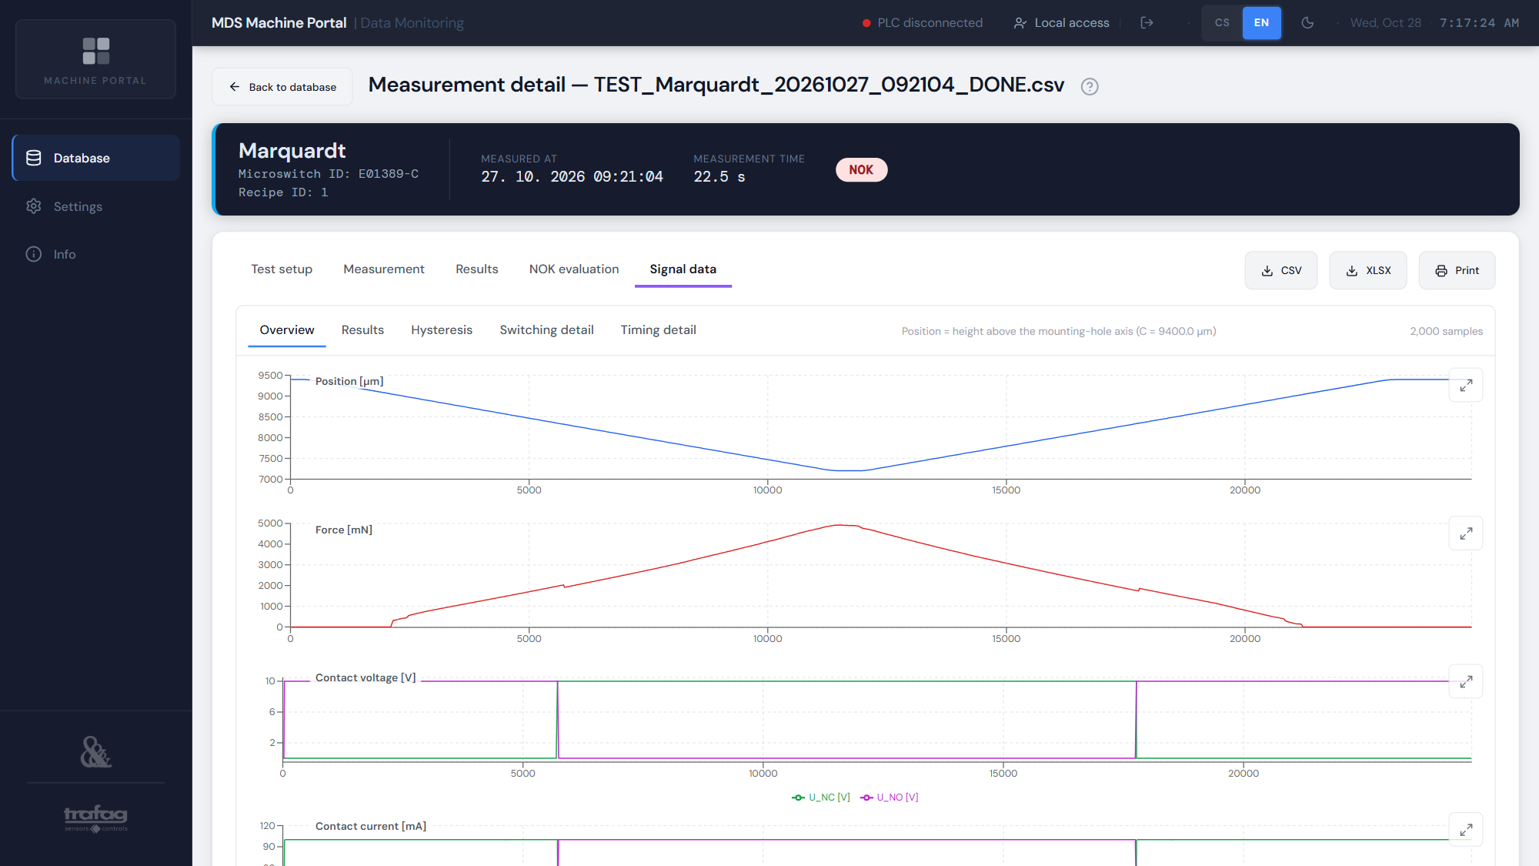
Figure 37 – Signal data — Overview
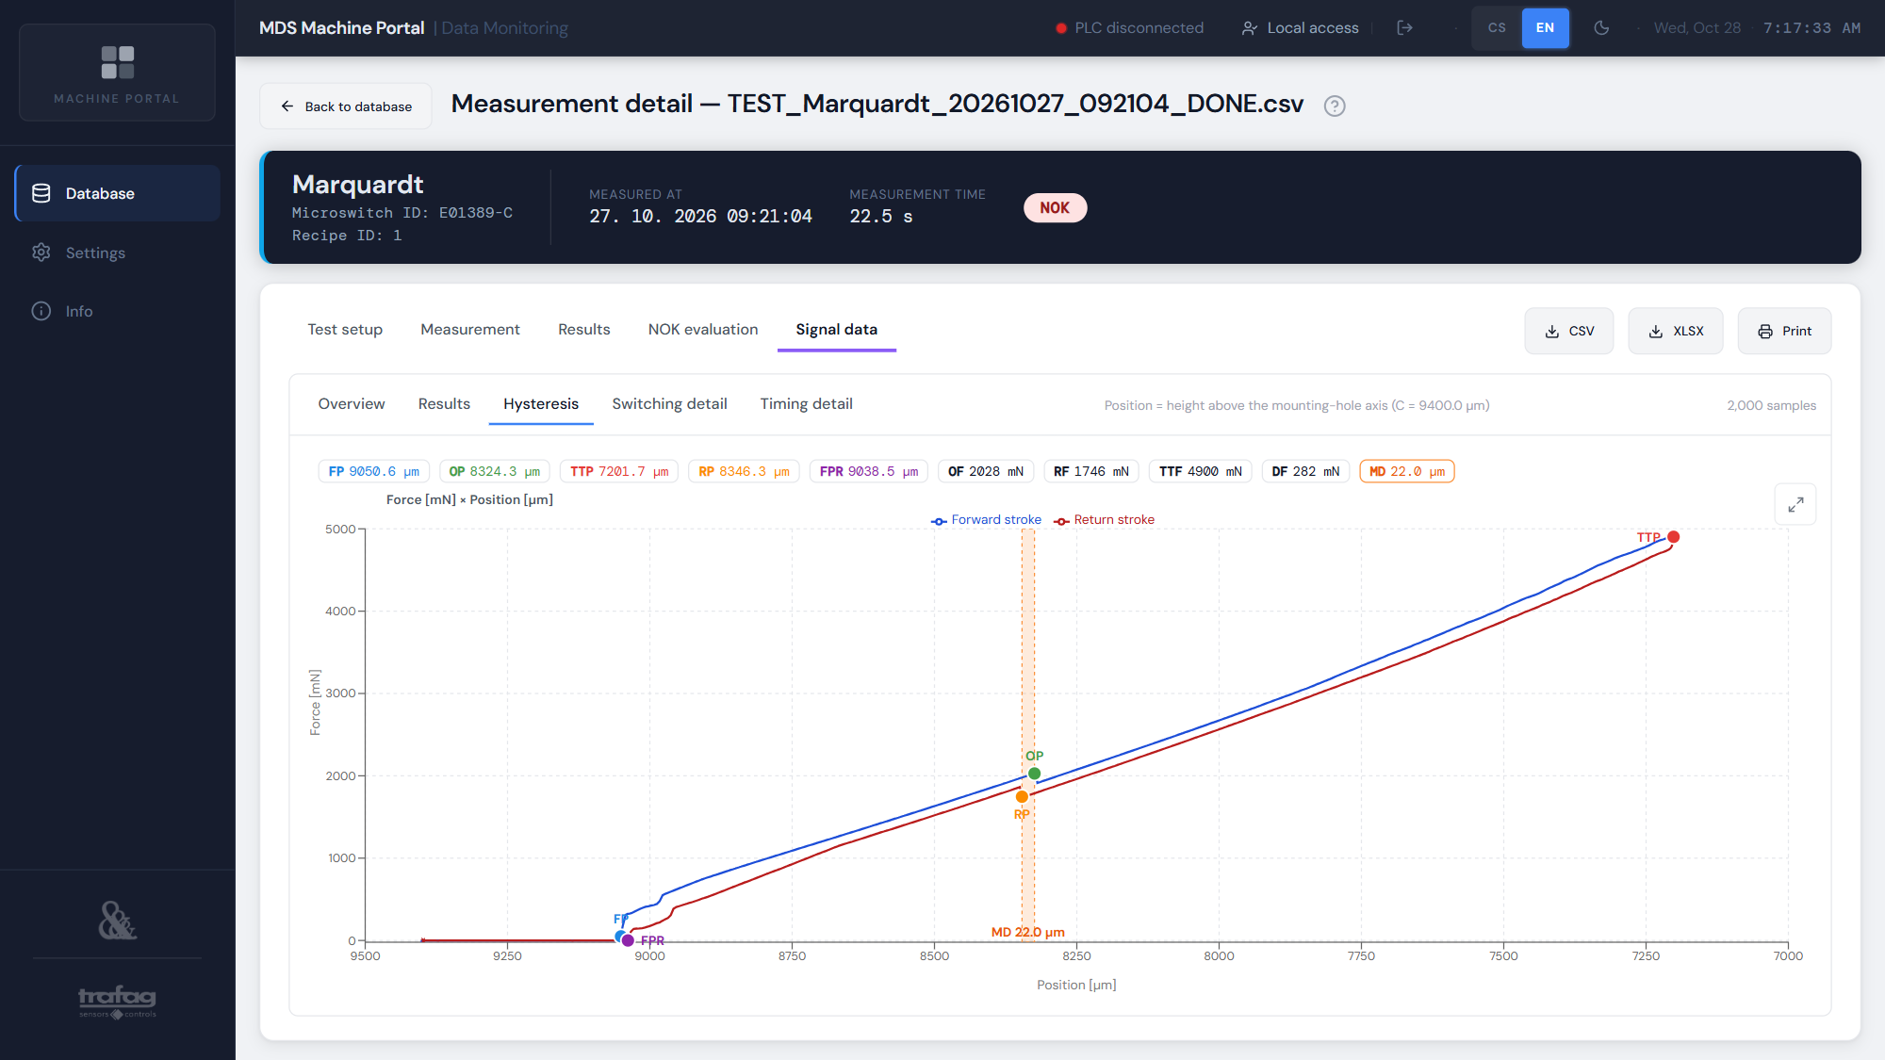
Figure 38 – Signal data — Hysteresis
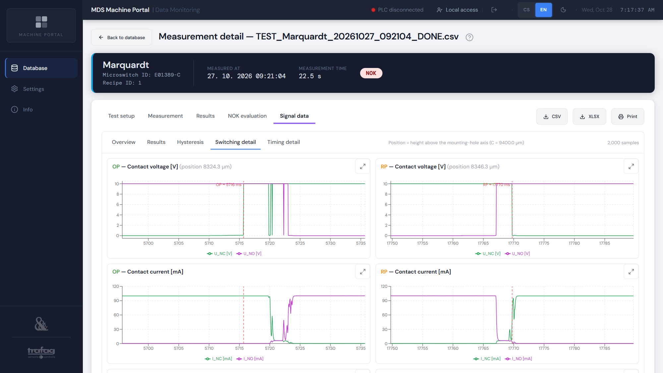
Figure 39 – Signal data — Switching detail
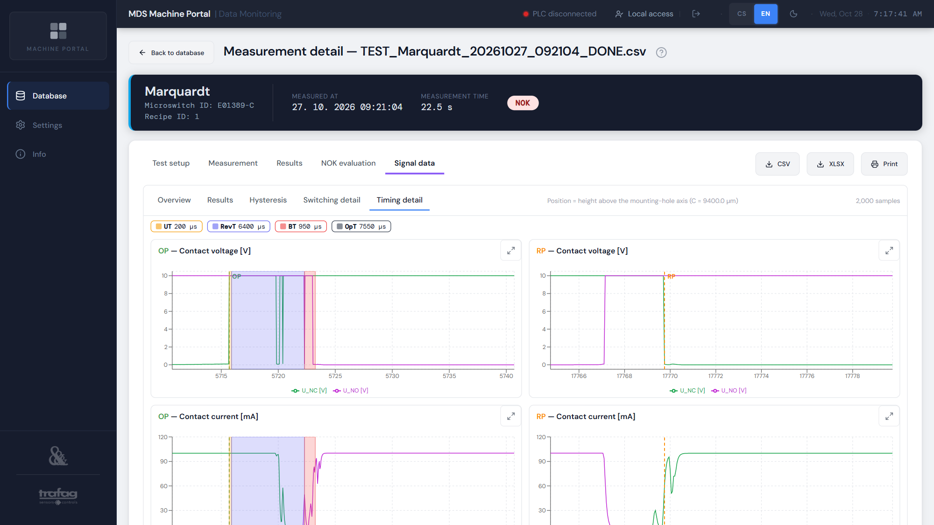
Figure 40 – Signal data — Timing detail (UT, RevT, BT, OpT; definitions in section 5.2)

Zooming a chart
- Ctrl + mouse wheel or two fingers on a touch screen — zoom the time axis. The zoomed section is loaded at full resolution (without decimation).
- Drag — move the zoomed section.
- Double-click — return to the default view.
- Arrows button in the corner of a chart — full screen (the wheel works without Ctrl here); close with Esc.

6.2 Printing a measurement report
The Print button (or Ctrl + P) prepares a report with all tabs — setup, measurement, results, NOK evaluation — and all five signal data charts. Preparing the charts takes a few seconds (the button shows “Preparing print…”), then the browser print dialog opens.

7 Settings
The page has four tabs: Preferences, Connection, Time / NTP and Users (Administrator and Manufacturer at the tester only). The ⓘ icon next to a row shows help for that setting.

7.1 Preferences
Table 12 – Preferences
Preference | Options
Language | Čeština / English
Theme | Dark / Light (dark reduces eye strain during night shifts).
Files per page | 10, 25 or 50 (default 50).
Auto-refresh | 15, 30 or 60 s (default 30 s). After a change in local storage the list additionally refreshes within a few seconds.
On-screen keyboard | Automatic (tester PC only) / On / Off.

Preferences are stored in the browser, so each computer can have its own.
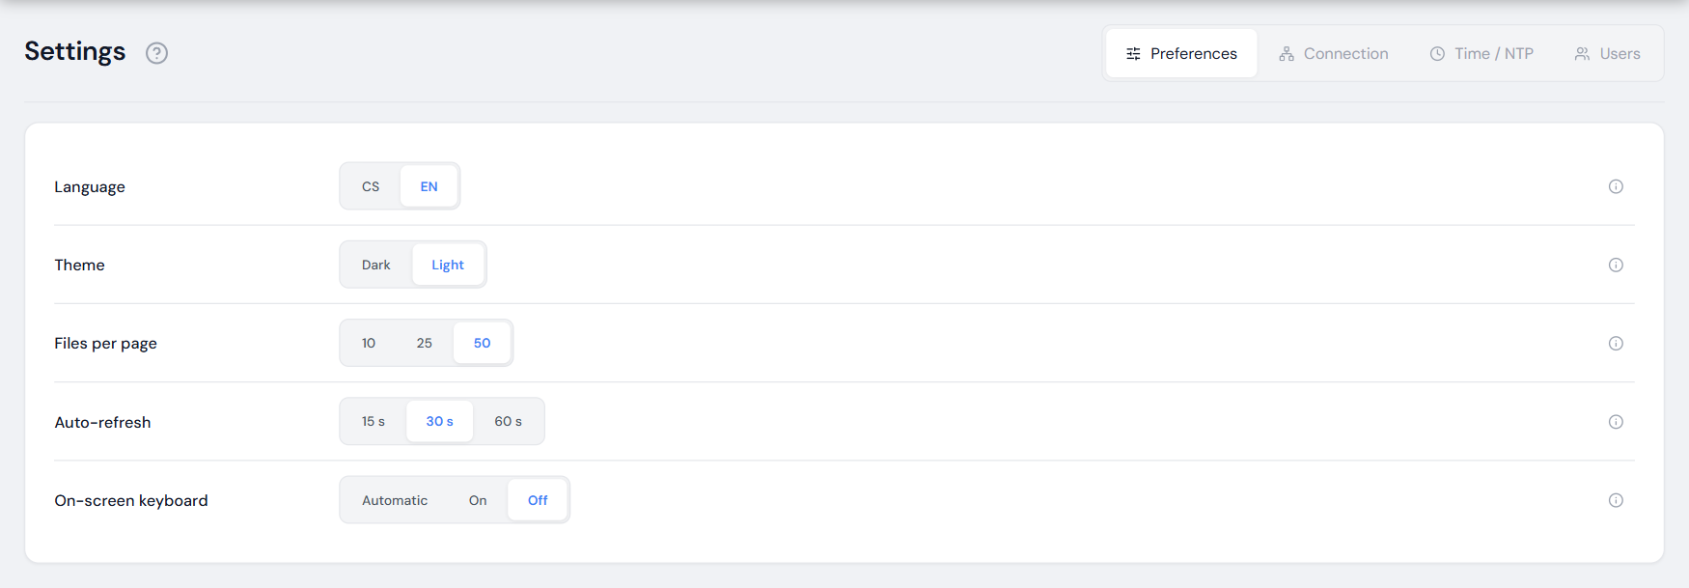
Figure 41 – Settings — Preferences

7.2 Connection
Status of the connection to the TwinCAT 3 PLC (ADS, AMS Net ID and runtime port), availability and path of local storage (the folder DatabaseGateway writes to), usage and limit of local storage, availability and network path (UNC) of the NAS and the NAS usage. NAS availability is checked every 30 s. Only an administrator at the tester can change the paths and the limit; confirm a change with Save – it takes effect immediately and is saved in the configuration. The folder-icon button (Browse) picks the local folder by browsing the disk.
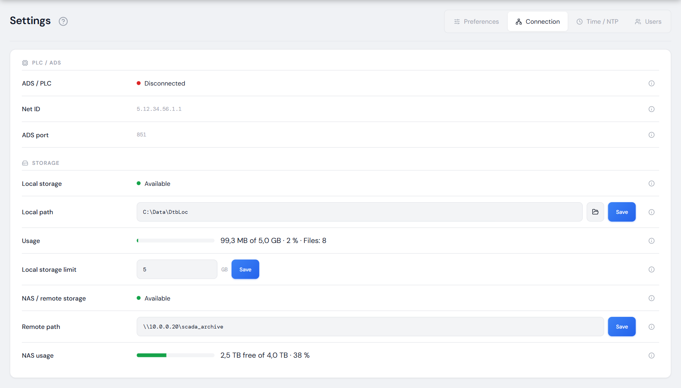
Figure 42 – Settings — Connection

7.3 Time / NTP
The tester PC acts as the NTP server from which the other industrial PCs (IPCs) of the tester take their time; all new records are also time-stamped with it. The top of the page states whether the IPCs can take their time from this PC — and if not, why (Windows Time service not running, NTP server disabled, UDP port 123 not listening, the PC not announcing itself as a reliable source). Below are the PC time, where the PC takes it from and the address for the IPCs — on the IPCs set the PC address in the tester network as the NTP server. Service details (time zone, difference to the device you are viewing from, service state, stratum, the output of w32tm /query /status) are in the collapsed Technical details.
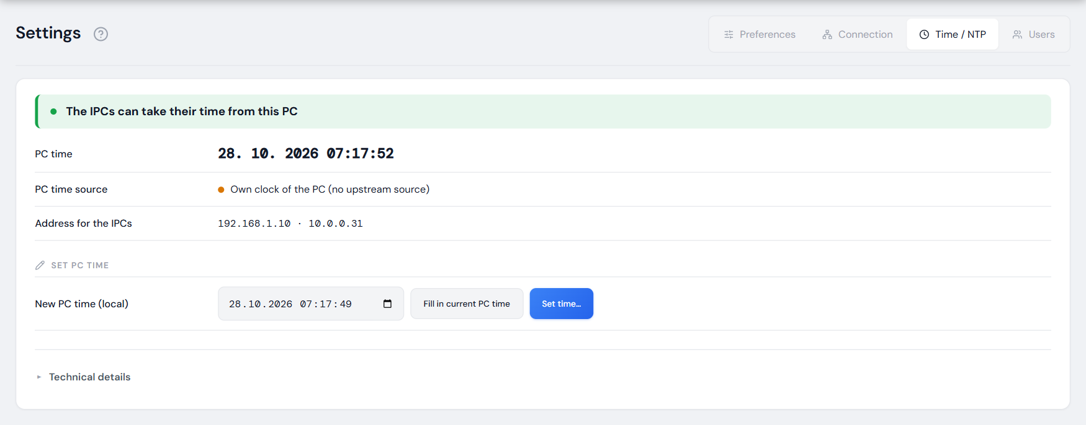
Figure 43 – Settings — Time / NTP
Setting the PC time is reserved for an administrator at the tester: enter the new local time (the Fill in current PC time button inserts the current one), press Set time… and confirm I understand, set the PC time in the dialog showing the difference. The IPCs adopt the new time and new records are time-stamped with it; a jump forward of more than 8 hours signs out all users. If the PC synchronises from an upstream source, a manually set time is overwritten at the next synchronisation (the application warns).
Note: The account the ScadaViewer service runs under needs the “Change the system time” right (secpol.msc → User Rights Assignment). Without it the application refuses to set the time and explains why.

7.4 Users
The tab is available only to the administrator and the manufacturer on the tester PC (it is not shown from the office). It shows the user name, display name and role of the accounts and lets you add a user, change a password and delete an account. Rules:
- A new account may have at most the same role as the user creating it.
- Another user’s password can be changed and their account deleted only for an account with a lower role (this also applies to the Manufacturer role). Your own password is always changed with the current password; after the change you are signed out.
- Operators and technicians do not see the Users tab and therefore cannot change their password in the application themselves – an administrator sets a new one for them. From the office the tab is not shown to anyone.
- Confirm deletion of an account by tapping Really delete?. Neither your own account nor the last user can be deleted. A deleted user is signed out immediately.
- The name plc_operator is reserved for sign-in via the PLC.
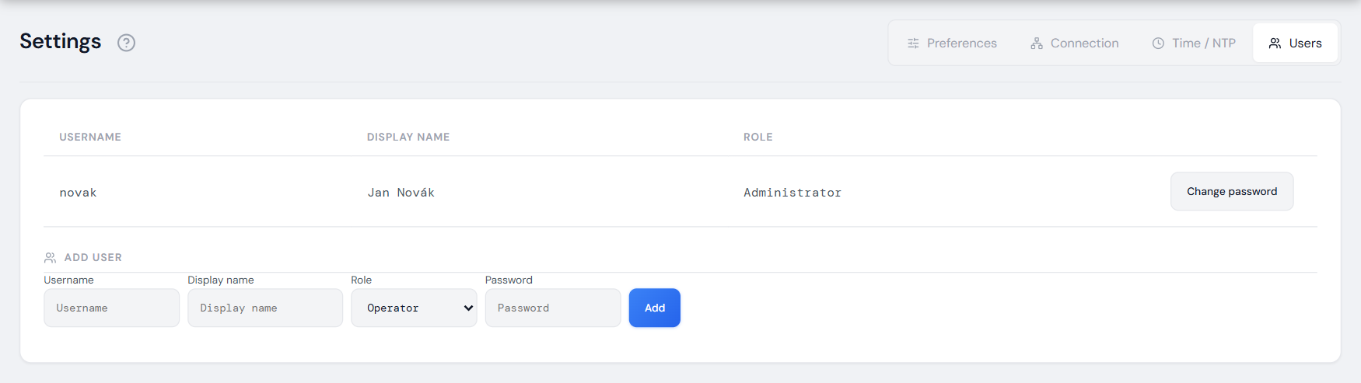
Figure 44 – Settings — Users

8 Info
The Info page shows the application version (reported by the server), project number, customer, supplier and contact; the Documentation tab contains a brief description of the application and a reference to the Instructions for Use (this document) and the Technical Manual. Please quote the version when reporting a problem.
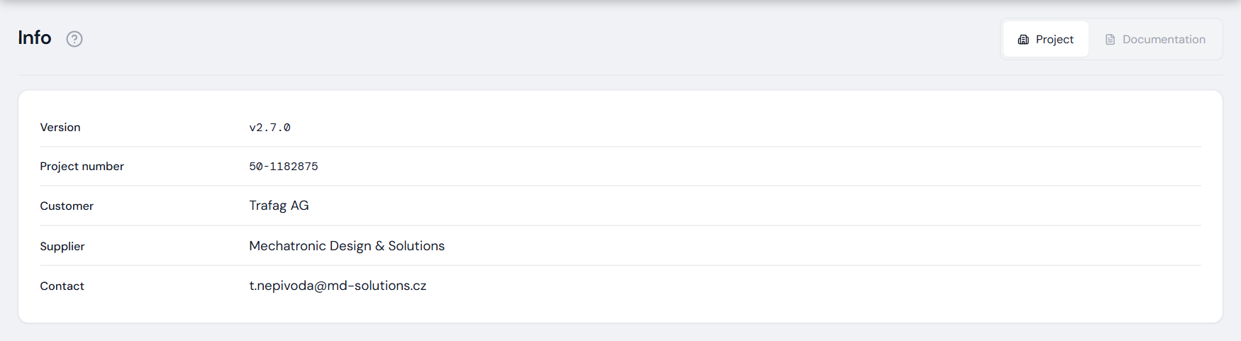
Figure 45 – Info page

9 Troubleshooting
Table 13 – Common situations and how to resolve them
Situation | Cause and solution
“PLC disconnected” in the top bar | The tester controller is unreachable (switched off, restarting, cable unplugged). Database data can still be viewed; a PLC sign-in ends. The connection is restored automatically.
Red bar “Server unavailable” | The browser lost the connection to the application server (PC or service restart, network outage). The bar disappears by itself; if it persists, contact your administrator.
The Remote tab is unavailable | The NAS cannot be reached on the network. Local data keeps working and orders will be uploaded once the NAS is reachable.
An order is missing in the Database | Check the From / To filter (default: today and yesterday) and the Local / Remote and Production / Testing switches, or search for the order by number (searches the whole archive).
“…” instead of the number of records | The count is being calculated in the background and fills in by itself (for large files on the NAS depending on network speed).
CSV / XLSX buttons are dimmed at the tester | No USB flash drive is inserted or the signed-in user is not an administrator. Insert a flash drive or sign in as an administrator.
The flash drive cannot be removed safely | A file on the flash drive is open (e.g. in Excel) or a bulk save to it is in progress. Close the file / wait for completion and try again.
“Not enough space on the flash drive” | Use a larger or empty flash drive, or narrow the bulk download filter.
Finish order reports “The order is running on the machine” | The PLC reports the order as active. End it on the tester; only an order that was not closed after an outage is finished manually.
“Session expired” | A password sign-in ends at the tester after 15 minutes of inactivity and always after 8 hours at the latest. Sign in again.
Cannot sign in from the office — “default password” | The account still has the default password. An administrator sets a new password for it at the tester (Settings → Users → Change password); an administrator account changes its own password there.
An operator or technician cannot change their password | The Users tab is available only to administrators and manufacturers at the tester. An administrator sets the new password (section 7.4).
Sign-in is blocked | After 5 wrong passwords, sign-in from that computer is blocked for 10 minutes. Wait and try again.
Storage filling up warning | Free up space with Clean synced files (section 3.5). If only Local files remain, check the NAS connection.
The IPCs do not take the time from the tester PC | Settings → Time / NTP shows the reason; the fix is described in the deployment documentation (in Czech, section „Čas PC — NTP server pro IPC“ – PC time, NTP server for IPCs).
Cannot delete, finish an order or change settings | You are connected from another computer (Remote access · view only label), or you do not have the required role (Table 2, section 1.4).

Appendix A Parameter overview
Parameter abbreviations and names are shown in English in the application (technical names as used by the customer). Value format: forces in mN (integers), positions and travels in µm with a resolution of 0.1 µm, times in µs, contact resistances in mΩ with a resolution of 0.1 mΩ; a resistance above 999.9 mΩ (open contact) is shown as ∞, an undetermined value as “—”. The abbreviations OvT and RvT (travels) differ from OpT and RevT (times) to avoid confusion. The descriptions of UT and RevT given here are more precise than the “?” help in the application and follow the calculation in Analyzing (see section 5.2).
Table 14 – Forces [mN]
Abbr. | Name | Description
OF | Operating Force | Force [mN] at the operating point (OP). If it is too high or too low, the switch does not meet the specification.
RF | Releasing Force | Force [mN] at which the contact releases on the return stroke (RP). Together with OF it defines the force hysteresis.
TTF | Total Travel Force | Maximum force [mN] at the end of travel (TTP). Must not exceed the permitted limit for the switch type.
DF | Differential Force (OF − RF) | Differential force [mN] — difference between the operating and the releasing force (DF = OF − RF), the force hysteresis of the switch. Older files do not contain this parameter.

Table 15 – Positions [µm]
Abbr. | Name | Description
FP | Free Position | Rest position of the actuator [µm] without external force — height above the mounting-hole axis (as in the drawing; decreases when actuated). Older files: carriage travel from its rest position.
OP | Operating Position | Position [µm] where the contact switches on the forward stroke — height above the mounting-hole axis. PT = FP − OP. Older files: encoder scale (increases when actuated).
RP | Releasing Position | Position [µm] where the contact releases on the return stroke — height above the mounting-hole axis. MD = RP − OP. Older files: encoder scale (increases when actuated).
TTP | Total Travel Position | Position [µm] at the end of travel — the deepest point of actuation (height above the mounting-hole axis). TT = FP − TTP. Older files: encoder scale (increases when actuated).
FPR | Free Position Return | Free position return [µm] — where the force drops back to zero for good on the return stroke (mirror of FP, height above the mounting-hole axis). For a good piece it lies close to FP. Older files do not contain this parameter.

Table 16 – Travel [µm]
Abbr. | Name | Description
PT | Pre-travel (FP → OP) | Pre-travel [µm] — distance from FP to OP (PT = FP − OP). Must be sufficient for reliable switching.
OvT | Overtravel (OP → TTP) | Overtravel [µm] — reserve beyond the operating point (OvT = OP − TTP). Protects the contact from overload.
RvT | Releasing Travel (FP → RP, Leerlaufweg; files before 27 Oct 2026: TTP → RP) | Releasing travel (Leerlaufweg, DIN 41636-1) [µm] — distance from the free position FP to the releasing point RP (RvT = FP − RP = PT − MD); independent of the actuation depth. Files before 27 Oct 2026: distance from the end of travel back to RP (TTP → RP) — the piece diagram shows which one applies.
MD | Movement Differential (OP → RP) | Movement differential [µm] — distance between OP and RP (MD = RP − OP, position hysteresis). Larger MD = more stable switching. Negative MD = negative hysteresis (RP lies beyond OP) — abnormal switch behaviour.
TT | Total Travel (FP → TTP) | Total travel [µm] — distance from FP to TTP (TT = FP − TTP).

Table 17 – Times [µs]
Abbr. | Name | Description
UT | Unstable Time | Unstable time [µs] — time from the start of opening of the NC contact until it is stably open (oscillation while opening).
RevT | Reverse Time | Reverse (transfer) time [µs] — time during which both contacts are open: from the stable opening of NC to the first touch of NO.
BT | Bounce Time | Bounce time [µs] — total duration of contact bounce after switching. Longer BT = more noise, slower response.
OpT | Operating Time (UT + RevT + BT) | Operating time [µs] — total switching time, the sum UT + RevT + BT.

Table 18 – Electric [mΩ]
Abbr. | Name | Description
R NCo− | NC — Operating Position Neg | Resistance [mΩ] of the NC contact just before switching at OP (median over a 3 µm travel window) — NC is still closed, a low value is expected (a few mΩ). High resistance = worn or dirty contact.
R NCo+ | NC — Operating Position Pos | Resistance [mΩ] of the NC contact just after switching at OP — NC is already open, ∞ is expected (above 999.9 mΩ).
R NCr− | NC — Releasing Position Neg | Resistance [mΩ] of the NC contact just before switching at RP (return stroke) — NC is still open, ∞ is expected (above 999.9 mΩ).
R NCr+ | NC — Releasing Position Pos | Resistance [mΩ] of the NC contact just after switching at RP — NC is closed again, a low value is expected (a few mΩ).
R NOo− | NO — Operating Position Neg | Resistance [mΩ] of the NO contact just before switching at OP — NO is still open, ∞ is expected (above 999.9 mΩ).
R NOo+ | NO — Operating Position Pos | Resistance [mΩ] of the NO contact just after switching at OP (median over a 3 µm travel window) — NO is closed, a low value is expected (a few mΩ). High resistance = poorly closed contact.
R NOr− | NO — Releasing Position Neg | Resistance [mΩ] of the NO contact just before switching at RP (return stroke) — NO is still closed, a low value is expected (a few mΩ).
R NOr+ | NO — Releasing Position Pos | Resistance [mΩ] of the NO contact just after switching at RP — NO is open, ∞ is expected (above 999.9 mΩ).
R NC stat | NC — Static Resistance (closed, outside switching) | Static resistance [mΩ] of the closed NC contact — the highest resistance in the conducting state outside switching (from the start of the measurement to 50 µm before OP and from 50 µm after RP to the end, without isolated spikes). Customer: ≤ 600 mΩ. A high value = worn / dirty contact or faulty measurement contacting. Older files do not contain this parameter.
R NO stat | NO — Static Resistance (closed, outside switching) | Static resistance [mΩ] of the closed NO contact — the highest resistance in the conducting state outside switching (from 50 µm after closing to 50 µm before opening). Customer: ≤ 600 mΩ. A high value = poorly closed contact or faulty measurement contacting. Older files do not contain this parameter.

Appendix B Terms and abbreviations
Table 19 – Terms and abbreviations
Term | Meaning
ADS | Beckhoff TwinCAT communication protocol through which the application monitors the PLC state.
Analyzing | Service that calculates the parameters of a piece from the measured signals and passes them to the PLC.
C | Calibration constant of the tester [µm]; customer position P = C − x (x = carriage travel).
DatabaseGateway | Service that writes order and measurement data to CSV and uploads it to the NAS.
EOL tester | Microswitch EOL (end-of-line) tester — test station at the end of production that measures every microswitch and sorts it into categories; “tester” for short in the text.
USB flash drive | USB flash drive inserted into the tester PC; at the tester CSV / XLSX exports are saved to it (folder Trafag_ScadaViewer).
HMI | Tester operator panel (TwinCAT HMI), running on the second screen of the tester PC.
IPC | Industrial PC of the tester; it takes its time from the tester PC (NTP).
Categories 1–6 | Sorting boxes: 1–4 OK by the sorting quantity, 5 NOK Trafag, 6 NOK Supplier.
Kiosk | Browser mode on the tester PC: the application is open full screen, without the system keyboard.
Trafag / supplier limits | Min / Max limits of the measured parameters from the order; outside Trafag = NOK Trafag, outside the microswitch supplier limits = NOK Supplier. In the limits table the supplier column is labelled “Manufacturer”.
NAS | Synology network storage — archive of orders and measurements.
NC / NO | Normally closed / normally open contact of the microswitch.
NOK category / area | Area in which a piece failed: Force, Position, Electric, Times, Process.
NTP | Network Time Protocol – time synchronisation over the network.
OK / NOK | The piece passed (categories 1–4) / failed (categories 5, 6, or NOK in some area).
Tester PC | Industrial PC of the EOL tester running Analyzing, DatabaseGateway and ScadaViewer (kiosk). The application texts call it “the PC at the machine”, working on it “at the machine”.
PLC | Tester controller (Beckhoff TwinCAT 3).
Recipe | Set of test and sorting parameters in the PLC used to measure the order (recipe ID).
Administrator / Manufacturer role | Administrator = application administrator at Trafag. Manufacturer = role for the tester supplier (MDS service); unrelated to the microswitch supplier.
Order in progress (WIP) | Order currently being produced (In progress state).
Sync | File state: In progress (being produced), Local (only on the tester PC), Synced (also on the NAS) – section 1.2.
Supplier lot | Supplier’s production lot number of the microswitches used in the order.
Sorting quantity | Parameter by which OK pieces are divided into categories 1–4 (usually MD).
UNC | Windows network path of the form \\server\folder (path to the NAS).
Microswitch supplier | Company supplying the microswitches; the lots and supplier limits (NOK Supplier) come from it.
XLSX / CSV | Excel format / semicolon-separated text format; CSV is the original order file.
Record | One measured piece = one row of the order file (Records column, Record detail page).

