RESUME
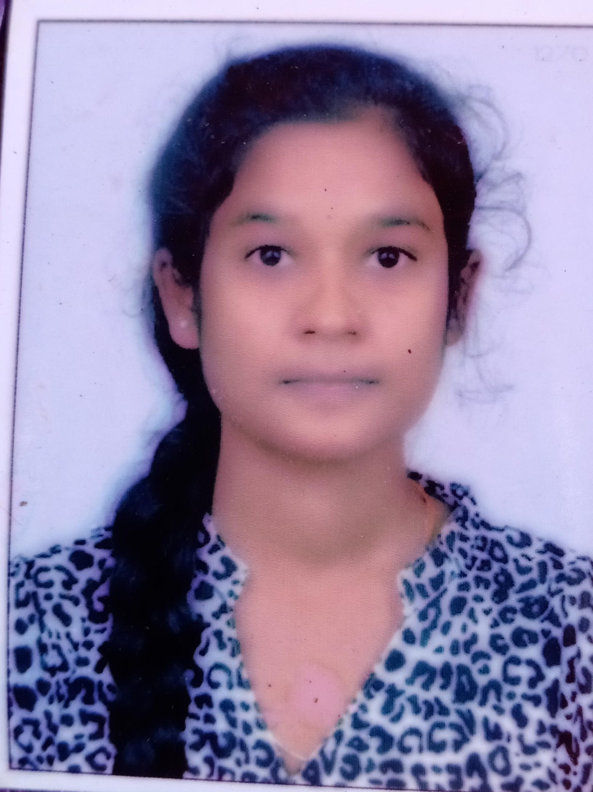
Netravati Chikkamath
- mail:mnetra2002@gmail.com
Ph no:81978-45192
Vinayak nagar Navalur dharwad
580009
CAREER OBJECTIVE:

To achieve professional by working in a challenging environment which requires human intellect and creativity by welcoming challenges for a successful career growth and demonstrate high self value in my professional career.

PROFESSIONAL SUMMARY:

- Strong trouble shooting and analytical skill.
- Ability to set goals and achieve them on a regular basis.

EDUCATION:

COURSE | EDUCATION | UNIVERSITY/BOARD | YEAR OF PASSING | PERCENTAGE
BCA | Sri sathya Sai Institute for women college,saptapur Dharwad | Akkamahadevi Women’s University,Bijapur | 2023 | 74
PUC | Govt pu college Navalur Dharwad | Pre-University Board of Karnataka  Education | 2020 | 58
SSLC | JSS vidyagiri ,  Dharwad | Karnataka Secondary Education Board | 2018 | 83.68

PERSONAL PROFILE:

Name:Netravati R Chikkamath .
Father name:Revanayya
Mother name:Mahadevi
DOB:23 june 2002
Languages:Kannada,English.
Hobbies:Cooking,

TECHNICAL SKILLS:

- Programming languages:C,C++,Java,c#,Adv Java.
- Software Skills:MS Word,MS Excel,MS PowerPoint.
- Tools:Ubuntu,Oracle,Visual Studio.

STRENGTHS:

- Positive attitude,self confidence,challenging person.
- Good at grasping new concepts and techniques quickly.
- Excellent team player.
- Hard worker,courageous,patience.

DECLARATION:

I here by declare that the above information is true to the best of my knowledge.

Place:Dharwad Sign
Date:

