STRATEGIC PLAN AND PRELIMINARY DATA ANALYSIS
Week 1 Task: Strategic Planning & Data Needs Assessment
Digital Government Services and E-Governance in India

1. Executive Summary
This project proposes an exploratory analysis of digital public-service delivery using public aggregate statistics displayed by the Government of India’s ServicePlus portal. It focuses on application totals, delivered applications, rejected applications, applications under process, and the number of services launched. Python and pandas are used to calculate descriptive indicators and create charts. The purpose is to demonstrate a transparent, reproducible workflow and identify questions for deeper investigation—not to rank government performance conclusively from a small sample.

2. Problem Statement
Digital government services can improve access and administrative efficiency, but service availability alone does not show whether applications are processed promptly or consistently. Aggregate service-delivery statistics can help identify large backlogs and differences in application status. Meaningful comparisons require consistent definitions, dates, denominators, and coverage.

3. Objectives
- Assess publicly reported application status indicators for selected states/territories.
- Calculate delivered, rejected, and under-process shares of the reported application total.
- Check whether the reported status categories reconcile with the reported total.
- Visualise absolute under-process counts and under-process share.
- Document limitations and recommend what additional data is needed for stronger conclusions.

4. Research Questions
- How many applications are reported as under process in each selected state/territory?
- What share of each reported application total is under process?
- How do delivered and rejected shares vary across the selected records?
- Do delivered, rejected and under-process counts add up to the reported total?
- What further data would be needed to measure processing speed, accessibility, and citizen experience?

5. Data Source and Collection
Primary source: ServicePlus, the Government of India’s service-delivery framework. The portal publishes national summary figures and state-wise information such as services launched, total applications, delivered, rejected and under-process applications. The state sample used here is the snapshot reported on 19 October 2026. The data are transcribed from the public portal’s displayed state-wise summary and included as a small sample for reproducible demonstration.
Official source: https://www.serviceonline.gov.in/ | Supporting portal information: https://www.serviceonline.gov.in/login.do
Other candidate sources for future expansion: Open Government Data Platform India (https://data.gov.in/), UMANG (https://www.umang.gov.in/landing/), and the National Portal of India (https://www.india.gov.in/services/details). Dataset availability, licensing, update frequency, and field definitions must be verified before use.

6. Dataset Fields
Field | Meaning | Use
State | State/territory label | Grouping and comparison
Services_Launched | Number of services reported as launched | Context only; not a direct quality measure
Applications_Total | Reported total applications | Denominator for shares
Delivered | Applications reported delivered | Status share
Rejected | Applications reported rejected | Status share
Underprocess | Applications reported under process | Backlog indicator at snapshot
Snapshot_Date | Date of displayed report | Provenance and freshness
Status_Sum_Check | Delivered + rejected + under process − total | Basic reconciliation check

7. Preliminary Results
The sample contains four state/territory records. These are descriptive snapshot statistics and should not be interpreted as a complete national comparison.
- Andaman and Nicobar Islands: 71,528 total applications; 45,394 under process (63.46%); 15,243 delivered (21.31%); 10,891 rejected (15.23%).
- Andhra Pradesh: 782,237 total applications; 111,909 under process (14.31%); 327,165 delivered (41.82%); 343,163 rejected (43.87%).
- Arunachal Pradesh: 277,011 total applications; 14,943 under process (5.39%); 246,821 delivered (89.10%); 15,247 rejected (5.50%).
- Assam: 3,741,327 total applications; 310,453 under process (8.30%); 3,114,831 delivered (83.25%); 316,043 rejected (8.45%).
Within this sample, Assam has the largest absolute under-process count (310,453) and the largest total application volume (3,741,327). Andhra Pradesh has the largest under-process share in this sample (14.31%). These figures describe the selected portal snapshot only; they do not establish that one state’s service is better or worse because service mix, eligibility rules, reporting practices and application volumes can differ.
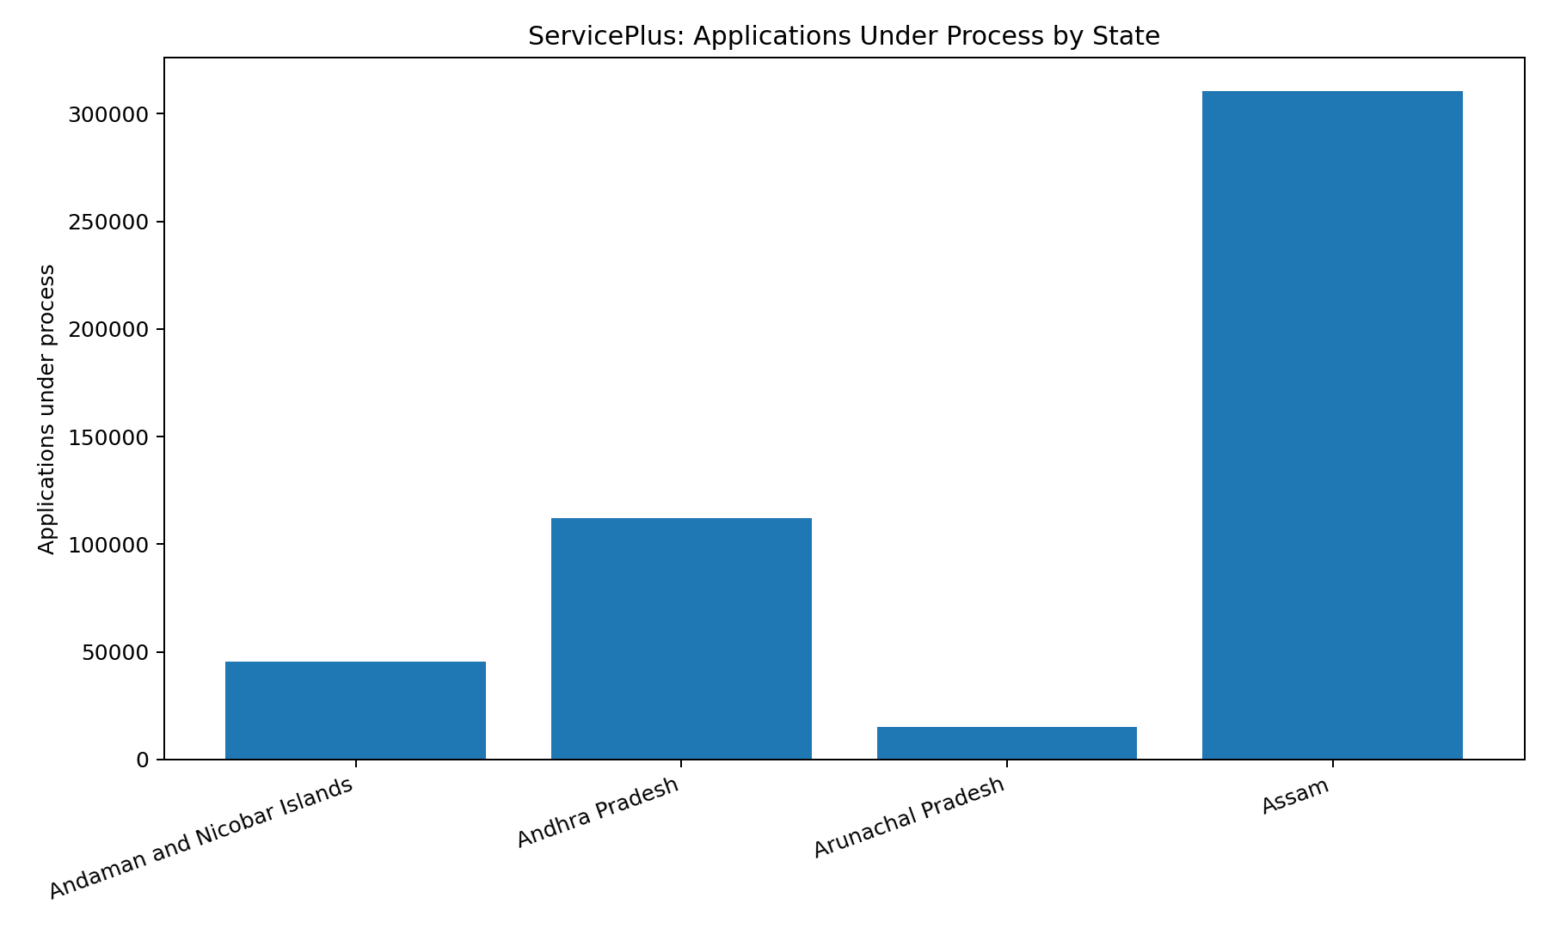
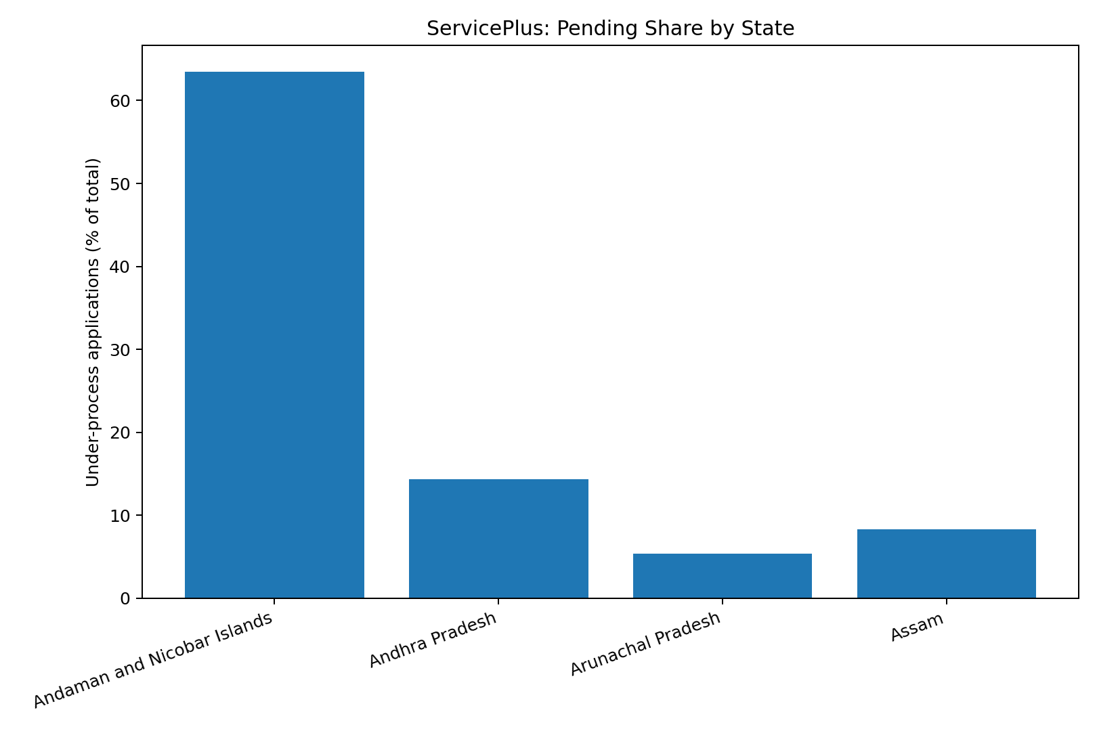

8. KPI Definitions
- Delivered share = delivered ÷ reported total applications × 100.
- Rejected share = rejected ÷ reported total applications × 100.
- Under-process share = under-process ÷ reported total applications × 100.
- Reconciliation check = delivered + rejected + under-process − reported total; zero indicates the categories add up for the record.
The denominator and category definitions should be confirmed in the portal documentation. “Under process” is a snapshot measure, not necessarily the number of applications newly received during a period. A rejection share is not automatically a rejection probability unless the reporting methodology supports that interpretation.

9. Methodology and Python Tools
- Collect public aggregate figures and record the source URL, report date, and date accessed.
- Load the CSV using pandas and inspect dimensions, types, missing values, and duplicates.
- Convert count fields to numeric values and calculate status shares.
- Check arithmetic reconciliation of status categories against reported totals.
- Create bar charts using Matplotlib and save an analysis output CSV.
- Interpret results cautiously and document assumptions, limitations and reproducibility details.
Tools: Python 3, pandas and Matplotlib. Jupyter Notebook may be used to run the same workflow interactively. The accompanying script is serviceplus_analysis.py.

10. Data Quality and Limitations
- The sample includes only four records and is not representative of all states/territories or all digital government services.
- The figures are a portal snapshot reported on 19 October 2026 and may change after the snapshot.
- The project uses displayed aggregate statistics, not application-level records or a historical time series.
- Differences in service types, reporting practices, application eligibility, and state coverage may affect comparisons.
- The project cannot estimate average processing time, citizen satisfaction, digital inclusion, or causes of delays without additional fields.
- The portal’s definitions should be checked before making strong claims about delivered, rejected or pending categories.

11. Challenges and Mitigation
Challenge | Mitigation
Missing or changing figures | Record report date and date accessed; re-check values before final submission.
Inconsistent definitions | Read official metadata and avoid comparing unlike measures.
Limited sample | Expand the sample only after collecting consistent records for more states.
Potential data-entry errors | Run numeric and reconciliation checks and retain source notes.
Privacy risk | Use aggregate public statistics only; do not collect citizen identifiers.
Confusing correlation with cause | Describe patterns only and avoid causal claims unsupported by the data.

12. Expected Deliverables
- Strategic plan and data needs assessment (this document).
- CSV file containing the sample data and calculated indicators.
- Python script for validation, KPI calculation, and chart generation.
- Two charts showing under-process counts and under-process share.
- Final interpretation with limitations and recommendations.

13. Project Timeline (30–35 hours)
Phase | Work | Estimated time
Planning and source research | Define scope, questions, source and fields | 6 hours
Data collection and documentation | Capture figures, metadata and limitations | 5 hours
Cleaning and validation | Inspect values and reconcile totals | 6 hours
Analysis and visualisation | Calculate indicators and build charts | 7 hours
Writing and review | Interpret results, cite sources, format document | 8 hours

14. Recommendations and Next Steps
- Expand the sample to all available states/territories using the same report date and definitions.
- If official historical reports are available, collect repeated snapshots to study changes in pending applications.
- Seek processing-time indicators, service-level deadlines, and service-category breakdowns where publicly available.
- Use population or service-volume context only when appropriate and supported by reliable sources.
- Publish the code, data dictionary, source register and limitations so the analysis can be reproduced.

15. Conclusion
This project demonstrates how publicly reported e-governance statistics can be organised and analysed using Python. The small sample reveals differences in absolute pending counts and pending shares, but stronger conclusions require broader coverage, consistent metadata and time-based information. The recommended next step is to expand the dataset and validate the portal’s definitions before drawing policy conclusions.

References
- ServicePlus, Government of India. https://www.serviceonline.gov.in/ (state-wise summary snapshot reported 19 October 2026; accessed for this project 20 October 2026).
- ServicePlus information and reports. https://www.serviceonline.gov.in/login.do
- Open Government Data Platform India. https://data.gov.in/
- UMANG, Government of India. https://www.umang.gov.in/landing/
- National Portal of India — Services. https://www.india.gov.in/services/details
Submission note: replace any required student/intern name, institute, mentor, or internship ID on the cover page if your portal requires it. Verify the figures against the live source immediately before submission.

