WEEK 3: DATA ANALYSIS & PYTHON IMPLEMENTATION
Virtual Data Analysis Intern – E-Governance & Digital Services
Prepared as an implementation blueprint for exploratory analysis of public digital-service performance. All sample data included with this package are synthetic and must not be represented as official government statistics.

1. Executive Summary
This report proposes a reproducible Python workflow for analysing digital-service delivery indicators in an e-governance context. The workflow covers data validation, cleaning, KPI construction, descriptive statistics, exploratory visualisation, correlation analysis, and optional clustering. The intended outcome is a transparent evidence base that can help service managers identify backlogs, compare processing performance, and decide where further investigation or operational support may be needed. The accompanying dataset is synthetic and exists only to demonstrate the workflow; a real deployment must replace it with verified, appropriately licensed data.

2. Objectives and Analytical Questions
- Measure application volume, disposal, pending workload, rejection rate, processing time, and citizen satisfaction.
- Identify states or service units with comparatively high pending counts or long processing times.
- Explore whether processing time and satisfaction move together in the sample; treat any association as exploratory, not causal.
- Produce clear tables and charts suitable for a technical report and non-technical decision-makers.
- Create a repeatable script so the same checks and calculations can be rerun when verified data are received.

3. Scope, Unit of Analysis, and Data Requirements
The example unit of analysis is one state-level aggregate record for a defined reporting period. A real dataset should include a clear reporting date or period and consistent definitions for every measure. Where possible, analysis should be performed at service and district level as well, provided aggregation and privacy rules are respected.
Recommended fields:
- Geography/service identifiers and reporting period.
- Applications received, disposed, pending at period end, and rejected.
- Average and median processing time, with a documented start/end event definition.
- Citizen feedback score and response count, if collected using a consistent method.
- Optional service category, channel (online/assisted), application type, and anonymised stage/status fields.
- Metadata: source URL/owner, extraction date, data dictionary, units, coverage, and known limitations.

4. Key Performance Indicators (KPIs)
KPI | Definition | Interpretation
Disposal rate | Applications disposed ÷ applications received | Throughput indicator; align periods and account for carry-over.
Pending share | Pending ÷ (disposed + pending) | Approximate pending workload share within the stated stock/flow definition.
Rejection rate | Rejected ÷ applications received | Can flag process or eligibility patterns; high values need contextual review.
Average processing time | Mean elapsed days from valid start to completion | Sensitive to outliers; pair with median and percentiles.
Median processing time | 50th percentile elapsed days | Represents a typical case more robustly than the mean.
Citizen satisfaction | Consistently measured survey score | Interpret with response count and possible response bias.

5. Data Quality and Preprocessing Plan
Before analysis, preserve a read-only raw copy and record every transformation. Apply these checks:
- Schema checks: required columns, expected data types, valid date formats, and unique identifiers where applicable.
- Completeness: quantify missing values by field and period; do not silently replace meaningful missing values with zero.
- Validity: reject negative application counts, impossible dates, invalid score ranges, and inconsistent category labels.
- Consistency: compare totals with source dashboards/reports and confirm whether counts represent flows or end-of-period stocks.
- Duplicates: check repeated records using the appropriate keys; document whether duplicates are removed or reconciled.
- Outliers: flag unusual values for source review rather than automatically deleting them.
- Privacy: remove direct identifiers, minimise sensitive fields, and use aggregated results where appropriate.

6. Statistical Methods

6.1 Descriptive statistics
Use count, mean, median, standard deviation, quartiles, minimum, and maximum to summarise numeric fields. Grouped summaries can compare geography, service type, and reporting period.

6.2 Trend and comparative analysis
With multiple periods, calculate month-on-month or quarter-on-quarter changes and plot trends. Use consistent periods and account for seasonality, changes in eligibility rules, and reporting changes.

6.3 Correlation and regression
Pearson or Spearman correlation can screen for associations between processing time, backlog, and satisfaction. If enough valid observations and relevant covariates exist, regression may estimate adjusted associations. Check assumptions, influential points, uncertainty intervals, and confounding. Do not infer causality from correlation alone.

6.4 Clustering
Standardise selected numeric indicators before an exploratory clustering method such as K-means. Assess cluster stability and interpretability; clusters are exploratory groupings, not official rankings or labels. Do not use them to make individual eligibility decisions.

6.5 Tests and uncertainty
Where appropriate, use confidence intervals and statistical tests only after checking sample size, independence, distributional assumptions, and practical significance. Report effect sizes and limitations, not only p-values.

7. Python Implementation Plan
Library | Example functions | Purpose
pandas | read_csv(), isna(), duplicated(), groupby(), describe(), merge(), to_csv() | Load, validate, transform, aggregate, and export tabular data.
NumPy | where(), select/replace operations, nan-safe calculations | Handle numerical calculations and safe division.
Matplotlib | figure(), bar(), scatter(), xlabel(), tight_layout(), savefig() | Build reproducible charts and export them for the report.
Seaborn | barplot(), scatterplot(), heatmap() | Create concise statistical visualisations.
SciPy | scipy.stats.pearsonr(), spearmanr() | Explore associations where assumptions are appropriate.
scikit-learn | StandardScaler(), KMeans() | Optional exploratory clustering after feature scaling.

8. End-to-End Workflow
- Acquire approved data and save source metadata, extraction date, and a data dictionary.
- Load raw data without overwriting it; record row/column counts and field types.
- Run schema, missingness, duplicate, range, and reconciliation checks.
- Clean and transform fields using documented, repeatable functions.
- Calculate KPIs with explicit denominators and reporting-period definitions.
- Generate descriptive summaries, comparative charts, and cautious exploratory association analyses.
- Validate surprising results against source records and subject-matter context.
- Export clean data, KPI tables, charts, and a concise findings/limitations note.
- Review outputs with service owners before recommending operational changes.

9. Simulated Workflow and Illustrative Interpretation
The supplied CSV contains ten illustrative state-level records. The accompanying script validates basic fields, calculates disposal rate, pending share, and rejection rate, exports summary statistics, generates charts, calculates a Pearson correlation, and creates an exploratory three-cluster segmentation. Because the records are synthetic and small in number, any apparent patterns are demonstrations of the code only. They do not describe actual state performance and must not be cited as official findings.
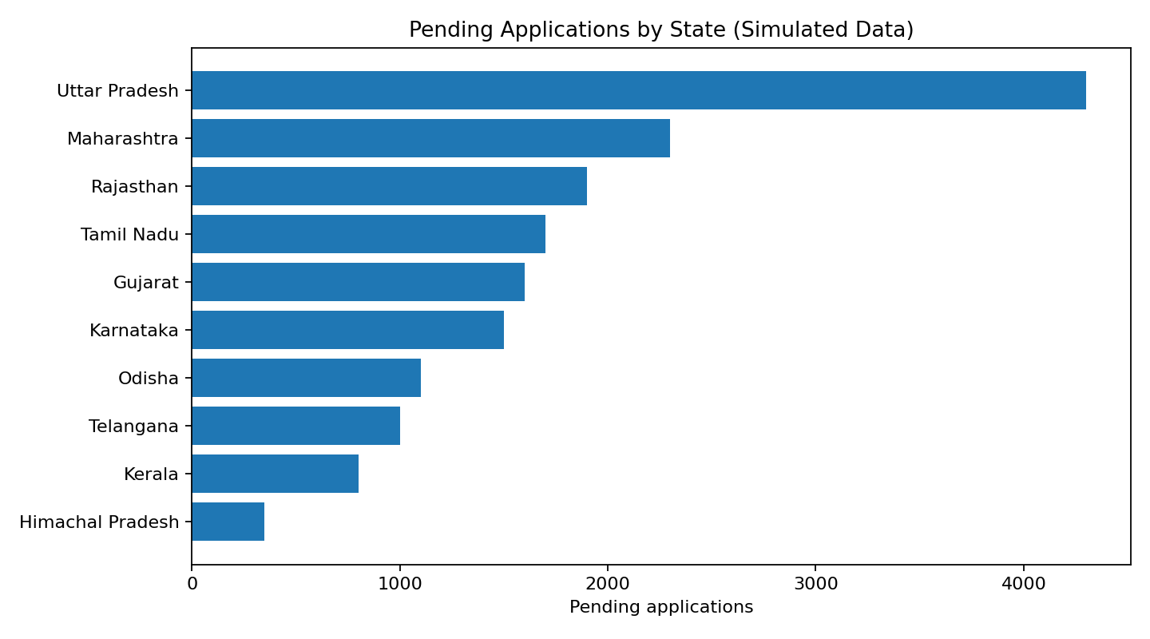
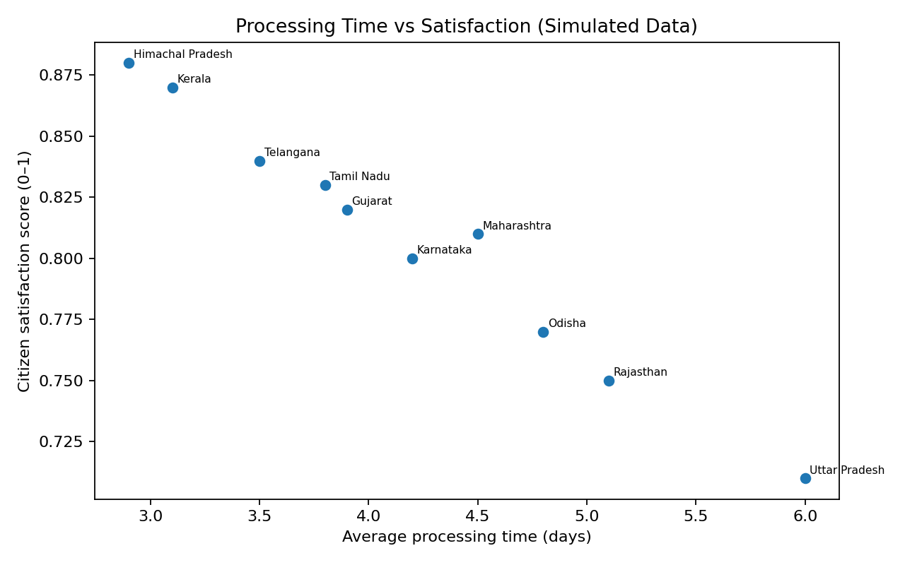

10. Expected Outputs and Decision Use
- A validated dataset and documented quality-check log.
- Summary statistics and a KPI table sorted by pending workload or processing time.
- Bar charts to locate large pending workloads and scatter plots to inspect possible relationships.
- Correlation matrix and optional exploratory clusters, accompanied by cautions and assumptions.
- A short action brief: investigate persistent backlog, verify process bottlenecks, assess staffing/workflow, and monitor results over time.
Charts should guide questions rather than automatically dictate action. For example, a large pending count may reflect a large population or service volume; rates and workload per staff member may be needed before comparing units fairly. Any intervention should be evaluated using comparable before/after periods and documented contextual factors.

11. Risks, Pitfalls, and Mitigations
Risk | Mitigation
Missing or inconsistent data | Publish a missingness report, validate against source owners, and document exclusions/imputation.
Small or unrepresentative sample | Avoid broad generalisations; obtain more periods/services and report uncertainty.
Bias in satisfaction surveys | Report response counts and collection methods; compare respondent coverage where lawful.
Confounding and causal overclaiming | Use cautious language, include relevant covariates where justified, and seek stronger evaluation designs.
Overfitting | Keep models simple, use holdout/cross-validation for predictive tasks, and compare against a baseline.
Misleading comparisons | Standardise definitions, periods, and denominators; consider service mix and population differences.
Privacy or security exposure | Use approved data, minimise identifiers, control access, and suppress small cells when needed.
Reproducibility failures | Version code, pin dependencies, log transformations, and keep raw data immutable.

12. Validation, Reproducibility, and Reporting
- Re-run the script from a clean environment and verify that outputs are generated without manual edits.
- Record Python and library versions in a requirements file.
- Use fixed random_state for reproducible clustering demonstrations.
- Review formulas, denominators, units, and data lineage with a second reviewer.
- State data limitations and separate observed facts from interpretations and recommendations.

13. Conclusion
This plan combines technical Python execution with analytical reasoning suited to public digital services. A reliable analysis begins with trustworthy data, transparent KPI definitions, and strong validation—not with complex modelling. The proposed workflow provides a practical starting point for descriptive analysis and carefully bounded exploratory methods. Once verified data become available, the same process can support evidence-informed service improvement while respecting privacy, fairness, and the limitations of observational data.

Appendix A: Package Files
- simulated_egovernance_data.csv — illustrative synthetic data, clearly labelled.
- week3_analysis.py — reproducible analysis script.
- pending_applications_by_state.png and processing_time_vs_satisfaction.png — example charts.
- README.md — setup instructions, data caveat, and run command.
- requirements.txt — Python dependencies.

