YUVA INTERNSHIP — WEEK 4 REPORT
Evaluation, Reporting & Presentation Strategy
Virtual Data Analysis Intern — E-Governance & Digital Services
Project: Exploratory analysis of digital public-service performance indicators
Data note: This report uses a small synthetic/illustrative dataset prepared for demonstrating an analysis workflow. It is not official government data and must not be represented as verified state performance. Replace it with validated, dated, public data before making operational or policy decisions.

1. Executive Summary
This report presents a reproducible reporting and stakeholder-communication plan for digital public services. The illustrative dataset contains 10 state-level records. Across these records, 119,200 applications were recorded as received and 95,000 as disposed, giving a simple aggregate disposal-to-received ratio of 79.7%. The dataset records 16,550 pending applications. These aggregate figures are descriptive of the synthetic sample only; they do not establish actual government performance.
In this sample, Uttar Pradesh has the largest pending count (4,300). Himachal Pradesh has the lowest average processing time (2.9 days), while Himachal Pradesh has the highest satisfaction score (0.88). The observed correlation between average processing time and satisfaction is -0.99; because the dataset is small and synthetic, this is only a demonstration of exploratory analysis, not evidence of causation.

2. Objectives and Key Performance Indicators
The reporting objective is to translate service-delivery records into clear, cautious, actionable information.
- Measure application throughput: applications received and disposed.
- Monitor backlog: pending applications and pending share of the active workload.
- Assess timeliness: average and median processing days.
- Review outcomes: rejection rate and disposal rate, with definitions confirmed against source metadata.
- Understand citizen experience: satisfaction score and survey coverage.
- Support comparison over time and across services only when definitions, reporting periods, and coverage are comparable.

3. Methodology Summary
- Acquire data from an approved public dashboard, official open-data portal, or authorized service-management export. Record URL, extraction date, reporting period, licence, and data dictionary.
- Preserve a read-only raw copy and create a cleaned analysis copy. Do not collect personal identifiers unless strictly authorized and necessary.
- Validate schema, data types, duplicates, missing values, negative counts, plausible ranges, and arithmetic consistency between received, disposed, rejected, and pending records.
- Standardize state/service names, dates, units, and category labels. Document every exclusion or transformation.
- Calculate KPIs using explicit denominators. For example, disposal rate = disposed / received, only when the reporting periods and cohort definitions align.
- Conduct descriptive analysis first; use correlation or regression only when sample size, data quality, and assumptions support them. Correlation does not prove causation.
- Create readable charts, verify them against tables, and write plain-language interpretations with limitations and recommended actions.

4. Illustrative Findings
The following observations demonstrate how an analyst could narrate results. They apply only to the synthetic dataset.
- Backlog prioritization: Uttar Pradesh has the largest pending count in this sample. A real analysis would inspect backlog age, service type, district, and staffing before recommending resources.
- Timeliness comparison: Himachal Pradesh has the lowest average processing time (2.9 days) in the sample. Confirm whether processing-time definitions exclude paused or incomplete applications.
- Citizen experience: Himachal Pradesh has the highest satisfaction score (0.88). Check survey response rates and sampling bias before comparing satisfaction.
- Association check: processing time and satisfaction have a sample correlation of -0.99. The result is exploratory and cannot show that processing time caused satisfaction to change.

5. Visualizations and Interpretation
Figure 1 compares pending application counts and can help identify where a backlog investigation may be useful. Counts should be normalized by service volume and population when comparisons require it.
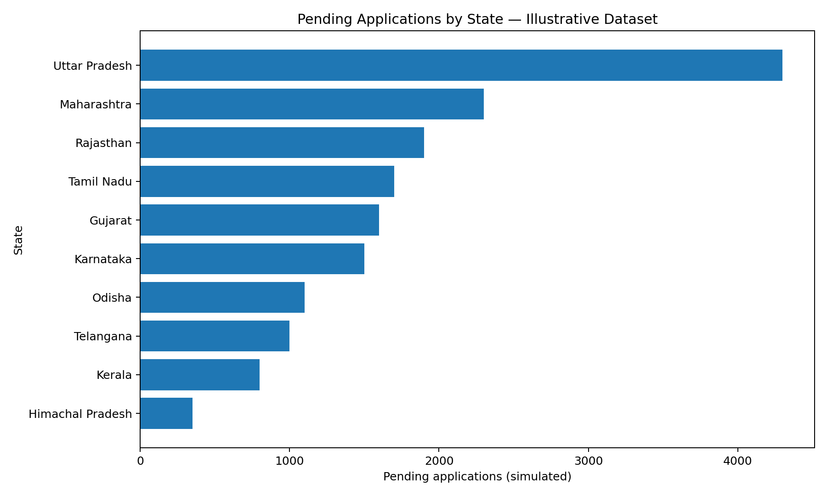
Figure 2 plots average processing time against satisfaction. It is useful for spotting patterns and outliers, but a small synthetic sample cannot support causal conclusions.
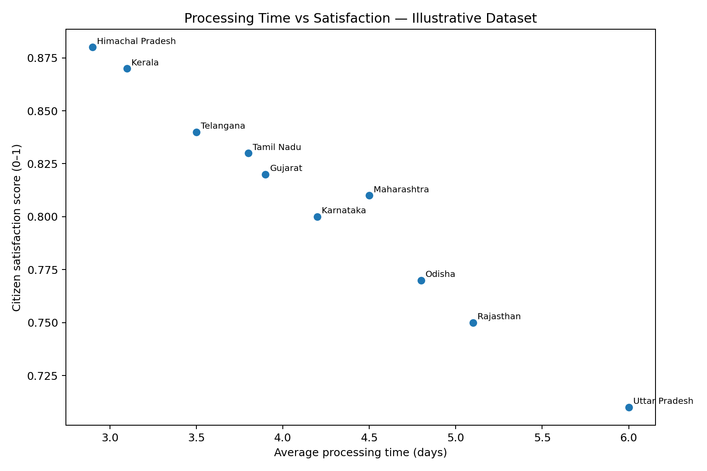
Figure 3 shows the disposal-to-received ratio. In operational reporting, label this KPI carefully and confirm that received and disposed counts refer to compatible cohorts and periods.
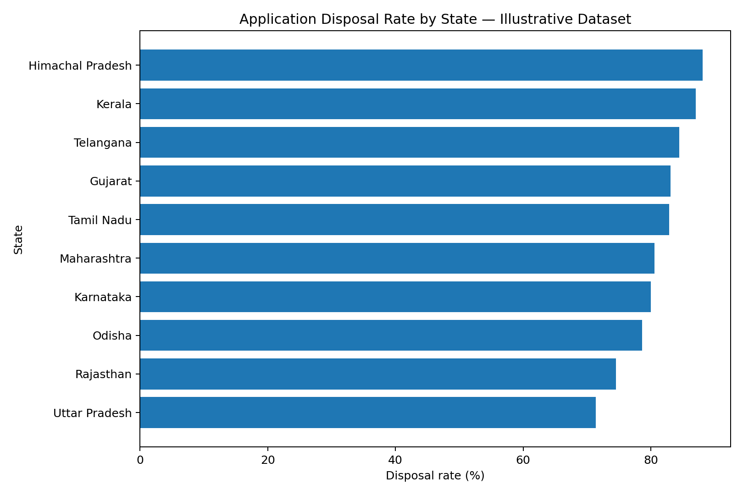

6. Strategic Recommendations
- Create a monthly dashboard with consistent KPI definitions, reporting cut-off dates, and data-quality flags.
- Investigate backlog by age bands (for example, 0–7, 8–15, 16–30, and over 30 days) rather than relying only on total pending counts.
- Review rejection reasons and publish clear citizen guidance to reduce avoidable incomplete or ineligible applications.
- Compare processing-time medians and percentiles, not only averages, because averages can hide long delays.
- Collect citizen feedback through a documented sampling approach; report response rate and accessibility coverage.
- Prioritize improvements using a transparent process that combines backlog, delay, service criticality, and citizen impact.
- Validate findings with service owners before action and track whether interventions improve KPIs in subsequent periods.

7. Limitations and Risk Controls
- Synthetic data: current figures are illustrative, not official observations.
- Small sample: ten records cannot represent all services, districts, or citizens.
- Metric definitions: inconsistent treatment of pending, rejected, reopened, or paused applications can distort comparisons.
- Reporting lag: dashboard extraction dates may differ from the period in which applications were received.
- Bias: satisfaction surveys may under-represent citizens with poor connectivity, language barriers, or low digital literacy.
- Privacy and security: remove direct identifiers, restrict access, and follow applicable data-governance requirements.
- Model risk: avoid complex predictive models until there is enough representative data; validate models on held-out periods and monitor drift.

8. Stakeholder Presentation Plan
Slide | Content | Purpose
1 | Problem, scope, and decision needed | Align stakeholders on the question
2 | Data sources, definitions, and quality checks | Establish confidence and caveats
3 | KPI summary and backlog visualization | Show where to investigate
4 | Timeliness and citizen-experience patterns | Explain operational signals
5 | Limitations and alternative explanations | Prevent over-interpretation
6 | Prioritized recommendations and owners | Turn analysis into action
7 | Measurement plan, timeline, and follow-up | Track whether changes work
Suggested 20-minute briefing: 2 minutes for context, 4 minutes for data quality and definitions, 7 minutes for findings and charts, 4 minutes for recommendations, and 3 minutes for questions and decisions. Send the report and chart pack in advance, and close by recording decisions, owners, and review dates.

9. Implementation Timeline
- Week 1 — Confirm the decision question, source permissions, KPI definitions, and reporting period.
- Week 2 — Collect and validate data; document missingness, duplicates, and reconciliation checks.
- Week 3 — Calculate KPIs, produce charts, perform sensitivity checks, and review findings with a service owner.
- Week 4 — Finalize the report and briefing; assign actions and define a follow-up measurement date.

10. Reproducibility and Tools
The accompanying Python script uses pandas for data validation and KPI calculation and matplotlib for charts. It writes a KPI table, summary statistics, visualizations, and an interpretation note. Run it from the package folder with Python installed after installing pandas and matplotlib. Keep the source dataset and script together.
Command: python week4_reporting_analysis.py
Install dependencies: python -m pip install pandas matplotlib

11. Conclusion
A useful e-governance report combines traceable data, transparent KPI definitions, appropriate visualizations, clear caveats, and recommendations tied to measurable follow-up. The sample workflow demonstrates how to structure that process. Before operational use, replace the illustrative dataset with authorized, verified data, document the source and extraction date, validate the measures with service owners, and review privacy and accessibility risks.

Appendix A — KPI Definitions
- Disposal rate = applications disposed ÷ applications received. Interpret only when cohort and period definitions match.
- Pending share of workload = pending applications ÷ (disposed applications + pending applications), as an illustrative workload ratio.
- Rejection rate = rejected applications ÷ applications received, if rejected counts are a subset of received applications in the same period.
- Average/median processing days = processing duration among completed applications; document treatment of paused cases and outliers.
- Satisfaction score = survey-derived measure; document scale, question wording, response rate, and sampling method.

