**Sri Sainandh Devineni (K00481104)**

**Shanthan Rao Nagineni (K00490477)**

**Mounika Gutha (K00479180)**

**Abstract:** As the world is rapidly moving towards e-commerce, fashion is one of the important thing in the space. Recommendations are key for any e-commerce company to improve sales of there products. Showing the right product at the right time is very important. In this project we are using MLE Density Estimation, Naïve Bayes classification and Logistic regression on Fashion MNIST data. It helps us to bifurcate the shirts and pants in a given set of images.

**Software used:** Python/Google Colab

**Python Packages used:** Scipy, Numpy and Pandas

**Lecture Review:**

# Procedure for Naïve Bayes classification:

1. The scipy, numpy and pandas packages have been imported
2. Using scipy, the fashion_MNIST data has been imported.
3. The training data(trX and trY) is extracted.
4. The trX data has 12000 rows and 784 columns. This means there are 784 pixels.
5. Two features of the 784 pixels have been extracted. The first feature, Feature1 is the mean. And the second feature, Feature 2 is the standard deviations.
6. The training data is bifurcated according to their class (which are class 0 and class 1). So, now we have training data for class 0 and class 1.

probability of class 0 is 0.5 and probability of class 1 is 0.5

1. Mean and Standard deviation for feature1 and feature2 for both classes (class0 and class1) have been extracted for Maximum likelihood estimation (MLE)

mean of means of class 0 is: 0.325607766439909 std of means of class 0 is: 0.11337491460878085 mean of stds of class 0 is: 0.3200360871033629 std of stds of class 0 is: 0.08798281005982794

mean of means of class 1 is: 0.22290531462585023 std of means of class 1 is: 0.05695100874843002 mean if stds of class1 is: 0.333941712027219

std of stds of class 1 is: 0.05703228654279648

1. The formula for MLE is given by:

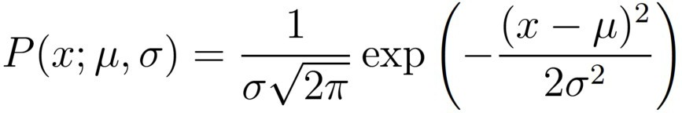

1. The Gaussian distributions are given by: distribution for

feature 1 for class 0 is:

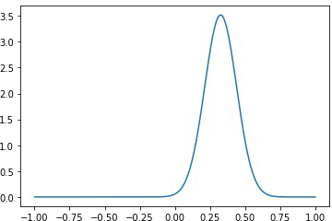

distribution for feature 2 for class 0 is:

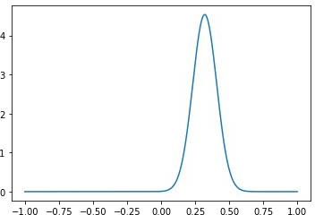

distribution for feature 1 for class 1 is:

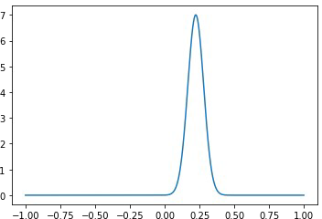

distribution for feature 2 for class 1 is:

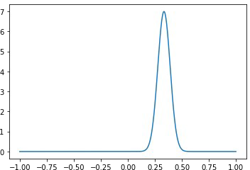

1. Test data, tsX and TsY have been extracted from fashion_mnist
2. The features of tsX, feature1 and feature 2 (means and stds) have been extracted.
3. Naive Baye’s classification is given by P(Y|X) = P(X1|Y)*P(X2|Y)*P(Y)
4. From the above formula, P(Y=0|X) and P(Y=1|X) are calculated
5. if P(Y=0|X) > P(Y=1|X) then X belongs to class 0 or else class 1. This is done to all test cases and a list is generated.
6. The generated list is compared to the given tsY data and the accuracy is estimated.
7. The accuracy of the Naive Baye’s classification for the fashion_Mnist is **83.15% Procedure for Logistic Regression:**
8. The training data is extracted (trX and trY)
9. For the training X data, a dummy column with 1 is concatenated. And now, the size of the training data is 785 pixels. This will be X.
10. Because there are 785 pixels for the training X data, 785 random weights have been generated. This will be W.
11. Sigmoid function is defined and given from the following formula:



1. Likelihood function is given by:

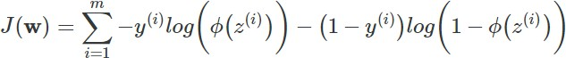

1. To update weights, we have to take in gradient of loss function. Which is partial derivative of likelihood function with respect to weights.

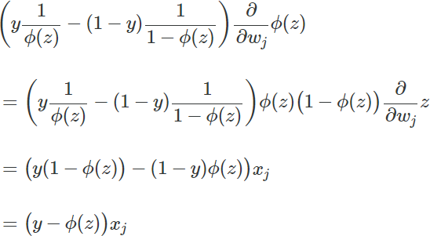

1. Weight update formula is given by:

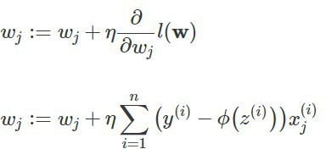

1. Using the above formula, weights are updated for about 30 cycles to get optimum result.
2. Test data is extracted. (tsX and tsY)
3. Sigmoid function is applied to each row of tsX with updated weights and result is generated.
4. The generated result is compared with the given result and accuracy is calculated.
5. The accuracy of linear regression is between **97.8% to 98.05%**