**(IaaS) (PaaS) Google Cloud Compute**

Google Cloud Platform Services

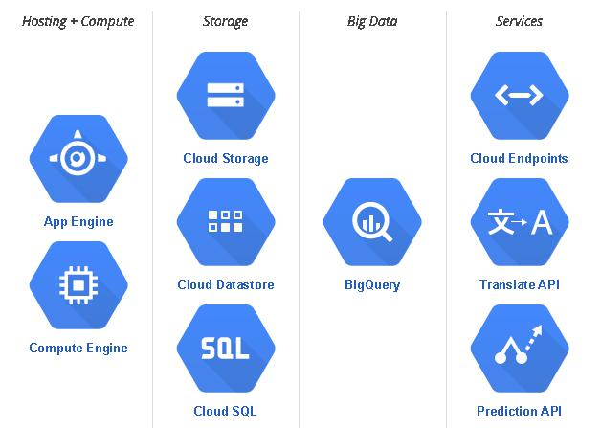

Step1

Sign in to developers console and create an application https://console.developers.google.com/project

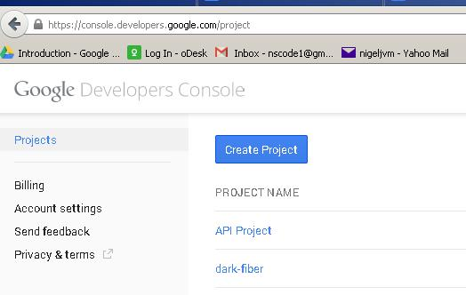

Once you click on “Create” button, It will ask for SMS verification to prevent the abuse.

Go through the process of SMS verification.

Click on the application and it will bring up the page that shows the possible application types

Click on the “Compute Engine” and it will ask for Enable Billing. You need to enable the billing

Step 2

Choose an instance

These are the possible machines

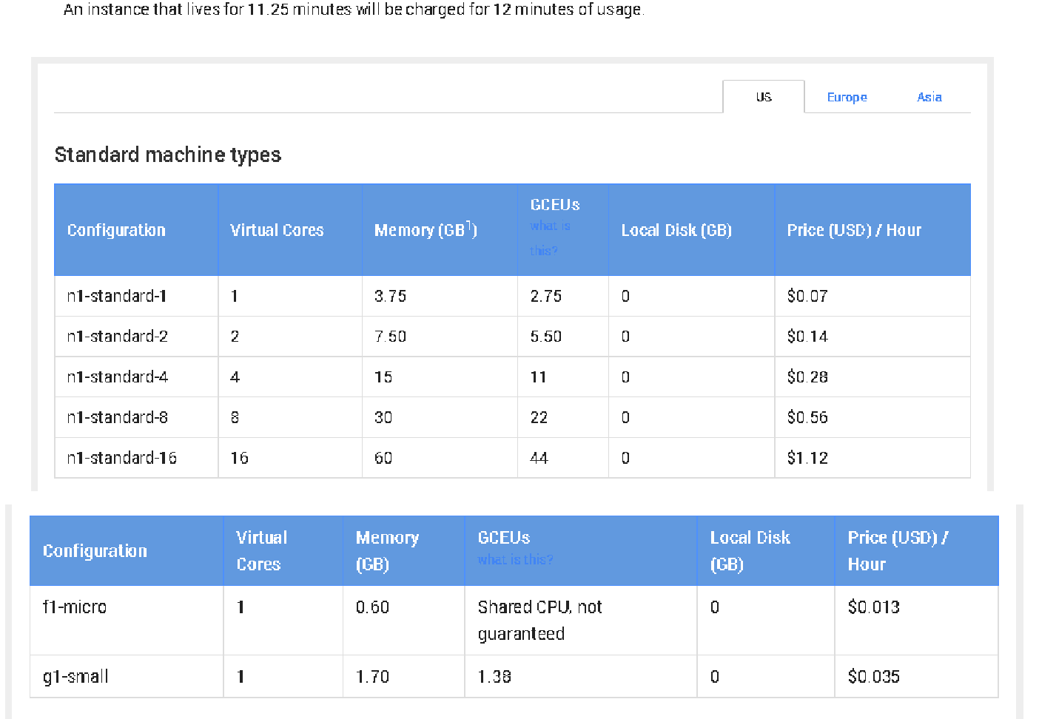

Step 3

Select your application with billing enabled and then select to the right “Spin up a Cloud Compute Engine VM”

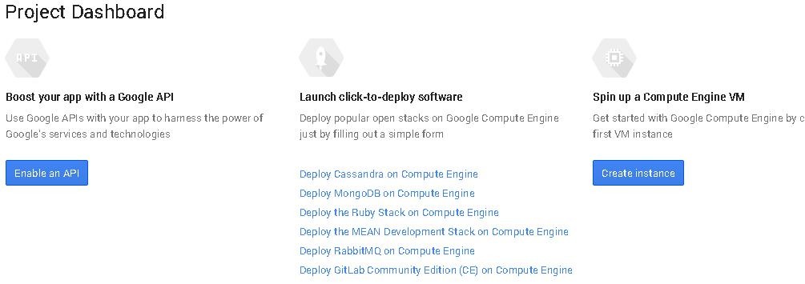

you may get this message



wait for a while and then refresh, repeat this until you see the screen below

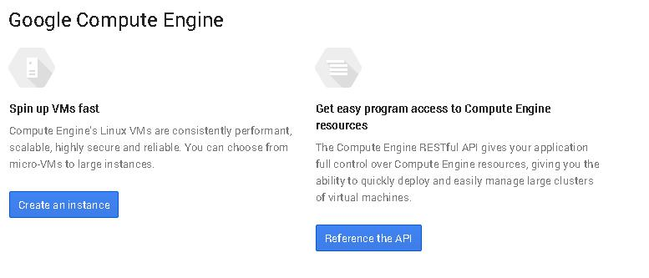

select create an instance you should then see the screen below

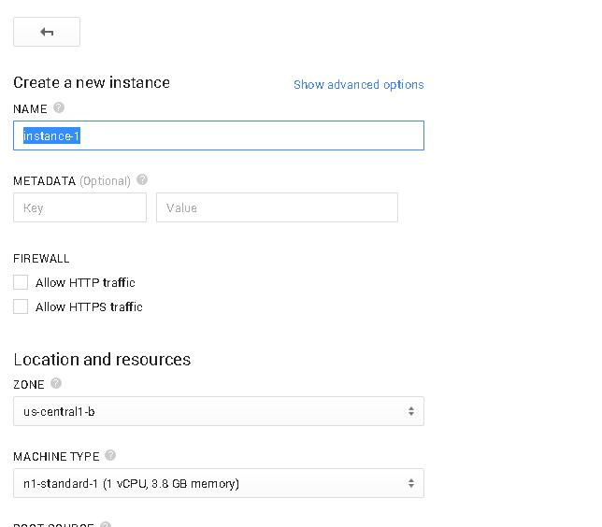

**Name** : Name of the Instance, this name will be used with in the Google VM Instances for

communication as a DNS name

**Tags :** tags to your instanceas EC2

**Metadata :** Every instance stores its metadata on the metadata server.

**Regions & Zones :** as EC2

**Machine Type : see ‘**These are the possible machines’ chart above

**Boot Source** : It determines the disk used to boot the instance. Keep the default

**Image :** It determines the Operating System installed on the system.

**Network :** A network performs the same function that a router does in a home network: it

describes the network range and gateway IP address, handles communication between

instances, and serves as a gateway between instances and callers outside the network.

**External IP :** This IP Address enables the communication with outside the instance’s network.

these are the values to enter to create the same machine as this video

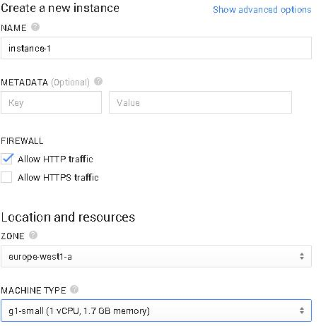

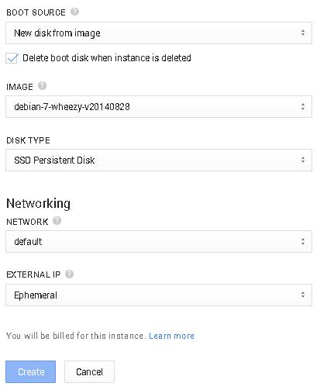

select create, you may see some confusing screens, wait for a few minutes and you should eventually see the screen below if so you are good

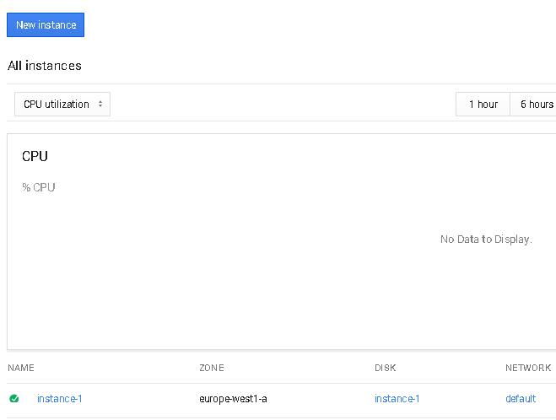

Step 4

Configure terminal access

now we will create the ssh keys to log in with putty

[http://winscp.net/eng/docs/ui_puttygen](http://www.google.com/url?q=http%3A%2F%2Fwinscp.net%2Feng%2Fdocs%2Fui_puttygen&sa=D&sntz=1&usg=AFQjCNFcqbstMXhX7S8xGploONgN9waCUg)

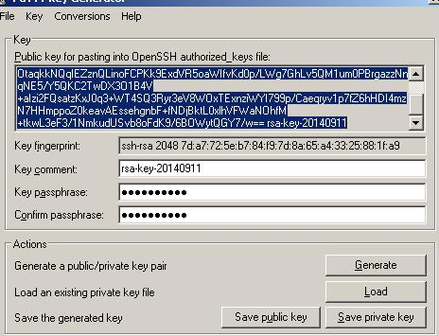

make sure to add a paraphrase this will be your login name with putty later press the Save private key button

now in the developer console

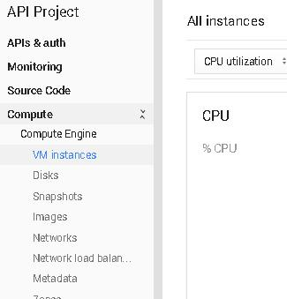

select the metadata link shown above

then select the ssh keys tab

from the puttygen key display copy the raw key just as i have pasted below

ssh-rsa

AAAAB3NzaC1yc2EAAAABJQAAAQEAytx42qjmJA1OJUmOZeOjw62uGER7MADYxxEcVqBclcVkZHdRfK4FDVKVInKIGlcRA0z4hBJlU5Z2

Ruw5hQhWCsCQ14vVnFbGiecREOtaqkkNQqIEZznQLinoFCPKk9ExdVR5oaWIfvKd0p/LWg7GhLv5QM1um0PBrgazzNnqNE5/Y5QKC2Tw

DX3O1B4V+aIzi2FQsatzKxJ0q3+WT4SQ3Ryr3eV8WOxTExnziWYI799p/Caeqryv1p7fZ6hHDI4mzN7HHmppoZ0keavAEssehgnbF+fN

DjBktL0xlhVFWaNOhfM+tkwL3eF3/1NmkudUSvb8oFdK9/6BOWytQGY7/w== rsa-key-20140911

then paste just what you have copied from puttygen like above



rsa-key-20140911 this will be the username when we login in with putty

in the instance view



the value for the external ip [130.211.59.133](http://www.google.com/url?q=http%3A%2F%2F130.211.59.133%2F&sa=D&sntz=1&usg=AFQjCNFPE7lRmXLSMzPk0wTP75JEGr4ZNg) will be used as the host name in putty

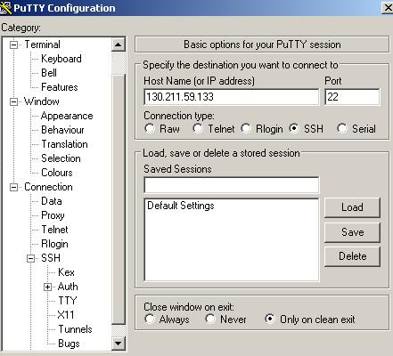

select Auth and load the key you created

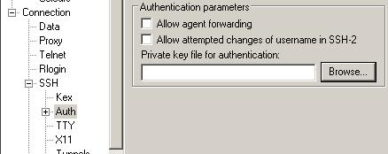

**return to the session view** select open and use the key username as login

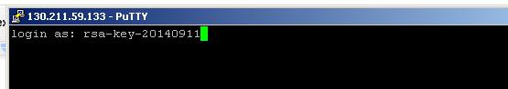

enter the key parahase when prompted

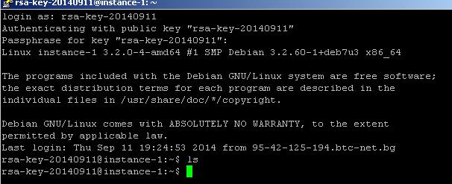

Step 5

Install an Application

now we have a debian box

lets install mongodb

There is [a bug in the GCE Debian images](https://www.google.com/url?q=https%3A%2F%2Fgithub.com%2Fandsens%2Fbootstrap-vz%2Fissues%2F49&sa=D&sntz=1&usg=AFQjCNHpEHRsGZ0OjSwcc7L8C_wR6_R_1g) where the default locale isn’t set. This prevents MongoDB from starting properly from the Debian packages. The workaround is to set a default:



sudo locale-gen en_US.UTF-8



sudo locale-gen en_IE.UTF-8



sudo dpkg-reconfigure locales



select all i the first pop up screen and in the second screen accept the default

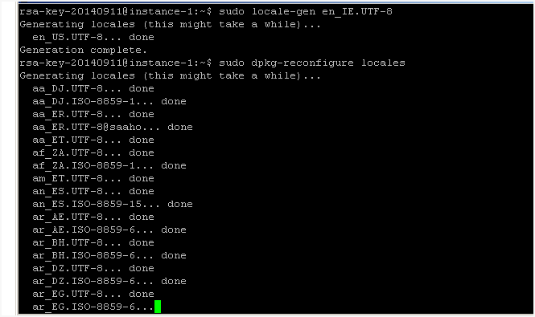

it will take a while

sudo apt­get update

sudo echo 'deb http://downloads-distro.mongodb.org/repo/debian-sysvinit dist 10gen' | tee /etc/apt/sources.list.d/mongodb.list

sudo apt-get update

sudo apt-get install -y mongodb

/etc/init.d/mongodb star