Low Level Design (LLD)

HELMET DETECTION

Revision Number:1.1

Swati Sinha Maitry Sinha

Document VersionControl

|  |  |  |  |
| --- | --- | --- | --- |
| **Date**  **Issued** | **Version** | **Description** | **Author** |
| **3rd sept**  **2021** | 1.1 | FirstDraft | Maitry Sinha & Swati Sinha |
|  |  |  |  |
|  |  |  |  |
|  |  |  |  |
|  |  |  |  |
|  |  |  |  |
|  |  |  |  |
|  |  |  |  |
|  |  |  |  |

Contents

Document Version Control.....................................................................................................2

Abstract.................................................................................................................................4

1 Introduction.....................................................................................................................5

1.1 Why this Low-Level Design Document? .......................................................................5

1.2 Scope.......................................................................................................................7

1.3 Constraints...............................................................................................................7

1.4 1.3Risks..................................................................................................................7

1.5 1.4 Out of Scope......................................................................................................7

2 Technical specifications..................................................................................................8

2.1ClassifyingtheImages...................................................................................…………..8

2.1.1FashionMnistDatasetoverview.................................................................………..8

2.2Predicting Images.........................................................................................................9

2.3Logging..........................................................................................................................9

2.4 Deployment...................................................................................................................9

3 Technology stack..........................................................................................................10

4 Proposed Solution.........................................................................................................11

5 Model training/validation workflow.................................................................................12

6 Exceptional scenarios...................................................................................................12

Abstract

More than two decades machine learning techniques have been applied in

Multi disciplinary fields in order to find more accurate, efficient and effective solutions.

In that specifically deep learning is a growing multi-layer neural network learning algorithm in the field of machine learning in recent years.

This research tries to detect Helmet. Custom SSD along with mobile detection is used for the detection task.

Python programming language have been utilized as the development language for this model.

For the evaluation purpose multiple techniques are used in order to compare and identify the more accurate model.

The primary goal of this project is to develop a system in which the system should be able to detect the Helmets automatically.

1 Introduction

1.1 Why this Low-Level Design Document?

The purpose of this document is to present a detailed description of the Vehicle Detection system.

It will explain the purpose and features of the system, the interfaces of the system, what the system will do, the constraints under which it must operate and how the system will react to external stimulate.

.This document is intended for both the stakeholders and the developer soft he system and will be proposed to the higher management for its approval.

Traffic Rule Violation is very common nowadays. Many riders as well as the passengers barely wear helmet while riding two wheelers. It is increasing day by day there are some problems happening like evaluation of traffic rules like not wearing helmet while driving or riding in the streets & as a result, many serious accidents happen very often and many more.

So here we are doing an AI application which will detect the helmets and this AI can be applied in all sorts of the problem discussed above

The Helmet Detection system is a web application which will detect the Helmets from the image which is being uploaded into the application and gives you detection by giving a bounding box for the detected helmets.

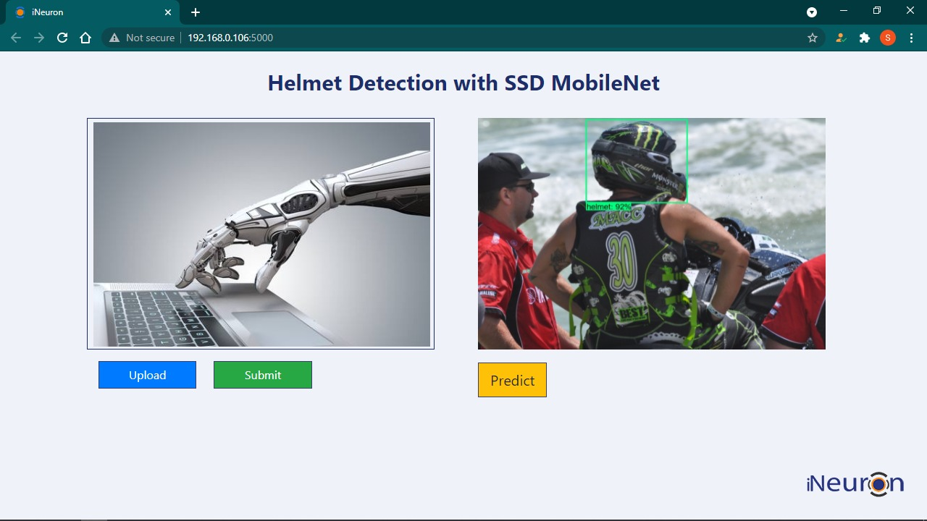

Name of Image with probability

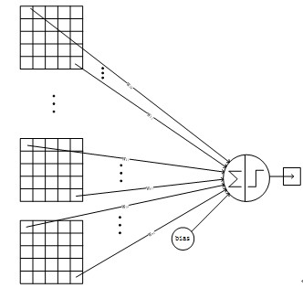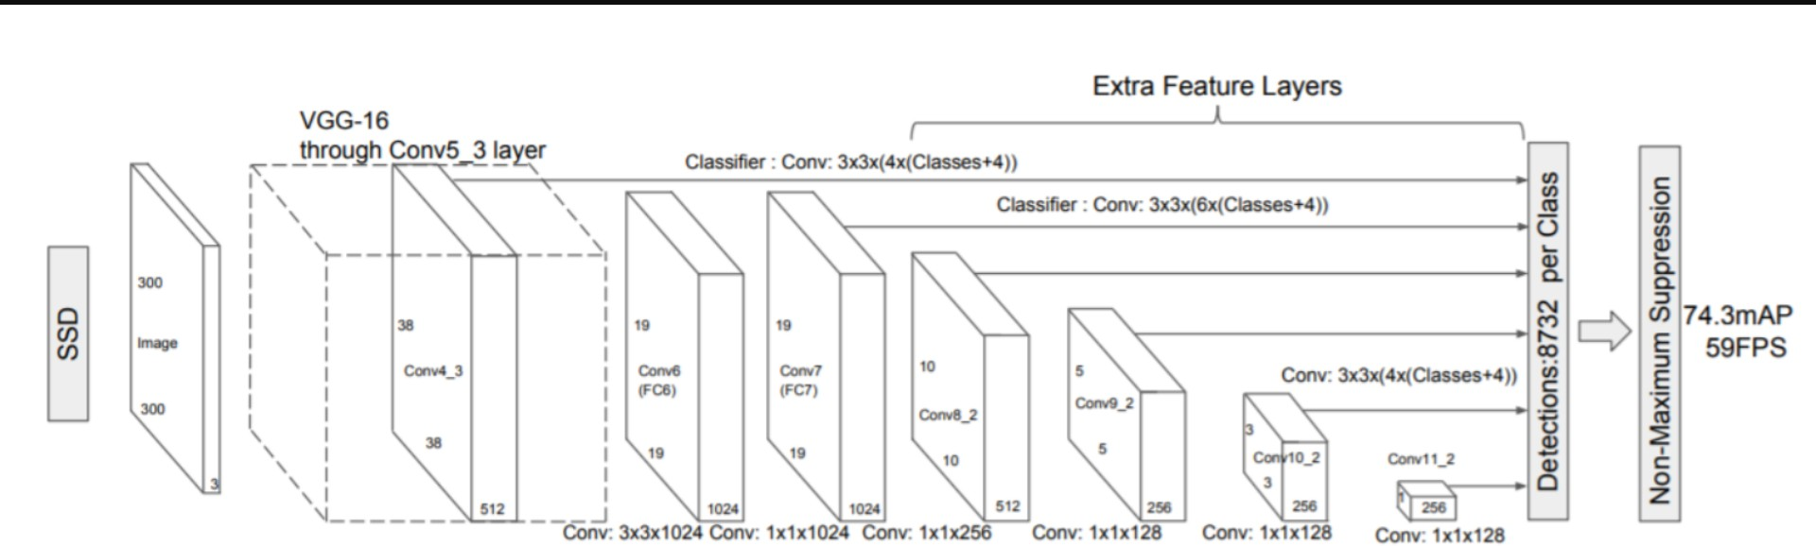

1.2 Scope

This software system will be a Web-application. This system will be designed to detect the Image just by seeing the images, improved interventions, and more efficient product classification in which you can classify the helmets so that it will be easy to manage the traffic rules even can prevent many accidents in the road and there are lot other application scope for this system.

1.3 Constraints

We will be detecting the helmets-

1.4 Risks

Document specific risks that have been identified or that should be considered.

1.5 Out of Scope

Delineate specific activities, capabilities, and items that are out of scope for the project.

2 Technical specifications

2.1 Dataset

|  |  |  |
| --- | --- | --- |
| Dataset | Finalized | **Source** |
| Custom Made Dataset. | yes | [Dataset link](https://drive.google.com/drive/folders/1V-Hr3NExcWOKy0UeEaRCOs9tK8U5pEwg?usp=sharing) |

2.1.1Helmet dataset overview

Used Custom made Dataset:

1. Downloaded images from Google & annotated them manually using labelmap.

2. Scraped frames from local videos & annotated them manually using labelmap.

The data consists of 2000 images & 2000 yml file corresponding to each image.

In train there are total 1300 data(1300 image & 1300 corresponding yml files) & in test there are total 700 data.

2.2PredictingImages

• The system will ask you for enter image of product.

• The User will upload a image of product.

• The system will try to extract features from images and it will predict the

Probability of image belonging to which class and make a bounding box surrounding the object

2.**3**Logging

We should be able to log every activity done by the user.

• The system identifies at what step logging required

• The system should be able to log each and every system flow.

• Developers can choose logging methods .You can choose database logging/ File logging as well.

• System should not be hung even after using so many loggings. Logging just because we can easily debug issues so logging is mandatory to do.

2.**4**Deployment

1. AWS



3 Technologystack

|  |  |
| --- | --- |
| FrontEnd | HTML/CSS |
| Backend | Python/Flask |
| **Libraries** | Tensorflow, Keras, Numpy, OpenCV |
| Deployment | AWS |

4 ProposedSolution

Refer  [https://ieeexplore.ieee.org/document/9182346](https://arxiv.org/pdf/1811.04374.pdf)

Over the past few years, deep learning has played a tremendous role in real time object detection, recognition and classification. Today, algorithms use deep learning not only for simple object detection but have also paved way for vehicle detection that is complex situation such as Indian roads. Different deep learning models can learn features of varied complexity and perform according to surrounding environment in which they are deployed.

Whereas SSD mobile-net V1 takes 31.89% less time than faster RCNN resnet101. On the flipped side, faster RCNN resnet101is 34.38% more accurate than SSD mobilenet v1.

Considering the real time environment time complexity is given more importance by which

SSD with mobilenet is used

5 Modeltraining/validationworkflow

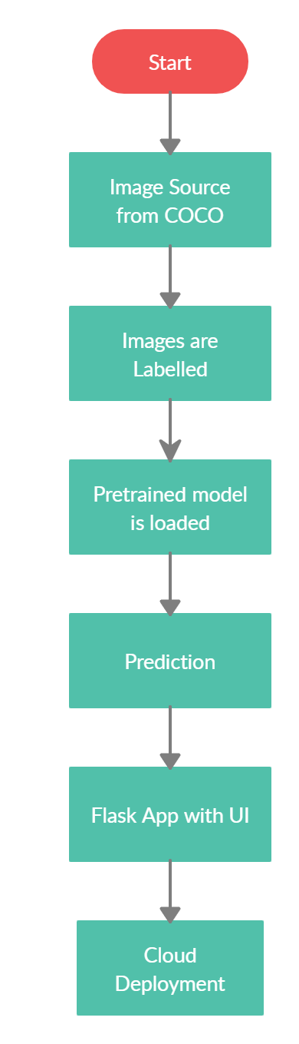

6Exceptionalscenarios

|  |  |  |  |
| --- | --- | --- | --- |
| **Step** | **Exception** | **Mitigation** | **Module** |
|  |  |  |  |
|  |  |  |  |

6 Testcases

|  |  |  |  |
| --- | --- | --- | --- |
| **Test case** | **Epochsto train** | **Module** | **Pass/Fail** |
|  |  |  |  |