
- High Level Design (HLD)

High Level Design (HLD)

Helmet Detection

Revision Number: 1.0

Last date of revision: 02/09/2021

Swati Sinha
Maitry Sinha


Helmet Detection 1

- High Level Design (HLD)

Document Version Control

Date Issued | Version | Description | Author
2nd sept,2021 | 1.0 | First Version of Complete HLD | Maitry Sinha & Swati Sinha

Helmet Detection 2

- High Level Design (HLD)

Contents

Document Version Control.................................................................................................... |  |  | 2
Abstract................................................................................................................................. |  |  | 4
1 | Introduction .................................................................................................................... |  | 5
 | 1.1 | Vehicle Detection…………………................................................................. | 5
 | 1.2 | Dataset.................................................................................................................... | 5
2 | General Description ....................................................................................................... |  | 6
 | 2.1 | Product Perspective ................................................................................................ | 6
 | 2.2 | Tools used .............................................................................................................. | 6
 | 2.3 | Constraints ............................................................................................................. | 6
 | 2.4 | Assumptions ........................................................................................................... | 6
3 | Design Details ................................................................................................................ |  | 7
 | 3.1 | Functional Architecture ........................................................................................... | 7
 | 3.2 | Database Design .................................................................................................... | 7
 | 3.3 | Web Application Architecture .................................................................................. | 8
 | 3.4 | Event log ................................................................................................................. | 8
 | 3.5 | Error Handling ......................................................................................................... | 9
 | 3.6 | Help ........................................................................................................................ | 9
 | 3.7 | Performance ........................................................................................................... | 9
 | 3.8 | Security ................................................................................................................... | 9
 | 3.9 | Reusability .............................................................................................................. | 9
 | 3.10 | Application compatibility .......................................................................................... | 9
 | 3.11 | Resource utilization ................................................................................................. | 9
 | 3.12 | Deployment............................................................................................................. | 9

Helmet Detection 3

- High Level Design (HLD)

Abstract

More than two decades machine learning techniques have been applied in
multi disciplinary fields in order to find more accurate, efficient and effective solutions.

In that specifically deep learning is a growing multi-layer neural network learning algorithm in the field of machine learning in recent years.

This research tries to detect Helmet. Custom SSD along with mobile detection is used for the detection task. Python programming language have been utilized as the development language for this model.

For the evaluation purpose multiple techniques are used in order to compare and identify the more accurate model.
The primary goal of this project is to develop a system in which the system should be

0able to detect the Helmets automatically.

- High Level Design (HLD)

- Introduction

  - Vehicle Detection

Traffic Rule Violation is very common nowadays. Many riders as well as the passengers barely wear helmet while riding two wheelers. It is increasing day by day there are some problems happening like evaluation of traffic rules like not wearing helmet while driving or riding in the streets & as a result, many serious accidents happen very often and many more.

So here we are doing an AI application which will detect the helmets and this AI can be applied in all sorts of the problem discussed above.

  - Datasets

Used Custom made Dataset:

1. Downloaded images from Google & annotated them manually using labelmap.

2. Scraped frames from local videos & annotated them manually using labelmap.

The data consists of 2000 images & 2000 yml file corresponding to each image.

In train there are total 1300 data(1300 image & 1300 corresponding yml files) & in test there are total 700 data

- High Level Design (HLD)

- General Description

2.1 Product Perspective

The Helmet Detection system is a web application which will detect the type of vehicles from the image which is being uploaded into the application and gives you detection by giving a bounding box for the Helmet. The Helmet Detection system designed will have many components. Most of these components will be programmed, while others will be implementations of open-source packages. The user interface will be using HTML/CSS to display the pages, Flask for deploying models and running the server.

2.2 Tools used

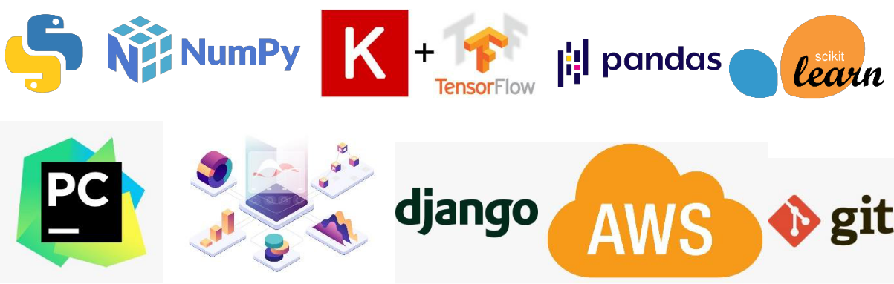

Front End(UI) | HTML, CSS
Back End | Flask
Libraries | Tensorflow, Keras, Numpy, OpenCV
Other Tools | VS Code, Pycharm – IDE, Postman-Monitoring API requests, Git – Version Control
Deployment Cloud | AWS

2.3 Constraints

The detection system must be user friendly, as automated as possible and users should not be required to know any of the workings. Need to build a UI which is very compelling and enhancing user’s experience. The app built needs to be very robust such that it can handle large number of API requests

2.4 Assumptions

The main objective of the project is to detect helmet from the images uploaded. It is also assumed that all aspects of this project have the ability to work together in the way the designer is expecting.

Helmet Detection 6

- High Level Design (HLD)

3 Design Details

3.1 Functional Architecture
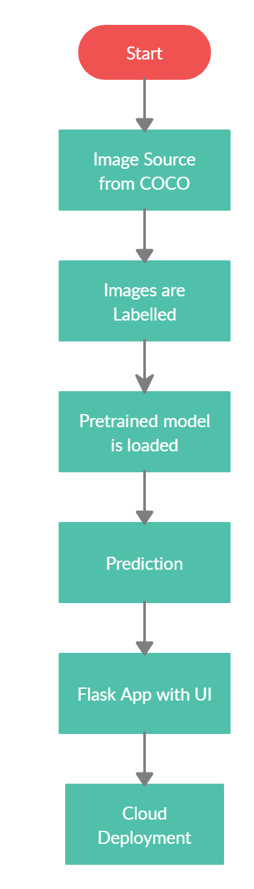

Figure 1: Functional Architecture of Vehicle Detection

We used the image source as custom made dataset and used custom-trained SSD model as our model. Here once the image is got is decoded and then sent to the model. The custom-trained model is set with all parameters ready. The class names are extracted and are assigned to images as labels. Then the model is validated with the data. Once the model is validated the predictions are checked from unseen data such a way to get input from user dynamically. Once the predictions are looked to be fine a flask app is developed along with a UI. And then this whole folder is dockerized and is pushed into the cloud

Vehicle Detection 7

- High Level Design (HLD)

3.2 Web Application Architecture

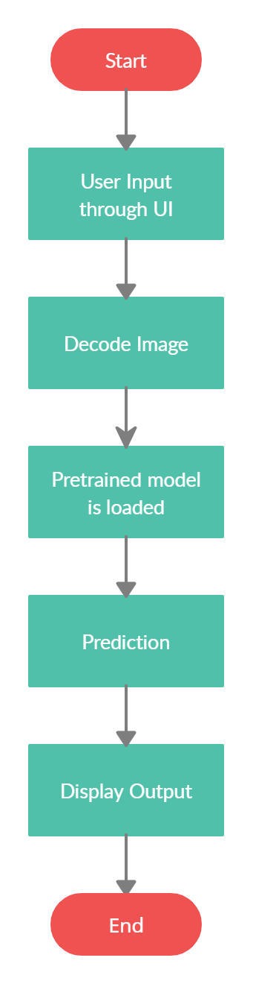

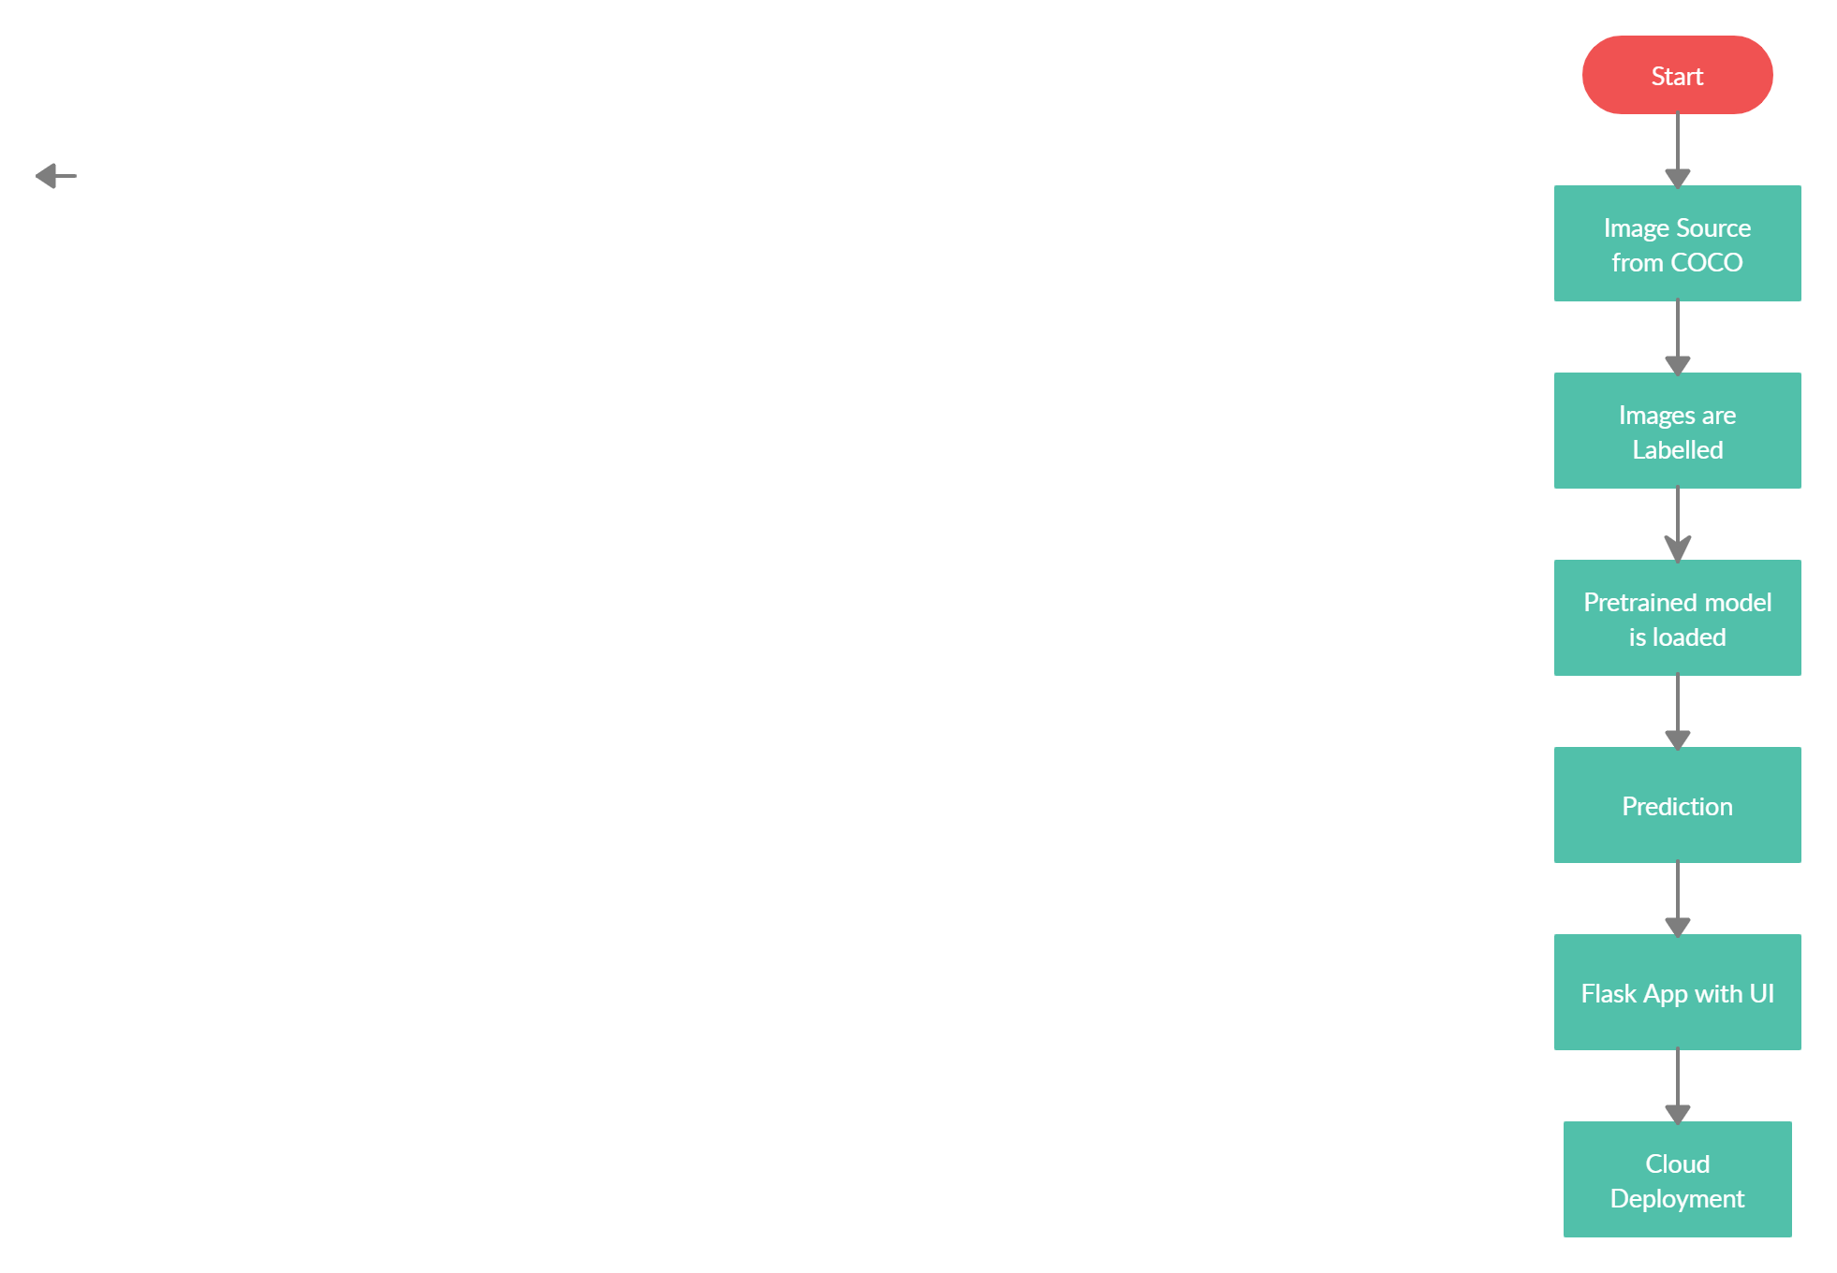Figure 2: Web application architecture

The front end of the program is a web application which comprises of just a single page. There is place for upload of the image. The users can upload their images in that place. Once the image is uploaded it is decoded and the decoded image goes to our model for prediction. Once the model runs and predicts the class of the vehicle, the output is displayed in the output screen.

3.3 Event log

The system should log every event so that the user will know what process is running internally.

Initial Step-By-Step Description:

- The System identifies at what step logging required

- The System should be able to log each and every system flow.

- System should not hang even after using so many loggings. Logging just because we can easily debug issues so logging is mandatory to do.

Helmet Detection 8

- High Level Design (HLD)

- General Description

2.1 Product Perspective

The Helmet Detection system is a web application which will detect the type of vehicles from the image which is being uploaded into the application and gives you detection by giving a bounding box for the Helmet. The Helmet Detection system designed will have many components. Most of these components will be programmed, while others will be implementations of open-source packages. The user interface will be using HTML/CSS to display the pages, Flask for deploying models and running the server.

2.2 Tools used

Front End(UI) | HTML, CSS
Back End | Flask
Libraries | Tensorflow, Keras, Numpy, OpenCV
Other Tools | VS Code, Pycharm – IDE, Postman-Monitoring API requests, Git – Version Control
Deployment Cloud | AWS

2.3 Constraints

The detection system must be user friendly, as automated as possible and users should not be required to know any of the workings. Need to build a UI which is very compelling and enhancing user’s experience. The app built needs to be very robust such that it can handle large number of API requests

2.4 Assumptions

The main objective of the project is to detect helmet from the images uploaded. It is also assumed that all aspects of this project have the ability to work together in the way the designer is expecting.

Helmet Detection

High Level Design (HLD)

3 Design Details

3.1 Functional Architecture

Figure 1: Functional Architecture of Vehicle Detection

We used the image source as custom made dataset and used custom-trained SSD model as our model. Here once the image is got is decoded and then sent to the model. The custom-trained model is set with all parameters ready. The class names are extracted and are assigned to images as labels. Then the model is validated with the data. Once the model is validated the predictions are checked from unseen data such a way to get input from user dynamically. Once the predictions are looked to be fine a flask app is developed along with a UI. And then this whole folder is dockerized and is pushed into the cloud.

- He Helmet Detection met H
- High Level Design (HLD)

3.2 Web Application Architecture

Figure 2: Web application architecture

The front end of the program is a web application which comprises of just a single page. There is place for upload of the image. The users can upload their images in that place. Once the image is uploaded it is decoded and the decoded image goes to our model for prediction. Once the model runs and predicts the class of the vehicle, the output is displayed in the output screen.

3.3 Event log

The system should log every event so that the user will know what process is running internally.

Initial Step-By-Step Description:

- The System identifies at what step logging required

- The System should be able to log each and every system flow.

- System should not hang even after using so many loggings. Logging just because we can easily debug issues so logging is mandatory to do.

Helmet Detection
8

3.4 Error Handling

Should errors be encountered, an explanation will be displayed as to what went wrong. An error will be defined as anything that falls outside the normal and intended usage.

3.5 Help

Help will come in the form of all the documentation created prior to coding which explain the uses of the system.

3.6 Performance

Vehicle detection system is used for many applications as discussed before, so it should be as accurate as possible. So that it will not mislead the user. Also, model retraining is very important to improve the performance because in the real-time data might vary from the trained data.

3.7 Security

Security is not the prime focus now

3.8 Reusability

The code written and the components should have the ability to be reused with no problems.

3.9 Application compatibility

The different components for this project will be using Python as an interface between them. Each component will have its own task to perform, and it is the job of the Python to ensure proper transfer of information.

3.10 Resource utilization

When any task is performed, it will likely use all the processing power available until that function is finished

3.11 Deployment


Helmet Detection

