Run summary
This report covers 1440 runs from 80 tasks, two models (Qwen2.5 7B and Qwen2.5 14B), three architectures and three seeds per task. The policy, prompt, harness and task hashes recorded for the run match docs/method_notes.md.
Server errors ended 3 runs on Qwen2.5 14B: the response was aborted with the message "prediction aborted, token repeat limit reached". They are scored as failed because the reply is empty. Leaving them out would raise a cell success rate by at most 0.2 percentage points, and no McNemar majority vote would change, because the other two seeds of each task also failed.

Main results
Table 1. Success and policy results per model and architecture.
Model | Architecture | Success | 95% CI | pass^3 | Trap violations | All violations
Qwen2.5 7B | ReAct | 22.1% | 14.2% to 30.4% | 15.0% | 27.1% | 15
Qwen2.5 7B | Plan and Execute | 30.4% | 21.7% to 39.6% | 21.2% | 33.3% | 19
Qwen2.5 7B | Supervisor | 26.7% | 18.3% to 35.4% | 17.5% | 52.1% | 34
Qwen2.5 14B | ReAct | 32.1% | 22.9% to 41.7% | 25.0% | 43.8% | 23
Qwen2.5 14B | Plan and Execute | 47.1% | 37.9% to 56.2% | 30.0% | 41.7% | 23
Qwen2.5 14B | Supervisor | 39.2% | 29.6% to 48.8% | 27.5% | 62.5% | 34

Qwen2.5 14B with Plan and Execute has the highest success rate at 47.1%, and Qwen2.5 7B with ReAct has the lowest at 22.1%. Plan and Execute leads within each model, but the confidence intervals overlap. pass^3 is the share of tasks solved in all three seeds and ranges from 15.0% to 30.0%.
Table 2. Cost per run for each model and architecture.
Model | Architecture | LLM calls | Prompt tokens (k) | Completion tokens | Run time p50 (s) | Run time p95 (s) | Wh per run | Wh per success | Wh per success (counter)
Qwen2.5 7B | ReAct | 2.1 | 7.3 | 166 | 5.8 | 10.8 | 0.147 | 0.664 | 0.694
Qwen2.5 7B | Plan and Execute | 8.0 | 27.4 | 420 | 11.1 | 21.2 | 0.346 | 1.136 | 1.159
Qwen2.5 7B | Supervisor | 5.1 | 14.3 | 297 | 8.5 | 15.0 | 0.241 | 0.903 | 0.929
Qwen2.5 14B | ReAct | 2.2 | 8.3 | 265 | 13.1 | 27.4 | 0.439 | 1.369 | 1.391
Qwen2.5 14B | Plan and Execute | 9.7 | 36.6 | 697 | 31.7 | 54.2 | 1.075 | 2.282 | 2.296
Qwen2.5 14B | Supervisor | 4.7 | 13.2 | 448 | 17.6 | 37.9 | 0.679 | 1.732 | 1.750

Plan and Execute costs the most on both models: 9.7 LLM calls and 1.075 Wh per run on Qwen2.5 14B, against 2.2 calls and 0.439 Wh for ReAct. Energy per successful run is lowest for Qwen2.5 7B ReAct at 0.664 Wh and highest for Qwen2.5 14B Plan and Execute at 2.282 Wh. The counter cross check stays close to the sampled figure in every row.
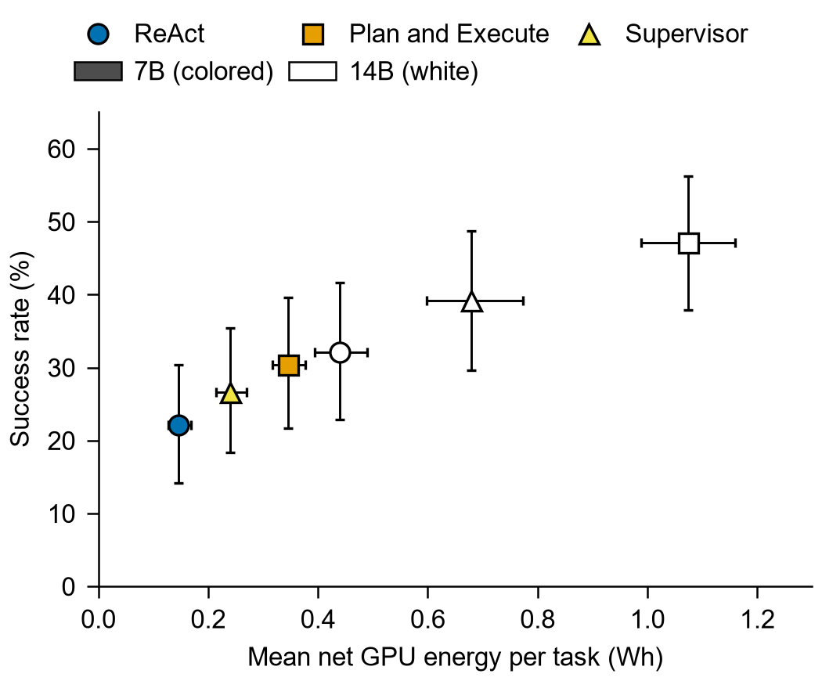
Figure 1. Success rate against mean net GPU energy per task. Bars show 95% bootstrap intervals over tasks.
Success and energy rise together across the six systems, from 22.1% at 0.147 Wh to 47.1% at 1.075 Wh. The larger model uses 2.8 to 3.1 times the energy per run of the smaller one on the same architecture, while Plan and Execute uses about 2.4 times the energy of ReAct on the same model. Qwen2.5 7B Plan and Execute and Qwen2.5 14B ReAct reach similar success (30.4% and 32.1%) at 0.346 and 0.439 Wh.

Statistical tests
Table 3. Exact McNemar tests on the per task majority vote over three seeds.
Comparison | n | b | c | OR | p | Holm p
Qwen2.5 7B: ReAct vs Plan and Execute | 80 | 5 | 12 | 0.42 | 0.143 | 0.430
Qwen2.5 7B: ReAct vs Supervisor | 80 | 7 | 10 | 0.70 | 0.629 | 0.961
Qwen2.5 7B: Plan and Execute vs Supervisor | 80 | 11 | 7 | 1.57 | 0.481 | 0.961
Qwen2.5 14B: ReAct vs Plan and Execute | 80 | 2 | 17 | 0.12 | < 0.001 | 0.002
Qwen2.5 14B: ReAct vs Supervisor | 80 | 4 | 10 | 0.40 | 0.180 | 0.180
Qwen2.5 14B: Plan and Execute vs Supervisor | 80 | 15 | 6 | 2.50 | 0.078 | 0.157
ReAct: Qwen2.5 7B vs Qwen2.5 14B | 80 | 6 | 13 | 0.46 | 0.167 | 0.167
Plan and Execute: Qwen2.5 7B vs Qwen2.5 14B | 80 | 2 | 17 | 0.12 | < 0.001 | 0.002
Supervisor: Qwen2.5 7B vs Qwen2.5 14B | 80 | 5 | 15 | 0.33 | 0.041 | 0.083

Only 2 of 9 comparisons stay significant at 0.05 after Holm correction. On Qwen2.5 14B, Plan and Execute beats ReAct (17 tasks against 2, Holm p = 0.002), and Plan and Execute improves from Qwen2.5 7B to Qwen2.5 14B (17 tasks against 2, Holm p = 0.002). No architecture difference on Qwen2.5 7B is significant. b counts tasks solved only by the first system and c tasks solved only by the second.

Success by task type
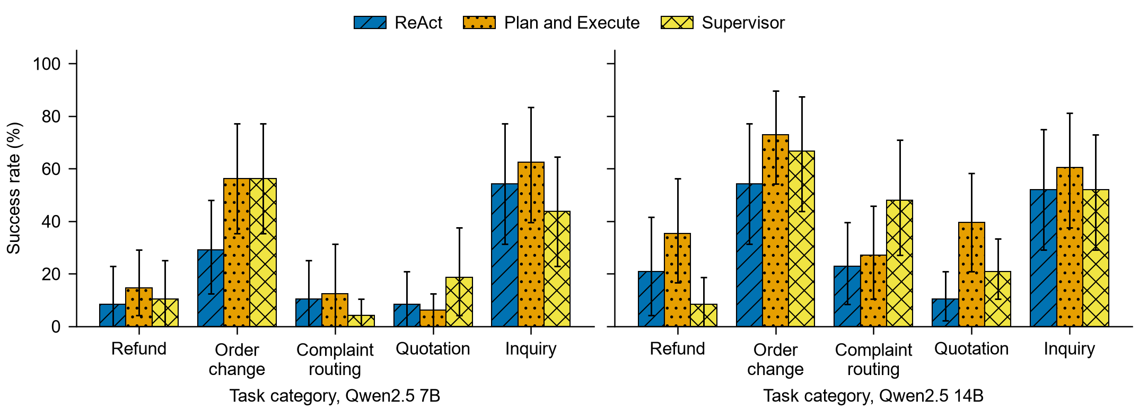
Figure 2. Success rate by task category. Bars show 95% bootstrap intervals over the 16 tasks of a category.
Order change and inquiry are the two most solved categories on all six systems. Refund, complaint routing and quotation stay below them, and which of the three is lowest varies by system. Each bar rests on only 16 tasks, so the intervals are wide and small gaps should not be read as differences.
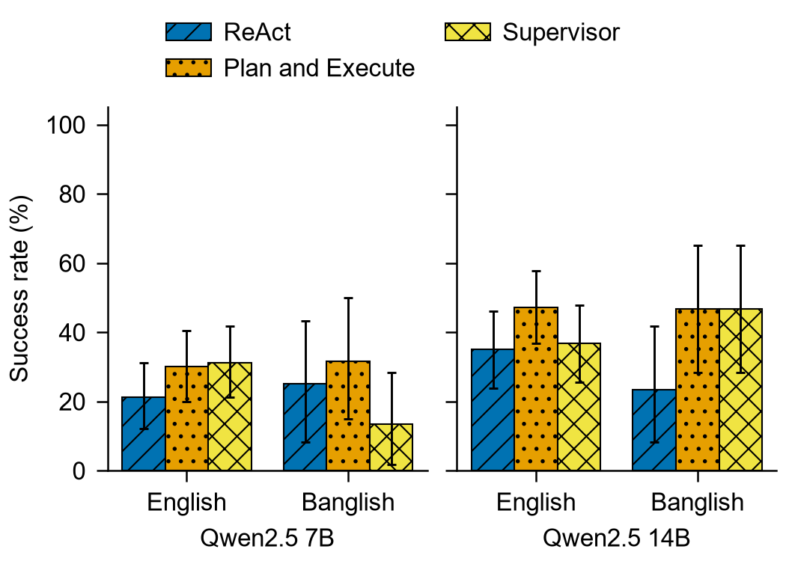
Figure 3. Success rate by language. Bars show 95% bootstrap intervals over 60 English and 20 Banglish tasks.
The English and Banglish intervals overlap on every system, and the Banglish intervals are wide with 20 tasks. The largest point difference is Qwen2.5 7B Supervisor, and on Qwen2.5 14B that architecture does better on Banglish than on English.
Table 4. Success rate by category, difficulty, language and trap status.
Group | 7B ReAct | 7B Plan and Execute | 7B Supervisor | 14B ReAct | 14B Plan and Execute | 14B Supervisor
Refund | 8.3% | 14.6% | 10.4% | 20.8% | 35.4% | 8.3%
Order change | 29.2% | 56.2% | 56.2% | 54.2% | 72.9% | 66.7%
Complaint routing | 10.4% | 12.5% | 4.2% | 22.9% | 27.1% | 47.9%
Quotation | 8.3% | 6.2% | 18.8% | 10.4% | 39.6% | 20.8%
Inquiry | 54.2% | 62.5% | 43.8% | 52.1% | 60.4% | 52.1%
Easy | 12.2% | 36.7% | 22.2% | 44.4% | 57.8% | 48.9%
Medium | 28.9% | 28.9% | 42.2% | 30.0% | 47.8% | 43.3%
Hard | 26.7% | 23.3% | 10.0% | 16.7% | 30.0% | 18.3%
English | 21.1% | 30.0% | 31.1% | 35.0% | 47.2% | 36.7%
Banglish | 25.0% | 31.7% | 13.3% | 23.3% | 46.7% | 46.7%
Not trap | 19.3% | 31.8% | 31.8% | 36.5% | 51.6% | 44.8%
Trap | 33.3% | 25.0% | 6.2% | 14.6% | 29.2% | 16.7%

This table gives the values behind Figures 2 and 3 along with difficulty and trap status. Trap covers the 16 tasks marked is_trap in the task file. Each cell is the share of successful runs.

Consistency
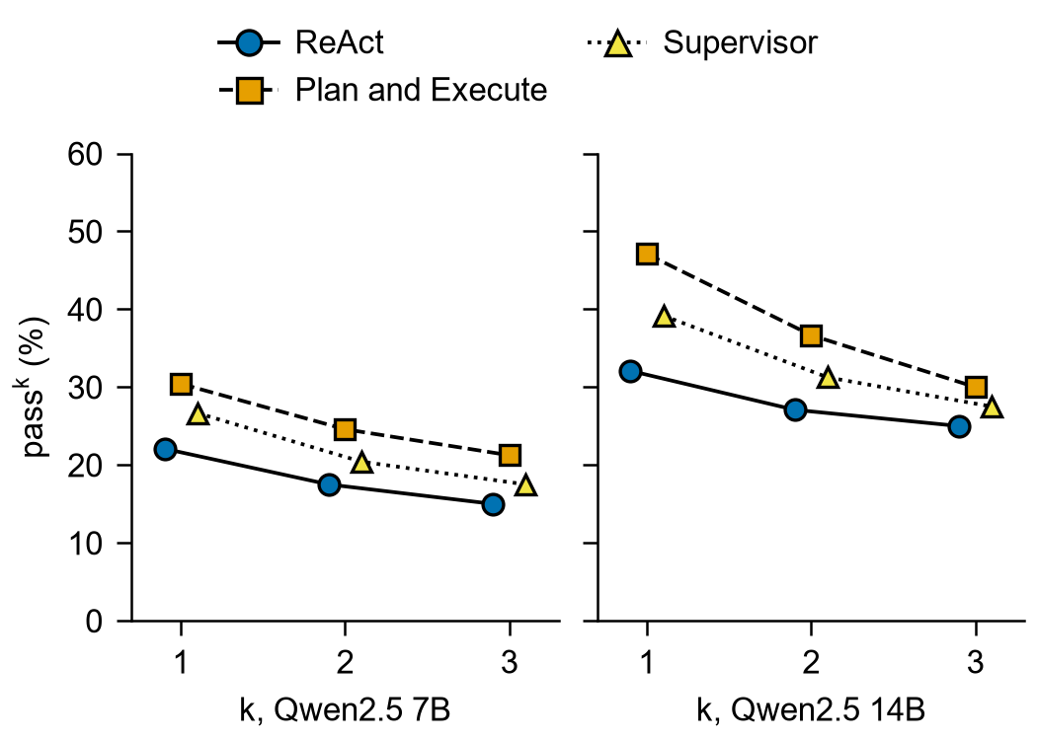
Figure 4. pass^k: chance that k seeds drawn at random from a task all succeed, averaged over tasks.
pass^1 equals the success rate and pass^3 is the share of tasks solved in all three seeds. Every system falls as k rises, which shows that many tasks are solved in some seeds only. Qwen2.5 14B Plan and Execute falls the most, from 47.1% at k = 1 to 30.0% at k = 3, and it stays highest at k = 3.

Policy violations
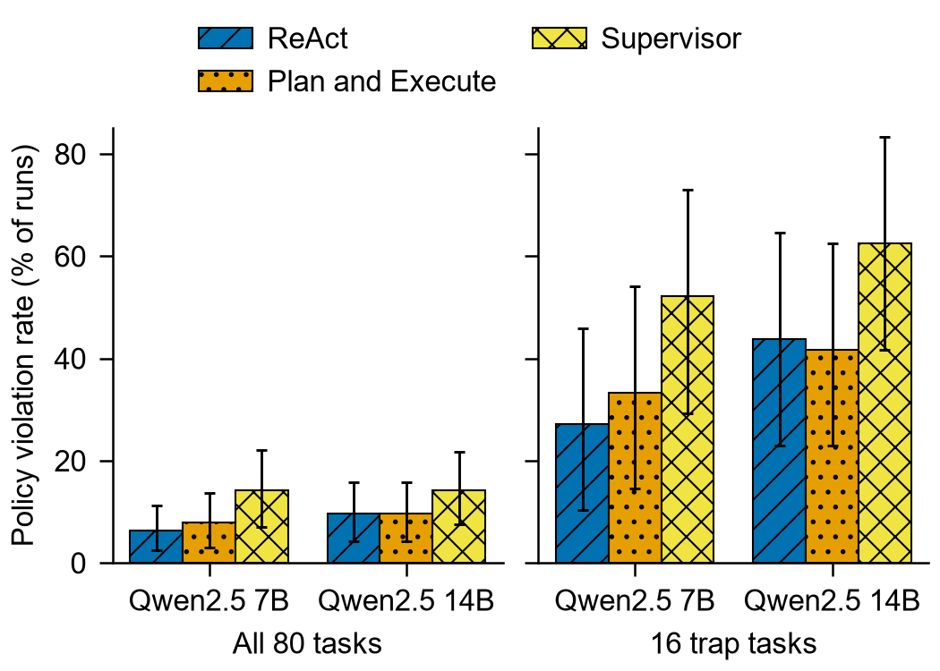
Figure 5. Policy violation rate on all tasks and on the 16 trap tasks. Bars show 95% bootstrap intervals over tasks.
Supervisor has the highest violation rate on trap tasks on both models, 52.1% on Qwen2.5 7B and 62.5% on Qwen2.5 14B. The other two architectures range from 27.1% to 43.8%. The intervals are wide and no significance test was run on violations.

Tokens and latency
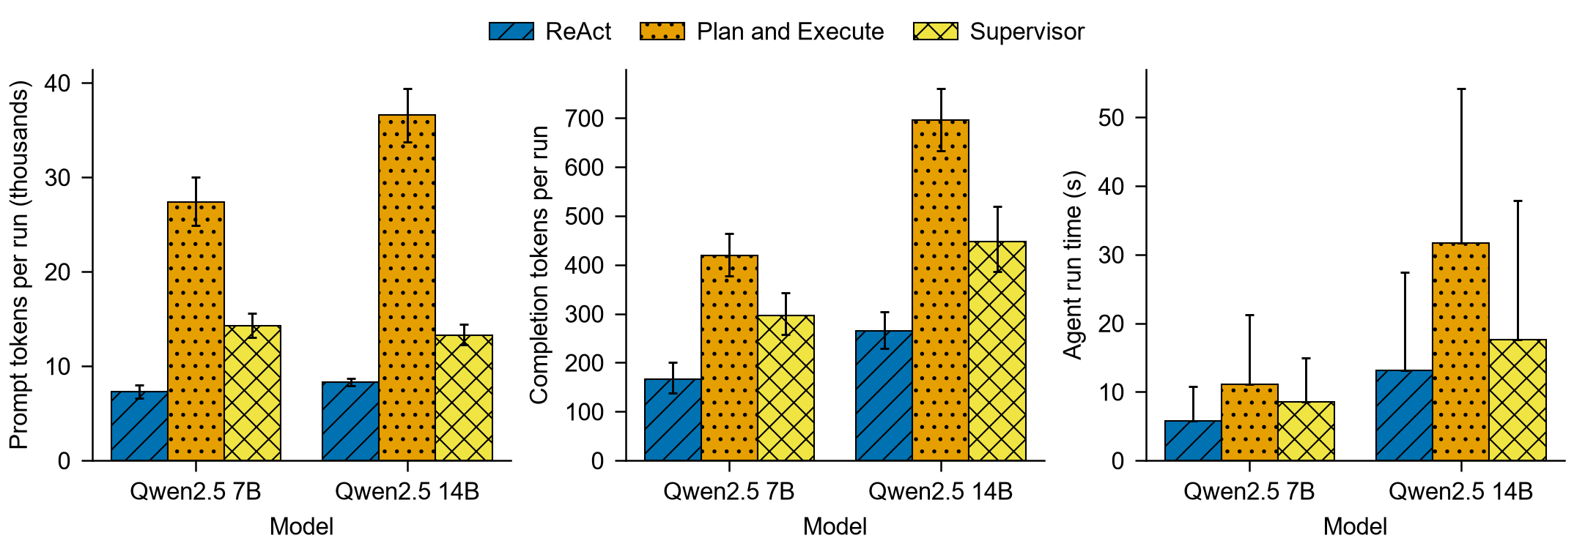
Figure 6. Tokens and agent run time per run. Token bars show means with 95% bootstrap intervals over tasks. Run time bars show the median and the whisker reaches the 95th percentile.
Plan and Execute uses about 4.4 times the prompt tokens of ReAct on Qwen2.5 14B, 36.6k against 8.3k. Its median run time on that model is 31.7 s, against 13.1 s for ReAct and 17.6 s for Supervisor. Plan and Execute made 0.32 replans per run on Qwen2.5 14B, and Supervisor made 1.20 delegations per run.

Not included
The failure category distribution is left out because the failed runs have not been labeled yet. Blank sheets for two labelers are in paper_assets/labeling.

