The Fixed Assets module follows a structured process that covers the entire lifecycle of a fixed asset. Here is a summarized flow of the Fixed Assets module:

### 1. Planning Stage
- Identify business needs, budget, and perform market research.
- Decide whether to purchase or construct the asset.

### 2. Acquisition Stage
- Create a master record for the fixed asset:
Go to Asset Management > Master Data > Fixed Assets.
- Register the purchase (Invoice Received) or construction costs.
- If constructed, track costs under Construction in Progress until ready for use.

### 3. Acceptance for Accounting
- Create a Fixed Asset Entry document:
Go to Asset Management > Fixed Asset Documents > Fixed Asset Entries.
- Specify inventory items, initial cost, salvage value, depreciation method (Straight Line or Units of Production), useful life, and related GL accounts.
- Once posted, the asset status changes to Active and depreciation can begin.

### 4. Usage and Depreciation
- Depreciation is calculated monthly based on the selected method.
- For Units of Production, monthly usage is entered.
- Depreciation continues until the asset’s net book value reaches the salvage value.

### 5. Maintenance and Capital Improvements
- Record any capital improvements using the Capital Improvements to Fixed Assets document.
- Update gross cost, useful life, and salvage value as needed.

### 6. Reassessment
- Periodically reassess asset value for impairment or gain.
- Use the Changes of Fixed Asset Parameters document to update gross cost, salvage value, and useful life.

### 7. Disposal or Sale
- When the asset is no longer in use, process its disposal or sale using the appropriate documents.

### 8. Reporting
- Use reports such as Statement of Depreciation and Inventory Card to monitor asset values and depreciation.

#### Key Documents in the Flow:
- Fixed Asset Entry
- Fixed Asset Depreciation
- Fixed Asset Monthly Usage
- Capital Improvements to Fixed Assets
- Changes of Fixed Asset Parameters
- Fixed Asset Write Off
- Preparation for Fixed Asset Sale

This flow can be visualized as a diagram with the following main steps:
- Planning → 2. Acquisition → 3. Acceptance for Accounting → 4. Usage & Depreciation → 5. Maintenance/Improvements → 6. Reassessment → 7. Disposal/Sale → 8. Reporting

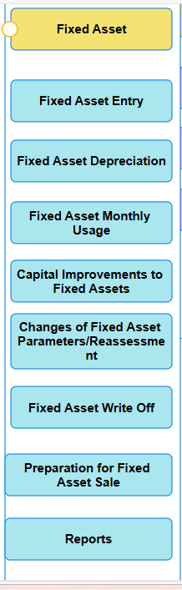
Master for the fixed assets the download option will be having this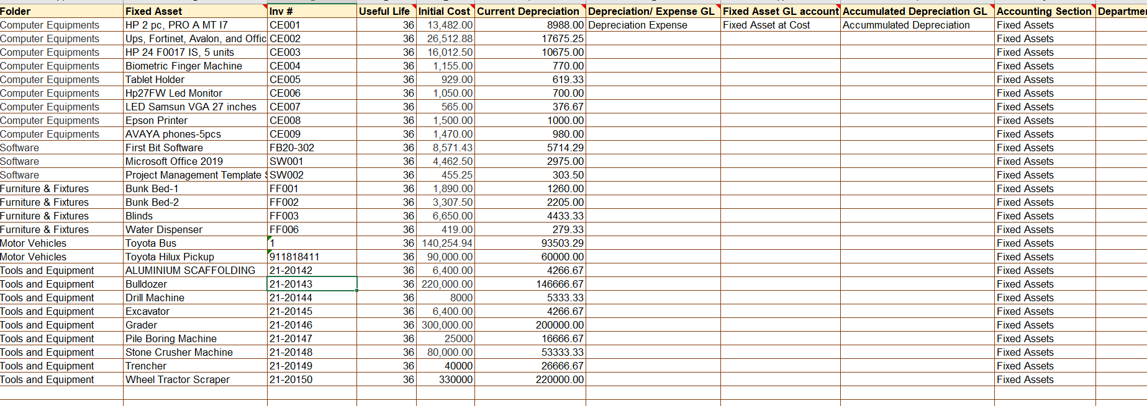
Chart of account for the fixed assets for example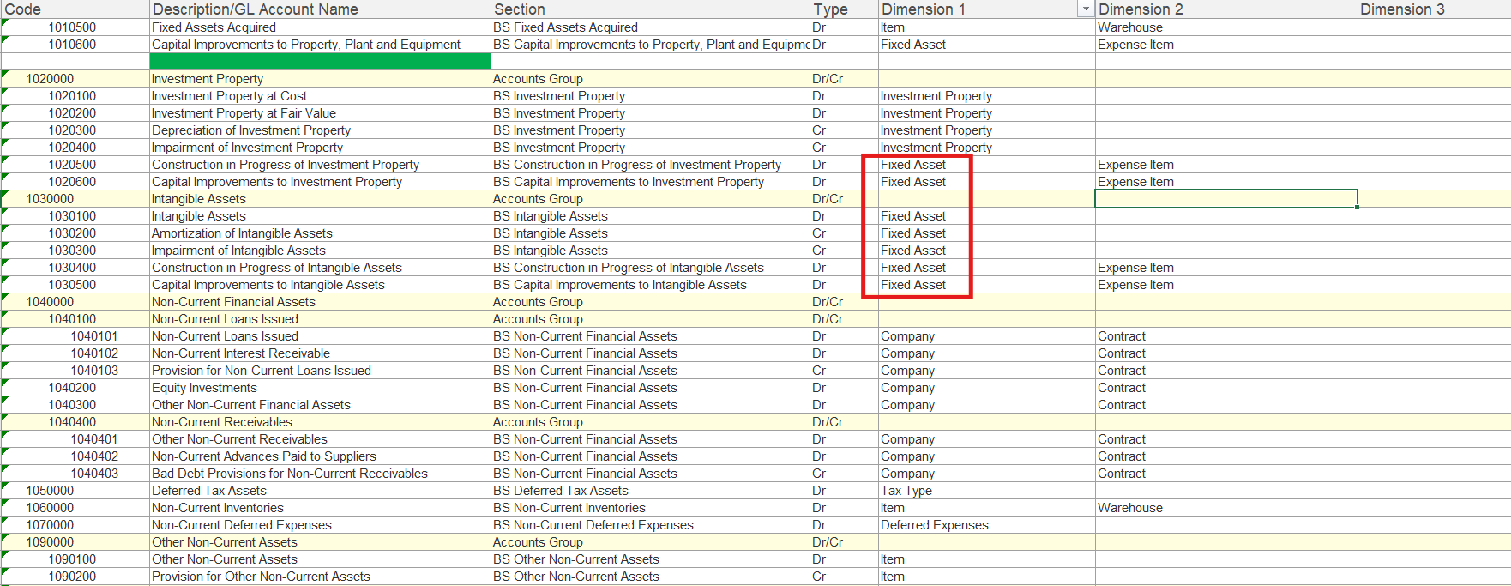
Master for the fixed assets
- Fixed Assets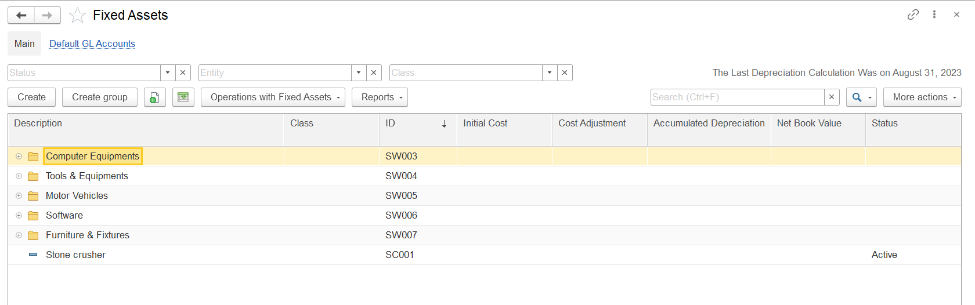
Create and to make active change the status: Active, Construction in progress and construction completed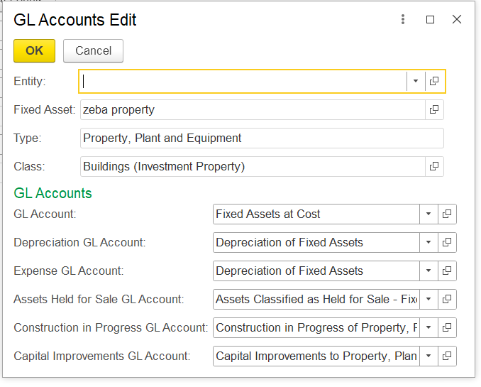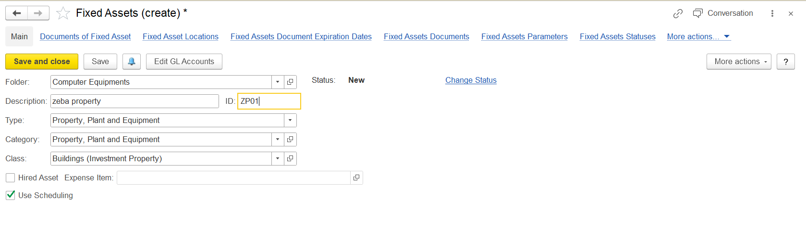
- Non Current Asset Classes
- 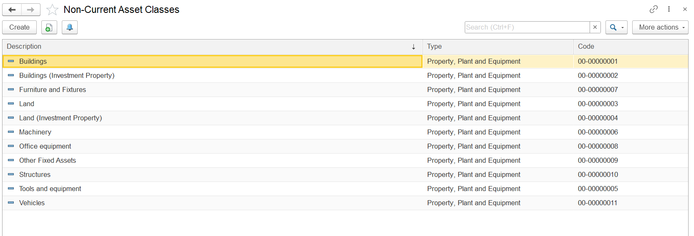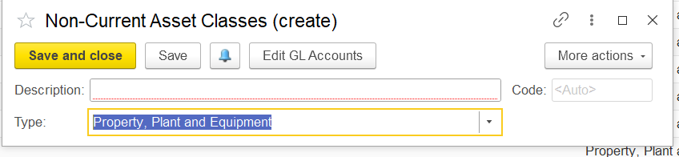Types: Intangible assets and property and equipment’s
- Fixed assets category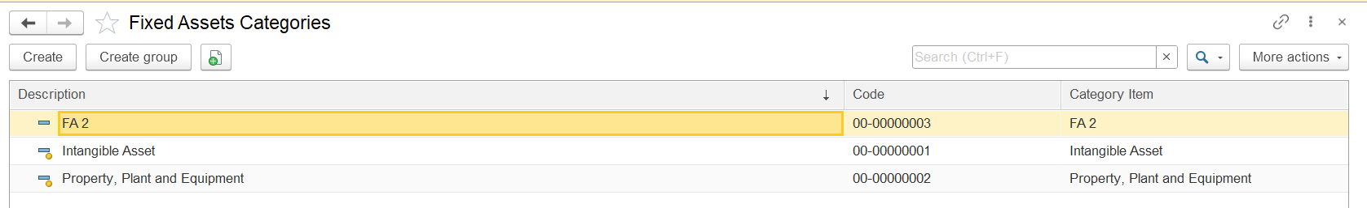
- Fixed asset status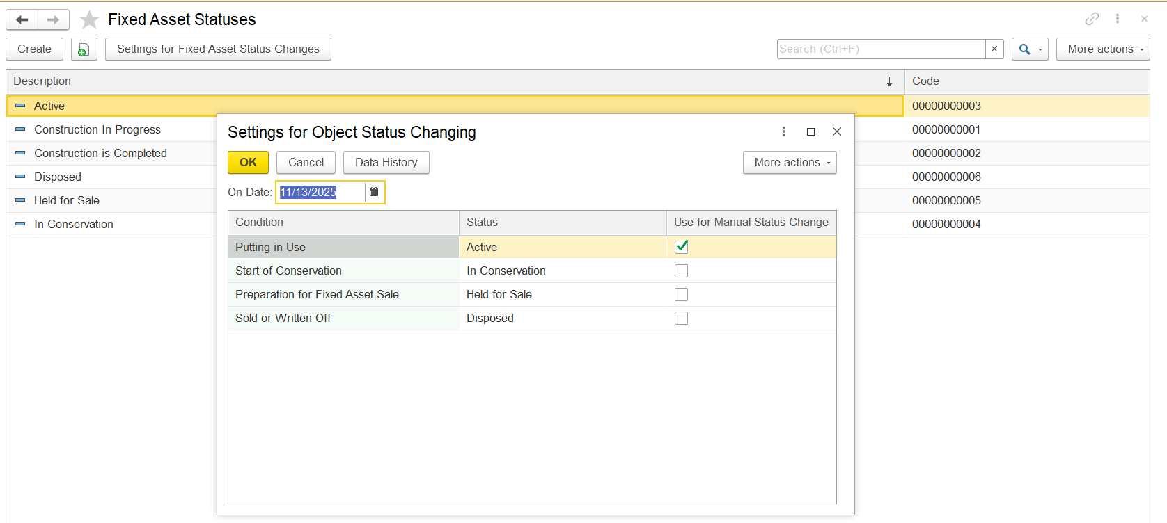
- Item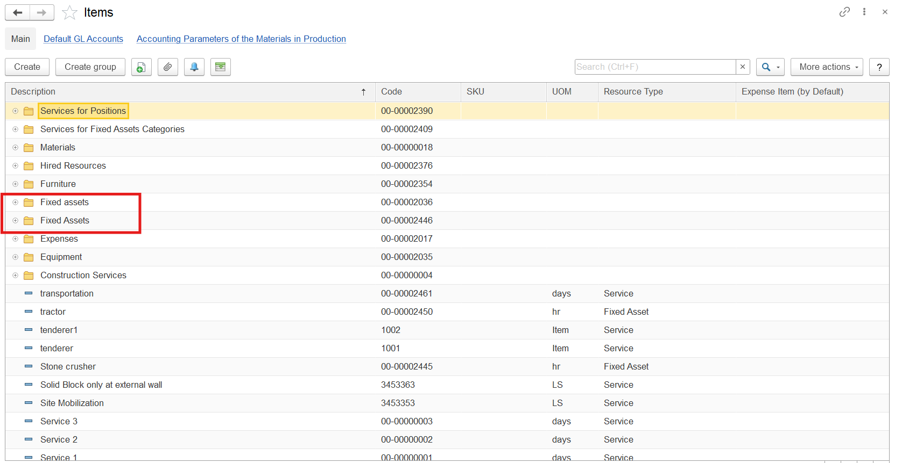
- Item categories: 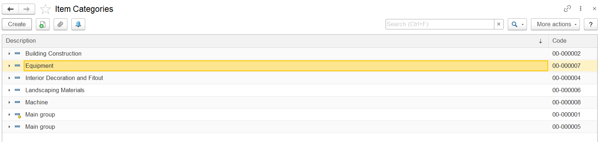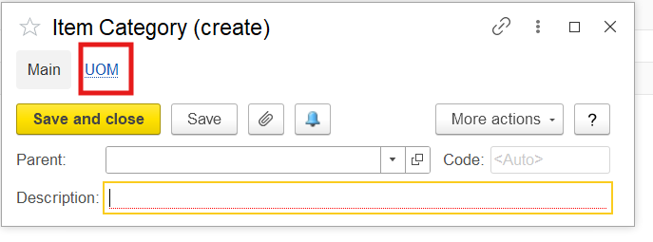
Operations documents:
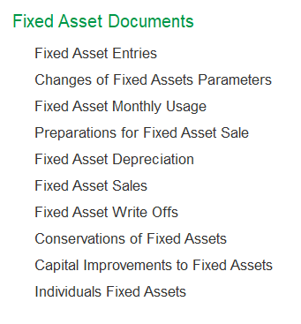
Fixed Assets Entries
the "Salvage Value" is the estimated residual value of a fixed asset at the end of its useful life, at which point depreciation will stop. This value represents the expected book value of the asset after it has been fully used or depreciated. The salvage value can also be used as a base for the sale price if the asset is sold at the end of its useful life.

When creating a fixed asset entry, you enter the initial cost and the salvage value. The system then automatically calculates the depreciable cost as the difference between the initial cost and the salvage value. Depreciation is calculated on this depreciable cost over the asset's useful life using the selected depreciation method (such as Straight Line or Units of Production).

Depreciation continues until the net book value of the asset reaches the salvage value. At that point, no further depreciation is calculated, and the asset's remaining value on the books is its salvage value. This approach ensures that the asset is not depreciated below its expected residual value.

For example, if an asset has an initial cost of 100,000 AED and a salvage value of 20,000 AED, the depreciable cost is 80,000 AED. Depreciation will be calculated on this 80,000 AED over the asset's useful life, and when the net book value reaches 20,000 AED, depreciation stops.
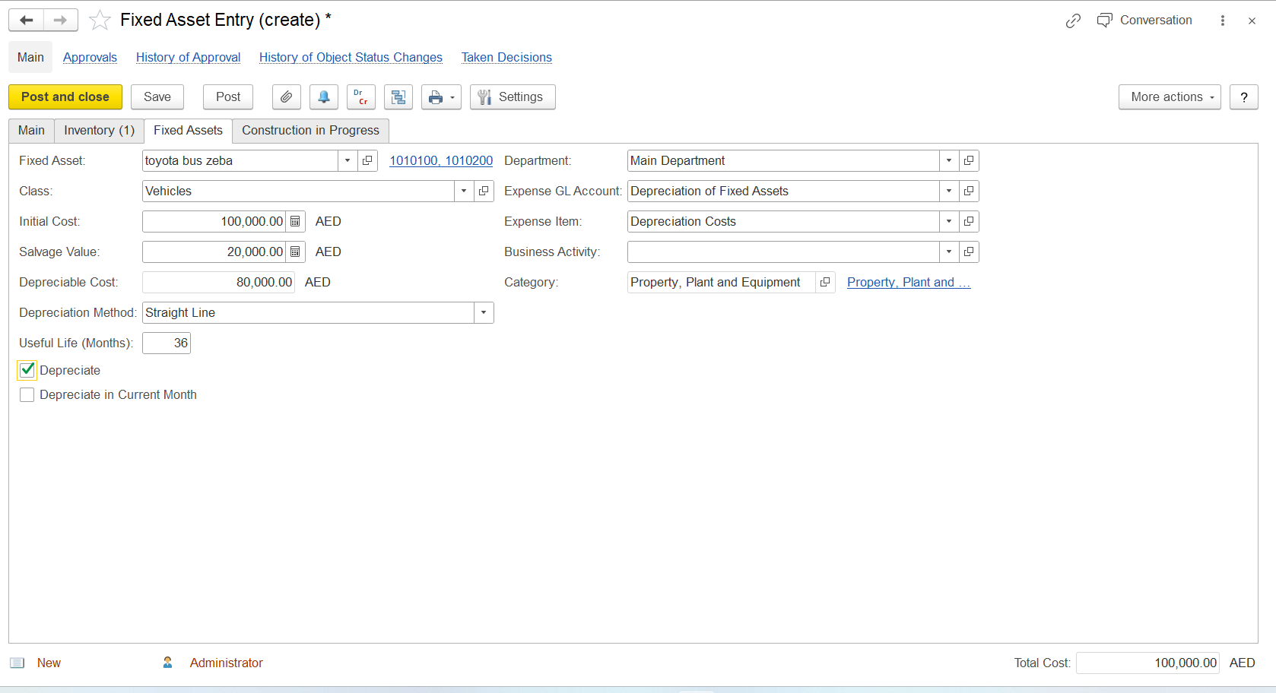
Changes of the Fixed Assets Parameters
Changes on the life cost salvage etc: If they are increase in the life after repair then that also we can update
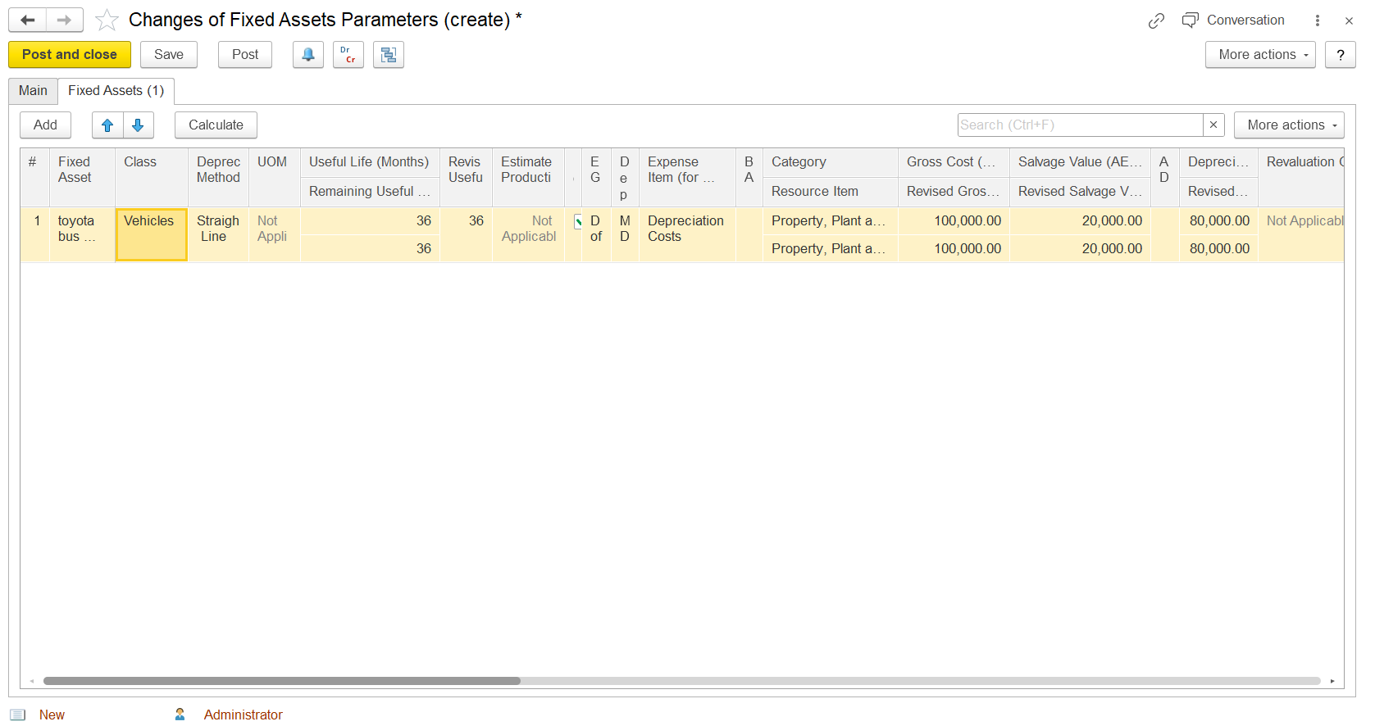

Fixed Asset Monthly usage: This will be for the depreciation method Unit of Production
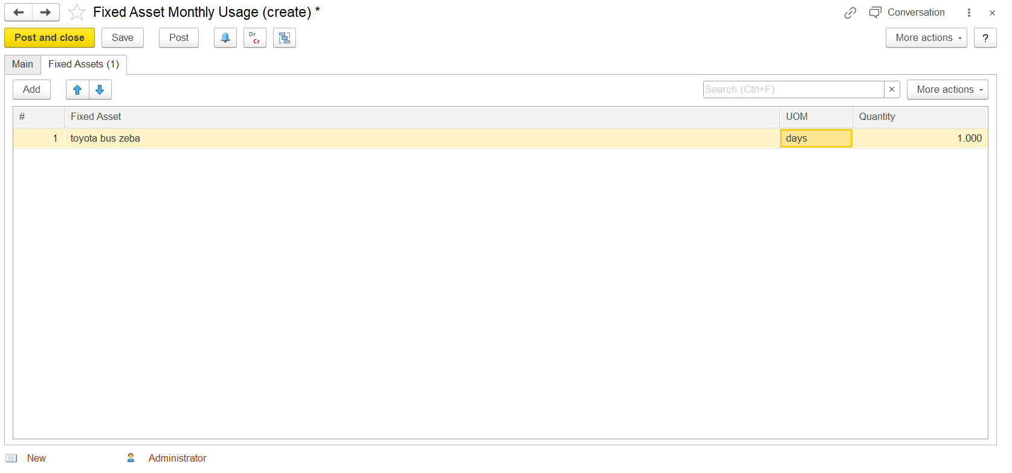Preparations for fixed asset sale
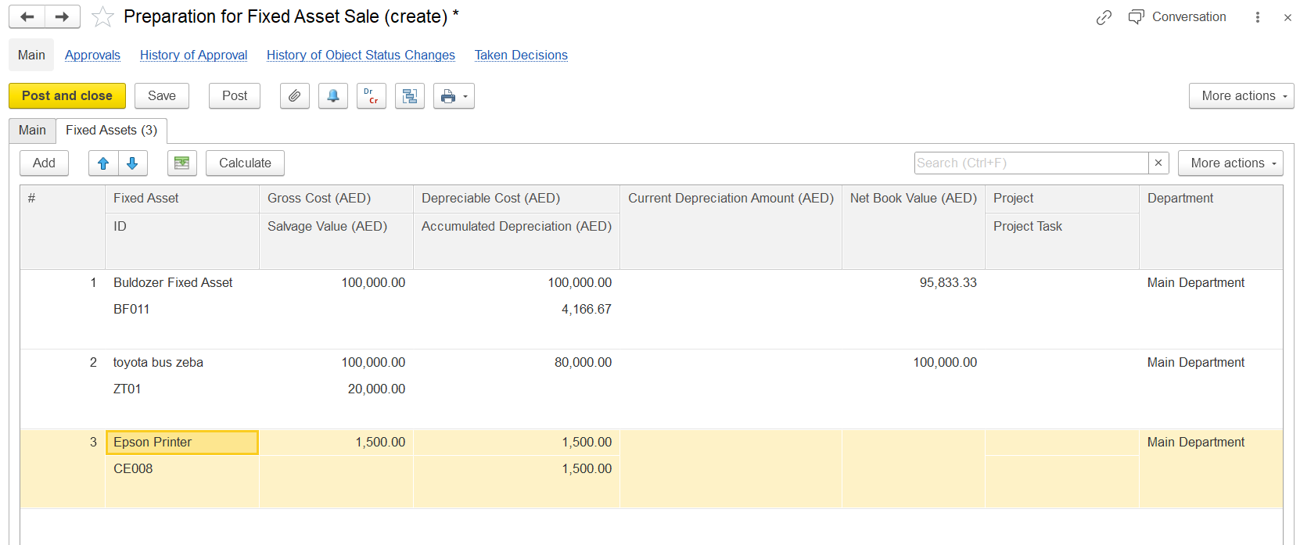
Fixed asset Depreciation for the selected month 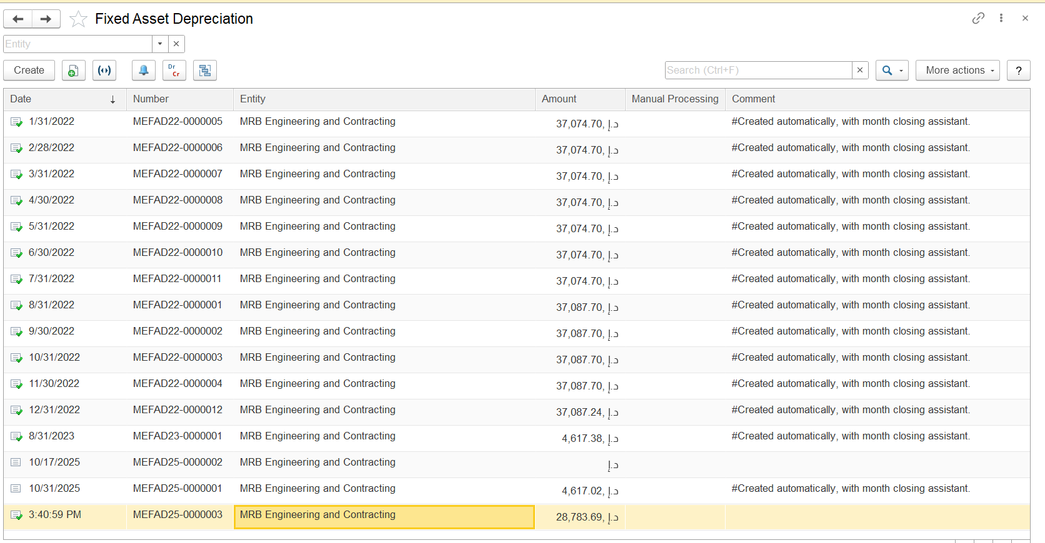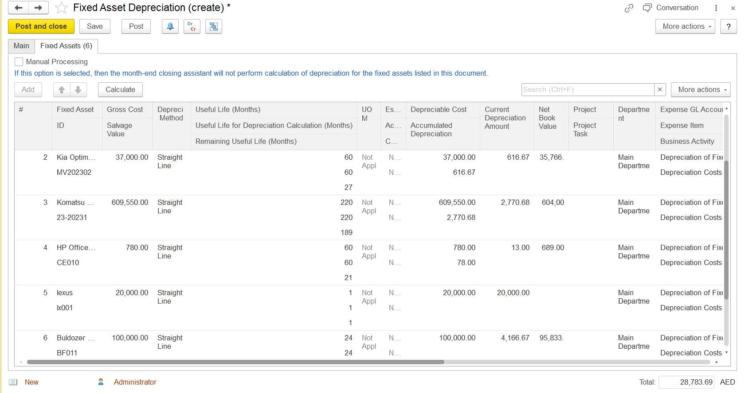
Statement of depreciation
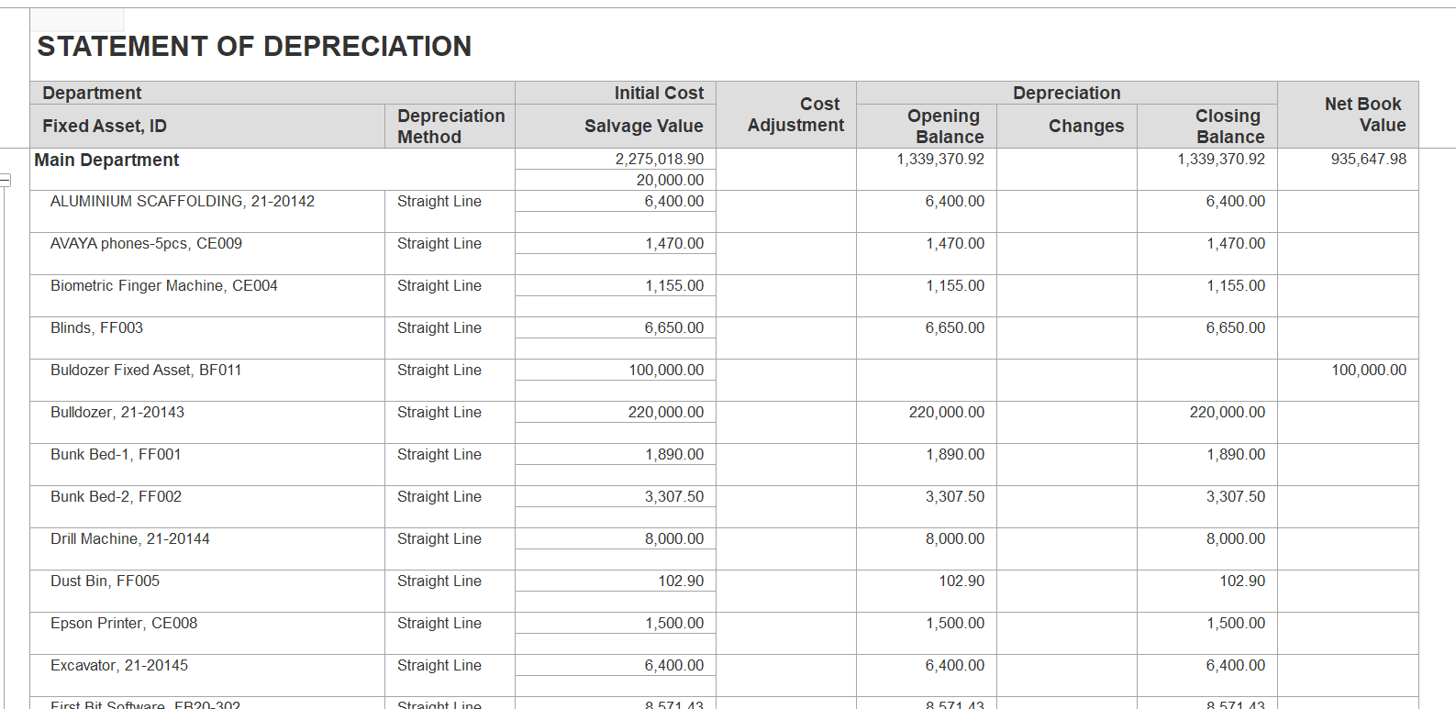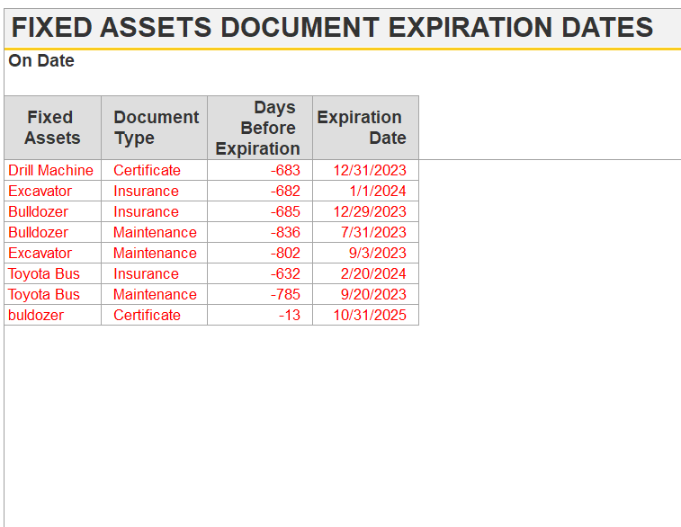
Fixed asset sales 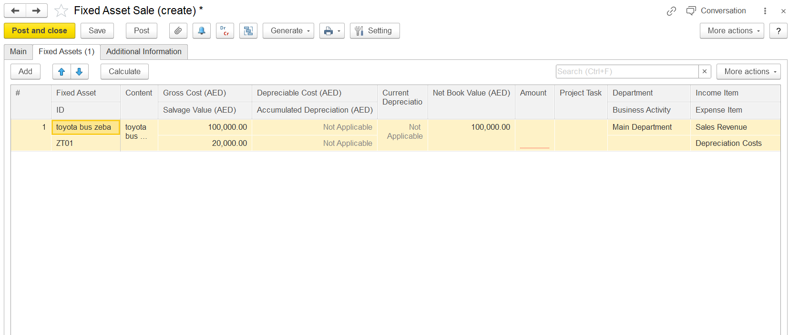
Here is a description of the main elements and the extracted text:
### Description of the Screen
- Toolbar Buttons (Top Left):
- "Post and close", "Save", "Post", and other standard document actions.
- Tabs:
- "Main", "Fixed Assets (1)", "Additional Information".
- Table Columns:
- # (row number)
- Fixed Asset (with subcolumns: ID and Content)
- Gross Cost (AED)
- Salvage Value (AED)
- Depreciable Cost (AED) (with subcolumn: Accumulated Depreciation (AED))
- Current Depreciation
- Net Book Value (AED)
- Amount
- Project Task
- Department (with subcolumn: Business Activity)
- Income Item (with subcolumn: Expense Item)

- Table Data (Example Row):
- Fixed Asset ID: "toyota bus zeba"
- Content: "toyota bus ..."
- Gross Cost (AED): 100,000.00
- Salvage Value (AED): 20,000.00
- Depreciable Cost (AED): Not Applicable
- Accumulated Depreciation (AED): Not Applicable
- Current Depreciation: Not Applicable
- Net Book Value (AED): 100,000.00
- Department: Main Department
- Business Activity: Sales Revenue
- Expense Item: Depreciation Costs

### Extracted Text from the Image
- "Post and close"
- "Save"
- "Post"
- "Generate"
- "Setting"
- "Main"
- "Fixed Assets (1)"
- "Additional Information"
- "Add"
- "Calculate"
- "More actions"
- "toyota bus zeba"
- "ZT01"
- "toyota bus ..."
- "100,000.00"
- "20,000.00"
- "Not Applicable"
- "100,000.00"
- "Main Department"
- "Sales Revenue"
- "Depreciation Costs"
### Functional Explanation
On the "Fixed Assets" tab of the Fixed Asset Sale document, you can specify the fixed assets being sold, their costs, depreciation, net book value, and related analytics such as department, business activity, and income/expense items. The "Calculate" button can be used to update the data for the listed fixed assets if changes have been made in other documents. The toolbar allows you to save, post, or close the document as needed
Fixed asset write offs:
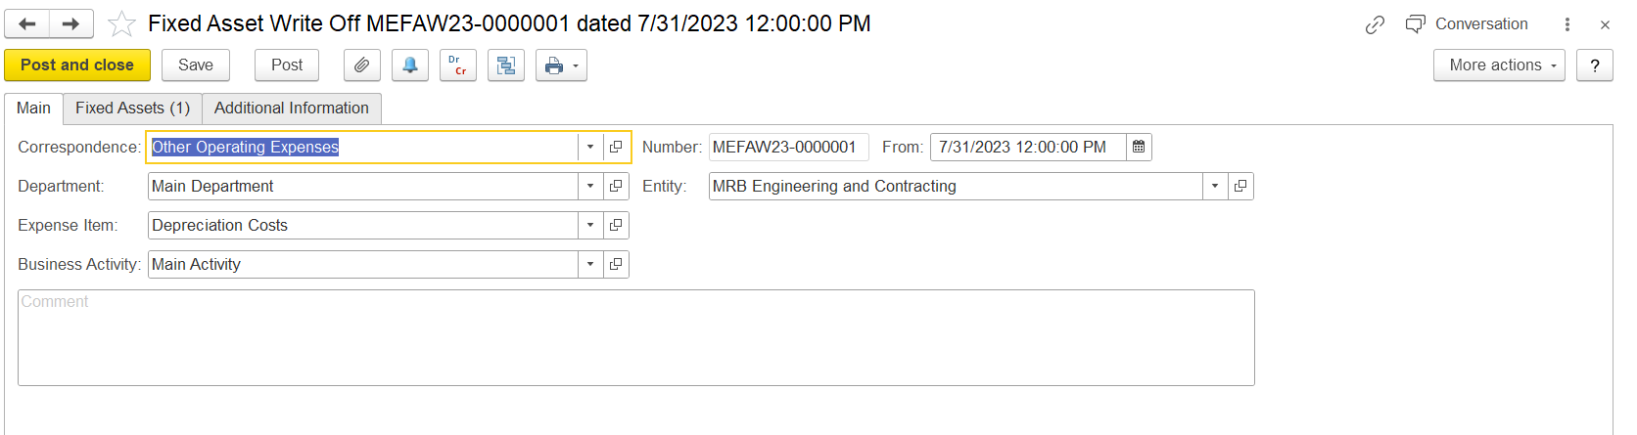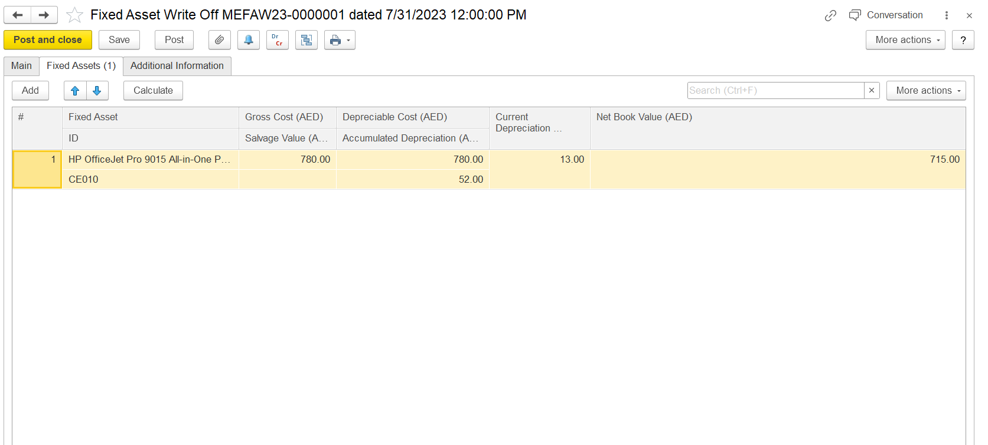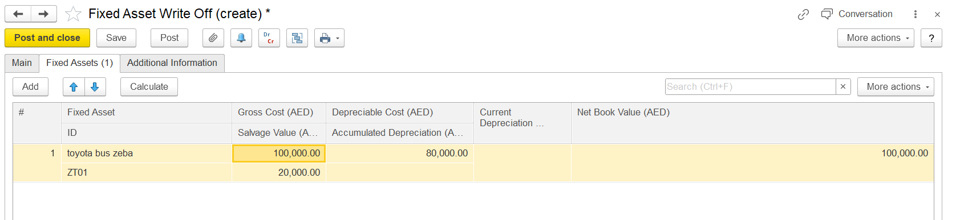
Conversations of fixed assets: After some period of fixed asset usage, the organization may decide to stop the usage due to various reasons and to stop depreciation calculation. For this, you can place the fixed asset into conservation for some time interval. The fixed asset's status changes to In Conservation and the net book value will remains the same during the conservation period. However, the depreciation calculation will be resumed and the status will change to Active once conservation of the fixed asset is cancelled.
Transaction types:start of conservation and cancel of conservation
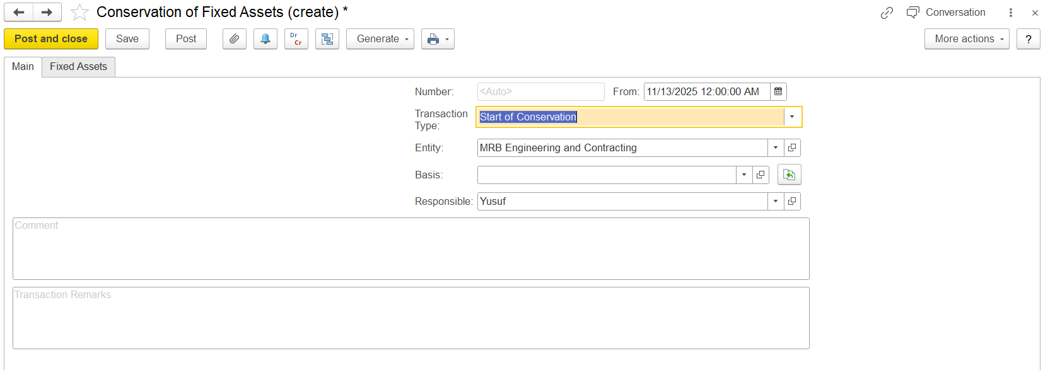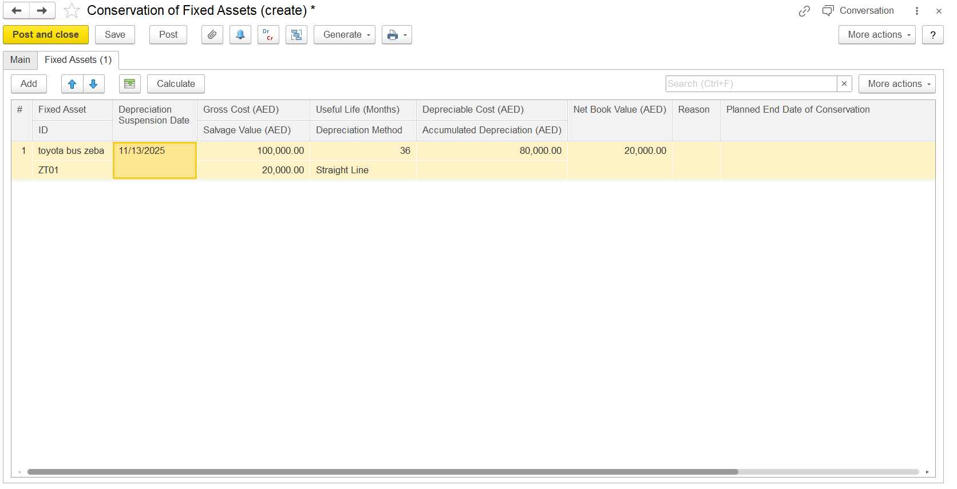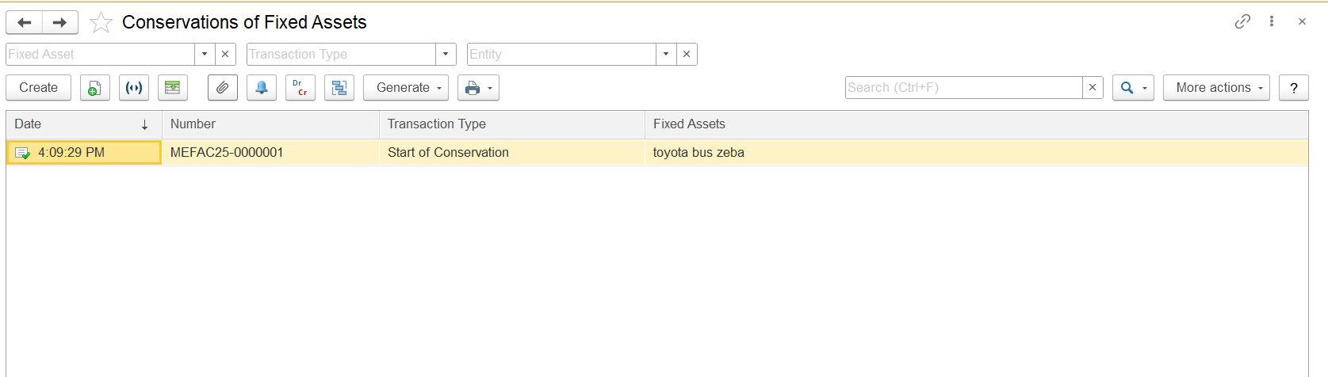
Cancel conservation:
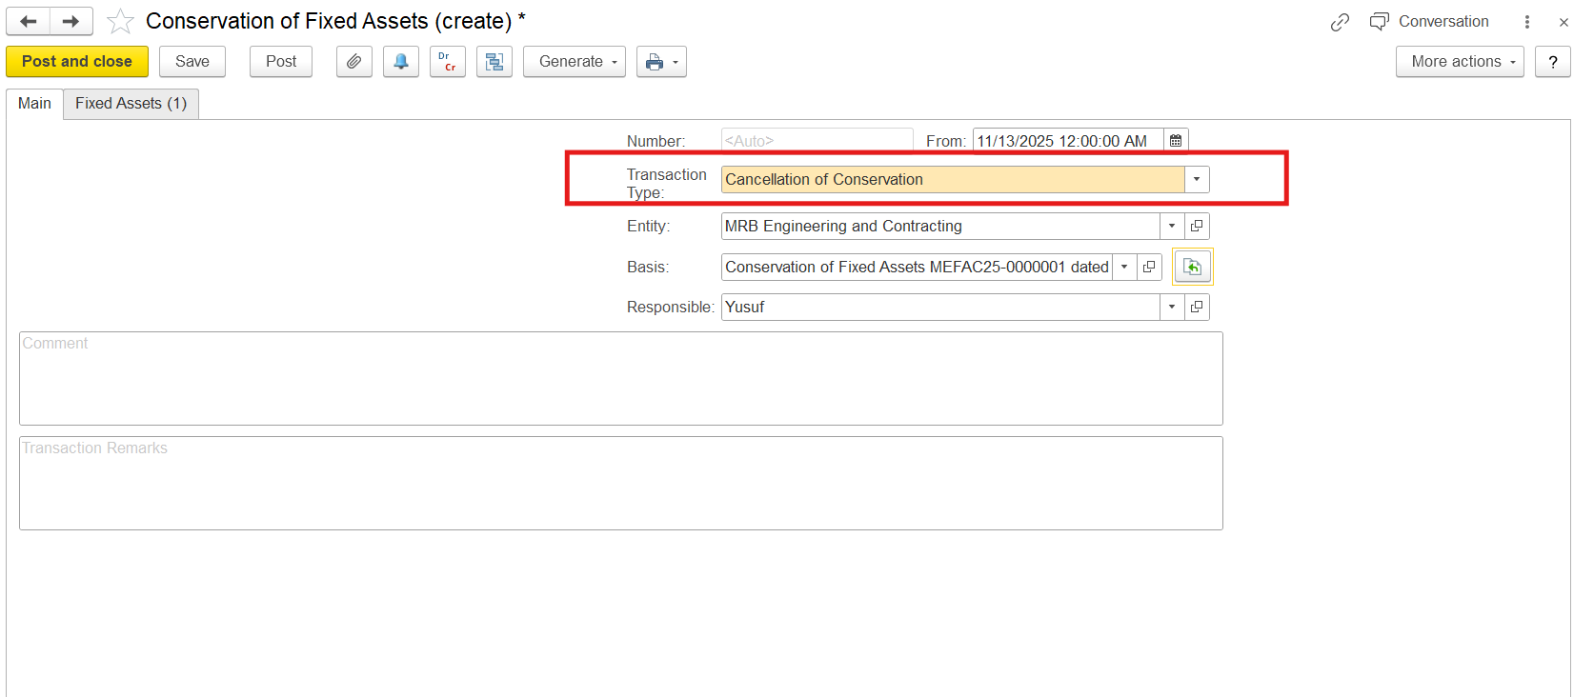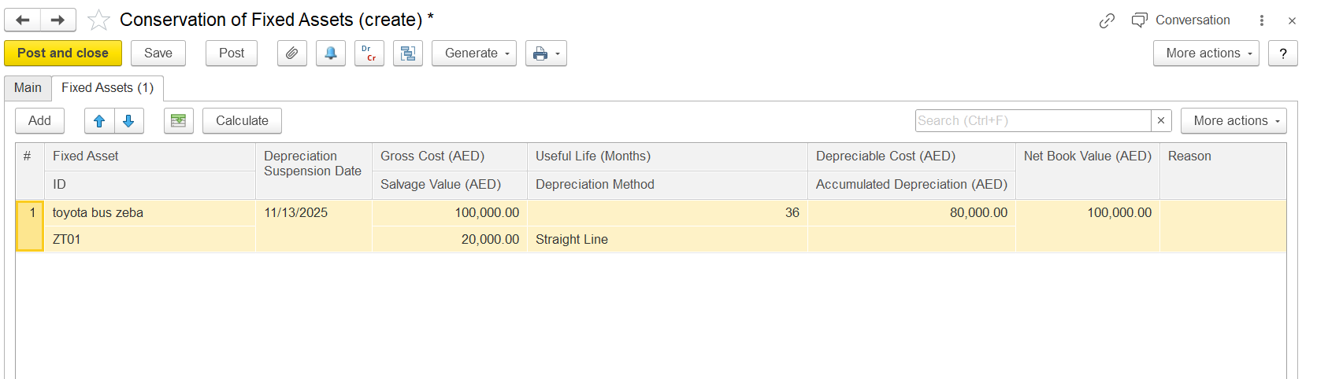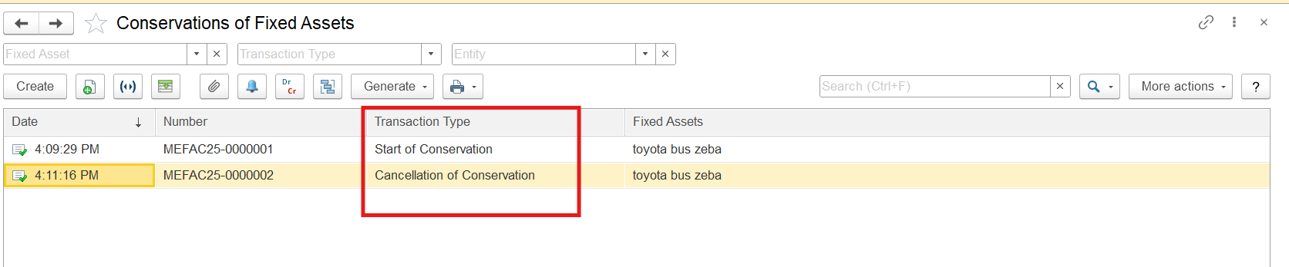
Capital improvements to fixed assets
The Extracted Inventory Amount field shows the cost of the inventory items resulted in the process of capital improvements made to the fixed assets.
The Cost of Capital Improvements field shows the total of costs incurred in the process of capital improvements.
The Capitalized Costs field shows the increase in Gross Costs of the assets as compared to their Gross Costs before the capital improvements were made.

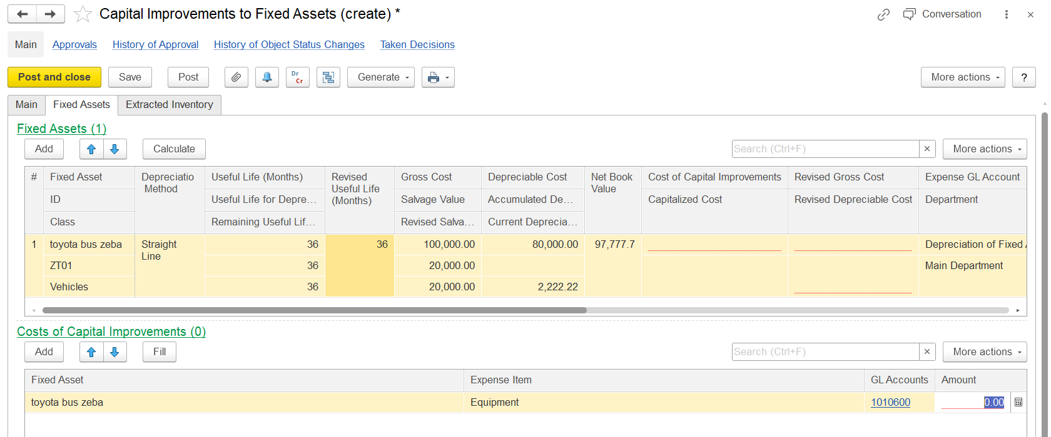
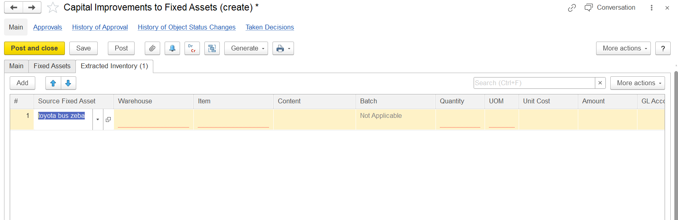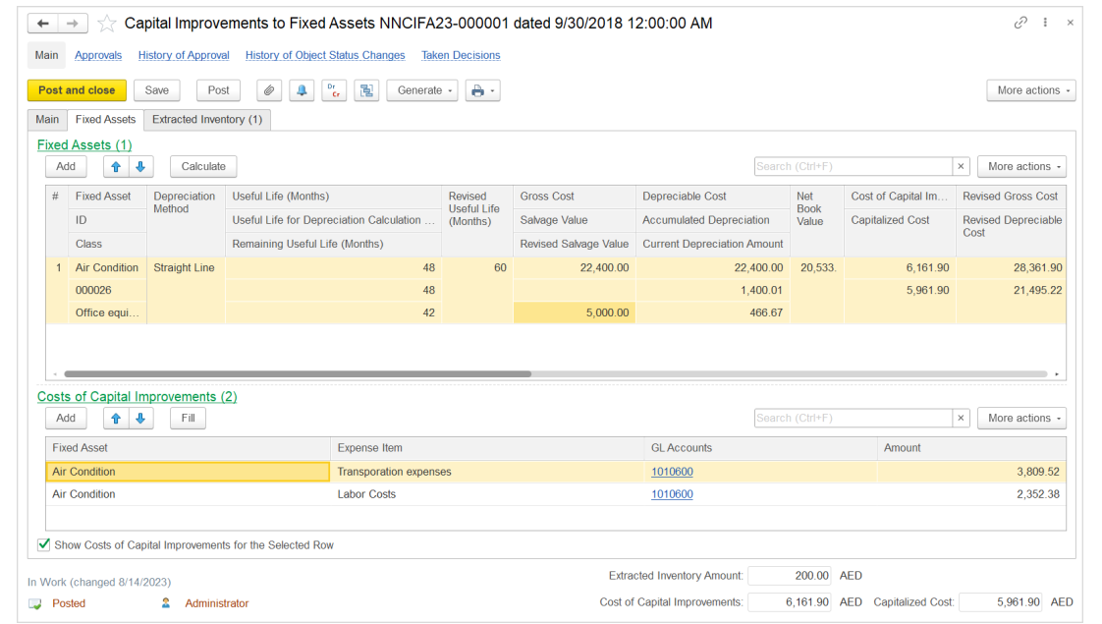In the Depreciation Method column, you can view the depreciation method used for the fixed asset depreciation. The following depreciation methods are available:
- Straight Line: To calculate depreciation in equal monthly amounts during the fixed asset useful life.
- Units of Production: To calculate depreciation amounts proportionally to actual usage of the fixed asset.
The Useful Life (Months) subcolumn shows the number of months the fixed asset was planned for usage if the Straight Line depreciation method is selected for the asset.
The Useful Life for Depreciation Calculation subcolumn shows the number of useful life months used for depreciation calculation in the current month. The Remaining Useful Life (Months) subcolumn shows the number of months the asset was planned to be depreciated after the current month if there were no changes.
Use the Revised Useful Life (Months) subcolumn to change the number of months the fixed asset is now being planned for usage with the Straight Line depreciation method selected for the asset depreciation.
If the Units of Production depreciation method is selected for the asset, the next two columns become available.
The UOM / Estimated Production Volume / Accumulated Production Volume column shows the default unit of measure selected for the production method, the estimation of production volume either defined initially or specified in the latest Changes of Fixed Asset Parametersdocument, and the production volume accumulated since the start of usage.
The Remaining Production Volume subcolumn shows the calculated production volume that is currently available for usage after the improvement. Use the Revised Estimated Production Volume subcolumn to enter the new estimation for the production volume.
The Gross Cost subcolumn shows the gross cost of the fixed asset before the current changes.
The Salvage Value subcolumn shows the salvage value defined earlier for this asset. The salvage value can be used as a base for sale price at the end of its useful life.
Use the Revised Salvage Value subcolumn to enter the new salvage value.
The Depreciable Cost subcolumn is automatically populated with the amount that is equal to difference between the previous Gross Cost and Salvage Value. The Accumulated Depreciation column shows the amount of depreciation accrued over periods of useful life since the start of depreciation. The Current Depreciation Amount subcolumn shows the depreciation amount to be written to expenses in the current month; this amount is calculated using the "old" parameters that were in effect before capital improvements are registered. If this amount is zero in this document, the depreciation for this month will be calculated during the month-end closing process with the revised parameters.
The Net Book Value subcolumn shows the current value of the fixed asset after the changes that is calculated as follows:
NetBookValue = GrossCost-AccumulatedDepreciation-CurrentDepreciationAmount
The Cost of Capital Improvements subcolumn is populated with the total of all costs associated with the fixed assets' improvements decreased by the sum of the Extracted Inventory costs.
The Capitalized Costs subcolumn shows the increase in the Gross Cost due to improvements.
Use the Revised Gross Cost subcolumn to enter the updated gross cost of the asset; by default, it is calculated as the sum of previous Gross Cost and current Capitalized Costs.
By default, the value in the Revised Depreciable Cost subcolumn is calculated as follows:
Revised Depreciable Cost = RevisedGrossCost - (RevisedSalvageValue + AccumulatedDepreciation + CurrentDepreciationAmount)

Individual fixed assets: The documents of this type are used to register the employees responsible for particular fixed assets and for some low-value, high-wear inventory items intended for personal use.
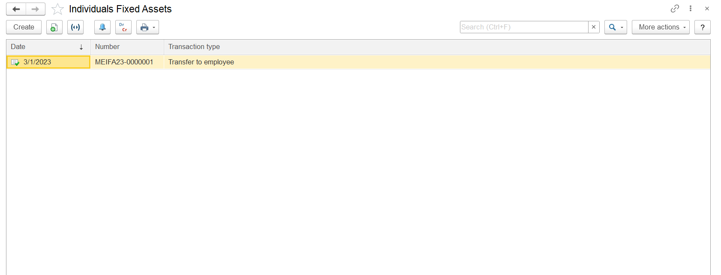
Transaction type: Transfer to employee and Transfer from Employee