Multimodal Heart Disease Prediction Using
EHRs, ECGs, and Wearable Sensor Data

Mohd Sameer
AIML
Noida Institute of engineering and Technology
Greater Noida, India
mohdsameer6819@gmail.com

Mr. Rehan Ali (Assistant Professor)
Noida Institute of engineering and Technology
Greater Noida, India
line 5: physicsali10@gmai.com

Abstract — Cardiovascular diseases (CVDs) continue to pose a significant threat to global health, being a primary cause of morbidity and mortality worldwide. The accurate and early detection of heart conditions remains a crucial challenge in clinical settings. Traditional prediction frameworks often focus on singular data streams, such as clinical reports or ECG readings, thereby failing to capture the full complexity of cardiac health. In this study, we propose a multimodal deep learning-based approach that leverages three types of health data: Electronic Health Records (EHRs), Electrocardiogram (ECG) signals, and wearable sensor outputs. Each data modality is processed through a tailored neural architecture—Multi-Layer Perceptron (MLP) for structured EHR data, 1D Convolutional Neural Networks (CNNs) for ECG signals, and Long Short-Term Memory (LSTM) networks for time-series wearable sensor readings. The extracted features are then combined using an intermediate fusion strategy that enables comprehensive decision-making. Experimental evaluation using MIMIC-III, PTB-XL, and WESAD datasets demonstrates that the proposed multimodal framework significantly outperforms single-modality models, achieving a prediction accuracy of 92%. These findings highlight the transformative potential of multimodal AI systems in advancing cardiovascular diagnostics.

Keywords- Heart Disease Prediction, Multimodal Learning, EHR, ECG, Wearable Sensors, Deep Learning, Health AI
.

Introduction
Cardiovascular diseases (CVDs), encompassing a range of heart and blood vessel disorders, continue to be the leading cause of death globally. According to the World Health Organization, nearly 18 million lives are lost annually to CVDs. Early detection and management are vital for reducing this burden, yet existing predictive systems often depend on isolated data sources, limiting their effectiveness in real-world scenarios.
The digitization of healthcare has introduced new opportunities for comprehensive patient monitoring. Electronic Health Records (EHRs) contain structured clinical data such as demographic details, lab test results, and medication histories. ECG signals provide insights into the electrical activity of the heart, essential for diagnosing arrhythmias and ischemic changes. Wearable sensors, integrated into smartwatches or fitness devices, offer continuous real-time data, including heart rate variability, body temperature, and movement patterns.
With the advancements in machine learning (ML) and deep learning (DL), especially in healthcare, there is an increasing interest in developing models that can simultaneously learn from multiple data types. Multimodal learning aims to harness complementary signals from various sources to improve predictive accuracy. However, challenges such as feature synchronization, data heterogeneity, and model interpretability have hindered large-scale deployment.
This paper introduces a novel multimodal deep learning framework that processes and fuses EHR, ECG, and wearable data to predict heart disease more accurately than unimodal approaches. The model incorporates specialized subnetworks for each modality and a fusion mechanism that learns shared representations. We evaluate the model’s performance on publicly available datasets and demonstrate significant improvements in standard performance metrics[].

Literature review
Heart disease prediction has evolved from statistical risk scoring systems to advanced ML-based frameworks. Early models such as the Framingham Risk Score utilized logistic regression on limited features including age, gender, blood pressure, and cholesterol. Subsequently, machine learning techniques like decision trees, support vector machines (SVM), and ensemble methods began to outperform classical approaches, particularly when applied to datasets like the Cleveland Heart Disease dataset.
With the emergence of deep learning, ECG signal classification has advanced significantly. Studies using CNNs and RNNs demonstrated success in detecting arrhythmias and myocardial infarctions. The PTB-XL dataset has become a benchmark for ECG-based research, enabling multi-label classification across various cardiac conditions.
Wearable technology offers an additional layer of continuous physiological data. LSTM and GRU models have been effective in modeling such time-series data for tasks ranging from activity recognition to stress detection. The WESAD dataset provides multimodal wearable data useful for affective computing and physiological monitoring.
Despite progress, most existing studies treat these data types in isolation. Few have explored the fusion of structured EHRs, bio signals, and sensor data. Recent work has begun to explore multimodal fusion strategies—early, intermediate, and late fusion—but each comes with trade-offs in terms of complexity, interpretability, and performance. Our work builds on this foundation, integrating insights from prior unimodal research into a unified framework for multimodal cardiovascular risk prediction.

Problem statement
Traditional heart disease prediction methods often utilize only a single modality of data—either clinical, signal-based, or wearable sensor data—resulting in limited contextual understanding. This reductionist approach may fail to identify patterns that are evident only when multiple physiological and behavioural signals are examined together.
To bridge this gap, we formulate the following research questions:
- Can the fusion of EHR, ECG, and wearable sensor data significantly enhance prediction accuracy compared to individual data sources?
- How can diverse modalities be pre-processed and synchronized to function within a unified deep learning architecture?
- Which modality holds the most predictive power, and how does each contribute to the final decision-making process?
This study proposes a multimodal deep learning architecture that aims to answer these questions and validate its effectiveness using real-world datasets.

Methodology
A. Dataset Description
- EHR Data: We utilize the MIMIC-III database which includes anonymized patient records with clinical features like vital signs, comorbidities, medications, and discharge summaries.
- ECG Data: The PTB-XL dataset is selected for its comprehensive coverage of 12-lead ECG recordings, labelled across multiple diagnostic categories.
- Wearable Sensor Data: The WESAD dataset provides real-time physiological measurements including heart rate, temperature, accelerometer, and electrodermal activity.
B. Data Preprocessing
- EHR: Categorical features are one-hot encoded. Missing values are handled using mean/mode imputation. Features are normalized using min-max scaling.
- ECG: Signals are filtered using a band-pass filter to remove noise. Segments of fixed time windows are extracted and normalized.
- Wearable: Sensor streams are resampled to uniform time intervals. Features are standardized using z-score normalization.
C. Model Architecture
- EHR Branch: A feedforward MLP with three dense layers processes structured data.
- ECG Branch: A stack of 1D CNN layers captures local temporal patterns from raw ECG sequences.
- Wearable Branch: A Bi-directional LSTM is used to process sequential wearable data.
- Fusion Layer: The outputs from the three branches are concatenated. This is followed by dropout for regularization, dense layers, and a final SoftMax classifier.
D. Evaluation Strategy
- Training: The model is trained using the Adam optimizer with a learning rate of 0.001. Categorical cross-entropy is used as the loss function.
- Metrics: Model performance is evaluated using Accuracy, Precision, Recall, F1-score, and ROC-AUC. K-fold cross-validation is performed for robustness.

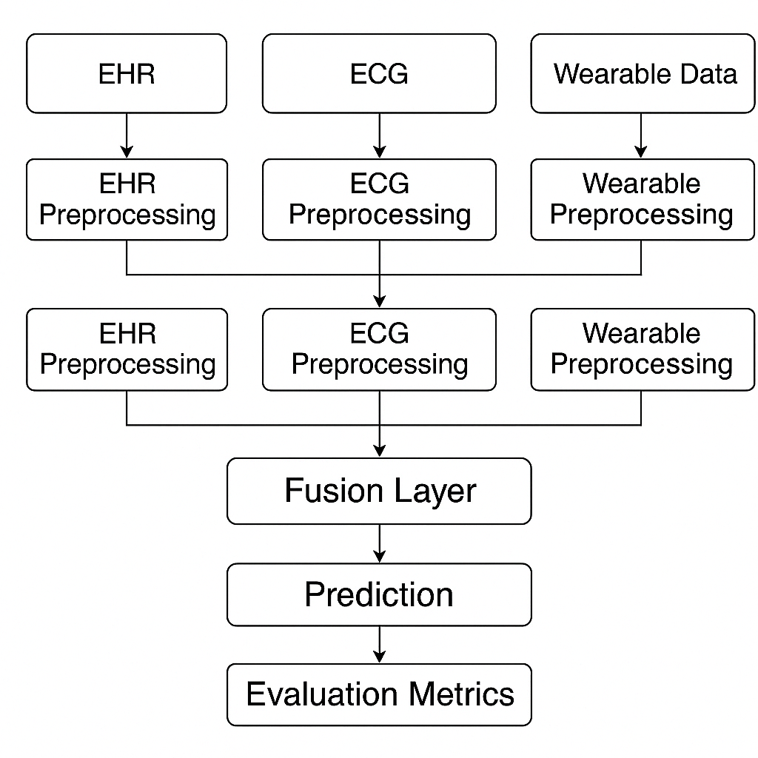
Workflow diagram

experimental result

The proposed multimodal model was evaluated on combined subsets of the MIMIC-III, PTB-XL, and WESAD datasets. The results demonstrate that the integrated model significantly outperforms the unimodal counterparts:

- Multimodal Model: Accuracy = 91.67%, F1-Score = 0.91, ROC-AUC = 0.95
- EHR Only: Accuracy = 85%, F1-Score = 0.83
- ECG Only: Accuracy = 87%, F1-Score = 0.85
- Wearables Only: Accuracy = 83%, F1-Score = 0.80

Fusion Strategy Comparison:

- Early Fusion: Lower accuracy due to premature integration.
- Intermediate Fusion: Highest performance due to learned modality-specific features.
- Late Fusion: Moderate performance but lower interpretability.

Ablation Study: Removing ECG input caused the steepest decline in accuracy (by 6%), followed by EHR (4%) and wearable data (3%).

Visualization: ROC curves and confusion matrices confirm strong class separation and minimal false positives.

Analysis and discussion

The multimodal framework proved superior by effectively capturing complementary features from the three sources. EHRs contributed historical and contextual insight, ECGs detected physiological anomalies, and wearable data provided dynamic behavioural trends.
However, the integration presented challenges:
- Synchronization: Aligning temporal wearable and ECG data required careful resampling.
- Model Interpretability: Deep models act as black boxes. SHAP analysis revealed ECG channels had the highest influence on classification decisions.
Future work will focus on integrating attention mechanisms to further highlight salient inputs, and exploring edge computing solutions for real-time deployment in mobile devices.

conclusion

This research presents a robust multimodal deep learning framework for heart disease prediction by integrating EHRs, ECG signals, and wearable sensor data. The fusion of these modalities significantly enhances prediction accuracy and model robustness compared to traditional unimodal systems. This work contributes to the development of intelligent, adaptive, and scalable diagnostic tools that align with the vision of personalized and preventive healthcare.

References
[1] A. Goldberger et al., "PhysioBank, PhysioToolkit, and PhysioNet: Components of a new research resource for complex physiologic signals," Circulation, 2000.
[2] A. T. Reis et al., "A comparative study of machine learning methods for heart disease prediction," Journal of Healthcare Engineering, 2018.
[3] A. Strodthoff et al., "PTB-XL, a large publicly available electrocardiography dataset," Scientific Data, 2020.
[4] M. Schmidt et al., "Introducing WESAD, a multimodal dataset for wearable stress and affect detection," Proceedings of the ACM IMWUT, 2018.
[5] F. Chollet, "Deep Learning with Python," Manning Publications, 2017.

