Software Requirements Specification

for

E-Farm

Prepared by

**Mossa. Sumaiya Akter BKH2025017F**

**Md. Sanwar Hossain MUH2025018M**

**Mehedi Hasan MUH2025032M**

**Toriqul Islam Shobuj MUH2025035M**

**Irfanul Haque Nabil ASH1925021M**

**Institute of Information Technology**

**Noakhali Science and Technology University**

**20.02.2023**

**Table of Contents**

1. Introduction 8

1.1 Problem Statement 8

1.2 Purpose 8

1.3 Project Scope 9

1.4 Glossary 9

1.5 References 10

1.6 Overview 10

2. Stakeholders and Characteristics 11

2.1 Farmers 11

2.2 Consumers: 11

2.3 Agro-Solution Providers 11

2.4 Agricultural Equipment Providers 11

2.5 Logistics Providers 11

2.6 Financial Institutions 12

3. Design and Implementation Constrains 12

3.1 JavaScript, JSX and React.js 13

3.1.1 Programming Language 13

3.1.2 CSS Framework 13

3.2 Server-Side Technology 14

3.2.1 Python, Django Rest API 14

3.2.2 Database Server 14

3.2.3 Cloud Storage 14

4. Requirement Specification 15

4.1 Functional Requirement 15

4.1.1 User login and register 15

4.1.2 Update Profile 15

4.1.3 Password Recovery 16

4.1.4 Receive confirmation mail 16

4.1.5 Search Products 17

4.1.6 Filter Products 17

4.1.7 Display Products Availability 17

4.1.8 Display Product Recommendation 18

4.1.9 Track Order 18

4.1.10 Feedback Submission 18

4.1.11 Makes Payment 19

4.1.12 Order Multiple Address 19

4.1.13 Live Chat 20

4.1.14 Pre-Order Request 20

4.1.15 Provide Ratings and Reviews 20

4.1.16 Display Agri Information 21

4.1.17 Upload product details 21

4.1.18 Request Membership 21

4.1.19 User Logout 22

4.2 Data Requirement 22

4.2.1 Customer Information 22

4.2.2 Farmer Information 23

4.2.3 Product Data 23

4.2.4 Transaction Data 23

4.2.5 Ratings and Reviews 23

4.2.6 Equipment Information 23

4.2.7 Farmer Contact Details 23

4.2.8 Maintenance Records 23

4.2.9 Soil and Weather Data 23

4.2.10 Crop Disease and Pest Information 24

4.2.11 Crop Yield and Quality Data 24

4.2.12 Platform Usage Metrics 24

4.2.13 Shipping and Delivery 24

4.2.14 Product Catalog 24

4.3 Performance Requirement 25

4.3.1 Response Time 25

4.3.2 Concurrent Users 25

4.3.3 Scalability 25

4.3.4 Availability 25

4.3.5 Security 25

4.3.6 Data Backup 25

4.3.7 System Maintenance 25

4.3.8 Load Testing 25

4.3.9 Resource Utilization 25

4.3.10 Capacity Requirement 25

Here are some capacity requirements for our project : 25

4.3.2.1 Bandwidth 26

4.3.2.2 Storage Capacity 26

4.3.2.3 Processing Power 26

4.3.2.4 Database Capacity 26

4.3.2.5 Server Capacity 26

4.3.2.6 Network Capacity 26

4.3.2.7 Memory Capacity 26

4.3.3 Safety Critical Requirement 26

4.3.4 Robustness or Fault-Tolerance Requirements 26

4.4 Maintainability and Supportability 27

4.4.1 Maintenance Requirements 27

4.4.2 Supportability Requirements 28

4.5 Security Requirements 28

4.5.1 Authentication and Authorization 28

4.5.2 Encryption 28

4.5.3 Access Control 28

4.5.4 Network Security 28

4.5.5 Audit Trails 29

4.5.6 Data Backup and Recovery 29

4.5.7 System Monitoring 29

4.5.8 Incident Response 29

4.6 Usability and Human Integrity Requirements 29

4.6.1 Ease of Use Requirements 29

4.6.2 Accessibility Requirements 29

4.7 Look and Feel Requirements 30

4.7.1 Appearance Requirements 30

4.8 Style Requirements 30

5. Requirement Engineering Process 31

5.1 Requirement Elicitation Techniques 31

5.1.1 Hold Interviews 31

5.1.2 Perform Document Analysis 31

5.1.3 System Interface Analysis 32

5.1.4 Distribute Questionnaires 32

5.2 Sample of requirement collection 32

5.2.1 Requirement collection -1 32

5.2.2 Requirement collection -2 33

5.3 Requirement Validation 34

5.3.1 Review the Requirements 34

5.3.2 Test the Requirements 35

5.3.3 Simulate the requirements 35

6. Use Case Diagram 36

7. Use Case Description 37

8. Requirement Traceability Matrix 79

9. Appendix 81

9.1 Prioritization of requirements 81

9.1.1 Three-level Scale 81

9.1.2 Prioritization of the requirements of E-Farm 81

**List of Figure**

Figure 1: Usecase Diagram 36

[Figure 2: Create Account 54](https://d.docs.live.net/e6684654ff6e04e1/Documents/Software%20Requirements%20Specification.docx#_Toc127765314)

Figure 2: Access Control 55

[Figure 4: Search Product 56](https://d.docs.live.net/e6684654ff6e04e1/Documents/Software%20Requirements%20Specification.docx#_Toc127765316)

[Figure 5:Show Product Availability 57](https://d.docs.live.net/e6684654ff6e04e1/Documents/Software%20Requirements%20Specification.docx#_Toc127765317)

[Figure 6:Search Category 58](https://d.docs.live.net/e6684654ff6e04e1/Documents/Software%20Requirements%20Specification.docx#_Toc127765318)

[Figure 7:Request Pre-Order 59](https://d.docs.live.net/e6684654ff6e04e1/Documents/Software%20Requirements%20Specification.docx#_Toc127765319)

[Figure 8:Order Product 60](https://d.docs.live.net/e6684654ff6e04e1/Documents/Software%20Requirements%20Specification.docx#_Toc127765320)

[Figure 9: Order Multiple Address 61](https://d.docs.live.net/e6684654ff6e04e1/Documents/Software%20Requirements%20Specification.docx#_Toc127765321)

[Figure 10: Make Payment 62](https://d.docs.live.net/e6684654ff6e04e1/Documents/Software%20Requirements%20Specification.docx#_Toc127765322)

[Figure 11: Update Profile Info 63](https://d.docs.live.net/e6684654ff6e04e1/Documents/Software%20Requirements%20Specification.docx#_Toc127765323)

[Figure 12: View Recommended Product 64](https://d.docs.live.net/e6684654ff6e04e1/Documents/Software%20Requirements%20Specification.docx#_Toc127765324)

[Figure 13:Display Confirmation report 65](https://d.docs.live.net/e6684654ff6e04e1/Documents/Software%20Requirements%20Specification.docx#_Toc127765325)

[Figure 14:Purchasing Promotion and Discount 66](https://d.docs.live.net/e6684654ff6e04e1/Documents/Software%20Requirements%20Specification.docx#_Toc127765326)

[Figure 15: Give Ratings and Reviews 67](https://d.docs.live.net/e6684654ff6e04e1/Documents/Software%20Requirements%20Specification.docx#_Toc127765327)

[Figure 16:Live chat 68](https://d.docs.live.net/e6684654ff6e04e1/Documents/Software%20Requirements%20Specification.docx#_Toc127765328)

[Figure 17: Return and Refund 69](https://d.docs.live.net/e6684654ff6e04e1/Documents/Software%20Requirements%20Specification.docx#_Toc127765329)

[Figure 18:Display Confirmation Report 70](https://d.docs.live.net/e6684654ff6e04e1/Documents/Software%20Requirements%20Specification.docx#_Toc127765330)

[Figure 19: Submit Feedback 71](https://d.docs.live.net/e6684654ff6e04e1/Documents/Software%20Requirements%20Specification.docx#_Toc127765331)

[Figure 20:Search Agri Info 72](https://d.docs.live.net/e6684654ff6e04e1/Documents/Software%20Requirements%20Specification.docx#_Toc127765332)

[Figure 21:Rent Agri Tools 73](https://d.docs.live.net/e6684654ff6e04e1/Documents/Software%20Requirements%20Specification.docx#_Toc127765333)

[Figure 22:Report Issues 74](https://d.docs.live.net/e6684654ff6e04e1/Documents/Software%20Requirements%20Specification.docx#_Toc127765334)

[Figure 23:Take Consultancy Service 75](https://d.docs.live.net/e6684654ff6e04e1/Documents/Software%20Requirements%20Specification.docx#_Toc127765335)

[Figure 24:Track Order 76](https://d.docs.live.net/e6684654ff6e04e1/Documents/Software%20Requirements%20Specification.docx#_Toc127765336)

[Figure 25:Forgot Password Recovery 77](https://d.docs.live.net/e6684654ff6e04e1/Documents/Software%20Requirements%20Specification.docx#_Toc127765337)

[Figure 26:Sign Out 78](https://d.docs.live.net/e6684654ff6e04e1/Documents/Software%20Requirements%20Specification.docx#_Toc127765338)

**List of Tables**

Table 2: Create Account 37

Table 2: Access Control 37

Table 3: View Products 38

Table 4: Order Product 38

Table 5:Search Product 39

Table 6: View Recommended Product 41

Table 8: Search Category 41

Table 9: Show Products Availability 42

Table 10: Deliver Products 44

Table 11: Track Order 44

Table 12: Submit Feedback 45

Table 13:Update Address 46

Table 14: Create Folder 46

Table 15: Display Confirmation Report 47

Table 16: Make Payment 47

Table 17: Search Agri Information 48

Table 18:Take Consultancy Service 49

Table 19: Rent Agri Tools 49

Table 20: Report Issues 50

Table 21: Upload Product Details 50

Table 22: Generate Recommended Product 51

# Introduction

The policy, scope, references, and summary of Software Requirements Specification (SRS) are all included in the SRS introduction. By presenting the problem statement in detail, the purpose of this document is to collect, evaluate, and provide a deeper understanding of the whole **"E-Farm** **"** system. The main services of **“E-Farm”** are providing an **agri marketplace** & **agri solution** to the farmers.

The agriculture industry plays a crucial role in the global economy, and is the primary source of food and livelihood for millions of people around the world. However, the traditional agricultural supply chain has several challenges that impact both farmers and consumers. Farmers often struggle to get fair prices for their products due to the involvement of intermediaries such as brokers and syndicate traders, while consumers may not have access to high-quality, fresh food due to limitations in the traditional supply chain.

## Problem Statement

The traditional agricultural supply chain involves intermediaries such as brokers and syndicate traders, who often take a significant share of the profits and leave farmers with a lower price for their products. This can lead to unfair treatment of farmers and unsustainable practices in the agriculture industry. Additionally, consumers are increasingly concerned about the quality and source of their food, but may not have access to fresh, high-quality products due to limitations in the traditional supply chain.

E Farm is a B2B aggregator platform that aims to address these challenges by providing a marketplace for farmers to sell their products directly to consumers, cutting out intermediaries and ensuring fair prices for farmers. E Farm also offers equipment rental and maintenance services to make farming more cost-effective and efficient, as well as agro solution and consultancy services to provide guidance on everything from plant protection to post-harvest management.

However, there may be challenges in creating a successful supply chain ecosystem that connects farmers and consumers in a sustainable and efficient way. The purpose of this report is to assess the effectiveness of E Farm's services and identify any potential challenges or areas for improvement in the platform's business model.

## Purpose

The purpose of this report is to evaluate the effectiveness of E-Farm's services and identify any potential challenges or areas for improvement in the platform's business model. This report will provide an in-depth analysis of E Farm's marketplace, equipment rental and maintenance services, and agro solution and consultancy services. It will also examine the current state of the agriculture industry and identify the challenges that farmers and consumers face in the traditional supply chain.

## Project Scope

This report will focus on evaluating the effectiveness of E Farm's services and identifying potential areas for improvement in the platform's business model. The analysis will cover the following areas:

* **E-Farm's Marketplace:** This section will examine the efficiency and effectiveness of E Farm's marketplace in connecting farmers and consumers. The report will assess the quality and freshness of the products offered on the platform and analyze the level of satisfaction among consumers who use the platform. The report will also evaluate the impact of E Farm's services on farmers' livelihoods and their ability to get fair prices for their products.
* **Equipment Rental and Maintenance:** This section will evaluate the quality and availability of the agricultural equipment rental and maintenance services provided by E Farm. The report will assess the effectiveness of these services in making farming more cost-effective and efficient, and identify any potential challenges in the delivery of these services.
* **Agro Solution and Consultancy:** This section will analyze the quality and effectiveness of the agro solution and consultancy services provided by E Farm. The report will assess the level of satisfaction among farmers who use these services and identify any potential areas for improvement in the delivery of these services.
* **Challenges in the Agriculture Industry:** This section will provide an overview of the challenges that farmers and consumers face in the traditional supply chain. The report will identify the key factors that lead to unfair treatment of farmers and limitations in the quality and freshness of the products offered to consumers.

## Glossary

This section provides definitions for all document names, acronyms, and abbreviations. The application domain's terms and concepts are defined.

GUI - Graphical User Interface

API – Application Programming Interface

SRS – Software Requirement Specification

UI – User Interface

SDLC – Software Development Life Cycle

MB – Megabytes

XML – Extensible Markup Language

RESTful – Representational State Transfer

HTML – Hyper Text Markup Language

## References

* IEEE. *IEEE Std 830-1998 IEEE Recommended Practice for Software Requirements Specifications.* IEEE Computer Society, 1998.
* Elsievier-*A systematic literature review on agile requirements engineering practices and challenges .*
* Bjarnason, E., Wnuk, K., & Regnell, B. (2011b*). Requirements are slipping through the gaps—A case study on causes & effects of communication gaps in large-scale software development*. In 2011 IEEE 19th international requirements engineering conference (pp. 37–46)
* Wolfgang, E. (2011). *Working with user stories. In Agile requirements engineering workshop*, July 2011.
* Bjarnason, E., Wnuk, K., & Regnell, B. (2011b). *Requirements are slipping through the gaps—A case study on causes & effects of communication gaps in large-scale software development*. In 2011 IEEE 19th international requirements engineering conference (pp. 37–46).

## Overview

This report evaluates the effectiveness of E-Farm's services and identifies potential areas for improvement in the platform's business model. E-Farm is a B2B aggregator platform that connects farmers to consumers by providing a range of services, including an agri marketplace, agricultural equipment rental and maintenance, and agro solution and consultancy services.

The report examines the efficiency and effectiveness of E-Farm's marketplace, the quality and availability of the agricultural equipment rental and maintenance services, and the quality and effectiveness of the agro solution and consultancy services. It also provides an overview of the challenges faced by farmers and consumers in the traditional supply chain and identifies the key factors that lead to unfair treatment of farmers and limitations in the quality and freshness of the products offered to consumers.

The report is divided into several sections, including the project scope, introduction, purpose, methodology, findings, and recommendations. The project scope outlines the key areas covered in the report, while the introduction provides a background to E-Farm and the agriculture industry. The purpose of the report is to evaluate the effectiveness of E-Farm's services and identify potential areas for improvement. The methodology outlines the research methods used to gather information for the report, while the findings section provides an analysis of the results of the research. The recommendations section provides practical and actionable recommendations for how E-Farm can improve its services.

The report is a valuable resource for E-Farm's management team and stakeholders in the agriculture industry who are interested in exploring alternative supply chain models that can provide fair prices for farmers and access to high-quality, fresh food for consumers. It provides insights into the challenges and opportunities in the agriculture industry and offers practical recommendations for how E-Farm can enhance its services to create a more sustainable and efficient supply chain ecosystem.

# Stakeholders and Characteristics

2.1 Farmers**:** Farmers are the primary stakeholders of the platform. They produce the agricultural products that are sold on the platform. The key characteristics of farmers are:

* They have limited technical expertise and may require guidance on how to use the platform.
* They may be located in remote areas, and the platform must be accessible to them.
* They are price-sensitive and require fair prices for their products.
* They require access to agricultural equipment and agro-solutions to improve their yields and efficiency.

2.2 Consumers: Consumers are the end-users of the platform. They purchase agricultural products from the platform. The key characteristics of consumers are:

* They require fresh and high-quality agricultural products.
* They are concerned about the source and origin of the products they purchase.
* They require convenient and reliable delivery of products.
* They may require support and guidance on how to use the platform.

2.3 Agro-Solution Providers**:** Agro-solution providers are third-party service providers who offer agricultural solutions and consultancy services to farmers. The key characteristics of agro-solution providers are:

* They require a platform to reach out to farmers and offer their services.
* They require a secure platform to store and manage sensitive information about farmers and their agricultural practices.
* They require a convenient and efficient way to communicate with farmers and offer their services.

2.4 Agricultural Equipment Providers**:** Agricultural equipment providers are third-party service providers who offer equipment maintenance and rental services to farmers. The key characteristics of agricultural equipment providers are:

* They require a platform to reach out to farmers and offer their services.
* They require a secure platform to store and manage sensitive information about farmers and their equipment needs.
* They require a convenient and efficient way to communicate with farmers and offer their services.

2.5 Logistics Providers**:** Logistics providers are third-party service providers who offer delivery and transport services for agricultural products. The key characteristics of logistics providers are:

* They require a platform to reach out to farmers and consumers and offer their services.
* They require a secure platform to store and manage sensitive information about products and delivery requirements.
* They require a convenient and efficient way to communicate with farmers and consumers and offer their services.

2.6 Financial Institutions**:** Financial institutions are third-party service providers who offer payment and financial services for transactions on the platform. The key characteristics of financial institutions are:

* They require a secure platform to store and manage sensitive financial information.
* They require a reliable and efficient way to process payments and transactions.
* They require compliance with relevant financial regulations and standards.
* These are the stakeholders and their key characteristics for the E-Farm platform.

# Design and Implementation Constrains

We have employed design and implementation constraints to ensure the success of this project. It also refers to a tool that allows developers and testers to inspect and interact with the application's user interface (UI) elements.

The design and implementation constraints for the E-Farm platform:

**Scalability:** The platform needs to be designed to handle a large number of users, transactions, and data. It should be able to scale easily and efficiently as the user base and demand grow.

**Security:** The platform needs to be secure to protect sensitive information such as user data, financial information, and transaction details. This includes measures such as data encryption, secure payment gateways, and secure user authentication.

**Availability:** The platform needs to be highly available and reliable to ensure users can access the platform and its services at all times. This includes measures such as redundancy, load balancing, and disaster recovery.

**User Experience:** The platform needs to provide a seamless and intuitive user experience for all stakeholders, including farmers, consumers, agro-solution providers, agricultural equipment providers, logistics providers, and financial institutions. This includes features such as easy navigation, responsive design, and personalized recommendations.

**Data Management:** The platform needs to be designed to manage and store large amounts of data related to users, products, transactions, and other relevant information. This includes measures such as database design, data security, and data backup.

**Integration:** The platform needs to integrate with various third-party services such as payment gateways, logistics providers, and other relevant services. This requires an API-based architecture that can easily integrate with other systems.

**Technology Stack:** The platform needs to be built using appropriate technology stacks that can support its features and requirements. This may include programming languages such as Python, JavaScript, and Java, frameworks such as Django and Node.js, and databases such as PostgreSQL and MongoDB.

**Testing:** The platform needs to be thoroughly tested to ensure its functionality, security, and performance. This includes unit testing, integration testing, and acceptance testing.

**Compliance:** The platform needs to comply with relevant laws and regulations related to data protection, financial transactions, and other relevant areas. This includes measures such as GDPR compliance, PCI DSS compliance, and other relevant regulations.

These are the key design and implementation constraints for the E-Farm platform.

## JavaScript, JSX and React.js

The visual layout of the components that a user could interact with in a website or technical product is referred to as user interface design, or UI design. In other terms, it is a website's visual design.

### Programming Language

**JavaScript:** Javascript is an ECMAScript-compliant high-level, frequently just-in-time compiled language. It has first-class functions, dynamic typing, and prototype-based object orientation. It's multi-paradigm, allowing you to program in event-driven, functional, or imperative styles.

React is a front-end JavaScript toolkit for creating user interfaces using UI components that is free and open-source. Meta and a community of individual developers and businesses support it.

JavaScript XML is abbreviated as JSX. It's just a JavaScript syntactic extension. It allows us to create HTML directly in React (within JavaScript code). It is straightforward to generate a template in React using JSX, but it is not a simple template language; instead, it has all of JavaScript's capability.

It is faster than standard JavaScript because it optimizes when converting to standard JavaScript. Rather than dividing the markup and functionality in different files, React makes use of components.

**Java:** Java is a high-level, class-based, object-oriented programming language that is designed to have as few implementation dependencies as possible. It is a general-purpose programming language intended to let programmers write once, run anywhere (WORA), meaning that compiled Java code can run on all platforms that support Java without the need to recompile.Java applications are typically compiled to bytecode that can run on any Java virtual machine (JVM) regardless of the underlying computer architecture. The syntax of Java is similar to C and C++, but has fewer low-level facilities than either of them. The Java runtime provides dynamic capabilities (such as reflection and runtime code modification) that are typically not available in traditional compiled languages. As of 2019, Java was one of the most popular programming languages in use according to GitHub, particularly for client–server web applications, with a reported 9 million developers.

### CSS Framework

Cascading Style Sheets (CSS) is a language for specifying the appearance of a document written in a markup language like HTML. Along with HTML and JavaScript, CSS is a key component of the World Wide Web. Semantic UI is a website using UI component framework. Developers may use Semantic UI to create websites with quick and clear HTML, as well as a fully mobile responsive experience. Semantic UI offers a React-integrated version called Semantic UI React, which includes the following functionalities:

* jQuery Free.
* Declarative API.
* Augmentation.
* Shorthand Props.
* Sub Components.
* Auto Controlled State

## Server-Side Technology

Server-side development refers to the actions that take place behind the scenes when an application is used. It primarily focuses on databases, scripting, website architecture, backend logic, APIs, and Servers.

### Python, Django Rest API

Python is a dynamically semantic, interpreted, object-oriented high-level programming language. Its high-level built-in data structures, together with dynamic typing and dynamic binding, make it ideal for Rapid Application Development and as a scripting or glue language for connecting existing components. Python's concise, easy-to-learn syntax prioritizes readability, which lowers software maintenance costs.

Python is widely used to create an application's back end. It should come as no surprise that there are a variety of Python frameworks available to help with server-side programming. The Django REST Framework (DRF) is a popular, robust, and versatile framework for creating Web APIs.

To get data from our server to our application, we'll use the Django Rest API. Representational State Transfer is abbreviated as REST. Application Programming Interface is what API stands for.

### Database Server

PostgreSQL is an advanced, enterprise class open-source relational database that supports both SQL (relational) and JSON (non-relational) querying. PostgreSQL's speed, security and robustness make it suitable for 99% of applications, so it's a great starting place for our application. It is a dependable, powerful, and stable solution with sophisticated features such as the following:

* User-defined types.
* Table inheritance.
* Sophisticated locking mechanism.
* Foreign key referential integrity.
* Views, rules, subquery.
* Nested transactions (save points)
* Multi-version concurrency control (MVCC)
* Asynchronous replication.

### Cloud Storage

Amazon S3 is a type of object storage that allows to store and retrieve any quantity of data from any location. It's a straightforward storage solution with industry-leading durability, availability, performance, security, and scalability. So we will use S3 to store audio files.

# Requirement Specification

All the requirements based on the elicitation process are described in this section.

## Functional Requirement

Functional requirements are those requirements that are used to illustrate the internal working nature of the system, the description of the system, and explanation of each subsystem. It consists of what task the system should perform, the processes involved, which data the system should hold and the interfaces with the user.

### User login and register

|  |  |  |  |
| --- | --- | --- | --- |
| **FR-1** | User Registration and Login to registered account. | | |
| **Description** | User should register his/her account for the first time and be able to login to the account which was registered once. Already registered users will not face this stage. | | |
| **Stakeholders** | Customer, Farmer | **Priority** | High |

### Update Profile

|  |  |  |  |
| --- | --- | --- | --- |
| **FR-2** | User updates their profile | | |
| **Description** | This functional requirement describes the process of allowing users to update their profile information. The feature allows users to edit their profile details such as name, email address, profile picture, password, and any other relevant information. To use the profile update feature, users must be authenticated, and access should be limited to authorized users only. The system should handle errors and display confirmation messages after the update is successful. The user interface should be intuitive and easy to use, and the system should maintain an audit trail of all profile updates. Overall, this feature should be implemented effectively to provide users with a seamless and secure experience while updating their profile. | | |
| **Stakeholders** | Customer | **Priority** | Medium |

### Password Recovery

|  |  |  |  |
| --- | --- | --- | --- |
| **FR-3** | Password recovery for forgot password. | | |
| **Description** | This functional requirement describes the process of password recovery for forgotten passwords in an online product purchasing system. The feature allows users to reset their password by providing a verification mechanism, such as an email or SMS, to ensure the user's identity. The system should enforce password strength requirements, display appropriate error messages, and provide a confirmation message to the user after they have successfully reset their password. The system should maintain an audit trail of all password recovery activities and ensure secure communication between the user's browser and the server. After resetting their password, users should be authenticated to the system and redirected to the appropriate page. | | |
| **Stakeholders** | Customer | **Priority** | Medium |

### Receive confirmation mail

|  |  |  |  |
| --- | --- | --- | --- |
| **FR-4** | Receive confirmation mail whenever an order is placed. | | |
| **Description** | User will receive a confirmation email after placing an order in an online product purchasing system is an essential feature. The confirmation email should contain all the necessary details of the order and should be sent to the email address provided by the user. The system should handle errors, provide appropriate error messages, allow users to control their notification settings, and maintain an audit trail of all email notification activities. | | |
| **Stakeholders** | General User, Premium User | **Priority** | Low |

### Search Products

|  |  |  |  |
| --- | --- | --- | --- |
| **FR-5** | Search Products according to user’s preferences | | |
| **Description** | System will allow users to quickly and easily find the products they are looking for, enhancing their shopping experience. The system should provide a search bar, search criteria, search results, product details, sorting and filtering options, appropriate error messages, and optimization for speed and mobile devices | | |
| **Stakeholders** | Customer | **Priority** | High |

### Filter Products

|  |  |  |  |
| --- | --- | --- | --- |
| **FR-6** | Filter Products based on the category. | | |
| **Description** | System will allow users to easily browse through products by category, enhancing their shopping experience. The system should provide a list of categories, sub-categories, product listings with details, sorting and filtering options, appropriate error messages, and optimization for speed and mobile devices | | |
| **Stakeholders** | Customer | **Priority** | Medium |

### Display Products Availability

|  |  |  |  |
| --- | --- | --- | --- |
| **FR-7** | Display Products based on the Availability | | |
| **Description** | System will provide users with a comprehensive view of the products available for purchase, enhancing their shopping experience. The system should provide a product listing with details, sorting and filtering options, product availability and alternatives, appropriate error messages, and optimization for speed and mobile devices. | | |
| **Stakeholders** | Customer | **Priority** | High |

### Display Product Recommendation

|  |  |  |  |
| --- | --- | --- | --- |
| **FR-8** | Display recommended products. | | |
| **Description** | System will provide users with personalized product recommendations based on their preferences and purchase history, improving their shopping experience and increasing sales. The system should use a recommendation algorithm, provide a product listing with details, sorting and filtering options, appropriate error messages, and optimization for speed and mobile devices | | |
| **Stakeholders** | Customer | **Priority** | Medium |

### Track Order

|  |  |  |  |
| --- | --- | --- | --- |
| **FR-9** | Track Order of the Products after Confirming Order . | | |
| **Description** | System will provide users with real-time information about the status of their orders, including delivery details and notifications. The system should display order status and history, provide notifications, offer error handling, and optimize for speed and mobile devices. This feature is essential for improving user satisfaction and reducing customer service inquiries. | | |
| **Stakeholders** | Customer | **Priority** | High |

### Feedback Submission

|  |  |  |  |
| --- | --- | --- | --- |
| **FR-10** | Feedback submission on their previous order history. | | |
| **Description** | System will allow users to provide feedback and complaint on the product or service, helping to improve the product or service quality and increase user satisfaction. The system should provide a feedback form, guidelines, authentication, display, moderation, notification, optimization, and mobile optimization. This feature is essential for providing potential buyers with insights and opinions from previous customers, helping them make informed purchasing decisions. | | |
| **Stakeholders** | Customer | **Priority** | Low |

### Makes Payment

|  |  |  |  |
| --- | --- | --- | --- |
| **FR-11** | Makes Payment through payment gateway | | |
| **Description** | System will allow users to complete their purchase securely and conveniently using multiple payment options such as mobile banking(Bkash,Nagad,Mkash etc),credit card . The system will be integrated with a secure payment gateway, authenticate the user, provide a payment confirmation, offer error handling, and optimize for speed and mobile devices. This feature is essential for facilitating transactions and generating revenue for the business. | | |
| **Stakeholders** | Customer,farmer | **Priority** | High |

### Order Multiple Address

|  |  |  |  |
| --- | --- | --- | --- |
| **FR-12** | Order in multiple Addresses. | | |
| **Description** | System will allow users to ship their purchases to multiple addresses, making it easier for them to send gifts or purchase products for different locations. The system should provide users with multiple shipping addresses, address validation, order summary, split payment, shipping options, order tracking, return policy, and mobile optimization. This feature is essential for providing a seamless and convenient purchasing experience for users. | | |
| **Stakeholders** | Customer | **Priority** | Medium |

### Live Chat

|  |  |  |  |
| --- | --- | --- | --- |
| **FR-13** | Live chat feature for 24/7. | | |
| **Description** | System will provide customers with instant assistance and support 24/7, improving customer satisfaction and resolving issues quickly. The system should have easy access, use chatbots, provide human support, offer multilingual support, be secure, optimized for mobile devices, and collect customer feedback. This feature is essential for providing excellent customer service and increasing customer loyalty. | | |
| **Stakeholders** | Customer | **Priority** | Medium |

### 4.1.14 Pre-Order Request

|  |  |  |  |
| --- | --- | --- | --- |
| **FR-14** | Request for pre-order. | | |
| **Description** | User can request for pre-order for stock out product.The system will collect customer information, notify customers when the item becomes available for purchase, send an order confirmation, charge the customer's payment method only when the item is ready to be shipped, manage inventory levels, and have a clear cancelation policy. This feature is critical for businesses to manage their inventory effectively and provide excellent customer service. | | |
| **Stakeholders** | Customer | **Priority** | High |

### Provide Ratings and Reviews

|  |  |  |  |
| --- | --- | --- | --- |
| **FR-15** | Give ratings and reviews based on the products . | | |
| **Description** | The system will allow customers to rate products on a scale of 1 to 5 stars and provide written reviews. The system should also have a moderation system to ensure that reviews are appropriate, display reviews prominently on the product page, allow businesses to respond to reviews, and generate reports on product ratings and reviews. This feature is critical for businesses to improve their products and services and enhance their customer experience. | | |
| **Stakeholders** | Customer | **Priority** | Low |

### Display Agri Information

|  |  |  |  |
| --- | --- | --- | --- |
| **FR-16** | View agri-information . | | |
| **Description** | The system will provide access to multiple sources of information, have a search function, filters, regular updates, notification features, a user-friendly interface, and compatibility with different devices and platforms. This feature is essential for farmers and other users to make informed decisions and improve their agricultural productivity. | | |
| **Stakeholders** | Farmer | **Priority** | High |

### Upload product details

|  |  |  |  |
| --- | --- | --- | --- |
| **FR-17** | Upload product details. | | |
| **Description** | The system will allow sellers to upload product details, set prices, specify availability, shipping options, payment methods, and respond to reviews and ratings. It should also provide analytics to sellers on product performance and have a user-friendly interface. This feature is essential for the smooth operation of the marketplace and the satisfaction of buyers and sellers. | | |
| **Stakeholders** | Farmer | **Priority** | High |

### Request Membership

|  |  |  |  |
| --- | --- | --- | --- |
| **FR-18** | Request Membership. | | |
| **Description** | The system will allow for user registration and verification, membership levels, payment, user profiles, search and browse, notifications, and support. Farmers can request for membership for being registered | | |
| **Stakeholders** | Farmer | **Priority** | High |

### User Logout

|  |  |  |  |
| --- | --- | --- | --- |
| **FR-19** | User logout from their account | | |
| **Description** | The system will provide a logout button, manage user sessions, provide a confirmation message, clear the user's session, delete the session cookie, and redirect the user after logging out. The system should also restrict access to sensitive information and allow users to provide feedback. This feature is critical for maintaining the trust and confidence of users and promoting a positive user experience. | | |
| **Stakeholders** | Customer | **Priority** | Low |

## Data Requirement

Based on the description of your project, it seems that your system would require several types of data to function effectively. Here are some potential data requirements for each of the three main services you are providing:.

|  |  |  |  |
| --- | --- | --- | --- |
| **Requirement Name** | **Requirement Description** | **Stakeholders** | **Priority** |
| Customer Information | Information about the consumers, including their demographics, location, buying behavior, preferences, and contact details. | Customers | High |
| Farmer Information | Information about the farmers, including their name, location, type of crops produced, farming practices, and contact details. | Farmer | High |
| Product Data | Information about the types of food products available, their quantities, quality, and pricing. | Customer, Farmers | High |
| Transaction Data | Information about orders, payments, and delivery status. | Information about orders, payments, and delivery status | High |
| Ratings and Reviews | Ratings and reviews of the products and the farmers to help ensure quality and build trust in the platform. | Customer | High |
| Equipment Information | Information about the types of equipment available for rent, their conditions, availability, and location. | Farmer,Equipment Provider | High |
| Farmer Contact Details | Contact details for farmers who rent the equipment, including their name, location, and contact information | Farmer | High |
| Maintenance Records | Maintenance records and schedules for each piece of equipment, to ensure proper maintenance and minimize downtime | Farmer | High |
| Soil and Weather Data | Data on soil, weather, and other environmental factors that affect crop production. | Farmer | Medium |
| Crop Disease and Pest Information | Information on crop diseases and pests and their treatment, to help farmers identify and address issues. | Farmer | Medium |
| Crop Yield and Quality Data | Data on crop yield and quality, to help farmers make informed decisions about their crops. | Farmer | Medium |
| Platform Usage Metrics | Usage metrics, such as the number of users, active sessions, and engagement metrics, to help you understand how the system is being used and make improvements over time. | Customer,Farmer,Developer | Medium |
| Shipping and Delivery | The system must provide shipping and delivery options for customers and track delivery status. | Customers, Sales, Customer Service | Medium |
| Product Catalog | The system must maintain a catalog of all products available for purchase, including product name, description, price, availability, and images. | Customers | Medium |

In addition to the above, your system would also require data on the usage of the platform, such as the number of users, active sessions, and engagement metrics, to help you understand how the system is being used and to make improvements over time. It's important to ensure that all the data is collected ethically, stored securely, and used in compliance with privacy regulations.

## Performance Requirement

It is important to maintain the performance of the software system. To ensure performance we maintain these steps:

| **Requirement Name** | | **Requirement Description** | **Stakeholders** | | **Priority** |
| --- | --- | --- | --- | --- | --- |
| Response Time | | The system must respond to user requests within 2 seconds for 90% of the time. | Customers | | High |
| Concurrent Users | | The system must support a minimum of 500 concurrent users at any given time. |  | | High |
| Scalability | | The system must be scalable to handle increased traffic and users over time. | IT, Management | | High |
| Availability | The system must have an uptime of 99.99% to ensure users can access it at any time. | | | IT, Management | High |
| Security | The system must ensure that customer data is secure and protected from unauthorized access or data breaches. | | | IT, Customers | High |
| Data Backup | The system must regularly back up data to prevent data loss in case of hardware or software failures. | | | IT, Management | Medium |
| System Maintenance | The system must undergo regular maintenance and updates to ensure optimal performance and minimize downtime. | | | IT, Management | Medium |
| Load Testing | The system must undergo regular load testing to identify and address performance issues. | | | IT, Management | Low |
| Resource Utilization | The system must utilize system resources efficiently to minimize hardware and infrastructure costs. | | | IT, Management | Low |

### Capacity Requirement

### Here are some capacity requirements for our project :

### 4.3.2.1 Bandwidth

The system must have sufficient bandwidth to support high traffic volume during peak periods, such as holiday seasons or promotional events.

### 4.3.2.2 Storage Capacity

The system must have sufficient storage capacity to store product information, customer data, and order history.

### 4.3.2.3 Processing Power

The system must have sufficient processing power to handle large volumes of data, including transactions, searches, and analytics.

### 4.3.2.4 Database Capacity

The system must have sufficient database capacity to store customer information, transaction data, and inventory information.

### 4.3.2.5 Server Capacity

The system must have sufficient server capacity to handle user requests and ensure that the system runs smoothly.

### 4.3.2.6 Network Capacity

The system must have sufficient network capacity to support multiple user connections and ensure that the system is accessible from different locations.

### 4.3.2.7 Memory Capacity

The system must have sufficient memory capacity to handle multiple transactions and user requests without any delay or interruption.

### 4.3.3 Safety Critical Requirement

There are no safety critical requirements for our project.

### Robustness or Fault-Tolerance Requirements

#### Error Handling

The system must have proper error handling mechanisms in place to handle unexpected errors or exceptions and prevent the system from crashing or becoming unresponsive.

#### Redundancy

The system must have redundant components, such as servers, databases, or network connections, to ensure that critical functions are available even in case of failures.

#### Failover

The system must have a failover mechanism that automatically switches to a backup system or component in case of a failure to ensure that the system remains operational.

#### Load Balancing

The system must have load balancing mechanisms that distribute the load across multiple servers to ensure that no single server is overwhelmed with requests and that the system remains responsive.

#### Performance Monitoring

The system must have performance monitoring mechanisms that track system performance and alert administrators if the system falls below defined thresholds.

#### Recovery Time Objectives (RTO)

The system must have defined RTOs for each critical component or system function, specifying the maximum acceptable downtime and the required recovery time in case of a failure.

#### Backups

The system must have a backup mechanism that regularly backs up critical data to ensure that data can be recovered in case of a catastrophic failure.

## Maintainability and Supportability

### Maintenance Requirements

#### Regular Software Updates

The system must have a mechanism to update the software to the latest version, which includes bug fixes, performance improvements, and security enhancements.

#### Regular Hardware Maintenance

The system must have regular hardware maintenance, which includes cleaning, inspection, and repair or replacement of faulty components.

#### Data Backup and Recovery

The system must have a regular data backup mechanism to ensure that critical data is not lost in case of hardware or software failures.

#### System Monitoring

The system must have a system monitoring mechanism that tracks system performance, usage patterns, and error logs to identify potential issues and optimize system performance.

#### User Support

The system must have a user support mechanism to help users troubleshoot issues, provide guidance, and resolve user complaints or issues.

#### Training

The system must provide training to administrators and users to ensure that they are familiar with the system's features and capabilities, and can use the system effectively.

#### Documentation

The system must have documentation that outlines the system architecture, design, and usage, which is helpful for troubleshooting, maintenance, and training purposes.

### Supportability Requirements

This system meets Testability, Maintainability, Compatibility, Configurability, Serviceability, and install ability which are related to supportability requirements.

## Security Requirements

Securing information is much more important for our system to get users dependability. Here are some of them:

### Authentication and Authorization

The system must have a mechanism to authenticate users and authorize access to system resources based on the user's role and level of access.

### Encryption

The system must use encryption mechanisms to secure sensitive data, such as login credentials, financial data, and personal information, during transmission and storage.

### Access Control

The system must have access control mechanisms to restrict access to sensitive data and system resources to authorized personnel only.

### Network Security

The system must have network security mechanisms, such as firewalls and intrusion detection systems, to protect against network attacks and unauthorized access to the system.

### Audit Trails

The system must have audit trail mechanisms that log user activity and system events, to enable the identification and investigation of security breaches and unauthorized access attempts.

### Data Backup and Recovery

The system must have a data backup and recovery mechanism to ensure that critical data can be restored in case of data loss or corruption.

### System Monitoring

The system must have system monitoring mechanisms that detect and alert administrators of any suspicious or malicious activity on the system.

### Incident Response

The system must have an incident response plan in place to handle security breaches or attacks and minimize the impact of such incidents.

## Usability and Human Integrity Requirements

This system will provide more user-friendly environment

### Ease of Use Requirements

Our system will be easier to use by any type of people and they don’t need any training to use the system.

### Accessibility Requirements

To get access to the application, the application provides authorization/authentication. This application will use various modules.

#### Navigation

The system must have a clear and consistent navigation mechanism, which includes keyboard shortcuts, to help users navigate the system effectively.

#### Text Size and Font

The system must have options to increase or decrease the text size and change the font style to help users with visual impairments read the content easily.

#### Color Contrast

The system must have sufficient color contrast between the background and foreground elements to help users with visual impairments distinguish between different elements on the screen.

#### Alternative Text

The system must provide alternative text for images, videos, and other multimedia elements to help users with visual impairments understand the content.

#### Audio and Video Transcripts

The system must provide transcripts for audio and video content to help users with hearing impairments understand the content.

#### Forms and Input Fields

The system must have accessible forms and input fields, which include labels, hints, and error messages, to help users with disabilities fill out the forms accurately.

#### Assistive Technology Compatibility

The system must be compatible with assistive technologies, such as screen readers, text-to-speech software, and voice recognition tools, to help users with disabilities access the system effectively.

**4.6.2.8** Standards Compliance

The system must comply with accessibility standards, such as Web Content Accessibility Guidelines (WCAG) 2.1, to ensure that the system is accessible to users with disabilities.

## Look and Feel Requirements

Look and feel requirements mainly refer to how the system will look.

### Appearance Requirements

|  |  |  |  |
| --- | --- | --- | --- |
| **AR-1** | Text color and font | | |
| **Description** | Our system has to be different and attractive from other existing system using a better look and feel. | | |
| **Stakeholders** | Developer, Customer, Farmer | **Priority** | High |

## Style Requirements

There are no style requirements in our system.

**4.8** Legal Requirements

Legal requirements normally refer to the terms and conditions or privacy policy of any organization. The terms and condition of our application is that, no third-party software or person is allowed to use our data for their business purpose.

# Requirement Engineering Process

Requirements Engineering (RE) determines software requirements according to customer requirements or needs. Requirements engineering process includes requirements elicitation, needs modeling, requirements analysis, requirements assurance & validation, and requirements management.

## Requirement Elicitation Techniques

Requirements elicitation is the practice of researching and finding system requirements for users, customers, and other stakeholders, also referred to as "requirement gathering". Requirement elicitation can be done by contacting participants directly or by doing some research, analysis and testing.

### H**old Interviews**

We hold discussions that can be held individually or with a small group of participants. They are an effective way to access services without spending a lot of time with participants because we meet with people to discuss only certain important requirements of this program. Negotiations are useful for obtaining individual requirements for members in organizing workshops where those members of the program come together to resolve any issues or conflicts. We mainly perform our interview based on some specific criteria.

* Short description about goals and objectives
* Registration process
* Searching Audio Files
* Storage system of each account
* Compression size of audio files

### Perform Document Analysis

Existing documentation can help to show how systems are currently operating or what they are what I should do. Documents include written information about current programs, business processes, needs specifications, and competitor research. Review once textual analysis can help determine which performance should remain and functionality that isn’t in use. After existing document

In analysis, we found several problems with the existing system.

* Existing systems cannot perform file compression.
* A user cannot share a file with others.
* No cloud storage system is provided by the existing systems.

### System Interface Analysis

The first thing to do is to identify which systems the system-to-be shall communicate with. It could be a server on the Internet, a piece of software on the same host as the system-to-be, some hardware or something completely different.

### Distribute Questionnaires

The questionnaire is a useful way to investigate styles, changes in attitudes and users' ideas, and user satisfaction with priorities and preferences. Our lists of questions were as short as possible. The respondent may be tired or frustrated. Had a basic reason for all the questions as well as group the topic areas together for the respondent to focus on. The main advantage of this survey responses was that they were collected in the usual way. Information was summarized by a large number of people.

## Sample of requirement collection

### Requirement collection -1

This report summarizes the results of the questionnaires distribution conducted to gather requirements for our system. The objective of the surveys was to identify the key needs and expectations of the stakeholders and to use this information to develop a comprehensive set of requirements for the system.

**Interview**

**Methodology :**

The interviews were conducted with stakeholders from various rural places, Sonaimuri & Banglabazar,Noakhali. The interviews were conducted in a one-to-one format, lasting approximately 7-10 minutes each.

**Participants :**

A total of 163 & 207 responses were collected for project requirements & functional requirements respectively .

**Findings:**

The following are the key findings from the interviews:

* Mobile Application is more comfortable.
* Product will be displayed and can be viewed with description without logging in the system.
* Customer can search in the search Box.
* Customer can filter based on category.
* Product recommendation should be available.
* Live Chat system should be available.
* Transaction can be done through mobile banking as well as credit card.
* Customer can submit feedback.
* Customer can examine their previous orders and reorder goods from previous orders.
* Customer can Track Order.
* Customer can order in multiple address.
* Customer can earn reward points for purchasing system.
* Customer can give reviews and ratings for their product and delivery experience .

**Key Requirements:**

Based on the findings from the interviews, the following are the key requirements for E-Farm System :

* User-friendly interface with easy navigation.
* Ability to search for products.
* Product recommendation system.
* Filter Products based on category.
* Track order
* Submit Feedback
* Transaction through multiple process.

**Assumptions:**

It was assumed during the survey process that the E-Farm system will be accessible via the web and we have to develop an android app for the system.

**Limitations:**

Responses were collected less than the expectation.

**Conclusion:**

The stakeholders’ questionnaires surveys are provided valuable insights into the requirements for the E-Farm system. The key findings and requirements will be used to develop a comprehensive set of requirements for the system.

### Requirement collection -2

This report summarizes the results of the stakeholder interviews conducted to gather requirements for our system. The objective of the interviews was to identify the key needs and expectations of the stakeholders and to use this information to develop a comprehensive set of requirements for the system.

**Distribute Questionnaires**

**Methodology :**

The Questionnaires were distributed to stakeholders from various cities and roles. It takes 3-4 minutes to complete the questionnaire.

**Participants :**

A total of 13-14 were interviewed, including:

10-12 farmers

3 agro owners

**Findings:**

The following are the key findings from the interviews:

* Mobile Application is more comfortable.
* Based on the findings from the interviews, the following are the key requirements for E-Farm System
* User-friendly interface with easy navigation.
* User friendly for non-tech persons.
* Language Option should be available.
* Farmers can search and view Agri Information.
* Farmers can rent Agri tools.
* Farmers can upload their product details.
* Farmers can take consultancy service based on subscription package.

**Key Requirements:**

Based on the findings from the interviews, the following are the key requirements for E-Farm System:

* User-friendly interface with easy navigation.
* Language Option.
* Search and view information.
* Order Agri Tools.
* Upload Product details.

**Assumptions:**

It was assumed during the interview process that the E-Farm system will be accessible via the web and we have to develop an android app for the system.

**Limitations & Challenges:**

Most of Farmers are non tech person and illiterate.

Communicating with the farmers in their language.

**Conclusion:**

The stakeholders’ interviews are provided valuable insights into the requirements for the E-Farm system. The key findings and requirements will be used to develop a comprehensive set of requirements for the system.

## Requirement Validation

Requirement validation ensures that the requirements are correct and reflect the quality you want from this program. In the beginning, our requirements looked good but when we read them and tried to work with them they came out having ambiguities and gaps.

### Review the Requirements

Negative peer review, especially the type of rigorous review called evaluation, is unique among the highest quality software processes available. We had a team of reviewers representing different perspectives and carefully examined written needs, analysis models, and related information on disability.

### Test the Requirements

The test creates another view of the requirements. We also performed writing tests regarding assurance of whether the expected performance was found or not. Getting tested by the user needs to document the expected product behavior under specified conditions.

### Simulate the requirements

To stimulate requirements, trading tools are available that we have used to simulate a proposed system in place or to add details of written requirements. The simulation takes prototyping to the next level.

# Use Case Diagram

*Figure 1: Usecase Diagram*

# Use Case Description

**Table-01:**

**UC-01: Create Account**

| **Use Case** | **Create Account** |
| --- | --- |
| **Goal** | Allow customers to create an account in the E-Farm System |
| **Precondition** | N/A |
| **Success End Condition** | Customer account is created and the system confirms the creation |
| **Failed End Conditions** | 1)The username or email is already in use  2)The customer's information is incomplete or invalid |
| **Primary Actor** | Customer |
| **Secondary Actor** | N/A |
| **Trigger** | The customer requests to create an account |
| **Main Success Flow** | 1)The system presents the customer with a registration form,  2)The customer enters their personal information (e.g. name, address, email, username, password)  3)The customer submits the form,  4)The system validates the customer's information,  5)The system creates a new customer account and assigns a unique ID,  6)The system sends a confirmation email to the customer,  7) The system displays a success message to the customer. |
| **Alternative Flow** | 2a)If the customer enters invalid or incomplete information, the system displays an error message and asks the customer to correct the information  6a)If the username or email is already in use, the system displays an error message and asks the customer to choose a different username or email |
| **Quality Requirements** | 1)The system should be able to handle a large number of customer account creations simultaneously without crashing,  2) The customer's information should be securely stored and protected from unauthorized access. |

**Table-02**

**UC-02: Access Control**

| **Use Case** | **Access Control** |
| --- | --- |
| **Goal** | Allow customers to log in to their account in the E-Farm System |
| **Precondition** | The customer must have an existing account in the system |
| **Success End Condition** | Customer is logged in and has access to their account information |
| **Failed End Conditions** | 1)The customer enters incorrect login credentials,  2) The customer's account has been deactivated |
| **Primary Actor** | Customer |
| **Secondary Actor** | N/A |
| **Trigger** | The customer requests to log in to their account |
| **Main Success Flow** | 1)The system presents the customer with a login page  2)The customer enters their username and password,  3)The customer clicks the "Log in" button  4)The system validates the customer's login credentials,  5) The system logs the customer in and grants access to their account information |
| **Alternative Flow** | 2a)If the customer enters incorrect login credentials, the system displays an error message and asks the customer to re-enter their credentials  5a)If the customer's account has been deactivated, the system displays an error message and asks the customer to contact customer support |
| **Quality Requirements** | 1)The system should protect the customer's login credentials from unauthorized access or disclosure,  2) The system should be able to handle a large number of simultaneous login requests without crashing or slowing down. |

**Table-03:**

**UC-03: View Product**

| **Use Case** | **View Products** |
| --- | --- |
| **Goal** | Allow customers to view the available agricultural products in the system |
| **Precondition** | The customer must be logged in to their account |
| **Success End Condition** | Customer is presented with a list of available products and can view their details |
| **Failed End Conditions** | None |
| **Primary Actor** | Customer |
| **Secondary Actor** | None |
| **Trigger** | The customer requests to view the available products |
| **Main Success Flow** | 1)The system presents the customer with a list of available products,  2)The customer can filter the list based on criteria such as product type or price range,  3)The customer selects a product from the list to view its details,  4)The system presents the customer with the selected product's details (e.g. product name, description, price, image) |
| **Alternative Flow** | 1a)If there are no products available, the system displays a message informing the customer that there are no products to display |
| **Quality Requirements** | 1)The system should be able to handle a large number of products without slowing down or crashing  2)The system should display accurate and up-to-date information about the products. |

**Table-03**

**UC-04: Order Product**

| **Use Case** | **Order Product** |
| --- | --- |
| **Goal** | Allow customers to order agricultural products from the system |
| **Precondition** | The customer must be logged in to their account and have selected a product to order |
| **Success End Condition** | Customer has successfully placed an order for the selected product |
| **Failed End Conditions** | 1)The customer has insufficient funds to complete the purchase,  2)The selected product is out of stock |
| **Primary Actor** | Customer |
| **Secondary Actor** | Admin |
| **Trigger** | The customer requests to place an order for a selected product |
| **Main Success Flow** | 1)The system presents the customer with a form to fill out their shipping and payment information  2)The customer fills out the form and clicks the "Place Order" button  3)The system validates the customer's payment information and confirms the order,  4)The system updates the product inventory to reflect the purchase,  5)The system sends a confirmation email to the customer |
| **Alternative Flow** | 3a)The customer has insufficient funds to complete the purchase, the system displays an error message and asks the customer to enter a different payment method,  5a)If the selected product is out of stock, the system displays an error message and asks the customer to select a different product |
| **Quality Requirements** | 1)The system should protect the customer's payment information from unauthorized access or disclosure  2) The system should update the product inventory in real-time to prevent overselling or underselling. |

**Table-04:**

**UC-05: Search Product**

| **Use Case** | **Search Product** |
| --- | --- |
| **Goal** | The goal of this use case is to allow the customer to search for and find the desired agri-product on the platform. |
| **Preconditions** | The customer must have a valid account on the platform and the platform must have a sufficient number of agri-products available for purchase. |
| **Success end condition** | The customer successfully finds the desired agri-product and adds it to their cart and proceeds to checkout. |
| **Failed end condition** | The customer is unable to find the desired agri-product or the customer’s search criteria are too specific, resulting in no matching results. |
| **Primary Actor** | Customer |
| **Secondary Actor** | Admin |
| **Trigger** | The customer clicks on the search button and enters their search criteria. |
| **Main Success Flows** | 1. Customer enters their search criteria into the platform’s search input field.  2. The platform displays a list of matching products.  3. Customer views detailed information about the desired product.  4. Customer adds the desired product to their cart and proceeds to checkout. |
| **Alternative Flow** | 2a) Customer navigates to different categories or sections of the platform to find the desired product.  3a) Customer contacts customer support for assistance with finding the desired product. |
| **Quality Requirements** | 1. The system must display the search results within 3 seconds of the user submitting the search query.  2. The platform must provide relevant and up-to-date information about each product.  3. The platform must provide clear and detailed product descriptions, images, and specifications. |

**Table-06**

**UC-06: View Recommend Products**

| **Use Case** | **View Recommended Products** |
| --- | --- |
| **Goal** | The goal of this use case is to allow the customer to view recommended agri-products on the platform. |
| **Preconditions** | The customer must have a valid account on the plaedtform and the platform must have a sufficient number of agri-products available for recommendation. |
| **Success end condition** | The customer successfully views the recommended agri-products. |
| **Failed end condition** | The customer is unable to view the recommended agri-products or the recommended products are not relevant to the customer’s preferences. |
| **Primary Actor** | Customer |
| **Secondary Actor** | Admin |
| **Trigger** | The customer clicks on the “View Recommended Products” button. |
| **Main Success Flows** | 1. The platform displays a list of recommended agri-products for the customer.  2. Customer views detailed information about the recommended products.  3. Customer adds a recommended product to their cart and proceeds to checkout. |
| **Alternative Flow** | 3a)The customer can choose to ignore the recommended products and continue searching for other products. |
| **Quality Requirements** | 1. The platform must provide relevant and up-to-date recommendations based on the customer’s previous purchases and viewing history.  2. The platform must provide clear and detailed product descriptions, images, and specifications for each recommended product.  3. The platform’s recommendation system must be fast and accurate. |

**Table-07:**

**UC-07: Add To Cart**

| **Use Case** | **Add To Cart** |
| --- | --- |
| **Goal** | The goal of this use case is to allow the customer to add agri-products to their shopping cart. |
| **Preconditions** | The customer must have a valid account on the platform and have selected an agri-product to purchase. |
| **Success end condition** | The customer successfully adds the selected agri-product to their shopping cart. |
| **Failed end condition** | The customer is unable to add the selected agri-product to their cart or the platform experiences an error during the add to cart process. |
| **Primary Actor** | Customer |
| **Secondary Actor** | Payment Gateway |
| **Trigger** | The customer clicks on the "Add to Cart" button for the selected agri-product. |
| **Main Success Flows** | 1. The platform updates the customer's shopping cart with the selected agri-product.  2. The customer is able to view the updated shopping cart.  3. The customer can choose to proceed to checkout or continue shopping. |
| **Alternative Flow** | 3a) The customer may cancel the add to cart operation if they change their mind about purchasing the selected product. |
| **Quality Requirements** | 1. The platform must provide clear and accurate information about the selected agri-product and its availability.  2. The platform must accurately update the customer's shopping cart.  3. The platform must be able to handle multiple add to cart operations simultaneously without errors.  4. The platform must provide real-time updates to the customer's shopping cart. |

Top of Form

**Table-08**

**UC-08: Authenticate Customer**

| **Use Case** | **Authenticate Customer** |
| --- | --- |
| **Goal** | The goal of this use case is to authenticate the customer's identity to ensure secure access to their account and personal information. |
| **Preconditions** | The customer must have created an account on the platform. |
| **Success end condition** | The customer successfully logs into their account using their login credentials. |
| **Failed end condition** | The customer is unable to log in due to incorrect login credentials or the platform experiences an error during the authentication process. |
| **Primary Actor** | Customer |
| **Secondary Actor** | Admin |
| **Trigger** | The customer clicks on the "Login" button and enters their login credentials. |
| **Main Success Flows** | 1. The platform validates the customer's login credentials.  2. The platform grants access to the customer's account and personal information.  3. The customer is able to view their account information and access the platform's features and services. |
| **Alternative Flow** | 2a) The customer may choose to reset their password if they have forgotten their login credentials. |
| **Quality Requirements** | 1. The platform must use secure methods for storing and transmitting login credentials.  2. The platform must provide clear and accurate error messages in case of incorrect login credentials.  3. The platform must provide real-time updates to the customer's account information.  4. The platform must ensure the confidentiality of the customer's personal information. |

**Table-09**

**UC-09: Search Category**

| **Use Case** | **Search Category** |
| --- | --- |
| **Goal** | The goal of this use case is to allow customers to search for products in specific categories in the E-Fram System. |
| **Preconditions** | The customer must have access to the platform and have basic knowledge of the available product categories. |
| **Success end condition** | The customer is able to view a list of products within the selected category, filtered by their desired criteria (e.g. price, availability, etc.). |
| **Failed end condition** | The customer is unable to search for products due to technical issues or a lack of relevant products in the desired category. |
| **Primary Actor** | Customer |
| **Secondary Actor** | System |
| **Trigger** | The customer selects the "Category Search" option and selects the desired category. |
| **Main Success Flows** | 1. The platform displays a list of subcategories within the selected category.  2. The customer selects a subcategory and the platform displays a list of relevant products.  3. The customer is able to filter the products based on desired criteria. |
| **Alternative Flow** | 3a) The customer may choose to navigate back to the main product catalog or search for products using a different method (e.g. keyword search). |
| **Quality Requirements** | 1. The system must display the targeted search results within 3 seconds of the user submitting the search category.  2. The platform must allow customers to easily navigate between categories and subcategories.  3. The platform must provide accurate and up-to-date information on product availability.  4. The platform must respond quickly to category search requests and display the results in a user-friendly manner.  5. The platform must provide relevant product filters to help customers quickly find what they are looking for. |

**Table-10:**

**UC-10: Show Products Availability**

| **Use Case** | | **Show Products Availability** |
| --- | --- | --- |
| **Goal** | | To show the availability of products in the Agri Product Delivery System |
| **Preconditions** | | 1. The customer has selected a product in the system. 2. The product information and availability data is stored in the system database. |
| **Success end condition** | | The customer can view the availability of the selected product in the system |
| **Failed end condition** | | The customer is unable to view the availability of the selected product in the system |
| **Primary Actor** | | Customer |
| **Secondary Actor** | | Admin |
| **Trigger** | | The customer selects a product in the system. |
| **Main Success Flows** | | 1. The customer selects a product in the system 2. The system retrieves the product information and availability data from the database 3. The system displays the availability information of the selected product to the customer |
| **Alternative Flow** | | 3a) If the product availability data is not found in the database, the system displays an error message indicating that the product information is not available |
| **Quality Requirements** | 1. The availability information should be accurate and up-to-date 2. The availability information should be displayed in a clear and concise manner 3. The system must display the availability of the searched product within 3 seconds of the user selecting the product. | |

**Table-11:**

**UC-11: Select Delivery Types**

| **Use Case** | | **Select Delivery Types** |
| --- | --- | --- |
| **Goal** | | To allow the customer to select a delivery type for their agricultural product order. |
| **Preconditions** | | 1. Customer has successfully placed an order for agricultural products. 2. Delivery options are available for the customer's location. |
| **Success end condition** | | The customer has selected a delivery type and the order is updated with the selected delivery information. |
| **Failed end condition** | | The customer is unable to select a delivery type due to unavailability or errors in the delivery options. |
| **Primary Actor** | | Customer |
| **Secondary Actor** | | Delivery System |
| **Trigger** | | Customer selects the option to choose a delivery type while placing an order. |
| **Main Success Flows** | | 1. Customer selects a delivery type. 2. System confirms the selected delivery type. 3. System updates the order with the selected delivery type. |
| **Alternative Flow** | | 1a) Delivery options are unavailable for the customer's location.  2a) System informs the customer that delivery options are not available. |
| **Quality Requirements** | 1. Delivery options should be accurate and up-to-date. 2. The system should provide clear information about delivery options and fees. 3. The selection process should be user-friendly and efficient. 4. The products should be delivered with in 6h. | |

**Table-12:**

**UC-12: Select Payment Types**

| **Use Case** | | **Select Payments Types** |
| --- | --- | --- |
| **Goal** | | To allow the customer to select a payment type for their agricultural product order. |
| **Preconditions** | | * Customer has successfully placed an order for agricultural products. * Payment options are available for the customer's location. |
| **Success end condition** | | The customer has selected a payment type and the order is updated with the selected payment information. |
| **Failed end condition** | | The customer is unable to select a payment type due to unavailability or errors in the payment options. |
| **Primary Actor** | | Customer |
| **Secondary Actor** | | Admin |
| **Trigger** | | Customer selects the option to choose a payment type while placing an order. |
| **Main Success Flows** | | 1. Customer selects a payment type. 2. System confirms the selected payment type. 3. System updates the order with the selected payment type. |
| **Alternative Flow** | | 1a) Payment options are unavailable for the customer's location.  3a) System informs the customer that payment options are not available. |
| **Quality Requirements** | 1. Payment options should be secure and reliable. 2. The system should provide clear information about payment options and fees. 3. The selection process should be user-friendly and efficient. | |

**Table-13:**

**UC-13: Deliver Products**

| **Use Case** | **Deliver Products** |
| --- | --- |
| **Goal** | To deliver the agricultural product to the customer |
| **Preconditions** | 1. Customer has successfully placed an order for agricultural products.  2. Payment for the order has been processed.  3. Delivery information has been confirmed and updated. |
| **Success End Condition** | The agricultural product has been successfully delivered to the customer. |
| **Failed End Condition** | The agricultural product delivery fails due to errors or unavailability of resources. |
| **Primary Actor** | Admin |
| **Secondary Actor** | Customer, delivery personnel |
| **Trigger** | The delivery system receives a request to deliver the agricultural product to the customer. |
| **Main Success Flow** | 1. Delivery system dispatches delivery personnel to the customer's location.  2. Delivery personnel deliver the agricultural product to the customer.  3. Customer confirms receipt of the product.  4. Delivery system updates the delivery status as successful. |
| **Alternative Flow** | 1a) Delivery personnel is unable to locate the customer's location. 2. Delivery system updates the delivery status as failed and reschedules delivery. |
| **Quality Requirements** | 1. Delivery personnel should be professional and well-trained.  2. Delivery should be timely and efficient.  3. Delivery personnel should handle the product with care to avoid damage.  4. The system should provide real-time tracking information to the customer. |

**Table-14:**

**UC-14: Track Order**

| **Use Case** | **Track Order** |
| --- | --- |
| **Goal** | To allow customers to track the delivery status of their agricultural product orders. |
| **Preconditions** | 1. Customer has successfully placed an order for agricultural products.  2. Payment for the order has been processed. |
| **Success End Condition** | The customer can view the current delivery status of their order. |
| **Failed End Condition** | The system fails to provide accurate or timely delivery status information. |
| **Primary Actor** | Customer |
| **Secondary Actor** | Admin |
| **Trigger** | The customer wants to track the delivery status of their order. |
| **Main Success Flow** | 1. Customer accesses the system and selects the "Track Order" option.  2. System retrieves the current delivery status of the order.  3. System displays the delivery status to the customer. |
| **Alternative Flow** | 2a) Delivery personnel encounters issues that affect the delivery status update, such as traffic delays or mechanical problems.  3a) System updates the estimated delivery time and informs the customer of the delay. |
| **Quality Requirements** | 1. Delivery status should be accurate and updated in real-time.  2. System should provide clear and concise delivery status information to the customer.  3. System should provide timely updates if there are any delays or issues with the delivery.  4. The system should be accessible and easy to use for the customer. |

**Table-15:**

**UC-15: Submit Feedback**

| **Use Case** | **Submit Feedback** |
| --- | --- |
| **Goal** | To allow customers to submit feedback on the quality of the product, delivery service, or overall experience. |
| **Preconditions** | The customer has received their order and wants to provide feedback. |
| **Success End Condition** | The system receives the customer's feedback and updates the appropriate records. |
| **Failed End Condition** | The system does not receive the customer's feedback or the feedback is incomplete or inaccurate. |
| **Primary Actor** | Customer |
| **Secondary Actor** | Admin |
| **Trigger** | The customer wants to submit feedback on their order or delivery experience. |
| **Main Success Flow** | 1. Customer accesses the system and selects the "Submit Feedback" option.  2. System prompts the customer to enter feedback on the product, delivery service, or overall experience.  3. Customer enters feedback and submits it.  4. System updates the appropriate records with the customer's feedback. |
| **Alternative Flow** | N/A |
| **Quality Requirements** | 1. System should provide clear and easy-to-use options for submitting feedback.  2. Feedback forms should be concise and easy to understand.  3. The system should store and track customer feedback and use it to improve the product and delivery service.  4. The system should have a way to follow up with customers if necessary. |

**Table-16:**

**UC-16: Update Profile**

| **Use Case** | **Update Profile** |
| --- | --- |
| **Goal** | To allow customers to update their profile information, including personal details and delivery preferences. |
| **Preconditions** | The customer has an existing profile in the system and wants to update their information. |
| **Success End Condition** | The system updates the customer's profile with the new information. |
| **Failed End Condition** | The system fails to update the customer's profile, or the updated information is incomplete or inaccurate. |
| **Primary Actor** | Customer |
| **Secondary Actor** | N/A |
| **Trigger** | The customer wants to update their profile information. |
| **Main Success Flow** | 1. Customer accesses the system and selects the "Update Profile" option.  2. System prompts the customer to enter their updated profile information.  3. Customer enters their updated information and submits it.  4. System updates the customer's profile with the new information. |
| **Alternative Flow** | N/A |
| **Quality Requirements** | 1. System should provide clear and easy-to-use options for updating profile information.  2. Profile forms should be concise and easy to understand.  3. The system should store and track customer profile information accurately.  4. The system should have a way to confirm changes with the customer. |

**Table-17:**

**UC-17: Update Address**

| **Use Case** | **Update Address** |
| --- | --- |
| **Goal** | To allow customers to update their delivery address. |
| **Preconditions** | The customer has an existing address in the system and wants to update it. |
| **Success End Condition** | The system updates the customer's address with the new information. |
| **Failed End Condition** | The system fails to update the customer's address, or the updated information is incomplete or inaccurate. |
| **Primary Actor** | Customer |
| **Secondary Actor** | N/A |
| **Trigger** | The customer wants to update their delivery address. |
| **Main Success Flow** | 1. Customer accesses the system and selects the "Update Address" option.  2. System prompts the customer to enter their updated address information.  3. Customer enters their updated information and submits it.  4. System updates the customer's address with the new information. |
| **Alternative Flow** | N/A |
| **Quality Requirements** | 1. System should provide clear and easy-to-use options for updating address information.  2. Address forms should be concise and easy to understand.  3. The system should store and track customers address information accurately.  4. The system should have a way to confirm changes with the customer. |

**Table-18:**

**UC-18: Display Confirmation Report**

| **Use Case** | **Display Confirmation Report** |
| --- | --- |
| **Goal** | To allow the customer to view a confirmation report for their order. |
| **Preconditions** | The customer has placed an order and wants to view a confirmation report. |
| **Success End Condition** | The system displays the confirmation report for the customer's order. |
| **Failed End Condition** | The system is unable to generate a confirmation report or the report is incomplete or inaccurate. |
| **Primary Actor** | Customer |
| **Secondary Actor** | N/A |
| **Trigger** | The customer wants to view a confirmation report for their order. |
| **Main Success Flow** | 1. Customer accesses the system and selects the "View Confirmation Report" option.  2. System retrieves the customer's order information and generates a confirmation report.  3. System displays the confirmation report for the customer to review. |
| **Alternative Flow** | N/A |
| **Quality Requirements** | 1. The system should generate accurate and complete confirmation reports for all customer orders.  2. The confirmation report should be presented in a clear and easy-to-understand format. 3. The system should be able to retrieve order information with in 5s. |

**Table-19:**

**UC-19: Make Payment**

| **Use Case** | **Make Payment** |
| --- | --- |
| **Goal** | To allow customers to make payment for their order. |
| **Preconditions** | The customer has selected their products, added them to the cart, and has selected the "Make Payment" option. |
| **Success End Condition** | The system accepts payment from the customer and the order is confirmed. |
| **Failed End Condition** | The system rejects the payment or the payment is not processed correctly. |
| **Primary Actor** | Customer |
| **Secondary Actor** | Payment Gateway |
| **Trigger** | The customer selects the "Make Payment" option. |
| **Main Success Flow** | 1. Customer selects "Make Payment" option.  2. System redirects the customer to the payment gateway to process payment.  3. Customer enters payment information (e.g., credit card number) on the payment gateway.  4. Payment gateway processes the payment and sends a response to the system.  5. System confirms the payment and finalizes the order. |
| **Alternative Flow** | 1a) The payment gateway is not available or offline.  2a) The payment is rejected or not processed correctly.  3a) The customer cancels the payment or closes the payment gateway window. |
| **Quality Requirements** | 1. The payment gateway should be secure and reliable. After complete payment, dashboard will be redirected within 2s.  2. The payment gateway should be integrated with the system for a seamless payment experience.  3. The system should provide clear and concise payment options for customers.  4. The system should provide an error message for failed payments. |

Top of Form

**Table-20**

**UC-20: View Agri Information**

| **Use Case** | **Search Agri Information** |
| --- | --- |
| **Goal** | To allow farmers to search information related to their agriculture products. |
| **Preconditions** | The farmer has logged into the system and searched the "View Agri Information" option. |
| **Success End Condition** | The system displays the agriculture information related to the farmer's products. |
| **Failed End Condition** | The system is unable to display the agriculture information due to technical issues or the information is not available. |
| **Primary Actor** | Farmer |
| **Secondary Actor** | N/A |
| **Trigger** | The farmer selects the "Search Agri Information" option. |
| **Main Success Flow** | 1. Farmer selects "Search Agri Information" option.  2. System retrieves the agriculture information related to the farmer's products.  3. System displays the agriculture information to the farmer. |
| **Alternative Flow** | 2a) The agriculture information related to the farmer's products is not available.  3a) Technical issues prevent the system from displaying the agriculture information. |
| **Quality Requirements** | 1. The system should provide accurate and up-to-date agriculture information with 3s after searching.  2. The system should be user-friendly and easy to navigate for farmers.  3. The system should be secure and protect farmers' information. |

**Table-21:**

**UC-21: Take Consultancy Service**

| **Use Case** | **Take Consultancy Service** |
| --- | --- |
| **Goal** | To allow farmers to access consultancy services for their agriculture products. |
| **Preconditions** | The farmer has logged into the system and has selected the "Consultancy Service" option. |
| **Success End Condition** | The system provides the necessary consultancy services related to the farmer's products. |
| **Failed End Condition** | The system is unable to provide the consultancy services due to technical issues or the services are not available. |
| **Primary Actor** | Farmer |
| **Secondary Actor** | Admin |
| **Trigger** | The farmer selects the "Consultancy Service" option. |
| **Main Success Flow** | 1. Farmer selects "Consultancy Service" option.  2. System retrieves the list of available consultancy services.  3. Farmer selects a consultancy service.  4. System connects the farmer to a consultant.  5. Consultant provides necessary consultancy services related to the farmer's products. |
| **Alternative Flow** | 3a) The consultancy service selected by the farmer is not available.  5a) Technical issues prevent the system from providing the consultancy services. |
| **Quality Requirements** | 1. The system should provide a range of consultancy services related to agriculture products with 24/7.  2. The system should connect farmers with experienced and knowledgeable consultants.  3. The system should be user-friendly and easy to navigate for farmers.  4. The system should be secure and protect farmers' information. |

**Table-22:**

**UC-22: Rent Agri Tools**

| **Use Case** | **Rent Agri Tools** |
| --- | --- |
| **Goal** | To allow farmers to rent agricultural tools for their farming activities. |
| **Preconditions** | The farmer has logged into the system and has selected the “Rent Agri Tools” option. |
| **Success End Condition** | The system provides the necessary tools to the farmer for a rental period. |
| **Failed End Condition** | The system is unable to provide the tools due to technical issues or the tools are not available. |
| **Primary Actor** | Farmer |
| **Secondary Actor** | Agri Tool Rental Service Provider |
| **Trigger** | The farmer selects the “Rent Agri Tools” option. |
| **Main Success Flow** | 1. Farmer selects “Rent Agri Tools” option.  2. System retrieves the list of available tools.  3. Farmer selects the tool and rental period.  4. System connects the farmer to the rental service provider.  5. Rental service provider provides the tools to the farmer for the rental period. |
| **Alternative Flow** | 3a) The tool selected by the farmer is not available.  4a) Technical issues prevent the system from providing the tools.  5a) The farmer is unable to return the tools on time. |
| **Quality Requirements** | 1. The system should provide a range of agricultural tools for rental with in 30minutes after selecting for renting.  2. The system should connect farmers with reliable and quality rental service providers.  3. The system should be user-friendly and easy to navigate for farmers.  4. The system should be secure and protect farmers’ information. |

**Table-23:**

**UC-23: Report Issues**

| **Use case** | **Report Issues** |
| --- | --- |
| **Goal** | To allow farmers to report any issues they encounter during their use of the Agri Product Delivery System. |
| **Preconditions** | The farmer has logged into the system and has encountered an issue that needs to be reported. |
| **Success End Condition** | The system receives the issue report and takes appropriate action to resolve the issue. |
| **Failed End Condition** | The system does not receive the issue report, or the issue is not resolved. |
| **Primary Actor** | Farmer |
| **Secondary Actor** | Admin |
| **Trigger** | The farmer encounters an issue that needs to be reported. |
| **Main Success Flow** | 1. Farmer selects "Report Issue" option.  2. System directs the farmer to a form for issue reporting.  3. Farmer fills out the form with details of the issue.  4. System receives the issue report and sends a confirmation to the farmer.  5. Support team reviews the issue report and takes appropriate action to resolve the issue. |
| **Alternative Flow** | 2a) The system does not receive the issue report due to technical issues.  4a) The support team is unable to resolve the issue. |
| **Quality Requirements** | 1. The system should have a user-friendly and accessible issue reporting process.  2. The system should have a responsive and effective support team to address reported issues.  3. The system should have a mechanism to track reported issues and ensure they are resolved in a timely manner.  4. The system should communicate with farmers about the status of their reported issues. |

Top of FormBottom of Form

**Table-24:**

**UC-24: Upload Product Details**

| **Use Case** | **Upload Product Details** |
| --- | --- |
| **Goal** | Allow farmers to upload product details on the Agri Product Delivery System to sell their products directly to customers. |
| **Preconditions** | The farmer must be registered and logged into the Agri Product Delivery System. The farmer must have products available for sale. |
| **Success End Condition** | The product details are successfully uploaded to the Agri Product Delivery System and are available for purchase by customers. |
| **Failed End Conditions** | The product details fail to upload to the Agri Product Delivery System due to technical errors or incorrect input. |
| **Primary Actor** | Farmer |
| **Secondary Actor** | Admin |
| **Trigger** | The farmer decides to upload product details for sale on the Agri Product Delivery System. |
| **Main Success Flows** | 1. Farmer selects the "Upload Product Details" option 2. System prompts the Farmer to enter product details 3. Farmer enters product details such as product name, category, description, quantity, price, and images 4. Farmer confirms the product details and submits them to the system 5. System verifies the product details and updates the database 6. System displays a confirmation message to the Farmer |
| **Alternatives Flows** | 3a. Farmer selects an option to upload product images  3b. Farmer uploads product images to the system  5a. System detects invalid or missing data and prompts the Farmer to correct the data |
| **Quality Requirements** | The system must ensure the security and privacy of the farmer's information and validate the input to avoid errors and ensure the accuracy of the product details. Uploaded Products details will be uploaded within 3s after uploading. |

**Table-25:**

**UC25: Request Membership**

| **Use Case** | **Request Membership** |
| --- | --- |
| **Goal** | Allow farmers to request membership on the Agri Product Delivery System to sell their products directly to customers. |
| **Preconditions** | The farmer must have an email address and be a registered farmer. |
| **Success End Condition** | The farmer's membership request is approved and they are granted access to sell products on the Agri Product Delivery System. |
| **Failed End Conditions** | The farmer's membership request is denied due to incomplete or incorrect information, or the farmer is not eligible for membership. |
| **Primary Actor** | Farmer |
| **Secondary Actor** | Admin |
| **Trigger** | The farmer decides to request membership on the Agri Product Delivery System. |
| **Main Success Flows** | 1. The farmer selects "Request Membership" on the Agri Product Delivery System. 2. The system prompts the farmer to input their personal information, including their name, address, contact information, and type of products they sell. 3. The farmer enters their personal information and submits the membership request. 4. The system verifies the eligibility of the farmer and approves the membership request. 5. The farmer is granted access to sell their products on the Agri Product Delivery System. |
| **Alternative Flows** | 1a) If the farmer's membership request is denied, the system displays a message explaining the reason and prompts the farmer to update their information and try again.  3a) If the farmer's eligibility is unclear, the system may require additional information or documentation to make a decision.  4a) If the farmer has previously requested membership, they can check the status of their request and make updates as necessary. |
| **Quality Requirements** | The system must ensure the security and privacy of the farmer's information and verify their eligibility to maintain the quality of products on the Agri Product Delivery System. |

**Table-26:**

**UC-26: Select Package**

| **Use Case** | **Select Package** |
| --- | --- |
| **Goal** | Allow farmers to select a package on the Agri Product Delivery System to sell their products at a discounted commission rate. |
| **Preconditions** | The farmer must be registered and logged into the Agri Product Delivery System. |
| **Success End Condition** | The farmer selects a package and the discounted commission rate is applied to their product sales. |
| **Failed End Conditions** | The farmer is unable to select a package due to technical errors or lack of available packages. |
| **Primary Actor** | Farmer |
| **Secondary Actor** | Admin |
| **Trigger** | The farmer decides to select a package on the Agri Product Delivery System. |
| **Main Success Flows** | 1. The farmer selects "Select Package" on the Agri Product Delivery System. 2. The system displays a list of available packages with details on the discounted commission rate, duration, and features. 3. The farmer selects the desired package and confirms the selection. 4. The system applies the discounted commission rate to the farmer's product sales for the duration of the package |
| **Alternative Flows** | 1a) If there are no available packages, the system displays a message and prompts the farmer to check back at a later time.  3a) If there are technical issues with the package selection, the system displays an error message and prompts the farmer to try again. |
| **Quality Requirements** | The system must ensure the accuracy of the package details and apply the discounted commission rate correctly to maintain the trust and satisfaction of farmers. |

**Table-27:**

**UC-27: Generate Recommended Products**

| **Use Case** | **Generate Recommended Products** |
| --- | --- |
| **Goal** | Generate a list of recommended products based on customer preferences |
| **Preconditions** | The customer has logged into the system and provided their preferences and past purchase history |
| **Success End Condition** | The system generates a list of recommended products that match the customer's preferences |
| **Failed End Conditions** | The system is unable to generate recommended products or generates a list that does not match the customer's preferences |
| **Primary Actor** | Customer |
| **Secondary Actor** | System |
| **Trigger** | The customer indicates they want to view recommended products |
| **Main Success Flows** | 1. The customer selects the "View Recommended Products" option.  2. The system retrieves the customer's preferences and past purchase history.  3. The system generates a list of recommended products based on the customer's preferences and purchase history.  4. The system displays the list of recommended products to the customer.  5. The customer can view the details of each recommended product and add them to their cart. |
| **Alternative Flows** | N/A |
| **Quality Requirements** | The system should generate recommended products accurately within 3s. The system should also protect customer data and ensure the privacy of their preferences and purchase history. |

1. **Activity Diagram**

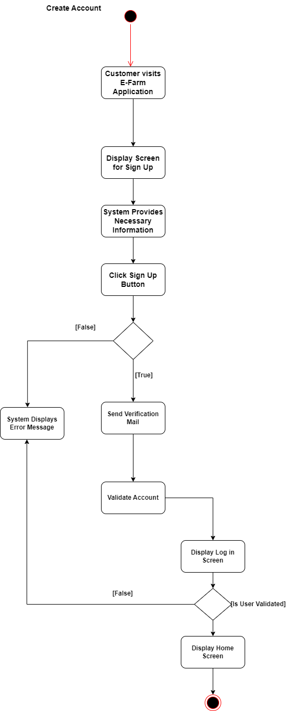 **(Create Account)**

**Figure 2: Create Account**

**Activity Diagram(Access Control)**

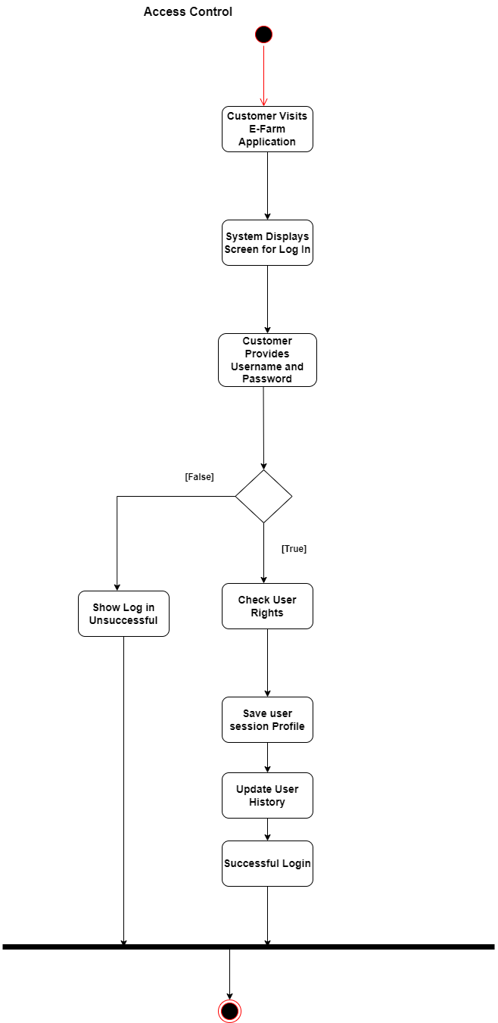

**Figure 3:Access Control**

**Activity Diagram(Search Product)**

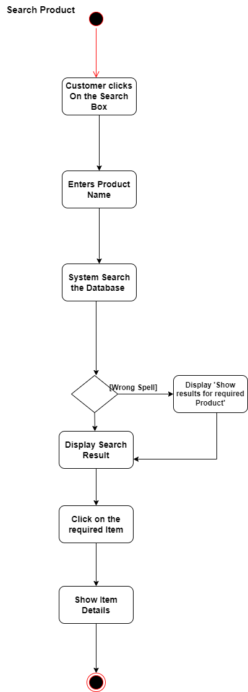

**Figure 4: Search Product**

**Activity Diagram(Show Product Availability)**

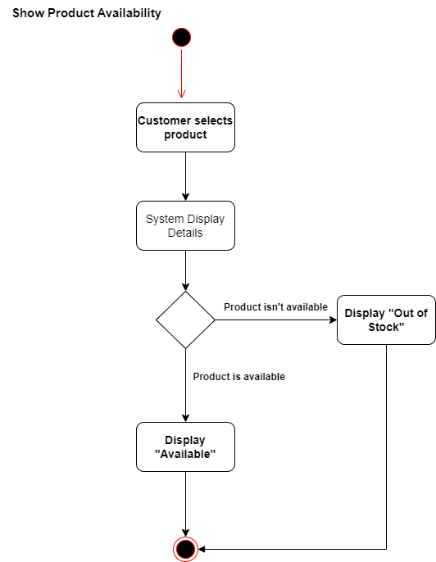

**Figure 5:Show Product Availability**

**Activity Diagram(Search Category)**

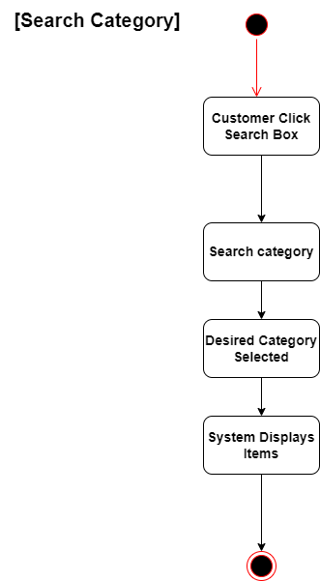

**Figure 6:Search Category**

**Activity Diagram(Request Pre-Order)**

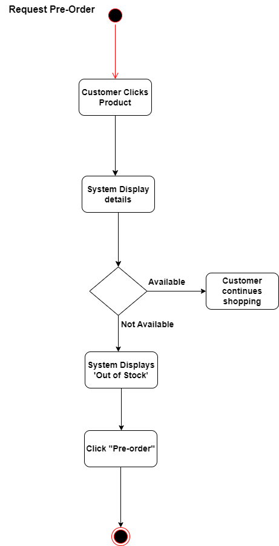

**Figure 7:Request Pre-Order**

**Activity Diagram(Order Product)**

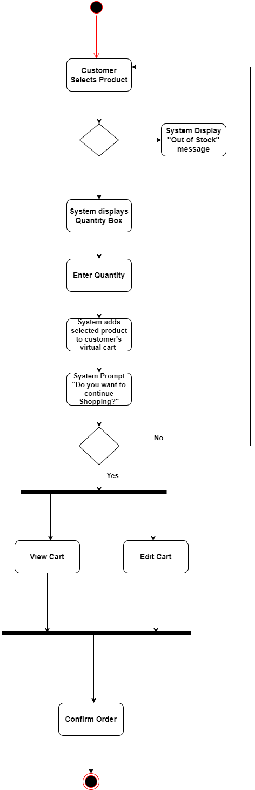

**Figure 8:Order Product**

**Activity Diagram(Order Multiple Address)**

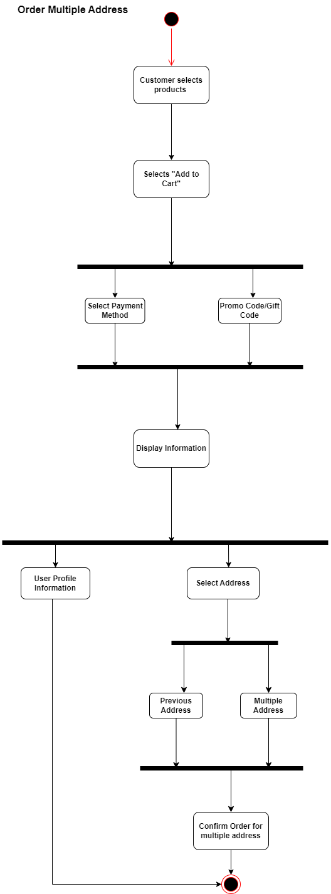

**Figure 9: Order Multiple Address**

**Activity Diagram(Make Payment)**

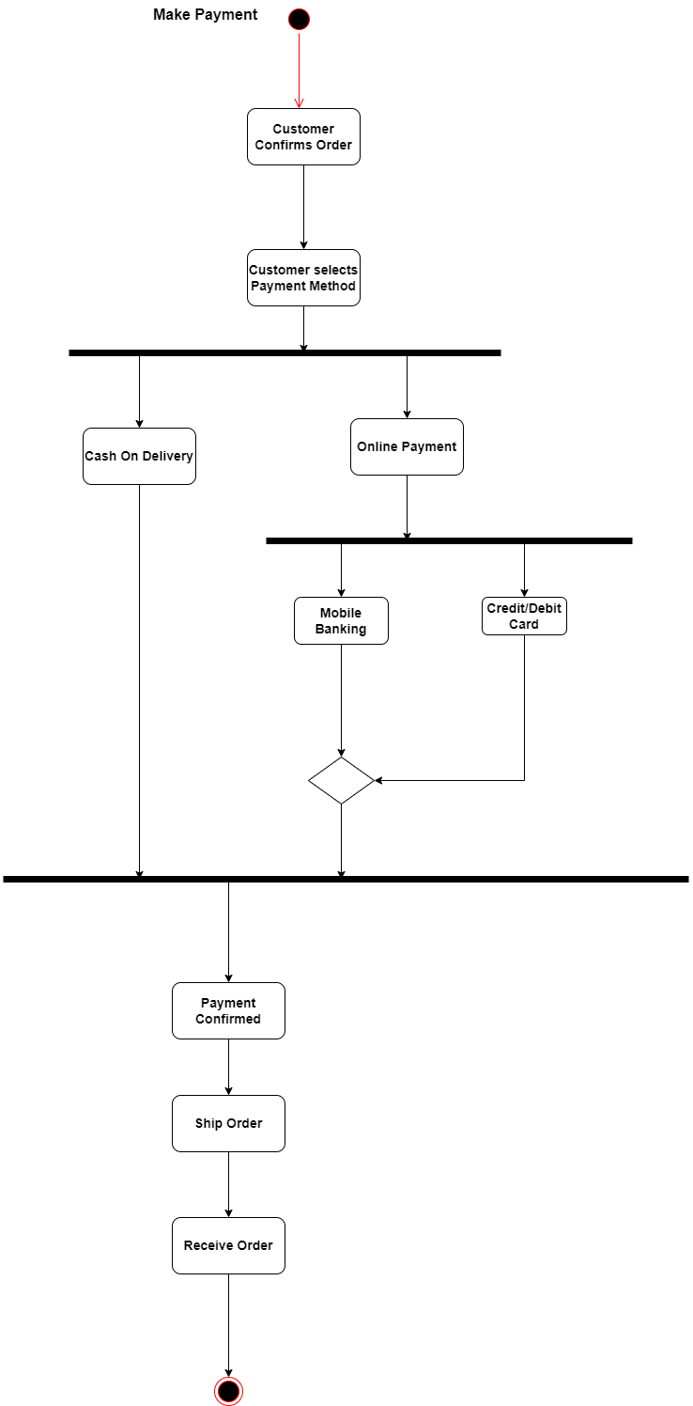

**Figure 10: Make Payment**

**Activity Diagram(Update Profile Info)**

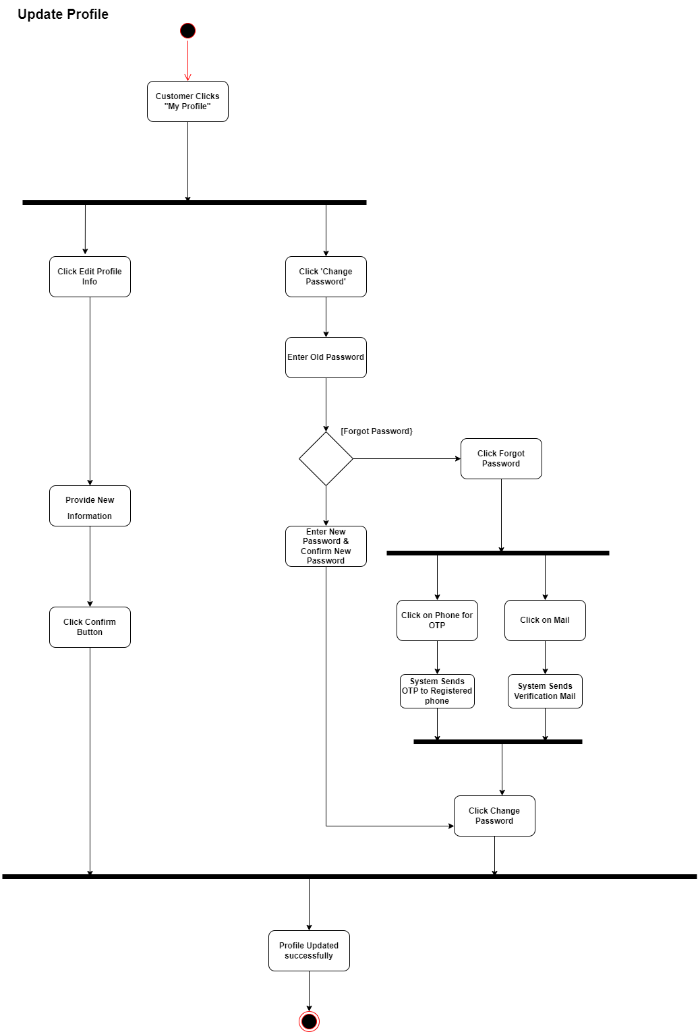

**Figure 11: Update Profile Info**

**Activity Diagram(View Recommended Product)**

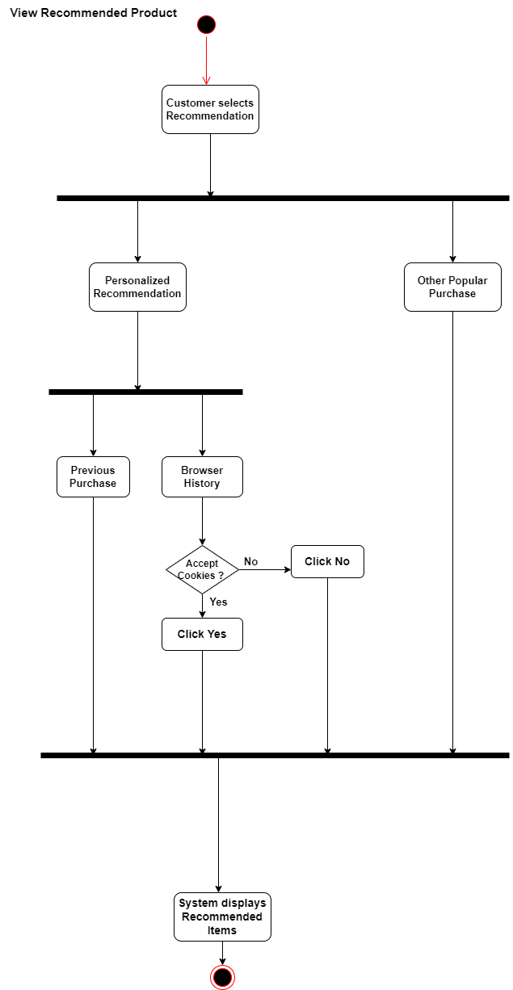

**Figure 12: View Recommended Product**

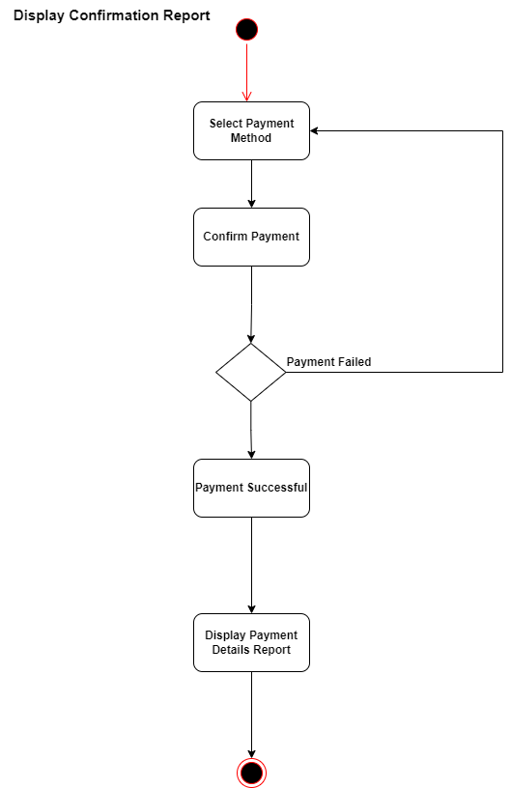**Activity Diagram(Display Confirmation report)**

**Figure 13:Display Confirmation report**

**Activity Diagram(Purchasing Promotion and Discount)**

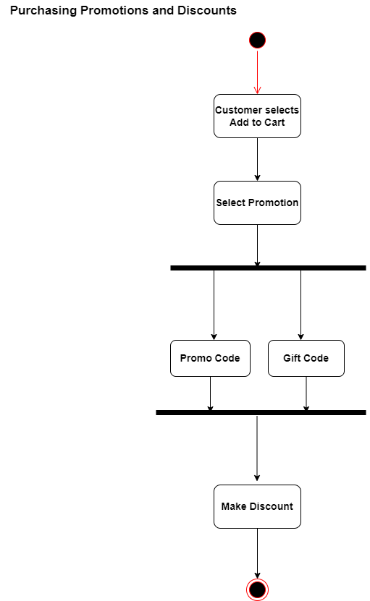

**Figure 14:Purchasing Promotion and Discount**

**Activity Diagram(Give Ratings and Reviews)**

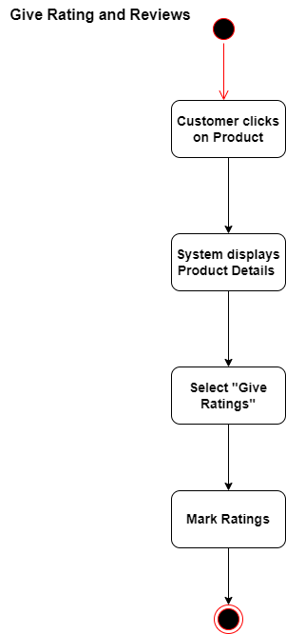

**Figure 15: Give Ratings and Reviews**

**Activity Diagram(Live chat)**

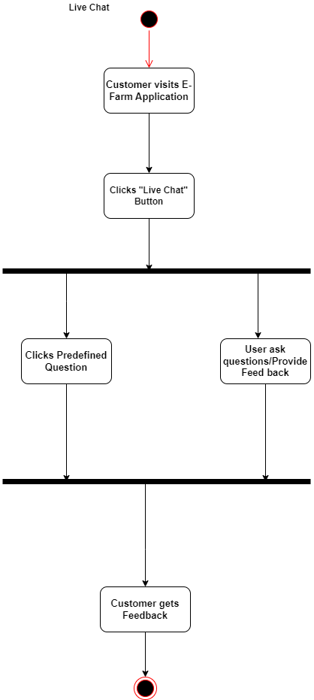

**Figure 16:Live chat**

**Activity Diagram(Return and Refund)**

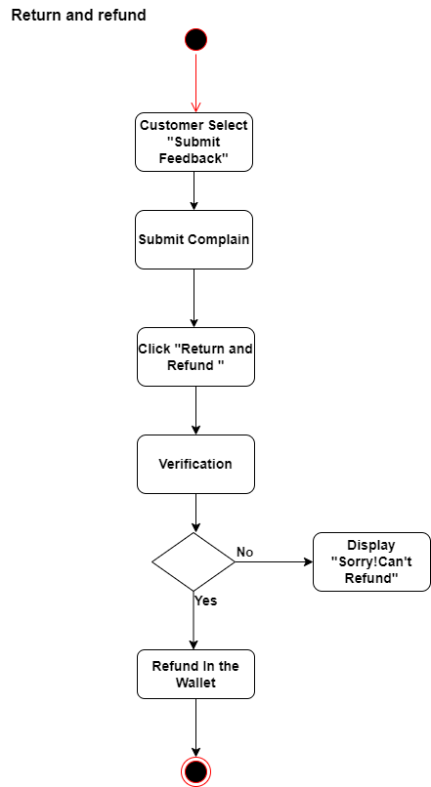

**Figure 17: Return and Refund**

**Activity Diagram(Display Confirmation Report)**

**Figure 18:Display Confirmation Report**

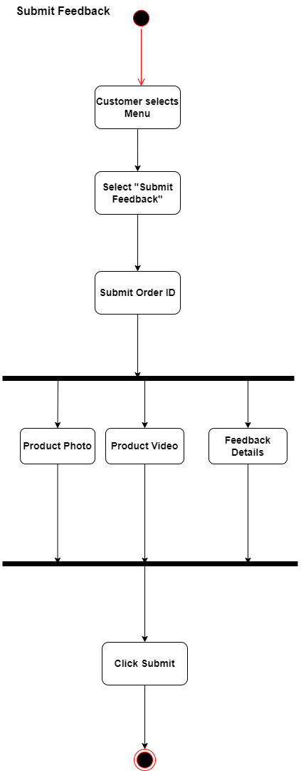**Activity Diagram(Submit Feedback)**

Figure 19: Submit Feedback

**Activity Diagram(Search Agri Info)**

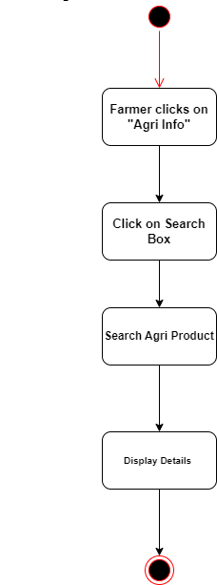

**Figure 20:Search Agri Info**

**Activity Diagram(Rent Agri Tools)**

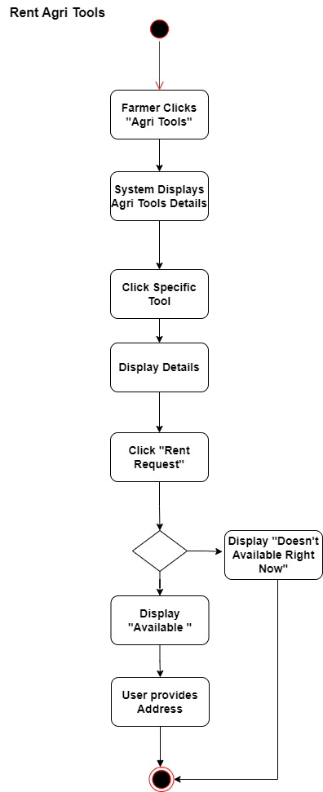

**Figure 21:Rent Agri Tools**

**Activity Diagram(Report Issues)**

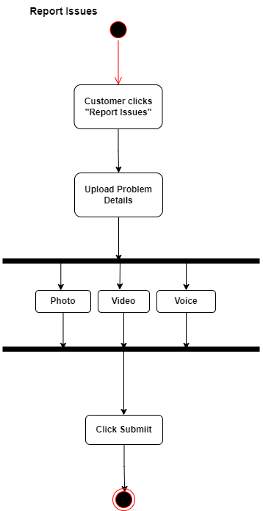

**Figure 22:Report Issues**

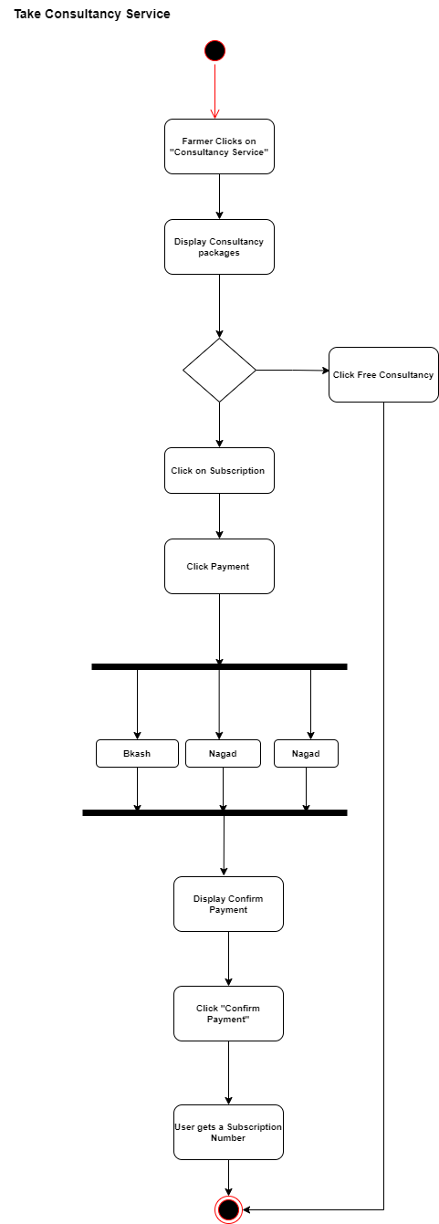**Activity Diagram(Take Consultancy Service)**

**Figure 23:Take Consultancy Service**

**Activity Diagram(Track Order)**

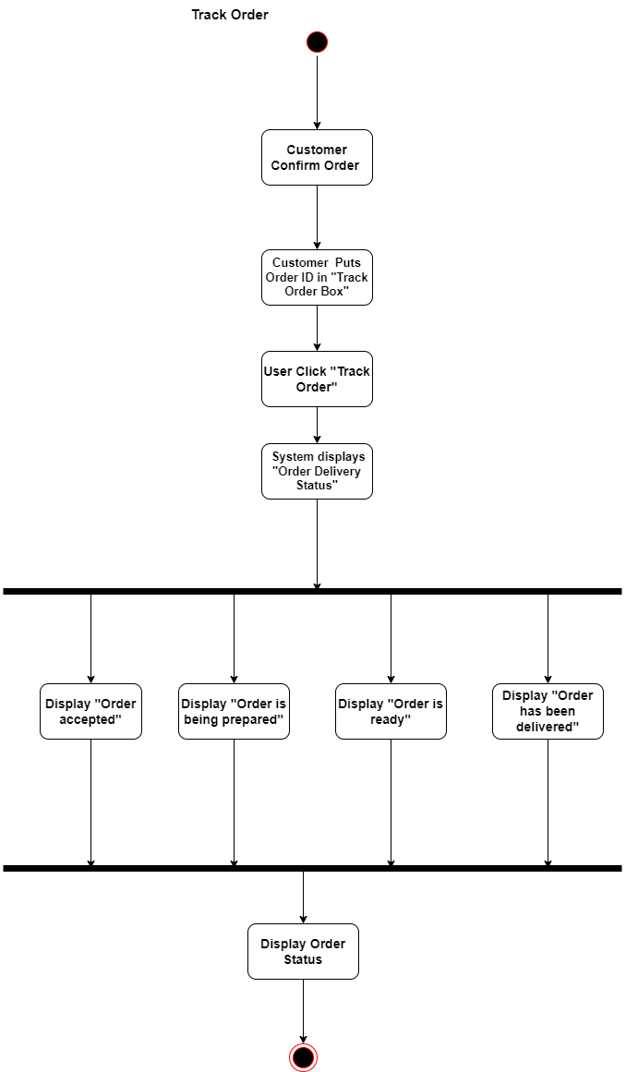

**Figure 24:Track Order**

**Activity Diagram(Forgot Password Recovery)**

**Figure 25:Forgot Password Recovery**

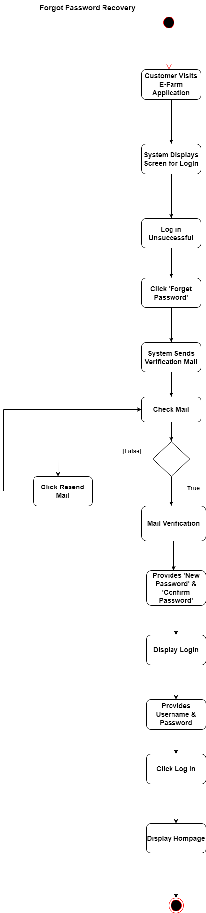

**Activity Diagram(Sign Out)**

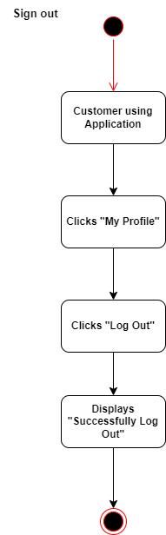

**Figure 26:Sign Out**

# Requirement Traceability Matrix

A traceability matrix is a document, usually in the form of a table, used to assist in determining the completeness of a relationship by correlating any two baselined documents using a many-to-many relationship comparison. It is often used with high-level requirements (these often consist of marketing requirements) and detailed requirements of the product to the matching parts of high-level design, detailed design, test plan, and test cases.

|  |  |  |  |  |  |  |  |
| --- | --- | --- | --- | --- | --- | --- | --- |
| **Requirements Traceability Matrix** | | | | | | |  |
| **Project Name** | **E-Farm** | | **Business Area** | | **Local** | |  |
| **Functional**  **Activity** | **Use Case Reference** | **Design**  **Document**  **Reference** | | **Code**  **Module/**  **Reference** | **User**  **Acceptance**  **Validation** | **Comments** | |
| **FR1** | UC1, UC2 |  | |  | Pass |  | |
| **FR2** | UC16 |  | |  | Verified |  | |
| **FR3** | UC16 |  | |  | Verified |  | |
| **FR4** | UC8 |  | |  | Verified |  | |
| **FR5** | UC5 |  | |  | Verified |  | |
| **FR6** | UC5 |  | |  | Verified |  | |
| **FR7** | UC5,UC10 |  | |  | Pass |  | |
| **FR8** | UC6 |  | |  | Verified |  | |
| **FR9** | UC14 |  | |  | Verified |  | |
| **FR10** | UC15 |  | |  | Verified |  | |
| **FR11** | UC12,UC19 |  | |  | Pass |  | |
| **FR12** | UC4 |  | |  | Verified |  | |
| **FR13** | UC21,UC15 | |  |  | Pass |  | |
| **FR14** | UC4 | |  |  | Verified |  | |
| **FR15** | UC15 | |  |  | Verified |  | |
| **FR16** | UC20 | |  |  | Verified |  | |
| **FR17** | UC24 | |  |  | Verified |  | |
| **FR18** | UC25 | |  |  | Verified |  | |
| **FR19** | UC2 | |  |  | Verified |  | |

# Appendix

## **Prioritization of requirements**

We’ve prioritized the functional requirements by following Three-level Scale technique.

### Three-level Scale

When a Business Analyst categorizes the requirements in any of the ordering or ranking scale, it is subject to the analyst’s understanding of the business. Many analysts suggest that this method has some drawbacks and advocate methods that have more than one scale.

### **Prioritization of the requirements** of E-Farm

FR1 – High priority

FR2 – High priority

FR3 – High priority

FR4 – Medium priority

FR5 – High priority

FR6 – Medium priority

FR7 – High priority

FR8 – Medium priority

FR9 – High priority

FR10 – Low priority

FR11 – High priority

FR12 – Medium priority

FR13 – Medium priority

FR14 – High priority

FR15 – Low priority

FR16 – High priority

FR17 – High priority

FR18 – High priority

FR19 – Low priority

DR1 – High priority

DR2 – High priority

DR3 – High priority

DR4 – High priority

DR5 – High priority

DR6 – High priority

DR7 – High priority

DR8 – High priority

DR9 – Medium priority

DR10 –Medium priority

DR11 – Medium priority

DR12 – Medium priority

DR13 – Medium priority

DR14 – Medium priority

PR1 – High priority

PR2 – High priority

PR3 – High priority

PR4 – High priority

PR5 – High priority

PR6 – Medium priority

PR7 – Medium priority

PR8 – Low priority

PR9 – Low priority