**Ensuring Quality Potato Yields with Early Detection of Diseases**

A Project work-II Report

Submitted in partial fulfillment of requirement of the Degree of

**BACHELOR OF TECHNOLOGY in COMPUTER SCIENCE & ENGINEERING**

BY

#### Maaz Qureshi (EN19CS301187)

#### Md Saqib (EN19CS301198)

**Mohd. Sami Khan (EN19CS301208)**

Under the Guidance of

### Dr. Harsh Pratap Singh



**Department of Computer Science & Engineering**

**Faculty of Engineering**

**MEDI-CAPS UNIVERSITY, Indore - 453331**

**Jan - May - 2023**

## Report Approval

The project work **“Ensuring Quality Potato Yields with Early Detection of Diseases”** is hereby approved as a creditable study of an engineering subject carried out and presented in a manner satisfactory to warrant its acceptance as prerequisite for the Degree for which it has been submitted.

It is to be understood that by this approval the undersigned do not endorse or approved any statement made, opinion expressed, or conclusion drawn there in; but approve the “Project Report” only for the purpose for which it has been submitted.

Internal Examiner

Name: Mr. Harsh Pratap Singh

Designation: Assistant Professor

Affiliation: Medicaps University

External Examiner

Name:

Designation

Affiliation

## Declaration

We hereby declare that the project entitled **“Ensuring Quality Potato Yields with Early Detection of Diseases”** submitted in partial fulfillment for the award of the degree of Bachelor of Technology, Computer Science and Engineering completed under the supervision of **Dr. Harsh Pratap Singh,** Assistant Professor, department of Computer Science and Engineering, Faculty of Engineering, Medi- Caps University Indore is an authentic work.

Further, We declare that the content of this Project work, in full or in parts, have neither been taken from any other source nor have been submitted to any other Institute or University for the award of any degree or diploma.

**Signature and name of the student(s) with date**

**Certificate**

I, **Dr. Harsh Pratap Singh** certify that the project entitled **“Ensuring Quality Potato Yields with Early Detection of Diseases”** submitted in partial fulfillment for the award of the degree of Bachelor of Technology by **Maaz Qureshi**, **Md Saqib** and **Mohd. Sami Khan** is the record carried out by them under my guidance and that the work has not formed the basis of award of any other degree elsewhere.

Dr. Harsh Pratap Singh

Computer Science and Engineering Department

Medi-Caps University, Indore

Dr. Ratnesh Litoriya

Head of the Department

Computer Science & Engineering Medi-Caps University, Indore

## Acknowledgements

I would like to express my deepest gratitude to Honorable Chancellor, **Shri R C Mittal,** who has provided me with every facility to successfully carry out this project, and my profound indebtedness to **Prof. (Dr.) Dileep K. Patnaik,** Vice Chancellor, Medi-Caps University, whose unfailing support and enthusiasm has always boosted up my morale. I also thank **Dr. Pramod S. Nair,** Dean Faculty of Engineering, Medi-Caps University, for giving me a chance to work on this project. I would also like to thank my Head of the Department **Dr. Ratnesh Litoriya** for his continuous encouragement for betterment of the project.

I express my heartfelt gratitude to my Internal Guide **Dr. Harsh Pratap Singh**, without

whose continuous help and support, this project would ever have reached to the completion.

It is their help and support, due to which we became able to complete the design and technical report. Without their support this report would not have been possible.

##### Maaz Qureshi

##### Md Saqib

**Mohd. Sami Khan**

B.Tech. IV Year

Department of Computer Science & Engineering

Faculty of Engineering

Medi-Caps University, Indore

**Table of Contents**

|  |  |  |
| --- | --- | --- |
|  |  | **Page No.** |
|  | Front Page |  |
|  | Report Approval | II |
|  | Declaration | III |
|  | Certificate | IV |
|  | Acknowledgement | V |
|  | Table of Contents | VI |
| Chapter 1 | Introduction | 1 |
|  | 1.1 Introduction | 2 |
|  | 1.2 Problem Statement | 3 |
| Chapter 2 | Literature Review & Theoretical work | 5 |
|  | 2.1 Literature Review | 6 |
| Chapter 3 | Machine Learning and Tools | 10 |
|  | 3.1 What is Machine Learning? | 11 |
|  | 3.2 Features of Machine Learning | 11 |
|  | 3.3 Definition of Machine Learning | 11 |
|  | 3.4 Machine Learning vs Deep Learning vs Neural Networks | 13 |
|  | 3.5 How Machine Learning works? | 14 |
|  | 3.6 What are Convolutional Neural Networks? | 18 |
|  | 3.7 Tools Used | 21 |
| Chapter 4 | Methodology | 25 |
|  | 4.1 Data Collection | 27 |
|  | 4.2 Augmentation | 28 |
|  | 4.3 Classification | 28 |
| Chapter 5 | Result | 31 |
|  | 5.1 Comparison | 35 |
|  | 5.2 Screenshots | 35 |
|  | 5.3 References and Citations | 37 |
|  | 5.4 Conclusion | 39 |
|  | 5.5 Discussion | 40 |

# Chapter-1

# Introduction

* 1. **Introduction**

Agriculture plays a vital role in reducing poverty and promoting economic growth. It is important to understand the significance of agriculture in reducing poverty and promoting economic growth. Food production plays a vital role in ensuring food security and preventing malnutrition. Rural populations, who are largely involved in agriculture, are particularly vulnerable to food insecurity. According to the World Bank, approximately 80% of people in rural areas are involved in farming.[1]

The potato is a widely popular and successful vegetable crop that is grown in gardens around the world. It is typically cultivated as a winter crop between the months of October and March. In Bangladesh, it is the third most important crop for enhancing economic growth, following rice and wheat. Bangladesh is also the fourth-largest producer of potatoes in Asia and ranks seventh in the world for potato production.[2]

Potato plants are vulnerable to various diseases during the harvesting period. Thus, early detection of the conditions in potato fields and prompt treatment can be an effective solution to boost potato production, which was the primary objective of this study. Traditional machine learning algorithms have been widely used to classify potato leaf diseases. In this study, we aimed to improve classification results by combining segmentation techniques and deep learning algorithms. Image segmentation was employed to mask potato leaf images, resulting in a better image dataset. Image segmentation is a technique commonly used to identify objects and boundaries in pictures. It involves assigning a label to each pixel in an image, such that pixels with the same label share specific characteristics. Various algorithms can be used for image segmentation, such as Otsu's Binary threshold algorithm, Contour Detection, and K-means clustering Algorithm. K-means algorithm is one of the most popular segmentation algorithms, which clusters objects based on their similarity and proximity to the nearest neighbors. The Euclidean distance is used to calculate the similarity distance of K-means algorithm, and the value of K usually ranges from 2 to 10.[3]

Various conventional machine learning techniques were commonly utilized for both identifying plant diseases and executing a range of computer vision tasks. Md. Asif Iqbal and Kamrul Hasan

Talukder put forward a method that employed seven widely-used conventional machine learning algorithms. In their research, they employed image segmentation techniques on 450 images gathered from the Plant Village dataset. Out of the seven algorithms, random forest was found to be the best model with an accuracy of 97%.[4]

Chaojun Hou et al. conducted a study that investigated different machine learning algorithms and utilized graph cut segmentation techniques to predict early and late blight diseases on potato leaves. Their research resulted in a 91% accuracy rate achieved by an SVM classifier after image segmentation was performed. [5]

In contrast, deep learning algorithms are now considered suitable for enhancing the accuracy of performance. A range of deep learning algorithms are available to conduct various experiments on diverse agricultural products, including rice, tomato, bell pepper, and potato. [6]

Image segmentation techniques are known to improve the accuracy of machine learning algorithms in various agricultural applications. This study aims to combine image segmentation techniques with deep learning algorithms to predict potato leaf disease with better performance results.

* 1. **Problem Statement**

Potato farming is a significant source of income for farmers worldwide. However, the crop is susceptible to various diseases, leading to significant financial losses each year. Early Blight and Late Blight are the most common diseases that affect potato plants, and they can cause devastating economic losses if not managed correctly.

Early Blight is a fungal infection that causes brown spots on leaves, which can then spread to the rest of the plant. The infection can also cause the leaves to yellow and die, leading to a significant reduction in potato yields. Late Blight, on the other hand, is caused by micro-organisms that infect the leaves and stems, causing them to turn brown and eventually collapse.

Timely detection and appropriate treatment are critical to prevent significant waste and economic

losses in potato farming. However, identifying the type of disease affecting the potato plant can be challenging, and the treatments for Early Blight and Late Blight differ slightly. Therefore, accurate disease identification is crucial to avoid mismanagement and ensure effective treatments.

To address this issue, Convolutional Neural Network-Deep Learning technology is being utilized to detect potato plant diseases accurately. Convolutional Neural Networks (CNN) are a type of deep learning algorithm that can recognize patterns and features in digital images. These networks can be trained using large datasets of images to accurately classify images into different categories, such as healthy or diseased plants.

The CNN model is trained on a large dataset of potato plant images, both healthy and diseased. When a farmer submits an image of a diseased plant to the system, the CNN algorithm processes the image, extracts the relevant features, and compares them to the pre-existing dataset. This comparison allows the algorithm to determine the type of disease affecting the plant accurately.

By utilizing CNN-Deep Learning technology, farmers can detect potato plant diseases accurately and efficiently. This technology can help farmers make more informed decisions about the management of their crops, leading to better yields and significant economic gains. By preventing the spread of disease, farmers can reduce the need for costly treatments, which can be harmful to the environment and human health.

In conclusion, the use of CNN-Deep Learning technology in potato farming is a significant step forward in the management of plant diseases. This technology enables farmers to detect and treat diseases accurately, reducing economic losses and environmental harm. The use of advanced technology in agriculture can contribute to sustainable farming practices and improve the livelihoods of farmers worldwide.

# Chapter-2

# Literature Review &

**Theoretical Framework**

**2.1 Literature Review**

Several research has done on agricultural development. It can enhance economic growth as well as can provide a healthy environment for human beings. To increase crop production speed already deep learning model and computer vision based studies have been got huge attention. Numerous studies have been conducted on the progress of agriculture, as it can not only contribute to economic growth but also promote a healthier environment for humans. The application of deep learning models and computer vision-based techniques has received significant attention in accelerating crop production. This section presents a comprehensive overview of previous research on this topic.

M. Islam et al. in 2017 [7] performed image segmentation-based potato leaf detection model and they used PlantVillage dataset. They utilized a multiclass Support Vector Machine on that segmented image to classify the diseases, finally achieved 95% accuracy. Samajpati et al. [8] introduced a hybrid model to recognize the disease of apples. The author segmented the images using k-means clustering after that classified the images using random forest algorithm. Their accuracy varied between 60 to 100%. For agricultural research PlantVillage dataset is one of the most popular public dataset sources. Many researches used this dataset to analyze agricultural data to improve production quality and amount.

In 2021, Hassan Afzaal et al used PlantVillage dataset to classify early blight potato disease from real-time system. Here, they used few recent network model, such as GoogleNet, VGGNet, and EfficientNet. A total of 5199 dataset collected from four fields. Selected models were performed better in different situations. Their highest accuracy was from EfficientNet that was 99-100 % for two classes [9]. Widiyanto et al. claimed a decent CNN model to classify four diseases including one healthy class. The author utilized 1000 images for every class and obtained 96.6% accuracy from the plantVillage dataset [10]. Kulendu et al. proposed VGG16 as a better model to detect early and late blight potato leaf diseases. Initially, they applied VGG16, VGG19, MobileNet and ResNet50 on PlantVillage dataset where they achieved better results from VGG16 after fine-tuning the model. Approximately 97.89% accuracy achieved to classify between two classes [11].

Zhou et al., [12] came up with a restructured residual dense network, a hybrid deep learning model that encompasses the upper hand of deep residual and dense networks, reducing the training process. The author applied this model to the Tomato leaf dataset from AI Challenger and identified the 9 classes of tomato leaf diseases with an accuracy rate of 95%. Farah Saeed et al. in 2021 [13] proposed a different approach to detect plant diseases. In their study they used deep neural model along with partial least squares (PLS) feature selection approach. They experiment on PlantVillage dataset for three popular crops (tomato, corn and potato) and the accuracy was 90.01%. In another promising work where author proposed a MobileNet to detect potato leaf diseases. Lightweight MobileNet V2 achieved 97.73% accuracy to predict potato leaf diseases. In this study again PlantVillage dataset was used to generate an average accuracy [14]. Ali Arshaghi et al. in 2022 [15] worked on five different potato diseases. As like potato leaf diseases detection potato diseases is also crucial to detect and classify for betterment of production proportion. In his study the used transfer learning and got around 100% accuracy.

A research article entitled "Krishi Mitra: Using Machine Learning to Identify Diseases in Plants" utilized the CNN model methodology through the TensorFlow framework to execute their project. This model's benefit was that it could detect fungal diseases in sugarcane by only measuring the leaf area. However, the drawback was that it necessitated a high level of computational complexity to implement.

In a research paper titled "Severity Identification of Potato Late Blight Disease from Crop Images Captured under Uncontrolled Environment," researchers utilized Fuzzy c-mean clustering and Neural Network to create the model. The model's main advantage was that it did not require special training for farmers, as it contained images captured from various angles. However, the disadvantage was that images captured by untrained farmers were not properly oriented and contained clusters of leaves with the background visible in several segments.

The research article titled "Potato Disease Detection Using Machine Learning" utilized image processing technology. The CNN model was used, which was a major advantage of the project as it achieved a validation accuracy of 90%. However, a significant drawback of this model was the requirement for a large training dataset.

Md. Khalid Rayhan Asif et al. [16] claimed CNN model to classify potato leaf images for several diseases. They divided the dataset into two classes: normal and disorder-impacted leaf. After applying five transfer learning algorithms they achieved 97% accuracy to classify the provided dataset. Image segmentation also used to detect disease region and predict leaf diseases. PlantVillage dataset used by Aditi Singh and Harjeet Kaur in 2021 [17], where they applied K- means segmentation and SVM was selected as a classification algorithm and 95.99% accuracy was achieved to detect potato leaf diseases. Hong H et al., [18] introduced a deep learning method to classify tomato leaf disease and other 8 types of disease leaves. Here applied transfer learning to reduce the size of train data, computational time, and model complexity. Five deep network structures were used, while Densenet_Xception offered the highest accuracy. Another impressive work proposed by Trong-Yen Lee et al in 2021 [19]. They also used PlantVillage dataset and applied effective CNN model to predict and classify potato leaf diseases and achieved 99.53% accuracy. Though several review paper already available on plant diseases prediction and classification [20, 21], still there are many scope to study on this field because early prediction and disease classification is necessary to enhance agricultural production. The major problem is appropriate dataset for agricultural development.

Several researches used PlantVillage dataset to preform unique experiments, only few research performed on own collected dataset but those datasets are not available for experiment. Yogeswararao, G e al. in 2022 [22] combined own collected data and PlantVillage dataset to predict and classify different crops diseases. They considered five most popular plants to improve economic growth. However, in future, research on making large and public dataset will be effective. After observing several previous studies, we have chosen potato leaf diseases prediction as our research topic.

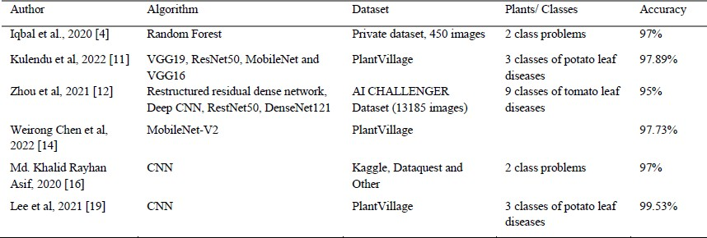

Table 1. Summary of Recent Papers for Potato Leaf Disease Prediction.

# Chapter-3

# Machine Learning And Tools

#### 3.1 What is Machine Learning?

Machine Learning is the field of study that gives computers the capability to learn without being explicitly programmed. ML is one of the most exciting technologies that one would have ever come across. As it is evident from the name, it gives the computer that makes it more similar to humans: The ability to learn. Machine learning is actively being used today, perhaps in many more places than one would expect.

#### 3.2 Features of Machine learning

* Machine learning is data driven technology. Large amount of data generated by organizations on daily bases. So, by notable relationships in data, organizations make better decisions.
* Machine can learn itself from past data and automatically improve.
* From the given dataset it detects various patterns on data.
* For the big organizations branding is important and it will become easier to target relatable customer base.
* It is similar to data mining because it is also deals with the huge amount of data.

**3.3 Definition of Machine Learning**

Arthur Samuel, an early American leader in the field of computer gaming and artificial intelligence, coined the term “Machine Learning ” in 1959 while at IBM. He defined machine learning as “the field of study that gives computers the ability to learn without being explicitly programmed “. However, there is no universally accepted definition for machine learning.

Different authors define the term differently. We give below two more definitions.

* Machine learning is programming computers to optimize a performance criterion using example data or past experience . We have a model defined up to some parameters, and learning is the execution of a computer program to optimize the parameters of the model using the training data or past experience. The model may be predictive to make predictions in the future, or descriptive to gain knowledge from data.
* The field of study known as machine learning is concerned with the question of how to construct computer programs that automatically improve with experience.

Machine learning is a subfield of artificial intelligence that involves the development of algorithms and statistical models that enable computers to improve their performance in tasks through experience. These algorithms and models are designed to learn from data and make predictions or decisions without explicit instructions. There are several types of machine learning, including supervised learning, unsupervised learning, and reinforcement learning. Supervised learning involves training a model on labeled data, while unsupervised learning involves training a model on unlabeled data. Reinforcement learning involves training a model through trial and error. Machine learning is used in a wide variety of applications, including image and speech recognition, natural language processing, and recommender systems.

**Learning**

A computer program is said to *learn* from experience E with respect to some class of tasks T and performance measure P , if its performance at tasks T, as measured by P , improves with experience E.

Examples

* Handwriting recognition learning problem
  + Task T : Recognizing and classifying handwritten words within images
  + Performance P : Percent of words correctly classified
  + Training experience E : A dataset of handwritten words with given classifications
* A robot driving learning problem
  + Task T : Driving on highways using vision sensors
  + Performance P : Average distance traveled before an error
  + Training experience E : A sequence of images and steering commands recorded while observing a human driver

#### 3.4 Machine Learning vs. Deep Learning vs. Neural Networks

Since deep learning and machine learning tend to be used interchangeably, it’s worth noting the nuances between the two. Machine learning, deep learning, and neural networks are all sub-fields of artificial intelligence. However, neural networks is actually a sub-field of machine learning, and deep learning is a sub-field of neural networks.

The way in which deep learning and machine learning differ is in how each algorithm learns. "Deep" machine learning can use labeled datasets, also known as supervised learning, to inform its algorithm, but it doesn’t necessarily require a labeled dataset. Deep learning can ingest unstructured data in its raw form (e.g., text or images), and it can automatically determine the set of features which distinguish different categories of data from one another. This eliminates some of the human intervention required and enables the use of larger data sets. You can think of deep learning as "scalable machine learning" as Lex Fridman notes in this MIT lecture (01:08:05) (link resides outside IBM).

Classical, or "non-deep", machine learning is more dependent on human intervention to learn. Human experts determine the set of features to understand the differences between data inputs, usually requiring more structured data to learn.

Neural networks, or artificial neural networks (ANNs), are comprised of node layers, containing an input layer, one or more hidden layers, and an output layer. Each node, or artificial neuron, connects to another and has an associated weight and threshold. If the output of any individual node is above the specified threshold value, that node is activated, sending data to the next layer of the network. Otherwise, no data is passed along to the next layer of the network by that node. The “deep” in deep learning is just referring to the number of layers in a neural network. A neural network that consists of more than three layers—which would be inclusive of the input and the output—can be considered a deep learning algorithm or a deep neural network. A neural network that only has three layers is just a basic neural network.

Deep learning and neural networks are credited with accelerating progress in areas such as computer vision, natural language processing, and speech recognition.

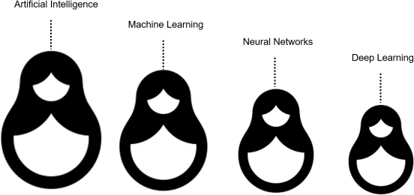

#### 3.5 How machine learning works?

1. A Decision Process: In general, machine learning algorithms are used to make a prediction or classification. Based on some input data, which can be labeled or unlabeled, your algorithm will produce an estimate about a pattern in the data.
2. An Error Function: An error function evaluates the prediction of the model. If there are known examples, an error function can make a comparison to assess the accuracy of the model.
3. A Model Optimization Process: If the model can fit better to the data points in the training set, then weights are adjusted to reduce the discrepancy between the known example and the model estimate. The algorithm will repeat this “evaluate and optimize” process, updating weights autonomously until a threshold of accuracy has been met.

#### Machine learning methods

Machine learning implementations are classified into four major categories, depending on the nature of the learning “signal” or “response” available to a learning system which are as follows:

**Supervised machine learning**

Supervised learning, also known as supervised machine learning, is defined by its use of labeled datasets to train algorithms to classify data or predict outcomes accurately. As input data is fed into the model, the model adjusts its weights until it has been fitted appropriately. This occurs as part of the cross validation process to ensure that the model avoids overfitting or underfitting. Supervised learning helps organizations solve a variety of real-world problems at scale, such as classifying spam in a separate folder from your inbox. Some methods used in supervised learning include neural networks, naïve bayes, linear regression, logistic regression, random forest, and support vector machine (SVM).

**Unsupervised machine learning**

Unsupervised learning, also known as unsupervised machine learning, uses machine learning algorithms to analyze and cluster unlabeled datasets. These algorithms discover hidden patterns or data groupings without the need for human intervention. This method’s ability to discover similarities and differences in information make it ideal for exploratory data analysis, cross-selling strategies, customer segmentation, and image and pattern recognition. It’s also used to reduce the number of features in a model through the process of dimensionality reduction. Principal component analysis (PCA) and singular value decomposition (SVD) are two common approaches for this. Other algorithms used in unsupervised learning include neural networks, k-means clustering, and probabilistic clustering methods.

**Semi-supervised learning**

Semi-supervised learning offers a happy medium between supervised and unsupervised learning. During training, it uses a smaller labeled data set to guide classification and feature extraction from a larger, unlabeled data set. Semi-supervised learning can solve the problem of not having enough labeled data for a supervised learning algorithm. It also helps if it’s too costly to label enough data.

#### Reinforcement machine learning

Reinforcement machine learning is a machine learning model that is similar to supervised learning, but the algorithm isn’t trained using sample data. This model learns as it goes by using trial and error. A sequence of successful outcomes will be reinforced to develop the best recommendation or policy for a given problem.

The IBM Watson® system that won the *Jeopardy!* challenge in 2011 is a good example. The system used reinforcement learning to learn when to attempt an answer (or question, as it were), which square to select on the board, and how much to wager—especially on daily doubles.

**Common machine learning algorithms**

A number of machine learning algorithms are commonly used. These include:

* **Neural networks:** Neural networks simulate the way the human brain works, with a huge number of linked processing nodes. Neural networks are good at recognizing patterns and play an important role in applications including natural language translation, image recognition, speech recognition, and image creation.
* **Linear regression:** This algorithm is used to predict numerical values, based on a linear relationship between different values. For example, the technique could be used to predict house prices based on historical data for the area.
* **Logistic regression:** This supervised learning algorithm makes predictions for categorical response variables, such as“yes/no” answers to questions. It can be used for applications such as classifying spam and quality control on a production line.
* **Clustering:** Using unsupervised learning, clustering algorithms can identify patterns in data so that it can be grouped. Computers can help data scientists by identifying differences between data items that humans have overlooked.
* **Decision trees:** Decision trees can be used for both predicting numerical values (regression) and classifying data into categories. Decision trees use a branching sequence of linked decisions that can be represented with a tree diagram. One of the advantages of decision trees is that they are easy to validate and audit, unlike the black box of the neural network.
* **Random forests:** In a random forest, the machine learning algorithm predicts a value or category by combining the results from a number of decision trees.

#### Real-world machine learning use cases

Here are just a few examples of machine learning you might encounter every day:

* **Speech recognition:** It is also known as automatic speech recognition (ASR), computer speech recognition, or speech-to-text, and it is a capability which uses natural language processing (NLP) to translate human speech into a written format. Many mobile devices incorporate speech recognition into their systems to conduct voice search—e.g. Siri—or improve accessibility for texting.
* **Customer service:** Customer service: Online chatbots are replacing human agents along the customer journey, changing the way we think about customer engagement across websites and social media platforms. Chatbots answer frequently asked questions (FAQs) about topics such as shipping, or provide personalized advice, cross-selling products or suggesting sizes for users. Examples include [virtual agents](https://www.ibm.com/products/watson-assistant) on e-commerce sites; messaging bots, using Slack and Facebook Messenger; and tasks usually done by virtual assistants and voice assistants.
* **Computer vision:** This AI technology enables computers to derive meaningful information from digital images, videos, and other visual inputs, and then take the appropriate action. Powered by convolutional neural networks, computer vision has applications in photo tagging on social media, radiology imaging in healthcare, and self-driving cars in the automotive industry.
* **Recommendation engines:** Using past consumption behavior data, AI algorithms can help to discover data trends that can be used to develop more effective cross-selling strategies. This approach is used by online retailers to make relevant product recommendations to customers during the checkout process.
* **Automated stock trading:** Designed to optimize stock portfolios, AI-driven high-frequency trading platforms make thousands or even millions of trades per day without human intervention.
* **Fraud detection:** Banks and other financial institutions can use machine learning to spot suspicious transactions. Supervised learning can train a model using information about known fraudulent transactions. Anomaly detection can identify transactions that look atypical and deserve further investigation.

#### 3.6 What are convolutional neural networks?

A convolutional neural network (CNN or ConvNet) is a network architecture for deep learning that learns directly from data. CNNs are particularly useful for finding patterns in images to recognize objects, classes, and categories. They can also be quite effective for classifying audio, time-series, and signal data.

Convolutional neural networks are distinguished from other neural networks by their superior performance with image, speech, or audio signal inputs. They have three main types of layers, which are:

* + Convolutional layer
  + Pooling layer
  + Fully-connected (FC) layer

The convolutional layer is the first layer of a convolutional network. While convolutional layers can be followed by additional convolutional layers or pooling layers, the fully-connected layer is the final layer. With each layer, the CNN increases in its complexity, identifying greater portions of the image. Earlier layers focus on simple features, such as colors and edges. As the image data progresses through the layers of the CNN, it starts to recognize larger elements or shapes of the object until it finally identifies the intended object.

#### Convolutional Layer

The convolutional layer is the core building block of a CNN, and it is where the majority of computation occurs. It requires a few components, which are input data, a filter, and a feature map. Let’s assume that the input will be a color image, which is made up of a matrix of pixels in 3D. This means that the input will have three dimensions—a height, width, and depth—which correspond to RGB in an image. We also have a feature detector, also known as a kernel or a filter, which will move across the receptive fields of the image, checking if the feature is present. This process is known as a convolution.

The feature detector is a two-dimensional (2-D) array of weights, which represents part of the image. While they can vary in size, the filter size is typically a 3x3 matrix; this also determines the size of the receptive field. The filter is then applied to an area of the image, and a dot product is calculated between the input pixels and the filter. This dot product is then fed into an output array. Afterwards, the filter shifts by a stride, repeating the process until the kernel has swept across the entire image. The final output from the series of dot products from the input and the filter is known as a feature map, activation map, or a convolved feature.

After each convolution operation, a CNN applies a Rectified Linear Unit (ReLU) transformation to the feature map, introducing nonlinearity to the model.

As we mentioned earlier, another convolution layer can follow the initial convolution layer. When this happens, the structure of the CNN can become hierarchical as the later layers can see the pixels within the receptive fields of prior layers. As an example, let’s assume that we’re trying to determine if an image contains a bicycle. You can think of the bicycle as a sum of parts. It is comprised of a frame, handlebars, wheels, pedals, et cetera. Each individual part of the bicycle makes up a lower-level pattern in the neural net, and the combination of its parts represents a higher-level pattern, creating a feature hierarchy within the CNN.

#### Pooling Layer

Pooling layers, also known as downsampling, conducts dimensionality reduction, reducing the number of parameters in the input. Similar to the convolutional layer, the pooling operation sweeps a filter across the entire input, but the difference is that this filter does not have any weights. Instead, the kernel applies an aggregation function to the values within the receptive field, populating the output array. There are two main types of pooling:

* + **Max pooling:** As the filter moves across the input, it selects the pixel with the maximum value to send to the output array. As an aside, this approach tends to be used more often compared to average pooling.
  + **Average pooling:** As the filter moves across the input, it calculates the average value within the receptive field to send to the output array.

While a lot of information is lost in the pooling layer, it also has a number of benefits to the CNN. They help to reduce complexity, improve efficiency, and limit risk of overfitting.

#### Fully-Connected Layer

The name of the full-connected layer aptly describes itself. As mentioned earlier, the pixel values of the input image are not directly connected to the output layer in partially connected layers. However, in the fully-connected layer, each node in the output layer connects directly to a node in the previous layer.

This layer performs the task of classification based on the features extracted through the previous layers and their different filters. While convolutional and pooling layers tend to use ReLu functions, FC layers usually leverage a softmax activation function to classify inputs appropriately, producing a probability from 0 to 1.

#### Convolutional neural networks and computer vision

Convolutional neural networks power image recognition and computer vision tasks. Computer vision is a field of artificial intelligence (AI) that enables computers and systems to derive meaningful information from digital images, videos and other visual inputs, and based on those inputs, it can take action. This ability to provide recommendations distinguishes it from image recognition tasks. Some common applications of this computer vision today can be seen in:

* + **Marketing:** Social media platforms provide suggestions on who might be in photograph that has been posted on a profile, making it easier to tag friends in photo albums.
  + **Healthcare:** Computer vision has been incorporated into radiology technology, enabling doctors to better identify cancerous tumors in healthy anatomy.
  + **Retail:** Visual search has been incorporated into some e-commerce platforms, allowing brands to recommend items that would complement an existing wardrobe.
  + **Automotive**: While the age of driverless cars hasn’t quite emerged, the underlying technology has started to make its way into automobiles, improving driver and passenger safety through features like lane line detection.

#### 3.7 Tools Used

1. **TensorFlow**

**TensorFlow** is a free and open-source software library for machine learning and artificial intelligence. It can be used across a range of tasks but has a particular focus on training and inference of deep neural networks.

TensorFlow was developed by the Google Brain team for internal Google use in research and production. The initial version was released under the Apache License 2.0 in 2015. Google released the updated version of TensorFlow, named TensorFlow 2.0, in September 2019.

TensorFlow can be used in a wide variety of programming languages, including Python, JavaScript, C++, and Java. This flexibility lends itself to a range of applications in many different sectors.

1. **TensorFlow lite**

TensorFlow Lite has APIs for mobile apps or embedded devices to generate and deploy TensorFlow models. These models are compressed and optimized in order to be more efficient and have a higher performance on smaller capacity devices.

TensorFlow Lite uses FlatBuffers as the data serialization format for network models, eschewing the Protocol Buffers format used by standard TensorFlow models.

TensorFlow Lite is a set of tools that enables on-device machine learning by helping developers run their models on mobile, embedded, and edge devices.

##### Key features

* + *Optimized for on-device machine learning*, by addressing 5 key constraints: latency (there's no round-trip to a server), privacy (no personal data leaves the device), connectivity (internet connectivity is not required), size (reduced model and binary size) and power consumption (efficient inference and a lack of network connections).
  + *Multiple platform support*, covering Android and iOS devices, embedded Linux, and microcontrollers.
  + *Diverse language support*, which includes Java, Swift, Objective-C, C++, and Python.
  + *High performance*, with hardware acceleration and model optimization.
  + *End-to-end examples*, for common machine learning tasks such as image classification, object detection, pose estimation, question answering, text classification, etc. on multiple platforms.

1. **Jupyter Notebook**

The Jupyter Notebook is an open-source web application that allows you to create and share documents that contain live code, equations, visualizations, and narrative text. Its uses include data cleaning and transformation, numerical simulation, statistical modeling, data visualization, machine learning, and much more.

Jupyter Notebook (formerly IPython Notebooks) is a web-based interactive computational environment for creating Jupyter notebook documents. The “notebook” term can colloquially make reference to many different entities, mainly the Jupyter web application, Jupyter Python web server, or Jupyter document format depending on context.

According to the official website of Jupyter, Project Jupyter exists to develop open-source software, open-standards, and services for interactive computing across dozens of programming languages.

Jupyter Book is an open-source project for building books and documents from computational material. It allows the user to construct the content in a mixture of Markdown, an extended version of Markdown called MyST, Maths & Equations using MathJax, Jupyter Notebooks,

reStructuredText, the output of running Jupyter Notebooks at build time. Multiple output formats can be produced (currently single files, multipage HTML web pages and PDF files).

1. **Fast Api**



FastAPI is a modern, fast (high-performance), web framework for building APIs with Python 3.7+ based on standard Python type hints.

The key features are:

* + - **Fast**: Very high performance, on par with **NodeJS** and **Go** (thanks to Starlette and Pydantic). [One of the fastest Python frameworks available](https://fastapi.tiangolo.com/#performance).
    - **Fast to code**: Increase the speed to develop features by about 200% to 300%. *
    - **Fewer bugs**: Reduce about 40% of human (developer) induced errors. *
    - **Intuitive**: Great editor support. Completion everywhere. Less time debugging.
    - **Easy**: Designed to be easy to use and learn. Less time reading docs.
    - **Short**: Minimize code duplication. Multiple features from each parameter declaration. Fewer bugs.
    - **Robust**: Get production-ready code. With automatic interactive documentation.
    - **Standards-based**: Based on (and fully compatible with) the open standards for APIs: [OpenAPI](https://github.com/OAI/OpenAPI-Specification) (previously known as Swagger) and [JSON Schema](https://json-schema.org/).

# Chapter-4

# Methodology

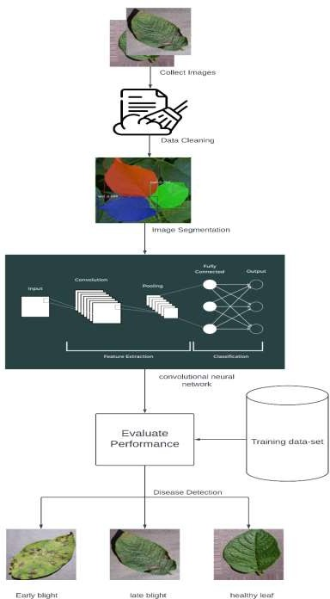The project involves various research phases, as illustrated in Figure 1 within the research framework. The proposed research framework consists of distinct stages, which are outlined below.

Fig. 1 : Data Flow Diagram

#### 4.1 Data Collection

Developing accurate leaf classification and disease detection algorithms is critical in the field of agriculture to help farmers identify and manage crop diseases quickly and effectively. In this research, two distinct datasets, namely Plant Village and Mendeley, were utilized to train and evaluate a model for classifying potato plant leaves into three categories: early blight, late blight, and healthy leaves.

The inclusion of a healthy leaf class in the dataset is essential to ensure that the model can accurately distinguish between healthy leaves and leaves affected by early blight or late blight. The dataset was divided into an 80:20 ratio for training and testing the models, with 80% of the dataset used for training and 20% used for testing.

The proposed network was evaluated on its ability to accurately classify potato plant leaves into the three classes. The results showed that the network was effective in distinguishing between the different classes, resulting in decent performance. This is a promising result as it indicates that the proposed network can potentially be used as a tool to assist farmers in identifying and managing potato plant diseases.

The use of multiple datasets in this research is a significant strength, as it helps to improve the accuracy of the model by providing a more comprehensive range of data. Additionally, the division of the dataset into training and testing sets ensures that the proposed network is evaluated objectively and can generalize to new, unseen data.

Overall, this research demonstrates the potential of using machine learning techniques to develop accurate leaf classification and disease detection algorithms for potato plant diseases. The proposed network has shown promising results in distinguishing between early blight, late blight, and healthy leaves, indicating that it could be a valuable tool for farmers in identifying and managing potato plant diseases. The dataset was taken from Kaggle website under the name “PlantVillage Dataset”.

|  |  |
| --- | --- |
| **Samples** | **Number** |
| Healthy leaf | 152 |
| Early blight | 1000 |
| Late blight | 1000 |
| **Total** | 2152 |

#### 4.2 Augmentation

Data augmentation is a technique used to improve the accuracy of image classifiers, and in this study, several augmentation methods were used to enhance the model's performance and recognition capabilities. One method involved applying a shear range of 0.2 to training images with one axis fixed and the other stretched to a predetermined angle. This helped to correct perception angles and produce images from different perspectives. Zooming with a range of 0.2x and horizontal flipping were also used to further enhance the dataset. These methods generated a total of 10,320 images, with 8,256 used for training and 2,064 used for testing the model.

#### 4.3 Classification

The Convolutional Neural Network (CNN) architecture is a popular choice for image classification tasks, including identifying diseases in potato leaves. This architecture is a supervised learning technique that utilizes an existing dataset to train a model to recognize images based on their attributes. In this project, we will use CNN to classify potato leaf images into healthy leaves, early blight, and late blight.

The CNN architecture is particularly useful for recognizing potato leaves based on their attributes. The convolutional layer in CNN applies a filter to the leaf image to identify features and patterns that can be used to distinguish between healthy leaves and leaves affected by early blight or late blight. The output image is then passed through a pooling layer, which reduces the image's resolution while preserving its quality.

In this project, the leaf images will be resized to 150x150x3 pixels, which means that each image will have three channels (red, green, and blue). The output image resulting from pooling will then undergo MaxPooling, which reduces the spatial size of the output while retaining the most significant information.

To enable the CNN to classify the images, the output of the MaxPooling layer will be flattened into vector form. The proposed model for identifying diseases in potato leaves will use four convolutional layers and four MaxPooling layers. The CNN architecture will be trained on the dataset of potato leaf images to learn the features that distinguish healthy leaves from those affected by early blight or late blight.

Overall, the proposed CNN architecture is a promising approach to identifying potato leaf diseases, as it utilizes the powerful capabilities of CNN to recognize patterns and features in potato leaf images. By training the model on a dataset of potato leaf images, the CNN can learn to accurately classify potato leaves as healthy or affected by early blight or late blight.

Fig. 2 : Healthy Leaves

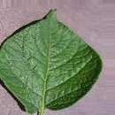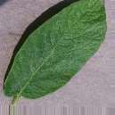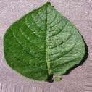

Fig. 3 : Early Blight

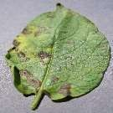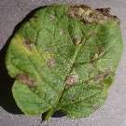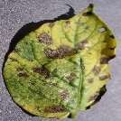

Fig. 4 : Late Blight

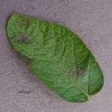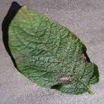

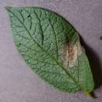

# Chapter-5

# Result

Plant leaf diseases are a major concern for farmers worldwide as they can cause significant losses in crop productivity and quality. In recent years, deep learning techniques have emerged as a promising approach for detecting and diagnosing plant leaf diseases. These techniques can help farmers to control biotic variables that cause severe crop yield losses, thereby improving overall crop productivity and quality.

Our project focuses on the detection of potato leaf diseases using a multi-level deep learning model. A Convolutional Neural Network (CNN) is a deep learning algorithm used for analyzing visual data. It learns and extracts features directly from raw input data by applying convolutional filters, using activation functions for non-linearity, down sampling with pooling layers, utilizing fully connected layers, and producing output probabilities for classification. CNNs are trained using backpropagation and gradient descent to optimize the network's weights. By employing these operations, CNNs can learn hierarchical representations of visual data, making them effective for tasks like image classification, object detection, and image segmentation.

The proposed model is fast and straightforward and can classify different types of potato leaf diseases. At the first level, the model takes potato leaf images as input and extracts potato leaves from the images. At the second level, a convolutional neural network is developed for potato leaf disease detection, which can classify early blight and late blight potato diseases based on the potato leaf images.

In addition, the proposed model considers the effects of environmental factors such as temperature, humidity, and light on potato leaf diseases. By taking into account these factors, the model can better predict and diagnose potato leaf diseases. This can help farmers to take appropriate measures to control the spread of diseases and improve crop productivity and quality. Overall, our project demonstrates the effectiveness of deep learning techniques for plant leaf disease detection and diagnosis, particularly in the context of potato crops.

In this statement, it is being conveyed that the CNN techniques proposed for detecting potato leaf disease were tested on a dataset that was different from the one it was initially trained on. The results showed that the proposed approach outperformed other methods that were being used for the same purpose.

The technique was trained on two versions of the PLD dataset - one with data augmentation techniques and the other without. Despite this, it achieved an accuracy of 96.41% and showed high precision, recall, F1-score, and ROC curve metrics.

What's interesting is that despite being simpler and having fewer parameters than existing state- of-the-art methods, the proposed CNN technique demonstrated superior performance, which resulted in significant savings in computational costs and speed.

Lastly, the results obtained from this study were compared with existing studies on potato leaf disease detection for comparison purposes. Overall, the statement highlights the effectiveness of the proposed CNN technique for detecting potato leaf disease and its potential to contribute to the development of more efficient and cost-effective methods for crop disease detection.

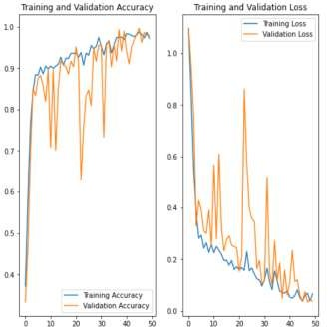

Fig. 5 : Training and Validation

(a)

Actual : Potato Early_blight, Predicted : Potato _Early_blight, Confidence : 97.79%

(b)

Actual : Potato Late_blight, Predicted : Potato _Late_blight, Confidence : 96.52%

(c)

Actual : Potato Late_blight, Predicted : Potato _Late_blight, Confidence : 89.05%

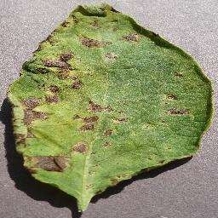

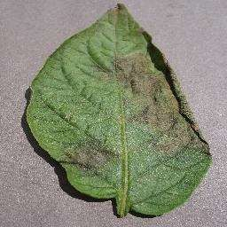

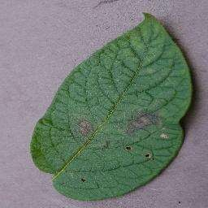

Fig. 6 : Outputs

##### 5.1 Comparison

**MODEL DATASET ACCURACY**

|  |  |
| --- | --- |
| VGG16 (K- MEANS CLUSTERING) | PlantVillage 97% |
| SVM (K- MEANS  CLUSTERING) | PlantVillage 95.99% |
| NOVEL CNN | PlantVillage 99.75% |
| CNN (PROPOSED) | PlantVillage 96.41% |

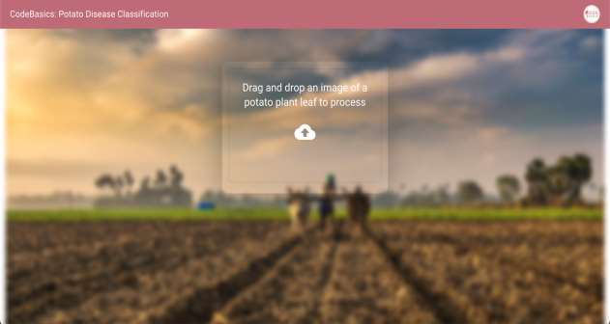**5.2 Screenshots**

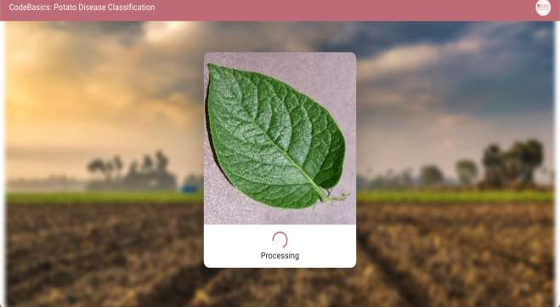

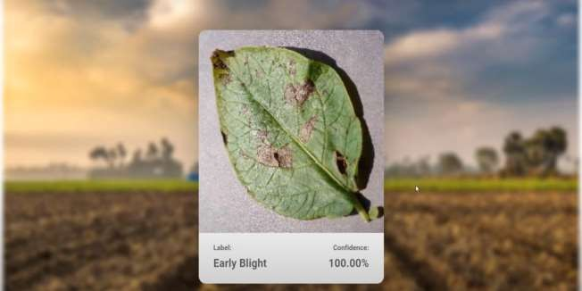

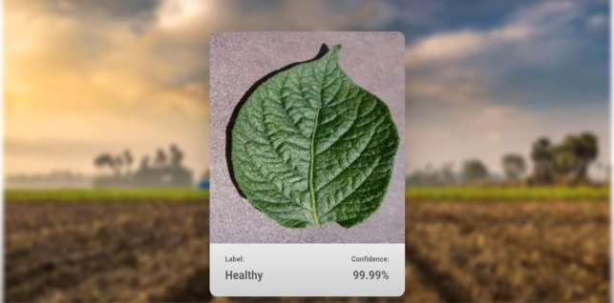

**5.3 References and Citations**

1. Nugroho N. Sunjoyo (2022) “Agriculture and Food.” https:/[/www.worldbank.org/en/topi](http://www.worldbank.org/en/topic/agric)c[/agric](http://www.worldbank.org/en/topic/agric) ulture. Accessed 11 Aug. 2022.
2. Bangladesh - Potatoes Production. https:/[/www.nationmaster.com/nmx/tim](http://www.nationmaster.com/nmx/time)e series/bangladesh-potatoes-production-fao. Accessed 24 Jun. 2022.
3. Zheng, Xin, et al. (2018) “Image segmentation based on adaptive K-means algorithm.” EURASIP Journal on Image and Video Processing 2018.1: 1-10.
4. Iqbal, Md Asif, and Kamrul Hasan Talukder. (2020) “Detection of potato disease using image segmentation and machine learning.” International Conference on Wireless Communications Signal Processing
5. Hou, Chaojun, et al. (2021) “Recognition of early blight and late blight diseases on potato leaves based on graph cut segmentation.” Journal of Agriculture and Food Research 5: 100154.
6. Lamba, Monika, Gigras, Yogita and Dhull, Anuradha. (2021) “Classification of plant diseases using machine and deep learning.” Open Computer Science, vol. 11, no. 1, pp. 491- 508. https://doi.org/10.1515/comp-2020-0122.
7. Resistance Evaluation for Native Potato Accessions against Late Blight Disease and Potato Cyst Nematodes by Molecular Markers and Phenotypic Screening in India.
8. Automated recognition of optical image based potato leaf blight diseases using deep learning by Kulendu Kashyap Chakraborty , Rashmi Mukherjee , Chandan Chakroborty , Kangkana Bora.
9. An effective CNN and Transformer complementary network for medical image segmentation
10. VGG-ICNN: A Lightweight CNN model for crop disease identification
11. A survey on disease detection of a potato leaf using cnn 2022
12. Recent Advances in Deep Learning CNN Models for Plant
13. https://[www.tensorflow.org/](http://www.tensorflow.org/)
14. https://[www.tensorflow.org/tfx/guide/serving](http://www.tensorflow.org/tfx/guide/serving)
15. https://[www.youtube.com/results?search_query=tf+serving](http://www.youtube.com/results?search_query=tf%2Bserving)

#### 5.4 Conclusion

Potato farming is a critical source of income for many farmers in India. However, potato plants are susceptible to various diseases, leading to significant economic losses each year. Late blight and early blight are two of the most common potato plant diseases that affect potato yield and quality. Unfortunately, many farmers lack knowledge about potato diseases and have limited access to the latest technology to manage them.

To address this issue, a deep learning-based approach using a convolutional neural network (CNN) was proposed to detect late blight, early blight, and healthy leaf images of potato plants. This method can help farmers identify the type of disease affecting their plants quickly and accurately, allowing for timely treatment and reducing economic losses.

The proposed approach utilizes CNN technology to classify potato plant images into three categories: late blight, early blight, and healthy leaves. The dataset used for training the model was prepared using three different augmentation techniques, which helped increase the number of training samples and improve the accuracy of the model. Additionally, k-means clustering segmentation was applied with three different values during the experiment to improve the accuracy of disease detection. The technique was trained on two versions of the PLD dataset - one with data augmentation techniques and the other without. Despite this, it achieved an accuracy of 91.41% and showed high precision, recall, F1-score, and ROC curve metrics.

The proposed approach has the potential to revolutionize the way potato diseases are detected and managed in India. By providing farmers with an accurate and efficient way of detecting potato diseases, the proposed method can help reduce economic losses and improve crop yields. This technology can also be used to educate farmers about potato diseases, helping them make more informed decisions about their crops.

Furthermore, the use of deep learning-based approaches in agriculture has significant potential to improve crop management and increase crop yields globally. This project is an excellent example of how technology can be used to address critical issues facing the agriculture sector, particularly in developing countries such as India.

In conclusion, the proposed deep learning-based approach using a CNN to detect late blight, early blight, and healthy leaf images of potato plants could have a significant impact on potato growers in India. This technology can help farmers detect and manage potato diseases efficiently, reducing economic losses and improving crop yields. The use of advanced technology in agriculture has the potential to revolutionize the sector and contribute to sustainable farming practices, ultimately improving the livelihoods of farmers worldwide.

#### 5.5 Discussion

The results of this project demonstrate the potential of using deep learning algorithms for the detection of potato diseases. The high accuracy of the system suggests that it could be a valuable tool for farmers and researchers who need to quickly and accurately identify diseases in potato plants.

One of the advantages of using deep learning algorithms for disease detection is that they can be trained on large datasets and can learn complex patterns in the images. This allows them to be more accurate than traditional methods of disease detection, which rely on human expertise and visual inspection.

However, there are also some limitations to using deep learning algorithms for disease detection. One of the main challenges is the need for large and diverse datasets to train the models. Collecting and labeling large datasets can be time-consuming and expensive, which may limit the scalability of these systems. In addition, deep learning algorithms can be susceptible to overfitting, where they become too specialized to the training dataset and do not generalize well to new data.

In conclusion, the results of this project suggest that deep learning algorithms have the potential to be an effective tool for the detection of potato diseases. Further research is needed to address the limitations of these systems and to explore their applicability in different agricultural settings.