MEDTRACK
Medicine Reminder & Health Record Manager
PROJECT DOCUMENTATION
Student Name: _____Mohammad Saziya_________________________
Batch No: _____Batch 03_________________________
Internship / Python Final Project
Internova
Submission Date: ___________09/09/2026___________________

Declaration
I hereby declare that the project titled “MedTrack — Medicine Reminder & Health Record Manager” has been prepared as part of the Python internship/final project requirements. The project demonstrates the practical application of Python programming concepts and has been developed for academic and learning purposes.

Acknowledgement
I would like to express my sincere gratitude to the internship mentors and training organization for providing the opportunity to learn and apply Python programming concepts through a practical final project. I also thank everyone who supported the development, testing, documentation, and presentation of MedTrack.

Abstract
MedTrack is a Python-based Medicine Reminder & Health Record Manager developed to organize medicine schedules, health records, medical appointments, and reminder information in one application. The project uses Python for core logic, Streamlit for the interactive interface, and JSON files for persistent storage. A modular architecture separates the user interface, data models, medicine management, health management, appointment management, reminder logic, and utility functions. The project demonstrates Python fundamentals, functions, data structures, file handling, exception handling, libraries, Object-Oriented Programming, and Git/GitHub practices. The system can be further extended using databases, authentication, notifications, cloud deployment, analytics, and AI-assisted features.

Table of Contents
1. Introduction
2. Problem Statement
3. Project Objectives
4. Scope of the Project
5. Major Features
6. Technologies Used
7. Python Concepts Implemented
8. System Modules
9. System Architecture
10. Project Workflow
11. Project Structure
12. Important Code / Functions
13. Screenshots / Output
14. Challenges Faced
15. Testing Approach
16. Future Improvements
17. Conclusion

1. Introduction
MedTrack is a Python-based medicine reminder and health record management application developed to organize medicines, medication schedules, health records, and medical appointments in one centralized system. The application provides an interactive user interface through Streamlit and uses JSON files for persistent storage. Its modular design separates medicine, health-record, appointment, reminder, model, and utility responsibilities, making the system easier to understand, test, maintain, and extend.
The project is designed as a practical implementation of the Python concepts covered during the internship. It demonstrates programming fundamentals, conditional statements, loops, functions, data structures, file handling, exception handling, Python libraries, and Object-Oriented Programming. The system can be demonstrated through a live application and can be maintained through Git and GitHub.

2. Problem Statement
Managing medicines, medication schedules, medical appointments, and personal health records manually can lead to missed doses, forgotten appointments, duplicated records, and difficulty retrieving previous information. A user may have several medicines with different timings and may also need to maintain health notes and appointment details.
The problem addressed by MedTrack is the lack of a simple, centralized application for organizing these activities. The proposed system provides a structured digital solution in which information can be entered, stored, viewed, updated, and reported through a single interface.

3. Project Objectives
The objectives of MedTrack are:
• To develop a practical Python application for managing medicine information.
• To provide medicine reminder and schedule management.
• To maintain health records in an organized digital format.
• To manage medical appointment information.
• To provide persistent storage using JSON files.
• To validate user input and handle runtime errors safely.
• To demonstrate Object-Oriented Programming and modular programming.
• To provide an interactive Streamlit interface.
• To generate useful summaries/reports from stored information.
• To create a project suitable for version control and GitHub submission.

4. Scope of the Project
The current scope covers medicine management, health-record management, appointment management, reminder-related functionality, data persistence, reporting, and an interactive interface. The application is intended as a personal health-organization tool and not as a replacement for professional medical advice, diagnosis, or treatment.
The architecture also allows future expansion to a database, authentication, notifications, cloud deployment, mobile access, analytics, and AI-assisted information retrieval.

5. Major Features
5.1 Medicine Management
Users can add, view, update, and manage medicine information such as medicine name, dosage, frequency, schedule, dates, and instructions.
5.2 Medicine Reminder
The application organizes medicine timing information so users can review scheduled medicines and reduce the chance of forgetting a dose.
5.3 Health Record Management
Users can maintain health-related records and notes with associated dates or details.
5.4 Appointment Management
Users can create and review medical appointments including doctor/provider, date, time, purpose, and status.
5.5 Reports and Summary
The application can summarize stored medicines, health records, and appointments to give the user a quick overview.
5.6 Persistent Storage
Information is stored in JSON files inside the data directory so that records remain available after the application is closed.
5.7 Input Validation and Error Handling
The system validates inputs and handles common errors without abruptly terminating the application.

6. Technologies Used
Python — Core programming language used for application logic.
Streamlit — Used to create the interactive web interface.
JSON — Used for lightweight structured data storage.
datetime — Used for date and time processing.
os — Used for file and directory operations where required.
Matplotlib / Python reporting libraries — Can be used for visual reports and analytics where implemented.
Git — Used for source-code version control.
GitHub — Used for repository hosting and project sharing.
Visual Studio Code — Development environment used to create and test the project.

7. Python Concepts Implemented
Python Fundamentals: variables, data types, input/output, operators, type casting, conditional statements, and loops.
Functions: reusable functions are used for operations such as adding, viewing, updating, deleting, validating, loading, saving, and reporting.
Data Structures: lists and dictionaries are suitable for storing collections of records; tuples and sets can be used where fixed or unique collections are appropriate.
File Handling: JSON files are read and written using Python file operations.
Exception Handling: try/except blocks can handle invalid input, missing files, malformed data, and other runtime conditions.
Python Libraries: standard libraries such as json, os, datetime, and uuid can support storage, time handling, identifiers, and file operations.
Object-Oriented Programming: classes and objects represent entities such as Medicine, HealthRecord, Appointment, and Reminder. Constructors initialize objects, while encapsulation, inheritance, polymorphism, and abstraction can be demonstrated through the model structure.

8. System Modules
8.1 User Interface Module — app.py
Provides the Streamlit pages, forms, controls, messages, and displayed records.
8.2 Medicine Manager — medicine_manager.py
Handles medicine-related operations such as adding, reading, updating, deleting, and preparing reminder information.
8.3 Health Manager — health_manager.py
Handles creation and retrieval of health records and related validation.
8.4 Appointment Manager — appointment_manager.py
Handles appointment creation, viewing, and management.
8.5 Reminder Manager — reminder_manager.py
Supports reminder-related logic and schedule processing.
8.6 Models — models.py
Defines reusable classes/data models for the application's entities.
8.7 Utilities — utils.py
Contains common helper functions such as validation, formatting, ID generation, or shared file operations where applicable.
8.8 Data Layer
The data directory contains JSON files such as medicines.json, health_records.json, and appointments.json.

9. System Architecture
MedTrack follows a simple modular architecture:
User
↓
Streamlit User Interface
↓
Manager / Service Modules
↓
Models and Utility Functions
↓
JSON Data Files
↓
Reports / Reminders / Displayed Results
This separation prevents the UI from containing all application logic in one place. Each manager module is responsible for a specific domain, while models and utility functions provide reusable structures and operations.

10. Project Workflow
Step 1: The user opens the MedTrack application.
Step 2: The Streamlit interface displays the available management options.
Step 3: The user enters medicine, health-record, appointment, or reminder information.
Step 4: Input values are validated.
Step 5: The appropriate manager module processes the request.
Step 6: The data is stored or retrieved from JSON files.
Step 7: The updated information is displayed in the application.
Step 8: The user can review schedules, records, appointments, and summaries.
Example medicine workflow:
Enter medicine → validate fields → create/update medicine record → save to medicines.json → display medicine → use schedule information for reminder view.

11. Project Structure
MedTrack/
├── app.py
├── main.py
├── models.py
├── medicine_manager.py
├── health_manager.py
├── appointment_manager.py
├── reminder_manager.py
├── utils.py
├── requirements.txt
├── README.md
├── .gitignore
└── data/
├── appointments.json
├── health_records.json
└── medicines.json
The structure shown above keeps the application modular and separates source code from persistent data.

12. Important Code / Functions
Example class:
class Medicine:
def __init__(self, name, dosage, frequency):
self.name = name
self.dosage = dosage
self.frequency = frequency
Example JSON loading:
import json
with open("data/medicines.json", "r") as file:
medicines = json.load(file)
Example JSON saving:
with open("data/medicines.json", "w") as file:
json.dump(medicines, file, indent=4)
Example exception handling:
try:
value = int(user_input)
except ValueError:
print("Please enter a valid number.")
The exact implementation may vary depending on the final version of the project. These examples illustrate the Python concepts used in the system.

13. Screenshots / Output
For final submission, screenshots should be captured from the running application and placed in this section. Recommended screenshots are:
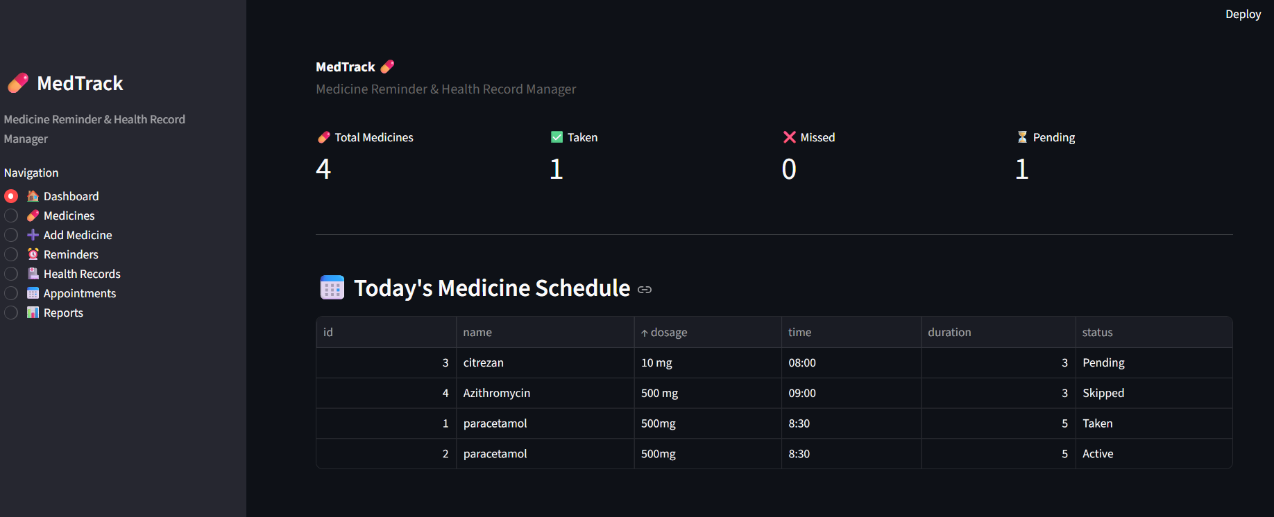
Figure 1 — MedTrack Home Dashboard
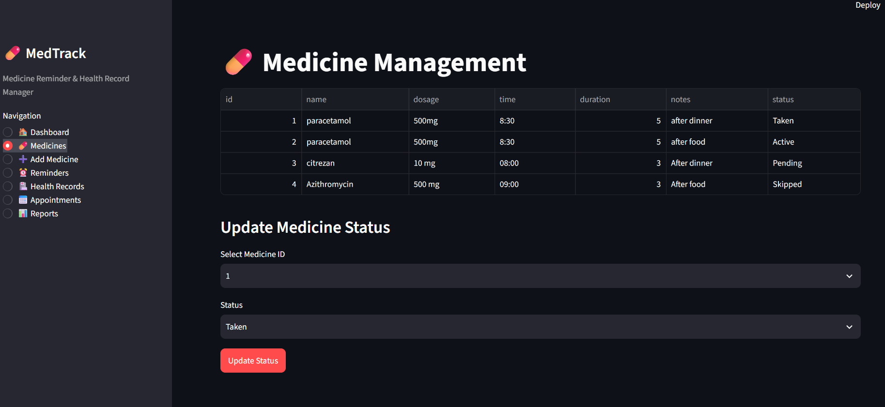
Figure 2 — Medicine Management Interface
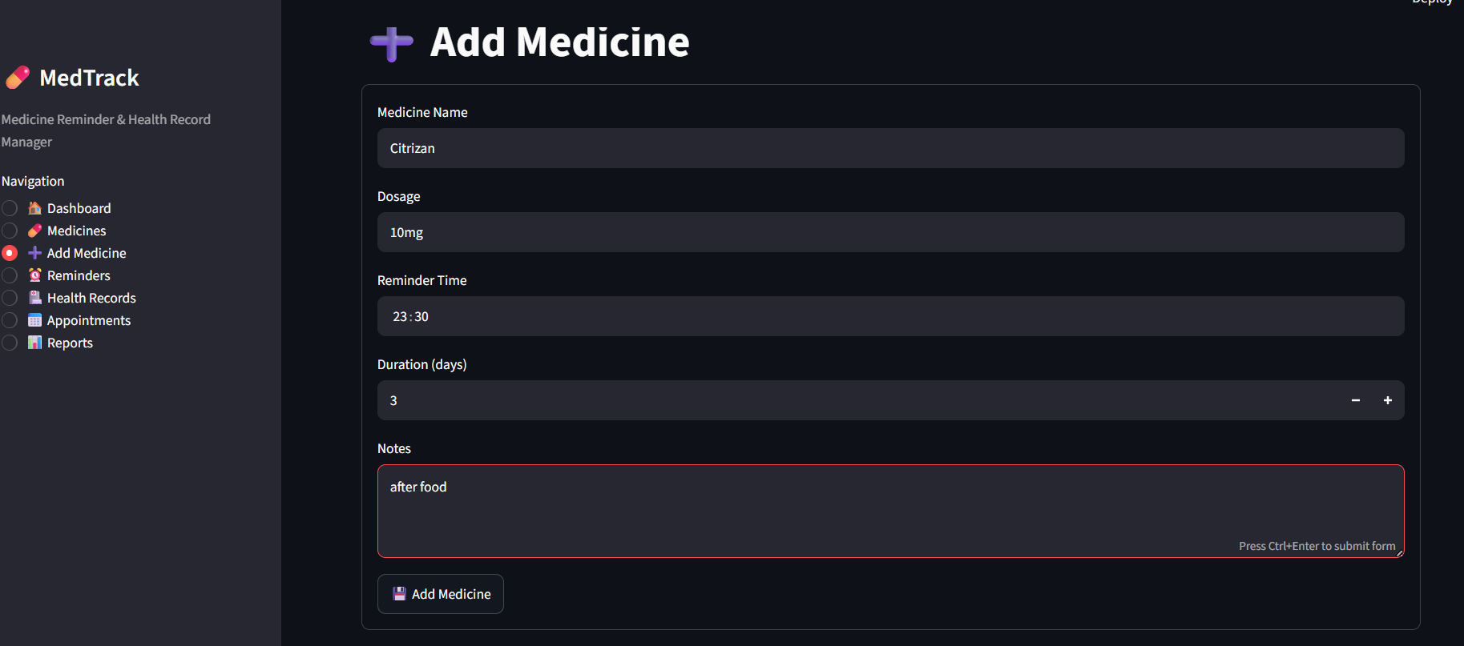
Figure 3 — Add / Update Medicine Form
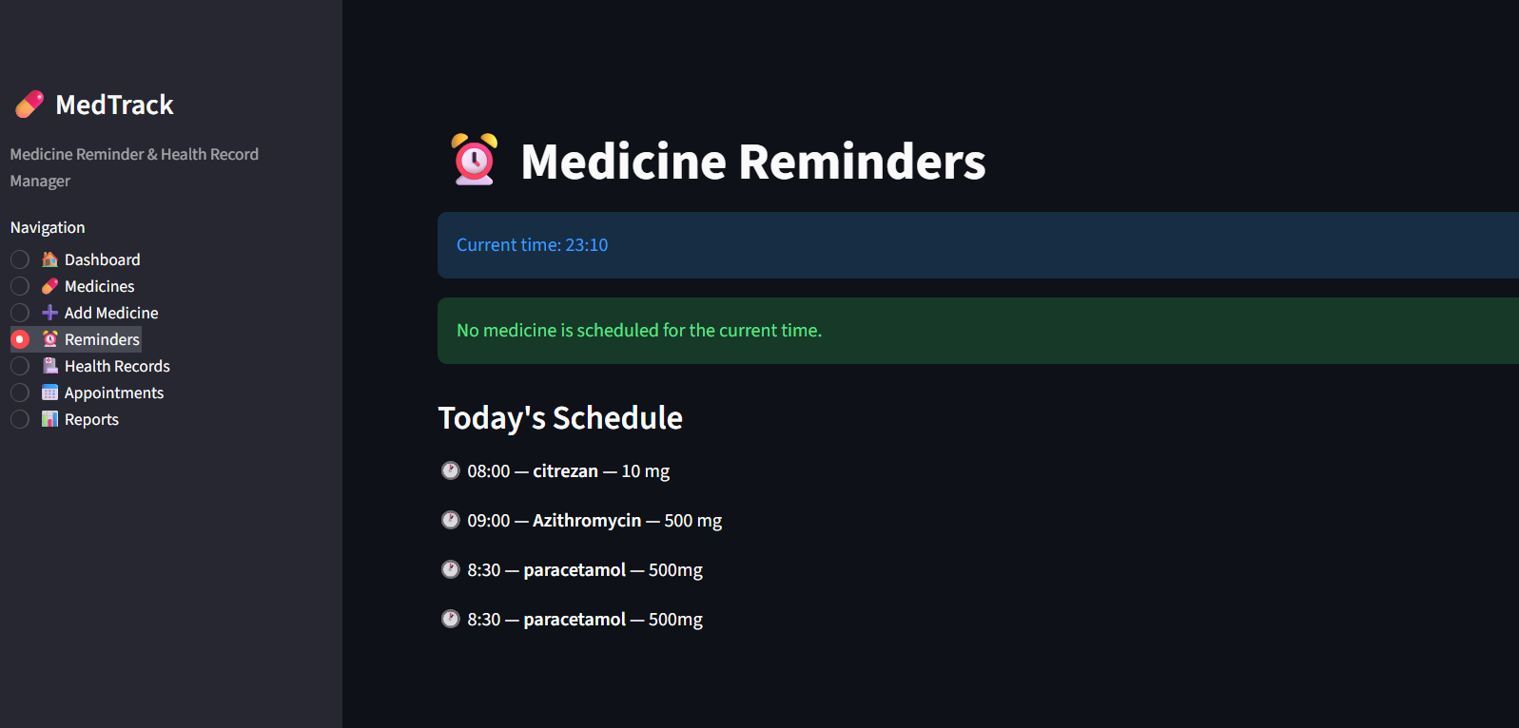
Figure 4 — Medicine Reminder / Schedule View
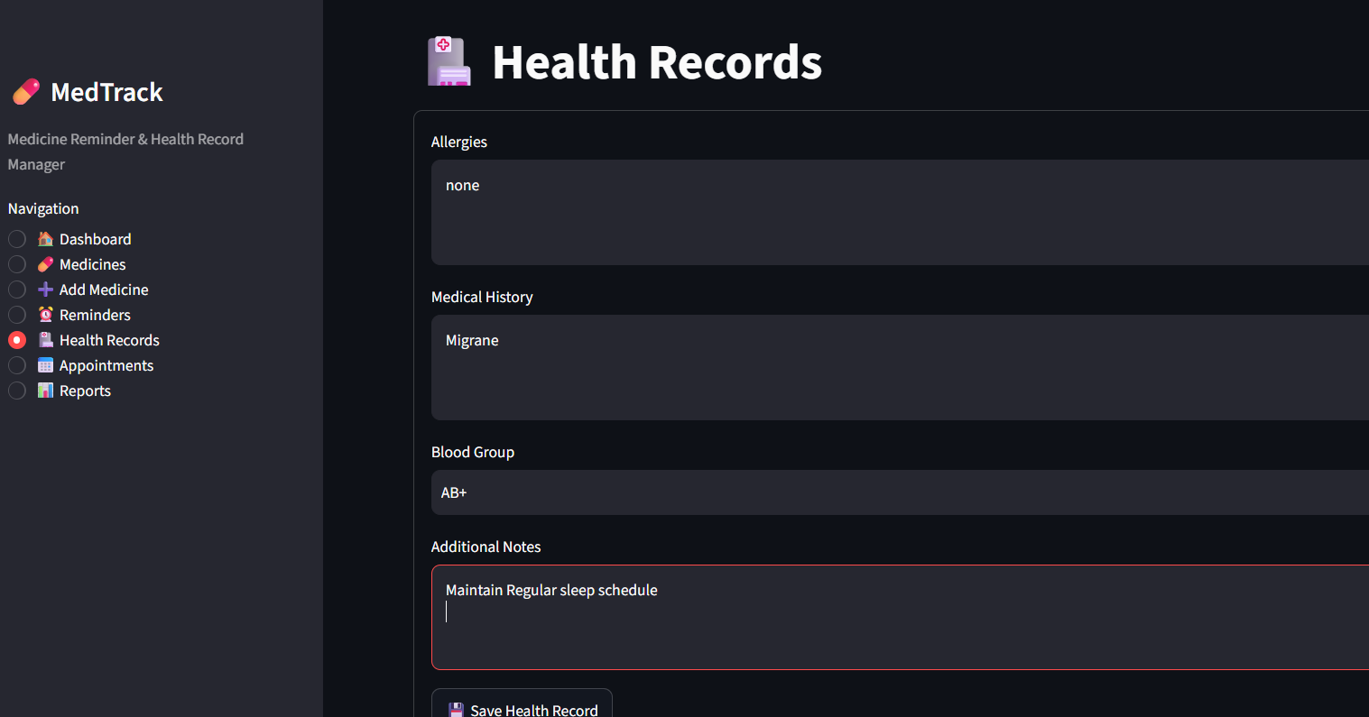
Figure 5 — Health Record Management Interface
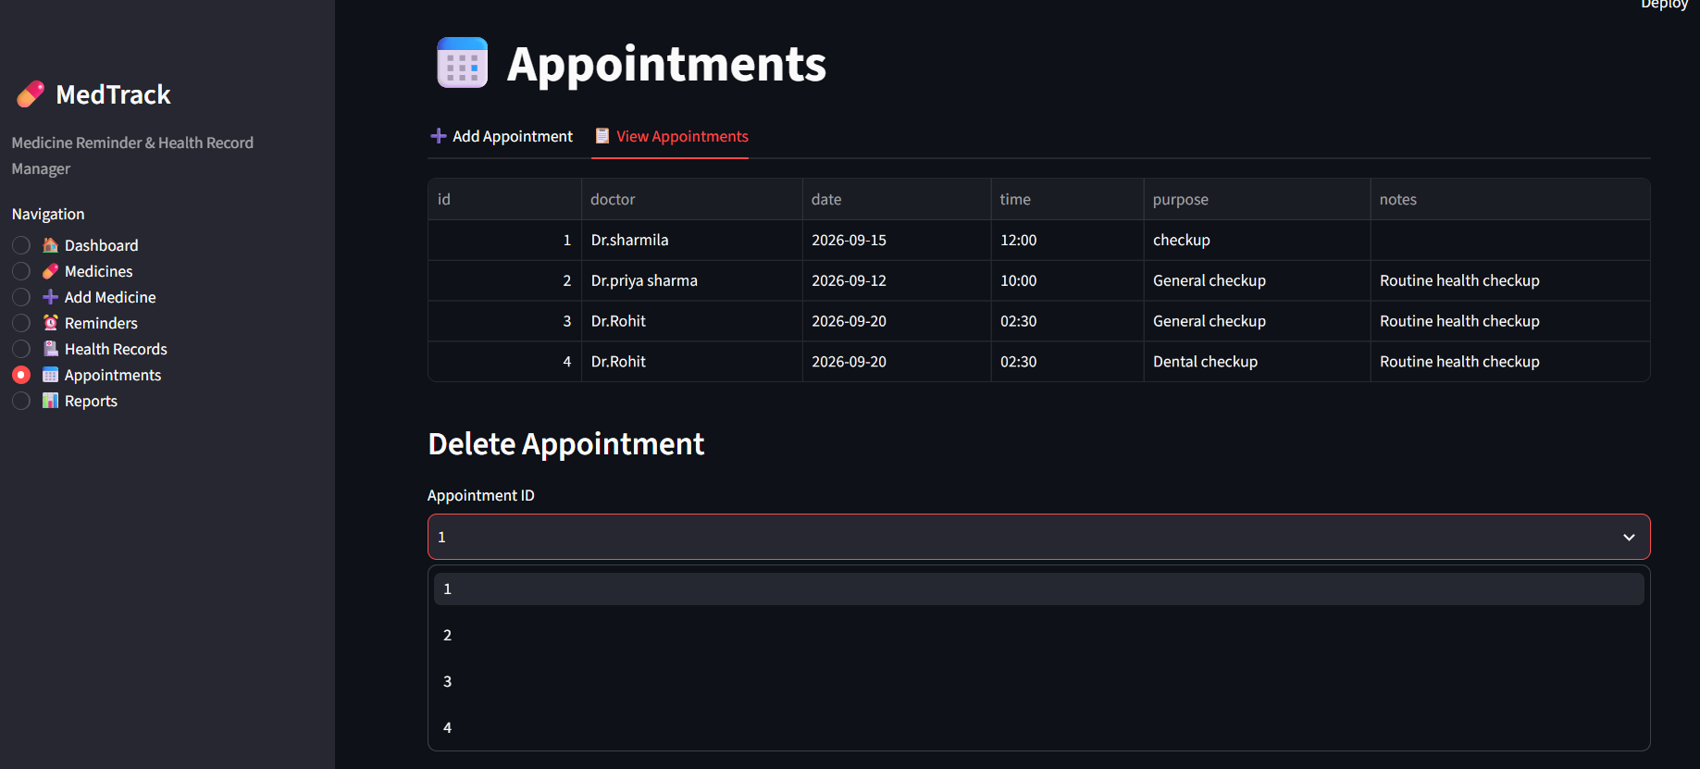
Figure 6 — Appointment Management Interface
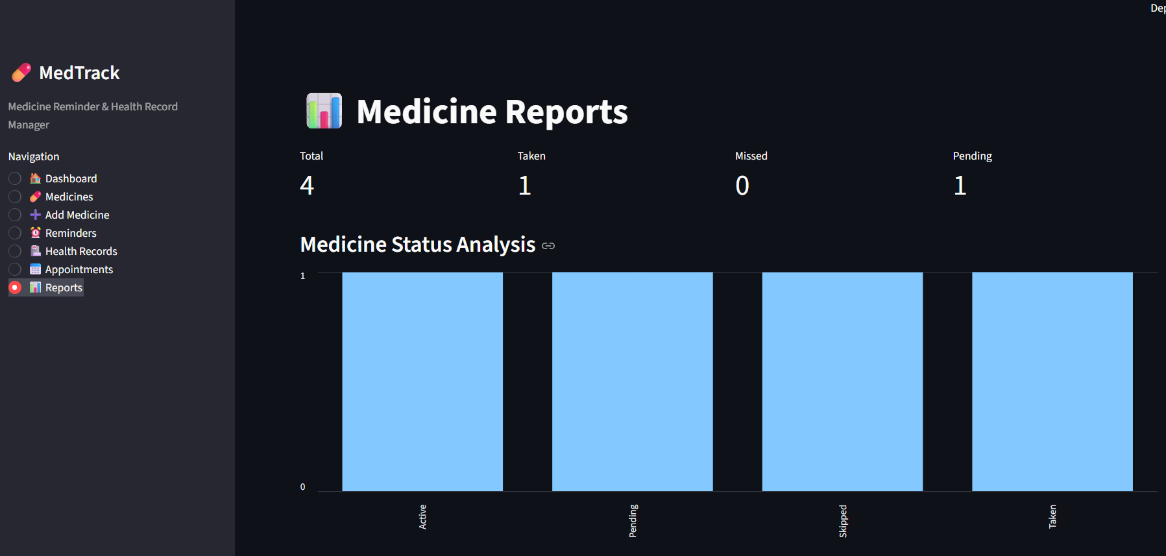
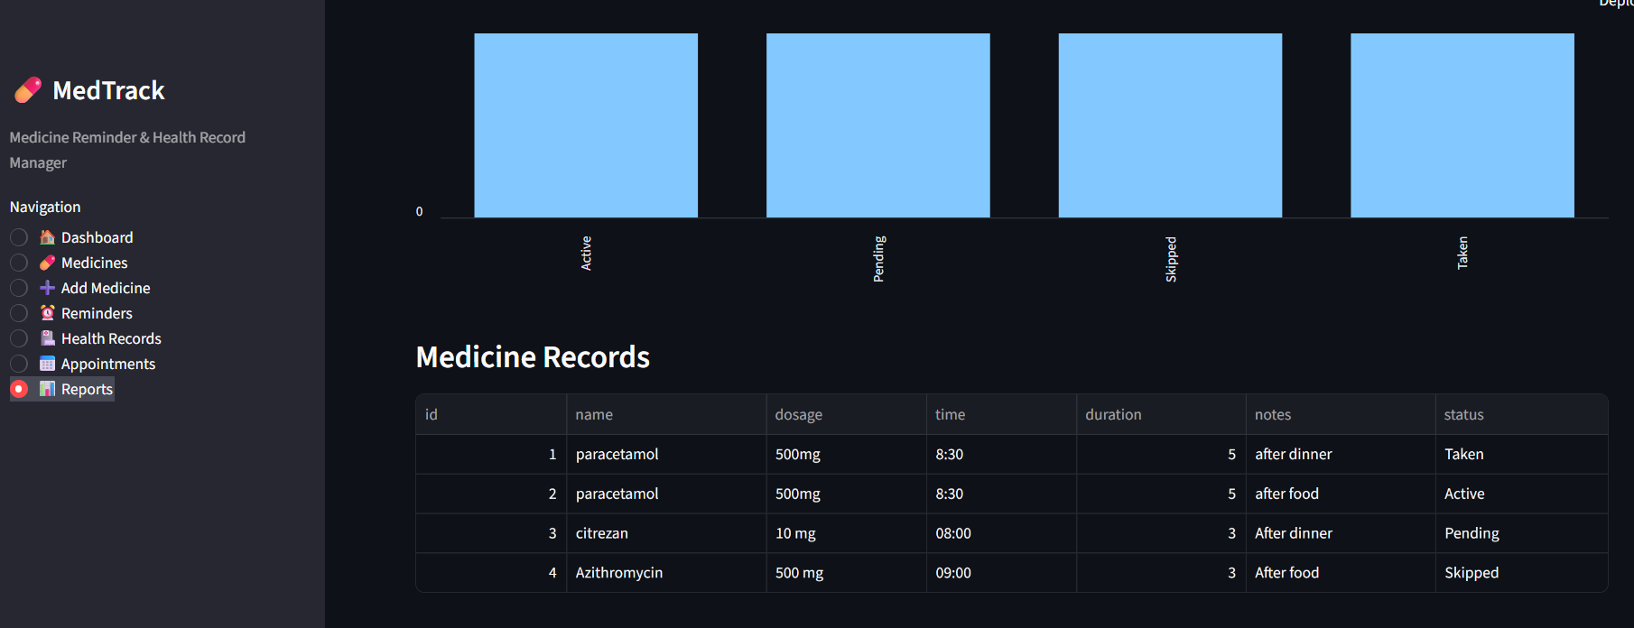
Figure 7 — Report / Summary Dashboard

14. Challenges Faced
1. Data persistence: ensuring that information remains available after closing the application.
Solution: JSON-based persistent storage.
2. Input validation: handling invalid dates, numbers, empty values, or incorrectly formatted data.
Solution: validation functions and exception handling.
3. Modular design: separating medicine, health, appointment, reminder, and UI responsibilities.
Solution: dedicated manager modules and model definitions.
4. Interface development: presenting multiple operations without making the application difficult to use.
Solution: Streamlit forms, sections, tables, status messages, and organized navigation.
5. Date and time processing: handling medicine schedules and appointment information consistently.
Solution: Python datetime functionality and validation.

15. Testing Approach
The application should be tested using unit-level and functional checks.
Unit testing examples:
• Verify medicine creation with valid data.
• Verify invalid dosage input is rejected.
• Verify JSON save and load operations.
• Verify appointment creation.
• Verify health-record storage.
Functional testing examples:
• Add a medicine and confirm it appears in the medicine list.
• Add a health record and confirm it is stored.
• Add an appointment and confirm it is displayed.
• Restart the application and verify persistent data.
• Enter invalid input and confirm a helpful error is displayed.
System testing should verify that the complete workflow from the user interface to the data layer works correctly.

16. Future Improvements
• SQLite/MySQL/PostgreSQL database integration.
• Secure user authentication and role-based access.
• Email, SMS, or desktop notifications.
• Mobile-friendly application.
• Cloud deployment.
• Advanced health and medication analytics.
• Export reports to PDF/CSV.
• Search and filtering across records.
• Calendar integration for appointments.
• AI-assisted natural-language search over stored records.
• Backup and restore functionality.
• Improved security, encryption, and audit logging.

17. Conclusion
MedTrack demonstrates how Python can be applied to build a practical, modular application for organizing medicine schedules, health records, appointments, and reminders. The project combines Python fundamentals with functions, data structures, file handling, exception handling, libraries, Object-Oriented Programming, and version control.
The system provides a strong foundation for future development. With database integration, authentication, notifications, analytics, cloud deployment, and AI-assisted features, MedTrack can be expanded into a more complete health-management platform.

