Randy Yin
Michael Schleicher
November 7, 2018
CS 4780
Project 1
Special Instructions:
To compile: javac SDES.java TripleDES.java CASCII.java Cracking.java
To run: Part 1 SDES: java SDES
Part 2 TripleSDES: java TripleDES
Part 3 Cracking: java Cracking
Part 1: SDES
Screenshot of “java SDES”:
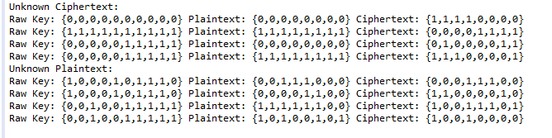
Raw Key | Plaintext | Ciphertext
0000000000 | 00000000 | 11110000
1111111111 | 11111111 | 00001111
0000011111 | 00000000 | 01000011
0000011111 | 11111111 | 11100001
1000101110 | 00111000 | 00011100
1000101110 | 00001100 | 11000010
0010011111 | 11111100 | 10011101
0010011111 | 10100101 | 10010000

Part 2: TripleSDES
Screenshot of “java TripleDES”:
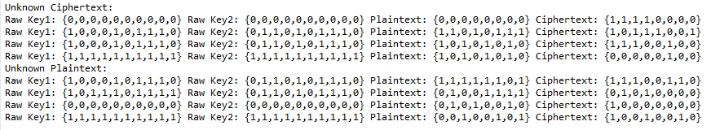
Raw Key 1 | Raw Key 2 | Plaintext | Ciphertext
0000000000 | 0000000000 | 00000000 | 11110000
1000101110 | 0110101110 | 11010111 | 10111001
1000101110 | 0110101110 | 10101010 | 11100100
1111111111 | 1111111111 | 10101010 | 00000100
1000101110 | 0110101110 | 11111101 | 11100110
1011101111 | 0110101110 | 01001111 | 01010000
0000000000 | 0000000000 | 01010010 | 10000000
1111111111 | 1111111111 | 00100101 | 10010010

Part 3 Cracking SDES and TripleSDES
Screenshot of “java Cracking”:
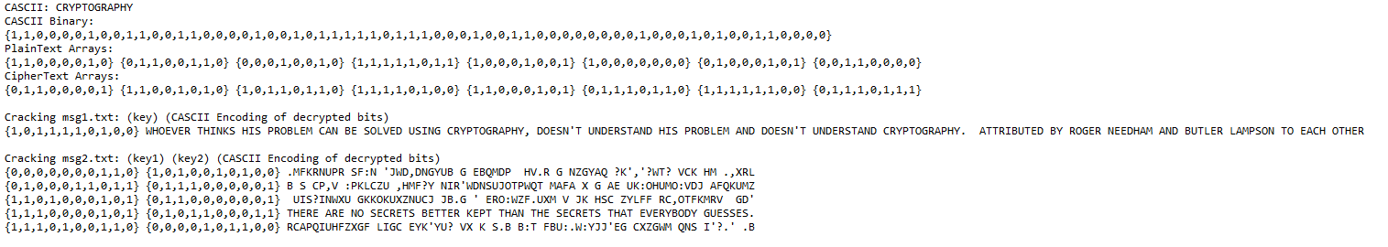
- SDES encoding of CRYPTOGRAPHY with key 0111001101:
0110000111001010101101101111010011000101011101101111110001110111
- Msg1.txt decrypted with key 1011110100 and resulting plaintext: “WHOEVER THINKS HIS PROBLEM CAN BE SOLVED USING CRYPTOGRAPHY, DOESN'T UNDERSTAND HIS PROBLEM AND DOESN'T UNDERSTAND CRYPTOGRAPHY. ATTRIBUTED BY ROGER NEEDHAM AND BUTLER LAMPSON TO EACH OTHER”
- Msg2.txt decrypted with key1: 1110000101 and key2: 0101100011 and resulting plaintext: “THERE ARE NO SECRETS BETTER KEPT THAN THE SECRETS THAT EVERYBODY GUESSES.”

