Dylan Kehres

Michael Schott

SoCialize GPS

Table of Contents:

* Introduction………………………………………………………2
* Narrative Customer Requirements ………………………………2
* Software Prescriptive Model……………………………………..3
* Use Case Diagram………………………………………………..4
* Activity Diagram………………………………………………..5-7
* Class Object Diagram……………………………………………8
* Entity Relationship Diagram……………………………………..8
* Context Data Flow Diagram……………………………………...9
* Level-0 Data Flow Diagram…………………………………...9-11
* State Transition Diagram……………………………………..12-13
* Hierarchical System Architecture Diagram………………….13-14
* GUI Functional View…………………………………………….15
* GUI Component View…………………………………………...16
* Software Architectural Model……………………………………16
* FP-Based Estimation……………………………………………..17
* LOC-Based Estimation…………………………………………..18
* Conclusion………………………………………………………..19

Introduction:

The task at hand is to create a GPS software application for mobile devices that integrates aspects of social media and promotes use through gamification. However the primary use of the application should prioritize supporting navigation above all else.

Narrative:

This software application should be supported on mobile operating systems, beginning with iOS and Android and, should funds permit, other mobile operating systems as well. There is no need for this application to be integrated with PC operating systems such as Windows. The application should have internet capabilities and must have access to the User’s location in order to operate. It is to be written in JavaScript.

As stated previously, the main function is Navigation; followed by being able to view maps, find locations, adding and removing friends, leaving feedback at visited locations, challenging and adding rivals (users with similar scores in local proximity), saving frequented locations, viewing leaderboards, obtaining achievements, editing account settings, and viewing friends’ locations on a map.

The system will require internet connectivity and the mobile devices using the system must have a GPS unit. This project is estimated to take between 112 and 124 man months. The budget provided is set at $1,000,000.00.

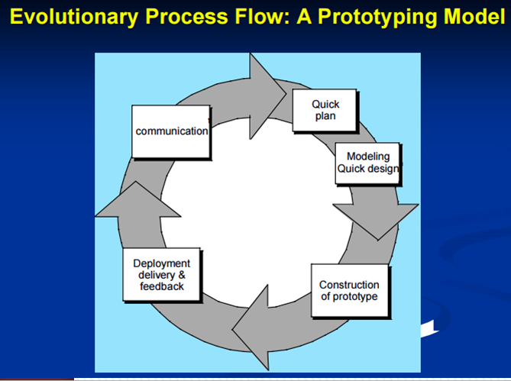Software Engineering Prescriptive Model:

* Our software is blending social media and GPS navigation with a gaming aspect; therefore it is critical that the User is enjoying the product.
* Users will be able to provide us with important feedback on aspects of our application such as the GUI; which is critical as our application must be user friendly.
* Users will also be able to let us know what features need to be added in future updates of the application that will enhance the User’s experience.

Use Case Diagram:

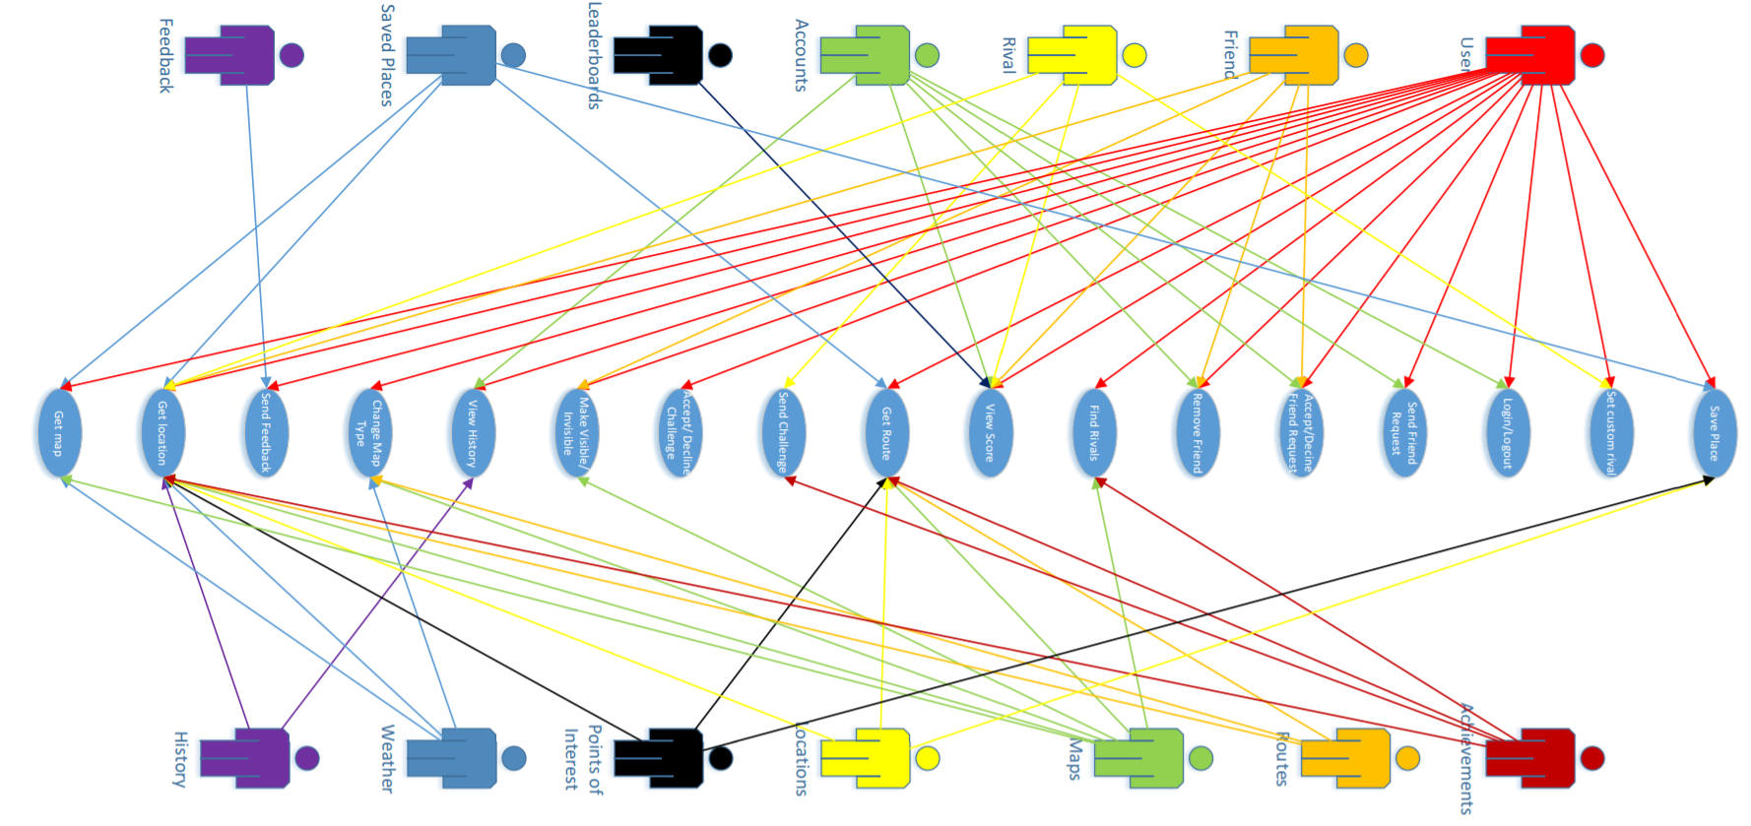

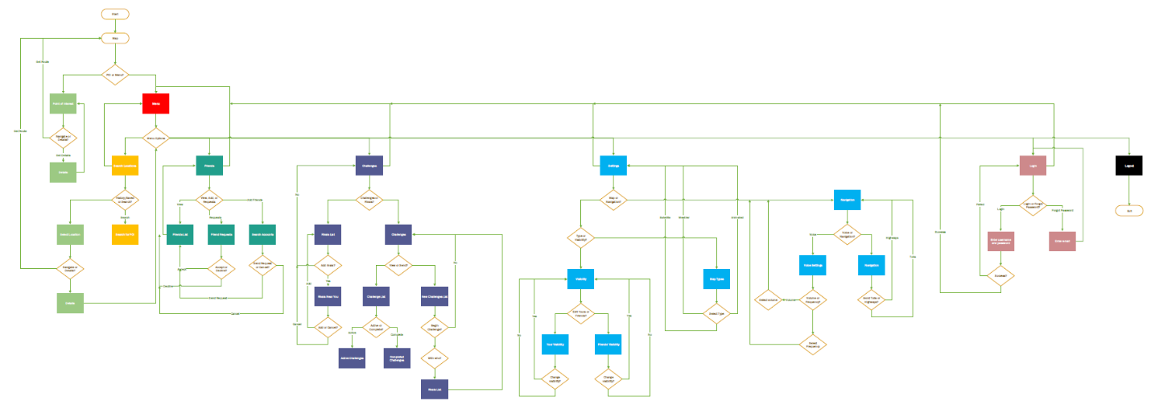Activity Diagram:

Points of interest and Menu:

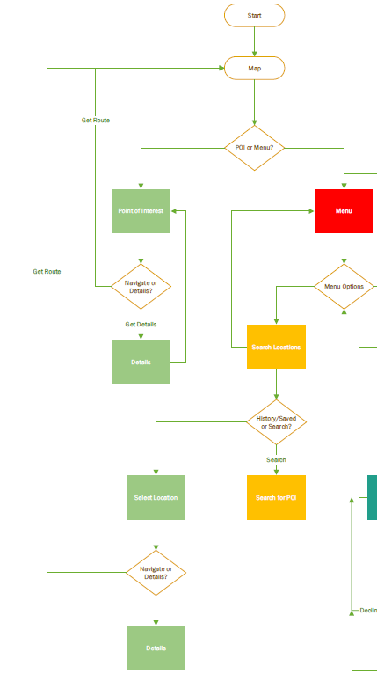

Friends:

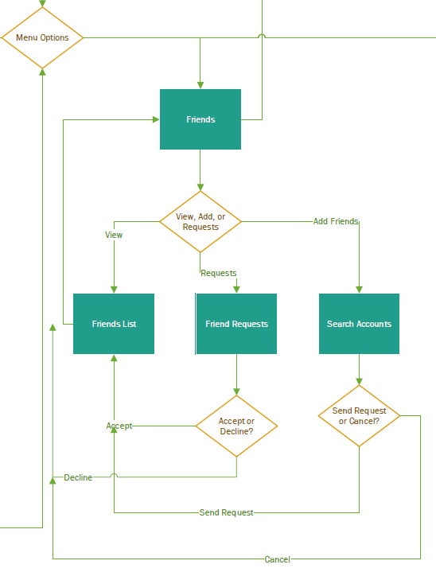

Challenges:

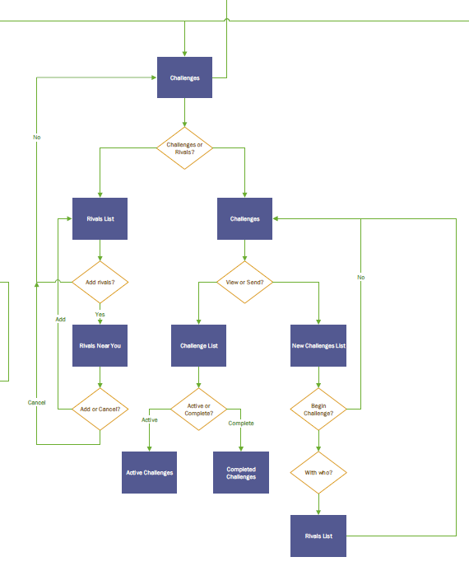

Settings:

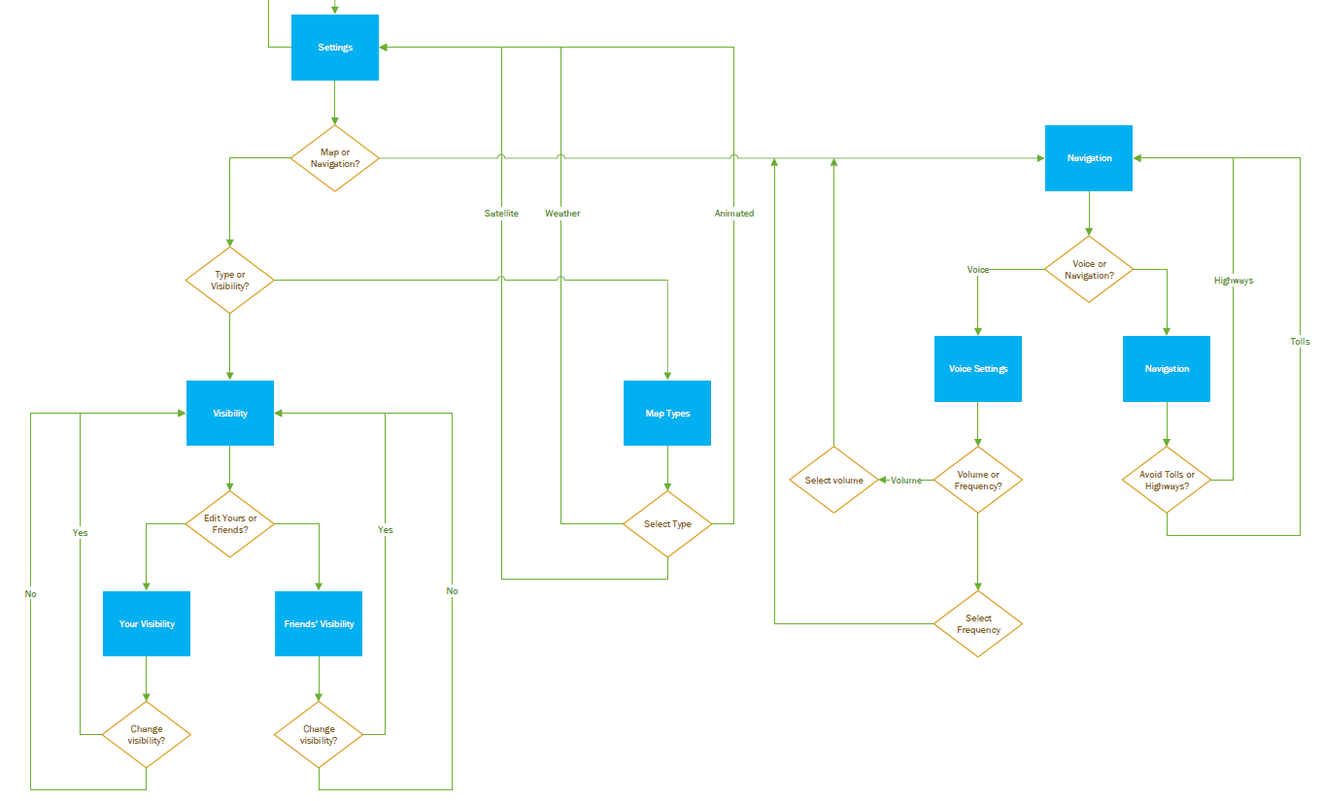

Login and Logout:

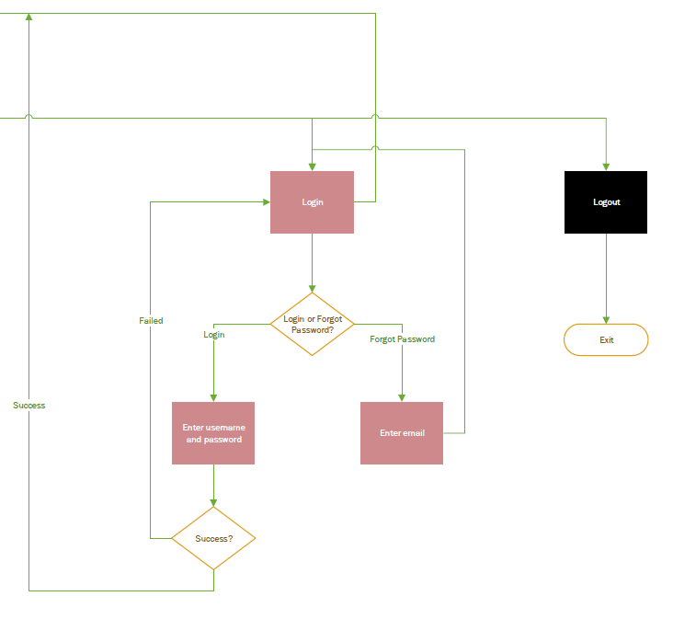

Class Object Diagram:

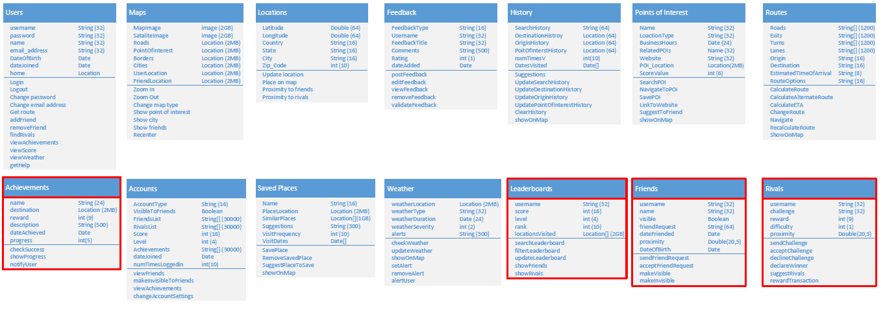

Optional Entity Relationship Diagram:

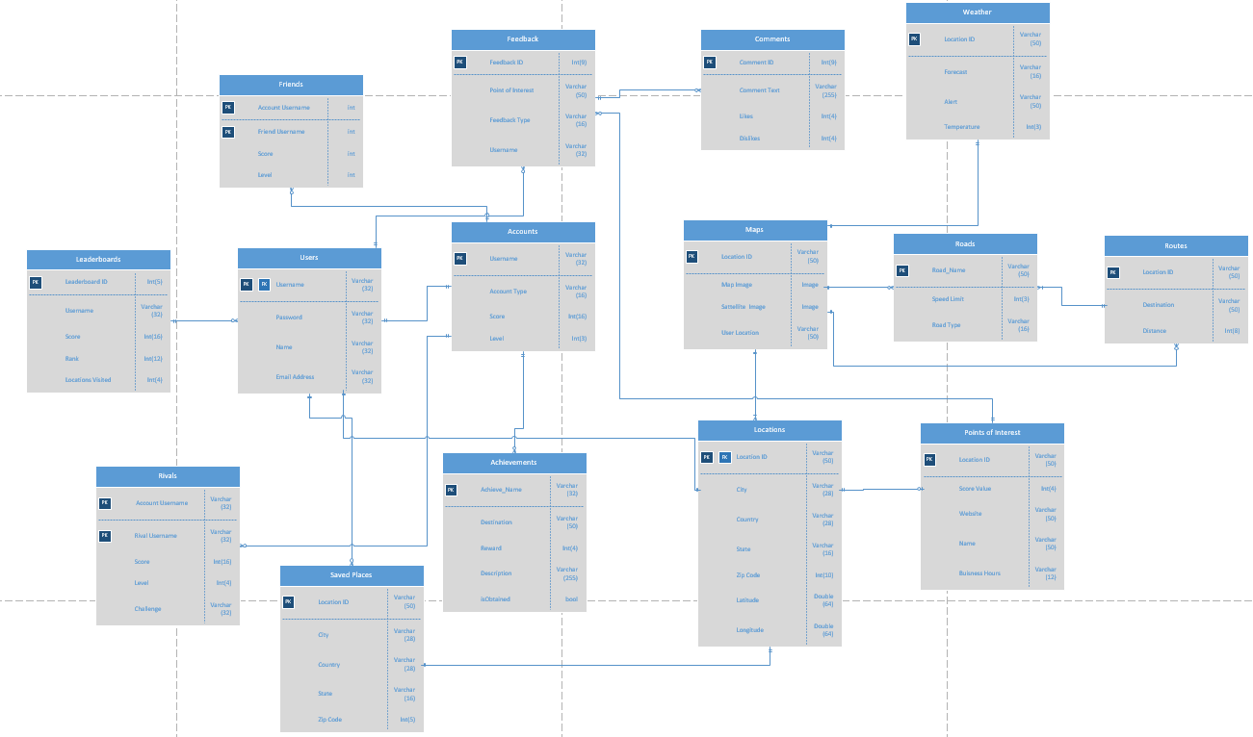

Context Data Flow Diagram:

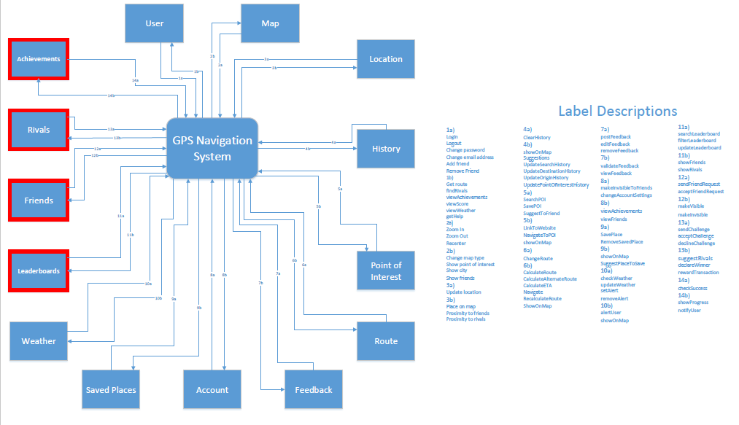

Level-0 Data Flow Diagram:

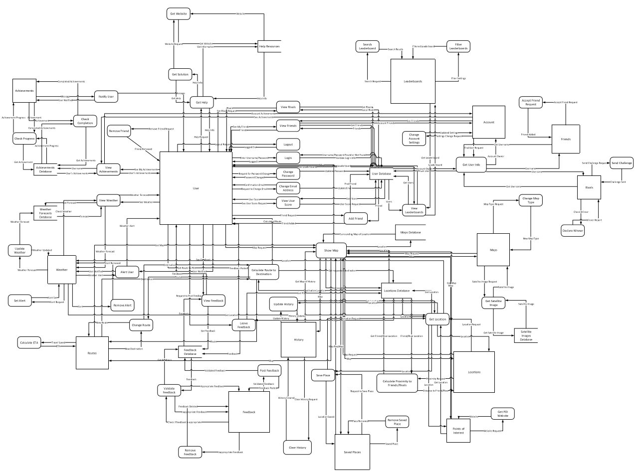

User and Achievements COs: 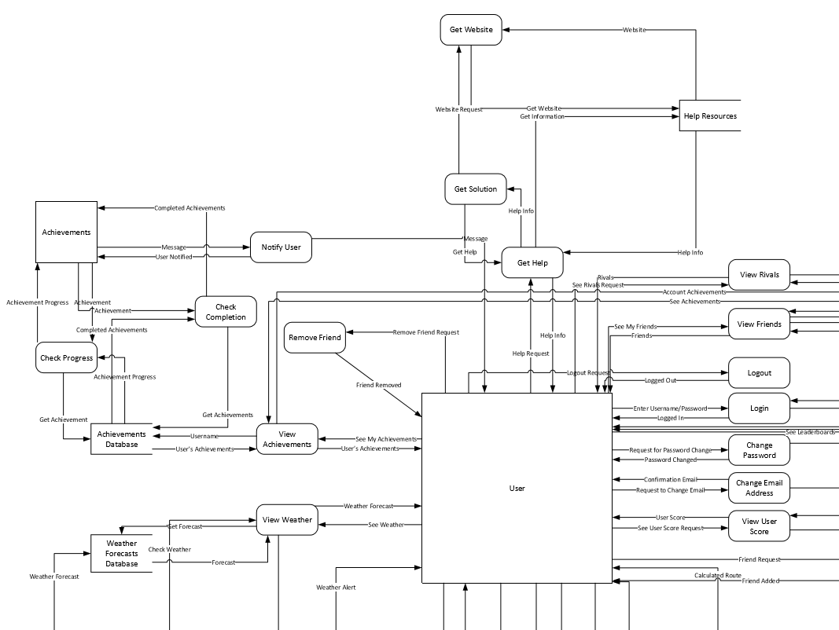

Leaderboards, Account, Maps: 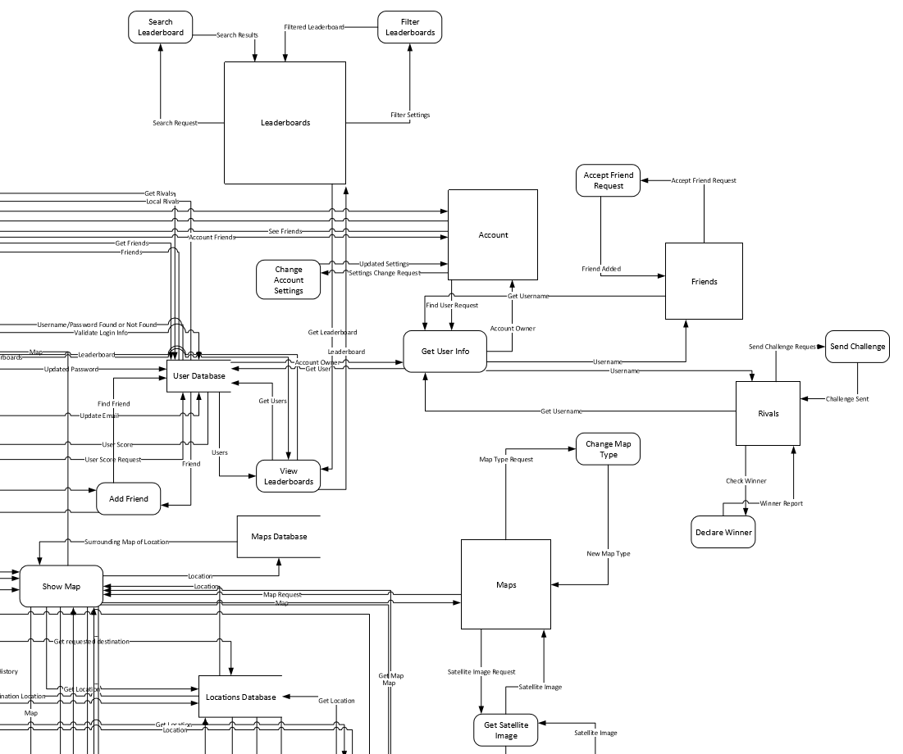

Weather, Routes, and Feedback: 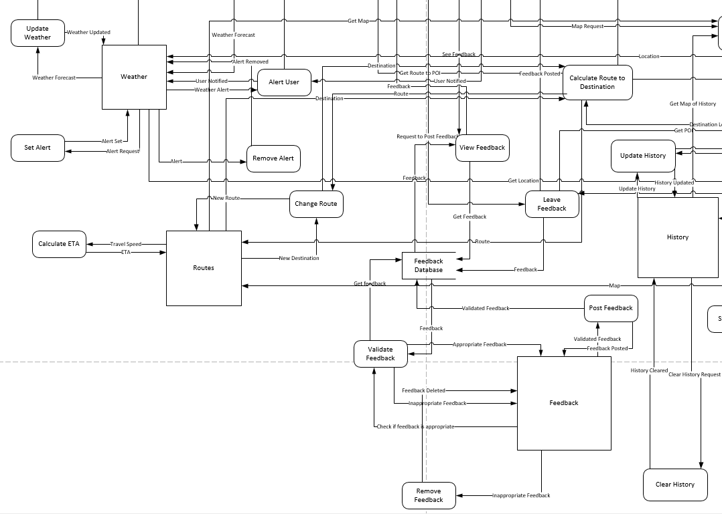

History, Saved Places, Locations: 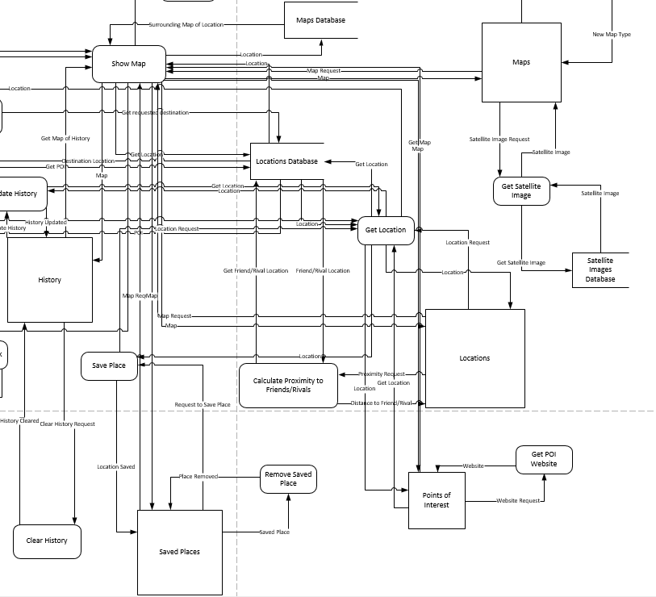

State Transition Diagram: 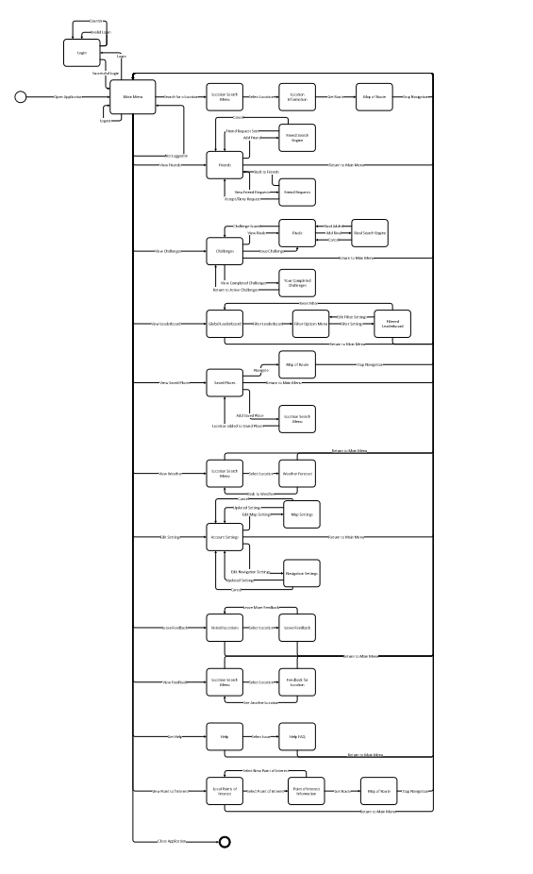

Login, Friends, and Locations: 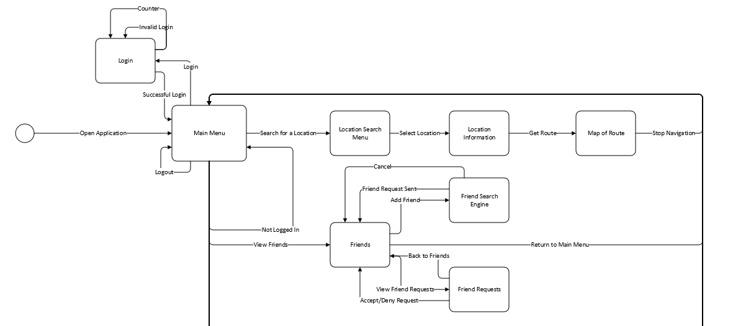

Challenges, Rivals, Leaderboards, and Saved Places: 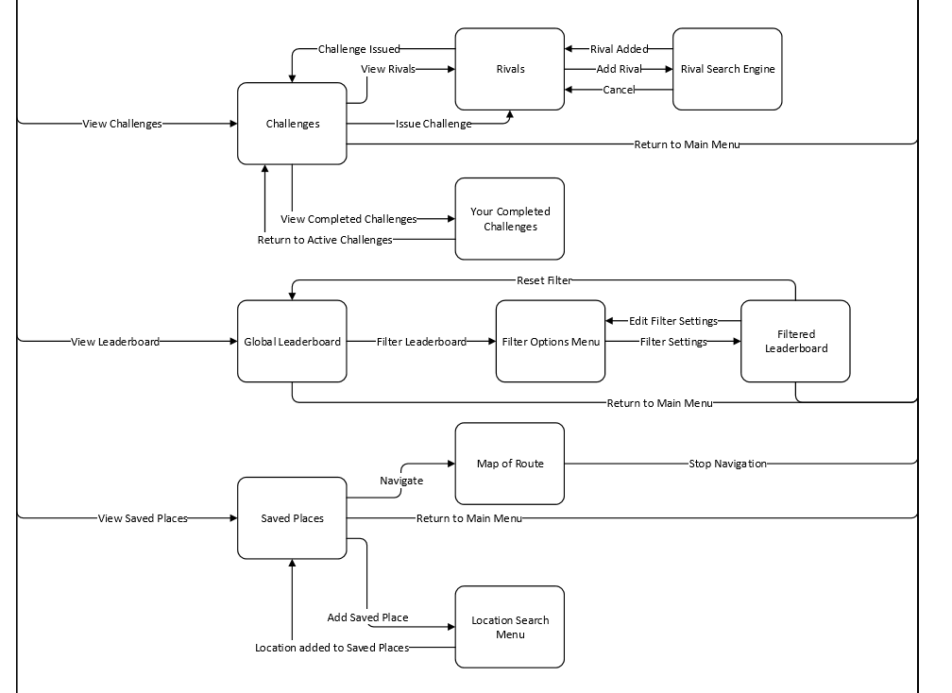

Weather and Account Settings: 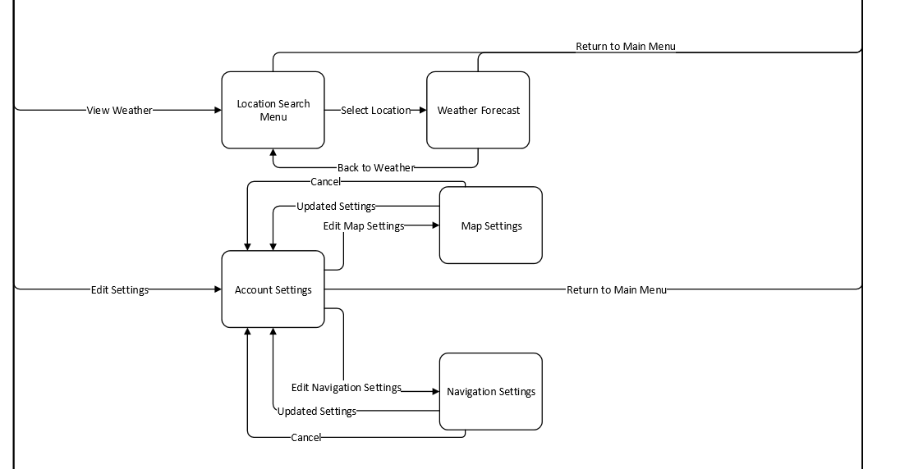

Feedback, Help, Points of Interest, and Close Application: 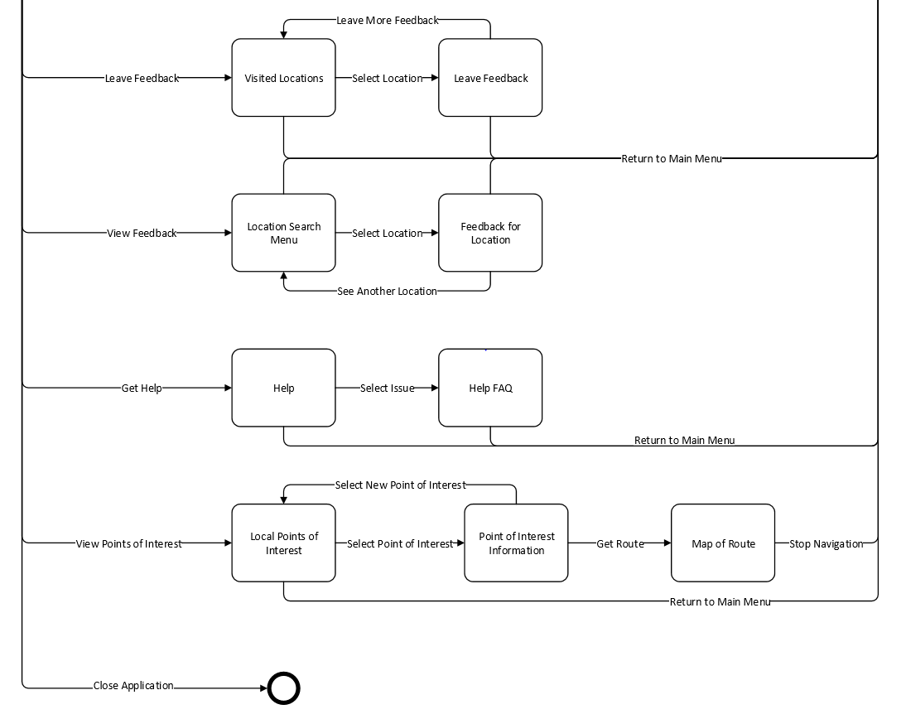

Hierarchical System Architecture Model: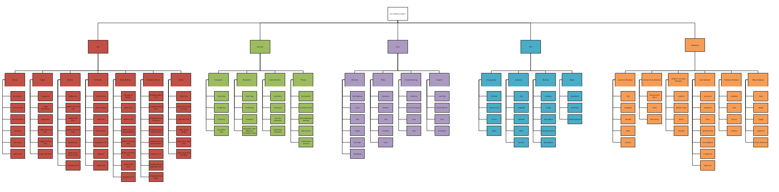

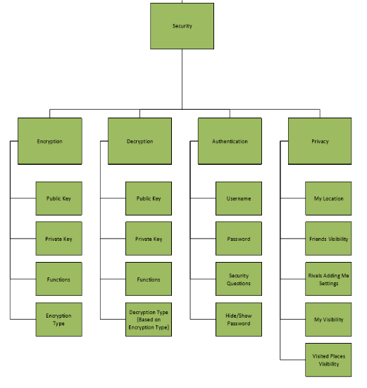GUI and Security Subsystems: 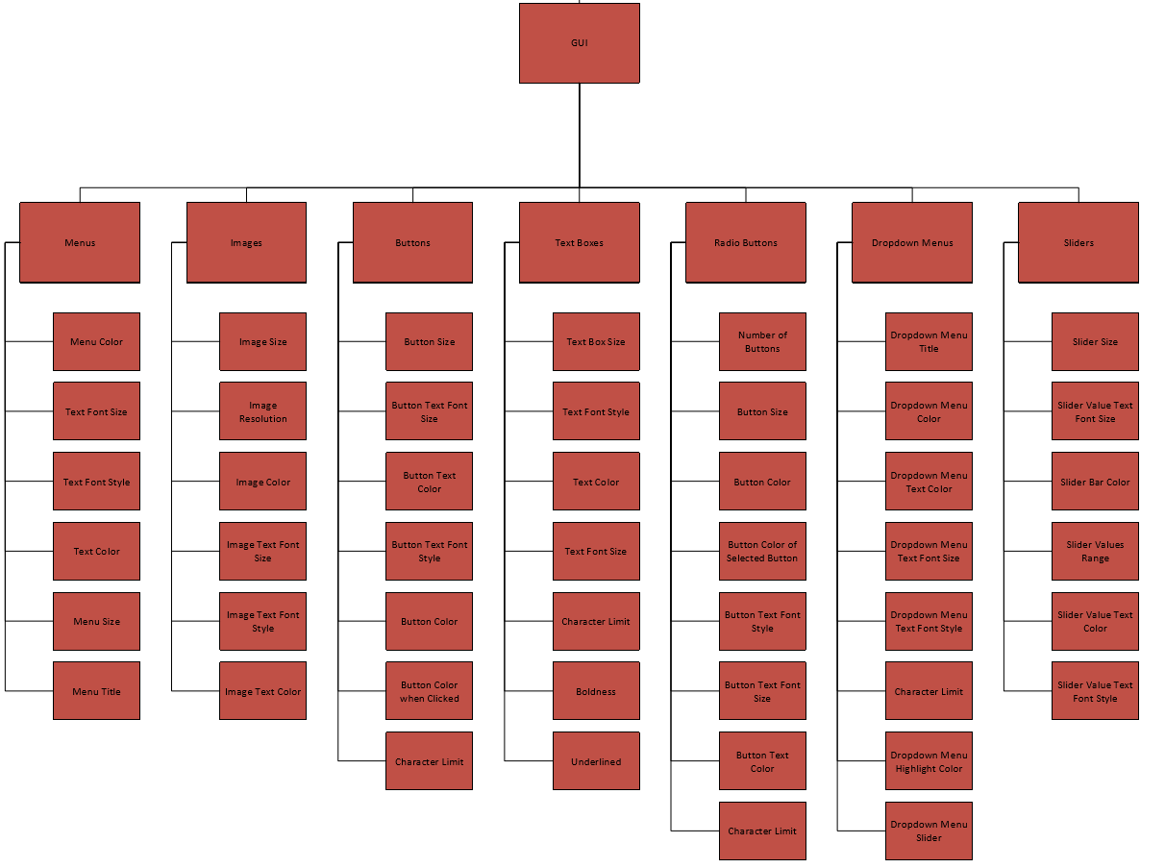

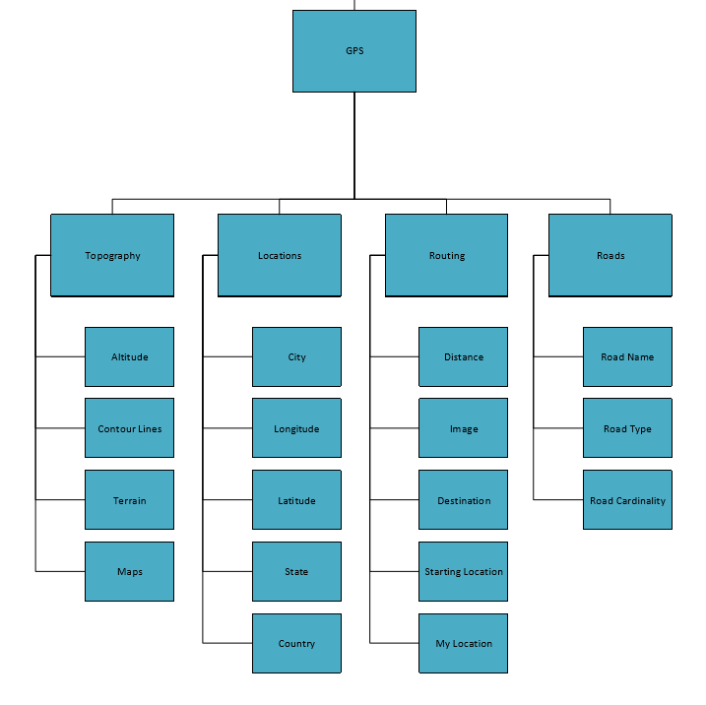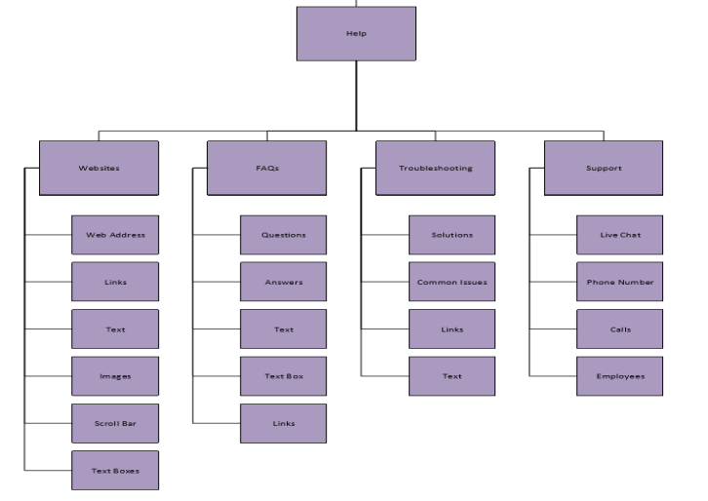Help and GPS Subsystems:

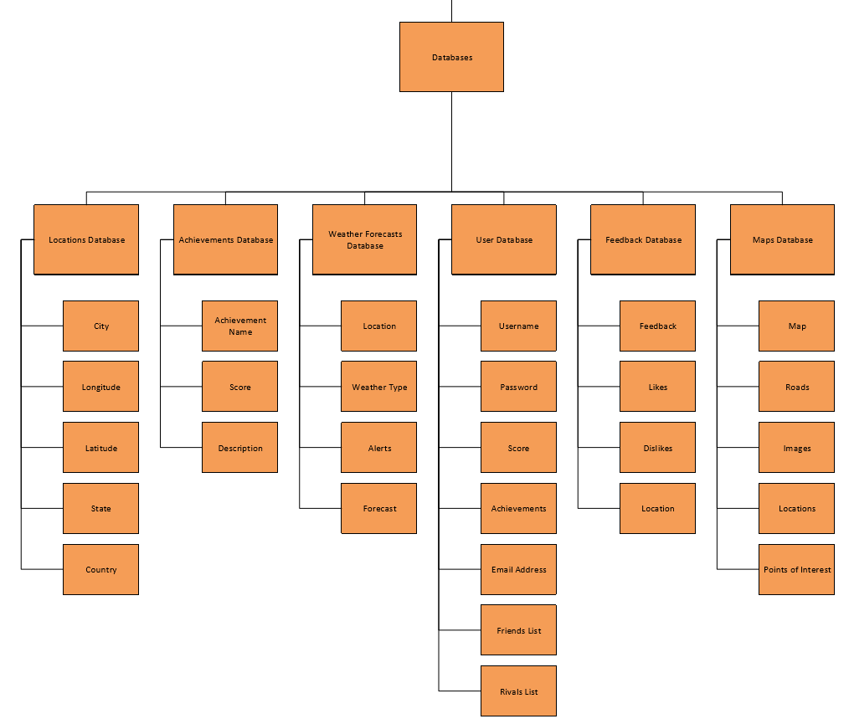Databases Subsystem:

GUI Functional View:

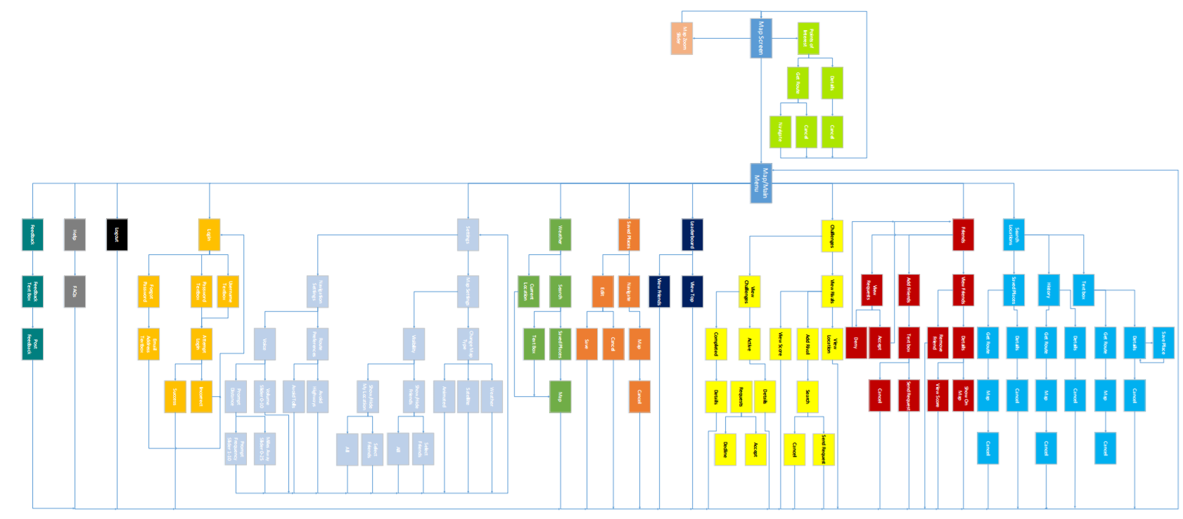

GUI Component View:

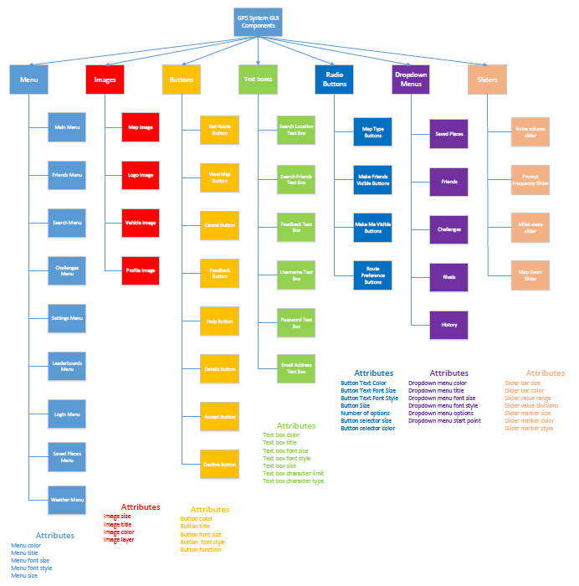

Software Architectural Model:

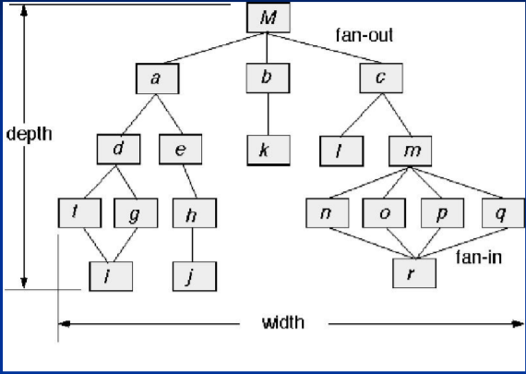Call and Return Model

* User inputs address to obtain route which is then passed into a subfunction.
* User searches for locations or friends in a data base, and that data is then handled by sub functions.

FP- Based Estimation:

|  |  |  |  |  |  |  |
| --- | --- | --- | --- | --- | --- | --- |
| Information Domain Value | Optimal | Most Likely | Pessimistic Estimation | Estimated Count | Weight | FP-Count |
| Number of inputs | 45 | 60 | 75 | 60 | 4 | 240 |
| Number of outputs | 35 | 50 | 80 | 50 | 8 | 400 |
| Number of inquiries | 10 | 15 | 25 | 15 | 3 | 45 |
| Number of files | 8 | 12 | 18 | 12 | 6 | 72 |
| Number of external interfaces | 4 | 6 | 8 | 6 | 8 | 48 |
| Total |  |  |  |  |  | 805 |

Number of Function Points: 805

Average productivity: 6.5 FP/month

Burdened Labor Rate: $8000/month

The project will take 124 man months and cost $992,000 to produce.

LOC-Based Estimation:

|  |  |
| --- | --- |
| Function System | Estimated LOC |
| User Interface | 5,000 |
| Route Calculation | 35,000 |
| Location Calculation | 20,000 |
| Database Management | 10,000 |
| Gamification | 10,000 |
| Total Estimate | 70,000 |

Lines of code: 70,000

Average productivity: 620 LOC/month

Burdened Labor Rate: $8000/month

The project will take 113 man months and cost $904,000 to produce.

Conclusion:

To summarize, we need a software system with an emphasis on Navigational capabilities that intertwines aspects of today’s Social Media applications while also integrating a form of gamification. We should enable the User to get from point A to point B in an enjoyable and user-friendly way that promotes adventurous activity. This project has a budget of $1,000,000 and should be completed between 112-124 man months.