7. Configuration Management
Report section prepared by Member 4 — Md Sharior Omar Fahim (63909), GitHub & Configuration Management.
Section number 7 follows Member 3's Risk & Issue Management section (Section 6).

7.1 Configuration Management Overview
Configuration management (CM) is the discipline of tracking and controlling changes to project deliverables, documentation, and any other project artifacts throughout the project lifecycle. For the LMS project, CM ensures that all project documents, design files, and reports are stored securely, that changes are tracked with a full history of who changed what and when, and that team members can collaborate without overwriting one another's work.
The primary CM tool selected for this project is GitHub, a cloud-based platform built on the Git version-control system. GitHub provides repository hosting, commit history, branching, and collaboration features that together satisfy the configuration-management requirements of the project.

7.2 Configuration Management Process
The CM process followed in this project consists of the following steps:
- Repository Setup — A central GitHub repository (LMS-Project-Plan) was created to
host all project artifacts.
- Folder Organisation — Deliverables were organised into member-specific folders
under a docs/ directory for traceability.
- Version Tracking — Every change is recorded as a Git commit with a descriptive
message, timestamp, and author identity, creating a complete audit trail.
- Branching Strategy — Feature branches (for example, feature/cm-documentation) were
used to develop documentation in isolation before merging into the main branch, preventing incomplete work from affecting the baseline.
- Change Control — All changes to the repository are visible in the commit history.
Any file modification, addition, or deletion is logged permanently.
- Backup and Redundancy — The repository exists both locally (on team members'
machines) and remotely (on GitHub's servers), providing redundancy against data loss.

7.3 Repository Structure
LMS-Project-Plan/
├── README.md
├── .gitignore
├── docs/
│ ├── member1-introduction/
│ │ └── Member1.pdf
│ ├── member2-planning/
│ │ └── Member2.pdf
│ ├── member3-risk-management/
│ │ └── Member3.docx
│ ├── member4-configuration-management/
│ │ └── configuration-management-section.md
│ └── member5-final-report/
└── screenshots/
├── 01-repo-creation.png
├── 02-folder-structure.png
└── ...

7.4 Version Control Evidence
Table 7.1 summarises the key commits made while building the repository. The full, authoritative history is available on GitHub under the repository's *Commits* tab, and can be reproduced locally with git log --oneline --graph.
Table 7.1 — Key commits
# | Date | Branch | Commit message | Files changed
1 | 30 May 2026 | main | Initialize repository structure and .gitignore | .gitignore, folder placeholders
2 | 30 May 2026 | main | Add member deliverables: Introduction, Planning, and Risk Management | Member1.pdf, Member2.pdf, Member3.docx
3 | 30 May 2026 | main | Add project README with overview, team roles, and structure | README.md
4 | 30 May 2026 | feature/cm-documentation | Add configuration management section (Section 7) — initial draft | configuration-management-section.md
5 | 30 May 2026 | feature/cm-documentation | Expand CM section with evidence table, tools, and benefits | configuration-management-section.md
6 | 30 May 2026 | main | Merge branch 'feature/cm-documentation' | (merge)
7 | 30 May 2026 | main | Add screenshots guide for version-control evidence | screenshots/README.md
8 | 30 May 2026 | main | Update README to link the configuration management section | README.md
The repository also demonstrates branching and merging: the configuration-management documentation was developed on the feature/cm-documentation branch and then merged back into main with a non-fast-forward merge, so the branch history is preserved in the graph.

7.5 Tools Used for Configuration Management
Table 7.2 — CM tools
Tool | Purpose
Git | Local version control — tracking file changes, creating commits and branches
GitHub | Remote repository hosting — cloud storage, collaboration, and commit-history visualisation
Git Bash / Terminal | Command-line interface for executing Git commands

7.6 Benefits of Using GitHub for This Project
- Traceability — Every change is permanently logged with author, date, and description.
- Collaboration — Multiple team members can work simultaneously without conflicts.
- Backup — The repository is stored both locally and in the cloud.
- Accountability — Each commit is attributed to a specific team member.
- Rollback capability — Any previous version of any file can be restored if needed.

7.7 Screenshots
The screenshots listed below are stored in the repository's screenshots/ folder and should be inserted here as figures. (See screenshots/README.md for the capture guide.)
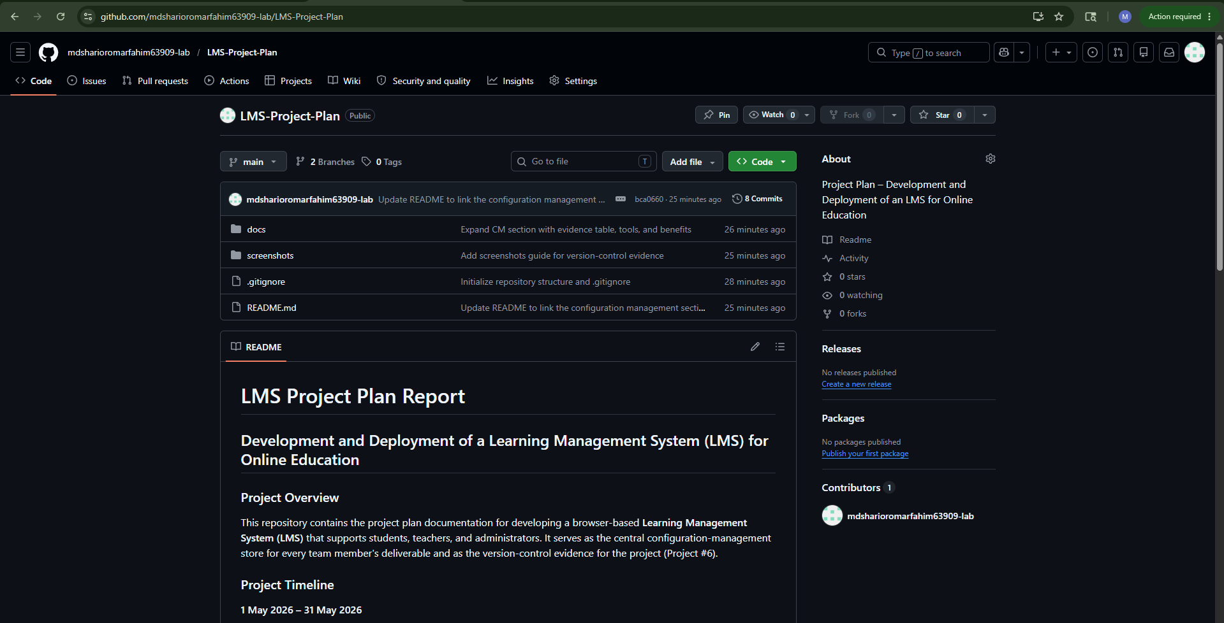
Figure 7.1 — GitHub repository main page
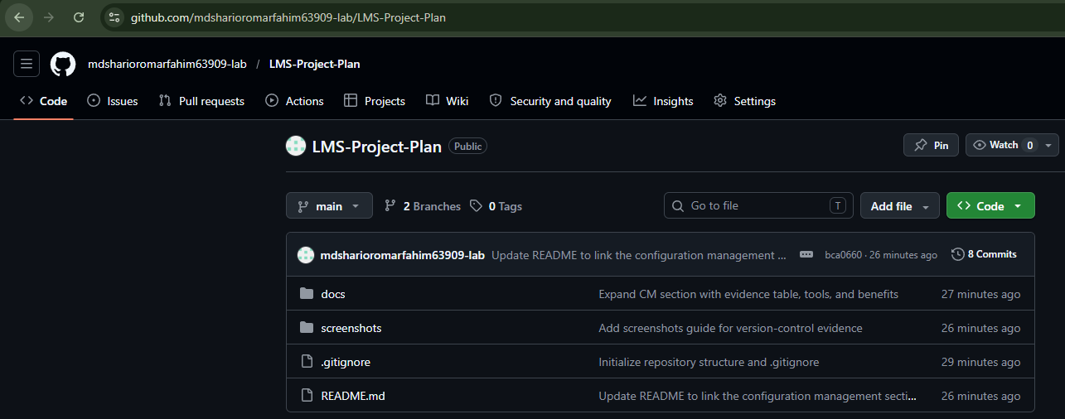
Figure 7.2 — Folder structure in the repository
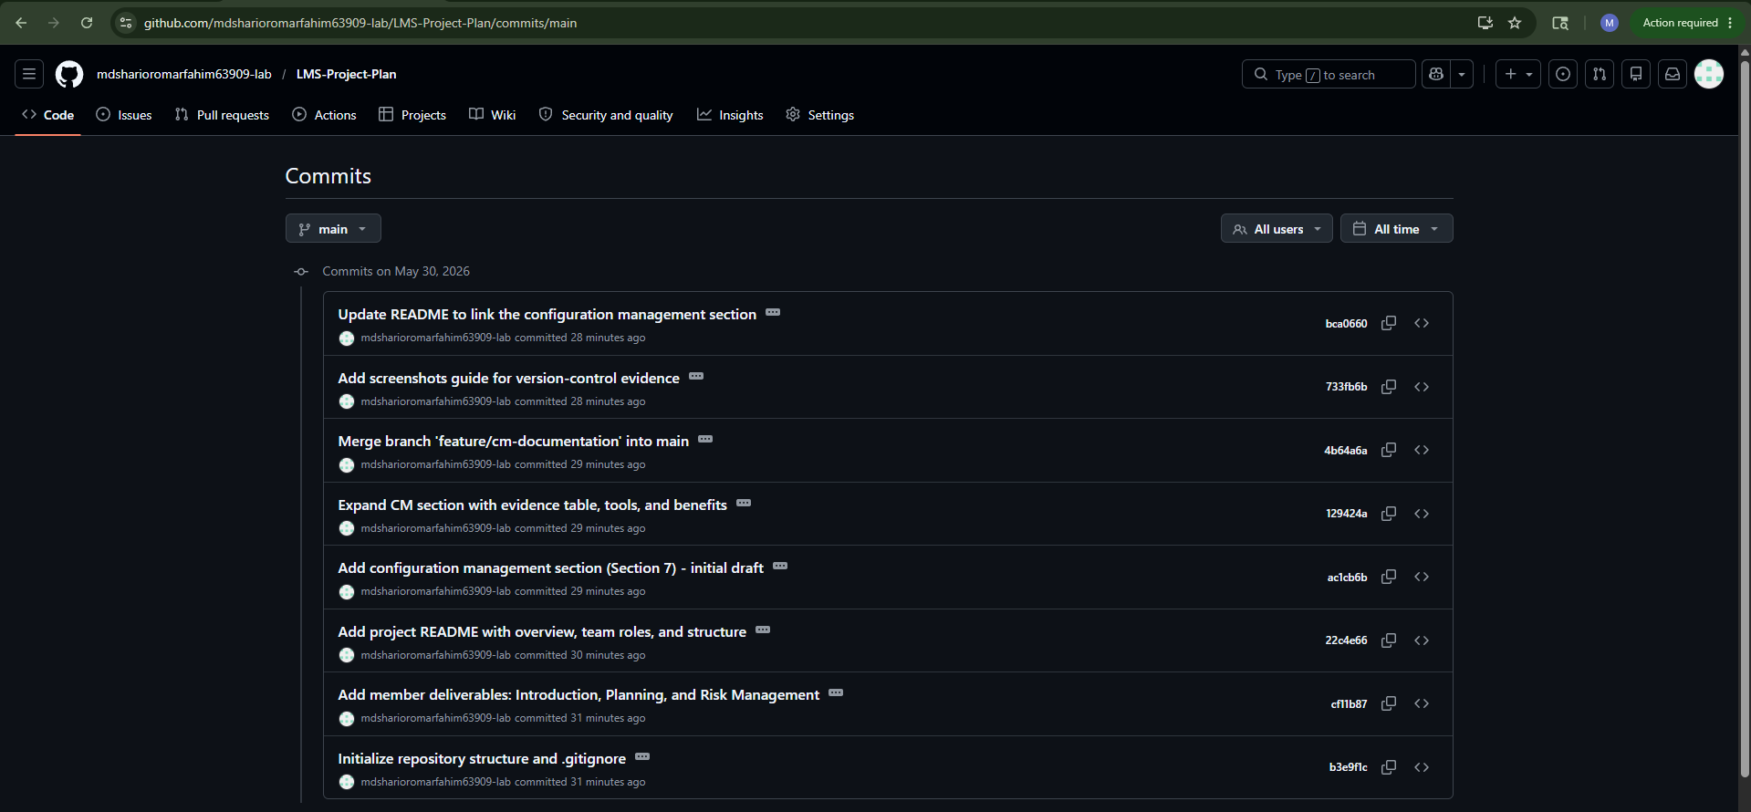
Figure 7.3 — Commit history showing multiple commits
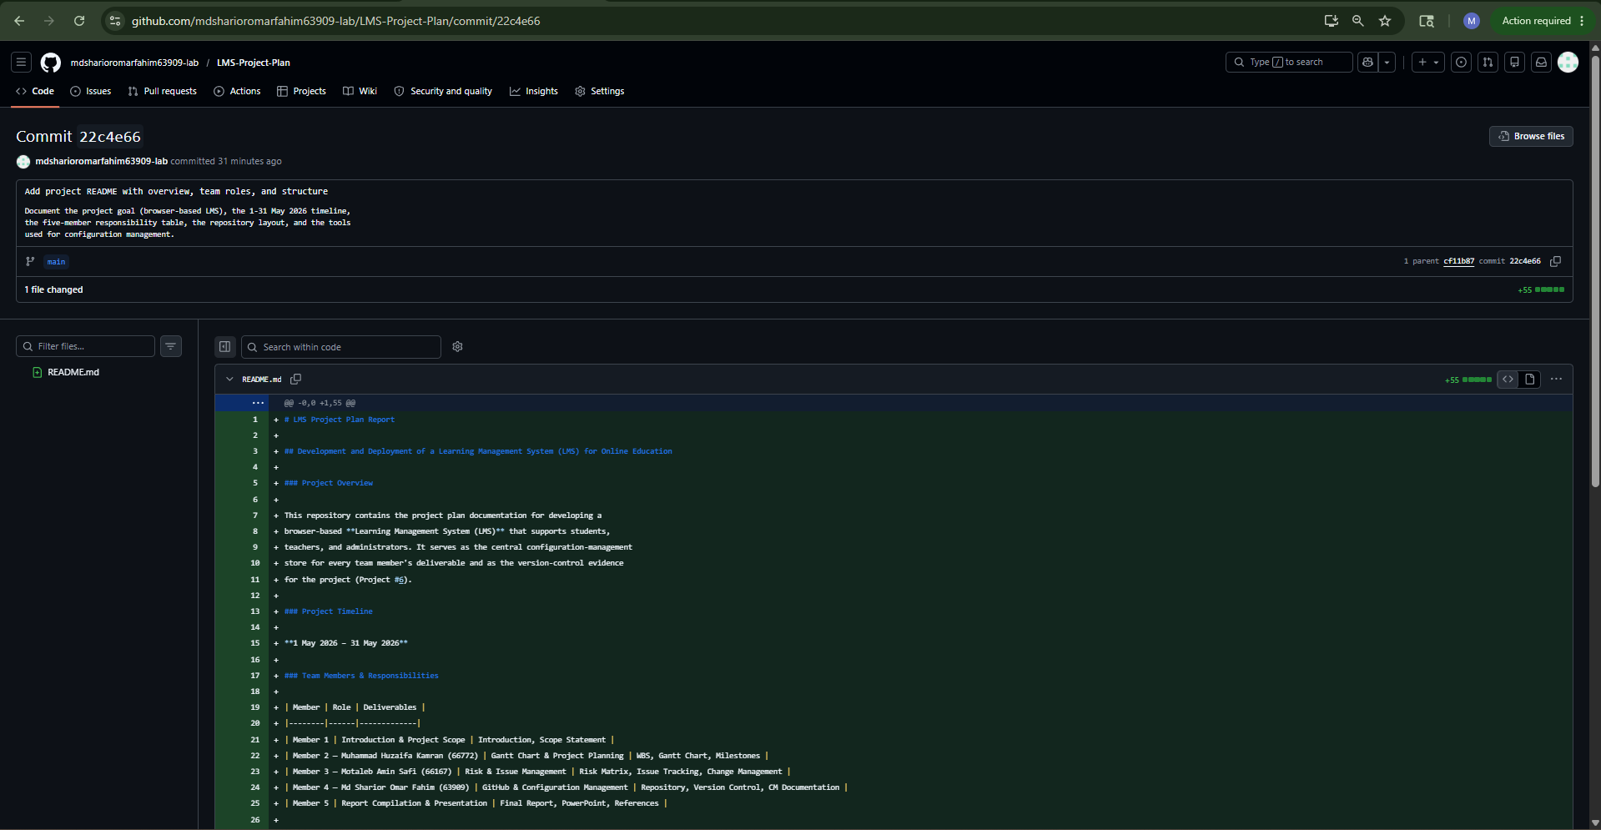
Figure 7.4 — Commit detail showing file changes / diff view
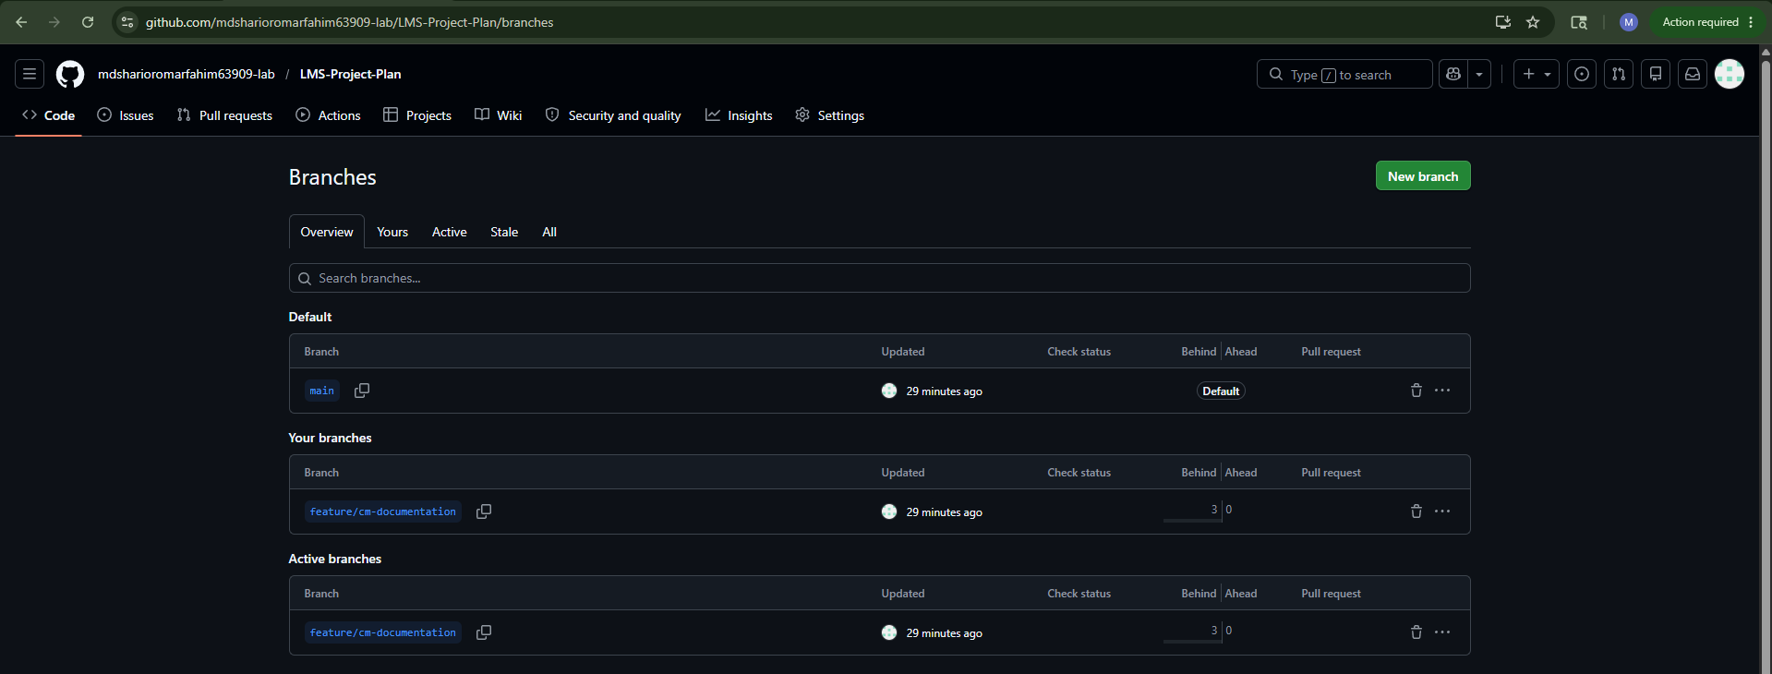
Figure 7.5 — Branch usage evidence
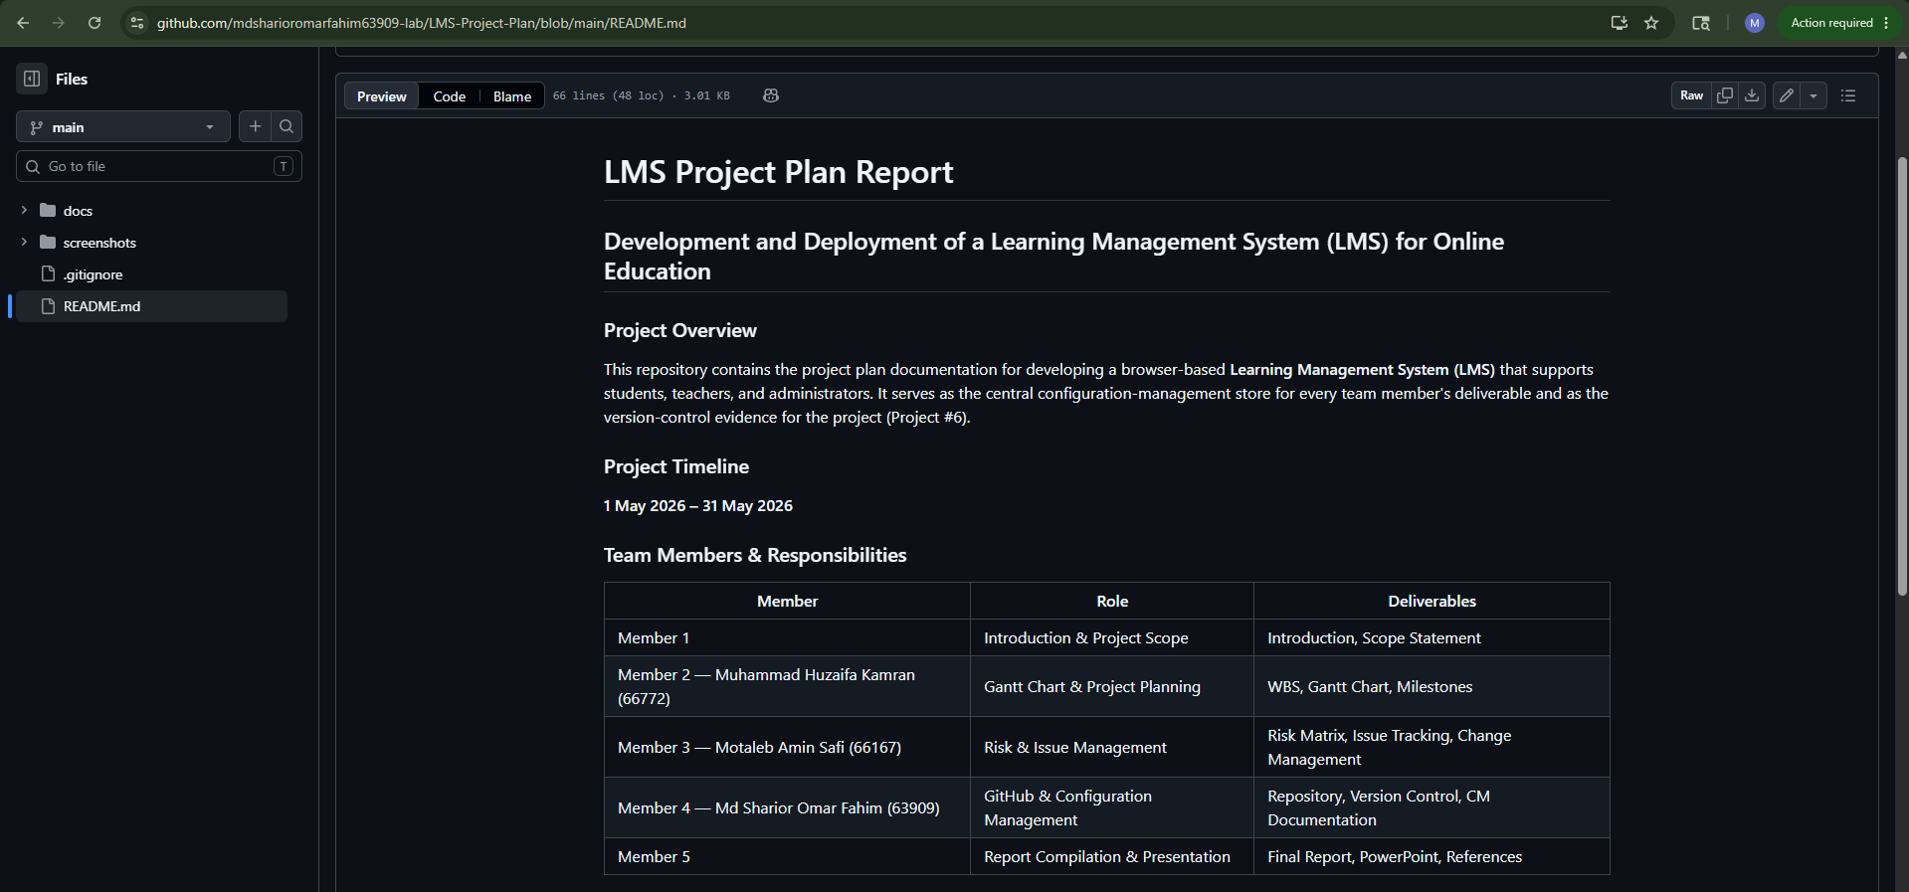
Figure 7.6 — README rendered on GitHub
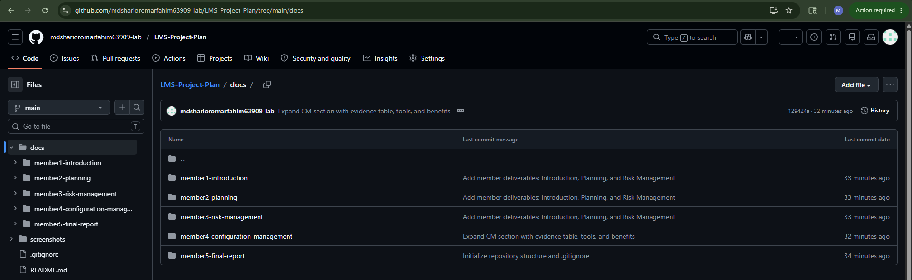
Figure 7.7 — Member files visible inside docs/
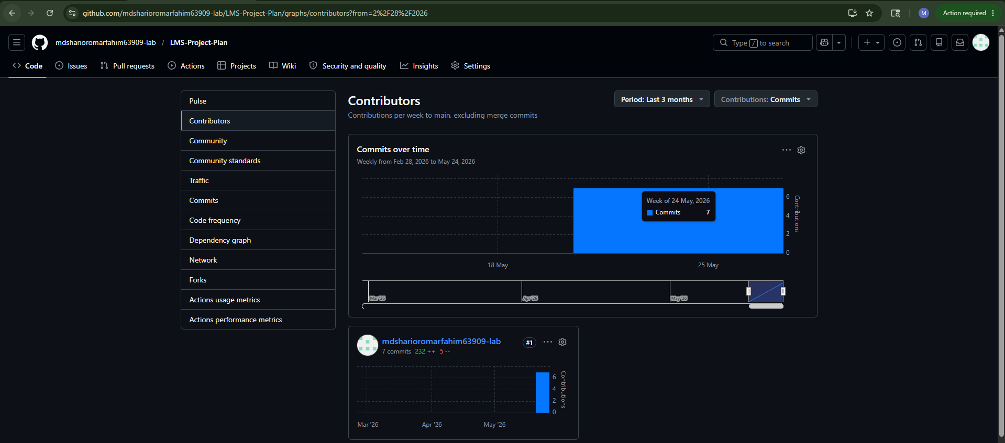
Figure 7.8 — Contributor activity

