SPR with Mo
Students Performance Report
Teacher's Operation Manual
A simple guide for teachers, written in plain English
Website: https://my-spr-with-mo.duckdns.org/
Designed for teachers, by a teacher — Mohammed Shehzad Khan (Teacher Mo)
Manual version 1.1 · October 2026

Contents
- 1. About this manual
- 2. What is SPR with Mo?
- 3. Before you start
- 4. First time on this computer — create your sign-in
- 5. Sign in on another day
- 6. Get to know the main screen
- 7. The sample class (Demo School) — only if you ask for it
- 8. Dashboard — your class at a glance
- 9. Students — your class list
- 10. Enter scores — typing in marks
- 11. Grading — how grades are calculated
- 12. Analysis — comparing and understanding progress
- 13. Report Cards — printing student reports
- 14. Manage & setup — classes, students and settings
- 15. Backups, Excel import and export
- 16. Share & sync — two teachers, one class
- 17. Privacy and safety
- 18. Words used in this app (glossary)
- 19. Common questions
- 20. Quick reference card

1. About this manual
This manual explains how to use the SPR with Mo website, step by step. It is written in simple English. You do not need to be good with computers to use this app.
How to read this manual:
- A step that looks like this: “Click Dashboard” means: move your mouse pointer onto the word Dashboard and click the left mouse button once.
- Words written in this style (for example Enter scores) are buttons or menu names you will see on the screen.
- Every part of the app has a picture (screenshot) so you can check that you are in the right place.
- The pictures in this manual were taken with the app's optional sample class (loaded via “Load sample data”), so your screen may show different names.
TIP: You can also use this app on a tablet or a large phone. The pictures show a computer screen, but the buttons are the same.

2. What is SPR with Mo?
SPR (Students Performance Report) is a free website for English teachers. It keeps all your students' marks in one place, works out the averages and grades for you, and prints clean report cards for parents.
With SPR with Mo you can:
- Keep a list of your students (Chinese name, English name, gender, student ID).
- Type weekly and monthly marks: listening, speaking, reading, writing, spelling, daily assignments and tests.
- See automatic averages, grades (A* to U) and colour warnings (red / amber / green).
- Compare semesters and see which students are improving.
- Print or save professional report cards for each student, and a class report.
- Move your data in and out of Microsoft Excel.
- Share one class with a co-teacher, safely.
- Use it offline — after the first visit it also works without internet.
TIP: Your data is private. It is saved inside your own browser on your own computer, locked with your password. There is no server that keeps your students' marks. See section 17 for details.

3. Before you start
You need:
- A computer or tablet with Google Chrome, Microsoft Edge, or another modern browser.
- Internet for the first visit only. After the app has loaded once, it also works offline.
- The website address: https://my-spr-with-mo.duckdns.org/ — save it in your favourites (bookmarks).
- A private computer is best. Student data stays in the browser of the computer you use. If you share the computer with other people, sign out when you finish (see section 5).

4. First time on this computer — create your sign-in
The first time you open the app on a computer, it asks you to do three things: read the privacy notice, create a sign-in (username + password), and then choose how to start your first class.

Step 1 — Open the website
- Open your browser (Chrome or Edge).
- Type the address: https://my-spr-with-mo.duckdns.org/ and press Enter.
- You will see the welcome page. Click the blue button “Open the App”.

Figure 1 — The welcome page. Click “Open the App”.

Step 2 — Read the privacy notice
- The app shows a short privacy notice. It explains where your data is kept and what you must do to protect it.
- Read it, then click “I understand”.
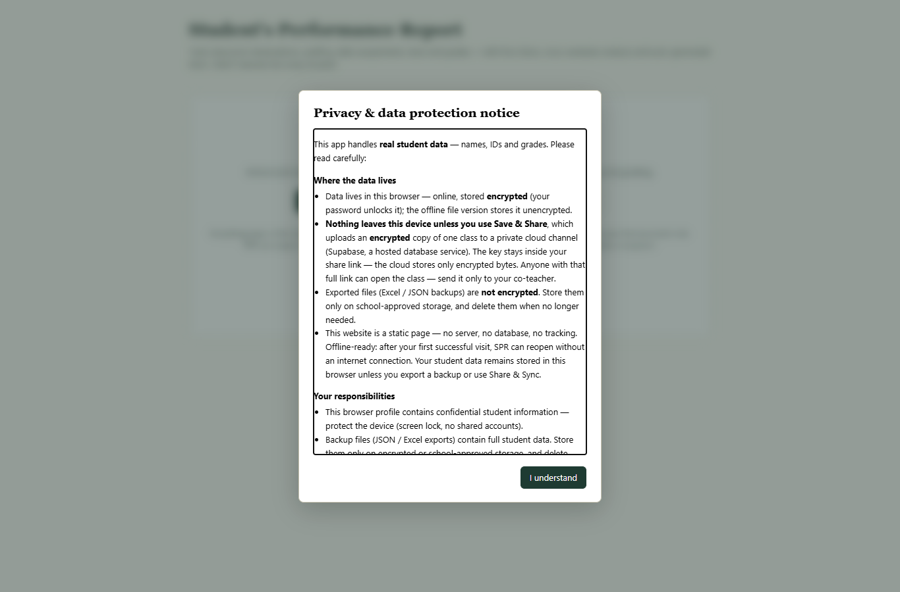
Figure 2 — The privacy notice appears the first time only.

Step 3 — Create your sign-in
This sign-in locks and unlocks the student data saved in this browser. It is not an internet account — nothing is sent anywhere.
- Choose a username you will remember (for example your name: teacher.mo ).
- Choose a password with 8 or more characters.
- Type the same password again to confirm.
- Click “Create sign-in”.
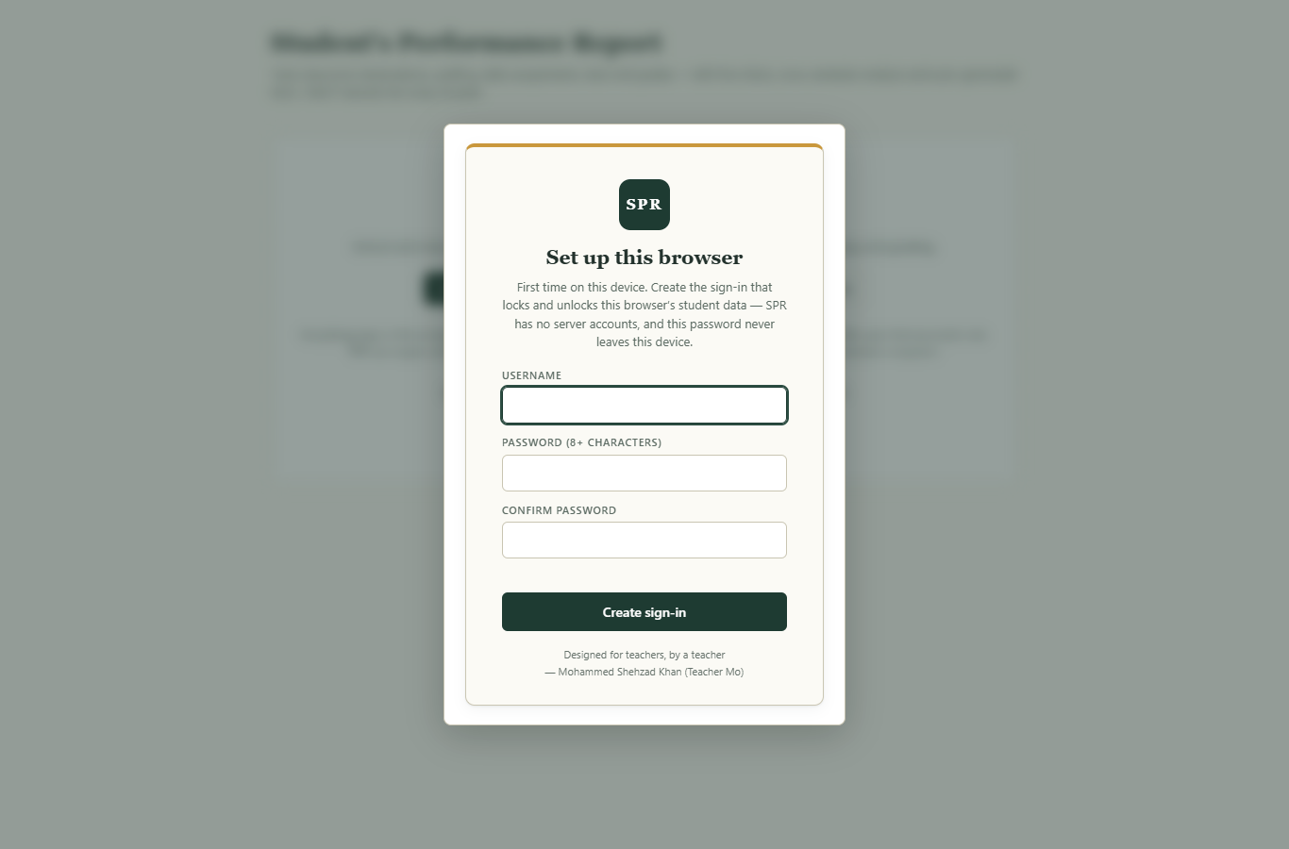
Figure 3 — Create your sign-in (first time only).
PLEASE NOTE: Please write your username and password on paper and keep it somewhere safe. The password never leaves your computer, so nobody — including SPR — can tell you the password if you forget it. If you forget it, the data in that browser cannot be opened and must be erased to start again.

Step 4 — Choose how to start
After your sign-in is created, the app shows the “Set up your first class” screen with three choices. Nothing is pre-loaded — the choice is yours:
- New class (guided setup) — start your own real class. This is the normal choice for most teachers (see section 14.1).
- Import SPR Excel file — bring in a class you saved from Excel before (see section 15.2).
- Load sample data — load a pretend class (Demo School) just to press buttons and learn. You can delete it later.
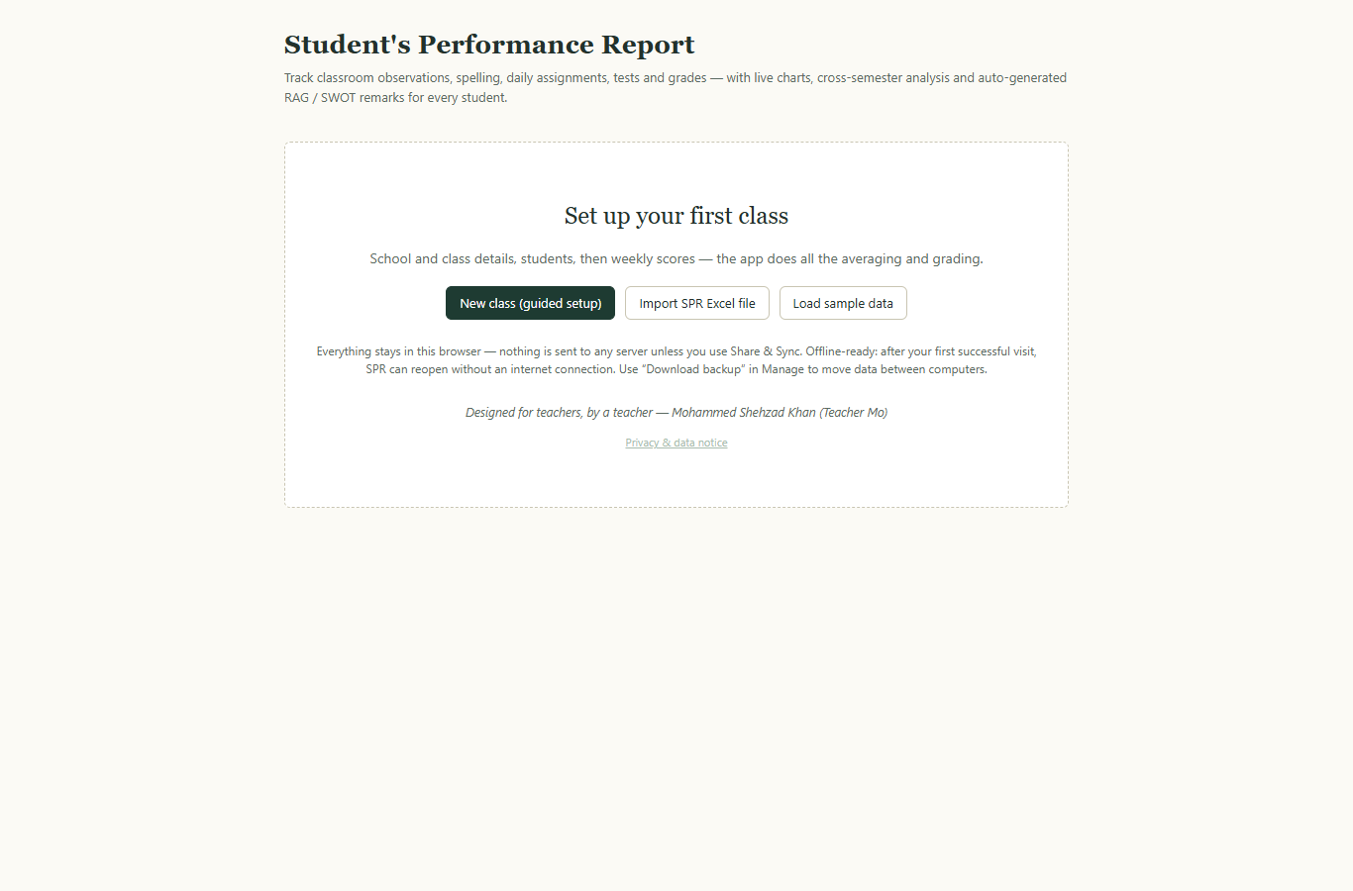
Figure 4 — The “Set up your first class” screen. Choose how to begin.
TIP: If you pick “Load sample data”, the pretend class is only there for practice. When you are ready for your real class, go to Manage & setup and delete the sample semesters (section 14.2).

5. Sign in on another day
Every time you open the app after that, it shows the sign-in screen. Type your username and password and click “Sign In”.
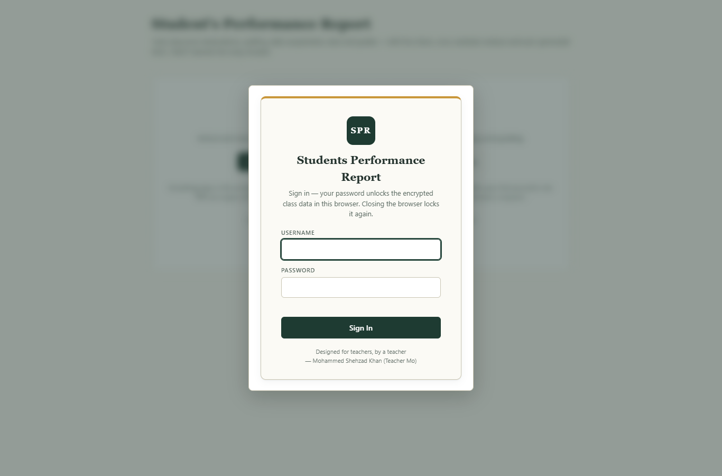
Figure 5 — The sign-in screen.
- “Welcome back” appears at the bottom — you are in.
- When you finish working, click “Sign out” at the bottom left. This locks the data again.
- If you type the wrong password, nothing is lost. Just type it again carefully.

6. Get to know the main screen
After signing in you see the main screen. (If this is a completely new start, you first see the “Set up your first class” screen — pick an option there and the main screen follows.) The main screen has three important parts:
- Left menu (dark bar) — this takes you to the six parts of the app.
- Top right buttons — quick actions for the page you are on (for example “Export SPR Excel” or “Print”).
- Semester selector — the small list under the SPR logo. Use it to switch between your semesters (for example 2026 Spring).
Left menu item | What it does
Dashboard | Your class at a glance: averages, priorities, evidence, charts.
Students | Your class list. Click a student to see their full profile.
Enter scores | Type marks here: observations, spelling, daily work, tests.
Grading | The big table of every student's component grades and final grade.
Analysis | Compare semesters; look at one student in depth.
Report Cards | Print a report for the whole class or for one student.
Manage & setup | Add classes and students; import/export; sharing; settings.
Sign out | Locks the app. Do this when you finish.

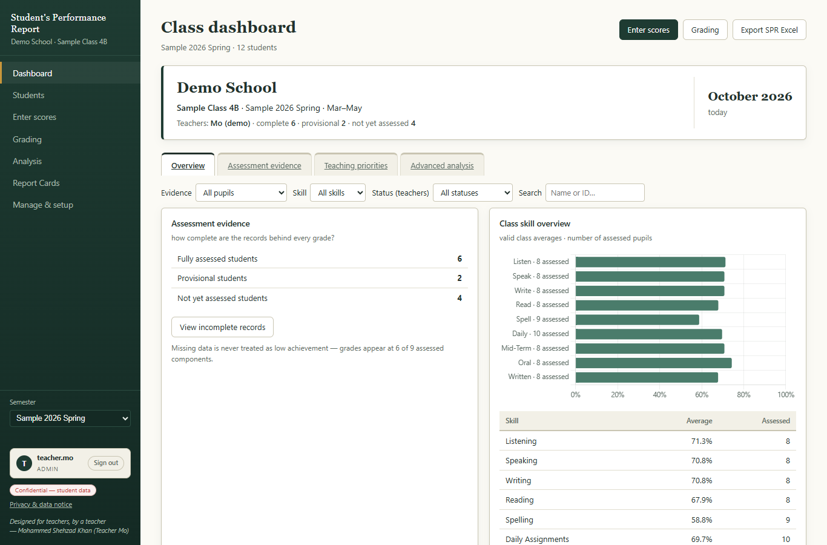
Figure 6 — The main screen (Dashboard).
TIP: The semester selector remembers your last choice. If a page looks empty, check that the correct semester is selected in the left bar.

7. The sample class (Demo School) — only if you ask for it
The app does not put any class in front of you. When you start, you choose (section 4, Step 4). If you click “Load sample data”, you get a pretend class: “Demo School · Sample Class 4B”, with 12 pretend students and two semesters of marks (Sample 2025 Fall and Sample 2026 Spring). It is there so you can press every button and learn safely, before you add your real class.
The pretend class is not connected to your work in any way. When you are ready for your real class, go to Manage & setup (see section 14) and either:
- Click “New class / semester” to create your real class, then delete the sample semesters (each semester card has a “Delete” button), or
- Click “Erase everything” (in Manage & setup, at the bottom) to clear all data and start fresh.
TIP: Deleting a semester always asks “Are you sure?” first, so you cannot lose work by one wrong click.

8. Dashboard — your class at a glance
The Dashboard has four tabs along the top: Overview, Assessment evidence, Teaching priorities and Advanced analysis. Click a tab name to switch. The filters on the right (Evidence, Skill, Status, Search) narrow the lists down.

8.1 Overview
- The top card shows your school, class, teachers, and how many students are fully assessed.
- The skill bars show the class average for each skill, with the number of assessed students next to it.
- “Recent progress / review” lists students who are moving up or down across semesters.
Figure 7 — Dashboard, Overview tab.

8.2 Assessment evidence
This tab shows, for every student, how much data you have recorded: complete, provisional (for example 7/9 components) or not yet assessed. Missing data is never treated as low marks — a final grade only appears when a student has at least 6 of the 9 components.
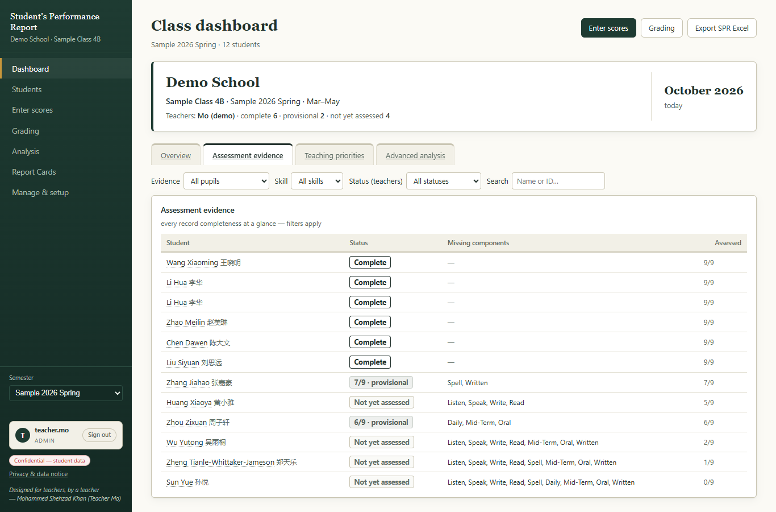
Figure 8 — Dashboard, Assessment evidence tab.

8.3 Teaching priorities
This tab helps you plan teaching. It shows the weakest skills first (only when at least 5 students have marks), suggests a teaching action for each, and lists the students who need focused support, with a suggested action for each one.
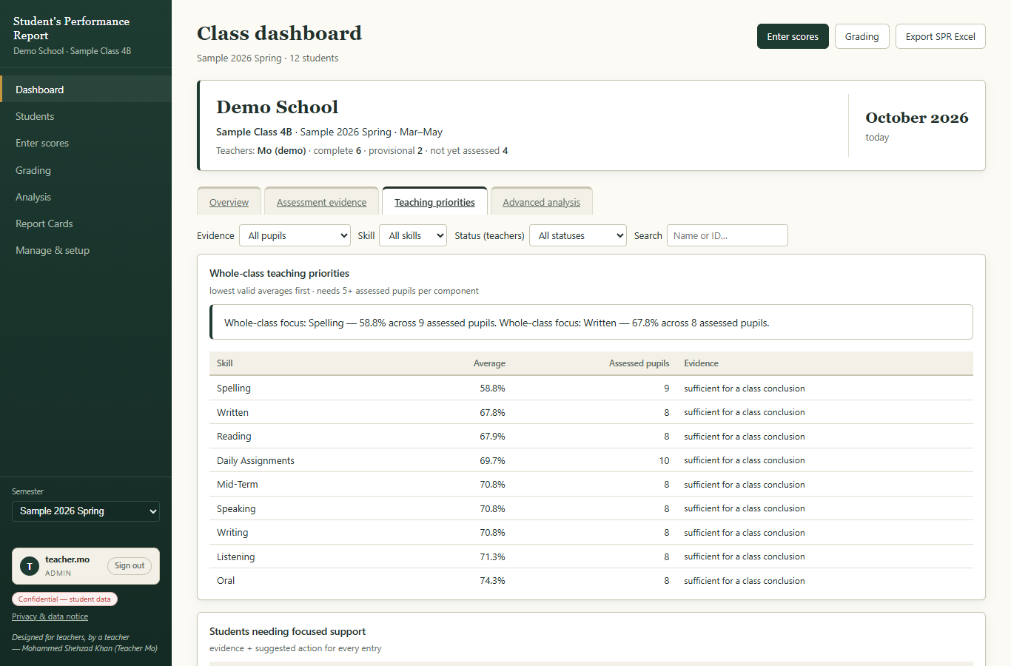
Figure 9 — Dashboard, Teaching priorities tab.

8.4 Advanced analysis
This tab shows scatter charts (for example: current score against change since last semester). It is for your own review — the app reminds you it does not measure ability by itself.
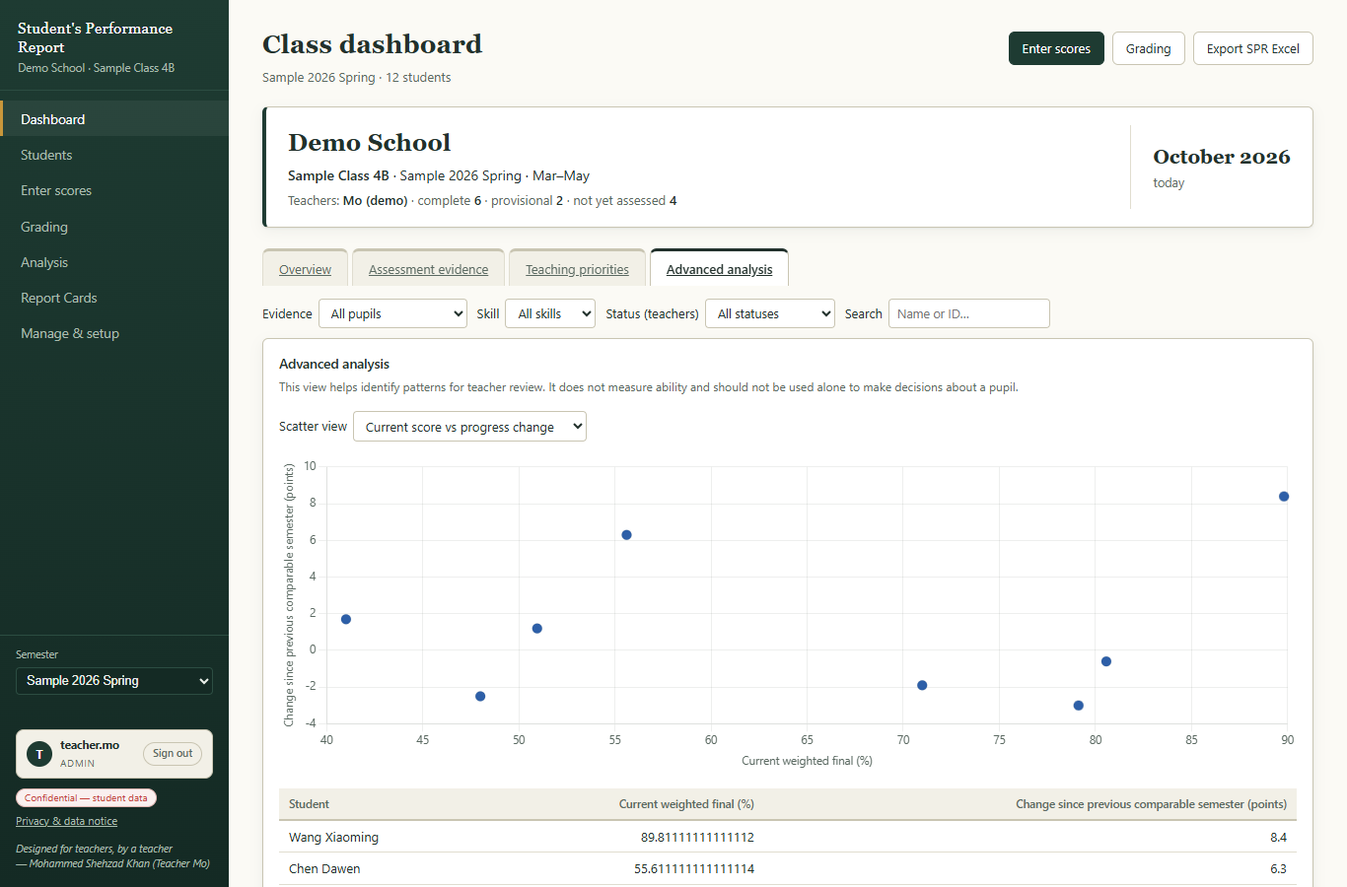
Figure 10 — Dashboard, Advanced analysis tab.

9. Students — your class list
The Students page shows one card per student: photo-style badge with the family name, Chinese and English name, student ID, the current grade letter (or how many components are recorded, like 7/9), and a small trend line.
- Use the search box (top right) to find a student by name or ID.
- Click a student card to open their full performance profile (the “Student deep-dive”, see section 12.2).
- To add or remove students, go to Manage & setup (section 14).
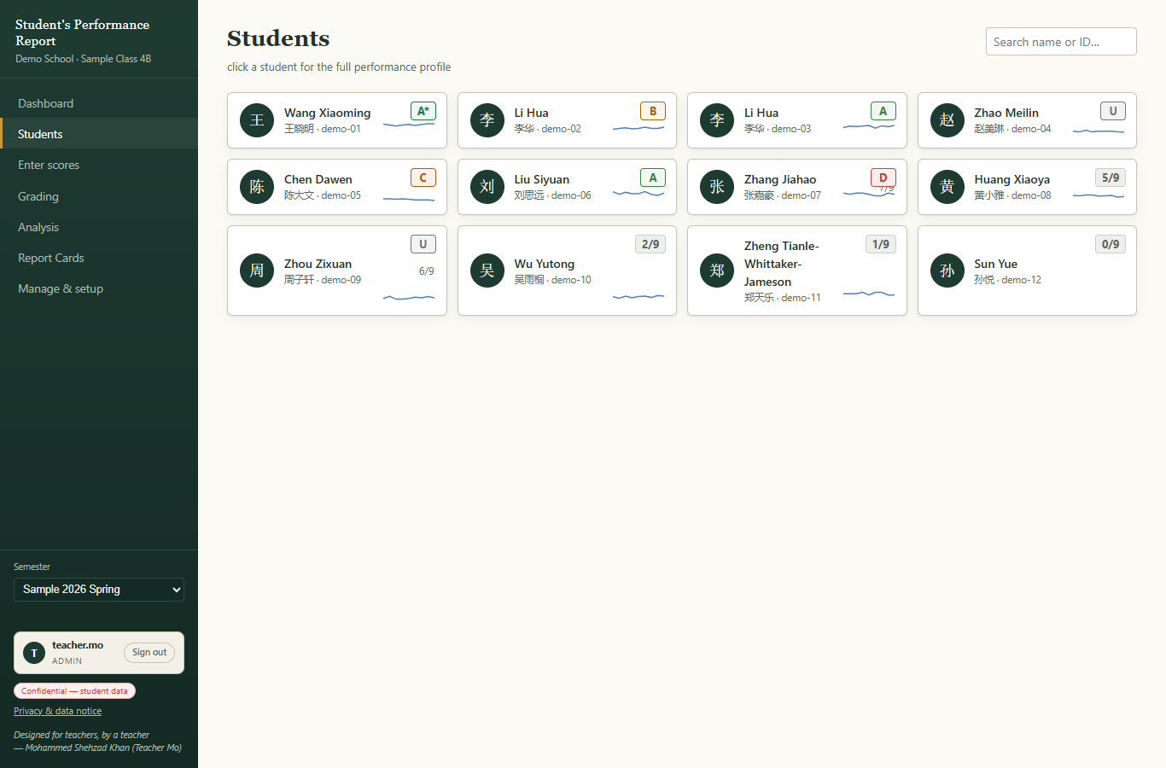
Figure 11 — The Students page.

10. Enter scores — typing in marks
This is the page you will use most. Across the top there are four tabs for the four kinds of marks. Under them there are month buttons (Mar, Apr, May …). Pick the month first, then type in the table.
Tab | What you type | How it is scored
Observations | Listening, Speaking, Writing and Reading. Two lines per skill: LO1 and LO2 (learning observation 1 and 2). | Each mark is out of 10. Recorded monthly.
Spelling | Weekly spelling tests: Week 1 to Week 5. | Score out of a total, usually 20. The app turns it into a percentage.
Daily assignment | Daily or weekly classwork marks: Week 1 to Week 5. | Score out of a total, usually 10.
Tests | Mid-Term, Oral and Written exams. | Score and total for each. Written counts double in the final grade.

- Click “Enter scores” in the left menu.
- Choose the month button you want (for example May).
- Click the tab for the kind of mark (for example Spelling).
- Click a box and type the number. Press Tab or Enter to move to the next box.
- That is all — the app saves automatically as you type. There is no “Save” button to forget.
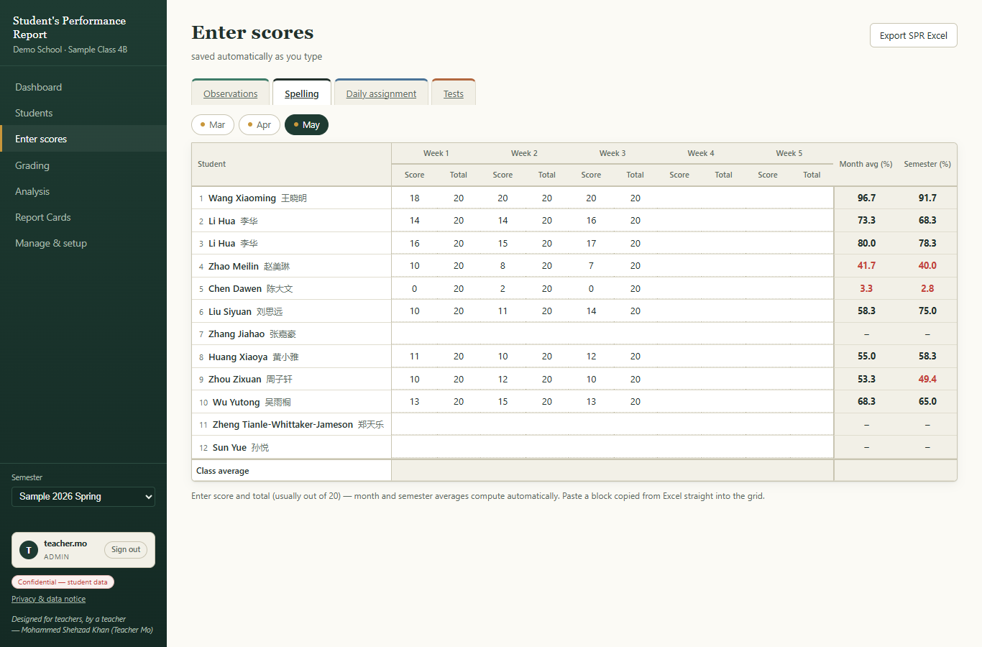
Figure 12 — Enter scores, Spelling tab. Weeks 1–5, then Month average and Semester average.

10.1 Observations tab
The Observations tab records listening, speaking, writing and reading. Each skill has two observation columns (LO1, LO2), each out of 10. If you are not sure what LO1 and LO2 mean for your school, click the question “What do LO1 / LO2 mean?” at the top of the table.
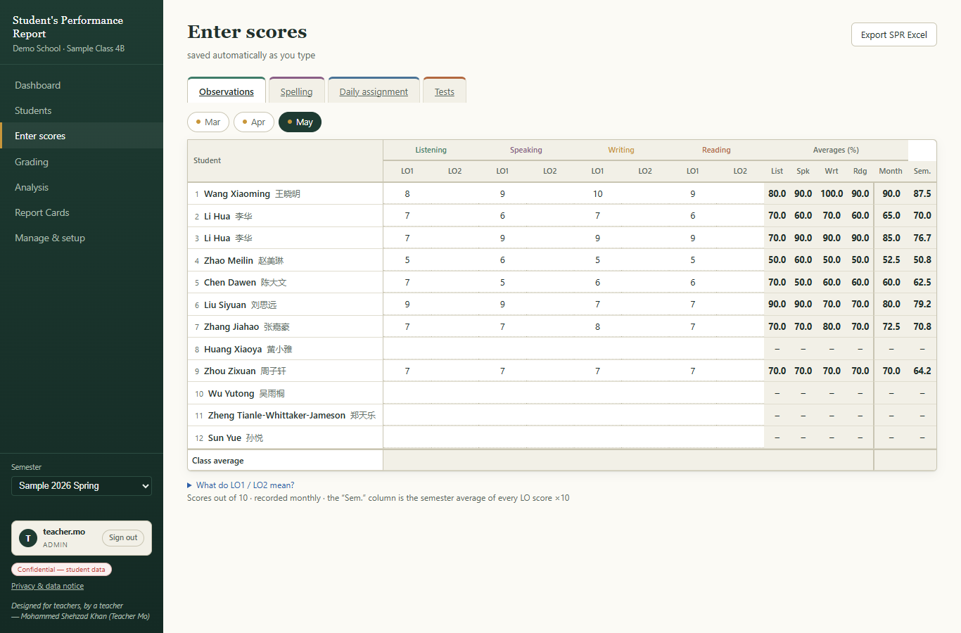
Figure 13 — Observations tab: four skills with LO1 and LO2 marks.

10.2 Daily assignment tab
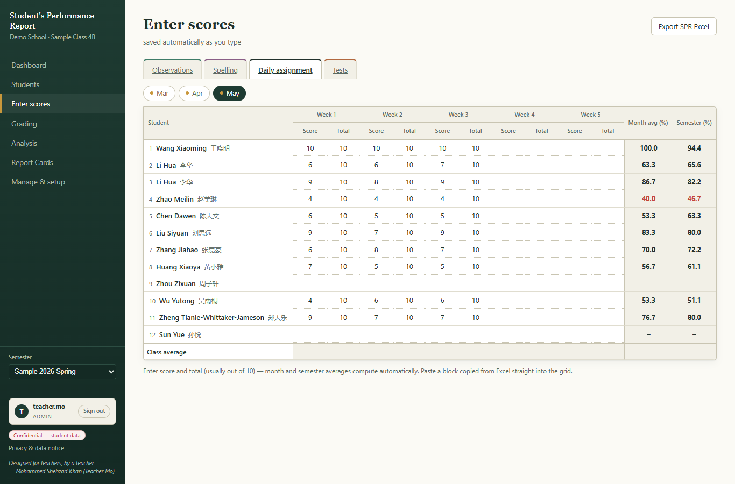
Figure 14 — Daily assignment tab: weekly marks with a total.

10.3 Tests tab
The Tests tab has three exams: Mid-Term, Oral and Written. Type the score and the total for each. The “Weighted final” line shows the exam-part grade. Remember: the Written exam counts 20% in the final grade; every other part counts 10%.
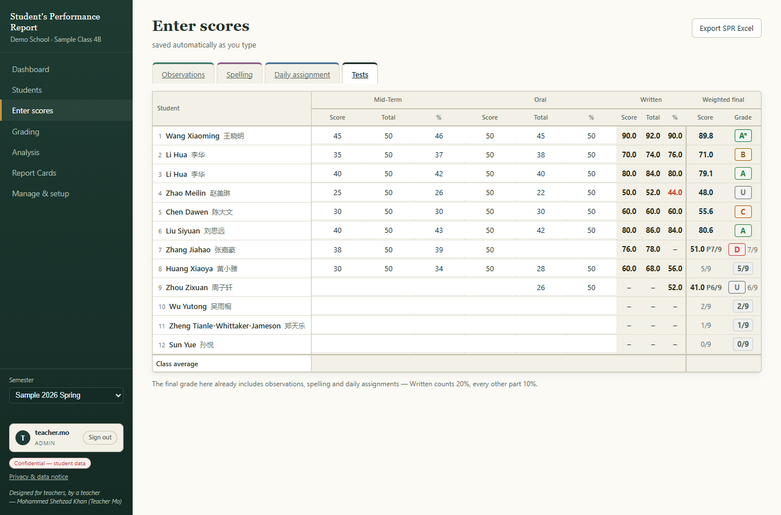
Figure 15 — Tests tab: Mid-Term, Oral and Written.

10.4 Good to know
- Copy from Excel: you can copy a block of numbers in Microsoft Excel and paste it straight into the grid.
- Auto-fill totals: in Manage & setup → Settings you can turn on “auto-fill totals”, so the total (20 or 10) is filled for you.
- Colours: the table uses colour to warn you — red usually means a low mark or a missing mark.
- The last row of each table shows the class average, so you can spot students far below it.

11. Grading — how grades are calculated
The Grading page shows one big table: every student, every component, the final percentage and the grade letter. You do not calculate anything — the app does it as soon as you type marks.
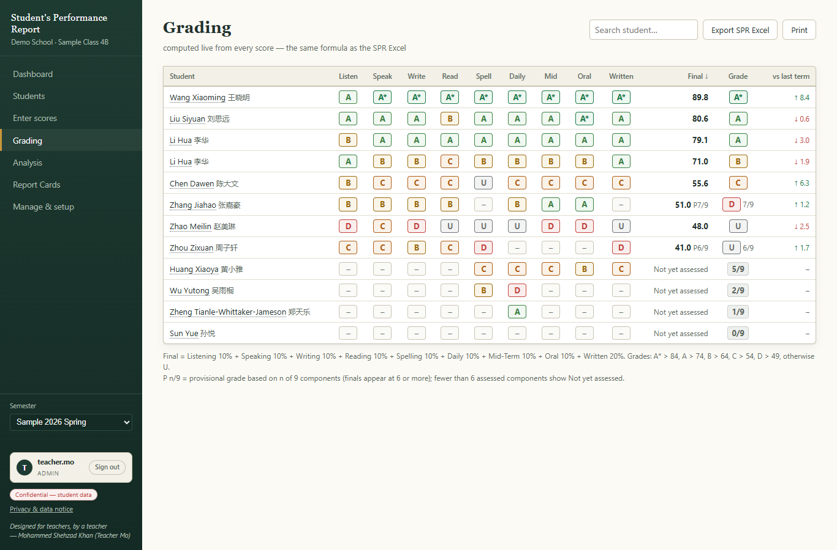
Figure 16 — The Grading table. The formula is printed at the bottom of the page.

11.1 How the final percentage is made
Component | Weight
Listening | 10%
Speaking | 10%
Writing | 10%
Reading | 10%
Spelling | 10%
Daily assignments | 10%
Mid-Term | 10%
Oral | 10%
Written exam | 20%

Final % = Listening 10% + Speaking 10% + Writing 10% + Reading 10% + Spelling 10% + Daily 10% + Mid-Term 10% + Oral 10% + Written 20%.

11.2 Grade letters
Grade | Final percentage
A* | above 84%
A | above 74% to 84%
B | above 64% to 74%
C | above 54% to 64%
D | above 49% to 54%
U | 49% and below

11.3 Fair grades for missing data
- A student with fewer than 6 of the 9 components recorded shows “Not yet assessed” — not a zero.
- A student with 6–8 components shows a provisional grade, marked with a P (for example P 7/9). It becomes a final grade when all 9 components are recorded.
- The last column “vs last term” shows the change against the previous semester (for example +8.4), so you can see progress at a glance.
TIP: The “Export SPR Excel” button (top right) saves this whole table as an Excel file. See section 15.

12. Analysis — comparing and understanding progress
The Analysis page has two tabs: “Class progress” for the whole class, and “Student deep-dive” for one student.

12.1 Class progress
- Class average across semesters — a line for each skill and the final, so you see the trend.
- Grade distribution per semester — how many A*, A, B… in each semester.
- Progress by component (RAG) — red / amber / green colours for each component (RAG = Red, Amber, Green).
- Movers — which students improved or slipped the most between the two semesters.
- Class summary — a short automatic written summary you can copy into your own reports.
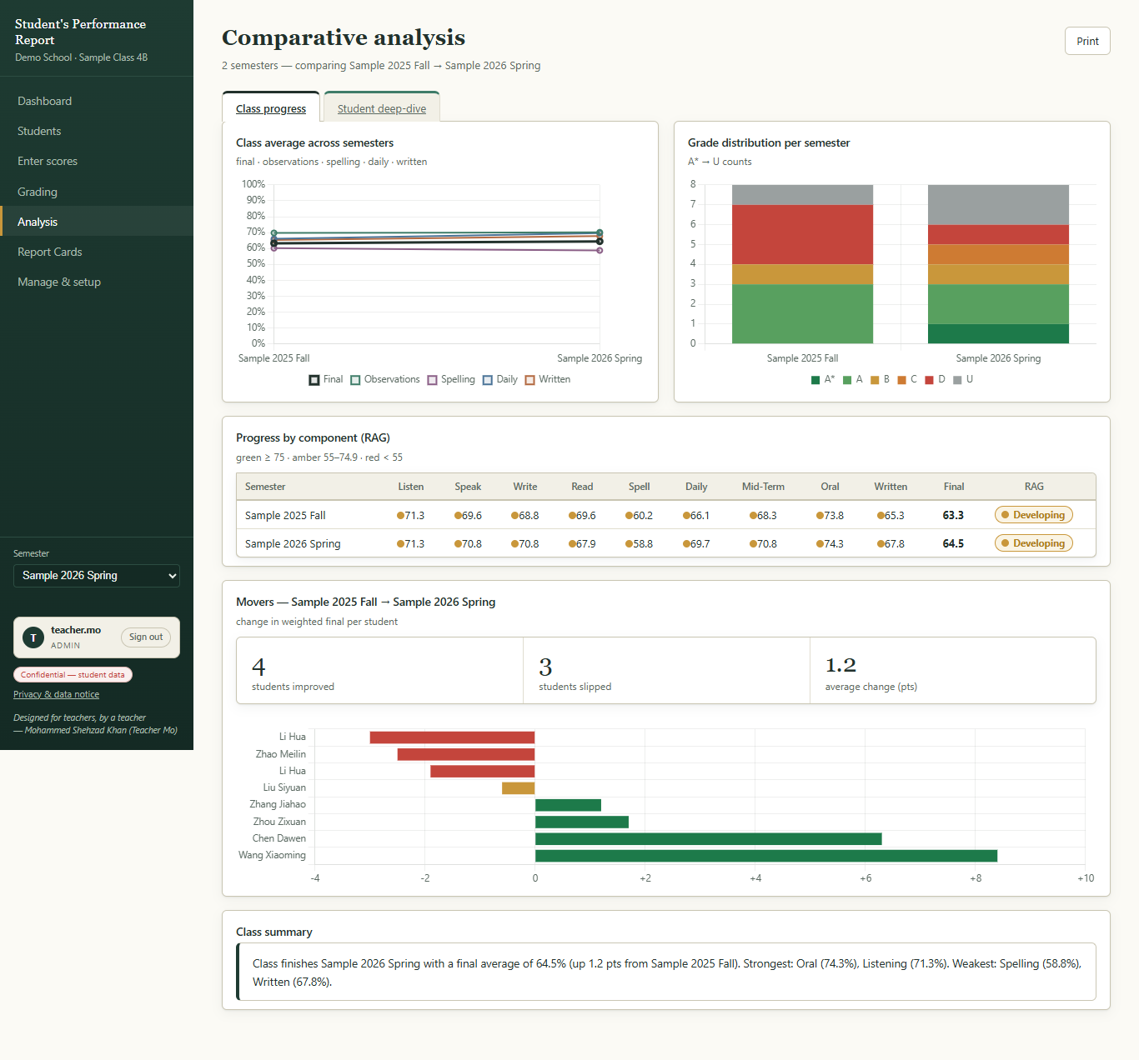
Figure 17 — Analysis, Class progress tab.

12.2 Student deep-dive
- Click “Student deep-dive”.
- Pick the student in the list at the top.
You will see the student's final score and change, their rank in the class, a stamp (for example “Secure / on track”), the score trajectory chart, a radar chart comparing this semester with the last one, a progress matrix with red/amber/green chips for all 9 components, and an automatic SWOT analysis (Strengths, Weaknesses, Opportunities, Threats) with a written summary.
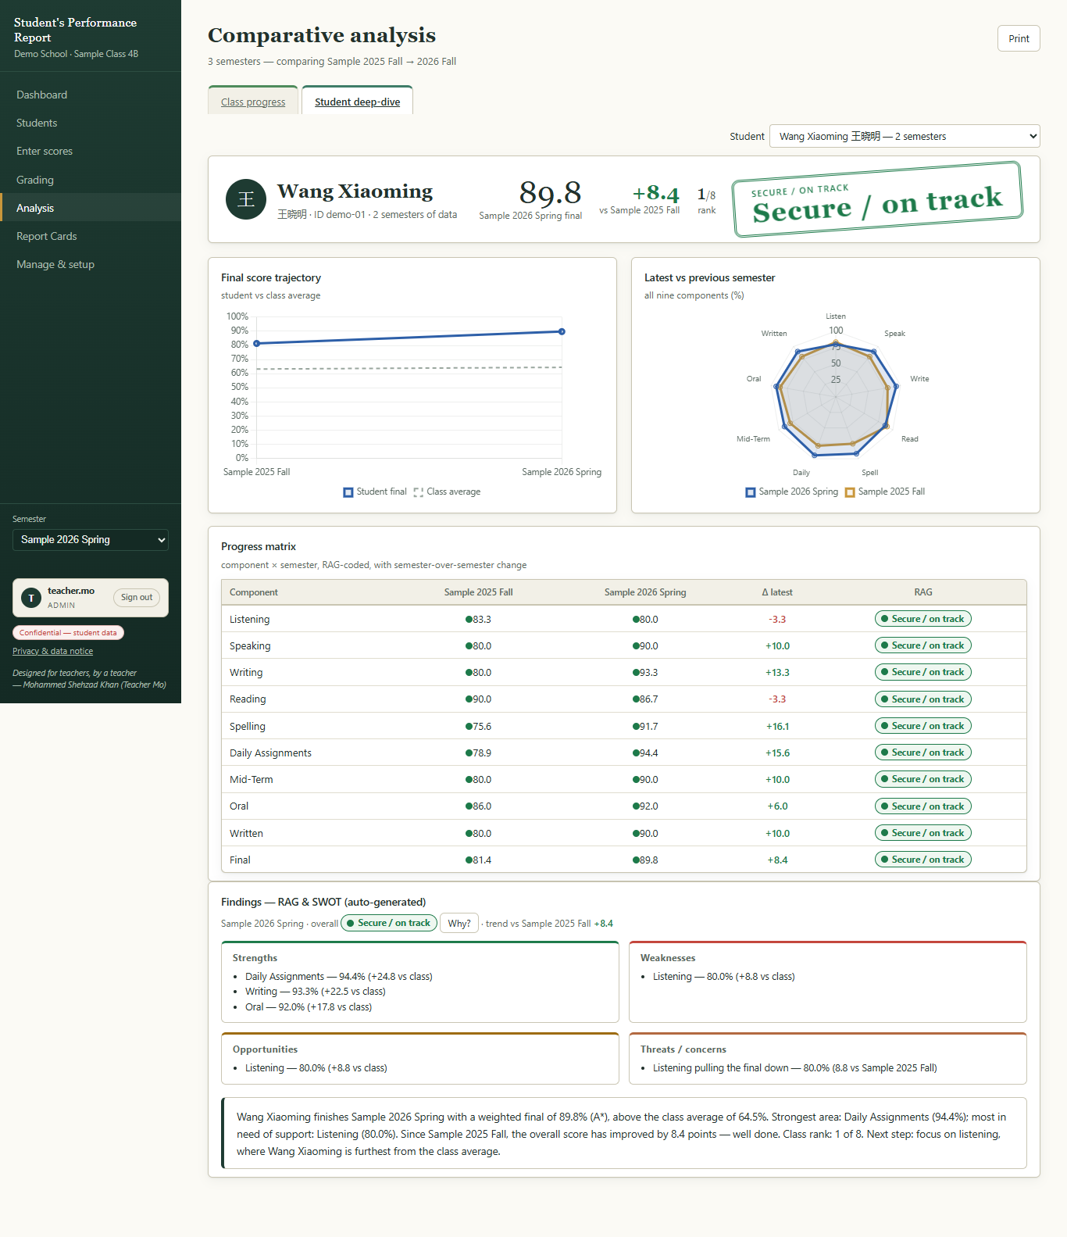
Figure 18 — Student deep-dive: charts, matrix and automatic findings.

13. Report Cards — printing student reports
The Report Cards page has two tabs: “Class report” and “Student report cards”. Use the “Print” button (top right) to print, or to save as PDF.

13.1 Class report
One page about the whole class: class average, grade distribution, recording status (how complete your data is), top performers, and the full results table. “Download Class Report (Excel)” saves it as a spreadsheet.
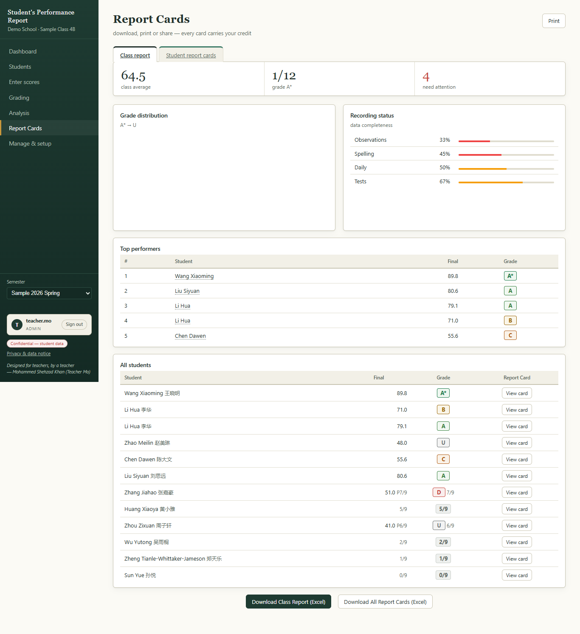
Figure 19 — Report Cards, Class report tab.

13.2 One student's report card
- Click the “Student report cards” tab.
- Choose the student in the list.
- Click “View Report Card”.
- The card appears below. Read it, then click “Print / Save PDF”.
- You can also click “Download (Excel)” to get the card as a file, or “Full profile” for the deep-dive view.
Above the card there are five comment boxes: Strengths, Next Learning Steps, Teacher Support, How Home Can Help, and Overall Comment. The app writes a first suggestion for you. You can change the words freely. If you make a mistake, click “Reset to suggested wording” to get the automatic text back. Comments save automatically.
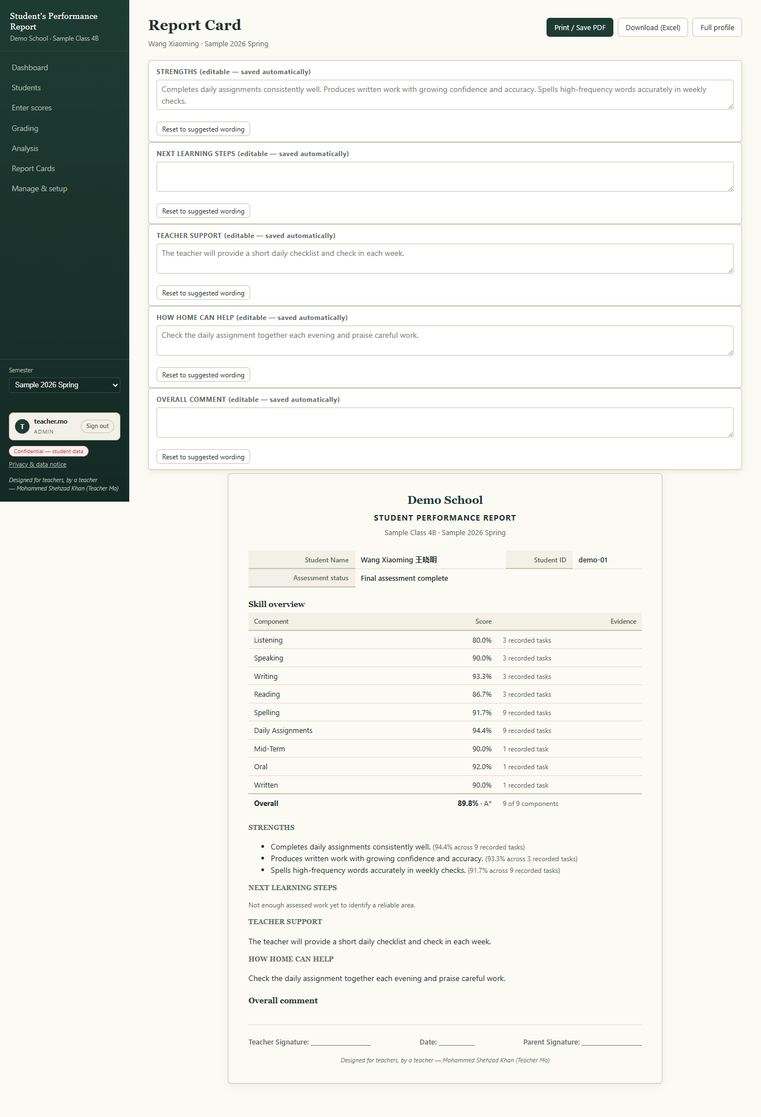
Figure 20 — A student's report card with the comment boxes above it.

14. Manage & setup — classes, students and settings
Everything about the app itself lives here: semesters (classes), the student list, settings, sharing and data tools.
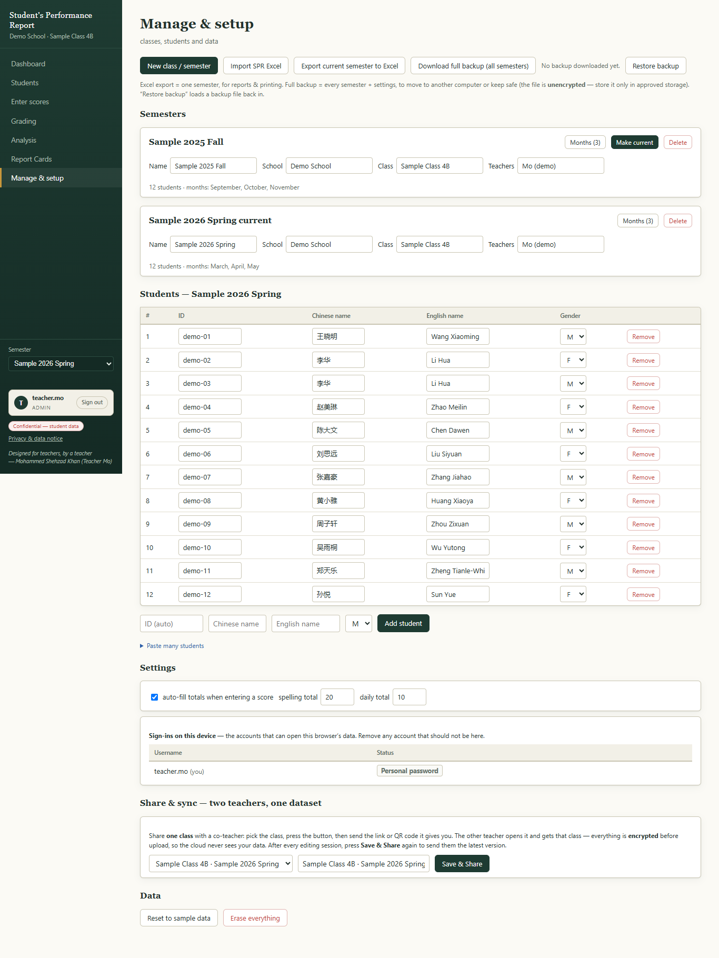
Figure 21 — The Manage & setup page.

14.1 Start a new class or semester
- Click “New class / semester”.
- Choose the year and the period (Fall or Spring). The app tick-lists the normal months for you — you can change them.
- Type the School, the Class (for example Grade 5 Class 1) and the Teachers.
- Choose how to add students: start empty, copy the roster from another semester, or paste a list.
- For “paste a list”, type one student per line like this: g5-01, 陈小小, Grace Chen, F (ID, Chinese name, English name, gender M/F).
- Click “Create”. The new semester becomes your current one.
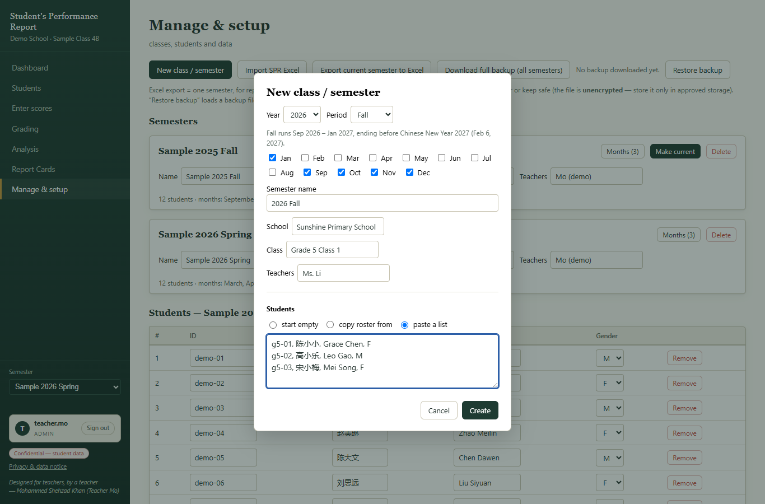
Figure 22 — The New class / semester window, filled in.

14.2 Semester cards
- Each semester is a card. You can correct the name, school, class or teachers by typing in the box.
- “Make current” switches the whole app to that semester.
- “Delete” removes the semester and its scores. The app asks “Are you sure?” first and reminds you to make a backup.
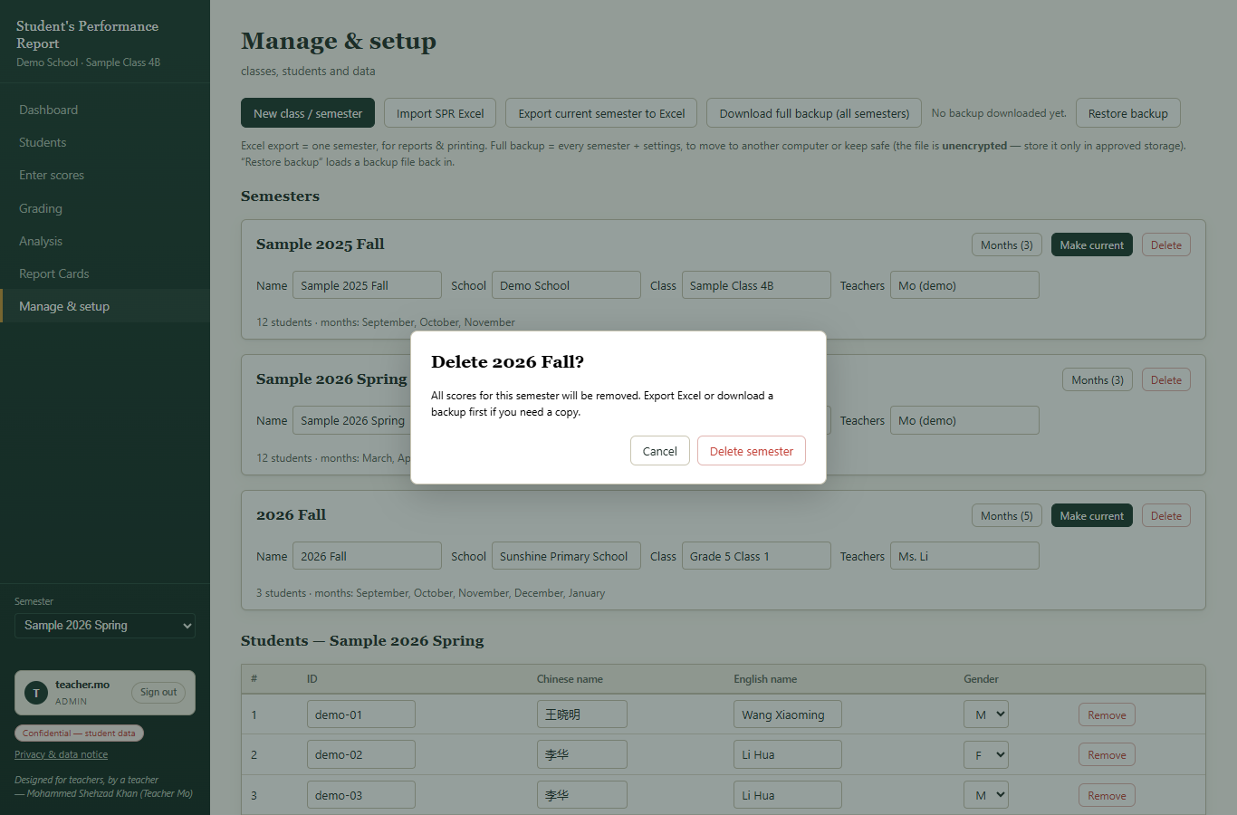
Figure 23 — Deleting always asks for confirmation first.

14.3 Add or remove students
- Use the row at the bottom of the students table: type the Chinese name, English name, choose M or F, then click “Add student”. The ID is made for you.
- “Paste many students” opens a box for a whole list at once (one student per line).
- “Remove” deletes one student (it asks for confirmation).
- Gender can be M, F or “–” (not stated).

14.4 Settings and sign-ins
- Settings: turn “auto-fill totals” on or off (fills 20 for spelling, 10 for daily work).
- Sign-ins on this device: shows the usernames that can open this browser's data, and lets you set a personal password.

14.5 Data tools (bottom of the page)
Button | What it does
Import SPR Excel | Load a class from an SPR Excel file (see section 15).
Export current semester to Excel | Saves the current semester as an SPR Excel file.
Download full backup (all semesters) | Saves ONE file with everything. Keep it somewhere safe (USB stick, school drive).
Restore backup | Loads a backup file back into the app.
Reset to sample data | Brings back the Demo School sample class.
Erase everything | Deletes all data from this browser. Asks for confirmation.

15. Backups, Excel import and export

15.1 Export to Excel
- Click “Export SPR Excel” (top right of Dashboard, Enter scores or Grading) or use Manage & setup.
- The file downloads to your computer. The name looks like: School-Class-SPR-Semester-by-Teacher.xlsx
- The file has six sheets: Instructions, Classroom Observations, Spelling, Daily Assignment, Tests and Grading.

15.2 Import from Excel
- Click “Import SPR Excel” and choose the file.
- The app shows what it found: the semester, the number of students and the months.
- Read the note: “Nothing is overwritten — your existing classes stay exactly as they are.”
- Click “Add class” to finish, or “Cancel”.
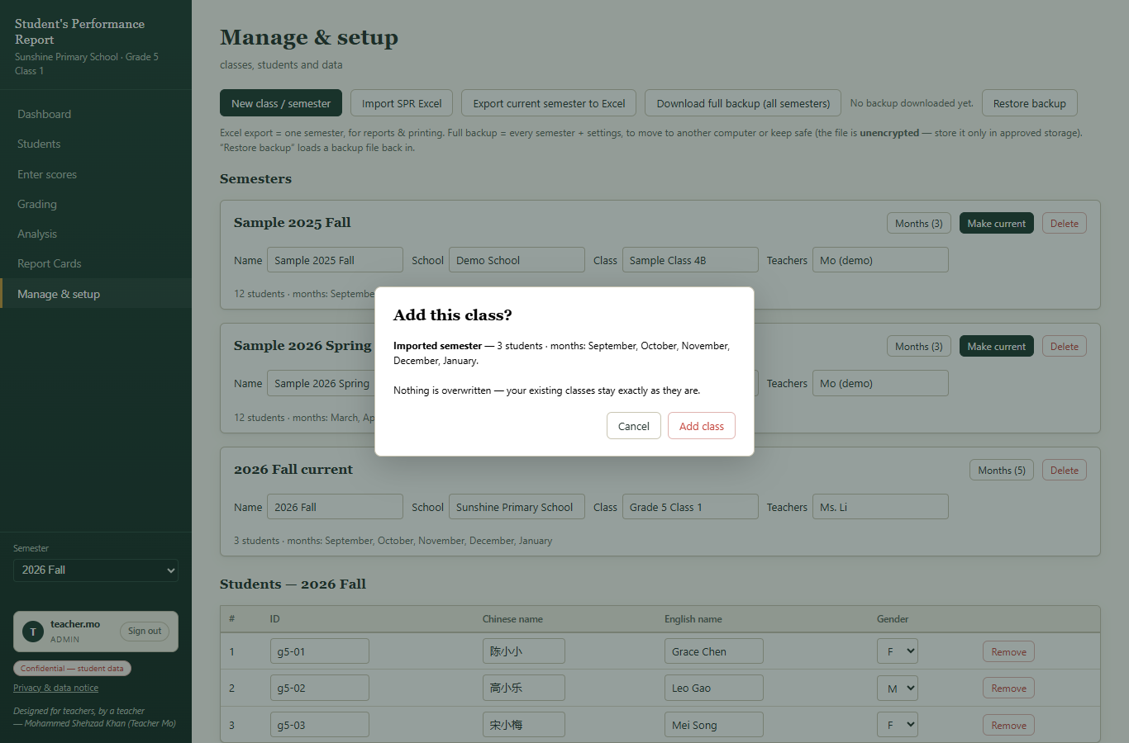
Figure 24 — Import always shows what it will do before it does it.

15.3 Make regular backups
PLEASE NOTE: Excel exports are for working with the marks. For a complete safety copy use “Download full backup (all semesters)” in Manage & setup. Do this at the end of every month, and keep the file on a USB stick or school drive. The backup file is NOT password protected — store it as carefully as you would store paper records.

- If your browser is refreshed, reset, or you clear its data, student data inside it is gone. A backup file is the only way to restore it (Manage & setup → Restore backup).

16. Share & sync — two teachers, one class
If two teachers teach the same class, one teacher can share the class with the other. Both can then work on the same marks from their own computers.

Teacher A — share the class
- Go to Manage & setup, find “Share & sync — two teachers, one dataset”.
- Pick the class in the list.
- Click “Save & Share”.
- A window opens with a link and a QR code. Click “Copy link” and send it to your co-teacher (for example by WeChat or email).
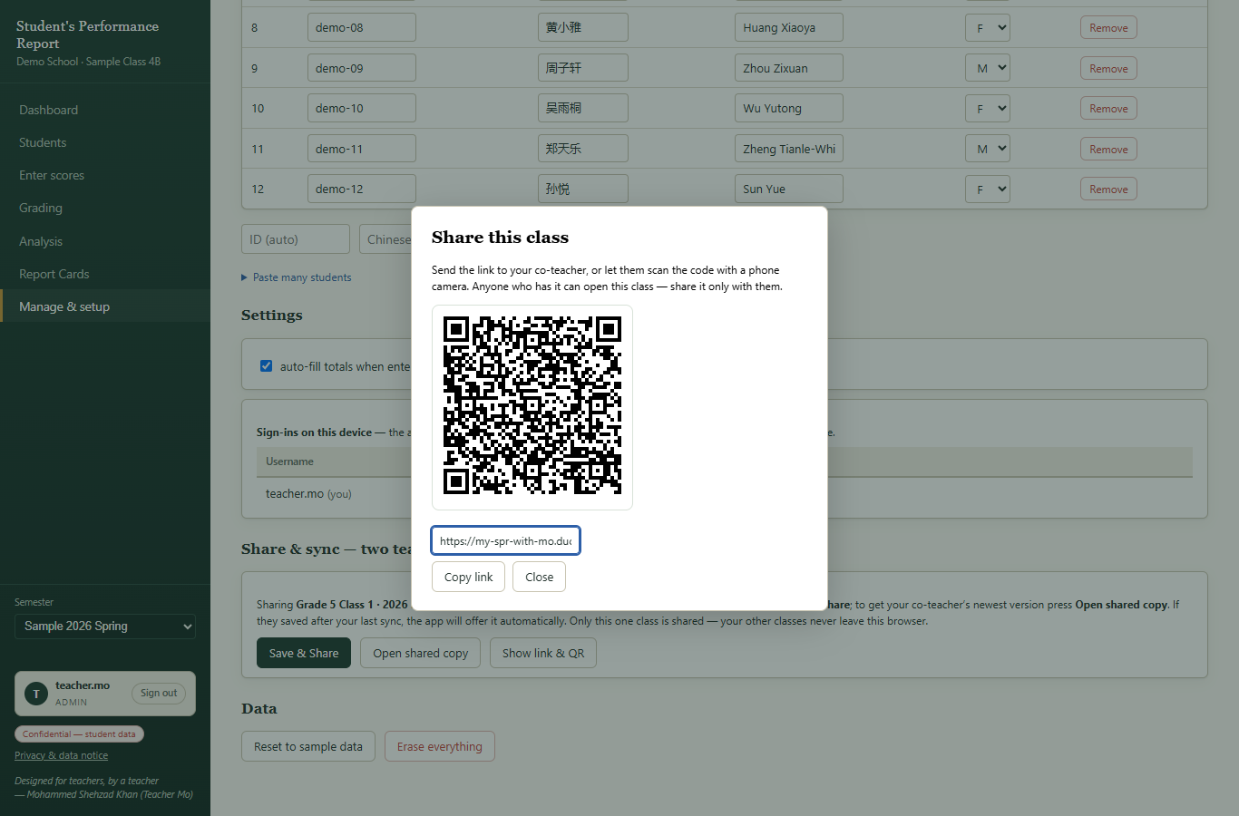
Figure 25 — The share window: link and QR code.

Teacher B — open the shared class
- Click the link (or scan the QR code with a phone camera).
- The app opens the class in your browser. Use “Open shared copy” in Share & sync to pull in your partner's latest changes.
TIP: The class data is locked (encrypted) before it is uploaded, and the key to unlock it travels inside the link itself. So: share the link only with your co-teacher. Anyone who has the link can open the class. Never post it in a public group.

17. Privacy and safety
In simple words:
- All marks stay inside your own browser, locked with your password. There is no SPR server with your students' marks.
- The app does not track you and does not ask for student photos or personal details beyond name, ID and gender.
- When you share a class (section 16), the data is encrypted before it leaves your computer.
- Excel exports and backup files are NOT encrypted. Store them like paper records.
- Your responsibilities: use a strong password, sign out on shared computers, keep backups, and follow your school's rules for student data.
You can read the full notice any time: click “Privacy & data notice” at the bottom left of the app.

18. Words used in this app (glossary)
Word | Plain meaning
Semester | One teaching period, for example “2026 Spring” (Mar–May). All marks belong to a semester.
Component | One kind of mark. There are 9: Listening, Speaking, Writing, Reading, Spelling, Daily, Mid-Term, Oral, Written.
LO1 / LO2 | Learning Observation 1 and 2 — the two monthly observation marks for each language skill.
Final % | The weighted average of all 9 components.
A* … U | Grade letters. A* is the best; U means the mark is very low.
Provisional (P n/9) | A temporary grade based on 6–8 components instead of all 9.
Not yet assessed | Fewer than 6 components recorded — no grade is shown yet.
RAG | Red / Amber / Green traffic-light colours. Green is strong, amber is middle, red needs attention.
Roster | The list of students in a class.
Backup | One file containing all your semesters, for restoring after a problem.
Sign-in | The username + password that locks this browser's data.
Offline | The app can open without internet after your first visit.

19. Common questions

I see “Set up your first class”. Where is my class?
That screen appears when this browser has no class yet. It is the normal starting point: choose “New class (guided setup)” to begin (section 14.1), or “Import SPR Excel file” if you have a file, or “Load sample data” just to practise.

How do I remove the pretend Demo School class?
Manage & setup → in the Semesters list, press “Delete” on each sample semester (Sample 2025 Fall, Sample 2026 Spring). Your own classes are not touched.

I forgot my password. What now?
Nobody can read the password — it never leaves your computer. On that computer the data is locked forever. You must erase the data (open the app, and if the browser still remembers, Manage & setup → Erase everything) and start again. This is why you should keep backups and write the password down.

My screen looks empty / students are missing.
Check the semester selector on the left (section 6). You may be looking at a different semester, or at the wrong class. Also check that you signed in as yourself. If you truly see the “Set up your first class” screen, this browser has no data — see the first question above.

Can I use it on my phone?
Yes, the pages adjust to small screens. Typing marks is faster on a computer, but viewing dashboards and report cards on a phone works well.

Does it work without internet?
Yes, after your first visit the app is saved by the browser and opens offline. Marks you type offline are kept. Sharing and importing need internet.

Where exactly is my data?
Inside the browser, on the computer you used. If you change computer, or even change browser (Chrome → Edge), the new browser starts empty. To move computers: make a full backup on the old one and restore it on the new one (section 15.3), or export/import Excel.

Can two teachers both type marks?
Yes — use Share & sync (section 16). One teacher shares; both open the shared copy. The link is the key: keep it between you two only.

A student left the school. How do I remove them?
Manage & setup → Students table → “Remove” (it asks for confirmation). Their marks go with them.

I deleted something by mistake.
Every delete asks for confirmation first. After deleting, a small message (toast) appears at the bottom of the screen with an “Undo” button — click it quickly to get the data back.

20. Quick reference card
I want to… | Do this
Open the app | Go to https://my-spr-with-mo.duckdns.org/ → Open the App → sign in. New start? Pick an option on the “Set up your first class” screen.
Type this week's marks | Enter scores → choose month → choose tab (Spelling / Daily / Observations / Tests) → type.
See who needs help | Dashboard → Teaching priorities.
See one student's story | Students → click the student (or Analysis → Student deep-dive).
Print a report for parents | Report Cards → Student report cards → choose student → View Report Card → Print / Save PDF.
Print a whole-class report | Report Cards → Class report → Print (or Download Class Report Excel).
Add a new student | Manage & setup → students table → “Add student” or “Paste many students”.
Start the new semester | Manage & setup → New class / semester → fill in → Create.
Save marks to Excel | “Export SPR Excel” button (Dashboard / Enter scores / Grading).
Safety copy of everything | Manage & setup → Download full backup (all semesters).
Share with my co-teacher | Manage & setup → Share & sync → Save & Share → send the link.
Finish work safely | Click “Sign out” (bottom left).

— End of manual —

