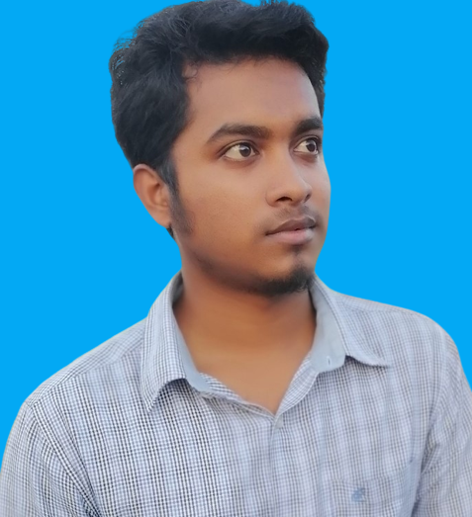


Muhammad Sibgatullah (Munna)

+8801601706606


msmmunna8@gmail.com

Career Objectives:

I am a web developer experienced in HTML, CSS, and Javascript.
Passionate about helping clients bring their project designs to life, creating fully responsive and pixel perfect pages.
My goal is to deliver clean and efficient code and exceed my clients expectations.
I am a professional web developer with 3 years of experience in frontend website development.
I have a strong grip on Html, CSS, JavaScript, and bootstrap.
I can create responsive sites according to your requirements.
My first priority is to provide customers with full satisfaction.

Experience
Template
Agency
Shopify
Blog
Ecommerce
PSD to HTML
Figma-XD
JPG-PNG Image
Land pages

Why to choose me?
Customer Satisfaction
Mobile friendly and responsive design
Quick & Fast response.
Modern interface Development
Communication at every stage of the procedure.
Excellent quality and prompt results.
Quick delivery of your project.
Unlimited Revisions until you are 100% satisfied.
24x7 Online
Educational Qualification:

- Secondary School Certificate (SSC): -
- Name of the institution : Biprobogdia High School
- Group : Arts
- Passing year : 2019
- Obtained G.P. A : 3.78 (Out of 5.00)
- Board : Jessore

Computer Liability:

- I am web designer ,3 Experience . HTML5 , CSS3, Bootstrap, JS , JQ.

Industrial training & practice:

Successfully completed the 3 Years Experience in Quamrul Islam Siddiki
Institute, Kushtia.

Working Experience :

- 3 years Experience.
Language Skills:
- 1. Bangla (Good).

- 2. English (Medium)

- 2. Hindi (Medium)

Relevant Skills:

- Capable of working in a team as well as independently.
- Fluent in speaking, writing & listening in both English, Bengali and Hindi.

Personal Information:

- Name : Muhammad Sibgatullah (Munna)
- Father’s Name : Md Atawur Rahman.
- Mother’s Name : Mst.Khadiza Khatun.
- Nationality : Bangladeshi (by birth).
- Religion : Islam.
- Sex : Male.
- Marital Status : Unmarried.
- Date of Birth : 01/01/2003.
- Height : 5 Fit 5 Inch.
- Weight : 64 kg.
- Blood Group : A+ (positive).
- Birth Place : Narayanganj (Dhaka).
Permanent Address :
- Village : Nagpara,
- Post Office : Biprobogdia,
- Police Station : Shailkupa,
- District : Jhenidah.
Present Address :
- Village : Nagpara,
- Post Office : Biprobogdia ,
- Police Station : Shailkupa,
- District : Jhenidah.

Reference:
MD Nazmul Islam
Instructor (Civil Technology )
Phone : 01826824005

Declaration:
“I do here by declare and certify that all the information stated above in this curriculum vitae are true and complete to the best of my knowledge and belief”.

07/02/2023 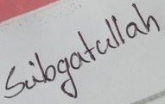
Date: ………………………
Sibgatullah (munna)

