CASE STUDY REPORT
Comparative Analysis of Classification
Algorithms for Bank Marketing Prediction
Predicting term-deposit subscriptions using four machine learning classifiers
Subject: Fundamentals of Data Science
Name: Md. Siddiq Juber
Roll No.: 160124733363
Section: [Enter Section]
Year: III Year, B.E. Computer Science and Engineering
Faculty Name: [Enter Faculty Name]
Dataset: UCI Bank Marketing - bank-full.csv (45,211 records)

1. Problem Statement and Methodology

Problem statement
A Portuguese bank carries out telephone marketing campaigns to promote term deposits. The objective is to predict whether a customer will subscribe (target y = yes) and compare Logistic Regression, Decision Tree, K-Nearest Neighbours (KNN), and Random Forest. The selected model should balance useful positive predictions with missed subscribers and unnecessary contacts.

Dataset profile and data quality
The supplied full dataset contains 45,211 rows and 17 columns, including the target. There are 39,922 non-subscribers (88.30%) and 5,289 subscribers (11.70%). No blank missing cells or exact duplicate rows were detected. Some categorical columns contain the literal value “unknown”; the most common are poutcome (36,959 records), contact (13,020), and education (1,857). These values were retained as categories, not silently treated as nulls.
Item | Treatment / result
Target | y; yes = 1, no = 0
Split | Stratified 80:20; 36,168 training and 9,043 testing rows
Numeric features | age, balance, day, campaign, pdays, previous
Categorical features | job, marital, education, default, housing, loan, contact, month, poutcome
Excluded predictor | duration; unknown before the call finishes, so excluded for pre-contact prediction

Preprocessing and fair comparison
All models use the same target, predictor set and stratified train-test split (random_state = 42). Numeric predictors are median-imputed and standardized; categorical predictors are mode-imputed and one-hot encoded. The transformers are fitted inside a scikit-learn Pipeline using training data only, then applied to the test data. The primary models exclude duration as required by the assignment. The models use documented fixed settings and are not an exhaustive hyperparameter search.
Evaluation metrics: accuracy measures overall correctness; precision measures the proportion of predicted subscribers who subscribed; recall measures the proportion of actual subscribers found; F1-score balances precision and recall; ROC-AUC evaluates ranking across probability thresholds.

2. Exploratory Data Analysis (EDA)
The target is imbalanced: nearly nine out of ten customers did not subscribe. Because a classifier that predicts “no” for everyone would already be 88.3% accurate, accuracy alone is insufficient for selecting a useful marketing model.
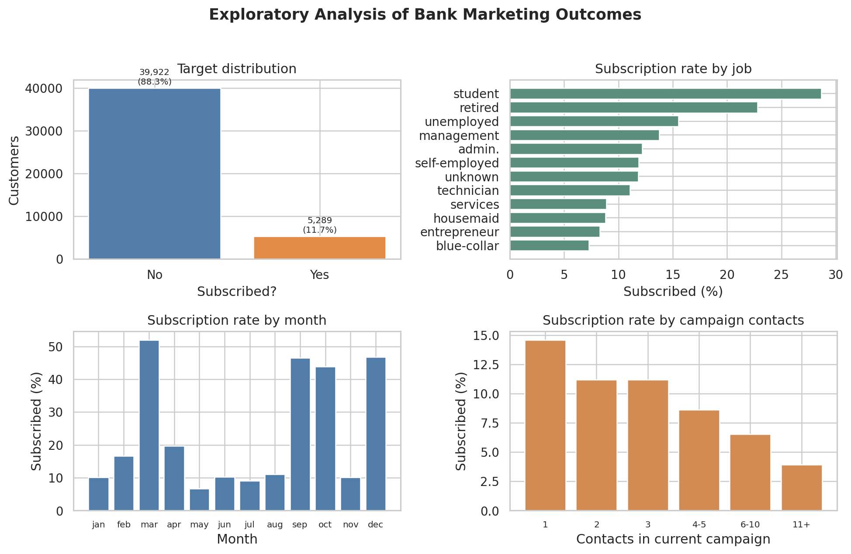
Figure 1. Target balance and observed subscription rates by job, month, and campaign contact count.

Evidence-based observations
- Job category: students had the highest observed subscription rate (28.7%; 269 of 938), followed by retired customers (22.8%; 516 of 2,264). Blue-collar customers had a lower observed rate (7.3%; 708 of 9,732). These are historical associations, not causal effects.
- Contact month: March had a 52.0% subscription rate (248 of 477), followed by December (46.7%; 100 of 214) and September (46.5%; 269 of 579). These groups are much smaller than May, so their rates are less stable and should not be interpreted without sample-size context.
- Campaign repetition: subscription rates tend to be lower among customers contacted more often in the current campaign. Repeated calls should therefore be managed carefully and evaluated against contact cost and customer experience.
Other descriptive analysis in the notebook also compares subscription rates by age group. All EDA percentages describe the supplied historical dataset and may reflect confounding by campaign timing, customer profile, or selection practices.

3. Model Performance Comparison
All four classifiers were fitted on the same 36,168 training records and evaluated on the same 9,043 test records. The “yes” class is treated as the positive class. Metrics below are generated by the executed code.
Model | Accuracy | Precision | Recall | F1-score | ROC-AUC
Decision Tree | 0.870 | 0.418 | 0.293 | 0.345 | 0.680
Random Forest | 0.896 | 0.668 | 0.218 | 0.329 | 0.803
K-Nearest Neighbours | 0.889 | 0.576 | 0.198 | 0.294 | 0.714
Logistic Regression | 0.893 | 0.664 | 0.178 | 0.280 | 0.772

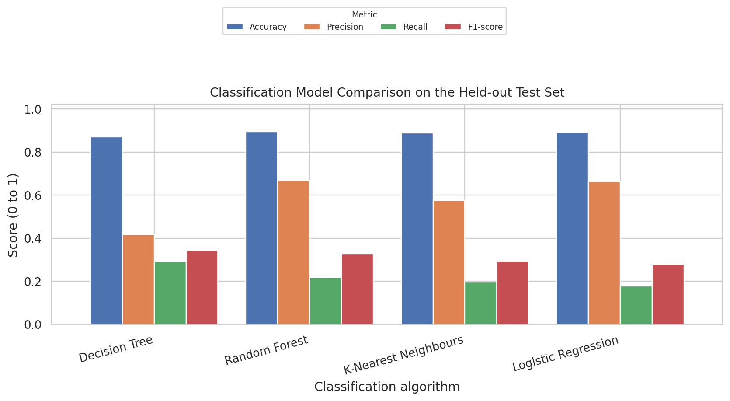
Figure 2. Accuracy, precision, recall, and F1-score on the held-out test set.

Interpretation
Decision Tree achieved the highest F1-score (0.345) and recall (0.293) among the four models, so it is selected under the stated criterion of maximizing F1-score, with ROC-AUC as a tie-breaker. Random Forest had the highest precision (0.668) and ROC-AUC (0.803), making it a strong alternative when the bank values fewer false-positive contacts and better ranking. Logistic Regression attained 89.3% accuracy, but its recall was only 0.178; the target imbalance makes its accuracy appear stronger than its ability to find subscribers.
The selected Decision Tree’s accuracy (87.0%) is below the 88.3% majority-class baseline. It is selected for its better precision-recall balance rather than overall accuracy; it still misses many subscribers and would need further tuning before operational use.

4. Confusion Matrix Analysis
The confusion matrices reveal the types of errors each model makes. False negatives are actual subscribers classified as “no”; false positives are non-subscribers classified as “yes.” The choice depends on whether the bank prioritizes reaching more potential subscribers or avoiding unnecessary calls.
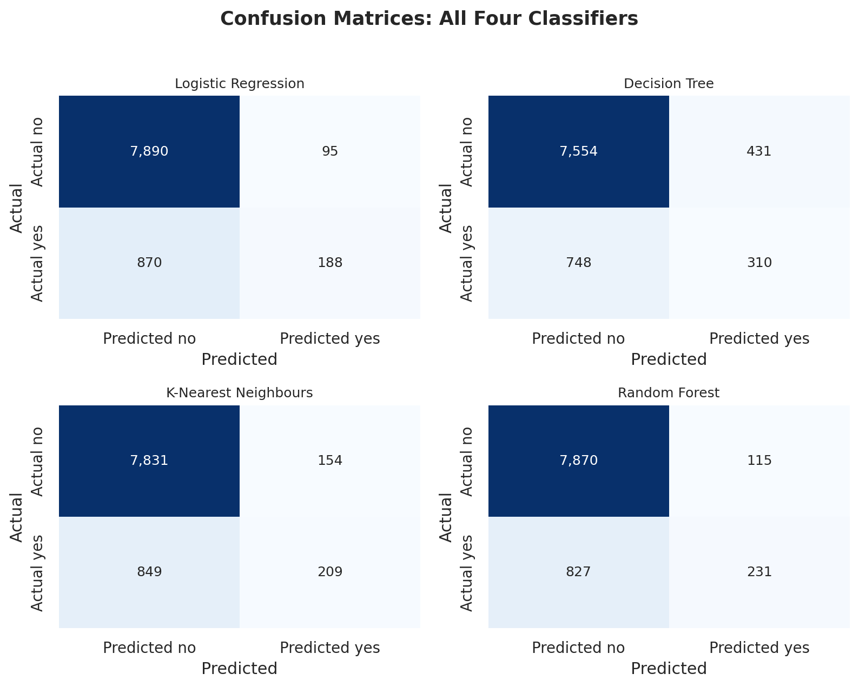
Figure 3. Confusion matrices for all four classifiers (test set, 9,043 customers).
Model | False Positives | False Negatives | True Positives
Logistic Regression | 95 | 870 | 188
Decision Tree | 431 | 748 | 310
K-Nearest Neighbours | 154 | 849 | 209
Random Forest | 115 | 827 | 231

What the errors mean
The Decision Tree identifies 310 subscribers but misses 748 (recall 29.3%), and it produces 431 false-positive contacts. Random Forest generates fewer false positives (115) and identifies 231 subscribers, but misses 827 subscribers. Logistic Regression misses 870 subscribers at the default 0.50 threshold. These results show a precision-recall trade-off; threshold tuning or cost-sensitive learning may improve business utility, but any tuning should use a validation set rather than repeatedly optimizing on the final test set.

5. ROC Analysis, Recommendation, and Conclusion
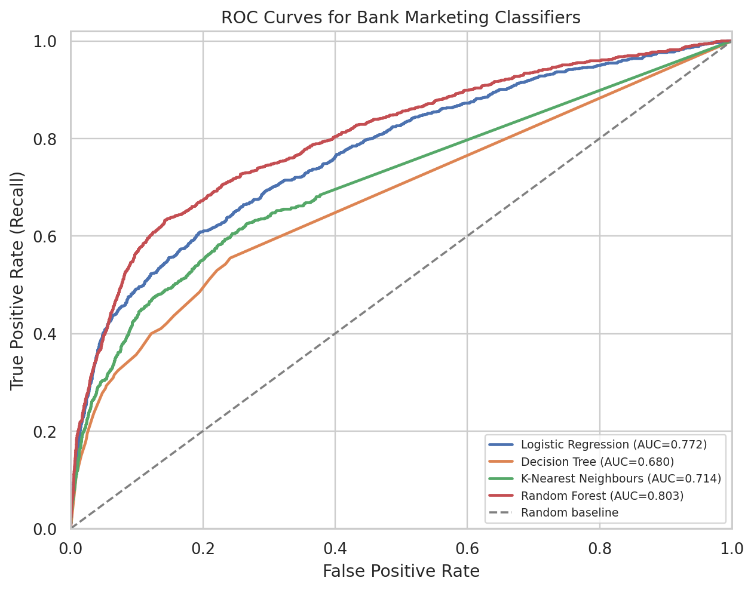
Figure 4. ROC curves compare true-positive and false-positive rates across thresholds.
Random Forest achieved the highest ROC-AUC (0.803), followed by Logistic Regression (0.772), KNN (0.714), and Decision Tree (0.680). ROC-AUC measures ranking across thresholds, while F1-score uses a fixed classification threshold; these metrics can select different models.

Recommended model and business use
For this assignment, select the Decision Tree because it has the highest test F1-score (0.345), the best observed precision-recall balance at the default 0.50 threshold among these four configurations. If the bank has a limited call budget and values high precision, Random Forest may be preferable; business costs should guide the final threshold and choice.
- Recommendation 1: Use predicted probabilities to rank call lists and pilot a high-probability segment. Track conversion, cost per subscription, and customer complaints against a control group.
- Recommendation 2: Tune the threshold on a validation set to reflect false-positive and false-negative costs. Evaluate recall, precision, and campaign profit, not just accuracy.

Limitations
- The target is imbalanced, and the default threshold misses many subscribers. Calibrate the model to campaign objectives.
- This is one historical split with fixed settings. Campaign behavior can change and `unknown` categories are ambiguous; validate on later campaigns and use cross-validation before deployment.

Conclusion
Decision Tree is the F1-based choice in this run, while Random Forest leads in precision and ROC-AUC. Validate newer campaigns and tune for business cost; predictions should support, not replace, marketing judgment.

Reference
Moro, S., Laureano, R., & Cortez, P. (2011). Using Data Mining for Bank Direct Marketing: An Application of the CRISP-DM Methodology. Proceedings of the European Simulation and Modelling Conference (ESM’2011), 117–121.

