CASE STUDY REPORT
TITANIC SURVIVAL
PREDICTION
Using Logistic Regression
Exploratory Data Analysis • Preprocessing • Model Evaluation • Interpretation

Academic detail | Information
Name | Md. Siddiq Juber
Roll Number | 160124733363
Section | CSE-3
Year | III Year
Subject | Fundamentals of Data Science
Faculty Name | Smt. S. Durga Devi

Dataset: Titanic passenger records (891 rows)

Executive Summary
This case study develops a binary classification model to estimate whether a passenger in the supplied Titanic dataset survived. The analysis includes descriptive exploration, visualizations, missing-value handling, categorical encoding, logistic-regression training, held-out evaluation, coefficient interpretation, and a saved model pipeline for a Streamlit demo.
Main result: on a stratified 20% test set (179 passengers), the model achieved 79.9% accuracy and ROC-AUC 0.844. These figures describe this fixed split and are not a guarantee of future performance.

1. Problem Statement
Given passenger characteristics, predict the binary target Survived (0 = did not survive, 1 = survived). The goal is to apply the data-science workflow prescribed in the assignment and explain the findings rather than present charts or scores without interpretation.

Objectives
- Inspect feature types, descriptive statistics, class balance, missing values, distributions, and relationships.
- Prepare usable predictors by imputing missing values, scaling numeric inputs, and encoding categorical inputs.
- Train logistic regression using a reproducible, stratified train/test split.
- Report accuracy, precision, recall, F1-score, ROC-AUC, a ROC curve, and a confusion matrix.
- Interpret model coefficients and make the trained pipeline available to a Streamlit app.

2. Dataset Overview
Item | Finding
Rows / columns | 891 rows and 12 columns
Target | Survived: 0 = did not survive; 1 = survived
Survived | 342 (38.4%)
Did not survive | 549 (61.6%)
Numeric predictors used | Age, SibSp, Parch, Fare
Categorical predictors used | Pclass, Sex, Embarked

PassengerId, Name, Ticket, and Cabin are not included in this baseline. PassengerId is an identifier; Name and Ticket are high-cardinality text fields that could require feature engineering; Cabin is missing for most records.

3. Exploratory Data Analysis

3.1 Target class distribution
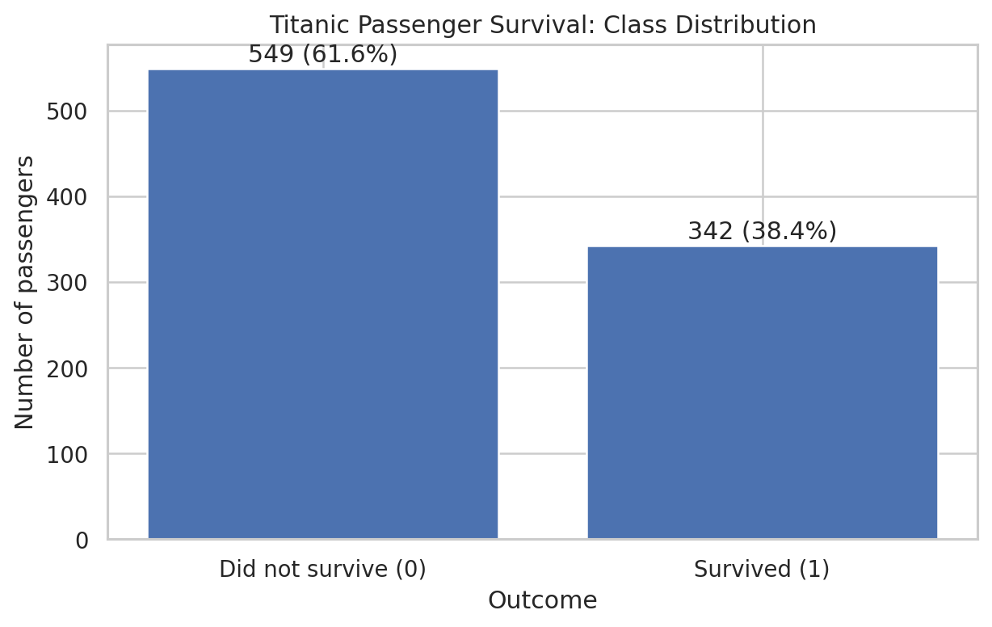
Figure 1. Count and proportion of passengers in each survival class.
Interpretation. The data contains 549 non-survivors and 342 survivors. The observed survival rate is 38.4%; non-survivors form the larger class. Because the target is not evenly split, the report uses precision, recall, F1-score, and ROC-AUC in addition to accuracy.

Observed target values
Outcome | Count | Share
Did not survive (0) | 549 | 61.6%
Survived (1) | 342 | 38.4%

3.2 Observed survival rate by sex
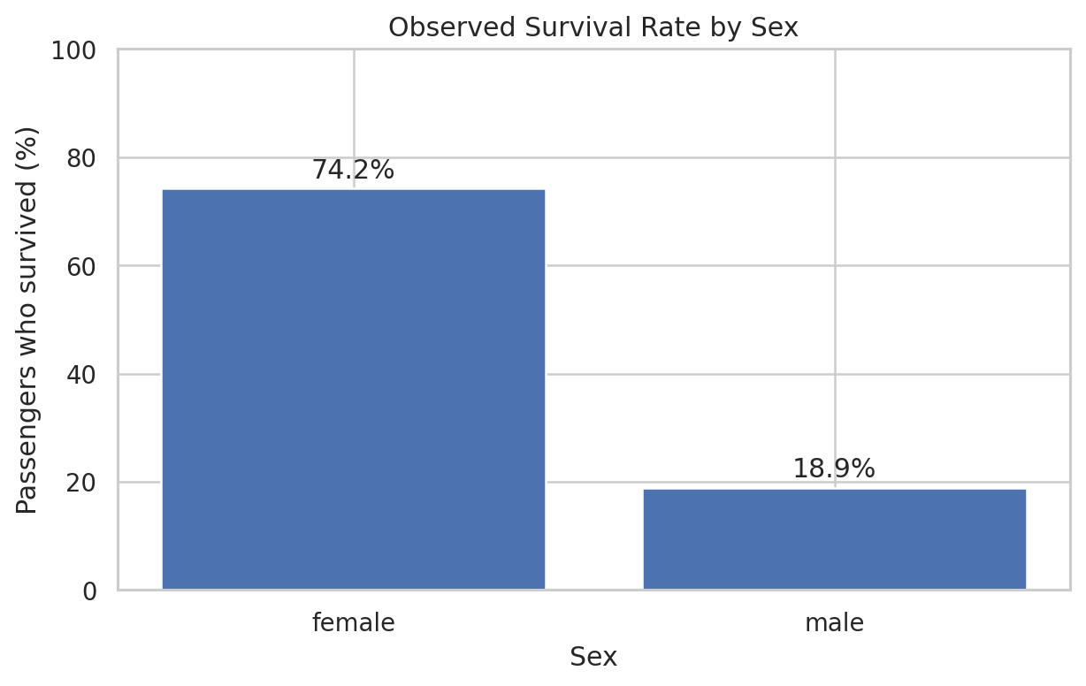
Figure 2. Percentage of passengers who survived, grouped by recorded sex.
Interpretation. The observed survival rate was 74.2% among female passengers and 18.9% among male passengers. This is a large descriptive difference in the supplied data and is reflected in the fitted model, but it should not be interpreted as a causal effect.

3.3 Observed survival rate by passenger class
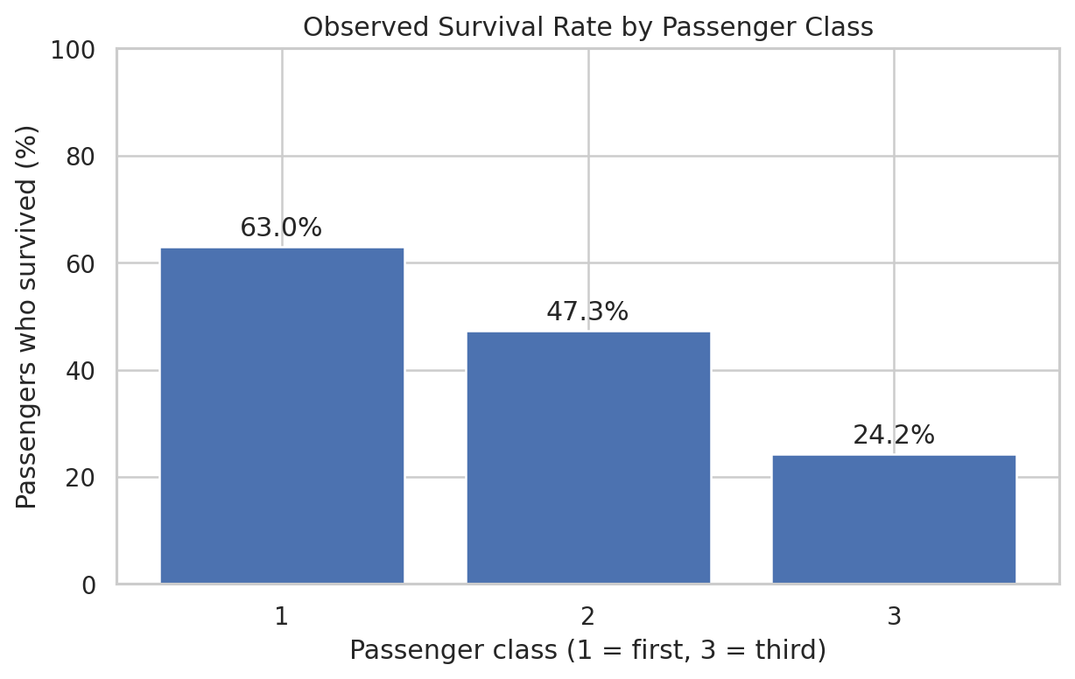
Figure 3. Percentage of passengers who survived, grouped by passenger class.
Interpretation. Observed survival rates were 63.0% in first class, 47.3% in second class, and 24.2% in third class. Survival rates decrease across these class groups in the dataset. Class may be associated with several other passenger characteristics, so this pattern alone does not explain the mechanism.

3.4 Age distribution by survival outcome
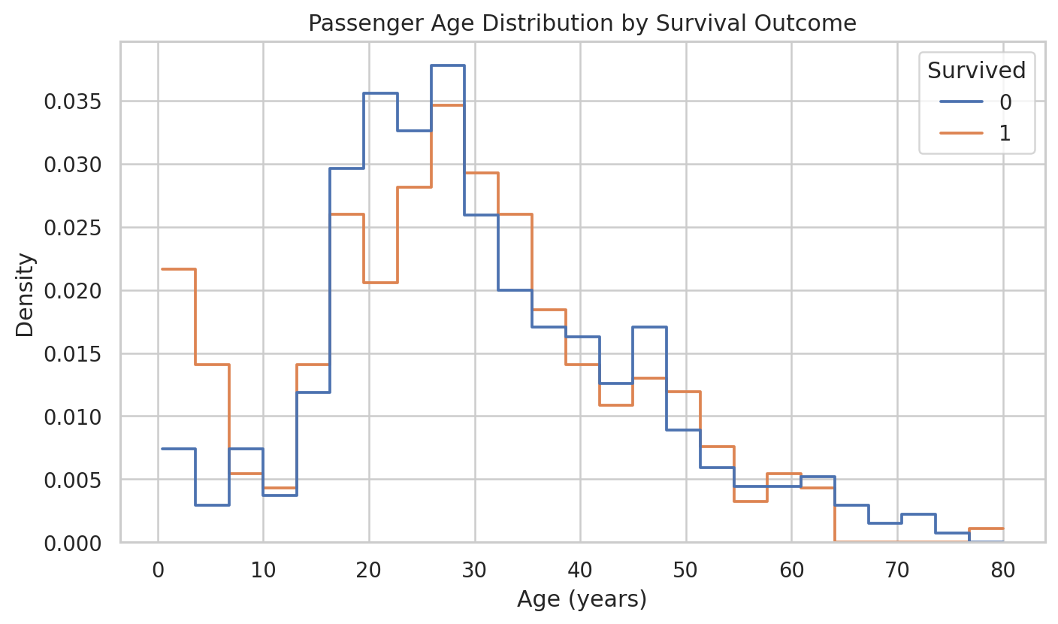
Figure 4. Age distributions for the two observed survival outcomes.
Interpretation. The age distributions overlap, meaning age alone cannot separate survivors from non-survivors. The plot includes available ages; missing ages are handled later inside the training pipeline so that test data do not determine imputation values.

3.5 Missing values
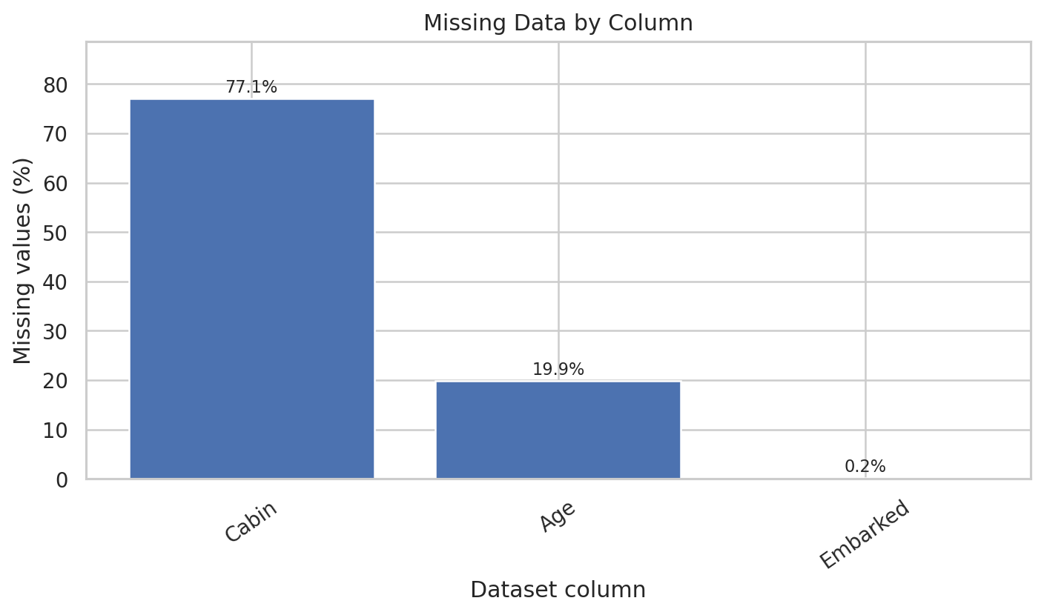
Figure 5. Percentage of missing observations in columns with at least one missing value.
Interpretation. Age is missing in 177 rows (19.9%), Cabin in 687 rows (77.1%), and Embarked in 2 rows (0.2%). Cabin is omitted from the baseline because of its high missingness; the selected predictors are imputed by the model pipeline.

3.6 Correlation among selected numeric columns
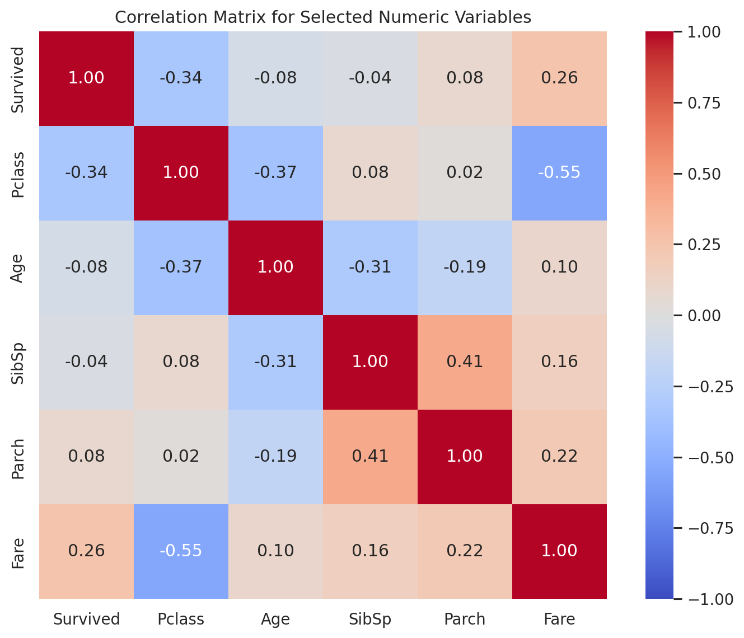
Figure 6. Pairwise Pearson correlation coefficients among selected numeric columns.
Interpretation. The heatmap summarizes linear pairwise correlation. In this dataset, Survived has a negative correlation with Pclass as its numeric coding increases from first to third class, and a positive correlation with Fare. This is a descriptive comparison; Pearson correlation does not establish causation, and Pclass is treated as categorical in the model rather than assuming equal numeric spacing.

Feature-type review
Feature type | Columns | Model treatment
Integer / numeric | PassengerId, Survived, Pclass, SibSp, Parch | Survived is target; PassengerId excluded; Pclass encoded categorically; SibSp/Parch numeric
Floating-point | Age, Fare | Median imputation and standardization
Categorical / text | Name, Sex, Ticket, Cabin, Embarked | Sex and Embarked encoded; Name/Ticket omitted; Cabin omitted for missingness

4. Methodology and Data Preprocessing

4.1 Predictor selection
The target is Survived. Seven predictors are retained: Age, SibSp, Parch, Fare, Pclass, Sex, and Embarked. The identifier PassengerId is excluded; Name and Ticket are left out because this baseline does not engineer information from high-cardinality text; Cabin is excluded because 77.1% of its values are missing.

4.2 Train/test split
Setting | Choice
Training fraction | 80% (712 rows)
Test fraction | 20% (179 rows)
Random seed | 42
Stratification | Yes, preserving the target class proportion in both sets
Classification threshold | 0.50 probability

4.3 Preprocessing pipeline
- Numeric features (Age, SibSp, Parch, Fare): median imputation followed by standard scaling.
- Categorical features (Pclass, Sex, Embarked): most-frequent imputation followed by one-hot encoding with the first category dropped as a reference.
- All preprocessing is fit on the training split as part of a scikit-learn Pipeline and ColumnTransformer, then applied to test data using the learned transformations.
- Classifier: scikit-learn LogisticRegression with max_iter = 2000 and random_state = 42.

Why logistic regression?
The target is binary and logistic regression estimates the probability of the positive class. It is a transparent baseline because coefficients can be inspected, but its results depend on the selected features, preprocessing, split, and classification threshold.

5. Model Evaluation
The model is evaluated once on the held-out test set of 179 passengers. All predictions in the following table use the default threshold of 0.50.
Metric | Score | Percent / value | Meaning
Accuracy | 0.7989 | 79.9% | Fraction of all test predictions that are correct.
Precision | 0.7797 | 78.0% | Among passengers predicted to survive, the fraction who survived.
Recall | 0.6667 | 66.7% | Among actual survivors, the fraction identified by the model.
F1-score | 0.7188 | 71.9% | Harmonic mean of precision and recall.
ROC-AUC | 0.8436 | 0.844 | Ranking ability over a range of classification thresholds.

5.1 ROC curve
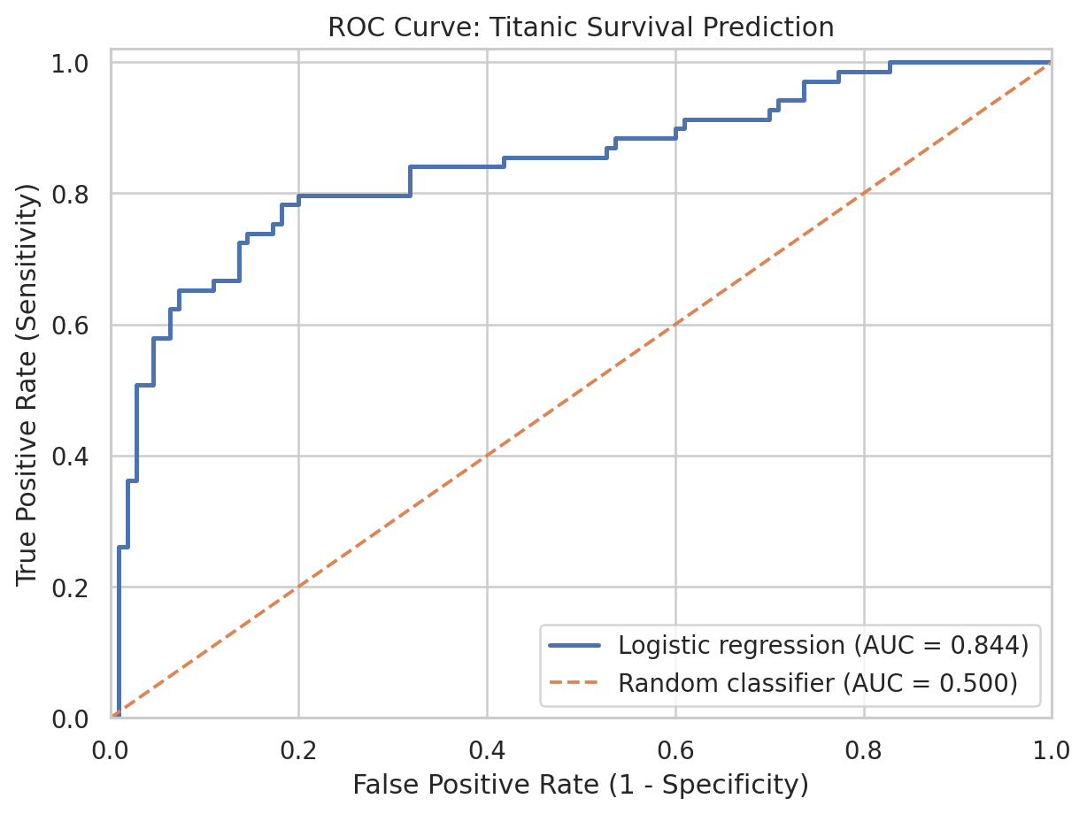
Figure 7. True-positive rate versus false-positive rate across decision thresholds.
Interpretation. The ROC-AUC is 0.844, above the 0.500 random-classifier reference. It indicates the model ranks positive cases above negative cases reasonably well on this split. ROC-AUC is not the same as accuracy or the probability that any individual prediction is correct.

5.2 Confusion matrix and error analysis
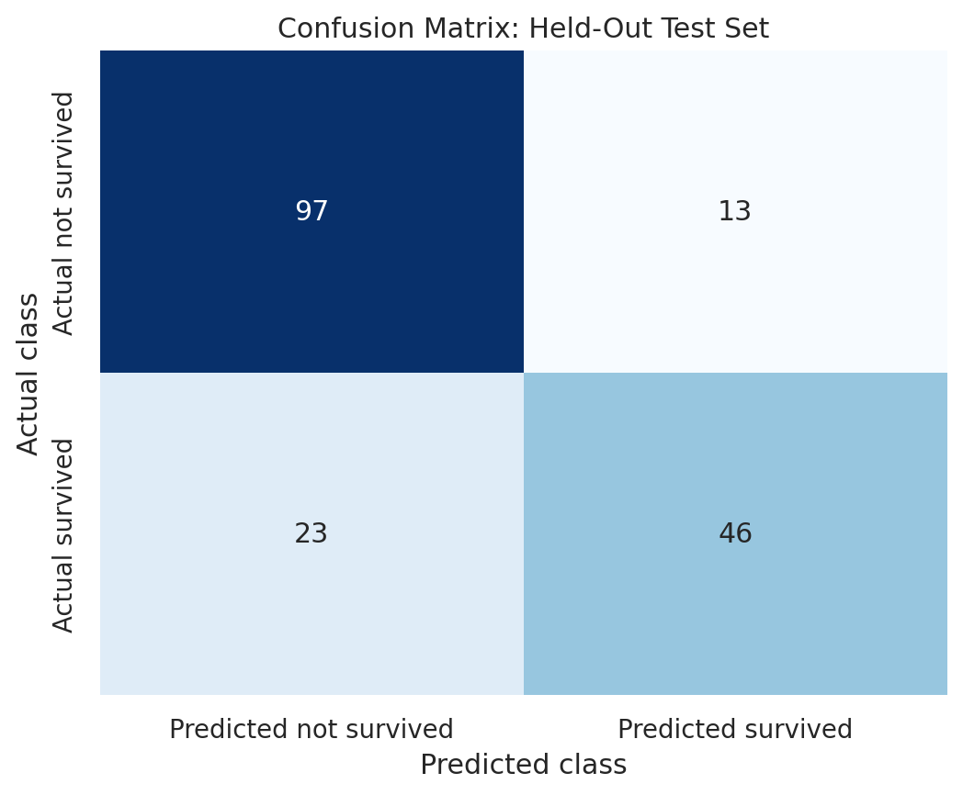
Figure 8. Counts of correct and incorrect predictions on the test set.
Outcome | Count | Meaning
True negative (TN) | 97 | Predicted did not survive; actual did not survive.
False positive (FP) | 13 | Predicted survived; actual did not survive.
False negative (FN) | 23 | Predicted did not survive; actual survived.
True positive (TP) | 46 | Predicted survived; actual survived.

Interpretation. The model correctly classified 143 of 179 passengers. It produced 13 false positives and missed 23 actual survivors (false negatives). Recall is lower than precision here because the model misses about one-third of the actual survivors at the 0.50 threshold. A different threshold may raise recall but can also increase false positives.

Metric interpretation at a glance
- Accuracy (79.9%) gives the overall correctness rate, but can hide differences between classes.
- Precision (78.0%) is useful when false positive survivor predictions matter.
- Recall (66.7%) shows that about two-thirds of actual survivors are identified at the current threshold.
- F1 (71.9%) summarizes the precision/recall balance; ROC-AUC (0.844) summarizes ranking across thresholds.

6. Interpretation of Logistic Regression Coefficients
A logistic-regression coefficient is on the log-odds scale. Positive coefficients increase modeled survival log-odds and negative coefficients decrease them, holding the other included features constant. The exponentiated coefficient is the odds ratio.
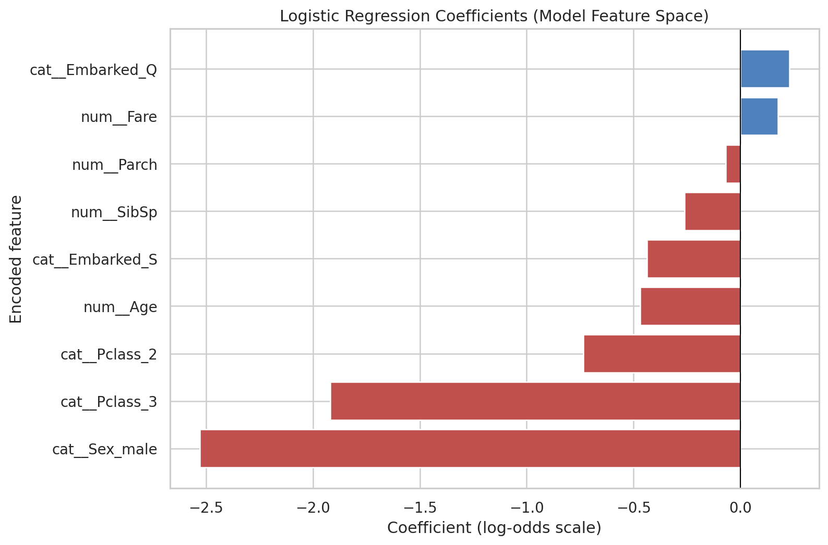
Figure 9. Coefficients for standardized numeric and one-hot encoded categorical features.
Feature comparison | Coefficient | Odds ratio
Male vs female (reference) | -2.530 | 0.080
Third vs first class (reference) | -1.920 | 0.147
Second vs first class (reference) | -0.735 | 0.480
Age (per 1 SD increase) | -0.469 | 0.626
Fare (per 1 SD increase) | 0.175 | 1.191
Siblings/spouses (per 1 SD increase) | -0.261 | 0.770
Southampton vs Cherbourg (reference) | -0.438 | 0.645
Queenstown vs Cherbourg (reference) | 0.229 | 1.257

Interpretation. The male indicator has a strongly negative coefficient (odds ratio about 0.08 relative to female, adjusted for the selected predictors). Third class also has a strongly negative coefficient relative to first class (odds ratio about 0.15). Age has a negative coefficient per standard deviation, while Fare has a modest positive coefficient. These are model associations, not causal effects. Numeric coefficients are interpreted per one standard deviation because the numeric columns were scaled. The reference categories are first class, female, and Cherbourg.
The coefficient plot does not report p-values or confidence intervals. Do not call a feature statistically significant based only on its coefficient size; formal statistical inference was outside the scope of this baseline analysis.

7. Conclusion
The case study completes an end-to-end binary-classification workflow on 891 Titanic passenger records. The model achieved 79.9% accuracy, 78.0% precision, 66.7% recall, an F1-score of 71.9%, and ROC-AUC 0.844 on the held-out test split. EDA showed substantial observed survival-rate differences by recorded sex and passenger class. The model coefficients show similar associations after adjustment for the selected predictors.

Limitations and future improvements
- Results depend on a single stratified split; cross-validation would give a more stable performance estimate.
- The dataset is historical and may reflect social and sampling biases; predictions should not be generalized casually.
- Cabin is mostly missing, and Name/Ticket were not feature-engineered in this baseline.
- The 0.50 threshold is a default; threshold tuning, probability calibration, and a cost-sensitive error analysis could be explored.
- Coefficient sizes are not proof of causality; confidence intervals and statistical tests were not calculated.

8. Streamlit Deployment
The project includes app.py. It loads the complete preprocessing + logistic-regression pipeline and accepts passenger class, sex, age, siblings/spouses, parents/children, fare, and embarkation port. It displays estimated survival probability and a class prediction at the 0.50 threshold.
Run locally: install packages with `pip install -r requirements.txt`, run `python analyze.py` to create the trained model, then run `streamlit run app.py`.

9. GitHub Submission
The repository package includes the executed Jupyter notebook, Python analysis and Streamlit files, requirements, dataset, figure files, model artifacts, metric outputs, and README. Create a GitHub repository, then initialize, commit, add the remote, and push the project as described in README.md. The GitHub URL should be submitted alongside this PDF.
Before final submission, replace the placeholders on the title page with the correct roll number, section, and faculty name, and verify the repository visibility/access rules required by the course.

