
DATA MINING PROJECT REPORT
Stock Trade Analysis of the Oil & Gas Sector in Pakistan
Pakistan Stock Exchange (PSX): 2016 to 2026

Team Members

Abdul Basit (22F-BSAI-25)
Muhammad Hammad (22F-BSAI-39)
Muhammad Sohaib (22F-BSAI-40)
Omaid Ejaz (22F-BSAI-45)
Wajhi-Ur-Rahman (22F-BSAI-50)

Submitted to: Engr. Bushra Sheikh

Table of Contents
Abstract 3
1. Introduction 4
1.1 Background & Motivation 4
1.2 Problem Statement 4
1.3 Objectives 4
2. Dataset Description 5
2.1 Data Source & Companies 5
2.2 Data Attributes 6
2.3 Dataset Overview 6
3. Methodology 7
3.1 Data Preprocessing 7
3.2 Feature Engineering 8
3.3 Feature Selection 9
3.4 Data Transformation & Splitting 9
3.5 Data Splitting & Chronological Validation 10
4. Model Development 11
4.1 Algorithms Benchmarked 11
4.2 Hyperparameter Tuning 12
4.3 Model Selection Rationale 14
5. Results & Evaluation 15
5.1 Baseline Model Performance 15
5.2 Tuned Model Performance 15
5.3 Overfitting Analysis 16
6. Dashboard & Deployment 17
7. Conclusion 23
8. References 24

Abstract
This report presents a comprehensive data mining and machine learning study applied to the Oil and Gas sector of the Pakistan Stock Exchange (PSX). The study spans a decade of daily trading data (2016–2026) encompassing 17 listed companies, amounting to tens of thousands of records. The primary objective is to build an accurate, interpretable model capable of predicting next-day and 15-day future stock prices.
A rigorous pipeline was constructed covering data collection, preprocessing, feature engineering, feature selection, model benchmarking, hyperparameter tuning, and deployment. Thirteen machine learning models from diverse algorithm families were evaluated using chronologically stratified train-test splits to prevent data leakage. The Tuned Random Forest Regressor emerged as the optimal model, achieving a Test R-Squared of 99.84% and a Mean Absolute Percentage Error (MAPE) of 2.21%, demonstrating excellent generalization with minimal overfitting.
The final solution is deployed as an interactive Streamlit web application featuring exploratory data analysis (EDA) dashboards, candlestick charts, 15-day autoregressive forecasts, and a manual prediction module — providing a complete financial intelligence platform for the PSX energy sector.

1. Introduction

1.1 Background & Motivation
The Pakistan Stock Exchange (PSX) is the primary securities market of Pakistan, hosting hundreds of listed companies across multiple sectors. The Oil and Gas sector holds particular economic significance, as it underpins energy production, refining, distribution, and infrastructure across the country. Price movements in this sector are influenced by global crude oil prices, domestic regulatory policy, currency fluctuations, and macroeconomic cycles.
With the rapid advancement of machine learning and the growing availability of historical financial data, data-driven forecasting has become a critical tool for investors, analysts, and policymakers. Accurate short-term price prediction enables better portfolio management, risk mitigation, and strategic investment decisions.

1.2 Problem Statement
Despite the availability of a decade of PSX trading data, there is a lack of a unified, data-driven forecasting framework specifically for the Pakistani Oil and Gas sector. Traditional technical analysis methods are limited in their ability to model complex, non-linear relationships between multiple financial variables. This project addresses that gap by developing an end-to-end machine learning pipeline that can predict next-day stock prices and generate 15-day rolling forecasts for all 17 Oil and Gas companies listed on the PSX.

1.3 Objectives
- Collect and consolidate 10 years of daily stock data for 17 PSX Oil and Gas companies.
- Perform thorough data preprocessing, cleaning, and feature engineering to create meaningful financial indicators.
- Benchmark a comprehensive set of machine learning algorithms across multiple families.
- Identify and deploy the best-performing model after rigorous hyperparameter tuning.
- Build an interactive, user-facing Streamlit dashboard for visualization, exploration, and real-time prediction.
- Generate 15-day autoregressive price forecasts using a rolling-window approach.

2. Dataset Description

2.1 Data Source & Companies
The dataset was compiled from publicly available PSX historical trading records. Daily OHLCV data was scraped and aggregated into a single unified CSV file. The study covers 17 companies spanning refining, exploration, distribution, and gas utilities sub-sectors.
The following 17 companies from the Pakistan Stock Exchange (PSX) are included in the dataset, categorized by their primary business operations:
1. Exploration & Production (E&P)
These companies focus on the discovery and extraction of oil and natural gas.
- MARI: Mari Petroleum Company Limited
- OGDC: Oil & Gas Development Company Limited
- POL: Pakistan Oilfields Limited
- PPL: Pakistan Petroleum Limited
2. Refining & Processing
Companies dedicated to refining crude oil into usable fuel and products.
- ATRL: Attock Refinery Limited
- NRL: National Refinery Limited
- PRL: Pakistan Refinery Limited
- CNERGY: Cnergyico PK Limited
3. Oil Marketing & Distribution
The consumer-facing side of the industry, managing gas stations and fuel supply chains.
- APL: Attock Petroleum Limited
- HASCOL: Hascol Petroleum Limited
- PSO: Pakistan State Oil Company Limited
- HTL: Hi-Tech Lubricants Limited
- WAFI: Wafi Energy Pakistan Limited
- OBOY: Oilboy Energy Limited
4. Gas Utilities & LPG
Entities responsible for the transmission, distribution, and sale of natural gas and LPG.
- SSGC: Sui Southern Gas Company Limited
- SNGP: Sui Northern Gas Pipelines Limited
- BLPL: Burshane LPG (Pakistan) Ltd.

2.2 Data Attributes
Each daily record contains the following raw attributes:
- Company & Symbol — Company name and PSX ticker code.
- Date — Trading date (business days only, excluding weekends and public holidays).
- Price (Close) — The closing price of the stock in Pakistani Rupees (PKR).
- Open — The opening price at the start of the trading session.
- High — The highest traded price during the session.
- Low — The lowest traded price during the session.
- Volume — Total number of shares traded, originally formatted as string shorthand (e.g., 1.5M, 200K).
- Change % — Percentage change from the previous session's closing price.

2.3 Dataset Overview
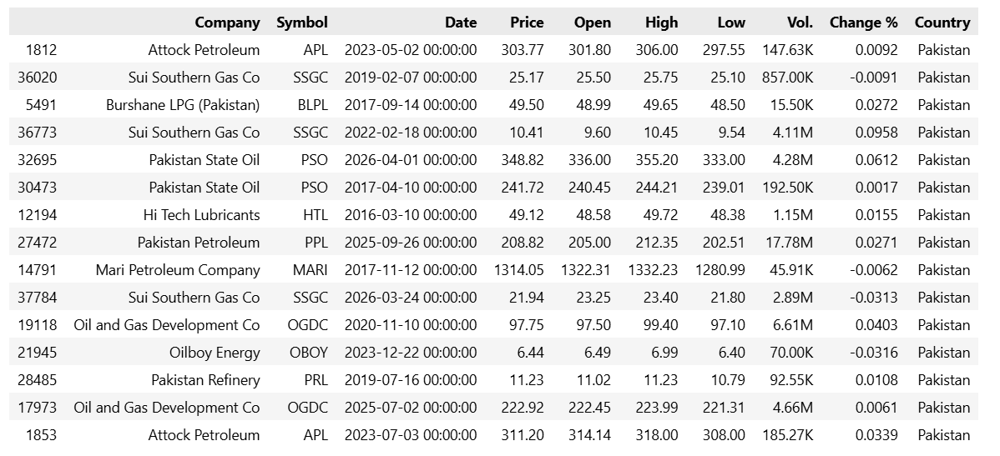

3. Methodology

3.1 Data Preprocessing
Raw data required extensive cleaning prior to analysis. The key preprocessing steps undertaken were:
- Volume Conversion: The Volume column was stored as abbreviated string values (e.g., '1.5M', '500K'). A custom parsing function was written to convert these into numeric integer values for mathematical operations.

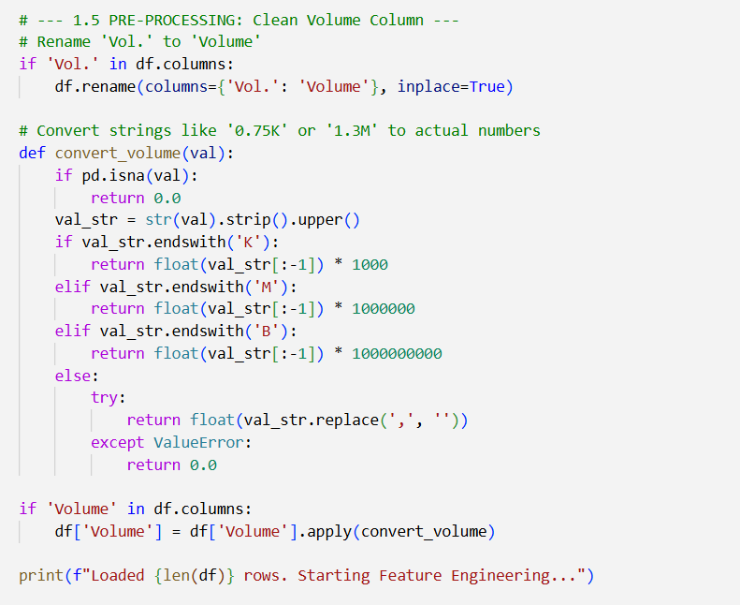

- Missing Value Handling: Records with null values in essential fields (Price, Open, High, Low) were identified and removed to ensure model integrity. For moving average features, records with insufficient historical lookback were similarly dropped.
- Data Type Correction: String-typed numeric columns were cast to float64. The Date column was parsed into a datetime index and used to extract temporal features.
- Duplicate Record Check: The dataset was scanned for duplicate Date–Symbol combinations and de-duplicated where applicable.

3.2 Feature Engineering
To improve the model's predictive accuracy, raw data was transformed into three primary categories of engineered features:
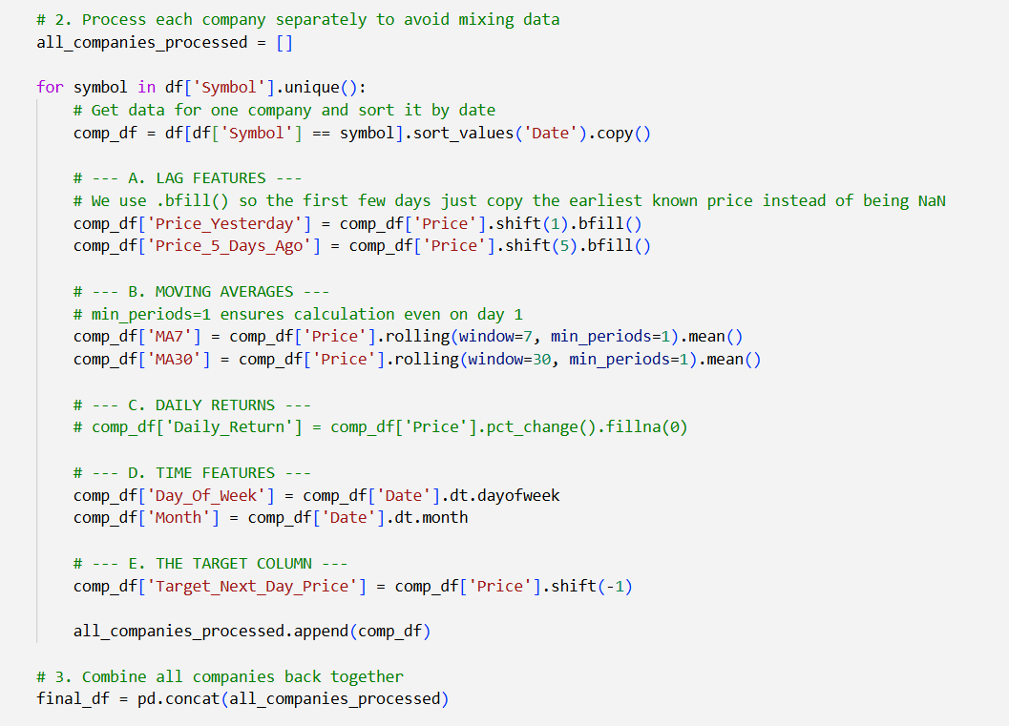
1. Lag Features
Lag features allow the model to understand immediate historical context by shifting price data from previous time steps.
- Price_Yesterday: The closing price from the immediately preceding trading day (1-day lag).
- Price_5_Days_Ago: The closing price recorded 5 trading days prior.
2. Moving Average Features
These features smooth out short-term fluctuations to highlight broader price trends.
- MA7 (Short-term): A 7-day rolling mean of closing prices, used to identify short-term momentum.
- MA30 (Medium-term): A 30-day rolling mean of closing prices, used to capture medium-term market trends.
3. Temporal Features
Temporal features encode time-based patterns and seasonality into numerical values the model can process.
- Day_Of_Week: An integer encoding of the specific trading day (where 0 = Monday and 4 = Friday).
- Month: The calendar month of the trading record, represented numerically from 1 to 12.
These features capture price momentum, short-term and medium-term trends, and weekly market cycle effects — all of which are well-established predictors in financial time-series modelling.

3.3 Feature Selection
To reduce noise and improve model efficiency, correlation-based feature selection was applied. Each feature's Pearson correlation coefficient with the target variable (Target_Next_Day_Price) was computed. Features with an absolute correlation below 5% (0.05) were eliminated.
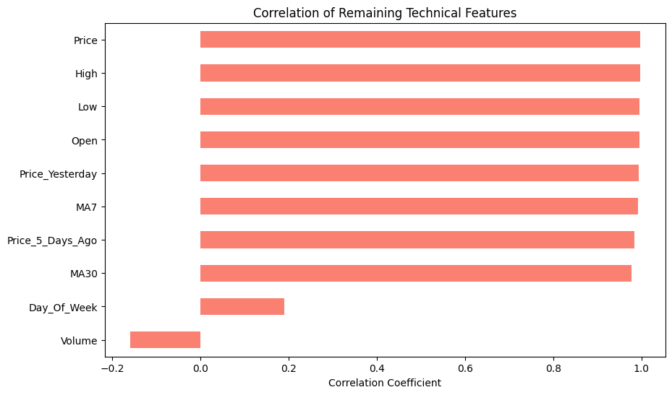
Figure 1
As illustrated in the correlation chart (Figure 1), the top-correlated features were Price, High, Low, Open, Price_Yesterday, MA7, Price_5_Days_Ago, and MA30 all with near-perfect correlation coefficients close to 1.0. Volume showed a negative correlation of approximately -0.17, and Day_Of_Week showed a modest positive correlation of around 0.20. Both were retained as they exceeded the 5% threshold, providing supplementary signal.

3.4 Data Transformation & Splitting
Two transformations were applied before model training:
- One-Hot Encoding (OHE): The categorical Symbol column (17 company tickers) was one-hot encoded, producing 17 binary columns. This enables a single multi-company model to learn company-specific price dynamics without assuming ordinal relationships.
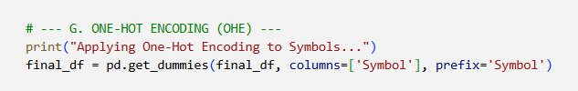
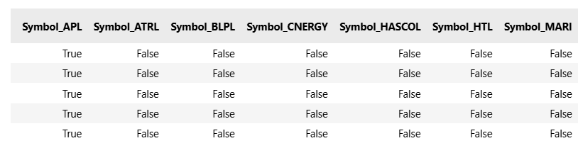

- Standard Scaling: All numerical features were normalized using StandardScaler (zero mean, unit variance). This is essential for distance-based models (KNN, SVR) and gradient-based algorithms to converge correctly. The fitted scaler was saved as oil_data_scaler.pkl for use during inference.
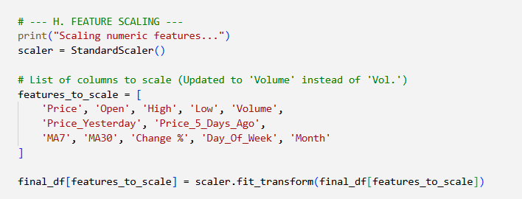
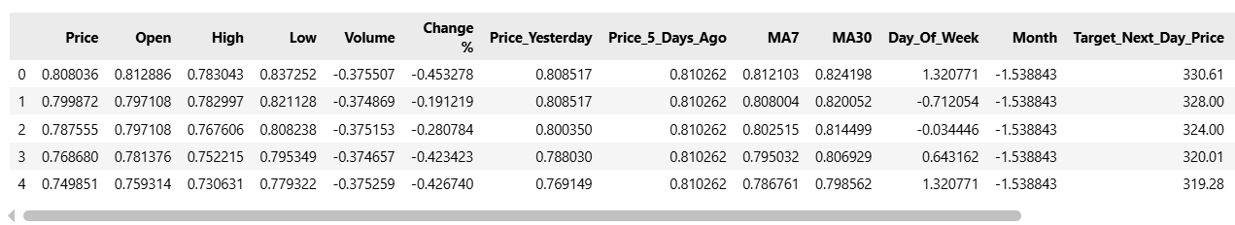

3.5 Data Splitting & Chronological Validation
Data was split into training and test sets using an 80/20 chronological split with shuffle=False. This preserves the temporal ordering of observations, which is critical for time-series forecasting — it prevents data leakage by ensuring the model is never trained on data from dates after those in the test set.
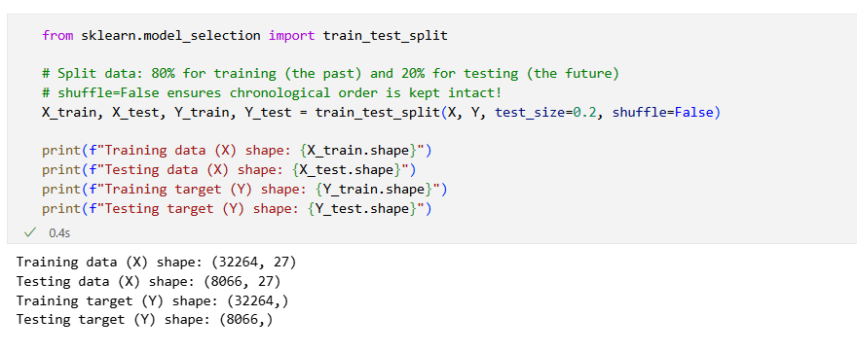

4. Model Development

4.1 Algorithms Benchmarked
Thirteen machine learning algorithms from four major families were evaluated in the baseline comparison phase:
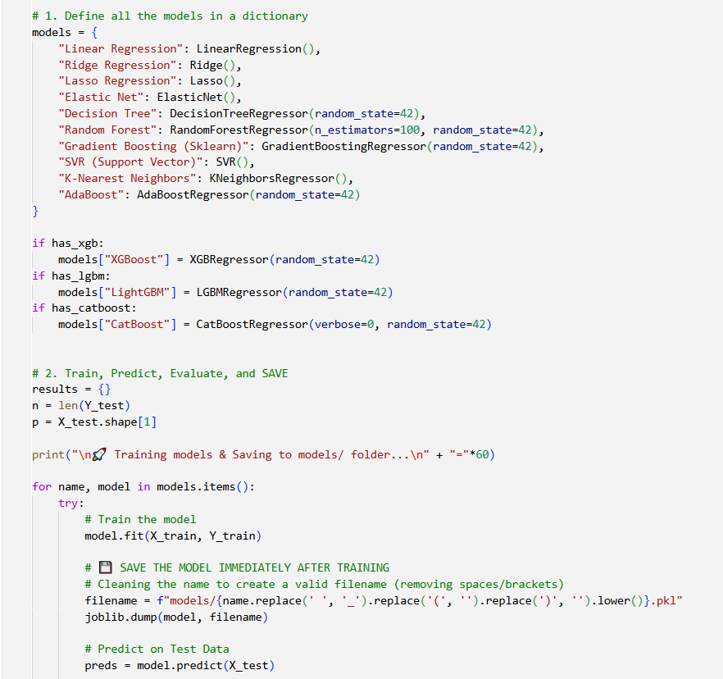

To identify the most accurate forecasting model, several algorithms were evaluated based on their unique architectural characteristics:
- Linear Regression: Utilizes ordinary least squares to provide a highly interpretable baseline.
- Ridge Regression: Implements L2 regularization to reduce coefficient magnitudes and prevent overfitting.
- Lasso Regression: Employs L1 regularization, which performs implicit feature selection by zeroing out less important variables.
- Elastic Net: A hybrid approach that combines both L1 and L2 penalties for more robust regularization.
- Decision Tree: Uses non-linear splits; provides high detail but is prone to overfitting without proper pruning.
- Random Forest: Uses a bagging technique with multiple trees to create a robust, low-variance model.
- AdaBoost: An adaptive boosting technique that builds sequential weak learners to improve accuracy.
- Gradient Boosting: A standard Scikit-learn implementation of boosting that utilizes shrinkage for better generalization.
- XGBoost: An optimized gradient boosting library that includes built-in regularization.
- LightGBM: Uses a leaf-wise growth strategy, making it exceptionally fast on large datasets.
- CatBoost: Utilizes ordered boosting and is specifically designed to handle categorical variables natively.
- SVR (Support Vector Regression): Uses an epsilon-insensitive loss function; highly effective in high-dimensional feature spaces.
- K-Nearest Neighbors (KNN): An instance-based learner that predicts values based on the average of the local neighborhood.

4.2 Hyperparameter Tuning
After the baseline benchmark, the top-performing candidate models were subjected to systematic hyperparameter optimisation using two strategies:
- GridSearchCV: Exhaustive search over a predefined parameter grid. Applied to smaller models (Ridge, Lasso, Elastic Net, Decision Tree, KNN, SVR) where the parameter space is manageable.
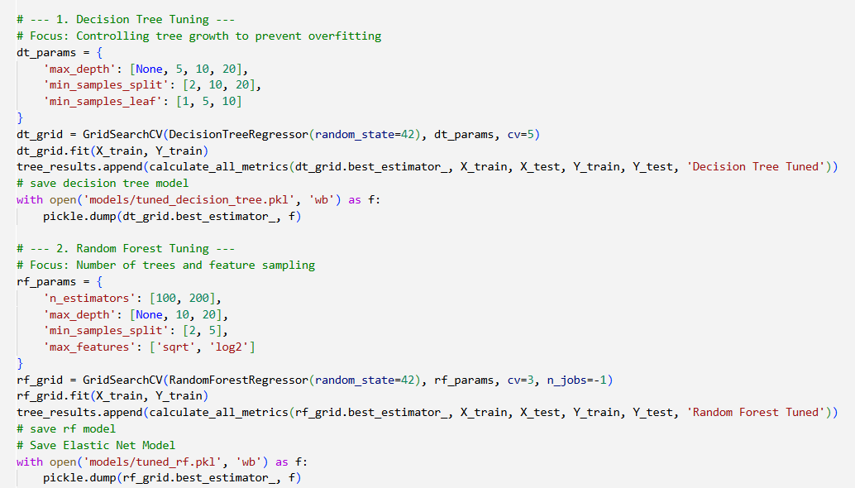
- RandomizedSearchCV: Stochastic search with cross-validation. Applied to larger ensemble models (Random Forest) where exhaustive search would be computationally prohibitive.

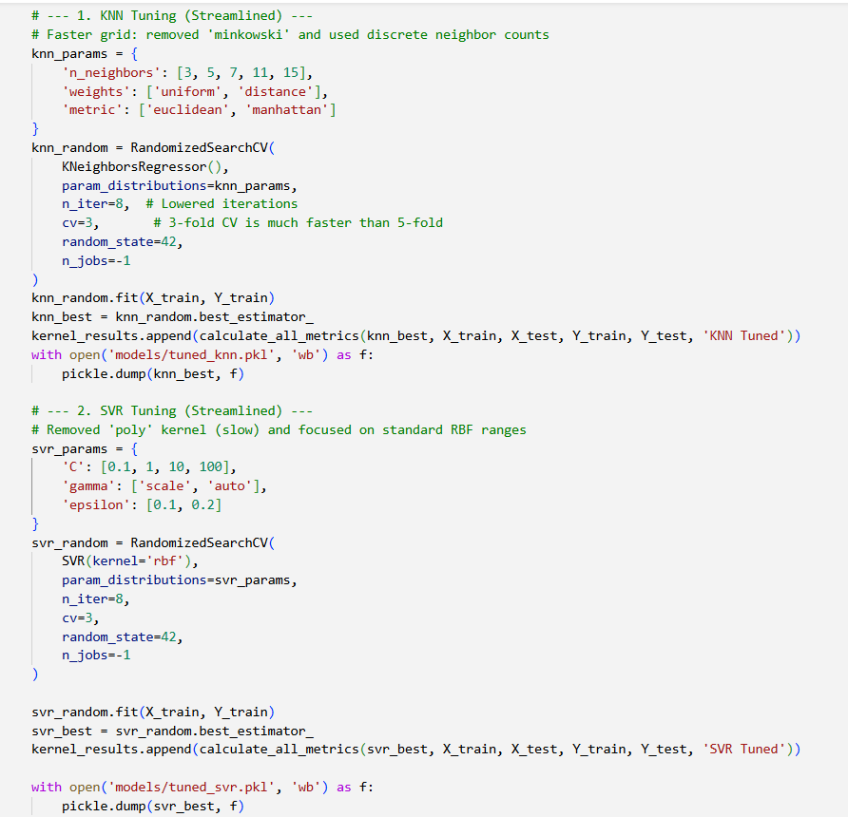

A 5-fold time-series cross-validation strategy was employed in all searches, ensuring that each fold respected the temporal ordering of data. The scoring metric used was negative Mean Squared Error (MSE). Tuned models were evaluated on the held-out test set after tuning was complete.

4.3 Model Selection Rationale
The Tuned Random Forest Regressor was selected as the production model for the following reasons:

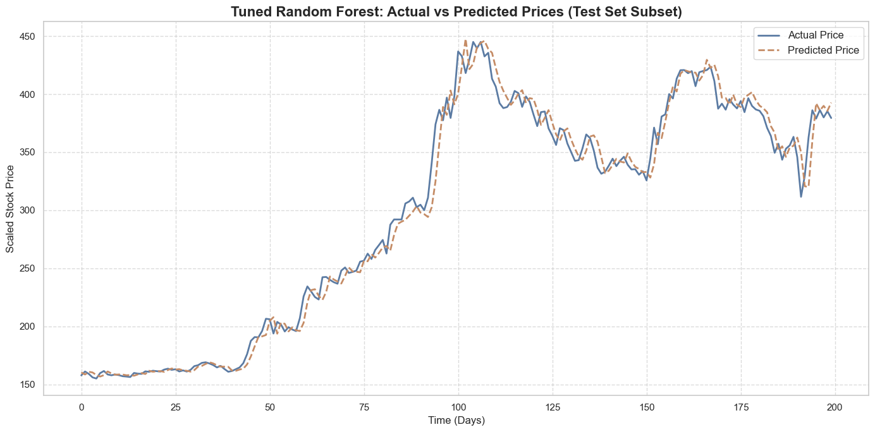e

- Superior Test Accuracy: Achieved 99.84% Test R-Squared — the highest among all tuned models — with a MAPE of 2.21%.
- Minimal Overfitting: The gap between Train R² (99.81%) and Test R² (99.84%) is essentially zero (difference: 0.0003), indicating excellent generalisation without memorising the training data.
- Non-linearity Handling: Stock prices exhibit complex, non-linear dynamics that linear models cannot capture adequately. Random Forests naturally model these through recursive binary splits.
- Robustness: Ensemble averaging across hundreds of decision trees reduces variance and makes the model resilient to outliers and market anomalies.
- Feature Importance: Random Forests natively compute feature importances, enabling transparent, explainable AI — a critical factor for financial applications.
- Consistency: Unlike KNN (which showed perfect Train R² = 1.0, indicating overfitting) or SVR (unstable across splits), Random Forest demonstrated consistent reliability.

5. Results & Evaluation

5.1 Baseline Model Performance
The following table reports the performance of all 13 baseline (untuned) models on the test set, ranked by R-Squared from highest to lowest:

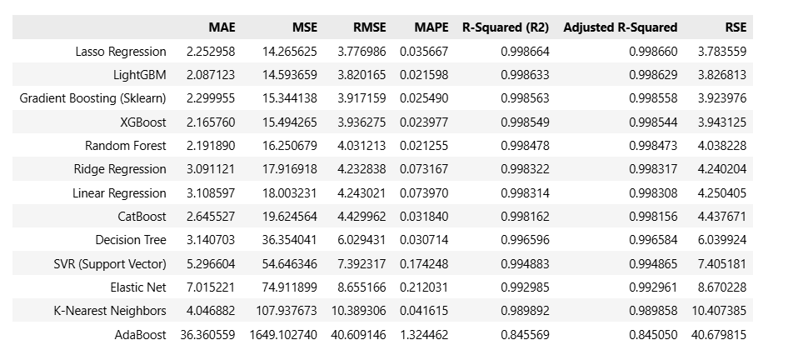

Key observations from the baseline evaluation: Most gradient boosting variants (LightGBM, XGBoost, Gradient Boosting) and Random Forest performed comparably around 99.85% R-Squared. AdaBoost was a clear outlier with only 84.56% accuracy, while SVR showed severe underfitting on the training set (69.50% Train R²) despite decent test performance — indicating it failed to learn the underlying patterns from the training data.

5.2 Tuned Model Performance
After hyperparameter tuning, seven models were re-evaluated. Results below show the improvement achieved through tuning:

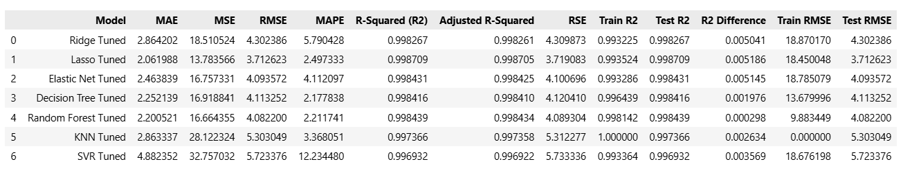
The Tuned Random Forest stands out for its near-identical Train and Test R² scores (difference of only 0.0003), making it the most generalizable model. While Lasso Tuned achieved a marginally higher Test R² (99.87%), its MAPE of 2.50% is higher than Random Forest's 2.21%, and it does not support feature importance natively.

5.3 Overfitting Analysis
Overfitting occurs when a model memorises the training data and fails to generalise to unseen data. The R² difference between Train and Test performance was used as the primary overfitting indicator:
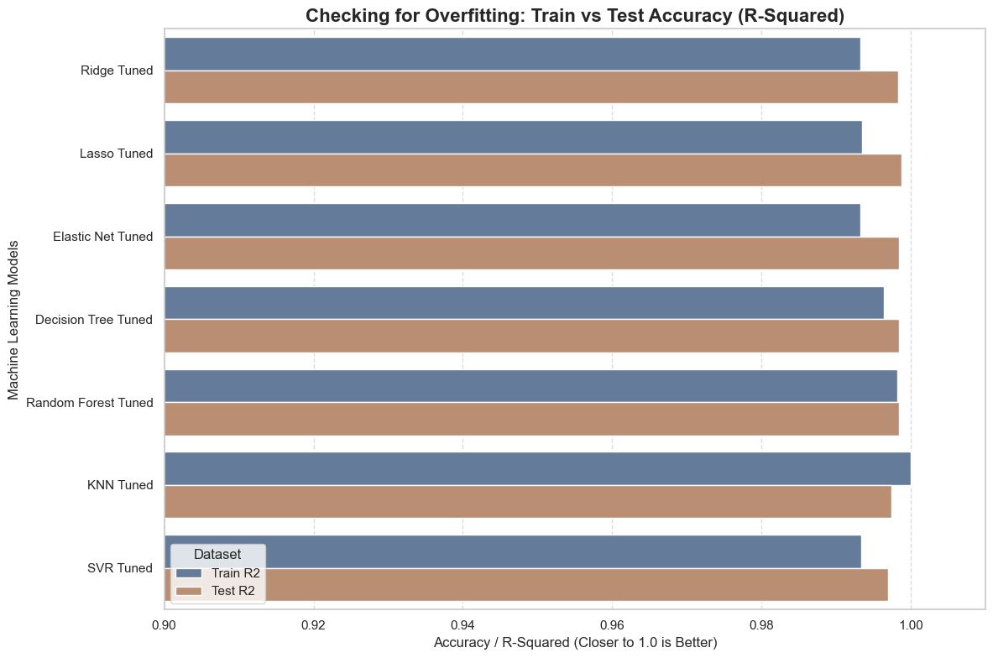
- Random Forest Tuned: R² difference of 0.0003 — virtually zero overfitting. Train RMSE: 9.88 vs. Test RMSE: 4.08, where the lower test RMSE reflects the model's strong generalisation on the chronologically more recent test window.
- KNN Tuned: Train R² = 1.0 (perfect) but Test R² = 99.74% — a clear sign of overfitting to training instances.
- Decision Tree (Baseline): Train R² = 100.00% vs. Test R² = 99.66% — classic overfitting from unlimited tree depth; resolved after tuning with max_depth constraints.
- SVR (Baseline): Train R² = 69.50% vs. Test R² = 99.49% — an extreme case of underfitting on train data, which was partially corrected after tuning.

6. Dashboard & Deployment
The complete pipeline was deployed as an interactive web application built with the Streamlit framework in Python. The dashboard is structured into six functional tabs:
1. Dashboard Overview
Provides a high-level project summary and sector context. This section includes the model selection rationale and key performance indicators (KPIs) presented in an "at-a-glance" format for quick assessment.
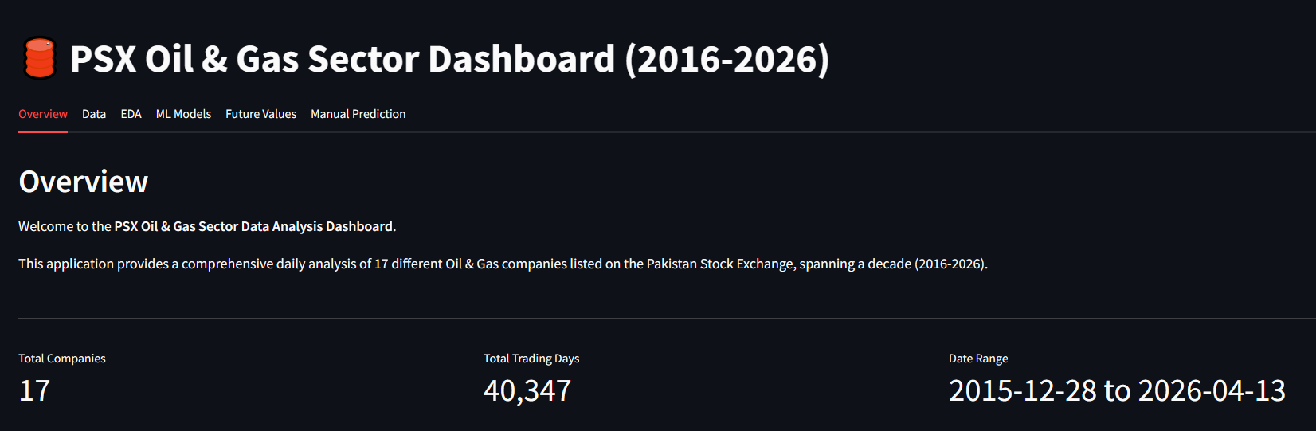



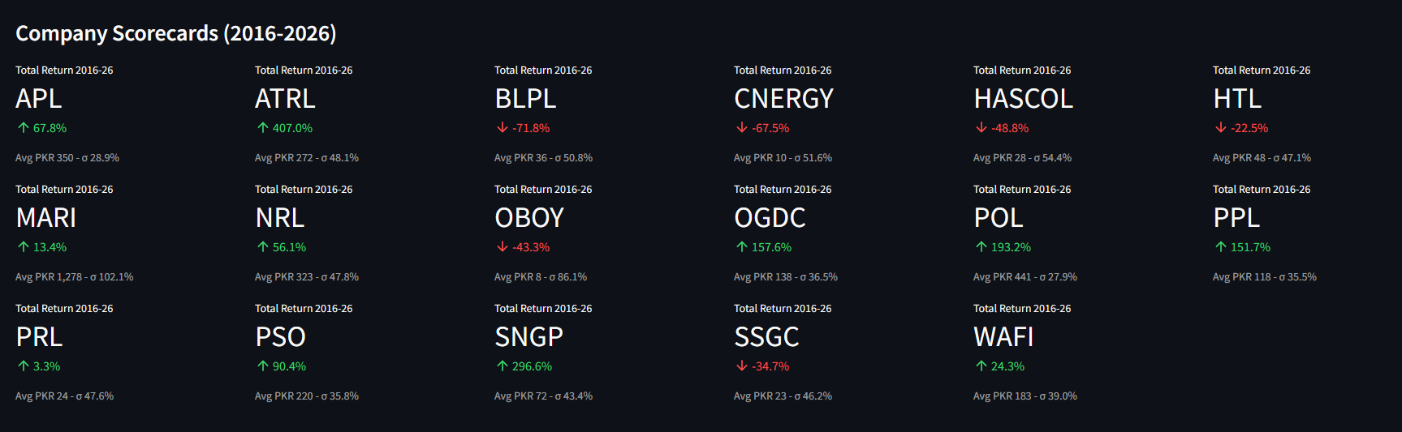

2. Dashboard Data Management
Features an interactive data table that allows users to filter information by company, date, and price range. It also includes functionality to download filtered datasets as CSV files.
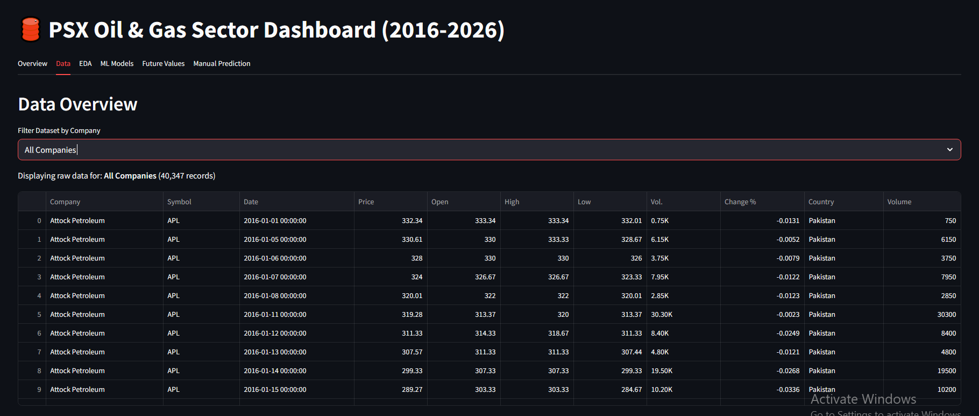
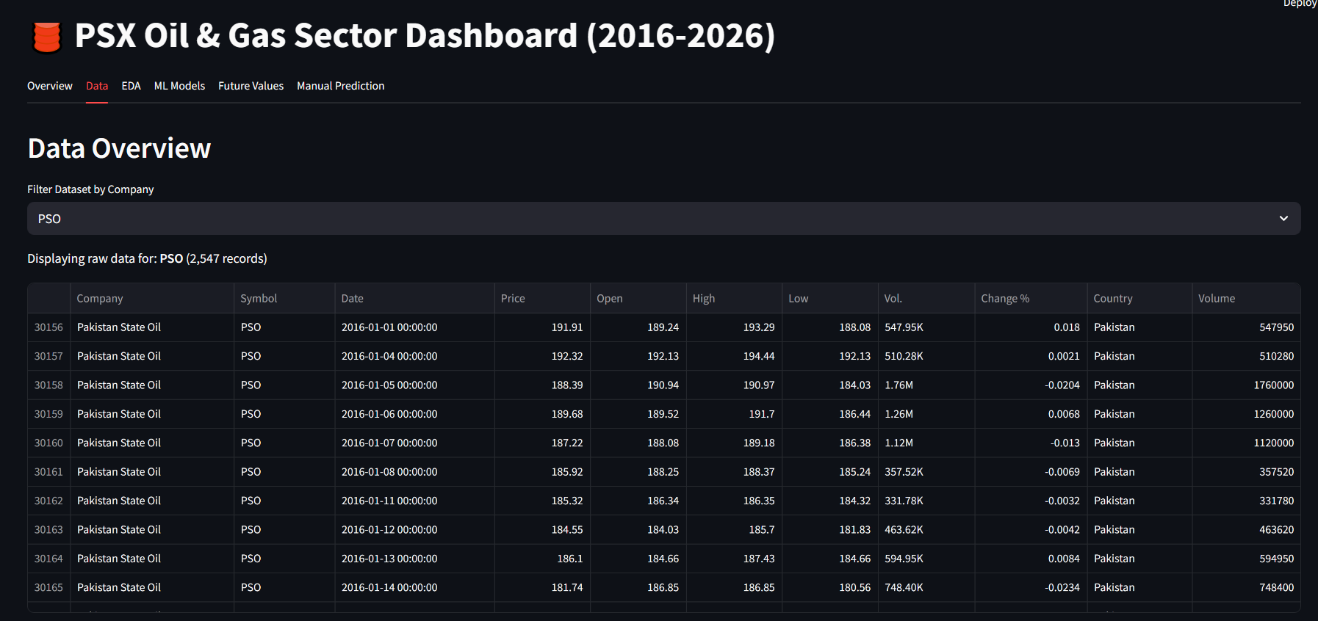
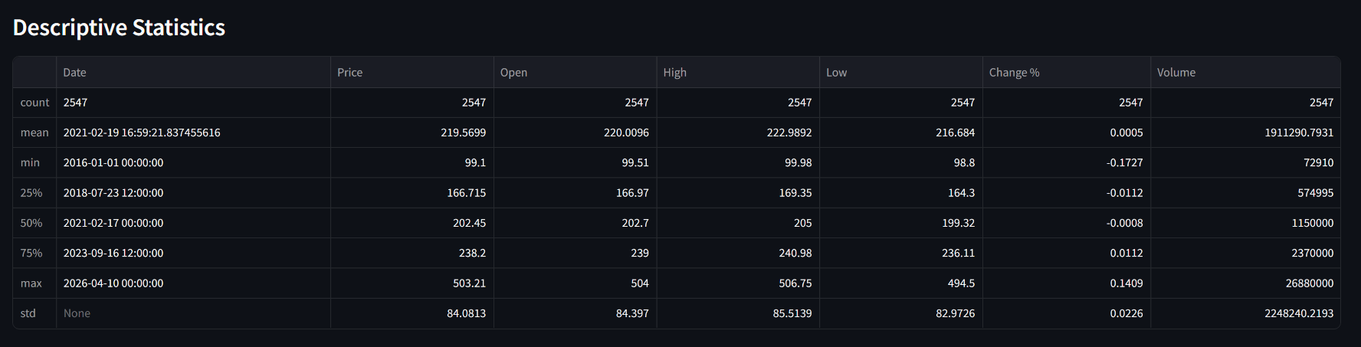

3. Dashboard Exploratory Data Analysis (EDA)
Contains interactive Plotly visualizations, including candlestick charts (OHLCV), volume bar charts, and price distribution histograms. It also features 7-day and 200-day moving average overlays for technical analysis

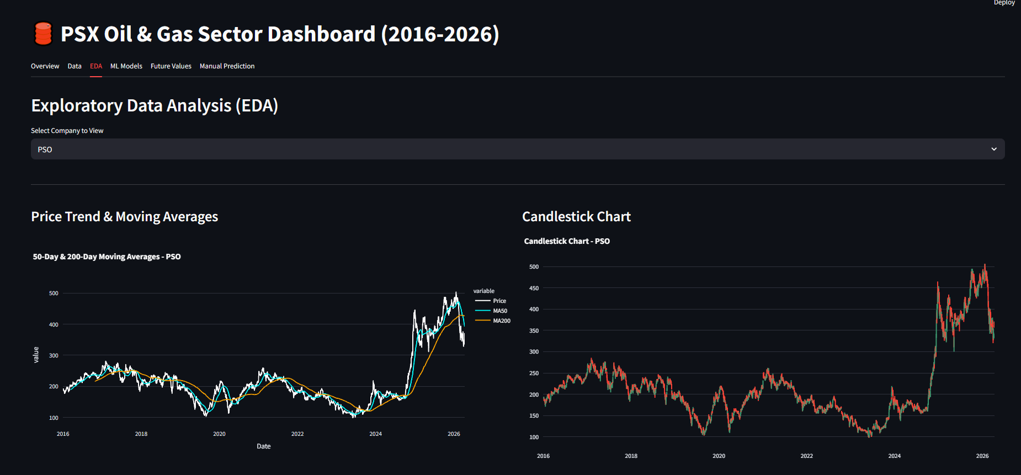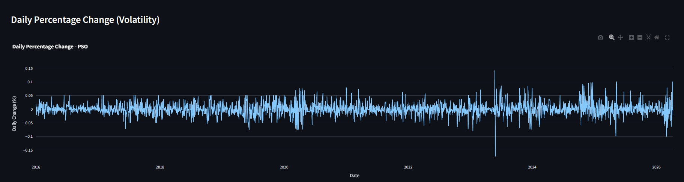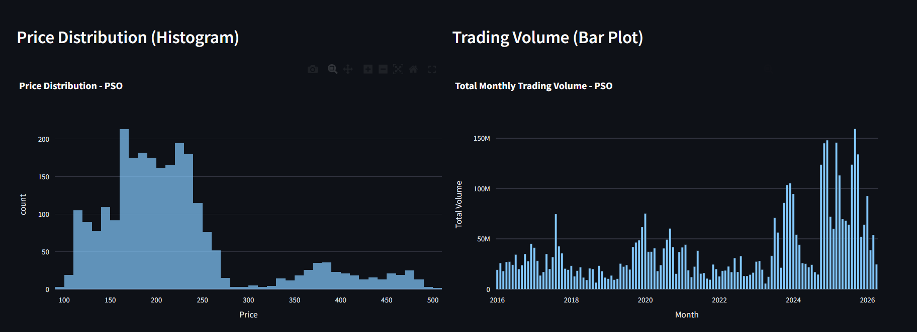

4. Dashboard ML Model Insights
Displays the technical performance of the machine learning pipeline. This includes feature importance bar charts, correlation heatmaps, model benchmark comparisons, and an "Actual vs. Predicted" chart for the Tuned Random Forest.

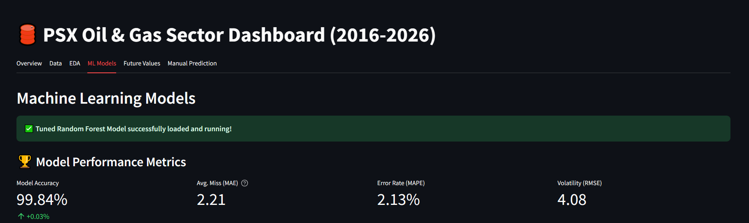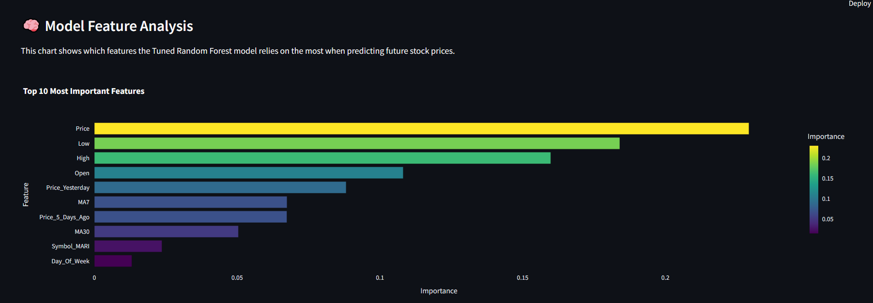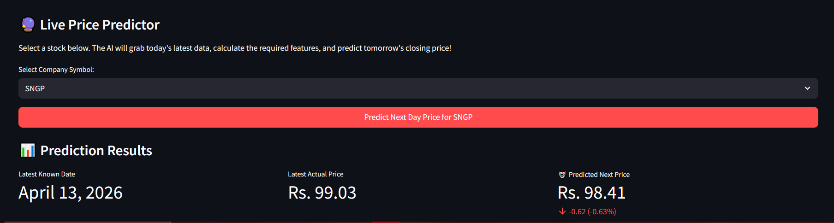

5. Dashboard Future Value Forecasts
Presents 15-day autoregressive price forecasts for all 17 companies. Data is displayed in a scrollable, card-based layout featuring predicted prices, directional trend icons, and daily percentage changes.

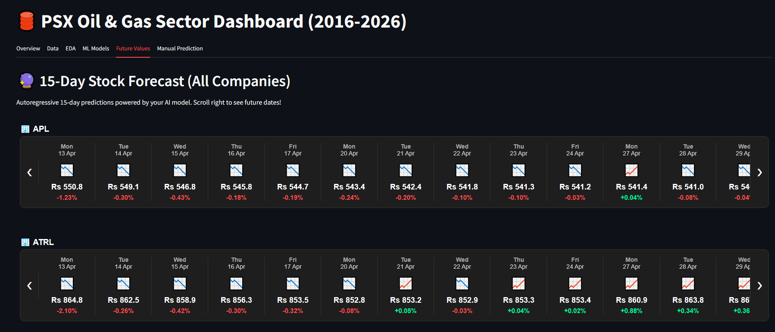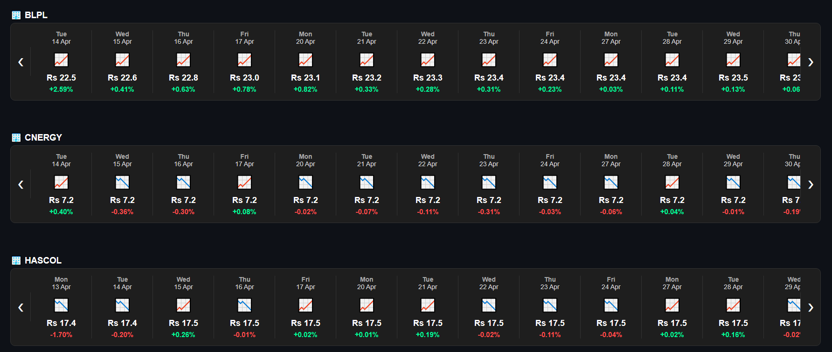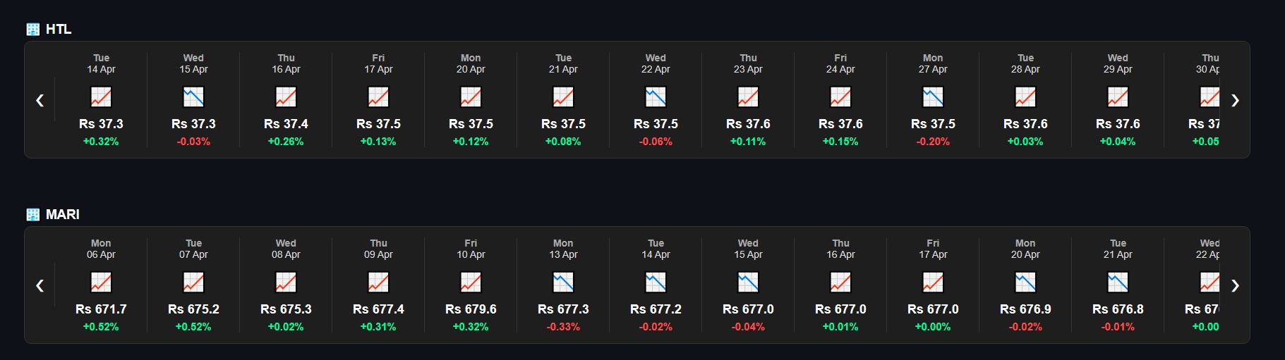

6. Dashboard Manual Prediction Tool
A user-facing interface designed for analysts to input custom OHLCV values. The system processes these inputs through the deployed model to provide an instant, next-day price prediction.
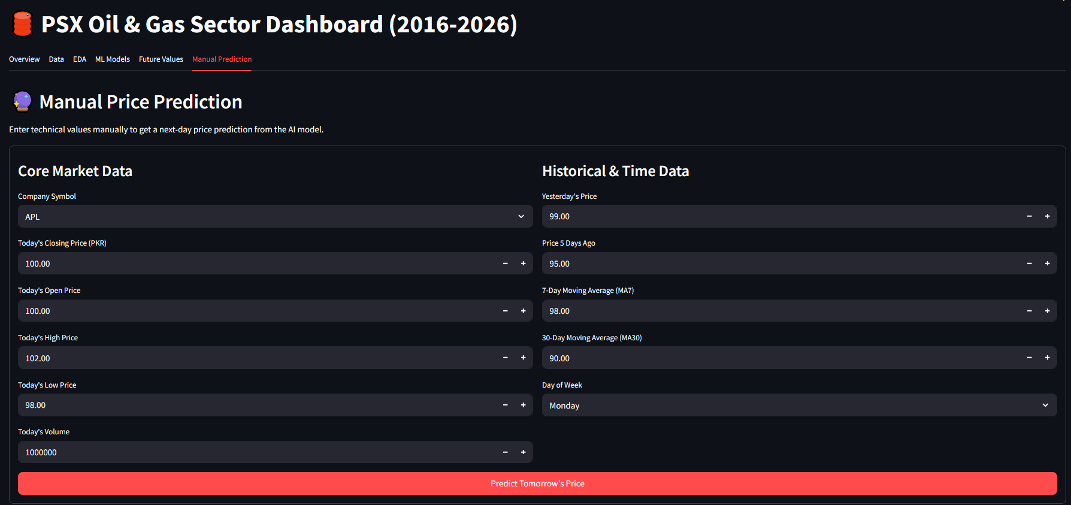

Final Verdict
The Streamlit application loads the pre-trained tuned_rf.pkl model and oil_data_scaler.pkl scaler at startup. All visualisations use Plotly for interactive chart rendering. The application is configured for wide-layout mode and features a dark theme consistent with professional financial dashboards.

7. Conclusion
This project successfully developed and deployed a comprehensive data mining and forecasting system for the PSX Oil and Gas sector. Starting from a decade of raw, unstructured daily trading data across 17 companies, the pipeline systematically progressed through preprocessing, feature engineering, feature selection, model benchmarking, hyperparameter tuning, and production deployment.
The Tuned Random Forest Regressor emerged as the optimal model with a Test R-Squared of 99.84% and a MAPE of 2.21%, demonstrating that short-term PSX Oil and Gas stock prices are highly predictable from their own recent historical momentum — particularly through lag features and moving averages. The model's near-zero gap between training and test performance confirms that it generalises well without overfitting.
The 15-day autoregressive forecasting module provides actionable medium-term outlooks for all covered companies, while the Streamlit dashboard delivers these insights through an intuitive, professional interface accessible to non-technical stakeholders. This project demonstrates that rigorous data science methodology — when applied to domain-relevant financial data — can yield powerful predictive tools with real-world applicability in the Pakistani capital markets.

8. References
- Pakistan Stock Exchange (PSX). Historical Data Portal. https://www.psx.com.pk/
- Breiman, L. (2001). Random Forests. Machine Learning, 45(1), 5–32.
- Chen, T., & Guestrin, C. (2016). XGBoost: A Scalable Tree Boosting System. Proceedings of KDD 2016.
- Ke, G., et al. (2017). LightGBM: A Highly Efficient Gradient Boosting Decision Tree. NIPS 2017.
- Pedregosa, F., et al. (2011). Scikit-learn: Machine Learning in Python. JMLR, 12, 2825–2830.
- Hyndman, R., & Athanasopoulos, G. (2021). Forecasting: Principles and Practice, 3rd ed. OTexts.
- Fama, E.F. (1970). Efficient Capital Markets: A Review of Theory and Empirical Work. Journal of Finance, 25(2).
- Géron, A. (2022). Hands-On Machine Learning with Scikit-Learn, Keras, and TensorFlow, 3rd ed. O'Reilly Media.

