Geospatial Cartography and Multi-Scale Study Area Delineation: Advanced Thematic Mapping and Vector Digitization for Environmental Research

1. Project Overview and Cartographic Rationale
Geographic Information Systems (GIS) and remote sensing provide the essential spatial foundation for environmental impact assessments, ecological modeling, climate vulnerability studies, and regional infrastructure planning. Establishing rigorous geographic boundaries, multi-level administrative hierarchies, field sampling geometries, and vector feature extractions is a critical prerequisite for analytical spatial research. Precise cartography ensures that spatial phenomena are communicated with mathematical rigor, correct coordinate registration, and clean visual hierarchy.
This comprehensive technical report documents an integrated portfolio of study area layouts, multi-scale nested administrative delineations, transboundary ecosystem mappings, dynamic coastal buffer zones, and high-precision raster-to-vector digitizations. The geographic extents represented span from international river basins and transboundary mangrove biomes to district, upazila, union, and sub-meter planimetric infrastructure features.

2. Transboundary Ecosystems and Mangrove Forest Delineations
2.1 Transboundary Sundarbans: Multi-Tier World and Continental Context
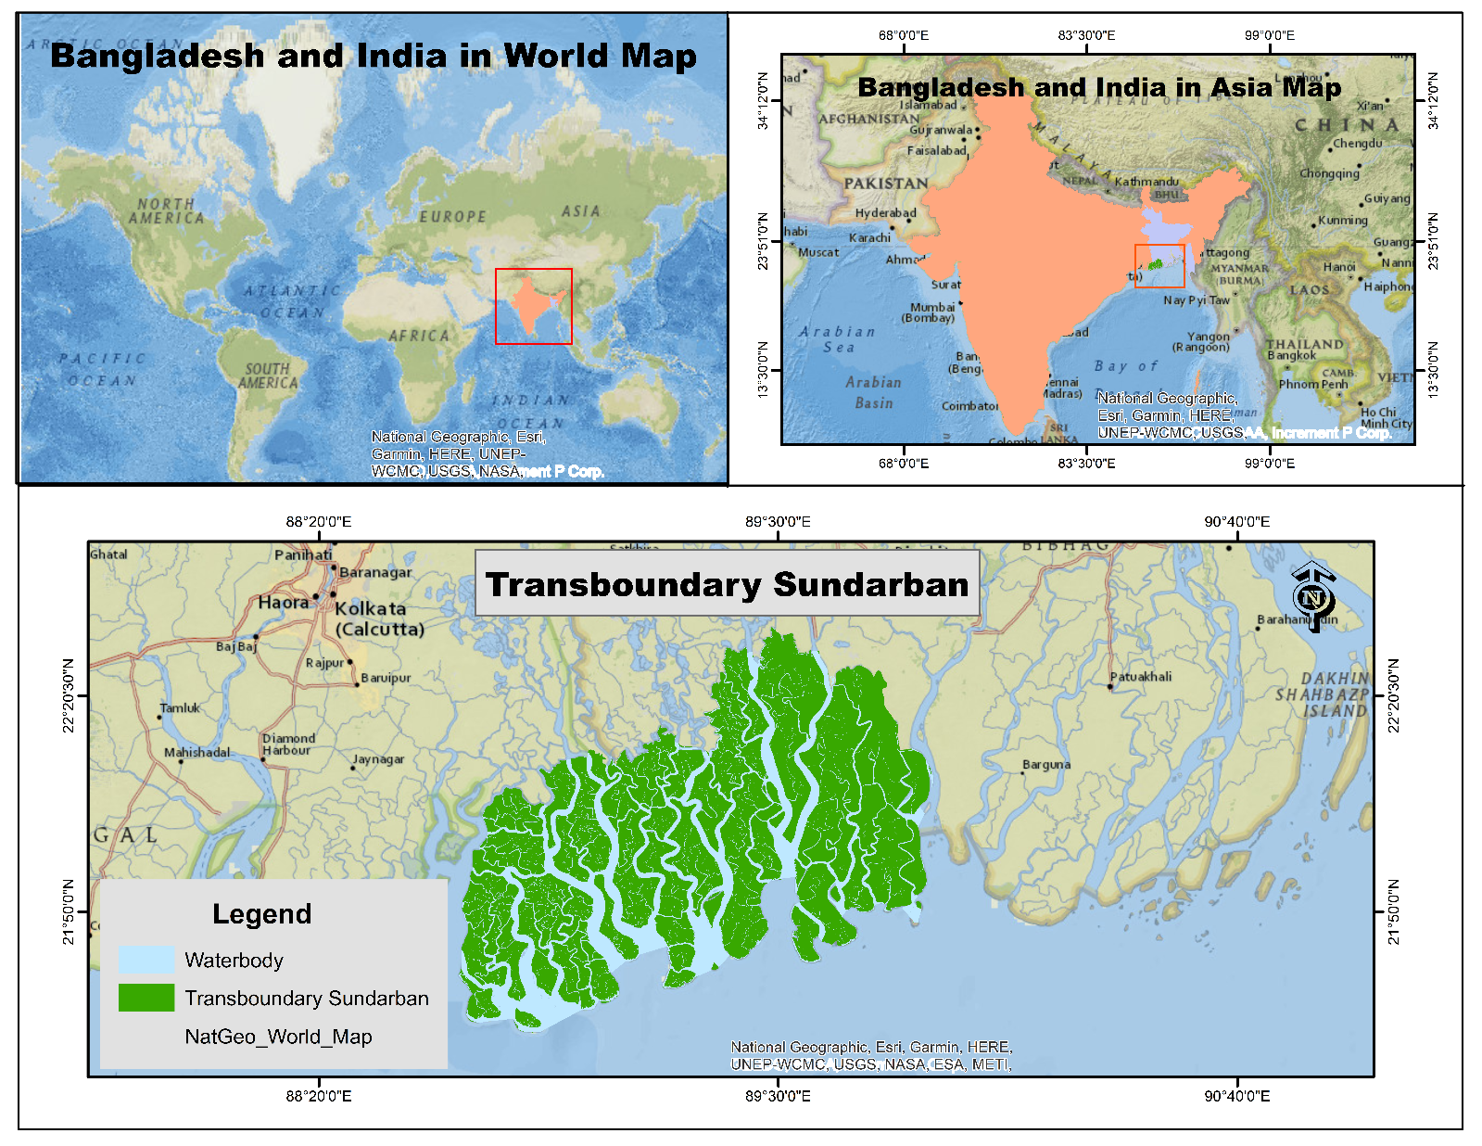
Figure 1: Multi-Scale Hierarchical Location Map of the Transboundary Sundarbans (World, Asia, and Regional Base).
This four-window hierarchical layout provides a comprehensive multi-scale geographic contextualization of the transboundary Sundarbans mangrove tract. The top-left panel displays the global position on a National Geographic World Map base, while the top-right panel zooms into the South Asian continental scale, highlighting the geopolitical boundaries of India and Bangladesh. The primary lower frame displays the transboundary forest polygon overlaid onto a detailed topographic and transport reference base, mapping neighboring urban centers such as Kolkata (Calcutta), Haora, Barisal, and Patuakhali alongside major estuarine waterways.
This layout is tailored for international peer-reviewed publications and environmental policy documentation where global and continental orientation is essential. It emphasizes the proximity of the mangrove buffer to dense human settlements and metropolitan corridors, illustrating how the ecosystem acts as a critical natural defense barrier against cyclones originating in the Bay of Bengal. The cartographic design incorporates accurate graticule markings (88°20′0″ E to 90°40′0″ E and 21°50′0″ N to 22°30′30″ N), clean layer legends, and source citations for global web map services.

2.2 Transboundary Mapping of the Sundarbans Region (True-Color Satellite Overlay)
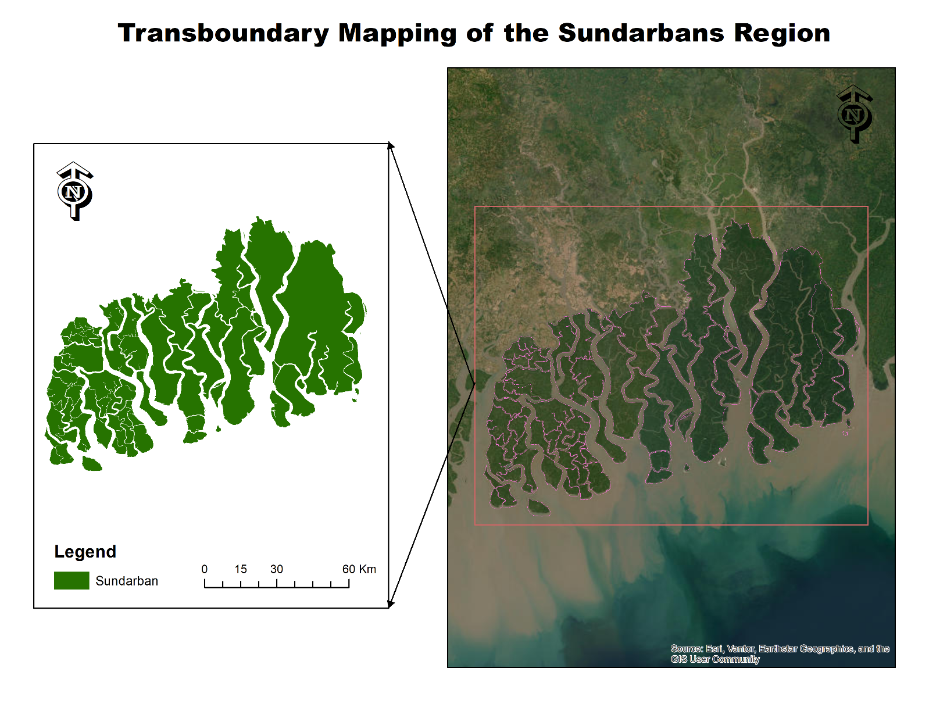
Figure 2: Transboundary Satellite and Vector Integration of the Entire Sundarbans Mangrove Complex.
This advanced cartographic layout combines high-resolution true-color satellite imagery with vector polygon overlays to delineate the entire transboundary Sundarbans mangrove forest, which spans across southwestern Bangladesh and the state of West Bengal, India. The right-hand panel integrates high-resolution optical imagery from Esri, Maxar, and Earthstar Geographics, displaying the dense, continuous dark green canopy intersected by complex braided river systems, tidal channels, and dynamic sediment plumes discharging into the northern Bay of Bengal. A pink focus boundary links the satellite extent directly to the vectorized thematic polygon on the left.
The vectorized forest boundary (displayed in solid dark green) isolates the archipelago-like network of mangrove islands. This map illustrates the ecological unity of the world's largest contiguous mangrove wetland, which operates as an unbroken biome despite being divided by an international border. The layout is designed for transboundary biodiversity monitoring, coastal storm-surge attenuation studies, carbon sequestration estimation, and landscape-level mangrove health tracking, highlighting the critical role of coordinated cross-border conservation.

2.3 The Bangladesh Sundarbans Coastal Forest Region
This layout isolates the national sovereign portion of the Sundarbans Reserved Forest under the administrative jurisdiction of the Bangladesh Forest Department.
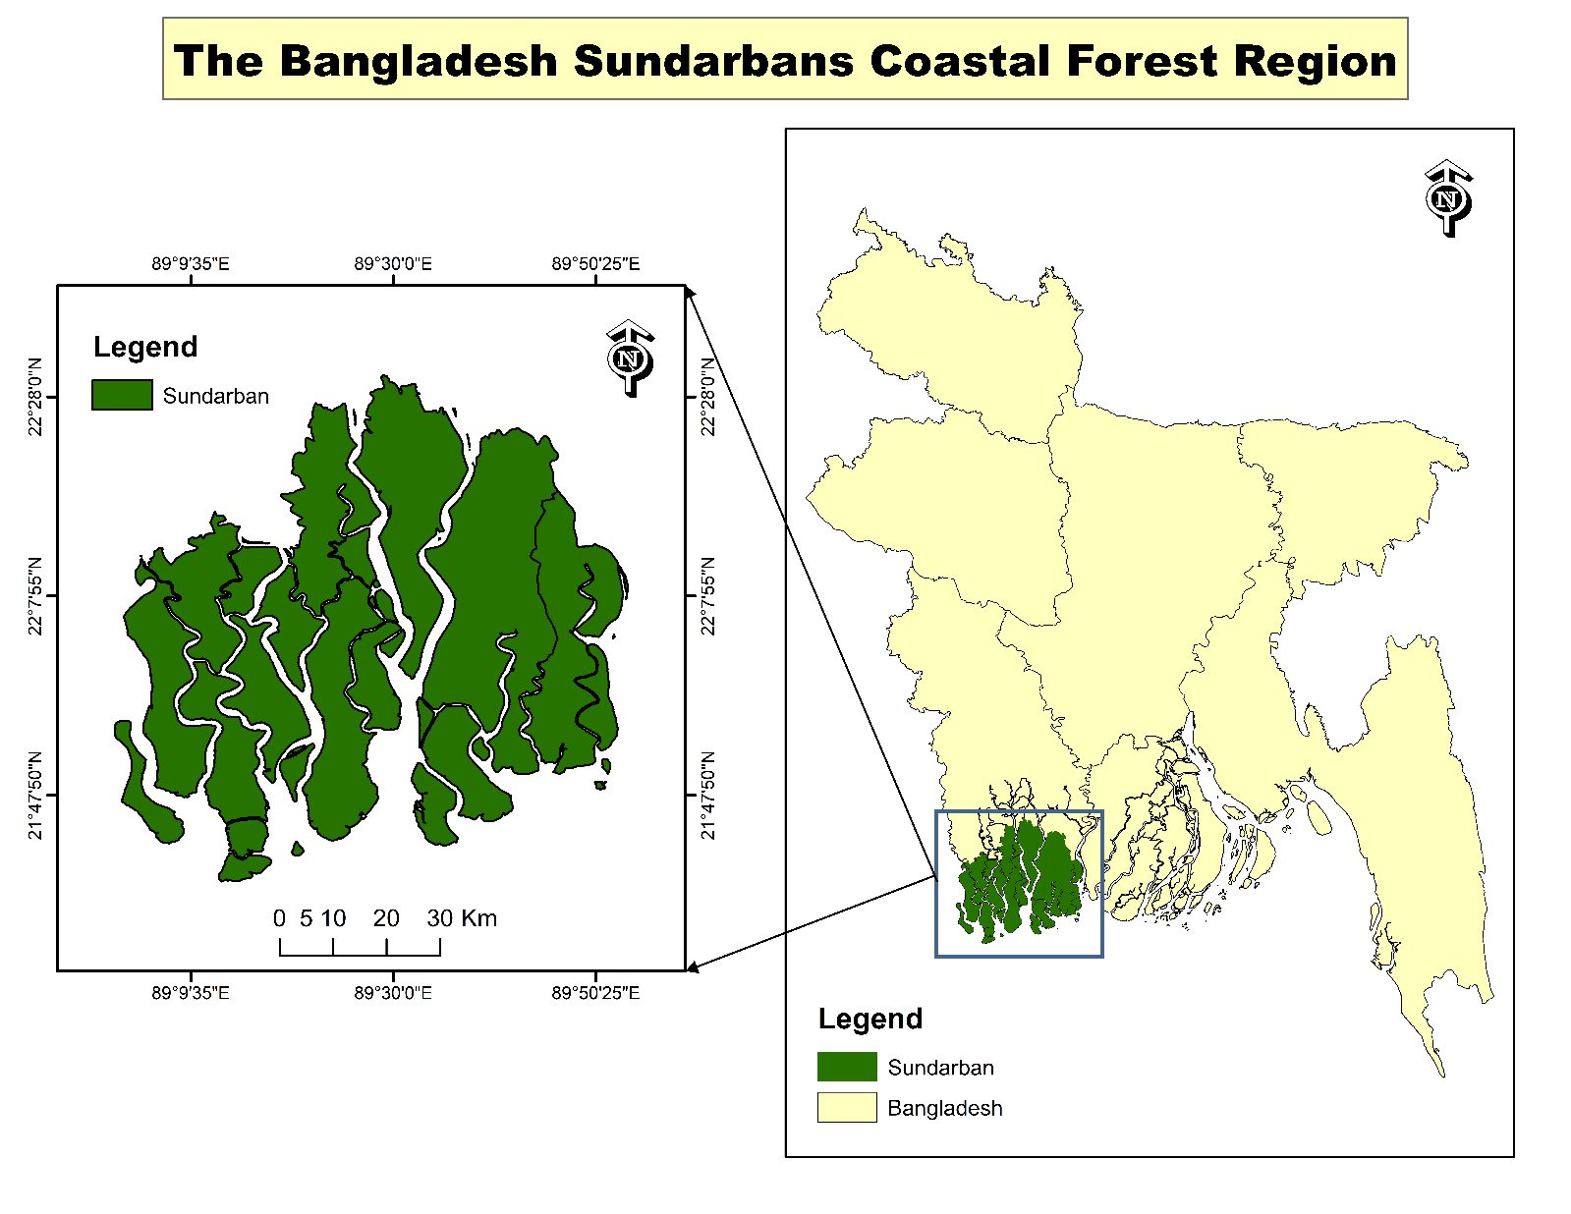
Figure 3: The Bangladesh Sundarbans Coastal Forest Region
The study area extends between 89°9′35″ E to 89°50′25″ E longitude and 21°47′50″ N to 22°28′0″ N latitude. The primary frame details the intricate, fragmented island morphology of the forest blocks, rendered in dark green, while the right-hand inset map contextualizes the reserve within the full coastal belt and administrative territory of Bangladesh.
The Bangladesh Sundarbans covers roughly 6,000 square kilometers and represents over 60% of the entire transboundary mangrove complex. This map serves as an indispensable reference for domestic forestry management, wildlife conservation programs (such as the Royal Bengal Tiger habitat initiatives), zoning of Ecologically Critical Areas (ECAs), and satellite-based Forest Canopy Density (FCD) multi-decadal change tracking. The clean white backdrop, bordered graticules, and graduated metric scale bar (0 to 30 km) maintain visual precision for scientific reporting.

2.4 Spatial Delineation of the Eastern Sundarbans Protected Reserve
This specialized multi-frame map isolates the Eastern Compartment of the Bangladesh Sundarbans, bounded geographically between longitudes 89°20′0″ E to 90°20′0″ E and latitudes 21°51′48″ N to 22°22′2″ N. The layout features three synchronized windows: a primary top frame showcasing the extracted forest boundary in solid green, a lower-left window providing a high-resolution natural-color satellite view (Esri/Maxar) detailing dense internal creek systems and estuarine riverbanks outlined in magenta, and a lower-right inset mapping its national location within Bangladesh.
The Eastern Sundarbans is characterized by lower salinity levels compared to the western zones due to direct freshwater influx from the Baleswar and Passur river systems, supporting dense stands of Heritiera fomes (Sundari). This sector is highly susceptible to recurring cyclonic landfalls, tidal surges, and riverbank morphodynamics. The map provides the exact spatial framework required for localized forest canopy health assessments, optical biophysical index modeling (AVI, BSI, CSI, VD, SVD, SSI), and post-cyclone vegetation recovery studies.
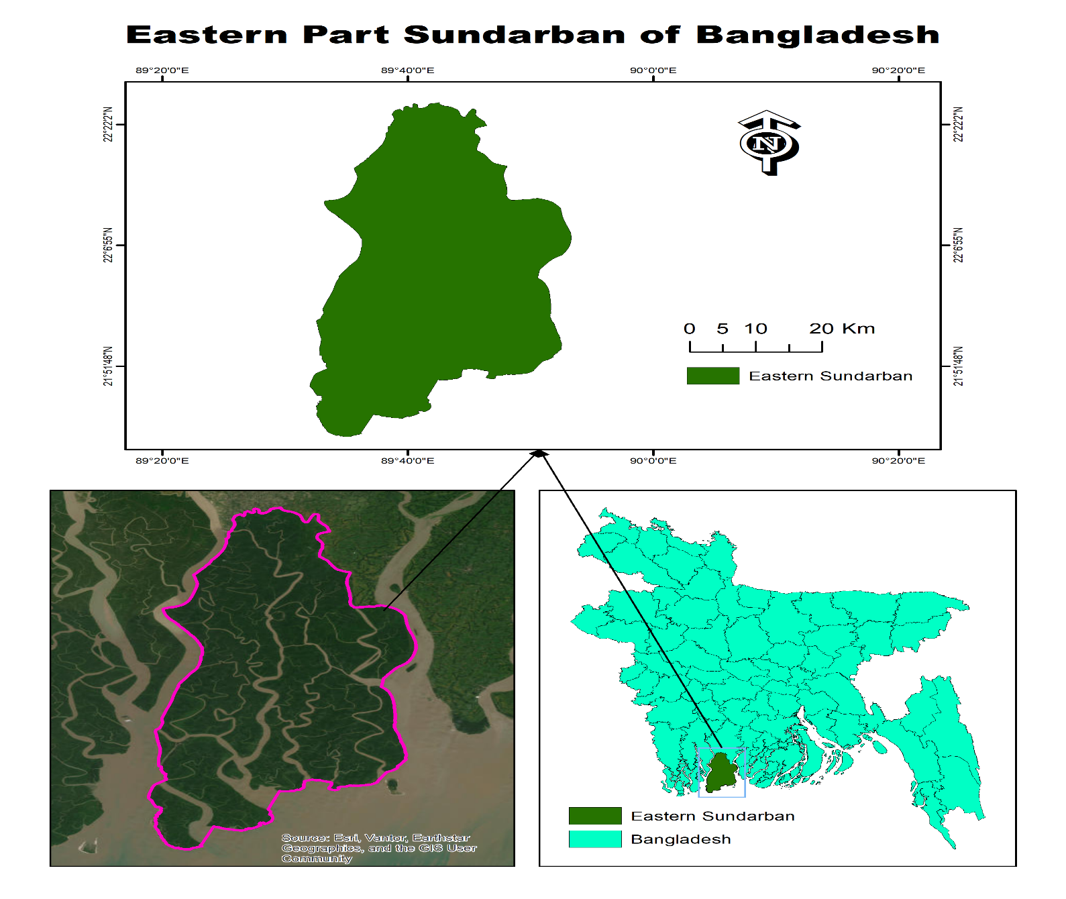
Figure 4: Spatial Boundary and Satellite Composite of the Eastern Sundarbans Mangrove Sector.

3. Macro-Scale Administrative and Regional Delineations
3.1 Study Area Map of Selected Coastal Districts of Bangladesh
This regional thematic map identifies four strategically important coastal districts located across the maritime boundary of Bangladesh: Khulna and Bagerhat in the southwestern deltaic zone, alongside Chattogram and Cox's Bazar in the southeastern littoral belt. Geographically referenced between longitudes 86°38′0″ E to 93°39′0″ E and latitudes 21°37′0″ N to 26°8′30″ N, the map establishes a macro-scale framework for comparative coastal research. The selected districts represent two distinct environmental systems: the southwestern estuarine mangrove ecosystem governed by brackish hydrology and tidal channels, and the southeastern shoreline characterized by linear sandy beaches, tertiary hills, and direct open-sea marine exposure.
The spatial delineation serves as a foundational baseline for marine resource management, saline intrusion assessments, commercial brackish aquaculture studies (specifically shrimp and crab farming), and cyclone vulnerability profiling. By highlighting these non-contiguous districts against the national base map (rendered in cyan), the layout allows researchers to isolate regional socio-ecological dynamics while maintaining full national spatial context. Standard cartographic elements, including an 8-interval graduated scale bar (0 to 180 km), geographic graticules, and a clear legend hierarchy, ensure full compliance with scientific publishing standards.
Furthermore, this multi-district spatial framework captures critical hydro-morphological gradients across the northern Bay of Bengal, contrasting the sediment-rich, mangrove-sheltered estuaries of the Ganges-Brahmaputra-Meghna delta with the high-energy oceanic surf zones of the southeastern coast. In the southwestern cluster, Khulna and Bagerhat function as critical ecological buffer zones, where extensive tidal river networks and low-lying mudflats regulate inland salinity progression and support dense commercial gher farming. In contrast, the southeastern corridor comprising Chattogram and Cox's Bazar represents a vital economic and maritime gateway characterized by steep continental shelf drops, major port infrastructure, and intensive marine capture fisheries. Incorporating both coastal zones into a unified GIS database enables cross-regional spatial modeling of compound disaster risks, including tropical cyclone storm surges, sea-level rise projections, and coastal embankment vulnerability. By bridging local administrative boundaries with broader oceanic and estuarine processes, this thematic cartography provides environmental scientists, disaster risk managers, and coastal zone planners with an empirical spatial reference to formulate targeted coastal resilience strategies and sustainable marine resource policies.
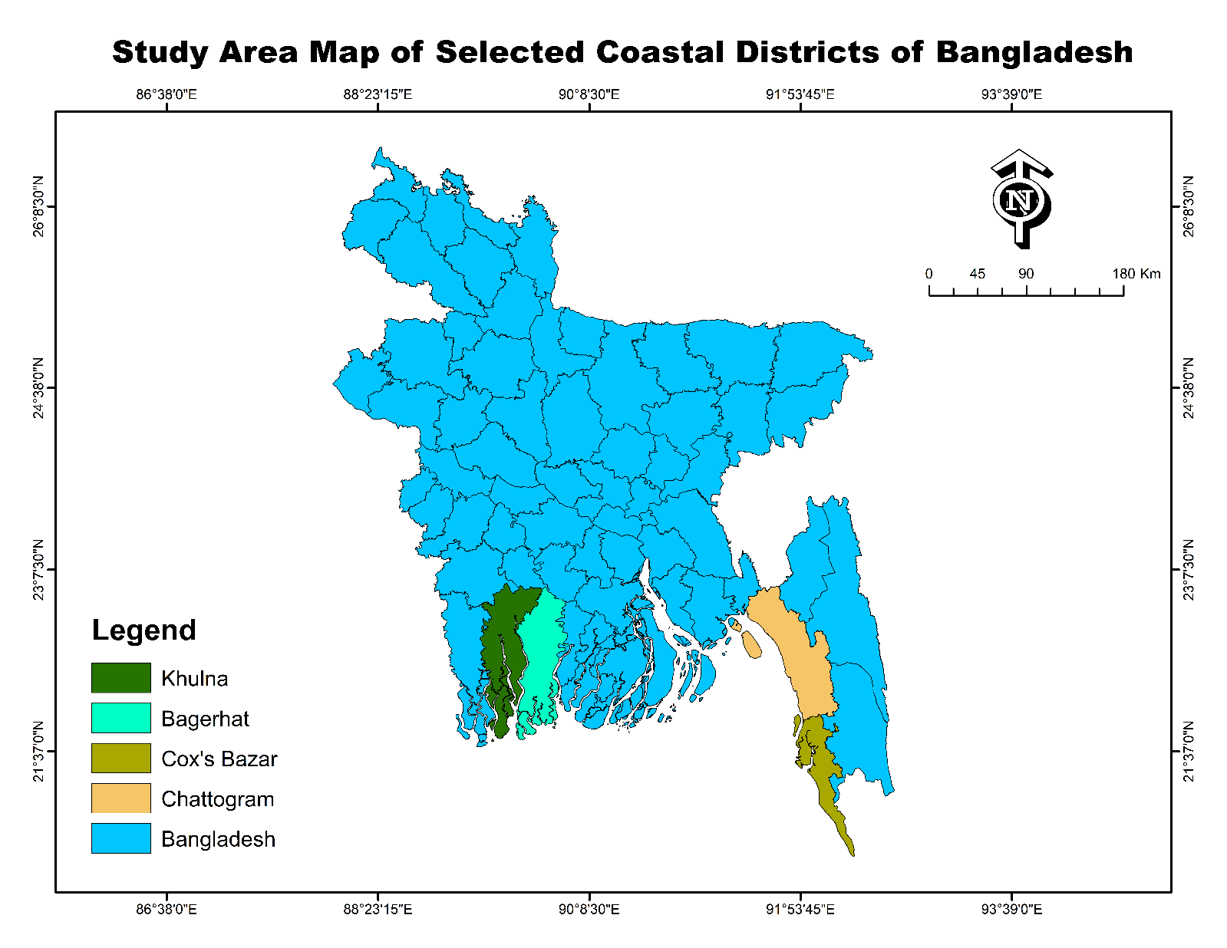
Figure 5: Geographic Distribution of Selected Coastal Districts across Bangladesh.
3.2 Study Area Map of Dhaka Division
This multi-frame cartographic layout delineates the administrative territory of Dhaka Division, positioned centrally within Bangladesh. The map spans geographically between latitudes 23° N and 26° N and longitudes 89° E and 91° E. The primary frame isolates the contiguous divisional polygon in soft periwinkle blue, revealing the intricate boundary defined by major river corridors, including the Padma, Jamuna, and Meghna systems. A nested locator map on the right contextualizes the division within Bangladesh using a distinctive hatched fill pattern and an illuminated cyan bounding outline, supported by dual coordinate indicators and an orientation rose.
Dhaka Division represents the political, economic, and demographic core of Bangladesh, characterized by rapid urbanization, high population density, and intensive industrial clusters. This layout is structured to support regional vulnerability assessments, seismic risk studies using Multi-Criteria Decision Analysis (MCDA), land use transition modeling, and urban disaster preparedness planning. The clean cartographic separation between the focus polygon and the national locator inset provides immediate regional orientation, enabling planners to evaluate central-tier infrastructure risks and environmental pressure zones with high spatial clarity.
Beyond its administrative significance, the division occupies a highly complex geomorphological setting situated across the Madhupur Tract and young alluvial floodplains, making its built environment particularly susceptible to multi-hazard risks. The convergence of active tectonic lineaments—such as the Madhupur Fault zone—and deep quaternary sedimentary layers amplifies localized seismic wave propagation and liquefaction susceptibility across dense urban wards. Integrating this precise spatial boundary into geospatial analysis pipelines allows researchers to perform multi-criteria spatial overlays combining geological fault proximity, peak ground acceleration (PGA), soil bearing capacity, structural building vulnerability, and high-density population exposure. Furthermore, the rapid expansion of impervious urban surfaces across the metropolitan core has severely disrupted natural drainage basins, exacerbating localized waterlogging, urban heat island intensity, and wetland conversion. By establishing an authoritative, georeferenced spatial baseline, this cartographic delineation serves as a critical decision-support instrument for municipal authorities, urban development agencies like RAJUK, and disaster management policymakers aiming to implement risk-sensitive land use zoning, structural retrofitting protocols, and resilient infrastructure development strategies.
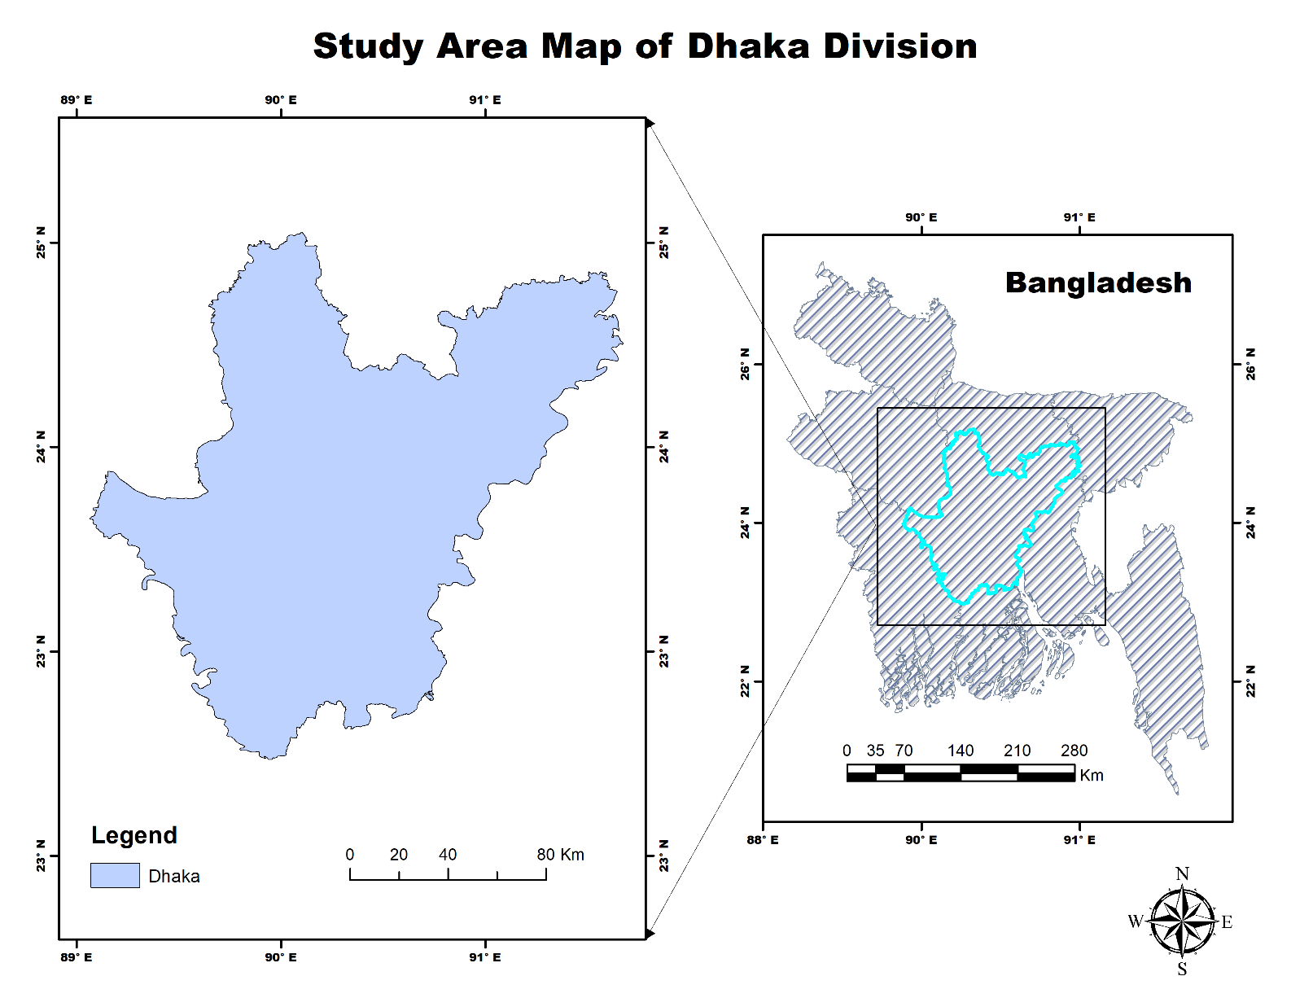
Figure 6: Administrative Boundary and Geographic Extent of Dhaka Division.
3.3 International Hydrographic Delineation: Transboundary River Basin
This large-scale hydrographic layout models an extensive transboundary river basin and watershed corridor situated in Eastern Africa. The delineated basin spans geographically between longitudes 42°50′0″ E to 46°20′0″ E and latitudes 0°28′0″ N to 5°4′0″ N, encompassing parts of the Juba-Shabelle drainage network. The polygon boundary, rendered in muted sage green, captures the complete topographic ridge that defines surface runoff accumulation, channel confluence, and downstream discharge into coastal outlets.
River basin delineations of this magnitude are fundamental for transboundary hydrological modeling, water resource accounting, drought monitoring, and climate-induced flood hazard simulations. By isolating the hydrologic unit independently of geopolitical borders, the map emphasizes hydrological integrity over political divisions. The layout includes an extended scale bar (0 to 180 km), high-precision latitude/longitude border graticules, and an authoritative four-point compass rose, providing an accurate spatial frame for cross-border water governance, environmental flow analysis, and regional ecological impact assessments.

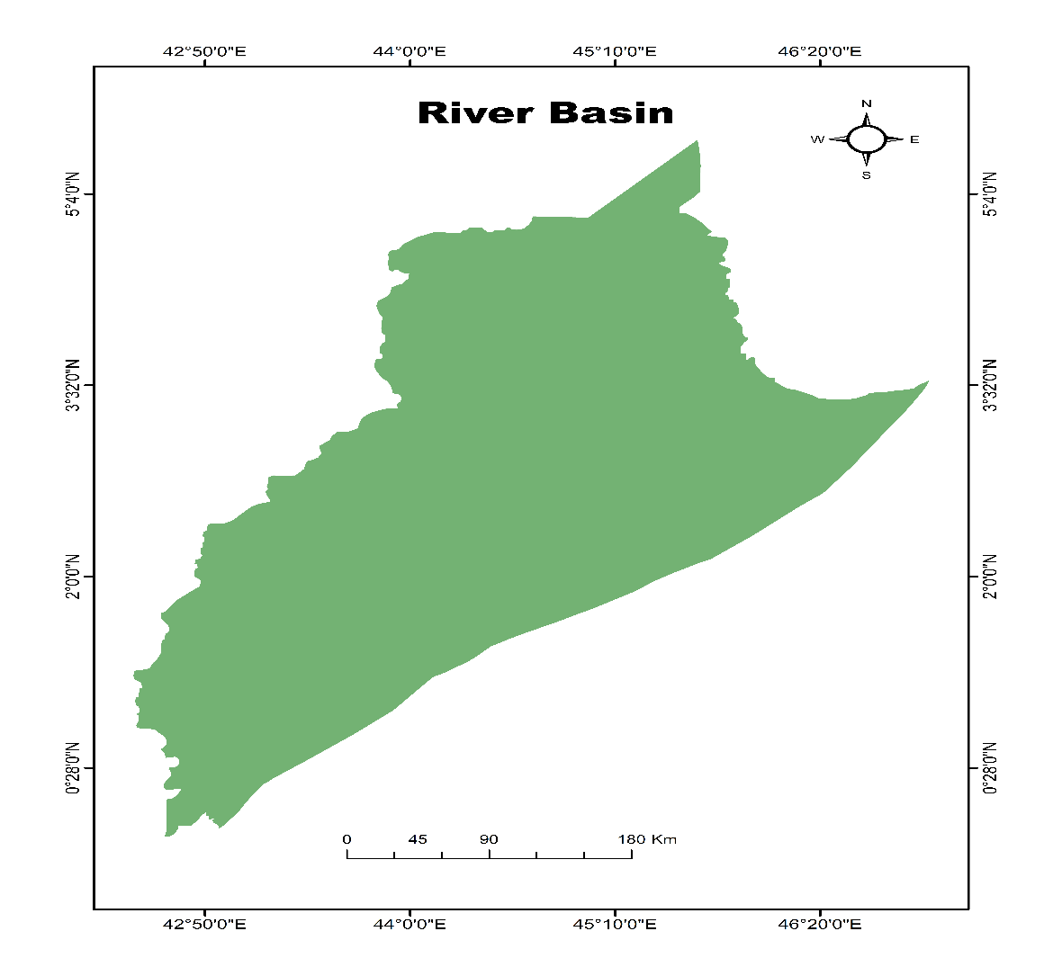
Figure 7: Hydrographic Boundary Delineation of Regional River Catchment Basin.

3.4 Study Area Map: Saskatchewan, Canada
This dual-frame cartographic layout presents the complete provincial boundary of Saskatchewan, Canada, extending from 49° N to 60° N latitude and 102° W to 110° W longitude. The primary frame displays the distinctive geometric boundary of Saskatchewan, highlighting internal census divisions and transport analysis zones in lime green. A large-scale locator map on the right positions the province within the full Canadian landmass, featuring a magenta focus rectangle and a north arrow designed for high-latitude continental projections.
Saskatchewan exhibits a sharp environmental and infrastructural division between its southern agricultural prairie belt—which contains major population centers like Saskatoon and Regina alongside dense highway grids—and its northern boreal transition zone, characterized by extreme winter temperatures, Canadian Shield bedrock, and isolated linear corridors. This map provides the foundational spatial unit for transportation network resilience modeling, climate hazard multi-criteria evaluations (evaluating snow severity, wind hazards, and thermal stress), and inter-provincial freight vulnerability assessments.
From a logistics and supply chain perspective, the province functions as a critical east-west land bridge connecting the Pacific ports of British Columbia to the central industrial heartlands of Ontario and Quebec via the Trans-Canada Highway and major railway corridors. The sparse connectivity of the northern road network makes rural and Indigenous communities particularly susceptible to seasonal isolation whenever severe blizzard events, extreme freeze-thaw cycles, or spring snowmelt floods compromise critical arterial links. By integrating this standardized provincial boundary with spatial multi-criteria decision analysis (GIS-MCDA), researchers can systematically weigh layered climatic parameters—including freezing rain frequency, extreme minimum temperatures, crosswind exposure, and snowpack accumulation—against structural transport vulnerabilities. Furthermore, incorporating traffic volume densities, detour availability indices, and proximity to emergency maintenance depots allows transport planners to identify high-risk roadway segments where failure risks are concentrated. Establishing this precise provincial baseline enables the Saskatchewan Ministry of Highways and regional infrastructure authorities to optimize maintenance resource allocations, prioritize capital retrofitting projects, and implement climate-adaptive transport infrastructure standards capable of withstanding the intensifying climate extremes of the Canadian Prairies.
Additionally, this geographic delineator provides a spatial framework for examining the complex socio-economic interdependencies between natural resource extraction corridors and inter-provincial trade logistics across the Great Plains.
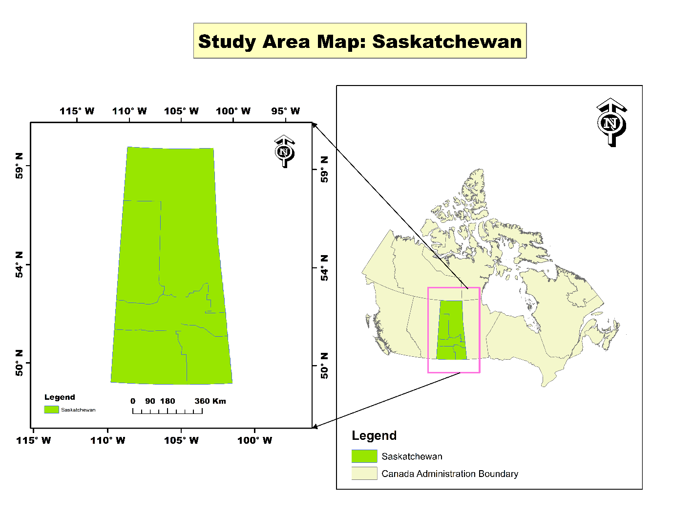
Figure 8: Geographic Boundary and Administrative Location of Saskatchewan within Canada.

4. Sub-District, Coastal Buffer, and Field Sampling Delineations
4.1 Comparative Coastal Vulnerability Study Area: Khulna, Barishal, and Patuakhali
This multi-tier regional cartographic layout establishes a comparative spatial baseline across the highly exposed southwestern deltaic fringe of Bangladesh, isolating three core administrative districts: Khulna (highlighted in vivid orange), Barishal (delineated in deep cobalt blue), and Patuakhali (rendered in rich green). Geographically referenced between longitudes 88°59′50″ E to 90°30′0″ E and latitudes 21°42′8″ N to 23°3′52″ N, the left analytical frame displays these non-contiguous study areas against an OpenStreetMap base layer, illustrating their complex hydrological interplay with major estuarine rivers, tidal creeks, and the Bay of Bengal coastline. A coordinated national locator map on the right contextualizes this three-district cluster within Bangladesh, using a clear red bounding focus frame and an orientation compass to maintain geographic reference. These three administrative units capture the distinct environmental, geological, and socio-economic gradients of the lower Ganges-Brahmaputra-Meghna delta. Khulna represents the semi-saline estuarine margin adjoining the Sundarbans mangrove tract, where brackish aquaculture and tidal river siltation dominate the landscape. Barishal serves as an inland alluvial wetland hub characterized by freshwater river confluence, dense agricultural production, and extensive canal networks. Patuakhali forms the marine-exposed frontline, directly confronting high-energy ocean surges, extensive coastline morphodynamics, and direct tidal inundation. Integrating these diverse landscapes into a unified GIS database provides an empirical foundation for multi-criteria vulnerability assessments, regional salinity tracking, and comparative climate change adaptation modeling across the southern delta.
From an environmental management and disaster risk perspective, this multi-district spatial framework is essential for assessing compound hazard vulnerabilities, including cyclonic storm surges, progressive soil salinity intrusion, embankment breaches, and seasonal waterlogging. By linking local administrative boundaries with regional hydro-morphological processes, the map allows spatial analysts to evaluate how sea-level rise and altered river discharge affect inland freshwater aquifers and agricultural security differently across each district. In Patuakhali and coastal Khulna, where low elevations rarely exceed two meters above mean sea level, extreme high tides frequently overtop earthen polders, salinizing arable paddy lands and disrupting rural potable water systems. Conversely, Barishal experiences intense fluvial flooding and riverbank erosion during the monsoon, necessitating distinct structural and community-based resilience strategies. The inclusion of standardized cartographic features—such as dual graduated scale bars (0 to 150 km on the primary frame and 0 to 180 km on the locator inset), precise graticule tick marks, and an organized visual legend—ensures full compliance with academic and professional cartographic standards. Ultimately, this multi-region layout serves as an indispensable spatial planning instrument for environmental researchers, coastal development authorities, and emergency response agencies, enabling data-driven prioritization of disaster shelter networks, climate-resilient cropping zones, and durable coastal protection infrastructure along Bangladesh's vulnerable southern margin.
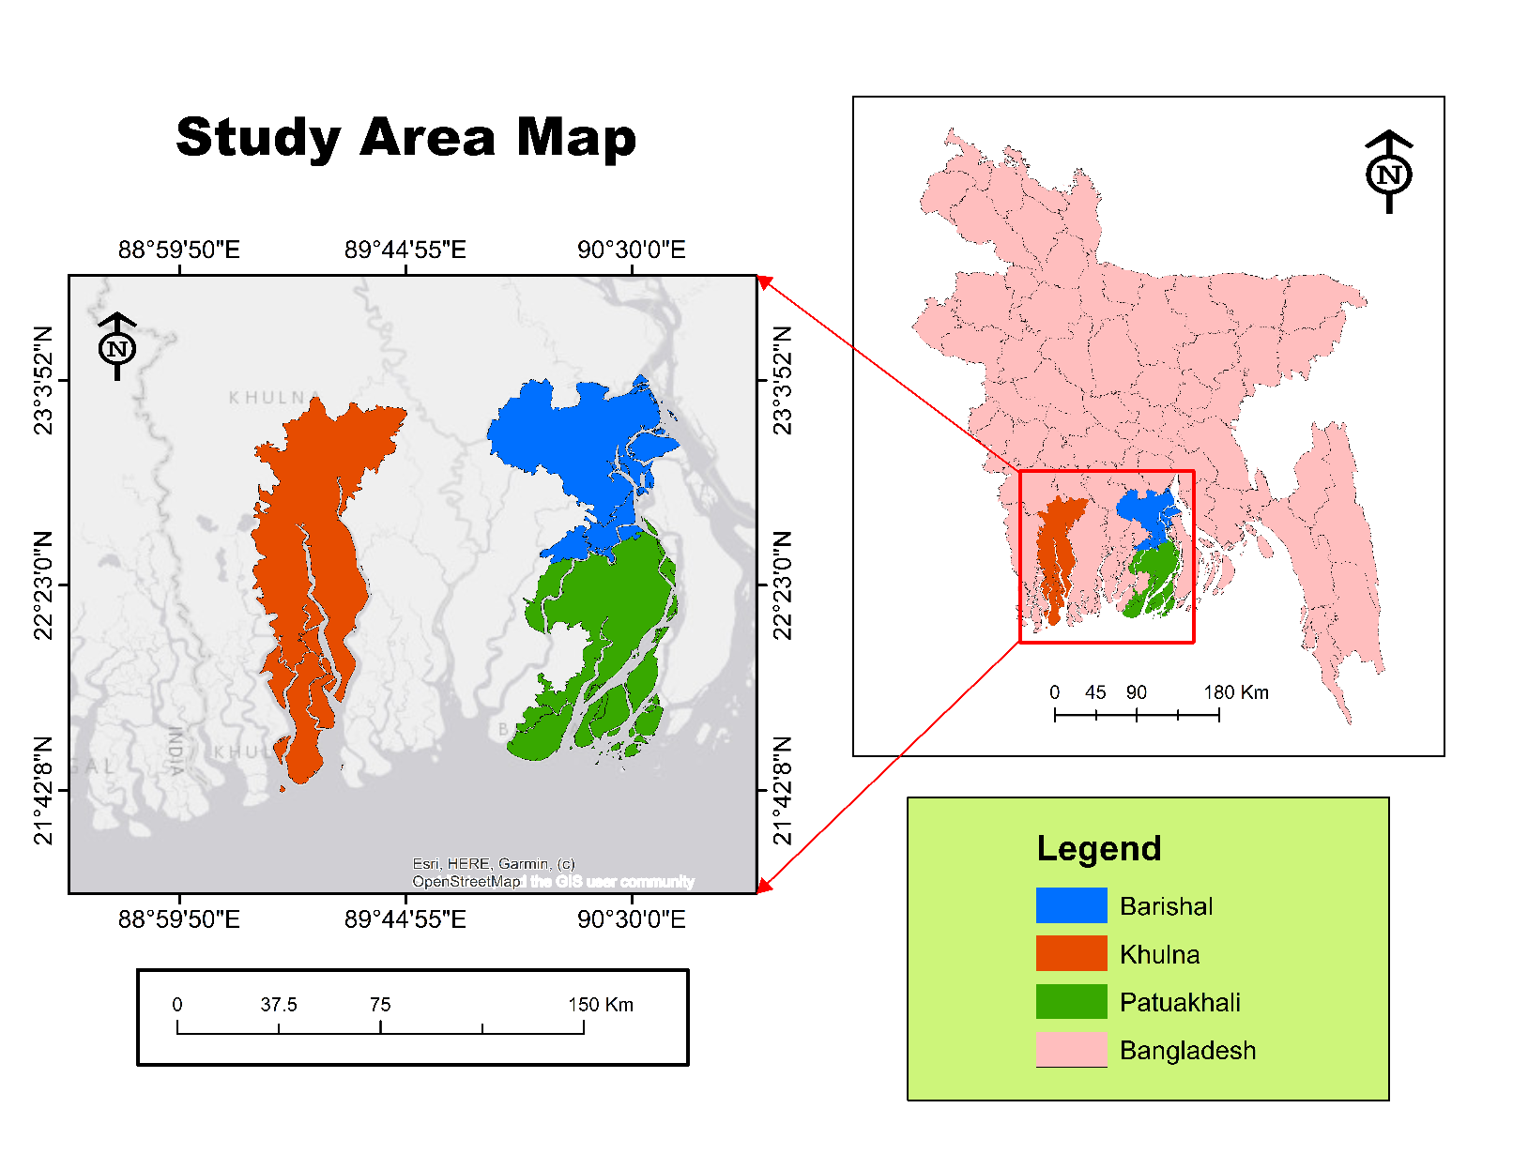
Figure 9: Spatial Delineation of Three Key Southwestern Coastal Regions across Bangladesh.

4.2 Study Area Map of Kukua Union, Amtali Upazila, Barguna
This nested three-tier administrative layout zooms from the national scale down to the localized union boundary. The map isolates Kukua Union (solid orange) situated between 90°16′30″ E to 90°19′30″ E longitude and 22°10′30″ N to 22°14′0″ N latitude. The upper-right inset marks Amtali Upazila within Bangladesh, the lower-right frame isolates Amtali Upazila (yellow) within Barguna District showing the nested position of Kukua Union, and the large left frame presents the detailed boundary of Kukua Union with sub-kilometer scaling.
Union-level delineations represent the fundamental administrative tier for grassroots disaster management, union parishad emergency shelter planning, localized crop damage assessments, and household-level climate vulnerability surveys. The multi-scale visual connection allows readers to trace the spatial lineage from national policy down to community-level implementation.
At this hyper-localized geographical scale, the complex spatial arrangements of rural mouzas, settlement clusters (paras), agrarian plots, and village drainage canals (khals) become fully visible for fine-scale analysis. Kukua Union is situated in an environmentally fragile coastal terrain governed by low-lying alluvial silt, where seasonal river backwater effects, heavy monsoon rainfall, and tidal fluctuations frequently threaten agricultural stability. Micro-level spatial mapping of this union allows researchers to precisely evaluate household accessibility to multi-purpose cyclone shelters, calculate maximum walking distances along unpaved rural roads, and identify isolated settlements vulnerable during severe storm surges. Furthermore, because union parishads serve as the frontline governance bodies during humanitarian relief distributions, having an accurate vector boundary assists local administrators in allocating emergency rations, freshwater supplies, and agricultural inputs based on ward-level population densities. The incorporation of a sub-kilometer scale bar (0 to 2 km) paired with high-precision corner graticules provides the spatial accuracy needed to overlay empirical field survey data, such as GPS-tagged water salinity points and household socioeconomic vulnerability indices. By bridging high-level regional policy with ground-level community dynamics, this layout functions as an essential spatial baseline for community-based disaster preparedness (CBDP), localized flood mitigation interventions, and climate-resilient rural development programs in coastal Barguna.
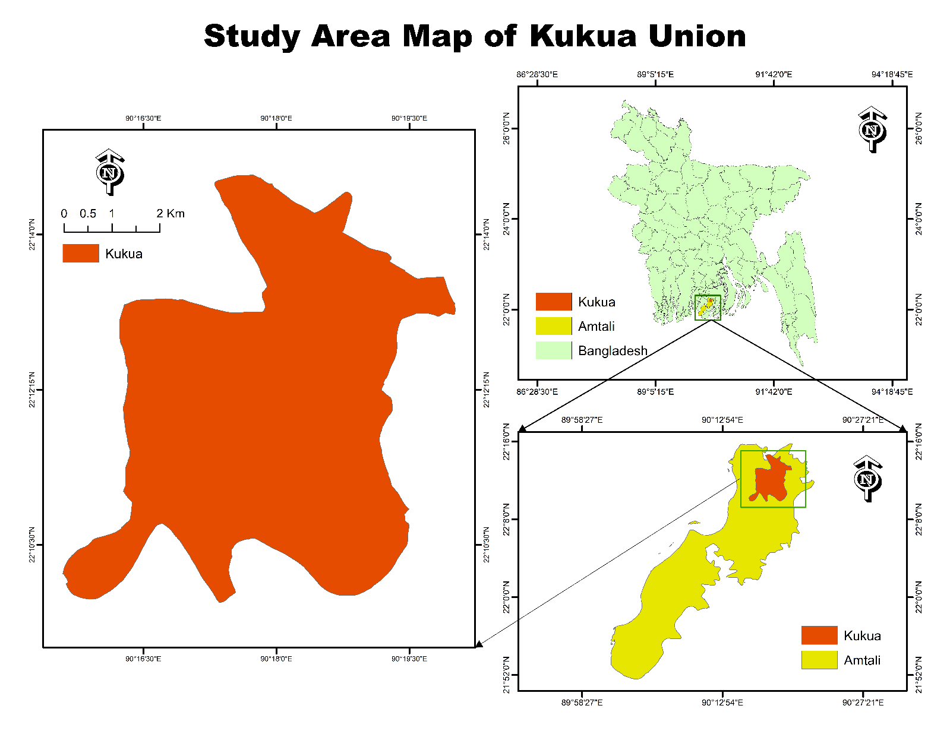
Figure 10: Three-Tier Hierarchical Administrative Delineation of Kukua Union, Amtali.
4.3 Study Area Map of Taltali Upazila, Barguna District
This three-tiered cartographic layout delineates Taltali Upazila, situated on the extreme coastal edge of Barguna District. The study area extends between 90°2′40″ E to 90°10′50″ E longitude and 21°55′0″ N to 22°3′30″ N latitude. The primary frame isolates the elongated boundary of Taltali in magenta, while the upper-right and lower-right insets display its position within Bangladesh and Barguna District, respectively.
Taltali is bounded by the Payra River to the east, the Barguna mainland to the north, and the Bay of Bengal to the south, placing it on the frontlines of coastal cyclones and tidal inundation. This layout supports coastal embankment breach modeling, gender-differentiated shelter accessibility studies, and local disaster preparedness planning. The nested window design maintains cartographic clarity across changing spatial scales.
Geomorphologically, Taltali Upazila comprises low-lying estuarine floodplains, dynamic tidal mudflats, and fragile barrier formations that are directly exposed to astronomical tides and intense storm surges generated in the northern Bay of Bengal. The convergence of the Payra and Bishkhali estuarine outlets subjects its coastal polders to persistent hydraulic pressure, severe bank scour, and saline intrusion into shallow freshwater aquifers. Utilizing this delineated boundary within a GIS framework allows spatial analysts to map multi-criteria coastal vulnerability, overlay digital elevation models (DEM) to simulate varying inundation depths, and evaluate the structural integrity of protective sea dykes. Furthermore, the map provides the baseline boundary required to conduct network analysis on rural road connectivity, pinpoint underserved village mouzas beyond the safe evacuation radius of existing multi-purpose cyclone shelters, and optimize emergency relief staging hubs. By linking macro-level national disaster strategies with localized sub-district geography, this cartographic product serves as an essential decision-support tool for upazila disaster management committees, local NGOs, and regional development planners working to build climate resilience along Bangladesh's exposed southern coast.
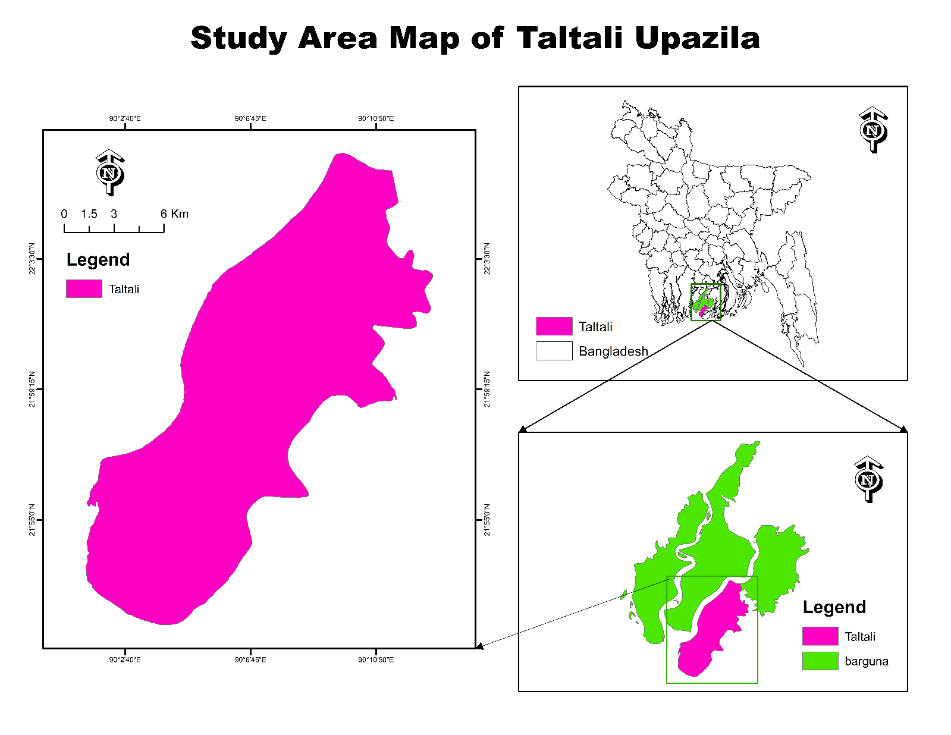
Figure 11: Multi-Scale Hierarchical Administrative Delineation of Taltali Upazila, Barguna.
4.4 Spatial Distribution of the Study Area within Kuakata Coastal Region
This coastal mapping layout illustrates a dynamic marine and intertidal buffer zone along the exposed shoreline of Kalapara Upazila within Patuakhali District. Spanning between longitudes 90°4′30″ E to 90°14′15″ E and latitudes 21°46′0″ N to 21°53′0″ N, the map defines an 8 km curved analytical buffer strip (rendered in blue) extending outward from a digitized coastal baseline. The right-hand insets display the national location and the administrative boundary of Kalapara Upazila.
The Kuakata coast is known for its wide sandy beaches, dynamic shoreline accretion-erosion processes, and intense seasonal wave energy during the southwest monsoon. This buffered delineation serves as an analytical domain for monitoring shoreline retreat rates using the Digital Shoreline Analysis System (DSAS), modeling storm surge inundation buffers, and managing coastal ecotourism infrastructure. The clean vector geometry and dual-window administrative linkage support shoreline management and coastal vulnerability zoning.
From an oceanographic and coastal morphodynamics perspective, this marine buffer zone encompasses a high-energy surf environment influenced by semi-diurnal tides, strong littoral drift, and dynamic sediment plumes discharging from the Meghna Estuary into the northern Bay of Bengal. Establishing an explicit 8 km nearshore buffer zone allows coastal modelers to project wave transformation dynamics, estimate nearshore bathymetric slope variations, and simulate the shoaling behavior of cyclonic storm surges before they make landfall. Coupling multi-temporal Landsat and Sentinel-2 optical imagery within this delineated domain enables the calculation of end point rate (EPR) and net shoreline movement (NSM) statistics to identify long-term coastal erosion hotspots versus accretionary sand spits. Furthermore, the rapid growth of beachfront commercial resorts and coastal tourism infrastructure along the Kuakata strip requires strict setback regulations to prevent beach degradation and structural loss during severe monsoonal surges. By providing a mathematically calibrated spatial zone anchored to an authoritative coastal baseline, this cartographic output functions as a vital decision-support asset for coastal zone management (ICZM) authorities, the Bangladesh Water Development Board (BWDB), and environmental planners implementing sustainable green-belt afforestation and nature-based coastal protection strategies.
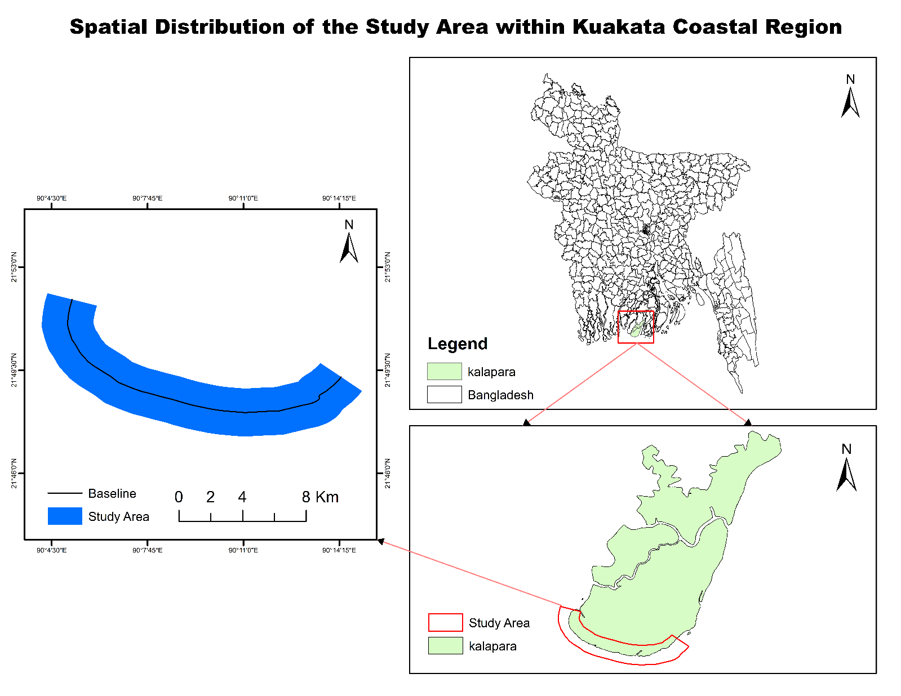
Figure 12: Dynamic Shoreline Buffer Zone and Baseline Delineation across Kuakata Coastal Belt.
4.5 Spatial Distribution of Empirical Field Sampling Sites across Patuakhali District
This point-pattern cartographic layout maps 25 empirical ground-truth sampling stations distributed across Patuakhali District. The district polygon spans from 90°0′0″ E to 90°45′0″ E longitude and 21°52′30″ N to 22°28′18″ N latitude, color-coded across administrative upazilas: Galachipa (bright green), Mirzaganj (orange), Bauphal (purple), and Dashmina (blue). Sampling points are symbolized by distinct red target markers overlaid with black survey stars.
The sampling distribution is structured to capture spatial variations in groundwater salinity, soil fertility, tidal flooding depth, and agricultural cropping intensity across inland and coastal zones. The right-hand inset map links Patuakhali directly to the national map of Bangladesh. The balanced point distribution across diverse environmental zones ensures statistical representation for field-validated environmental science and hydrological research.
From a spatial modeling and geostatistical perspective, establishing this stratified point network enables continuous surface interpolation using methods such as Ordinary Kriging (OK), Inverse Distance Weighting (IDW), and Empirical Bayesian Kriging (EBK). By collecting in-situ physicochemical metrics—such as soil electrical conductivity (EC), total dissolved solids (TDS), and pH levels—at each survey station, researchers can map the spatial extent of seasonal saltwater intrusion driven by tidal surges and dry-season upstream flow reductions. The distribution strategically spans inland agricultural plains in Mirzaganj and Bauphal down to the exposed estuarine networks of Galachipa and Dashmina, providing the spatial variance needed to correlate surface water dynamics with satellite-derived vegetation indices (e.g., NDVI, NDRE, and NDWI). Furthermore, this rigorous ground-truth lattice serves as an indispensable training and validation dataset for remote sensing classifications, land suitability modeling, and localized climate resilience planning conducted across the deltaic coastal belt. Integrating these field coordinates into a unified GIS database directly supports precision agriculture and regional groundwater vulnerability mapping. Local agricultural extension officers and water management authorities can cross-reference the site-specific empirical findings with regional cropping calendars to identify vulnerable agrarian pockets requiring saline-tolerant crop varieties or improved polder sluice-gate management. Ultimately, this point-pattern network bridges empirical field observations with high-level spatial decision-support systems, establishing a scientifically validated foundation for long-term coastal adaptation and natural resource management across southern Bangladesh.
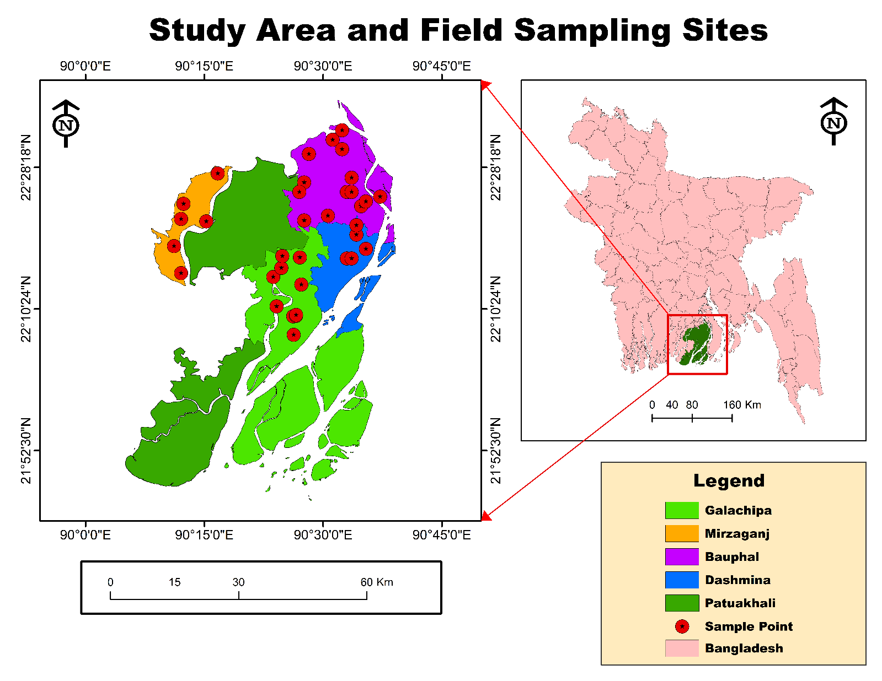
Figure 13: Empirical Field Survey Sampling Stations Categorized by Upazila across Patuakhali District.

5. Advanced High-Resolution Vector Digitizations
5.1 Urban Infrastructure and Institutional Boundary Vector Extraction
This high-precision planimetric vectorization converts a scanned raster map into structured GIS geometries. The digitized dataset extracts transport centerlines, dual-carriageway corridors, traffic roundabouts, cadastral parcel boundaries, an inland waterbody, and an institutional landmark building footprint. The dataset is georeferenced within a localized coordinate system spanning 88° E to 90° E and 23° N to 24° N.
Planimetric vectorization of this type is essential for urban municipal planning, utility network layout, emergency evacuation routing, and base-map creation from legacy cartography. The differentiation between solid road centerlines, dashed boundary divisions, and detailed polygon structures demonstrates high topological accuracy with clean line intersections and zero overshoots, providing an analysis-ready vector GIS layer.
From a spatial modeling and topological integrity perspective, this digitization pipeline enforces strict geometric validation rules, including node snapping, edge matching, planar enforcement, and the elimination of sliver polygons. Converting unstructured raster graphics into discrete vector entities (points, lines, and polygons) allows each feature to be populated with rich alphanumeric attribute tables detailing road class hierarchies, surface pavement types, estimated lane capacities, parcel ownership records, and building occupancy classes. The precise extraction of the road network—ranging from major multi-lane thoroughfares and roundabout interchanges down to local access lanes—provides the geometric backbone required to perform origin-destination (O-D) matrix calculations, shortest-path emergency evacuation routing, and transit accessibility modeling. Simultaneously, the delineation of natural landcover features, such as the central waterbody and surrounding green spaces, enables civil engineers to assess surface stormwater runoff coefficients, model localized urban drainage paths, and prevent encroachment on natural retention basins. By integrating parcel cadastre lines directly with structural building footprints, municipal planners can evaluate building-to-land area ratios (FAR), assess setback compliance, and simulate urban expansion patterns. This clean, mathematically structured spatial dataset bridges legacy analogue drafting with modern enterprise GIS platforms, providing municipal authorities and urban developers with an authoritative digital framework for smart city infrastructure management, asset valuation, and disaster-resilient zoning.
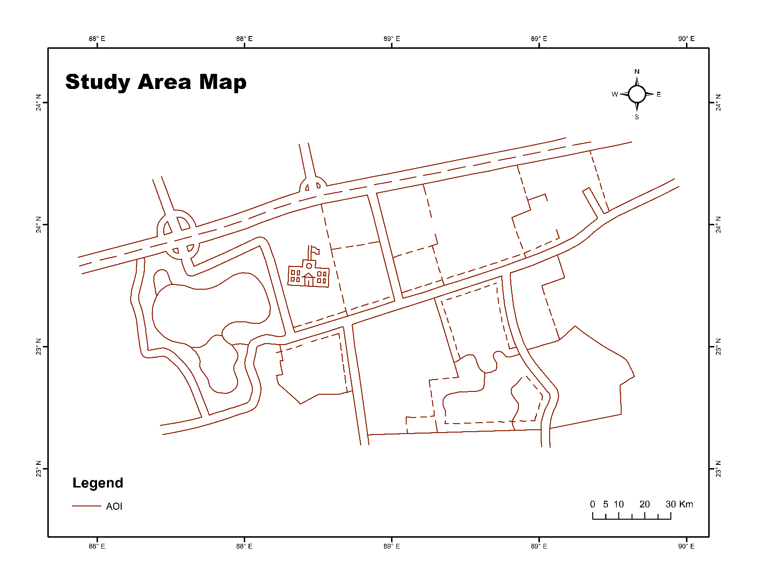
Figure 14: Planimetric Vector Digitization of Road Networks, Institutional Parcels, and Waterbodies.
5.2 Fluvial Geomorphology and Agricultural Parcel Digitization
This vector digitization captures complex natural fluvial geomorphology and adjoining agricultural land partitions. Rendered in clean magenta linework across a local coordinate frame (80° E to 80° E and 28° N to 29° N), the vector model extracts meandering river courses, abandoned channel loops, oxbow lakes, and intersecting field boundaries.
Dynamic deltaic floodplains require high-precision digitizing to track river migration, bank erosion, and land-use fragmentation over time. The smoothly interpolated curvilinear vectors follow complex shoreline sinuosity, preserving hydraulic contours while maintaining clean topological structure across intersecting land-tenure polygons. This dataset serves as a foundational input for hydrodynamic modeling and land administration GIS.
From a fluvial geomorphology and hydraulic analysis perspective, converting analogue river morphology into topologically sound vector layers allows researchers to compute quantitative meander parameters, including channel sinuosity indices, radius of curvature, meander wavelength, and arc lengths. Capturing relict fluvial landforms—such as scroll bars, chute cutoffs, and oxbow depressions—provides a spatial chronology of historic avulsion pathways, revealing how the main river channel has shifted across the alluvial plain over time. These geometric boundaries integrate directly into numerical hydraulic modeling platforms (such as HEC-RAS and Telemac-2D) to establish cross-sectional geometries, define active conveyance channels, and simulate two-dimensional floodplain inundation depths during peak discharge events.
Simultaneously, delineating the adjoining cadastral boundaries alongside dynamic riverbanks addresses the challenges of land administration in shifting riparian zones. As lateral channel migration continuously erodes arable plots and deposits newly accreted alluvium (char lands), overlapping cadastral parcels onto active bank lines enables land revenue departments to quantify land-loss rates, detect property fragmentation, and resolve boundary disputes with legal precision. By enforcing strict topological rules—such as preventing overlapping polygons, closing dangling lines, and preserving shared boundaries between water bodies and agricultural parcels—this vectorization bridges physical geomorphic modeling with cadastral land management, providing river basin authorities and land-use planners with an empirical dataset to design sustainable river training works, flood-control embankments, and adaptive riparian zoning policies.
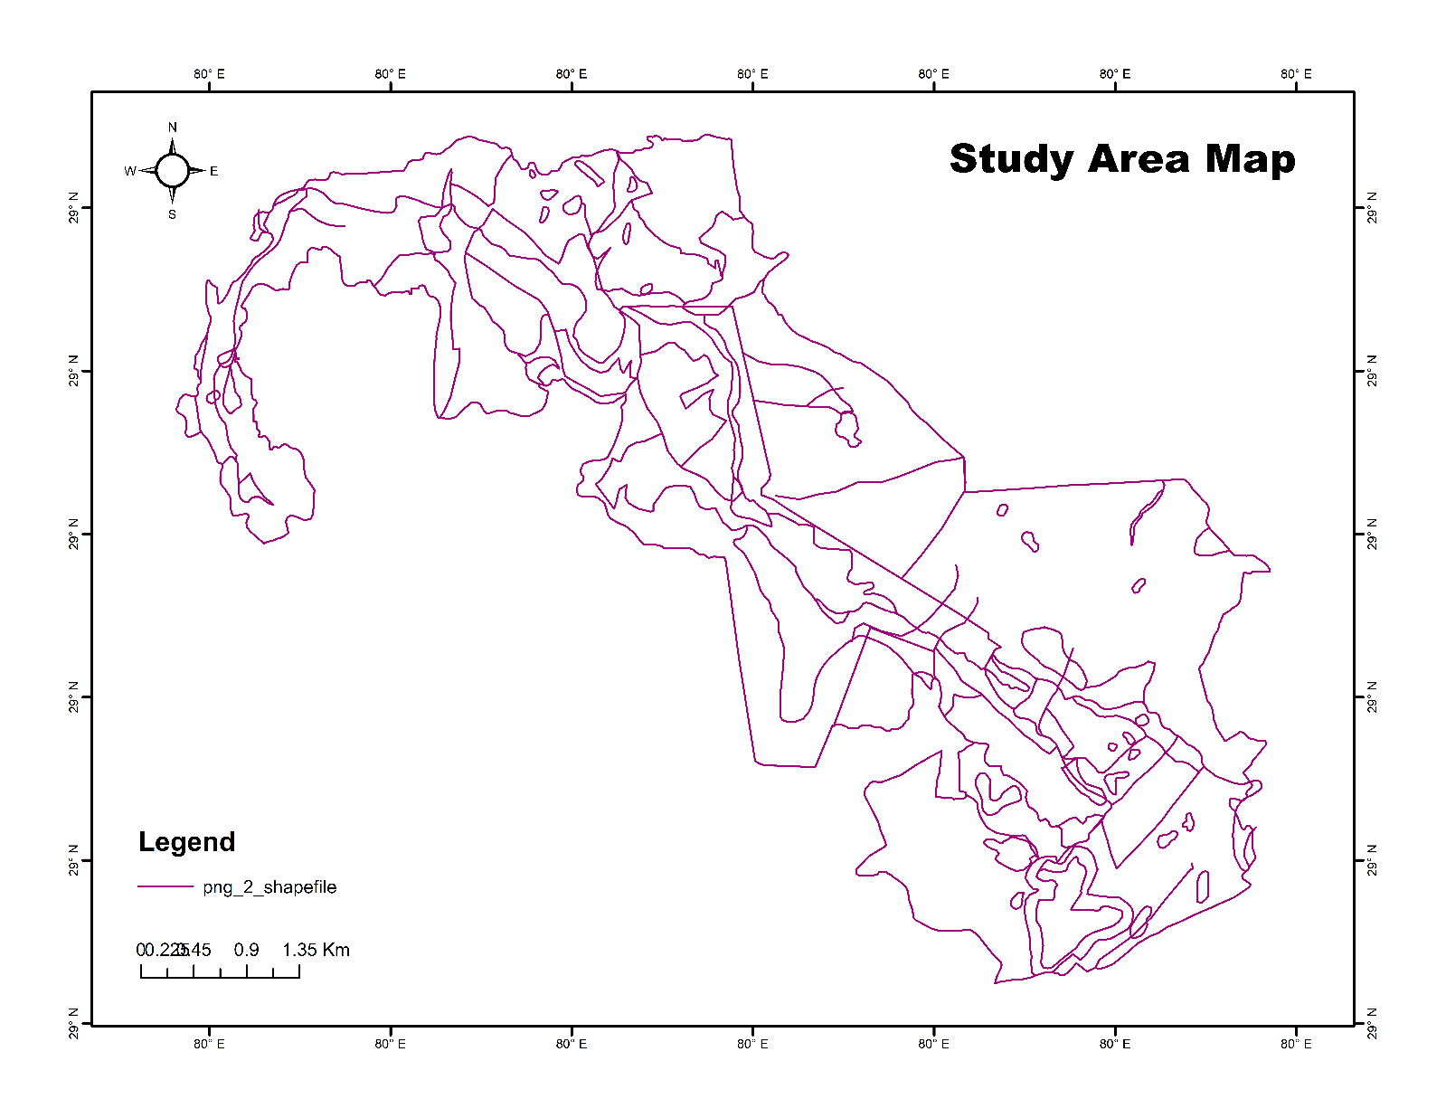
Figure 15: Vectorized Delineation of Meandering Fluvial Channels and Intersecting Land Boundaries.
5.3 Urban Grid Street Network and Riparian Corridor Digitization
This fine-scale cartographic vectorization documents a dense urban center bounded by a riparian river corridor. Extracted across coordinates 89° E to 91° E and 23° N to 25° N, the linework captures a structured grid-pattern street network, arterial feeder roads, agricultural plots, an adjacent river channel, and a major public stadium landmark.
Converting legacy engineering paper maps into digital vector layers enables municipal GIS integration, urban density modeling, traffic capacity calculations, and urban flood hazard assessments. The clear topological distinction between the dense rectangular urban street grid and the flowing curvilinear lines of the riverbank illustrates high technical digitizing precision and spatial consistency.
From an urban systems and infrastructural modeling perspective, transforming static planar drawings into topologically validated network datasets allows transportation planners to run complex service area analyses, calculate intersection density metrics, and assess road hierarchy connectivity. The systematic delineation of secondary access lanes connecting to principal radial arteries provides the geometric framework needed for dynamic traffic flow assignments and micro-simulation of peak-hour bottleneck scenarios. Furthermore, isolating prominent civic infrastructure—such as the centrally located public stadium complex—enables crowd ingress-egress modeling and the designation of critical emergency muster points during civic emergencies or urban disaster evacuations.
Along the urban-water interface, the precise digitization of the meandering river boundary provides the physical geometry required to model riparian buffer setbacks and compound flood vulnerability. During high-intensity convective precipitation events or seasonal upstream discharge peaks, high-density impervious street grids accelerate overland stormwater runoff toward low-lying riverbanks. Having an exact, georeferenced spatial boundary of both the built fabric and the natural drainage corridor empowers municipal engineers to identify vulnerable outfall zones, model potential backwater inundation levels, and optimize the placement of retaining seawalls, sluice gates, and pump stations. By bridging historical engineering basemaps with modern analytical GIS platforms, this vector dataset equips municipal corporations, utility authorities, and urban resilience planners with a reliable spatial baseline to guide smart growth management, infrastructural retrofitting, and sustainable waterfront development.
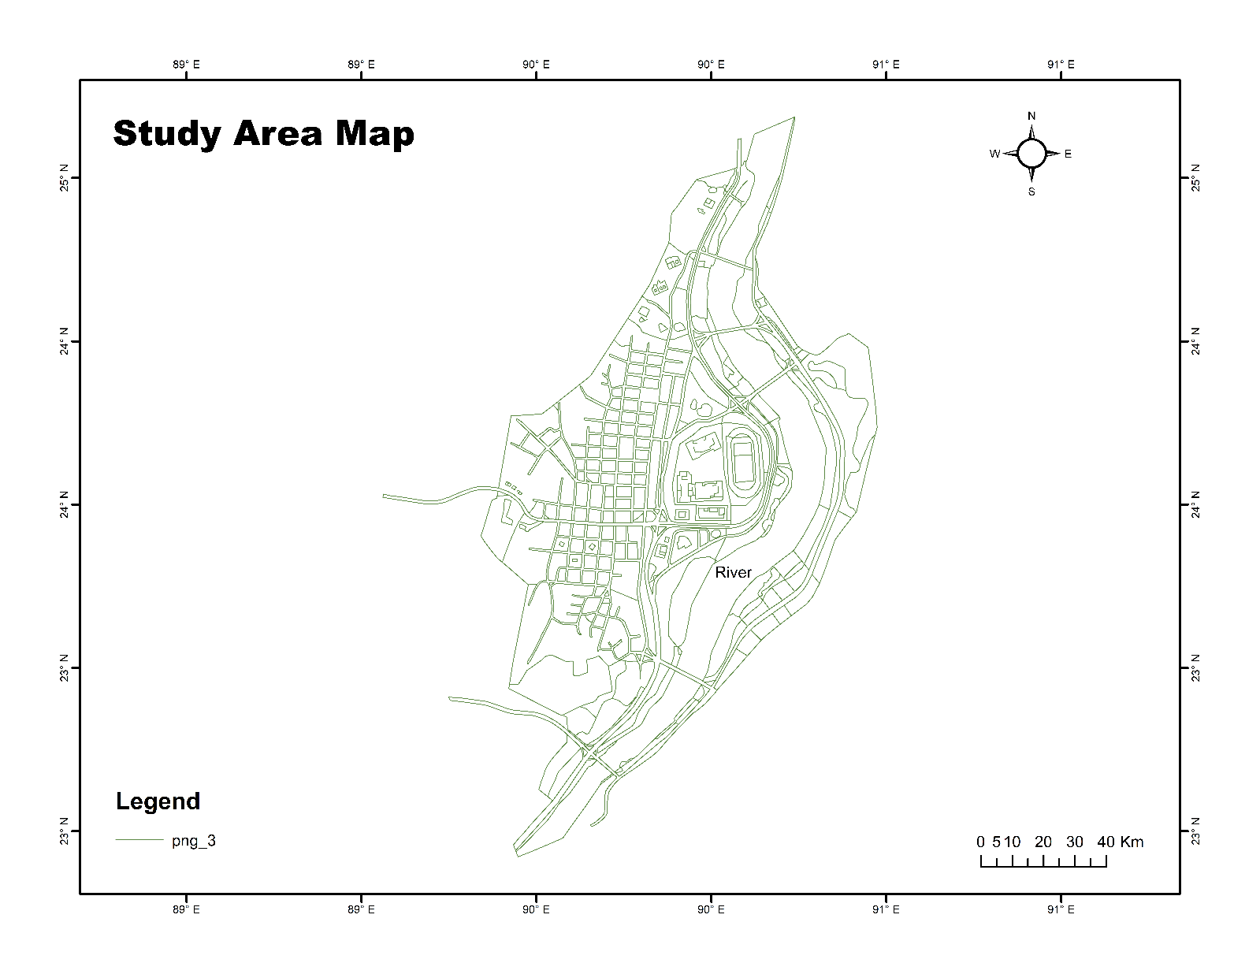
Figure 16: Detailed Vector Extraction of Urban Grid Streets, Stadium Landmark, and River Boundary.
6. Technical Summary Matrix of Cartographic Outputs
Figure Number | Map Layout Title | Geographic Domain | Spatial Methodology | Primary Application & Thematic Focus
Figure 1 | Transboundary Sundarban (World & Asia Map Inset) | Sundarbans Complex | Multi-Tier Global/Regional Mapping | Global context, regional orientation, and marine buffer studies
Figure 2 | Transboundary Mapping of the Sundarbans Region | Transboundary Sundarbans | Satellite Imagery & Vector Overlay | Cross-border mangrove ecology and conservation monitoring
Figure 3 | The Bangladesh Sundarbans Coastal Forest Region | Bangladesh Sundarbans | National Sovereign Forest Mapping | Protected area governance, forestry tracking, and ECA zoning
Figure 4 | Eastern Part Sundarban of Bangladesh | Eastern Sundarbans, BD | Multi-Frame Satellite & Boundary | Biophysical index modeling (FCD) and cyclone impact tracking
Figure 5 | Study Area Map of Selected Coastal Districts of Bangladesh | Coastal Bangladesh | Multi-District Thematic Selection | Marine fisheries, aquaculture, and coastal livelihood zoning
Figure 6 | Study Area Map of Dhaka Division | Dhaka Division, BD | Regional Administrative Inset | Urban planning, MCDA seismic risk, and demographic modeling
Figure 7 | River Basin | Juba-Shabelle Basin | Basin-Scale Watershed Extraction | Transboundary river management and hydrologic modeling
Figure 8 | Study Area Map: Saskatchewan | Saskatchewan, Canada | Provincial / National Locator Inset | Transportation network resilience and climatic risk analysis
Figure 9 | Study Area Map (Khulna, Barishal, and Patuakhali) | Southwestern Coastal Belt | Comparative Regional Selection | Multi-region climate vulnerability and salinity comparisons
Figure 10 | Study Area Map of Kukua Union | Kukua Union, Amtali, BD | Three-Tier Nested Administrative Inset | Community-level disaster planning and field survey baseline
Figure 11 | Study Area Map of Taltali Upazila | Taltali Upazila, BD | Multi-Scale Hierarchical Isolation | Coastal hazard management and shelter accessibility studies
Figure 12 | Spatial Distribution of the Study Area within Kuakata Coastal Region | Kuakata Shoreline, BD | Dynamic Marine Spatial Buffering | Shoreline dynamics (DSAS), erosion, and tourism management
Figure 13 | Study Area and Field Sampling Sites | Patuakhali District, BD | Point-Pattern Sampling Cartography | Ground-truth sampling distribution for environmental surveys
Figure 14 | Study Area Map: Local Infrastructure Digitization | Local Municipal Site | Planimetric Infrastructure Digitization | Urban parcel mapping, building footprints, and road extraction
Figure 15 | Study Area Map: Fluvial & Parcel Shapefile | Fluvial Floodplain | Curvilinear Hydrographic Digitizing | River morphodynamics, oxbow lake extraction, and cadastre
Figure 16 | Study Area Map: Urban Grid & Riparian System | Urban Riparian Zone | Grid Network & Landmark Digitizing | Municipal GIS, street networks, and urban flood modeling

7. Synthesis and Strategic Conclusion
Accurate cartographic design, multi-scale spatial delineation, and high-precision vector digitization are essential components of geospatial science. The maps compiled in this portfolio represent a complete methodological spectrum:
- Transboundary ecosystem mappings capture continuous environmental biomes regardless of political borders.
- Macro-scale administrative frameworks establish the broader socioeconomic and political context.
- Localized buffer and field sampling layouts provide the spatial rigor required for empirical ground-truthing.
- Sub-meter planimetric digitizations transform static historical raster assets into dynamic, analysis-ready GIS vector layers.
By maintaining coordinate precision, strict topological standards, and clean cartographic layouts across regional, district, upazila, and local scales, these geospatial products provide the empirical foundation necessary for academic research, peer-reviewed publications, environmental monitoring, and sustainable regional development planning.

