Gender-Based Barriers in Accessing Cyclone Shelters: Evidence from Coastal Communities and Policy Implications

1. Executive Summary and Research Rationale
Cyclone shelters represent the primary life-saving infrastructure across the vulnerable coastal belt of Bangladesh. Despite significant advancements in early warning dissemination and structural shelter construction, severe gender disparities persist in evacuation compliance and shelter access. Women in coastal communities face structural, socio-cultural, infrastructural, and institutional bottlenecks that heighten their vulnerability during extreme hydro-meteorological events.
This empirical study investigates the socio-demographic drivers, intra-household decision-making dynamics, safety perceptions, and structural barriers that prevent women from accessing cyclone shelters. By analyzing primary field data across seven vulnerable coastal unions—Barabagi, Karaibaria, Nishanbaria, Pachakoralia, Sharikkhali, Sonakata, and Sutobagi—this report delivers an empirical baseline and formulates actionable policy interventions to transform cyclone shelters into safe, inclusive, and gender-responsive disaster management hubs.
2. Demographic Profile and Sample Distribution
The survey sample comprises a representative cross-section of coastal residents with balanced demographic stratification. Women constitute 56.2% of total respondents, while men represent 43.8%, ensuring that gender-differentiated perspectives are robustly captured.
The age distribution of respondents spans from 18 to 75 years, with the highest concentration clustered in the young and economically active reproductive age bracket of 20 to 35 years. A secondary demographic peak is observed among older cohorts between 55 and 75 years, who experience compound physical limitations during emergency evacuations.
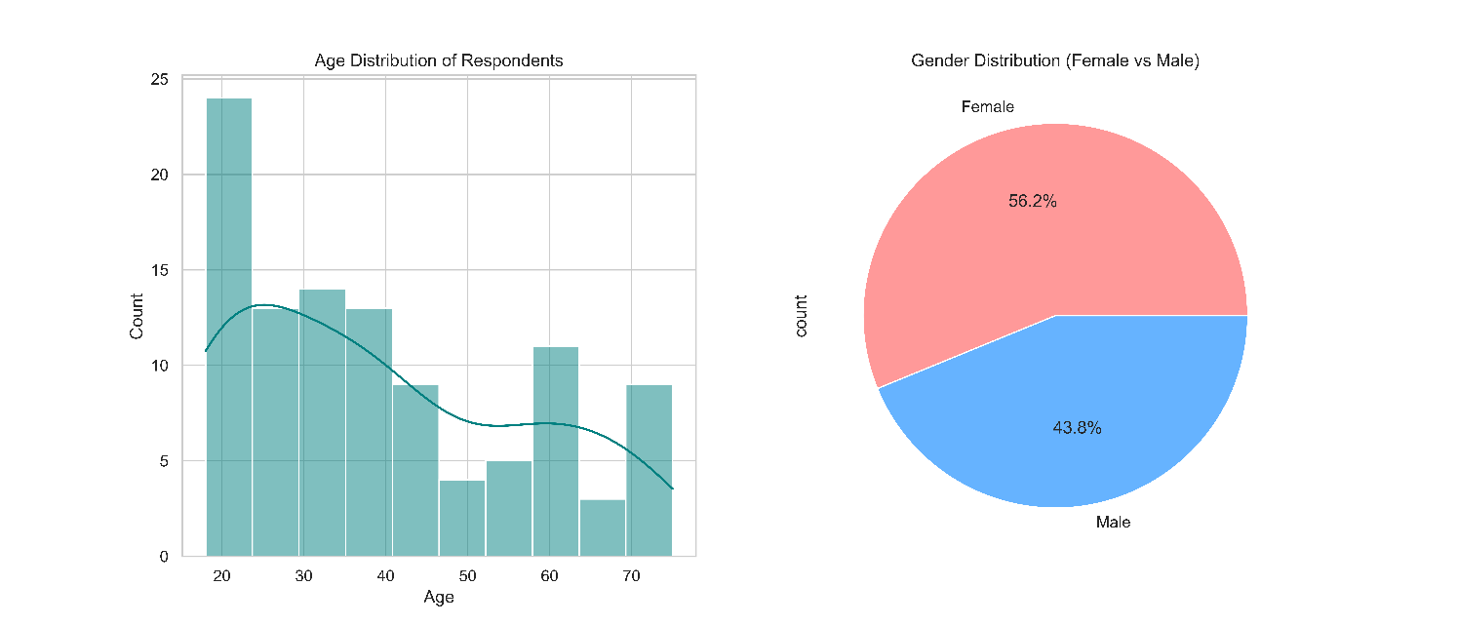
Figure 1: Age histogram with kernel density estimation (left) and gender distribution pie chart (right) of surveyed coastal respondents.

3. Structural and Physical Barrier Analysis
Field observations and quantitative frequency analyses identify severe deficiencies in shelter capacity, design, and basic facility management as primary drivers of female evacuation avoidance.
Overcrowding emerges as the most prominent barrier, cited by more than 100 respondents. This is closely followed by the lack of privacy or separate gender-segregated spaces, cited by over 95 respondents, and poor sanitation facilities, cited by approximately 90 respondents. Secondary yet critical deterrents include severe shortages of safe drinking water and food supplies, poor shelter administration, absence of female-friendly support staff or female volunteers, unpaid care burdens involving children and elderly relatives, and the persistent reluctance to abandon household livestock and productive assets.
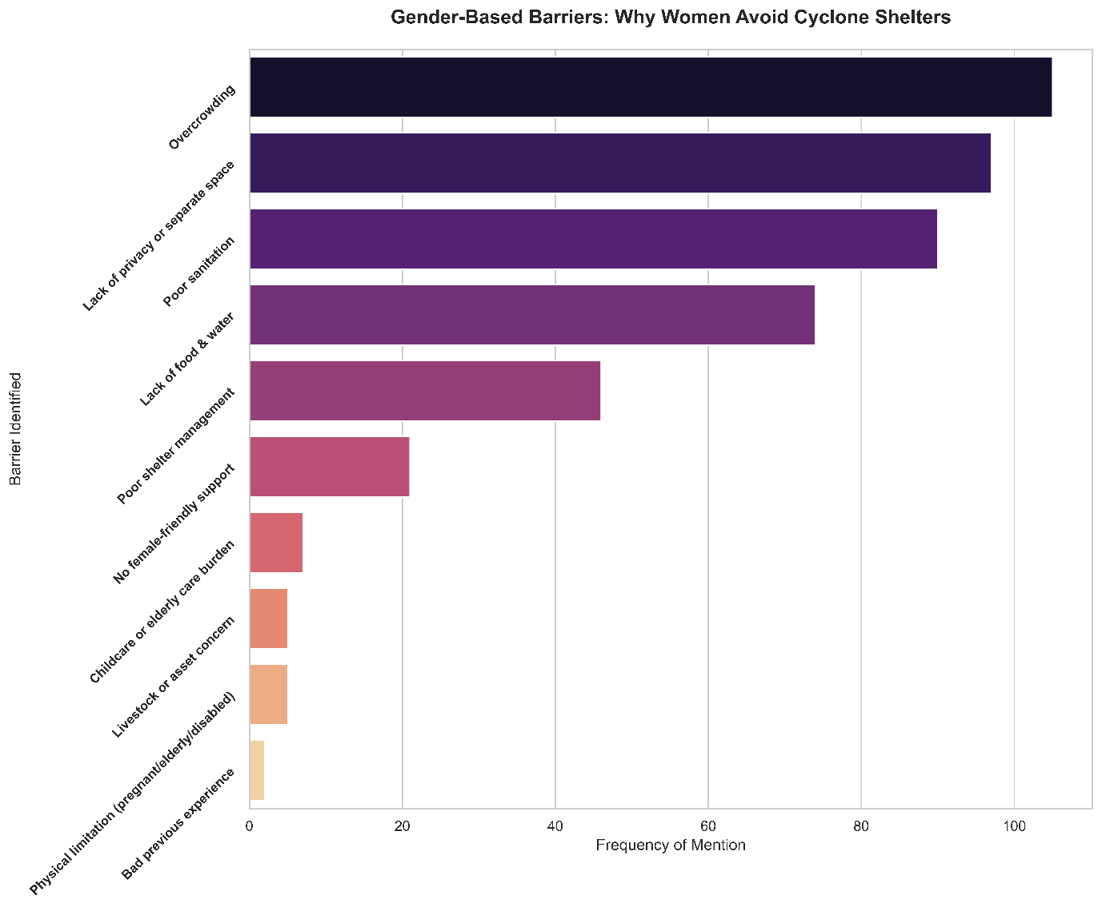
Figure 2: Frequency ranking of gender-based structural and operational barriers preventing women from seeking cyclone shelter refuge.

4. Sanitation Deficits and Cross-Demographic Vulnerability
Sanitation deficiencies represent a decisive operational deterrent that disproportionately affects women across all age brackets.
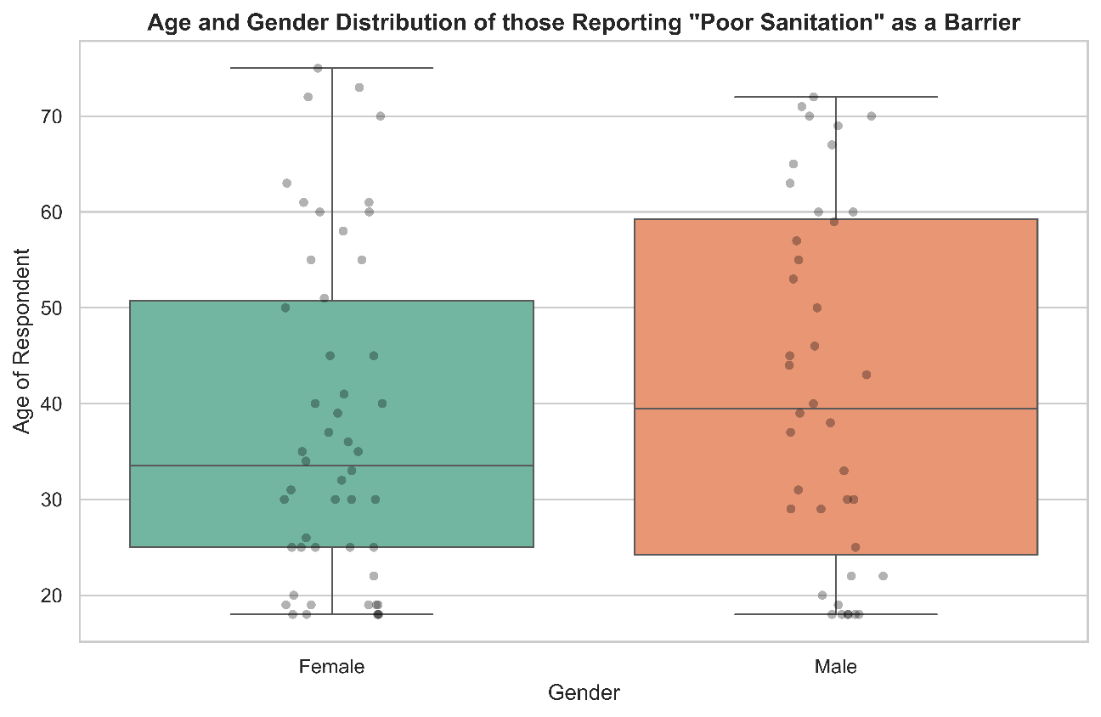
Figure 3: Box plot and scatter distribution of respondent age and gender identifying poor sanitation as an evacuation barrier.
A detailed distributional analysis of respondents reporting poor sanitation as a barrier reveals distinct gender dynamics. Among female respondents, concern over sanitation is prevalent from young adulthood through old age, with the median age centered at approximately 34 years and an interquartile range spanning from 25 to 51 years. Among male respondents, the median age is higher at approximately 40 years, with an interquartile spread from 24 to 59 years. The presence of numerous young female respondents reporting sanitation challenges highlights severe concerns regarding menstrual hygiene management, lack of private latrines, and water scarcity during emergency shelter occupancy.

5. Intra-Household Agency and Decision-Making Authority
Household decision-making structures directly govern evacuation timing and shelter access in coastal communities.
Analysis of decision-making authority indicates that patriarchal dominance remains the primary governing model, with 55.2% of households reporting that the male head of household exercises sole decision-making power during cyclone warnings. Joint decision-making between spouses occurs in only 44.8% of households. When disaggregated by gender, 47.9% of female respondents report participating in joint decision-making, compared to 41.3% of male respondents. This institutionalized lack of female agency frequently delays evacuation until floodwaters reach critical levels, substantially increasing female mortality risks during transit.
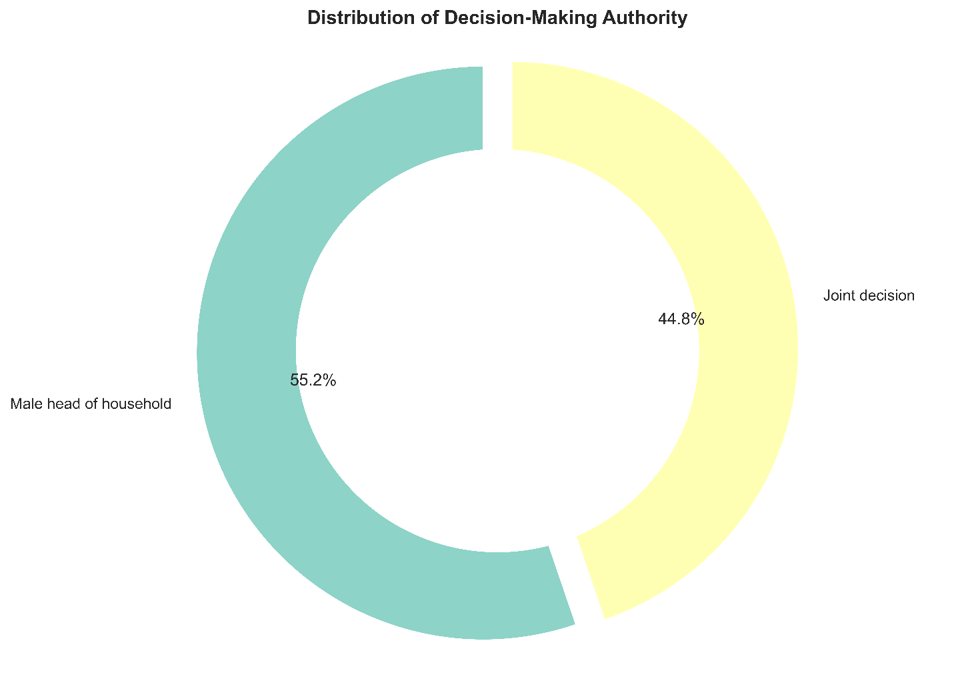
Figure 4: Overall percentage distribution of household evacuation decision-making authority.
The gender-disaggregated agency analysis demonstrates a persistent disparity in evacuation decision-making power between men and women in coastal households. While joint decision-making is reported by 47.9% of female respondents and 41.3% of male respondents, the majority of households remain governed by male heads of household, who account for over 52% to nearly 59% of the decision-making authority across reported groups. This pronounced reliance on patriarchal authority highlights the structural constraints on women's independent agency, often delaying timely evacuation during cyclone warnings and underscoring the urgent need for inclusive, community-based early warning and preparedness strategies.

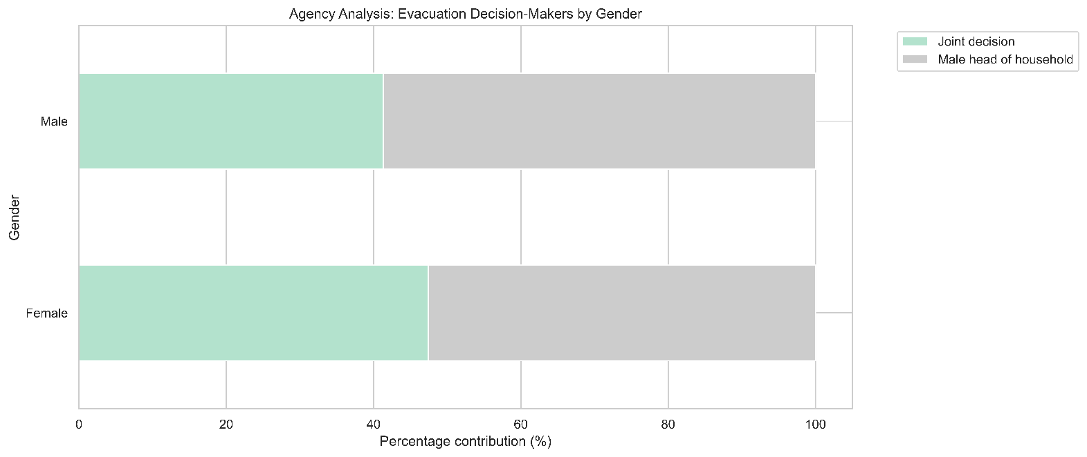
Figure 5: Gender-disaggregated comparison of household evacuation decision-makers.

6. Safety Perceptions and Shelter Security
Perceptions of physical security, privacy, and harassment inside communal evacuation facilities determine whether families allow female members to evacuate.
Survey findings demonstrate an overwhelming consensus regarding the lack of safety for women inside cyclone shelters. More than 95% of both female and male respondents explicitly state that women are not safe in communal shelters. This pervasive lack of safety stems from unlit corridors, lack of gender-segregated rooms, absence of female security personnel, and documented risks of verbal and physical harassment in overcrowded conditions.
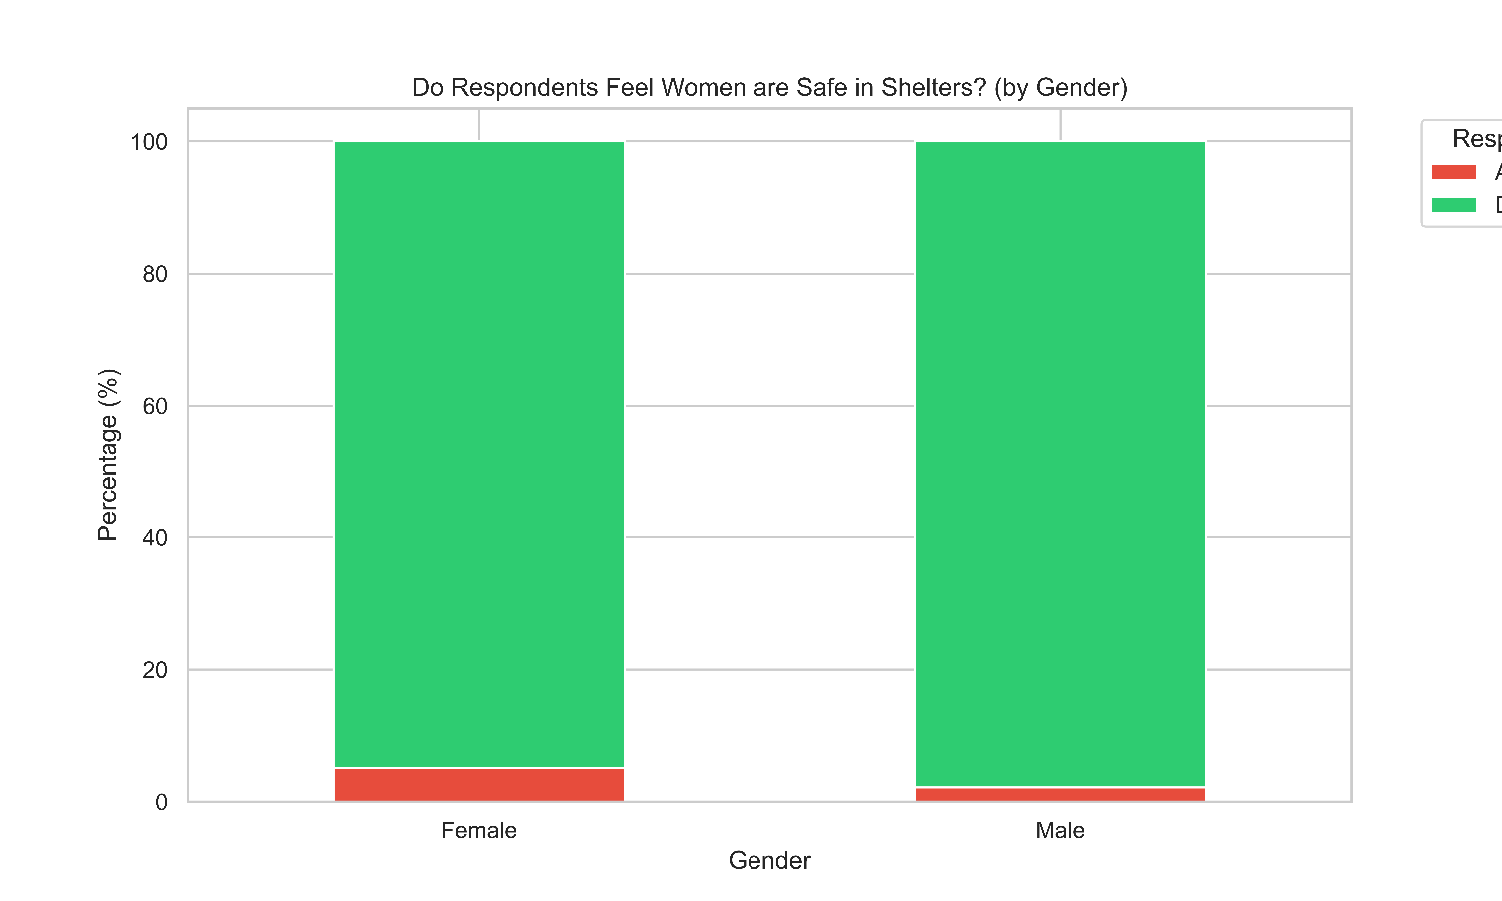
Figure 6: Respondent perceptions on whether women feel safe in cyclone shelters, disaggregated by gender.
7. Economic Vulnerability, Asset Dependency, and Spatial Accessibility
Livelihood asset protection is intrinsically linked to disaster evacuation behavior. An overwhelming 87.6% of respondents agree, and an additional 1.0% strongly agree, that livelihood factors—specifically the protection of livestock, poultry, and household assets—directly dictate evacuation decisions. Only 9.5% disagree. In coastal households, women are traditionally tasked with managing small livestock, creating a direct conflict between physical survival and economic asset preservation.
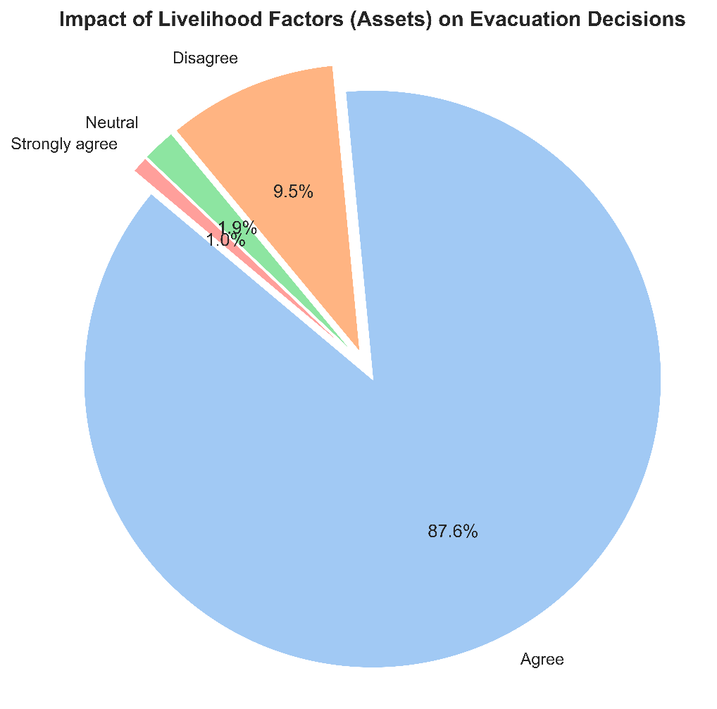
Figure 7: Impact of livelihood asset protection on household cyclone evacuation decisions.
Economic marginalization further amplifies physical access difficulty. Households earning below 5,000 BDT monthly report severe access difficulties, with median responses falling in the "Difficult" to "Very Difficult" categories. In contrast, higher-income households earning above 20,000 BDT report lower access difficulty, as financial resources enable private transport and motorized movement.
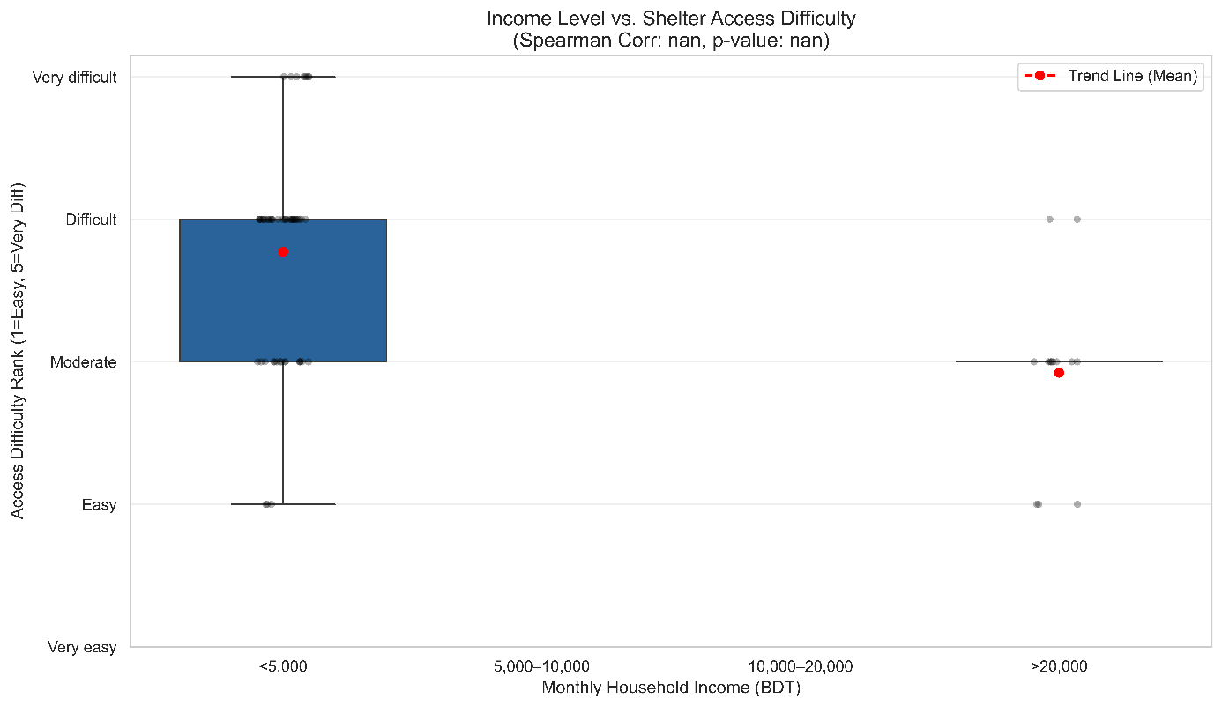
Figure 8: Shelter access difficulty ranking across monthly household income tiers.
Spatial access difficulty exhibits sharp geographic variation across administrative unions. In Sharikkhali, Sutobagi, and Karaibaria, more than 65% to 75% of respondents categorize shelter access as either Difficult or Very Difficult. Conversely, Nishanbaria records the highest proportion of Easy access (40%), reflecting localized investments in elevated access roads and proximity to multi-purpose cyclone shelters.
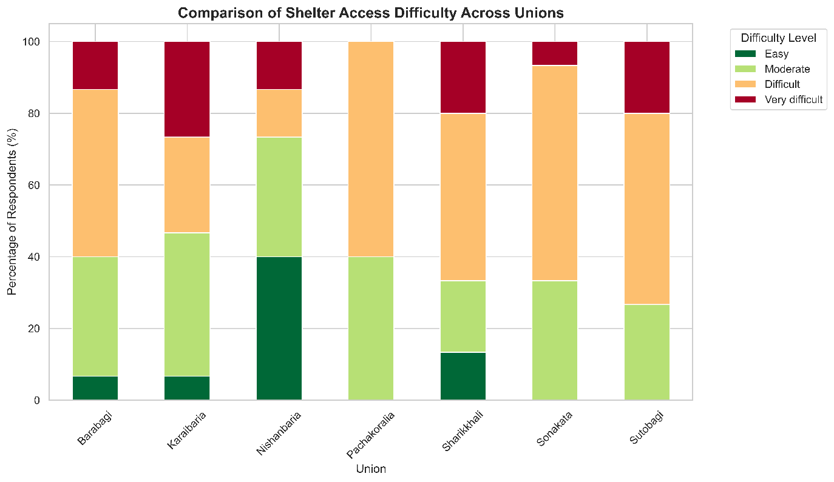
Figure 9: Spatial comparison of shelter access difficulty tiers across seven coastal unions.
8. Statistical Correlation Matrix of Barrier Factors
Inter-variable correlation analysis illustrates the systemic linkages among socio-demographic drivers and physical access barriers:
- Age demonstrates a moderate positive correlation with Household Size ($r=0.56$) and Access Difficulty ($r=0.45$), indicating that older household heads managing larger families encounter severe transit and logistics constraints during evacuation.
- Household Size is strongly correlated with Access Difficulty ($r=0.46$), reflecting the difficulty of moving multi-generational family units, children, and dependent elders through flooded pathways.
- Income Level displays a strong negative correlation with Access Difficulty ($r=-0.41$), confirming that financial capital serves as a critical buffer against spatial accessibility barriers.
- Mobility Restriction correlates positively with Access Difficulty ($r=0.14$) and Household Size ($r=0.16$).
The correlation analysis underscores how systemic socio-economic and demographic vulnerabilities interact to dictate physical access to cyclone shelters. As demonstrated by the strong negative association between income and access difficulty, poverty acts as a major structural barrier, depriving marginalized coastal families of the resources, elevated transportation, or flexible timing needed to evacuate safely before landfall. Concurrently, larger households and older family heads face severe logistical hurdles, as the responsibility of coordinating multi-generational evacuation—frequently involving dependent children, frail elders, and livestock—delays movement through inundated and fragile road corridors. These intertwined dynamics indicate that physical access constraints are not solely a function of distance, but are heavily driven by intra-household economic capacity and social dependency. Consequently, targeted disaster risk reduction interventions must account for these underlying vulnerabilities rather than relying on one-size-fits-all evacuation protocols. Enhancing connectivity, developing community-level evacuation assistance for elderly and large families, and implementing localized social protection mechanisms will be critical to lowering access thresholds and ensuring that the most disadvantaged community members reach life-saving shelter infrastructure in a timely manner.

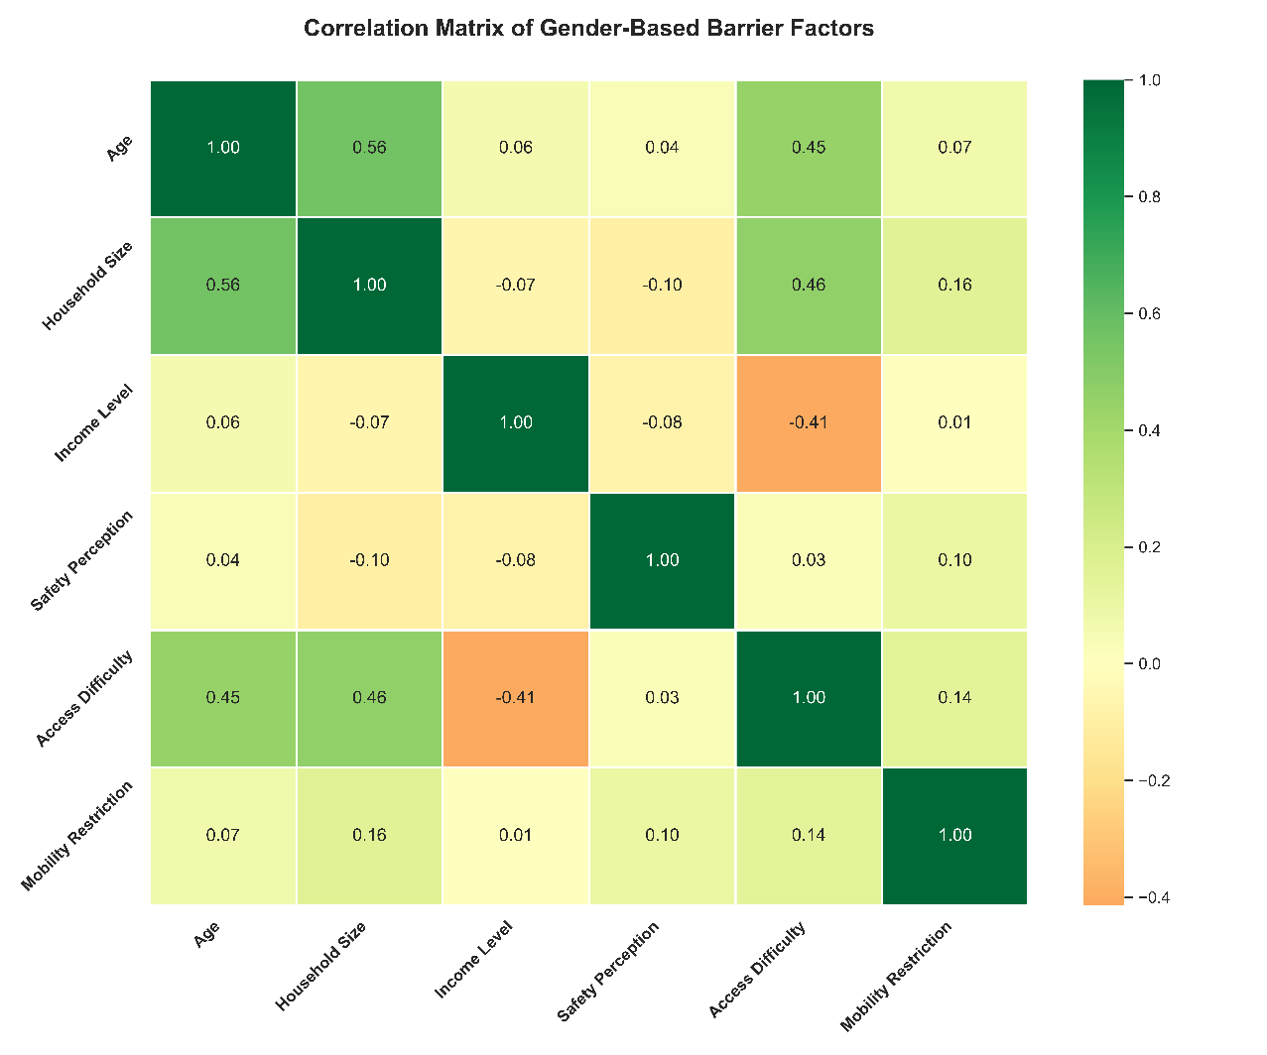
Figure 10: Pearson correlation matrix across demographic, economic, and operational barrier indicators.
9. Strategic Policy Implications and Recommendations
To dismantle gendered structural barriers and enhance coastal resilience, disaster management authorities, municipal planners, and non-governmental organizations must execute targeted policy reforms:
9.1 Gender-Responsive Infrastructure Modernization
All existing and future multi-purpose cyclone shelters must incorporate physical architectural partitions ensuring dedicated, lockable spaces for women, lactating mothers, adolescent girls, and pregnant women. Sanitation facilities must be upgraded to provide separate, well-lit, fully functional latrines equipped with running water, disposal mechanisms for menstrual hygiene management, and secure interior locks.
9.2 Integrated Livestock and Asset Protection (Killas)
Because over 88% of evacuation decisions are bound to asset preservation, shelters must be co-located with elevated earthen killas (livestock mounds) and secure ground-floor pens. Providing safe holding spaces for cattle and poultry eliminates the economic trade-off that forces women to remain behind in fragile homesteads during storm surges.
9.3 Female-Led Shelter Management and Protection Committees
Institutional governance of cyclone shelters must enforce equal gender representation. Deploying trained female Cyclone Preparedness Programme (CPP) volunteers and female community police officers inside shelters will address the pervasive 95% safety deficit, deter harassment, and ensure dignified relief distribution.
9.4 Universal Design and Spatial Connectivity
Local government engineering departments must prioritize all-weather, elevated concrete walkways and solar-illuminated access roads linking remote coastal settlements to shelters. Prioritizing infrastructure connectivity in high-difficulty unions—such as Sharikkhali, Sutobagi, and Karaibaria—will minimize evacuation transit times for marginalized, low-income households.

