Spatial Multi-Criteria Decision Analysis for Transportation Network Resilience: Integrating Climatic Hazards and Socio-Economic Vulnerability in Saskatchewan, Canada

1. Project Importance and Rational Background
Transportation networks form the critical backbone of regional economic stability, inter-provincial supply chains, and social connectivity. In high-latitude continental zones, highway corridors are continuously exposed to compound climate extremes including severe freeze-thaw cycles, winter snowstorms, intense precipitation, convective wind events, and localized flooding. When these environmental hazards intersect with heavy freight corridors, dense commuter nodes, and structurally isolated rural road links, systemic network disruptions can lead to severe economic losses, prolonged supply chain severance, and compromised emergency response capabilities.
Traditional transportation planning frequently isolates physical hazard engineering from regional socio-economic exposure. This project develops a unified, spatially explicit multi-criteria risk assessment framework. By integrating hydro-meteorological stressors with demographic concentration, freight density, economic productivity, and network accessibility using the Bayesian Best-Worst Method (B-BWM) and Geographic Information Systems (GIS), this study provides actionable spatial intelligence to prioritize highway maintenance, allocate capital resources, and build climate-resilient transport corridors across the province of Saskatchewan.

2. Study Area Profile
The study area encompasses the entire province of Saskatchewan, Canada, extending geographically from 49°N to 60°N latitude and 102°W to 110°W longitude.
Saskatchewan features a distinct geographical dichotomy between its southern agricultural plains and northern boreal shield. The Southern Prairies are characterized by flat, fertile agricultural terrain, high population concentration centering on primary urban nodes such as Saskatoon and Regina, intensive commercial freight corridors, and a dense, interconnected grid-pattern highway network. In contrast, the Northern Boreal Transition and Shield Region is characterized by rugged terrain, extensive water bodies, sparse demographic settlements, extreme cold conditions, and isolated linear transport routes with limited network redundancy.
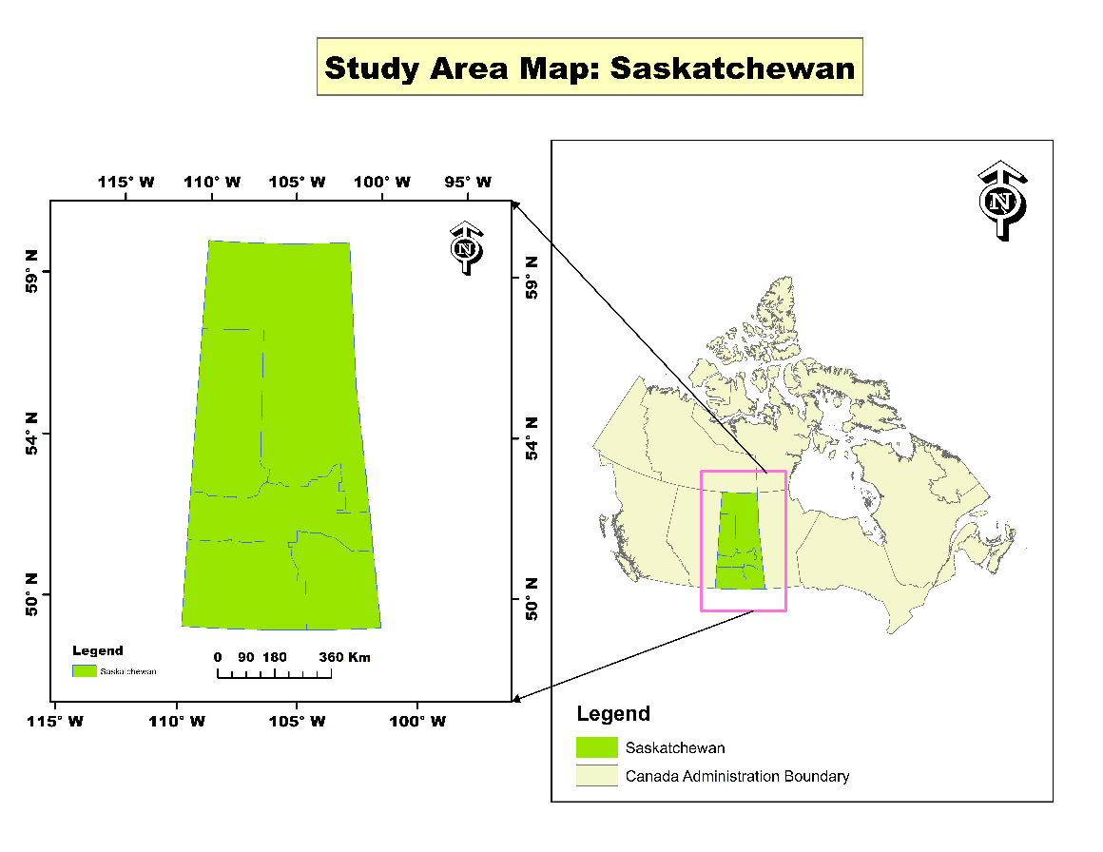
Figure 1: Study Area of Saskatchewan
3. Thematic Spatial Factor Analysis
The multi-criteria evaluation is constructed upon two primary analytical domains comprising individual spatial layers standardized on an ordinal risk scale.
3.1 Climatic and Hydro-Meteorological Hazard Factors
A. Wind Hazard Risk
Extreme wind gusts induce vehicle instability, particularly for high-profile commercial freight, while causing debris hazards and structural fatigue along exposed highway corridors. The southern and southwestern border regions exhibit peak wind risk zones with velocities ranging between 98.88 and 137.80 km/h, posing acute operational hazards to east-west arterial freight routes.
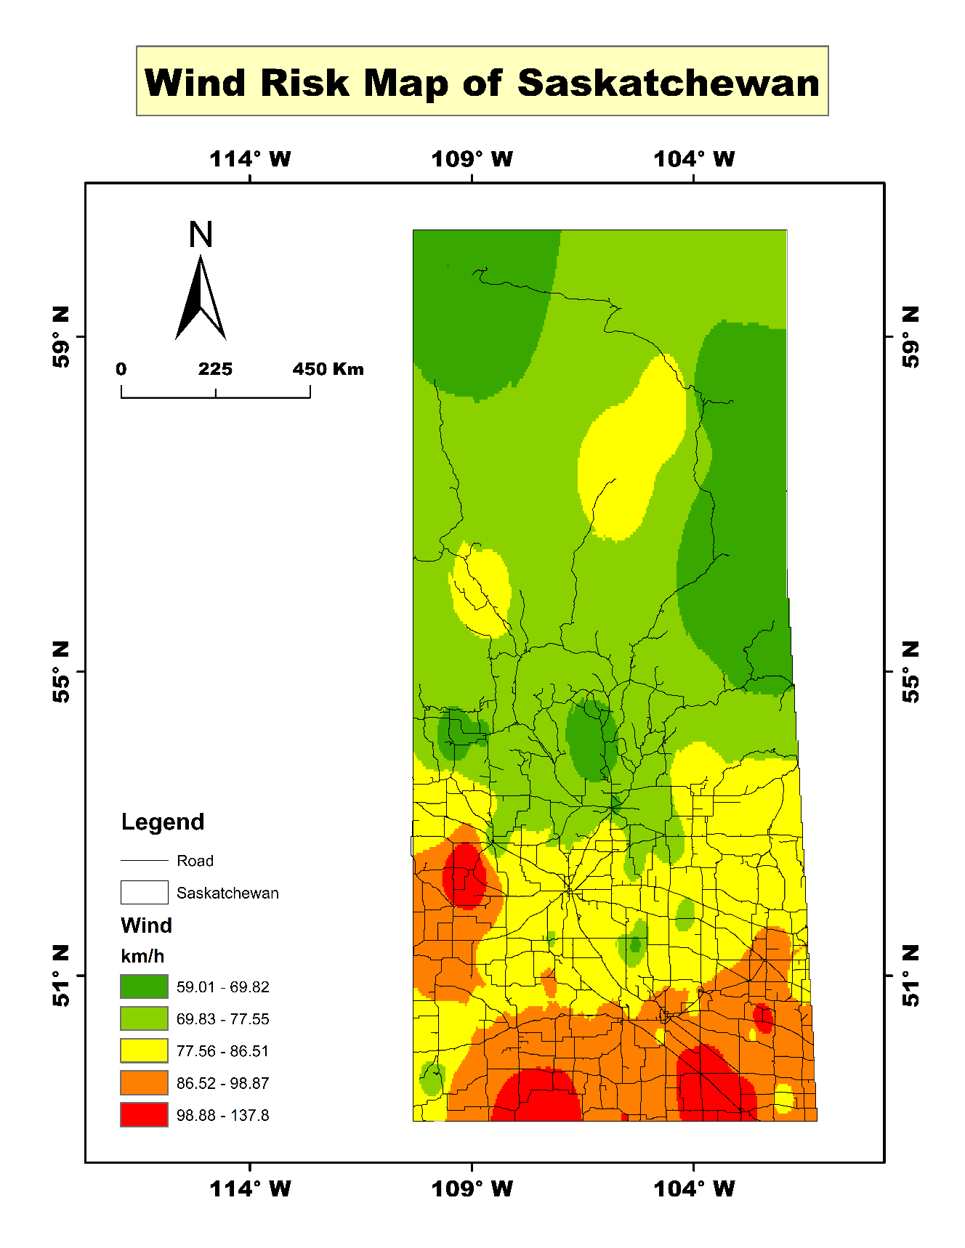
Figure 2: Spatial distribution of wind speed hazard across Saskatchewan
B. Flood Inundation Susceptibility
Low-lying topography, river crossings, and critical drainage culverts face acute surface runoff risks during seasonal snowmelt and flash storm events. Areas with elevated flood depths reaching between 3.38 and 6.30 meters threaten localized washouts, structural foundation scouring, and highway closures along key transport intersections.
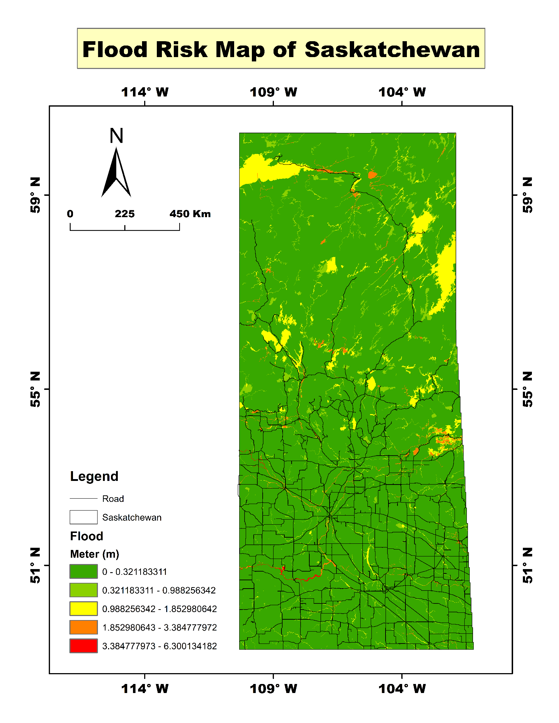
Figure 3: Flood risk and surface water accumulation depth (0 - 6.30 m).
C. Snow Severity and Accumulation
Heavy winter snowfall severely limits vehicular traction, increases snow-clearing operations, and amplifies collision risks. The northern and northeastern corridors record extreme snowfall accumulation levels ranging from 48.47 to 62.98 cm/day, causing seasonal route blockages and requiring dedicated cold-weather logistics.
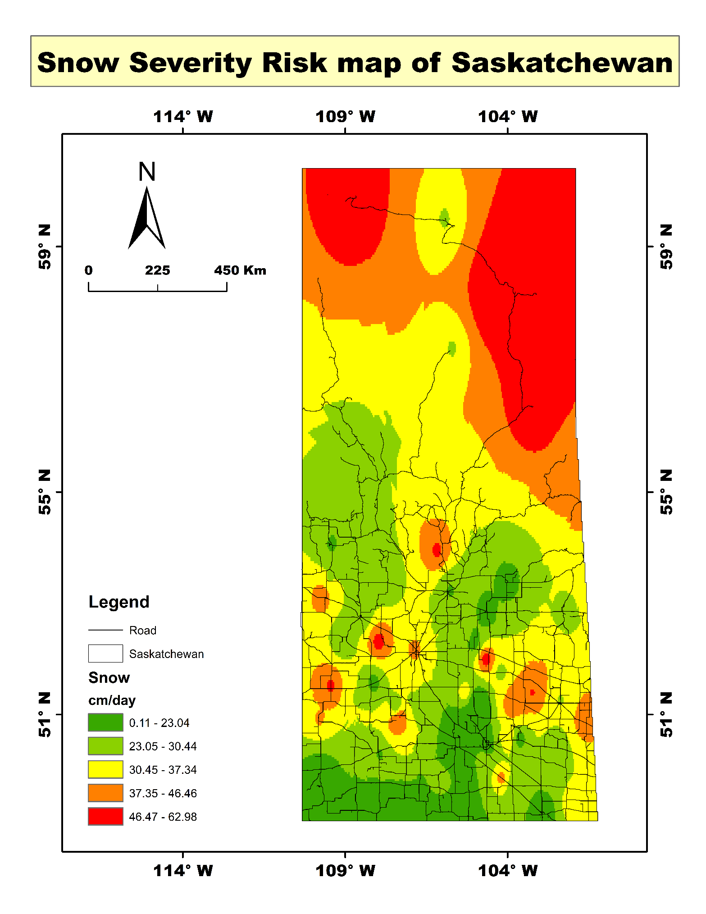
Figure 4: Snow severity and daily accumulation intensity (0.11 - 62.98 cm/day).
D. Precipitation Extremes
Intense localized precipitation events contribute directly to hydroplaning hazards, reduced driver visibility, and accelerated pavement deterioration. Peak daily rainfall zones reaching 33.56 to 45.80 mm/day are concentrated in central and north-central pockets of the province.
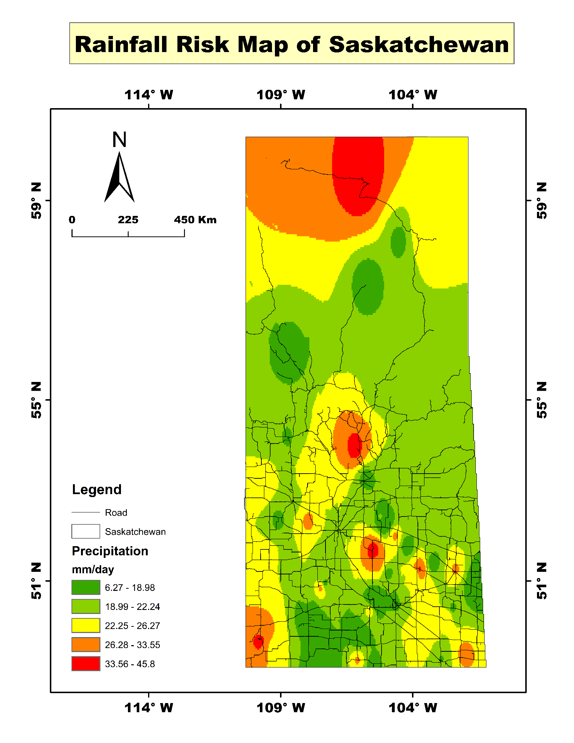
Figure 5: Spatial precipitation distribution across the province (6.27 - 45.80 mm/day).
E. Maximum Thermal Stress
High summer temperatures induce asphalt rutting, pavement bleeding, and thermal expansion on heavily trafficked highways. The southernmost tier experiences the highest maximum thermal exposure, exceeding 30.29°C to 33.24°C.
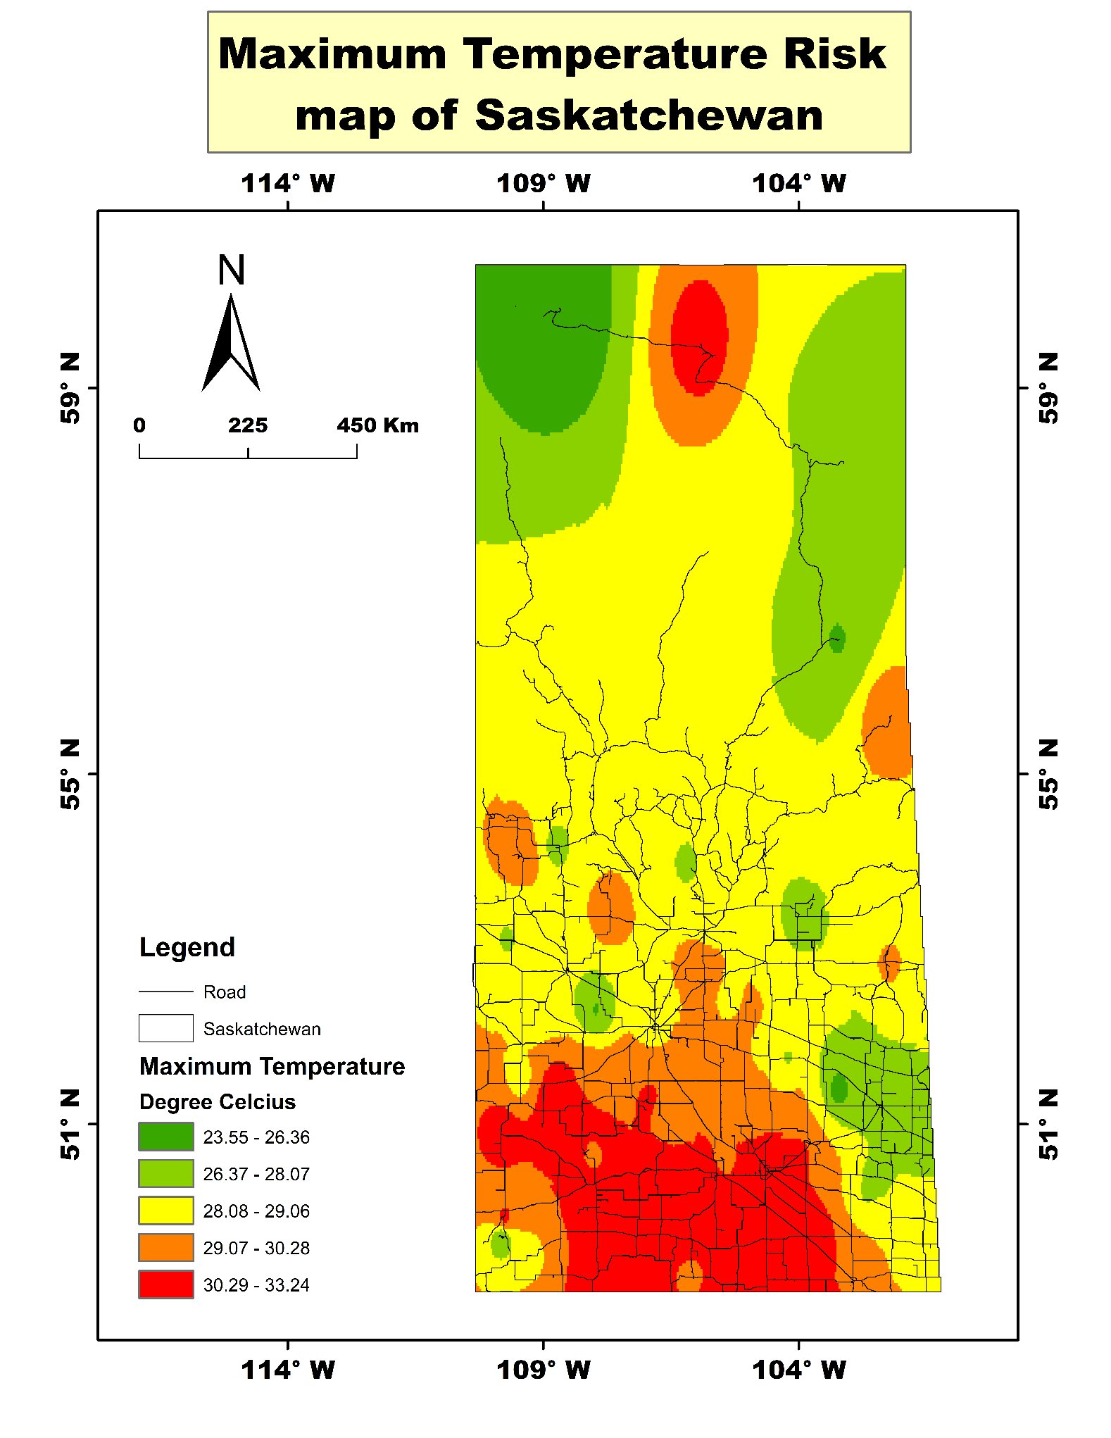
Figure 6: Maximum temperature risk mapping during summer periods (23.55 - 33.24°C).

F. Minimum Thermal Stress (Extreme Cold)
Sub-zero winter temperatures trigger thermal cracking, subgrade frost heave, and rapid pavement degradation. The central-eastern and northern highway sections experience prolonged minimum temperatures dropping between -15.82°C and -21.95°C, representing severe subgrade freeze-thaw cycles.
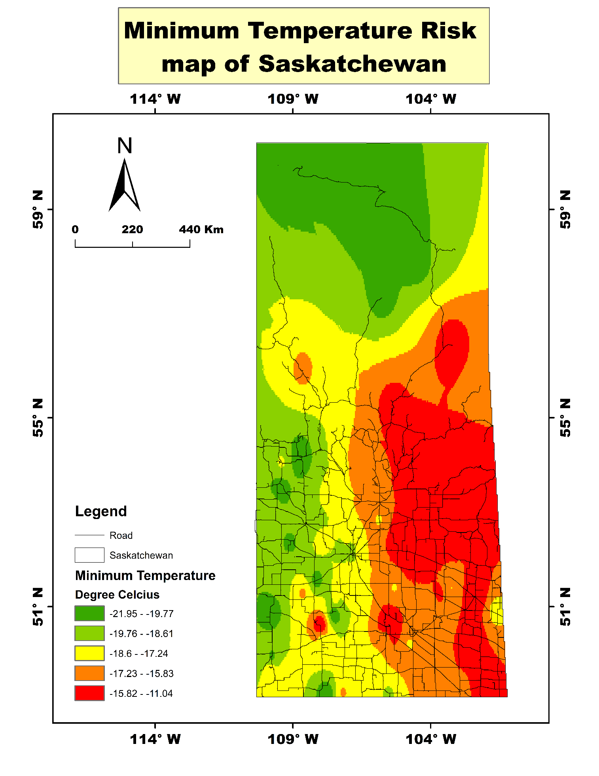
Figure 7: Minimum temperature risk distribution during winter extremes (-21.95°C to -11.04°C).

3.2 Socio-Economic Exposure and Network Criticality Factors
G. Freight Volume Density
Freight volume measures the logistical criticality of the road network. Primary arterial highways connecting Saskatoon, Regina, and southern border crossings handle heavy loads between 6,918 and 25,920 vehicles/day, making them the most economically critical corridors where any interruption generates high financial impacts.
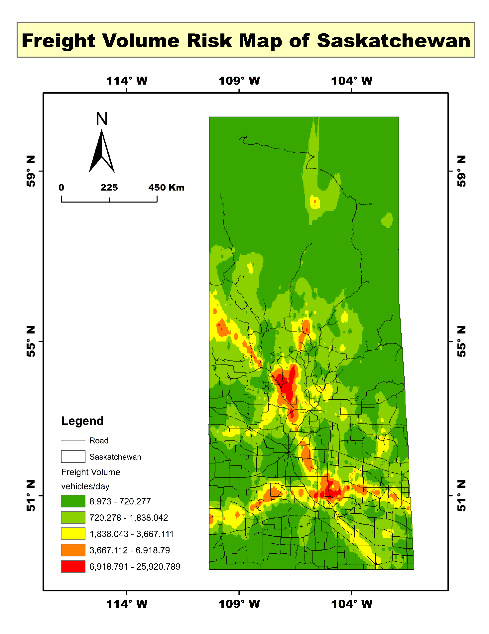
Figure 8: Freight traffic volume across Saskatchewan highway networks (8.97 - 25,920.78 vehicles/day).
H. Population Density Exposure
Urban population concentrations represent dense commuter movement and critical emergency evacuation corridors. The metropolitan nodes around Saskatoon and Regina show peak density values between 220,492 and 317,397 people/km², marking these corridors as high-priority zones for life safety and mobility.
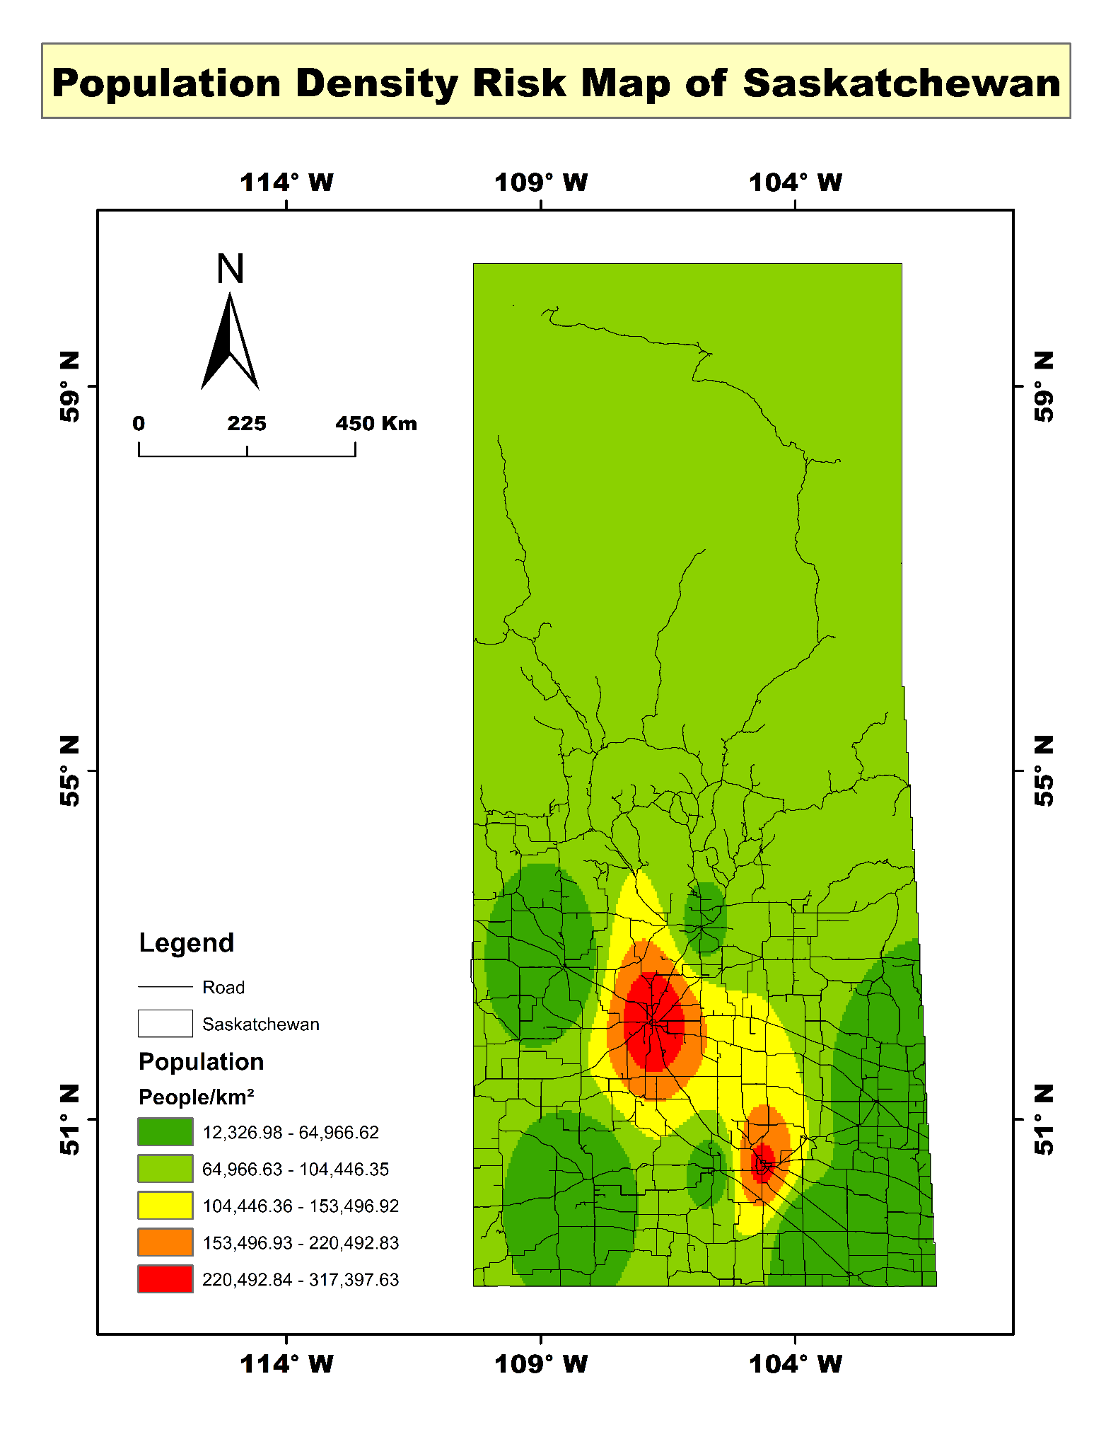
Figure 9: Demographic exposure and population density distribution (12,326 - 317,397 people/km²).
I. Economic Asset Importance
Economic importance reflects regional gross domestic output, agricultural value, and industrial revenue tied directly to transport reliability. The southeastern commercial and resource belts record the highest values between $77,862 and $81,993 CAD, identifying highway corridors that require high structural serviceability to prevent economic loss.
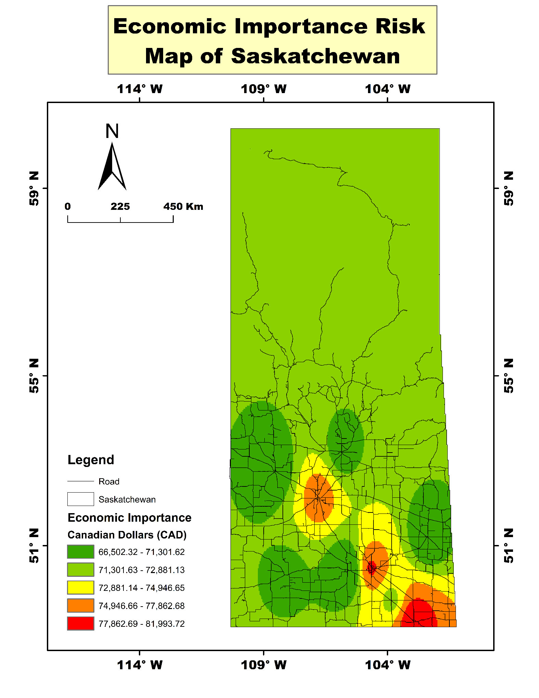
Figure 10: Demographic exposure and population density distribution (12,326 - 317,397 people/km²).
J. Network Accessibility and Isolation Risk
Accessibility models the distance and connectivity of local corridors to primary emergency routes. Northern and peripheral roadways located more than 8 km away from alternative arterial connections suffer from low redundancy and high isolation risk, meaning an environmental disruption can completely sever access for remote communities.
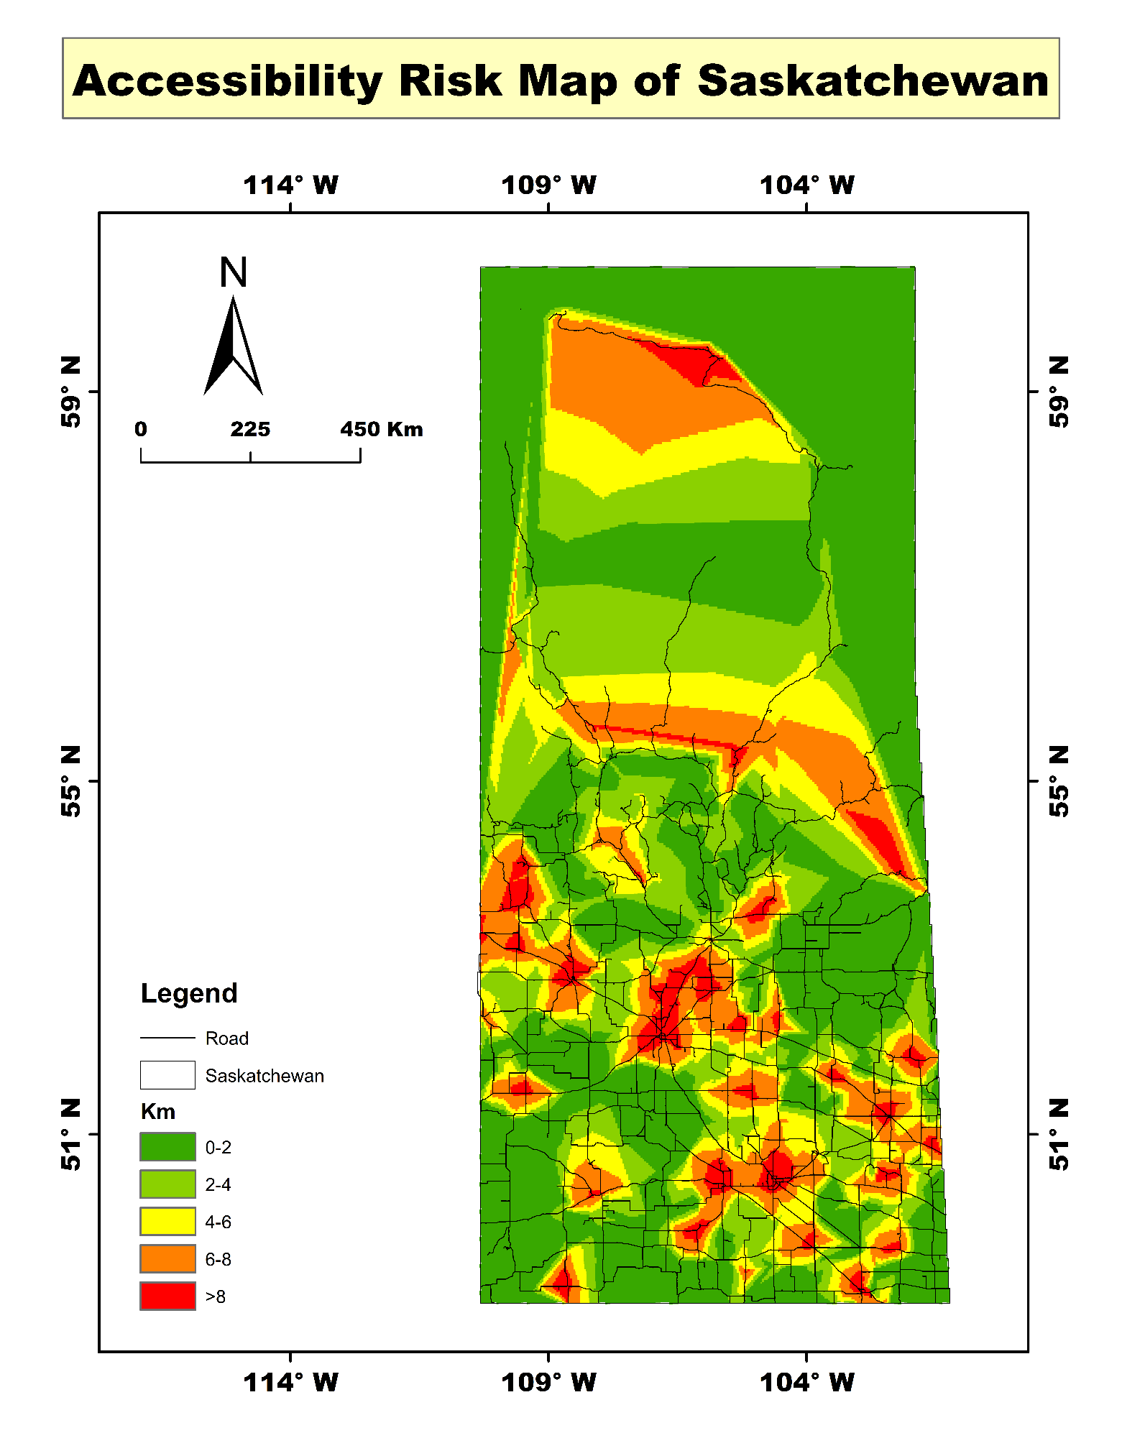
Figure 11: Network accessibility and emergency buffer distance (0 - >8 km).
4. Evaluation of Final Risk Maps and Strategic Interpretation
The integration of all ten spatial criteria was synthesized using the Bayesian Best-Worst Method (B-BWM) to calculate optimized criterion weights, which were then processed through multi-criteria raster overlay analysis in GIS. The results are translated across three distinct final risk map outputs.
4.1 Zonal Composite Risk Surface
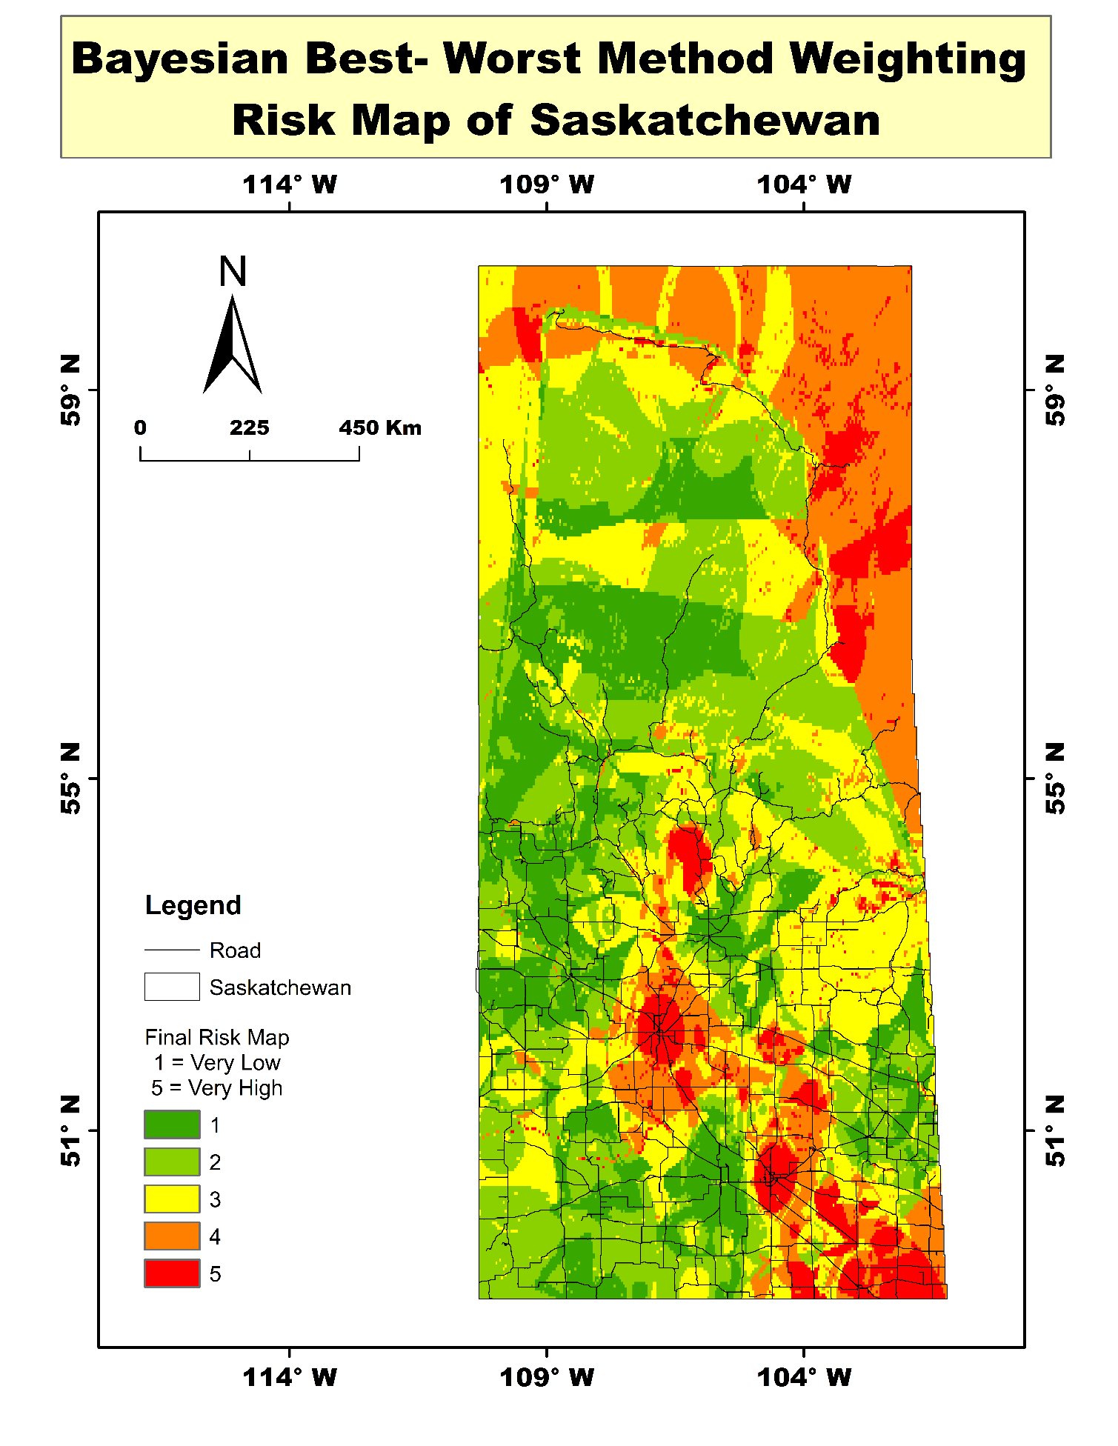
Figure 12: Continuous Bayesian Best-Worst Method Weighting Risk Map of Saskatchewan (Classified Tiers 1 to 5).
This layout illustrates the macro-scale, continuous spatial risk surface across the entire province, categorized into five ordinal tiers ranging from Tier 1 (Very Low) to Tier 5 (Very High). The highest overall composite vulnerability is heavily concentrated in the southern agricultural and industrial belt. This concentration is driven by the severe spatial confluence of high freight movement, peak population concentrations, extreme wind corridors, and intense summer thermal stress. Secondary elevated risk pockets appear across the far north, primarily governed by extreme snowfall accumulation and significant network isolation.
4.2 Highway Segment Multi-Tier Risk Classification
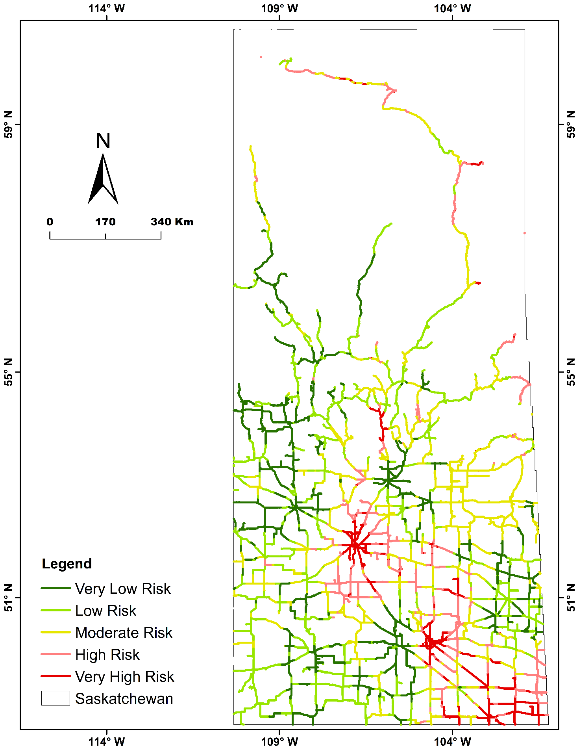
Figure 13: Classified Multi-Tier Risk Mapping Directly Overlaid on Saskatchewan Road Segments.
This layout translates the continuous raster risk surface directly onto the physical vector highway network, segmenting every road corridor into five specific operational tiers: Very Low Risk (Dark Green), Low Risk (Light Green), Moderate Risk (Yellow), High Risk (Pink), and Very High Risk (Dark Red). The dark red segments clearly highlight the highest priority arterial routes, particularly the Trans-Canada Highway and core expressways connecting Saskatoon and Regina. Northern corridors are predominantly classified as Moderate Risk with localized High-Risk endpoints where access redundancy is zero, while standard rural collector roads in central zones maintain Low to Moderate Risk ratings.
4.3 High and Very High-Priority Risk Corridors
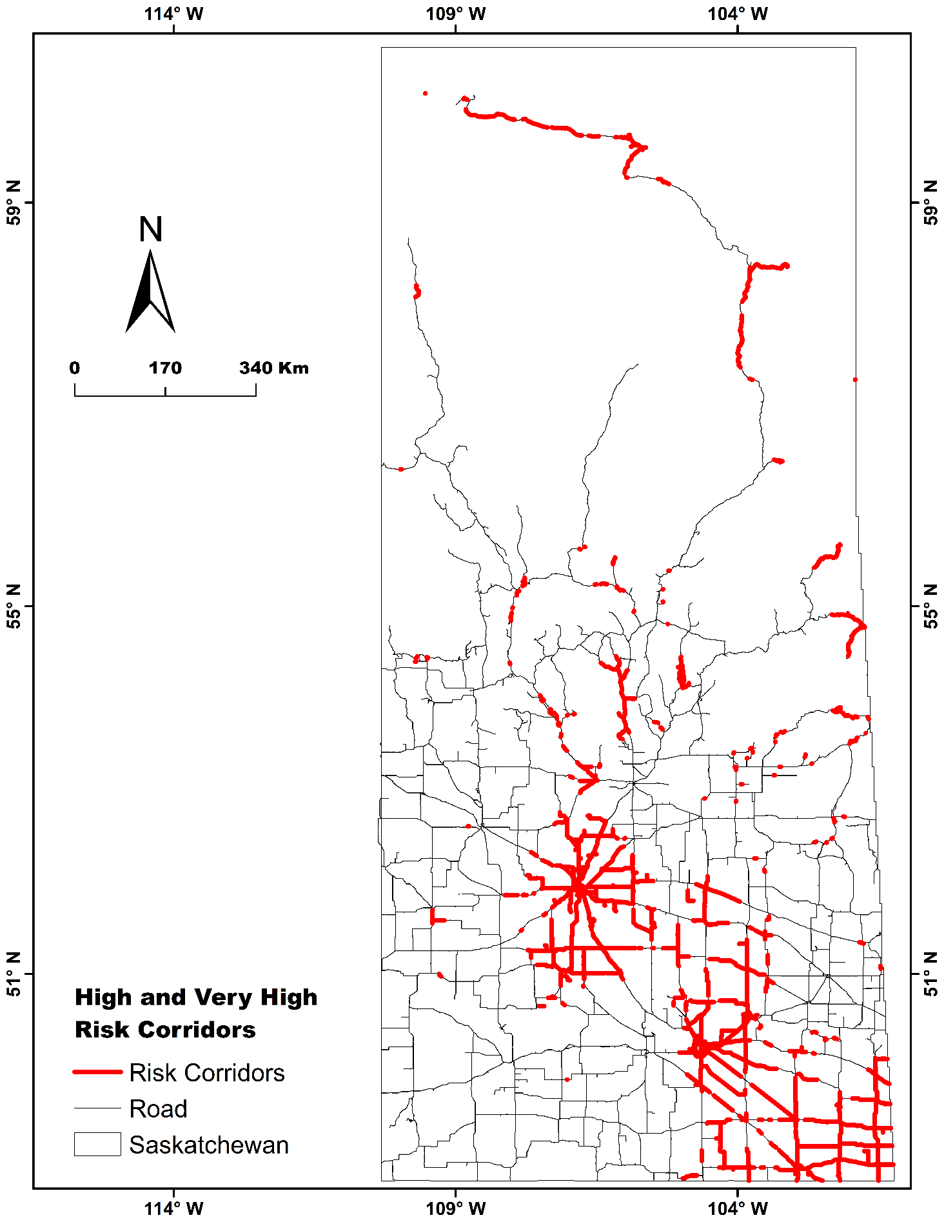
Figure 14: Isolated Critical Corridor Layer Highlighting High and Very High-Risk Segments.
This layout serves as an executive decision-support tool by isolating solely the Tier 4 (High) and Tier 5 (Very High) risk corridors in solid red against the remaining baseline network. From a capital investment perspective, these highlighted red links represent the exact highway segments requiring immediate budget allocation for pavement reinforcement, drainage culvert up-sizing, and roadside wind barriers. From an emergency response standpoint, it pinpoints high-volume economic lifelines in the south that require proactive winter de-icing, as well as critical single-access northern routes where emergency detours and localized stockpiling are essential to prevent complete community isolation.

