Performance Analytics and Growth Dynamics: A Multi-Year Interactive Sales Intelligence Dashboard for United States Commercial Operations

1. Project Background and Dashboard Architecture
This project delivers an interactive business intelligence (BI) sales dashboard designed to evaluate revenue trajectories, product line contributions, customer value distributions, and regional performance across the United States commercial market from 2014 through 2017. Built with dynamic cross-filtering capabilities across categories (Furniture, Office Supplies, and Technology) and longitudinal annual slices, the dashboard provides executive decision-makers with a unified framework to analyze profit margins, customer acquisition trends, and seasonal sales behaviors.
The dashboard interface integrates seven core analytical modules:
- Product Funnel Performance: Sub-category revenue ranking.
- Profit Gained Over Time: Longitudinal profitability tracking across three core categories.
- Geographic Sales Heatmap: State-level commercial distribution across the US.
- Customer Base Expansion: Annual active customer acquisition volume.
- Top 5 Profit-Generating Customers: High-value account contribution shares.
- Monthly Sales Seasonality: Intrayear order volume flow from January through December.
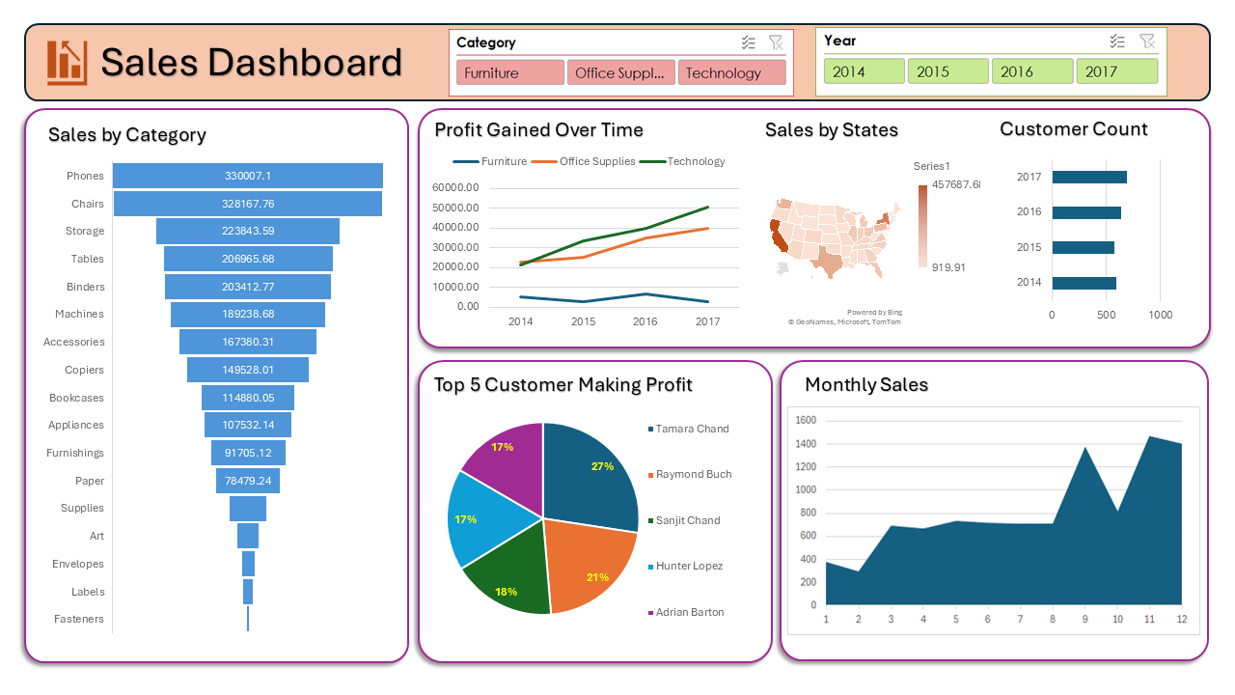
Figure 1: Comprehensive Multi-Year Sales Dashboard (All Categories and Years Aggregated).

2. Longitudinal Performance Evaluation (2014–2017)
2.1 Fiscal Year 2014 Baseline Performance
In 2014, the baseline operations generated balanced revenue across high-value technology and office essentials, led by Phones ($77,390.82), Chairs ($76,960.18), and Machines ($62,023.38). Profit margins across Technology and Office Supplies were closely aligned, each generating approximately $21,000 to $22,000, while Furniture yielded a lower initial profit of roughly $5,000. Geographically, California and New York emerged as the primary revenue drivers, reaching peak state sales of $91,303.54. Customer profitability was heavily concentrated in Sanjit Chand (accounting for 40% of the top 5 profit share), followed by Tom Boeckenhauer (19%). Monthly transaction flow displayed moderate mid-year stability followed by significant fourth-quarter surges peaking in September and November.
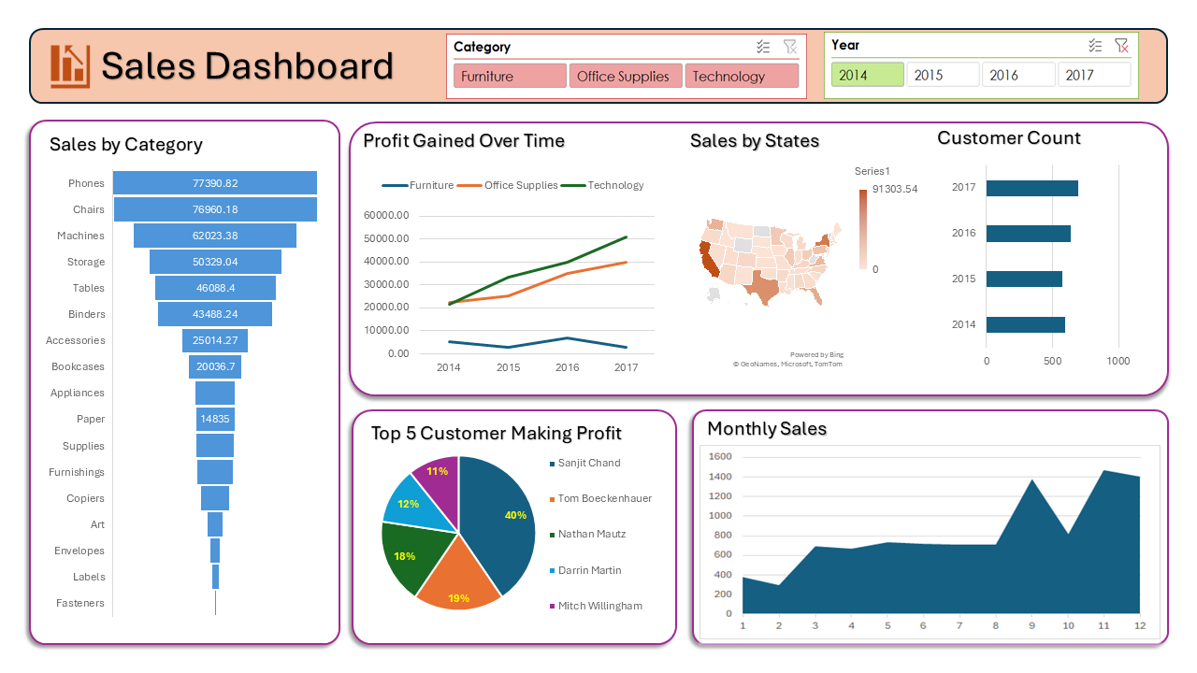
Figure 2: Interactive Sales Dashboard Filtered for Fiscal Year 2014.
2.2 Fiscal Year 2015 Growth and Product Rebalancing
During 2015, Chairs surpassed Phones as the top revenue-generating sub-category ($71,734.54 versus $68,313.68), with Storage ($45,048.23) and Accessories ($40,523.96) demonstrating steady middle-tier volume. Technology profitability accelerated to approximately $33,000, widening its margin lead over Office Supplies ($25,000), while Furniture profitability experienced a localized contraction toward $3,000. The highest state sales volume stood at $88,443.88. The customer profitability profile became more evenly distributed, led by Christopher Martinez (25%), Keith Dawkins (22%), and Harry Marie (20%).
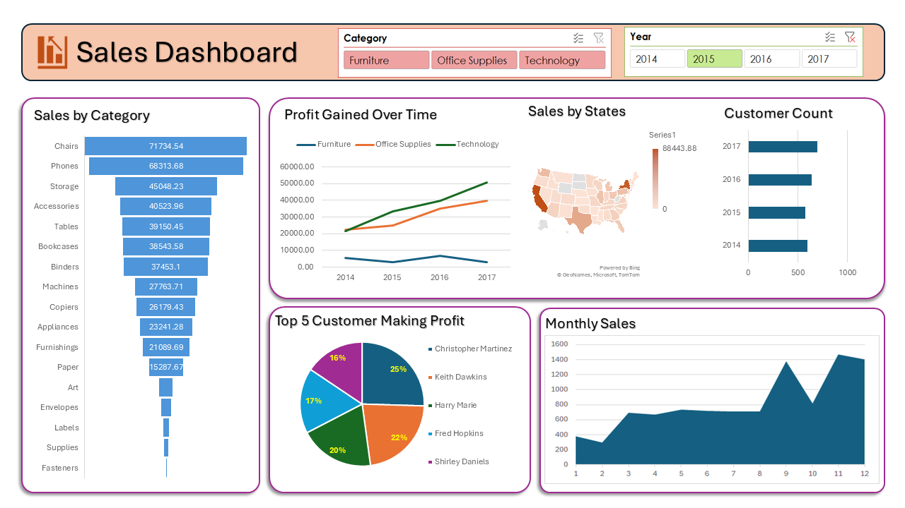
Figure 3: Interactive Sales Dashboard Filtered for Fiscal Year 2015.
2.3 Fiscal Year 2016 Margin Expansion
The 2016 operating period marked substantial sales expansion across core enterprise equipment, with Chairs reaching $83,918.70 and Phones climbing to $78,962.03. Tables experienced a surge to $60,833.25, while Copiers reached $49,599.43. Technology profits climbed past $40,000, and Furniture rebounded sharply to achieve its multi-year peak profit exceeding $7,000. State-level concentration deepened significantly, with top-tier state revenue rising to $131,551.93. Key client profitability was led by Tamara Chand (42%) and Adrian Barton (23%).
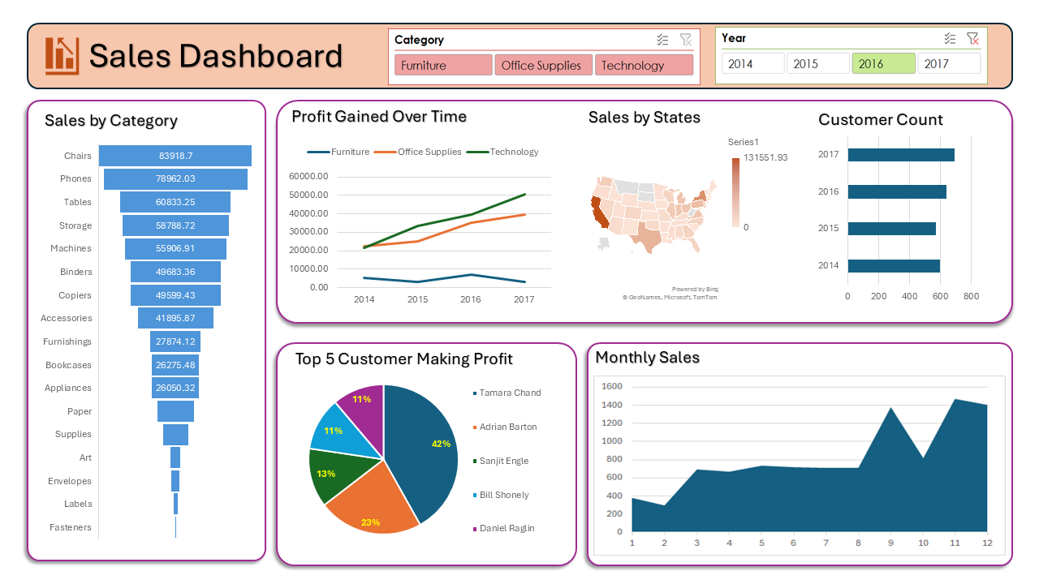
Figure 4: Interactive Sales Dashboard Filtered for Fiscal Year 2016.
2.4 Fiscal Year 2017 Peak Commercial Scaling
By 2017, top-line sales reached historic highs, led by Phones breaking six figures at $105,340.57 and Chairs reaching $95,554.34. Binders ($72,788.07) and Storage ($69,677.60) demonstrated robust recurring demand. Total customer count expanded to its highest four-year level, exceeding 650 active enterprise clients. State revenue concentration peaked at $146,388.33. Technology maintained its dominant profit generation trajectory, exceeding $50,000, while Office Supplies reached $40,000. High-margin client contributions were driven by Raymond Buch (32%), Hunter Lopez (24%), and Tom Ashbrook (22%).
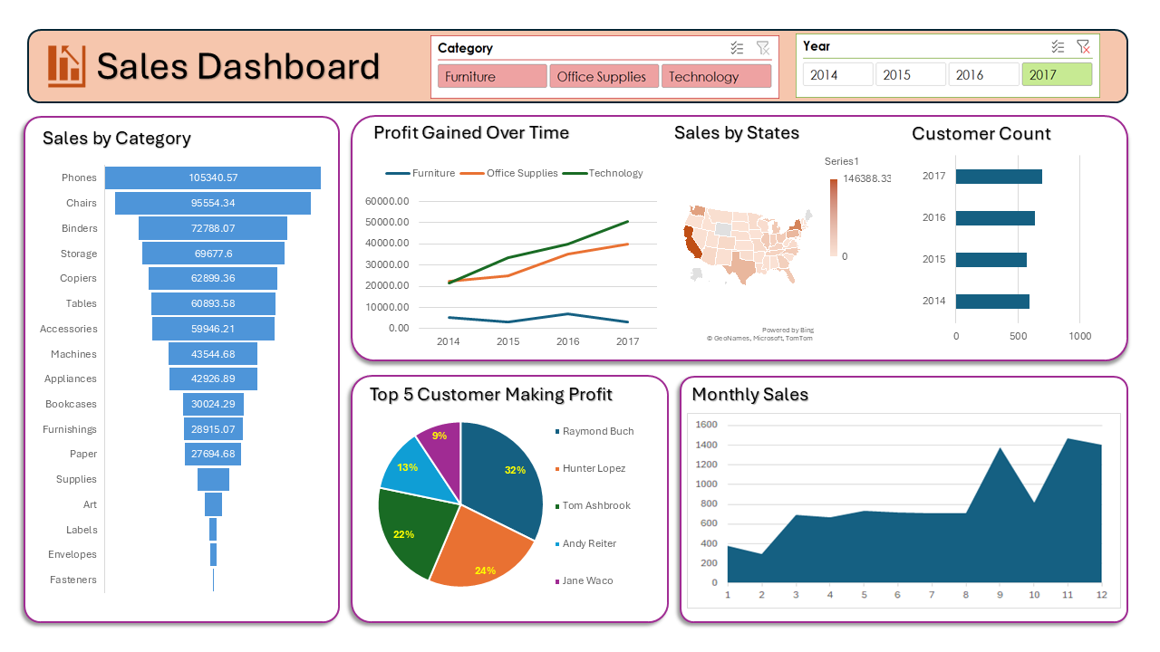
Figure 5: Interactive Sales Dashboard Filtered for Fiscal Year 2017.

3. Sectoral Category Drilldown Analysis
3.1 Furniture Category Dynamics
Aggregated across the four-year lifecycle, the Furniture segment generated substantial gross sales led by Chairs ($328,167.76) and Tables ($206,965.68), alongside Bookcases ($114,880.05) and Furnishings ($91,705.12). However, profit tracking indicates substantial margin volatility: starting near $5,500 in 2014, dropping below $3,000 in 2015, peaking above $7,000 in 2016, and contracting back toward $3,000 in 2017. This volatility reflects heavy discounting, high shipping/freight costs, and production overheads associated with bulky inventory. State-level sales reached a peak of $156,064.67, with customer profits led by Laura Armstrong (24%) and Quincy Jones (22%).
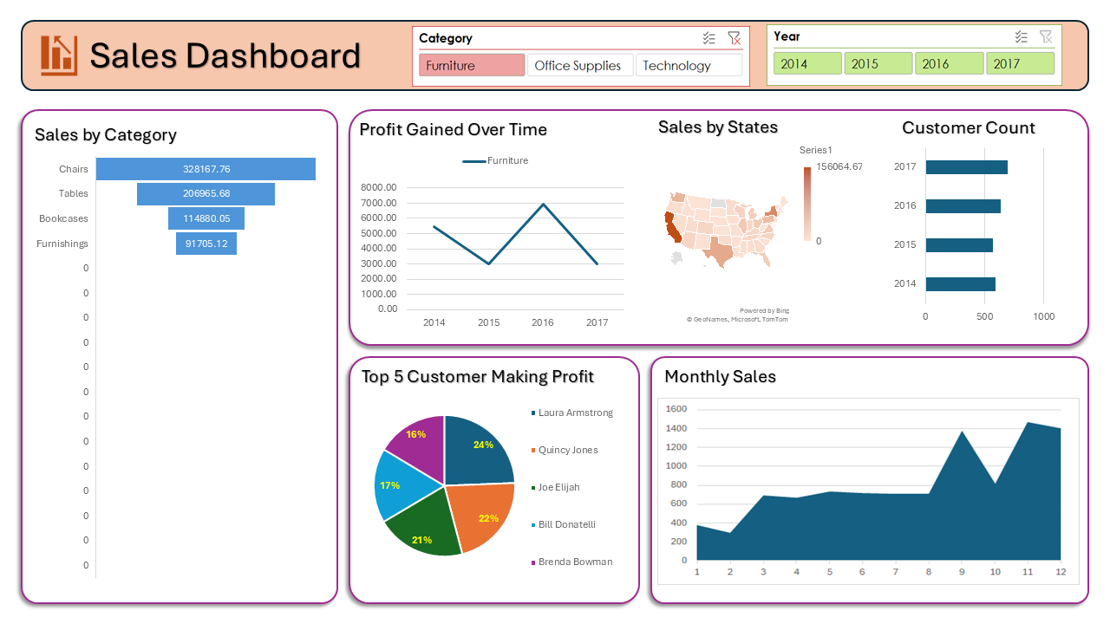
Figure 6: Dashboard Filtered Exclusively for the Furniture Category.
3.2 Office Supplies Category Dynamics
The Office Supplies sector demonstrated steady, low-volatility revenue and continuous profit expansion, rising consistently from $21,000 in 2014 to $40,000 in 2017. Volume was led by Storage ($223,843.59) and Binders ($203,412.77), followed by Appliances ($107,532.14) and Paper ($78,479.24). Top state sales totaled $142,351.89. The customer profit share showed high engagement from Sanjit Chand (29%), Adrian Barton (27%), and Christopher Martinez (20%), proving that everyday consumable products provide a reliable operational cash flow foundation.
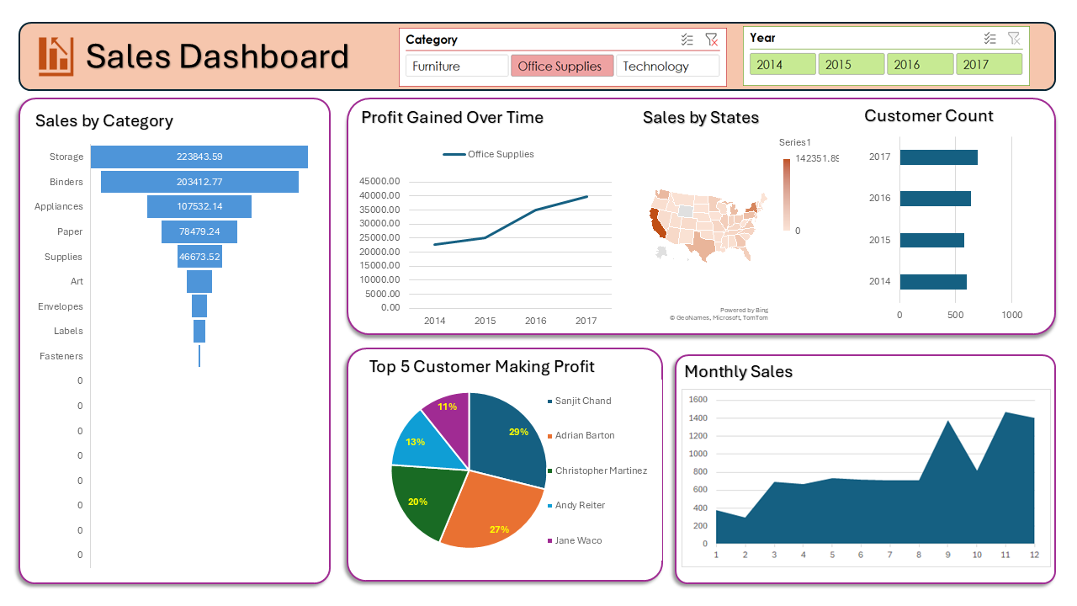
Figure 7: Dashboard Filtered Exclusively for the Office Supplies Category.
3.3 Technology Category Dynamics
Technology emerged as the primary growth engine and most lucrative commercial segment. Total category revenue was anchored by Phones ($330,007.10), Machines ($189,238.68), Accessories ($167,380.31), and Copiers ($149,528.01). Profit expanded along a steep linear trajectory from $22,000 in 2014 to over $51,000 in 2017. Peak state revenue reached $159,271.12. High-value account profit contributions were led by Tamara Chand (30%), Raymond Buch (24%), and Hunter Lopez (19%).
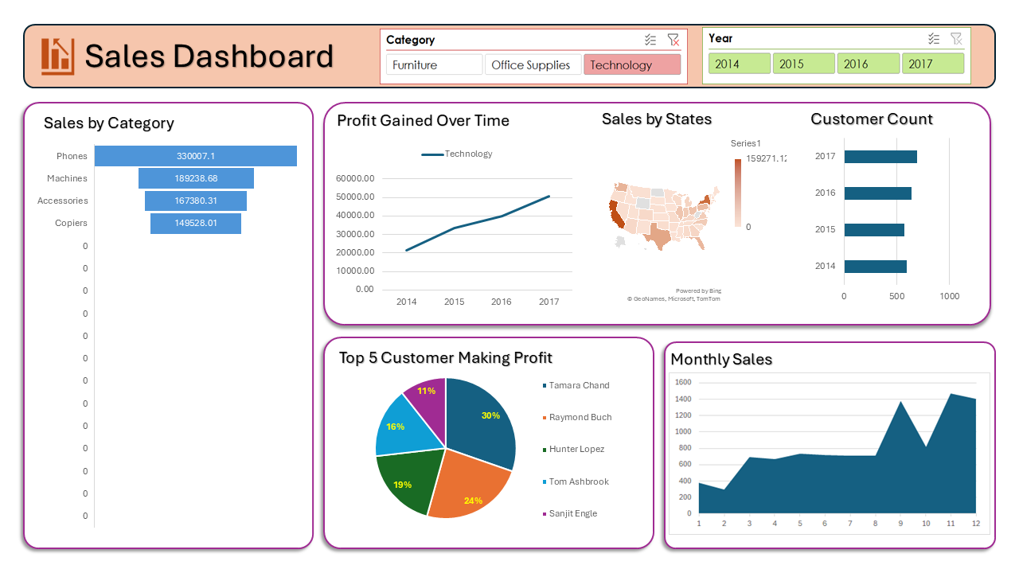
Figure 8: Dashboard Filtered Exclusively for the Technology Category.

4. Multi-Year Comparative Summary
Metric Dimension | FY 2014 | FY 2015 | FY 2016 | FY 2017
Top Sub-Category by Sales | Phones ($77,390.82) | Chairs ($71,734.54) | Chairs ($83,918.70) | Phones ($105,340.57)
Highest Single State Sales | $91,303.54 | $88,443.88 | $131,551.93 | $146,388.33
Leading Profit Category | Technology (~$22k) | Technology (~$33k) | Technology (~$41k) | Technology (~$51k)
Trailing Profit Category | Furniture (~$5.5k) | Furniture (~$3.0k) | Furniture (~$7.2k) | Furniture (~$3.0k)
Top Account Profit Driver | Sanjit Chand (40%) | Christopher Martinez (25%) | Tamara Chand (42%) | Raymond Buch (32%)
Seasonality Sales Peak | Nov (Month 11) | Nov (Month 11) | Nov (Month 11) | Nov (Month 11)
5. Strategic Insights and Final Conclusion
The empirical findings from the dashboard demonstrate a robust, expanding commercial enterprise with distinct structural strengths and optimization opportunities:
- Portfolio Profit Realignment: While Furniture generates massive top-line gross numbers ($328k in Chairs alone), its net margin remains thin and vulnerable to supply chain fluctuations. Management should re-evaluate pricing strategies, renegotiate logistics overhead, and bundle low-margin furniture items with high-margin technology products.
- Capitalizing on Technology and Office Supplies: Technology and Office Supplies represent the core drivers of enterprise value, showing uninterrupted year-over-year profit expansion. Targeted sales incentives, enterprise leasing programs, and premium product tiers should be prioritized in these two sectors.
- Regional and Seasonal Optimization: Sales remain heavily concentrated in large coastal economic hubs (California and New York) with pronounced Q4 seasonality peaks in September and November. Strategic expansion into underserved central states—combined with targeted Q1–Q2 promotional campaigns—can smooth annual revenue flows, maximize market penetration, and ensure sustained multi-year profitability.

