# Issues

1. TravisAlertsApplication.java deals with loading up all of the polling services upon boot. We force the thread to sleep for 20 milliseconds between starting each polling service to try and avoid overwhelming Travis if we are loading too many records. This is a basic way of doing it and if we had more time, we would try and make this more efficient. 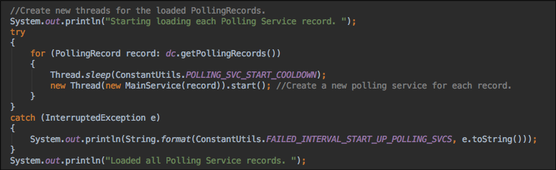
2. When we write the channel and polling records to disk, we wipe the file and re-write all of them. This might be an unnecessarily expensive operation in some cases and it may be better to just append to the end of the existing file instead? See DataController.java