**ASMEmailServices**

**USER GUIDE**

**USING SAPWEBSERVICES ON APPLICATION**

**1.Insert New Record into the tblmsglist table to queue new email message to be send by services.**

**Refer below example to trigger email out by adding new records to the table.**

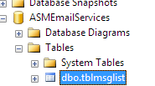

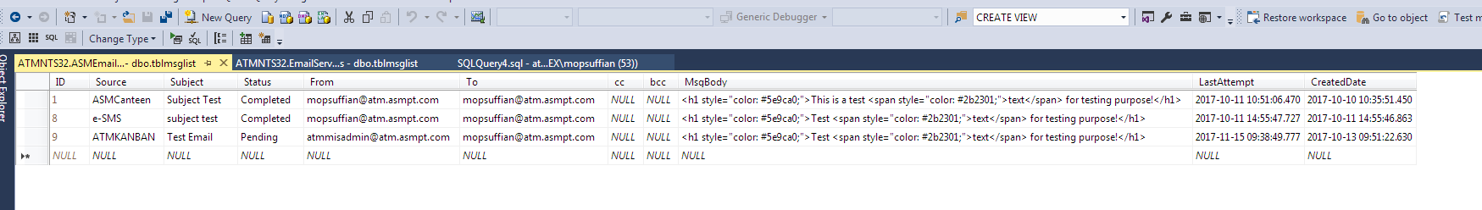

**\*Email will only be send if the status is still pending. Once email sent the status will be changed to completed**